Military Biography

Dan Michael Davis

USMC 1967 – 1971 & USMCR 1971 – 1973

USNR-R 1973 – 1993, USNR-S 1993 – 2003 &

USN-Ret 2003 – …

Prologue 2
Origins 2
University of Colorado: Naval Science 4
The Corps 7
Morse Training at Pensacola 15
Language School in DC 18
Going to Việtnam 20
Phú Bài 23
Con Thien 29
More Duty at Phú Bài 34
Back to “The World” 39
Udorn Thani, Thailand 41
Finishing up my USMC Tour 45
The Naval Reserves 47
Commissioned as an Ensign 51
Getting Senior 56
Naples, Italy 63
Regular Reserve Duty 66
The Commanding Officer 69
Military Demeanor, While in Drill Status and After 72
Hard Lessons and Aphorisms 73
Epilogue 74
Ribbon Breakout 76

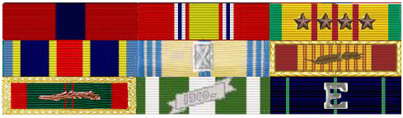

Prologue
Growing up in the 50’s and 60’s, I diligently read Ernest Hemmingway, Herman Wouk, Leon Uris, James Jones, C.S. Forrester, Alistair McLean, and others. Through their experiences and thanks to their art, I imagined that I got the some feel for what it would be like to be in combat and vicariously witnessed its impact on people. Some of the authors related their experiences as if they had been traumatized by the events, while some seemed more detached and scientifically disinterested. I wondered: What would it be like? Would I ever see any of this? What effect would it have on me? In my youth, it seemed unlikely that I would ever know; the Pax Nuclear had reduced warfare to a fraction of its earlier frequency. The stories from the novelists and biographers were all from so long ago and from so far away. Then, kawhump! “Innn-come-iiing!” It was Phú Bài, Việtnam, 1969, and somebody was trying to kill me. No one could have been more surprised than I was about the way I reacted.

Origins
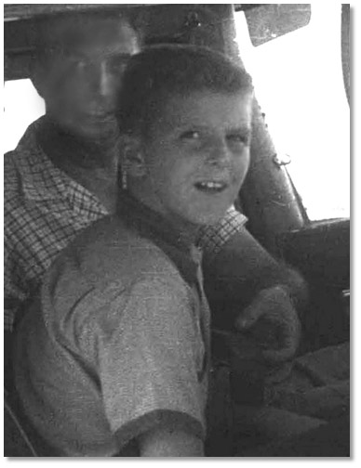
I was born in 1944, during the greatest war this world has even known. The war was a long way off though, across both of our oceans. My Parents were trying to keep their marriage together in Southern Illinois, home to both the Davises and the Eisfelders. My Father had just been commissioned as a Supply Officer in the Navy and had asked for permission to delay reporting for duty so he could be there for my “arrival.” He waited and waited, but I came a month late, so he finally had to report for duty before I was born. We joined him in Buffalo several months later, where he was in charge of the PT Boat engine procurement contract. After the War, we moved to Champagne Illinois while Dad was in Law School there, then down to Carbondale where Dad tried to get a law practice going. He was a private pilot and we spent a lot of time flying around the mid-West, just for fun.

Neither the Davis nor the Eisfelder families were particularly military, my father being the first Davis to serve in a hundred years and my mother’s family having come to the US in the mid-19th century to avoid the wars in Germany. I often have wondered where my enthusiasm for things martial had originated. Physically, I was virtually the spitting image of my Paternal Grandfather, tall but not very athletic. “Grandpa Bill” had lived through two World Wars without serving a day. My Maternal Grandfather Edward Eisfelder was a second generation German, but spent his entire life working for the Illinois Central Railroad, also having lived through WWI and WWII, also without serving a day. So there you have it: German, Welsh, English and Scotch-Irish. Did my military orientation come only from my lineal ancestors or was it the product of some more recent fermentation? One of my brothers served briefly in the Korean War, teaching electronics for the Navy in Memphis; one never served; and my younger brother, Mark, was to become a “Cold War” Navy officer, serving in subs and getting out as a LCDR after 12 years.
William T. Davis, III and Dan in a Cessna 172, Illinois, 1955

In my formative years, I never really intended to have any military career at all. The “draft” was something you could slide around, if you wanted to. Born in Illinois, but raised in Colorado Springs, I grew up in an area where we thought John Wayne was the ideal man and where we felt Barry Goldwater was one of the few from Washington with the courage to say what we believed. In retrospect, I am not sure we were not right on both accounts. By the way, I got to shake Barry’s hand when he made a speech up at the Broadmoor Hotel; that was when I was a senior at Cheyenne Mountain High. I think I asked him a rather trite question along the lines of, “Do you think conservatism has a future?”

I grew up with military kids. Their dad’s were Colonels in the Air Force or Army, stationed at NORAD or Fort Carson. Being from military families, these guys would appear out of nowhere in the middle of the school year, their dad’s having just been transferred to “The Springs.” They were later to become my high school drinking buddies. This group of my classmates had spent their early lives in real adventure, cruising around Tokyo in “Samurai” taxis, running around Berlin on the streetcars and scrambling over the battlefields in Okinawa. Perhaps a quarter of my classmates were Army or Air Force Officers’ kids, while about ten percent were Royal Canadian Air Force kids. The RCAF families all knew that they had gotten lucky; they had escaped a couple of the winters in Canada while they were stationed at NORAD, which was just south of Colorado Springs. It was from the Canadians that I learned, contrary to our history books, that the U.S. had “lost” at least one war already, the War of 1812. It is always good to hear others’ perceptions of the truth, then to compare that with the facts you know, e.g. the Brits marched virtually unopposed into our national capitol and burned it down, two U.S. invasion attempts of Canada were bloodily repulsed and the only major land battle the U.S. won came after the treaty had already been signed.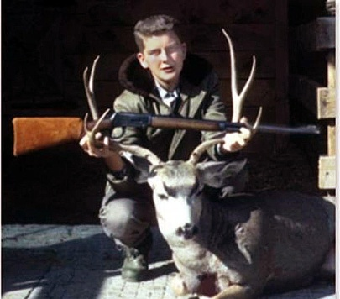

I had grown up shooting and hunting in Colorado and Wyoming. Dad did not hunt and rarely shot with us. Of all of the brothers, only my elder brothers, Bill and Ed, and I really took to shooting. My good friend in High School, Jim McCammon, was a shooter of great enthusiasm and he hand-loaded most of his ammunitions. He had a 6.5x55 Swedish Mauser that was the apple of my eye. Once in a while we would get in trouble for shooting in the wrong place, but usually we could go and shoot whenever the mood struck us. I frequently would go deer hunting up in Wyoming with my brother Bill, frequently using his 30-30 Winchester.

Speaking of hearing something different, one year a Canadian Military bagpipe band came to the high school. I remember being very moved and having tears come to my eyes. My Scottish Blood still ran deep. Back then, and in Colorado, having military personnel on campus was thought of as a “good thing.” I remember the recruiters coming to High School one day, but none of us was interested; we were all going to college. Việtnam was still called Indochina and the “real” trouble was in Cuba.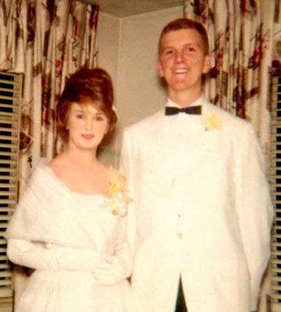

Obligatory Prom Picture
With Carol McElvaine 1962

Other than that, it was a Norman Rockwell kind of High School experience. I had a regular girl friend, but Jim did not, so we didn’t double date much. I inherited Brother Ed’s job at a drug store, “Skiffington’s”, down on Nevada Avenue, in Colorado Springs, where I worked half-time during the school years and full time during the summers. That was where I got to know the "other", enlisted Army; not the Majors, Colonels and Generals whose kids were my High School chums; it was quite a difference. My job was close to where my girlfriend Carol lived, so it was great for me; bad for my grades.

While it now seems incredible, you could buy dynamite in hardware stores at that time, and we had a good time blowing up rocks, trees, and one particular stop sign we didn’t like. Had we ever been caught, my life would have taken a very different path. Only God stood between us and an early demise. However, it was now time to “… put aside childish things”, and go on to college. I did well on the SATs and got accepted to the University of Colorado up in Boulder. After one more “American Graffiti” summer, I was off.

University of Colorado: Naval Science
Great courses of personal history are sometimes directed by trivial choices. When I got to the University of Colorado in the fall of 1962, I had to take a physical education course, band, or ROTC. P.E. didn’t sound like any fun and I did not play any instrument, so, as both my Dad and my elder brother Bill had been in the Navy, I went by the Naval Reserve Officer Training Corps (NROTC or “En-Rottsey”) and they signed me up. I really loved it. We studied Naval History the first year with Lieutenant Commander Peterson and did drills in uniform on Thursdays. Everybody else in the unit was a Midshipman, getting some amount of financial assistance. I was the only "Naval Science Student" and did it for fun. I got to fly out to the Marine bases in California over spring break in 1963 with about 40 other NROTC students.

The trip to Southern California was a real adventure for us. I didn’t have a Navy ID, so our Marine officer host for the trip, Major Bernard Trainor, drafted a letter for me saying that I was on the tour and was to be treated like a Midshipman. One glitch occurred when the instructions for the trip said we were to wear “Dress Blues, w/gloves.” Now that confused me a little, as we had been issued both suede gray gloves and cloth white gloves. Not being sure what “w/gloves meant”, white gloves or with gloves, I took both. Some guys were not so cautious, so it turned out that everybody at least had white gloves, even though we were supposed to be wearing the gray ones. We looked a little strange, walking around in our white gloves, usually reserved for very formal occasions, like changes of command. We had one really short guy who looked like a cartoon character. At one of the chow halls, some Marines waiting for lunch saw him and started jeering. I saw him later as an enlisted reservist in one of the Denver USNR units. I guess he washed out of NROTC somewhere along the line. He had a physical cross to bear and I hope he wound up happy with his life.

Anyway, we all lashed up during Spring break that year and got ready to leave. We flew out of Denver from the old Lowry Air Force Base, flying two aging C-47s, and went to Marine Corps Recruit Depot in San Diego, a place that figures significantly later in my story.

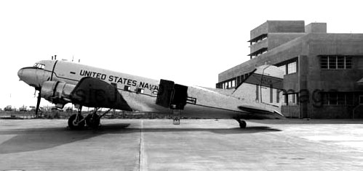 | A Navy R4D/  Also called C-47

At the MCRD I was able to see firsthand the application of a method that the Marines had developed over the decades. I saw, and later came to appreciate, what it was able to do with young Marine recruits. The Marine Corps Boot Camp sequences in Full Metal Jacket, with the exception of the melodramatic and absurd shooting scene in the “head,” were quite close to what I observed and what I was later to endure. It all seems so juvenile and counterproductive, if not sadistic, to the “silly-villians,” but it is hard to argue with success and it had a theoretical foundation that was satisfying to me: Young men conform and converge more quickly and deeply when under stress. It is better for them to go through that process when that stress can be applied benignly, than it would be to wait for the time when the rounds start coming in.

But those ordeals were still in the future for me; I was on a Midshipman’s tour. Our evenings in California were our own and while in San Diego, we went over to Coronado Island one night. As that was before the bridge was built, we rode over in an open Navy motorboat. About 9 PM, as we sat on the ocean beach looking out into the Pacific, we noticed that the surf seemed to glow when it broke. Some of the other guys thought it was a reflection of the lights of the city. I had never heard of phosphorescing surf before, so it was not till later that I found out this was a not uncommon phenomenon caused by organisms that phosphoresce when disturbed. We also went down to Tijuana on another night. Back then, I didn’t like it much either.

During the rest of the trip they took us up to Camp Mathews just north of San Diego, out to Camp Pendleton, over to Twenty-nine Palms, and we wound up at the Marine Corps Air Station at El Toro. The first and last of these have suffered the final indignity for any Military Base; both were closed at the end of the 20th Century. On the flight back to Colorado, we hit really rough weather and I was one of the few aboard who did not get airsick. As mentioned earlier, we were escorted for this trip by Major Bernard Trainor, the Marine Program Instructor at the University of Colorado, who was working on a PhD in History while he was there. He later served in Việt Nam and retired as a Lieutenant General (That’s three Stars for you silly-vilians) and became a well-known expert in military affairs, appearing often on national TV. General Trainor died in Virginia in June of 2018.

At the NROTC unit in Boulder, they had an anti-sub warfare simulator. It had a full-sized mock-up bridge, a combat information center and a control room. It was a huge simulator, filling up three rooms, each of about 20 feet square. In the control room they would simulate the approach of a submarine up to the “ship” and the Midshipmen would try to detect it with the simulated sonar and guide the “ship” over the sub so you could drop depth charges. It was a lot of fun and sometimes we would beleaguer the senior enlisted man who was in charge of it and get him to run it on weekends. I loved it and usually asked to be the sonar man. This facility was actually one of the first computer-operated video games and it was as much fun then as the games are now.

It was one of the few experiences I really enjoyed at CU. I loved to go to the Naval Science classes, enjoyed the drill, and reveled in the tradition. I did enjoy standing watches in the lounge and observing the traditions of the service. I had the honor of lowering the Navy ROTC office's US Flag to half-staff the day Kennedy died in Dallas. But my enjoyment was to be short-lived due to my leaving school “early”; I really do regret not being able to finish all of the Junior and Senior NROTC classes. Now that I am retired, I regret as well, not ever having been called to teach at a ROTC unit as a Senior Naval Reserve Officer. There is a lot I think I could have enjoyed teaching the next generation of Naval Officers. For that class, I would ask for a co-instructor: CTICS Howard Spaulding, USN, Ret, who was my classmate and drinking buddy when I later went to language school in DC. But that was all in the future; I was still trying to get my “head screwed on straight” back in Boulder.

One weekend, a couple of Naval Reserve pilots came to Boulder to fly the Midshipmen around and try to talk them into opting for pilot training when they got commissioned. They told us that the NROTC graduates had a well proven record of doing the best down at Flight Training in Pensacola. The theory was that the Academy boys were too full of themselves and had too many “wild oats” to sow to really buckle down on their flight training, the OCS/AOC’s were too new to the Navy and had to spend a lot of time just figuring out who to salute and what to do, and the Naval Aviation Cadets were still too involved in their civilian status to get serious. The visiting pilots said the numbers for these rankings were from both written test scores and flight evaluations by instructors and were not “fudged.”

Anyway, these two young officers were flying propeller driven trainers, T-34Bs, which had a tandem cockpit configuration. Before the flight we had to don flight suits and parachutes. We got about 30 seconds of instruction on how to bail out. They told us the old joke that if the pilot decides you have to jump or eject, he is duty-bound before he himself jumps to call out to his second-seat man “Eject! Eject! Eject!”, but if the second seat man says “What did you say?”, he will be talking to himself.

They took us up and we did some aerobatics, loops and rolls. My pilot kept asking me if I was getting airsick, but I loved it and didn’t feel at all ill. Unlike Lord Admiral Nelson, God had given me a strong stomach. We did a mock strafing run on a train and I thought that was very cool. Then we headed out over the mountains West of Boulder. He let me take the stick. Having flown with my Dad, I knew enough to monitor the altimeter and other instruments. I was also familiar with the fact that I needed to use a very “light hand” on the stick. Pretty soon I noticed the plane was ascending, so I gently gave the stick a little forward pressure. After a few moments, it began to rise again, so I increased the pressure again. The Pilot up front said nothing. After a few iterations like this, climbing then pushing harder, we were at the point where I really had to keep pushing hard over on the stick to keep the nose down. Finally the pilot says: “Are you pushing on the stick?” “Yes sir. You told me to take over and I am just trying to hold my altitude and heading.” “Well” says he, “I have been adding trim tab like crazy to get us to a higher altitude and I had no idea you knew how to read the instruments and fly so I couldn’t figure out what was going wrong.” Having gotten that squared away, we had a great flight. He was very disappointed I was so tall, fully two inches over the limit for pilots. He opined that there was no way I could ever get into Navy pilot training, or, as it turned out later, Army helicopter training.

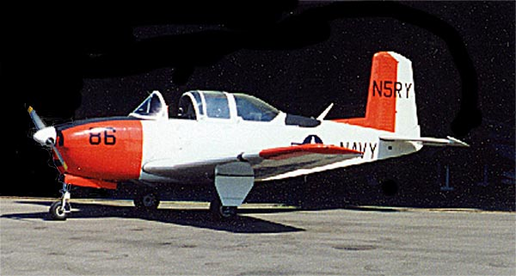 | Contemporary Picture of  US Navy  Beech T-34B Mentor

Later, I applied for admission into the formal NROTC program, had my picture taken, got terrific scores on the aptitude test, and was found acceptable. I have always said that I am proud of the fact that I am certified by the US Navy to not be grossly ugly, as "gross ugliness" was a disqualifying physical characteristic for a commission at that time. Despite my being seen as acceptable in all those respects, my non-Navy classroom grades had slipped due to cutting classes, skipping exams, etc. I always got A's in the Naval Science classes and set some kind of a record for the weapons class for non-engineering majors the second year. Our weapons instructor was a Lieutenant Morgan, a Naval Academy grad who was on his way to Nuclear Power school after being an instructor at C.U.

During the summers, I worked as a brakeman on the Pikes Peak and Manitou Railway, following my Maternal Grandfather into railroad work. We made good money and met a ton of people. One of the old conductors was a guy name “Dutch” Schultz. He had been a trombonist in a Division band in WWI and told me stories of the horror of having to bury the dead from that war’s slaughter. My two best buddies, Jim McCammon and Chuck Remmel worked on the road crew, maintaining the tracks. There was lots of beer and we had lots of good times. We used to buy pop-bottle rockets and shoot them at each other from a distance of twenty yards or so. Why are young men so self-destructive? By now the war in Việtnam was heating up, but the voluntary enlistment rate was so high in El Paso County that virtually no one was drafted. My brother Ed was never called, even though he was, to the best of my knowledge, not ever deferred.

The Corps
The Dean thought I needed “a little break,” to put it politely, remembering all of those missed classes I mentioned earlier. The term “academic suspension” sounds so harsh. I left the University of Colorado the summer after my sophomore year, doing one final year on Pikes Peak. That fall I went to Illinois where I worked at Abbott Laboratories in North Chicago for the next two years as a lab technician. They arranged to have me draft-deferred due to its being a defense-related industry. I was in a team made up of Chemical Engineers and technicians who were making antibiotics that were vital to the Việtnam War effort. In 1966 I did not put in for a deferment but returned to Colorado Springs in early ‘67 and visited all of the recruiters. Both Dad and Bill had spent their entire war years, WWII and Korea respectively, in the "States" and I did not want to do that. The Air Force offered me technical work and promised no chance of “… having to go to Việt Nam.” The Navy basically said the same, asserting that only medical corpsmen were going to “the Nam.” The Army said I had such good test scores they would either make me an officer or guarantee me duty in Germany for my entire tour. Only the Marines promised me "… an M16 and a one-way ticket to Việt Nam."

They gave all of the potential enlistees a little qualifying test and I “aced it.” It was really very easy and clearly was intended to just make crude evaluations of a candidate’s abilities. In any case, my scores were so good that my Marine Recruiter offered me what they called an Aviation Option, i.e. you would be guaranteed a job in an aviation specialty. God whispered in my ear, I guess, because I decided instead to trust my luck and just take what they gave me. After Boot Camp, I got the best possible orders for me (Cryptologic service), while the Aviation Option designees all got jobs loading bombs onto planes as they sat on the runways in Việt Nam: hard, dirty, hot and thankless, boring duty. Not exactly the same as the pictures of the avionics repairman on the front of the Aviation Option brochures at the recruiters’ office. God has always taken better care of me than I deserve.

When I went up to Denver for my induction physical, all went well until I was weighed and measured. The Hospital Corpsman who measured me said “You’re 78 and a quarter inches tall, so we can’t let you enlist.”. All of the services have a maximum height of six feet or 78 inches. He told me, I would be reclassified from 1-A (Available) down to 1-Y (Only in national emergency). You may recall that 1967 was a year when many students were fleeing to Canada, shooting themselves in the foot, or other such methods to avoid being drafted. It was clear the Corpsman thought he was giving this 22-year old good news. I told him I really did want to enlist and asked if there was any appeals process. He went away and a Navy Physician came back and took me into his office. He asked “Have you been feeling sad lately? Just break up with your girl-friend? Have any thoughts of hurting yourself?” After being assuaged by my answers, he said with obvious resignation: “Go ask the Corpsman to measure you again and don’t stand up too straight when he measures you this time.”. I did; he did; I got in.

I enlisted that March and was ordered to report on 06 April 1967. I would have my 23rd birthday in Boot Camp. I was in Platoon 353, made up of about 50 recruits. (More than a decade later, a man stopped me in an elevator in Denver and said, “Hey, weren’t you in Boot Camp in the spring of ’67? I was in platoon 351 and I remember you.”) Being tall does get one noticed.

Boot camp was the hardest thing I ever did. I never was in very good physical shape and was not at all athletic. Later in life I found out that I had a pretty bad case of hypo-thyroid and that keeps you from developing as much muscle mass as you would otherwise and is known to make a sufferer get fatigued easily. Not exactly a good candidate for the jock-oriented Marines. The emotional pressure part wasn’t bad, as I was pretty stable and was 23. Most of the “kids” were straight out of high school, so were 18 or so. There were a couple of us who were college guys who for one reason or the other had enlisted.

We did several weeks in the Quonset huts of the old MCRD recruit area next to the airport in San Diego. Last time I was down there (early in the 21st Century), those huts were gone. But, at the time we were in the same quarters shared by the WW-II Marines who fought and died anywhere from Tarawa to Okinawa. Recruit life was NOT easy. No liberty, no TV, no radio, no food other than what we got in chow hall, no civilian clothes, and no free time. As soon as we arrived at MCRD, we were thrown into an amorphous mass and we were put under the charge of two middle-twenties sergeants; one was a really evil-sounding and angry-looking black Marine named Sgt. Maynor. He was so mean that when I first heard his name I was really hoping they were saying “Sergeant Major,” a rank that I knew was too lofty to be a D.I. Unfortunately, he was in charge of us, nominally for the duration. The other guy was a much more agreeable young Sergeant named Carter. The Corps shaved our heads, gave us fatigues (“utilities” to the Marines), and we started P.T. It was brutal for me.

While my education was somewhat more advanced than my brethren, we now existed in a more primitive and predominantly physical world. I enjoyed and respected my barracks mates and I would always value the basic strengths and good will of all of the men with whom I served. If I found some of their mental missteps humorous, it was not, and still is not, an indication of any sense of superiority or intended as any kind of derogation by me. After all, they got to laugh at my lack of physical talents and I rarely felt hurt by that. We were, after all, comrades in the Marines. I really made an effort not to make a big deal of my intellectual strengths.

We were allowed to go to church on Sundays, “… but don’t you go believin’ any of that B.S. Your soul may belong to Jesus, but yo’ ass belongs to the Marine Corps!” One of the D.I.s asked the platoon who wanted to go to church. About 90% said they wanted to go. He then asked, of that group, who was Catholic: about a third. Then, who was Protestant: another third. Well, then, “What about the rest of you? What the hell are you.” “Sir, we’re all Baptists, sir.” If you never have seen mirth dancing around the eyes of an otherwise faultlessly scowling face, you should have seen Sgt. Carter as he received that declaration. He missed only one beat; then issued a proper order, “The Baptists will go to chapel with the Protestants.” Matter closed. D.I.s are all saints in wolves clothing!

Part of the drill was “thumping.” It was clear that the D.I.s wanted to convince the tough guys in the platoon that they were not so tough and they wanted to convince those of us who were easy going that we could take it. To do this, they would sucker punch the ostensibly tough boots and would bang the rest of us around. I remember well the day they popped me a few times and I was a little bummed out when they went so lightly on me, as I thought I could have easily handled more severe blows. In my case, it involved striking me in the chest while I was standing in formation until they hit me so hard it knocked me back a step. My platoon-mates complimented me on my “taking it like a man.” One of the guys who decided he really didn’t want to “get with the program,” got a more serious session in one of the Quonset huts. Nobody was ever hit hard enough to sustain an injury or even a bruise. I think we were all quite proud of our forbearance, this surely being the D.I.’s goal.

There was no familiarity allowed. Drill ground etiquette was enforced. You addressed everyone by title, never pronoun. Asking to speak, a terrible occasion in any case, certain to result in punitive push-ups, went something like: “Sir, the private requests permission to speak to the Drill Instructor, sir.” A slip-up involving the use of the pronoun “you” for a Drill Instructor would be immediately and vehemently met with the response, “Do I look like a bleeping sheep to you? I ain’t no bleeping ‘ewe’!”, followed by the obligatory, “Get down and give me twenty.” As for me, when we were away from the rest of the platoon, both of the D.I.s were civil and encouraging, but never friendly. I assume this was because I was not much different in age from either of them, and perhaps was even a few years older than they were.

The days were a never-ending grind of calisthenics, marching, running, verbal abuse, classes, and general harassment (like tearing up an entire barracks with all the bedding thrown around in disarray because one of the racks was not properly made.) The idea they were trying to inculcate was that we had to comply and we had to stick together, becoming responsible for all of our unit-mates.

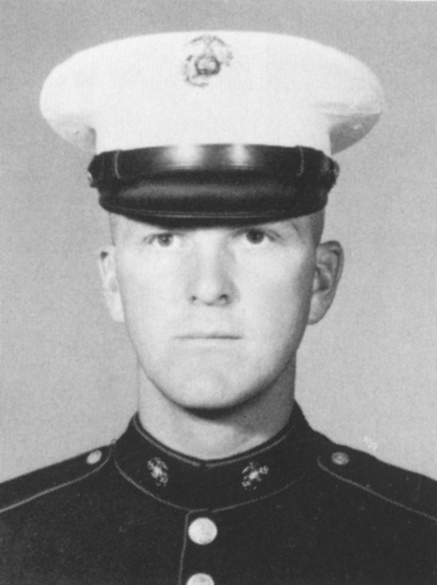 | Pvt. Dan Davis  MCRD San Diego  Spring 1967

I picked up an enflamed foot, which was diagnosed as cellulitis, and spent a day and a night in the dispensary. They gave me 180,000 units of penicillin, TID. The dispensary was in the permanent building complex part of the base. The architecture was quite beautiful and “boots” were not allowed to go there, except on specific orders. You have very likely seen the façade in movies about Marines. It was classical Southwest Architecture and consisted of a series of two and three-story buildings connected all around the huge drill field quadrangle that must be a half-mile long and a quarter-mile wide. An arched promenade, wide and cool, connected all of the buildings and faced the drill field. The dispensary had a high ceiling, with enormous and exposed wooden beams for support. I cannot but believe it is a building of significant historical importance. The Navy Medical Corpsman who gave me the shots was a sadist of the first order. He always said “Don’t tense up!”, just before he gave everyone the injection in the rump. I am convinced he intentionally did that, knowing that most young Marines would tense up. It’s like saying, “Don’t think of the word 'elephant'.” Fortunately for me, I was able to relax. Because my foot went bad and then got better on a weekend, they let me go back to my platoon late the next day. I was and am glad I did not get washed out.

The best time of the week was when we could go to church on Sunday morning. The rest of the day was spent drilling and doing our laundry by hand. We were not allowed to go to chapel on our own, but were marched over, entered as a group, and sat when ordered. But, it was quiet, cool and no one was hollering at you. That was literally the only time that we were able relax, knowing that it was the one place that the D.I. could not run up to us, slap us “up-side the gourd” and scream at us. The Protestant services were held in the large auditorium at the south end of the parade ground. The presiding chaplain was a Baptist with a true “preacher man” style.

The days were all taken up by constant physical fitness: runs, push-ups, squat-thrusts, jumping-jacks and more push-ups. We marched everywhere and were constantly assaulted by some of the most creative profanity I had ever heard. There was never a still moment. There was mile after mile of marching in platoon formation on the parade ground.

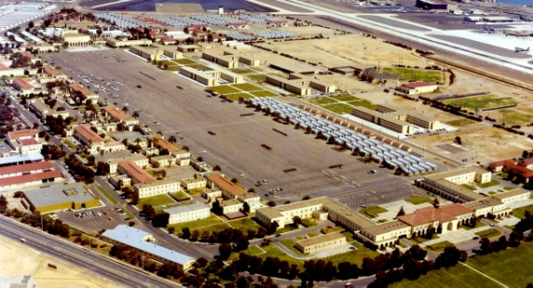 | Two views of MCRD  San Diego  Parade Ground  100 x 600 Yards | 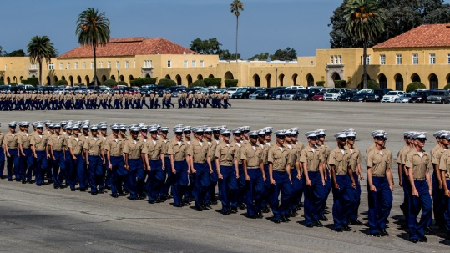

I did quite well on the GCT (General Classification Test) and had no criminal record, both of these being a little unusual for the Marines. I got a score significantly above the 120 required for cryptologic duty and way above the 110 required for a commission. I didn’t even know what cryptology was. It was still very closely held secret. Anyway, one more time, they called me out of the formation and I went, along with a buddy: Pete Yost, over to talk to a guy from NSA, the National Security Agency, of which I had never heard. Later I found out that, in those days, the joke was that NSA stood for “No Such Agency”.

The Agency man wanted to know if I had anything in my personal history about which I was embarrassed. He also wanted to know if I would object to a background investigation. Of the four of us who went over, two left the offices very quickly and returned to the platoon. Pete and I had to fill out about a million forms and were told nothing more. We got the special deal of being able to call home to get addresses and family names and birthdates and the like. I didn’t know anything else until the very end of Boot Camp when my Platoon Leader, Gunnery Sergeant Leonard Green, told me that I had gotten orders to the Naval Communications Training Center and he further ventured that I would really like the duty I was getting. He was a radio communications chief, so I am guessing he was one of the few who had any concept of what I’d really be doing.

While still at MCRD in San Diego, we were doing physical training and classes. One night we were standing guard watches, consisting of marching up and down between the Quonset huts with our rifles. It was raining, a rare thing for San Diego. The word came down to me to report to the Company Office. There I was ushered into the Captain’s office. I had never even seen him before. Our entire world centered around our two D.I.s, the Sergeants Maynor and Carter, and our Platoon Commander, GySgt Green. When I got before the Captain, I was more curious than concerned. He commenced in the following way, “Private Davis, I know there has been physical abuse by the D.I.s in this platoon and I know you are aware of it. Have you seen any abuse?” “Sir, no sir.” “Now Private Davis, some of the recruits who came in here before you have told me that it did happen and that you did see it. What did you see?” “Sir, the Private did not see anything, sir.” He gave me a look of contempt and said, “Private Davis, I know you are lying to me and I can write you up for disobeying a direct order and filing a false report. You WILL go to the brig and get a dishonorable discharge. Now tell me what you saw and what you know.” “Sir, the Private didn’t see anything, sir.” “Private Davis, get out of my sigh!” “Sir, aye-aye sir.”

I may be many bad things, but I am loyal to a fault. Evidently, some of our 18 year-old recruits who got called before the Captain, didn’t know about this old, tried and true interrogation routine and the next day we had two new D.I.s, the Sgt.s Smith and Boyer. Our first two had been “relieved of duty,” a humiliating and usually career-ending event in the military.

The majority of the recruits thought the removal of our D.I.s was really awful, but we never could figure out who finked. The day before graduation, one of our new D.I.s took us down in front of the Company Office, put us all “at-ease,” and said, “The Marines have a lot of good officers, but the sorry excuse for a Marine that removed your two D.I.s did you more harm than you will ever know. This unit never really could recover from that mistake. You will all do fine, but you will have to work extra hard to make up for the loss of focus caused by that travesty.” He was really hot under the collar and risked his career to “unload” like that where the Captain might have heard him.

After a few more weeks, we were piled into trucks and taken forty miles up to the marksmanship area on Camp Pendleton, Edson Range (Edson had been a hero at Guadalcanal and a well known expert shot.). While there, I was called out of formation one day and sent to talk to an officer. He wanted to know if I would be interested in going to OTS (Officer Training School) and becoming a commissioned officer. They gave me a test, asking me some standard questions about my best and worst qualities, etc. During the interview, he asked me why I had listed clumsiness as one of my less desirable characteristics and I said "I guess anyone wearing size 14 shoes is inclined to be clumsy." "Private Davis, I wear size 14 shoes!" End of interview!

Boot Camp was really hard on me, as I noted before, but I toughed it out. I was a good shot and was the only man in my unit who shot Expert every day we scored, including the day we formally qualified. During our service week, I was lucky to not pull food service duty, called “galley duty” in the Marine Corps. I was instead assigned to a couple of Corporals to help change light bulbs. Due to my height, I could do most of it without a ladder. They were goof-offs and just wanted to go drinking, so they frequently sent me back to our barracks early. Despite their lackadaisical attitude toward me, even this week was completely tension wracked. At any time you could suffer that wrath of any permanent personnel and especially of any Drill Instructor. This would invariably result in additional P.T. or some other undesirable consequence.

Several people kept telling me I “looked like” an officer and one of my Drill Instructors even saluted me before he realized I was just a private. This is something that I have pondered on since then. As I have grown more experienced, I also recognize the importance that voice quality has in “command presence.” In my case, being 6’ 6” didn’t hurt, my voice having more volume the sonorousness.

In the course of Recruit Training, we dropped five people from our 47-man platoon: two got sick, one was dropped for “unfitness” and two for physical failings, these two being sent to the Physical Fitness Platoon for more physical work outs, then back to the start with another platoon. Ugh! A fate worse than I can ever explain to you. The unfitness in the other man was an inability to control his bladder and he just went away. I hope God has been good to him in other ways.

Late in our training, we had what they called pugil-stick fights, using a three-foot wooden pole with things like boxing gloves on both ends. They were used to simulate bayonet fighting. I surprised myself by really beating up on the guy I was matched against. Funny thing was, despite this victory, when I went back to the end of the line to wait for the next round, I felt faint and had to drop to one knee. The next day, my hand hurt so badly, that I was unable to pick up my rifle and the Drill Instructor sent me to medical. I had broken a big chunk out of my wrist while driving the pugil-stick into my opponent. I went over to Balboa Naval Hospital on the other side of San Diego and the medical staff there were all amazed. They said they had never seen anybody with big bones like mine break a wrist like that. They bent my hand back as far as it would go to force the bone down into my wrist where it would heal, then put me in a cast.

When I went back to my unit, the Gunny almost died on the spot. I had a cast all the way up to my shoulder. I should have been transferred to the Medical Holding Platoon, treated like a “boot” for the six to eight weeks of recuperation, then sent back to do the whole recruit training again. In an act that probably saved my life (I cannot imagine I would have survived three consecutive Boot Camps!), Gunny Green literally hid me in one of the Quonset huts for the last week of Boot Camp. Later, I found out that my record reflected that it was a very good week for me. I ran a record time (for me) in the three-mile run, climbed the rope well, did the obstacle course, … If nothing else, it gave me a perspective on when “gun-decking” can be a blessing and is justified if it is for “the good of the Corps” as opposed to covering for a person who will never contribute or just to hide a problem.

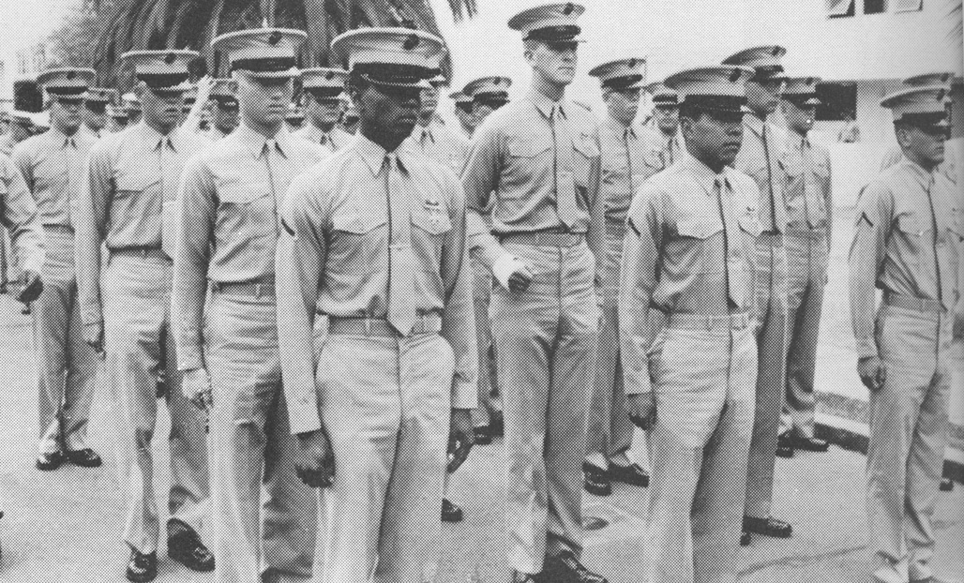 | Platoon 353,  Graduation Day Parade  MCRD San Diego CA  June 1967

Graduation day was very emotional for me. As I sat in the big Marine auditorium in San Diego, I wept as they played the Marine Corps Hymn. Back out on the Parade Ground, the Recruit Company Captain was amazed to find one of his troops had a broken arm. But, too late; I had graduated. I am prouder of having gone through the Marine Boot Camp experience and having graduated than any other thing else I ever have done. My mother and father came out. They had to miss my Brother Bill’s MBA graduation from the University of Chicago in order to be with me.

Evelyn, Dan and William Davis  MCRD, San Diego CA  June 1967 | 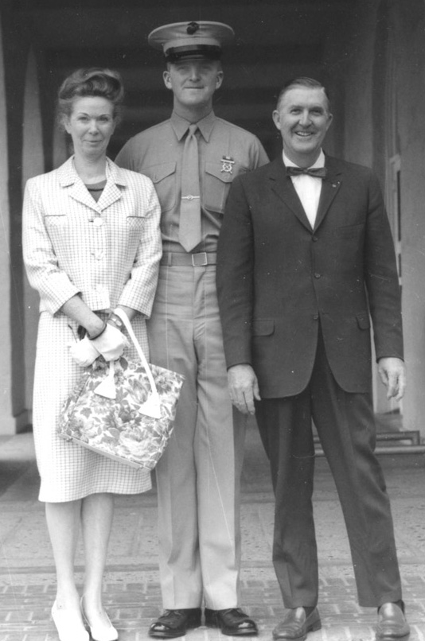

The Corps gave me orders to stay on there, at Boot Camp, as a Chaplain’s Assistant for a couple of months while my arm healed. I was not treated as a boot, but was not given leave either, as I had not completed Infantry Training. I had two really great Chaplains, an EUB Chaplain named Osborne, and a Lutheran, Chaplain Olsen. He was a Reservist who was a Professor at Saint Olaf College in Minnesota. He was doing his summer drills by filling in for Chaplain Osborn, who was off on leave. Chaplain Olsen and I spent a lot of time together discussing the moral obligations of a person in combat and the sanctity of taking communion.

I enjoyed marching more than I can really convey to you. The feeling of being with a group of like-minded men, in the company of comrades you respect, being in good shape, and marching along in the cool of the evening, with only the “chunk, chunk, chunk” of the boot-falls as music, is very peaceful. Executing a smart maneuver, with everyone hitting the mark in perfect order, is very gratifying. Someone asked me if I had ever enjoyed dancing. In its broadest definition, “rhythmic motion in time with music,” I guess you could call close-order drill a kind of dance and I did love it. Not, of course, when you were hot and tired and the D.I.’s were yelling at you, but in the evening, on the way back from chow, marching along and at peace, it was a wonderful experience.

If you happen to be a romantic Irishman, such as I am, then you may understand another feeling that comes back to me as a beautiful memory. There is no more beloved time in the service than Evening Colors. I think the Brits call it “tattoo.” This is not taps, but earlier in the evening, at the end of the workday, indicated when the flag is lowered, exactly at sundown. In the Marine Corps, Evening Colors is accompanied by a bugle call. First comes the bugle call to attention, “Ta da, ta da.” Those hearing the call, echo it to their companions, calling out “Colors!” This is said with an upswing in tone, not imparting a questioning intonation, but close. Respects are paid by all those who are outside and this is called “Being caught in the rain.” All stop what they are doing and face toward the flag, if they can see it, or in the general direction of the base flag, if it is out of sight. Those who are covered (wearing uniform hats) salute; those in civilian or work clothes stand to attention, but do not salute. The bugler then plays “retreat.” First the ascending “Ta da ta dee”, then the falling tones, “Ta ta doo dum”, mournful and restful in the twilight cool. The workday is done; relaxation and camaraderie are in the offing and you remember old friends. When the flag is finally down and the last note of the bugle dies away, you get the sprightly all-clear call. “Ta ta, dee dee, doodley dum.” I know that the preceding is a poor substitute for the real call. You really have to be there to experience it. If you have access to a network connection, try http://www.agentz.com/USFlag/EveningColorsRoutine.mp3 . After boot camp, I always volunteered for Color Guard when we had the duty section, such as down at Pensacola. Ah, yes, I did love it so. Once down in Pensacola, I was in charge of Morning Colors on a Sunday Morning. When it was time for Church Call, I ran up the Admiral’s Pennant instead of the Church Pennant. Oooops! The Chief Petty Officer who was on watch got a little upset.

Anyway, back to my story. After Boot Camp and my stint as a wounded Chaplain’s Assistant, I was assigned to the Infantry Training Regiment at Camp Pendleton. I would note that the staff at Balboa had done an excellent job. The cast never caused me any discomfort and the treatment I received was always very professional. When it was time for the cast to come off, I went back over to the hospital to get it removed. Some emergency had come up, so after the physician, a Navy Lieutenant Commander (O-4) as I recall, looked at it, he could find no technician to cut the cast off. “Never mind.” says he, “I’ll do it.” He then proceeds to use a motorized cast saw to cut the underside of the cast from my arm. It was mildly uncomfortable, but not painful. When he was done, off it came and there was a welt all the way down my arm. No big deal. Then the First Class Corpsman (E-6) who usually would have done that, came back from his emergency duty, casting an accident victim. He took one look at the cast and the welt and begins, good naturedly, to castigate the Medical Officer for not cutting the cast off properly and instructing him on how it should be done. The officer looked at me, more amused than sheepish, and said, “He’s right, you know. He’s the best man in the Navy at this.” Several orthopedic surgeons since then have examined that wrist and said it is virtually a miracle that it healed so well and they have all asked, with admiration, where the work was done. The Navy gave the Marine Corps good medical treatment. I got up to an X-ray counter once and an Admiral came up, the Corpsman immediately turned to him, but the Admiral said, “No, take care of the Marine first.”

ITR was a short, three-week course to learn to fire weapons, launch a bazooka, use a map, throw grenades, and other fun stuff. Speaking of bazookas, I was aware that they were rockets, launched from a shoulder-supported steel tube, and I “knew” from the motion pictures that they went “ffwoooosh” when they were shot. Wrong! In real life they have a very loud explosive sound and go “BLAUMP!!” and really shake the ground around you. Then, for a couple of seconds, you can see the rounds flying off on a pretty high arc toward the target, a burnt-out M4 Sherman tank about two hundred meters away. Most of the guys were missing by a couple of yards and you could see the inert rounds kicking up dust close to the tank. Some shots were way off. Anyway, I got down in prone position in firing pit number five, put the bazooka on my shoulder, got loaded by the Corporal instructor and got ready to fire. He went over the routine and then ordered me: “Fire!” “BLAUMP” “You flinched!” says my coach disgustedly! “Ge-dank” goes the round as it hits the tank. “Nice shooting, Number Five!” comes the word from the loudspeaker at the Range Officer’s bunker. I took one quick look at my Corporal, but, with God whispering in my ear, I said nothing and exited stage left.

I was put in charge of a unit and, upon graduation, was given a meritorious promotion to Private First Class (E-2). The most fun thing I did while we were there was leading a unit of ~30 Marines on brush-fire-fighting duty. It seemed to entail those activities that would later be important: keeping track of your troops, making sure everybody was fed and watered, looking out for danger, putting out the word, and keeping everyone focused on what we were trying to accomplish.

We were given weekend liberty for the first time. I was one of the only guys who could buy beer at the club, when I went there on the weekends. I did leave base one weekend to go up to Los Angeles. Made it to Disneyland and rode around L.A. on the bus some. The instructors warned us that if we gave a girl a fake name but then took off our under-shorts with our real name stenciled on it in front of them, it would cause trouble. You learn all kinds of “valuable” skills and techniques in the Marine Corps. My unit did well and the rumor was one of us was getting PFC. Our "spy" in the Company office said it was Davis, and it was assumed that it was the young private who was in my section, but who was the son of a well-known Marine officer, a Col. Davis. Turned out it was me instead.
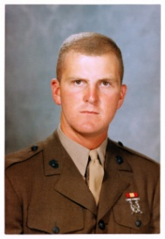
While at ITR, I met another guy there from Colorado Springs, so when we graduated, Dad drove out and the three of us drove home. My new buddy, Marlin Bradley, had also gone to Cheyenne Mountain High School. Last I heard, he was ranching back near the “Springs.” His sister Sheryl and I were classmates. In September of 1967, I was home for leave (Grossmutter, i.e. my Mother, said that I talked through clenched teeth the whole time). I was in the best shape of my life, but that was not saying much. I weighed in at about 225 pounds, which, according to the weight charts, is still overweight. This picture was taken while I was in Colorado Springs on leave for a week. All of my friends had moved, so I just hung around the house and read and luxuriated in the peace and quiet.
PFC Dan Davis September 1967

Morse Training at Pensacola
I then went south to attend Morse code intercept operator training in Pensacola Florida. That was to be a very good time for me, one of the best years of my life. I was excellent at the written stuff and about average as a code taker. We were known familiarly as “ditty-bops.” The white-sand beaches on the Gulf of Mexico were wonderful and the Dixieland Jazz was terrific. We used to go out to the beaches and dig hole, put a trash can in it, fill it with ice and beer and just have good time: drinking, talking, swimming, running around, and going crazy. There was never a crowd, so we weren’t bothering anyone. The other people closest to us on the beach would be nearly out of sight. It was an idyllic time with no worries.

I took the Foreign Language Aptitude Test and did well. I got promoted to Lance Corporal (E-3), drank an ocean of beer; hated the heat, stood gate-guard duty, and just loved being part of the group. One night I was in charge of a fire-watch section and we were looking for one of the guys who was supposed to be coming on watch. We found him in the “head,” drunk and passed out. We tried to rouse him unsuccessfully. I put an entry in the log about that and we got somebody else to stand his watch for him. A day later I was called up to the C.O.’s office where he was getting an Article 15, Non-Judicial Punishment. Wow!. I hadn’t meant for that to happen. Turns out he had a drinking problem and the C.O. said, “We’ll take care of that for you!” and gave him 30 days in the brig, of which he served 15. That was the only man I ever “wrote up” in my total of 25 plus years in the active and reserve military. I hope he was able to come to grips with his problem, but I am not sanguine about that; many have not.

We lived in open-bay barracks that had been built for World War II Naval Aviation personnel. Our classrooms were in the old hangars sitting next to the runways, now unused, which covered most of the base. We had frequent inspections, both personnel (standing in ranks) and quarters (making sure your barracks is spotless). When we had a “quarter’s inspection”, we would wax the floors. We used the old Johnson and Johnson, yellow paste wax. About three or four of us abreast, would get down on our hands and knees and apply a thick coat of the wax, rubbing it in using discarded skivvy-shirts. This was let dry for about a half hour. Then, one of our artists with a floor buffer would come along with one of the big industrial buffers with a piece of a blanket as a buffing pad and buff the floor to a sheen that reflected the otherwise humble setting. Everyone wore socks and no shoes or boots for the whole day. Our favorite MSgt (E-8) came through once, doffed his shoes, then walked gingerly to the door. Such actions merited and earned our respect. This was all very competitive; the competitors being the other “squad bays.” Silliness?? Maybe it was, but overly clean is much better than the alternative, especially when living in close quarters with a lot of people. It was fun, as long as we were all of good spirit and had a common goal. Everybody pitched in; everybody took a turn at cleaning the head. If you didn’t want to be part of the team, “Get the Hell out of my Corps!!” Gung Ho doesn’t mean mindless enthusiasm; it means, “pull together” in Chinese.

I organized a special three-day weekend liberty for six of us in March of ‘68 and we all went over to Mardi Gras in New Orleans, with a trunk full of beer we bought cheap at the commissary. We had a great time and met some interesting people. We slept in the airport waiting room, something you cannot do now, with all of the increased security. The celebration was really amazing and we lashed up with a couple of young men who were Navy Officers. They were having a good time, but I felt a little put down by their success and my lowly Corporal status. The old self-confidence thing was back again. But the group came to my rescue; I could not be down in the dumps and spoil their time. The rest of the time, we just enjoyed the party, drank and walked around. We all made it back OK and our NCOIC was relieved to see us back in time, I am quite sure.

The Navy Commanding Officer for the whole school was Captain Tamborello, while our Marine C.O. was a Major O'Brien and our XO was Captain Sepulveda (He pronounced it sep-pul-VEE-da, not Se-PUL-veh-da.) Note that a Navy Captain is an O-6 while Army, Air Force and Marine Captains are O-3s. A Major is an O-4, equal in rank to a Navy Lieutenant Commander. Just before I left, I picked up Corporal, E-4. This was important, as I was now a Non-Commissioned Officer (NCO), which meant I was supposed to be given a four-man room in the barracks (E-1 through E-3s lived in open-bay barracks), better treatment, our own NCO club, and some status.

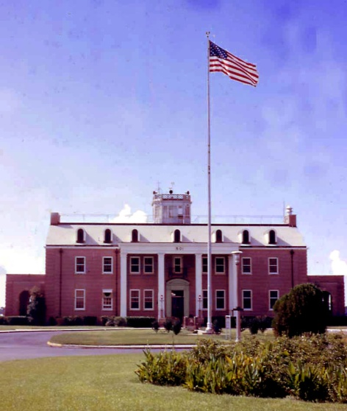 | NCTC Headquarters Building  Corry Field, Pensacola – 1960s

Once when we had a personnel inspection, I was standing in ranks and was addressed by Capt. Sepulveda. He was significantly shorter than I, so he stood back a bit so he could talk to me without getting a cramp in his neck. It was the usual “getting to know the troops” chatter where the inspecting officer tries to learn something about his people. I seemed always singled out for more than my fair share. He wanted to know who I was, what I was doing in “his Corps,” what my background was, and in response to finding out I had a couple of years of college, he asked a fateful question: “Why did you drop out of college?” “Too much drinking and not enough studying, Sir.” (Damn!! A pox on my Father for bequeathing to me a tongue faster than my brain!!) “Well, Lance Corporal, if you have a drinking problem, we can take care of that!” “No, Sir! It was more a social activity than an alcoholic one.” (Thank God for my Father’s bequeathing to me a brain that can catch up when necessary.)

The enlisted club there was a nice one. It had a bandstand where they had some really good rock and roll bands play. Several of the groups were marvelous. The clubs were in good shape in those days. The entire system was rich from all of the guys who stayed on base, bought a lot of food, pop, beer and other drinks. There was money left over to make a nice club, hire a band, have free picnics, … The enlisted club at NCTC had a dry section (80% of the floor space) and a little wet lounge (20%). I could go into the latter, as I was over 21. I could go in there and buy a pint of Michelob draft for thirty-five cents and a pickled egg for a quarter. When I began to labor with my code taking ability, around 18 groups (90 letters) per minute, I found a beer before I hit the rack (went to bed) at night relaxed me to the point I was able to master “18’s” and move on up.

One of the most unusual sights I ever saw was one winter night in the Panhandle of Florida. It did not snow there in the winter and we were driving somewhere with one of the guys who had a car. We were, as always, full of beer. All of a sudden I noticed a butterfly hatch, or so I thought, because the air was full of big white shapes, fluttering in the wind. A second later it came to me that it was a snowstorm. It melted as soon as it hit the ground and was eerily reminiscent of the little snow-globes you can buy at Christmas.

I had a number of friends there, but their names have all drifted away from me. Roger Werth was one good buddy, with whom I went to church every Sunday. The Protestant Chapel had a marvelous Chaplain from Georgia. He and his wife would meet us at the door and say, “Ghood Mohrnin’.” in that lush, educated Georgian drawl. One of the stories that stuck with me was his reminiscence of being a Chaplain on an aircraft carrier and having to counsel pilots who had lost their nerve and could no longer face carrier landings. He spoke with barely concealed emotion of the destructive effect that had upon them. It was very close to the scene in “Top Gun”, a movie that came out some two decades later, when one of the aviators turns in his wings. The NCTC Chapel was graced with a good, albeit heavily male, choir. It was a very special time of the week for me and I rarely missed a service.

I was the oldest man in the barracks and was frequently referred to as “Mr. Davis” in a jovial, but somewhat derisive, manner. I was content to spend most of my time on base. It was a lot more affordable than downtown and we were quite busy. As a junior enlisted, i.e. not an NCO, we did not have many freedoms, always having some kind of duty, watch, or cleaning obligation. Pay was quite limited in those days, so saving up for an airfare home for Christmas was a big deal.

Unlike today, virtually all of us were un-married and there were maybe two or three cars for every barracks full of Corporals and below. That meant that you had to wrangle up a ride from one of the guys with a car to even go downtown or to drive out to the beach. But, your meals were all free; the laundry was very inexpensive, and the clubs were very economical. I was getting a pint of draft Michelob for fifty cents and I used to sit in the alcohol section of the club and drink beer and eat pickled eggs for an hour or so every night, usually reading a book, as most of my friends were not yet 21 and could not join me. There was some grousing about “… why it was that you were old enough to fight and die, but not old enough for a beer, …”, but we all just accepted that.

Some of my classmates had orders to the USS Pueblo, but those orders were cancelled in a hurry when the newspapers reported that the Pueblo had been seized by the North Koreans. It was a very shameful affair. Many of the other Morse operators were getting orders to Việtnam, but mine were held up for a while. In March of 1968, I graduated from NCTC (which the comedians in the barracks said stood for “Never Could Take Code” and another, more salacious acronym) with my best code speed being 25 groups per minute. As so often happens in the Corps, there was a hiatus until my orders came through.

Language School in DC
I got orders to Defense Language Institute-East Coast (DLI-EC) in DC and was selected to take a Việtnamese (Hanoi) course. I was disappointed, as I had wanted one of the European languages, but, at least, with Việtnamese I was sure to use it and to go to “Nam.” I was assigned to one of the contract schools, LVS (Lacaze, Vox and Sanz). The school was housed in an office building down town on 14th street in DC, just around the corner from the White House.

Map showing LVS School  and Barracks at Navy Yard | 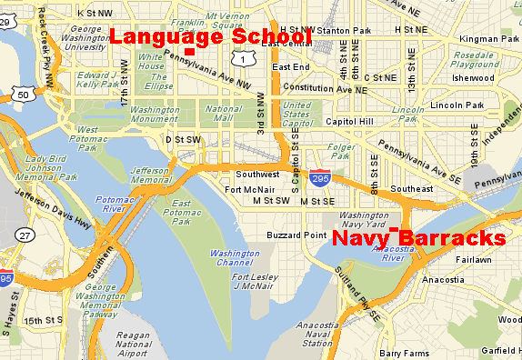

Việtnamese was one of the easier languages, so I had plenty of time to carouse and go to museums. The guys doing Russian and Chinese were working their butts off every night. We lived in the Navy Yard, close to the quarters for the Marine Honor Guard detachment, who did ceremonies and funerals and the like. I enjoyed drinking with them; they were real Marines, most had been to Nam.

D.C. was so much fun! We went to all the museums, drank like fish, partied with the locals, learned to eat with chopsticks, took pictures, and generally enjoyed life. It was fun to go to all of the free concerts down on the Mall. The service bands were terrific. These were not pick-up groups from amongst the troops. They would introduce a flute concerto like, “Our soloist this evening is Corporal ‘Talented Flautist’. Cpl. ‘Flautist’ got his bachelor’s degree in music from the University of California, Berkeley, and his master’s degree in Music Performance from the Julliard School in New York.” Obviously not exactly your typical enlisted man. Later I found out these service band billets were considered real plums for musicians and were special enlistments, not a Marine’s typical career.

We especially liked going to Matt Kanes “Bit O’ Ireland” pub on Wednesday nights, because that’s when the local bagpipe bands came to play after their practices. Brother Mark was a NROTC regular down at Duke and he came up for Thanksgiving. We were supposed to have a really good meal at the chow hall and I knew I could sneak him in. They crossed me up, unfortunately, by requiring, uniforms, IDs and a check against the mess roster. It was the only time they EVER did that the whole time we were there. Poor Mark got White Castle burgers. Everything else was closed.

I found out that I could fly home for free on an Air Force flight (four prop Douglas DC-7), stopping at Wright Patterson Air Force Base and then on to Peterson Field in Colorado Springs. Most of the passengers were Air Force Colonels and Majors. They treated me like a prince and the enlisted Crew Chiefs took care of me like a son. I guess I made that flight two or three times.

After about half a year, a new young lady came to work at LVS. She had just graduated from the University of Maryland with a degree in French and had been hired so she could speak French to the Việtnamese who all spoke fluent French. She worked in the office and soon I was spending a lot of time with her, just shooting the breeze. Her name was Linda. She was very tall and interested in the arts. All the guys said, “That one is yours, Davis.” But she had a lot of friends and her office was usually crowded with young service men wanting to chat.

One day, early in December, I was talking to a bunch of the guys and Linda. I said, “Hey, if any of you want to come out and go skiing over Christmas break, my folks have an extra room in their house.” I meant it for all of them, but I was especially careful to make sure she was there when I made the offer. No takers. I didn’t think anything else of it. Maybe a week later, I was in the break room alone and Linda came in, sat down and looked at the floor quietly for a second or two, and then got up and left without saying anything. That seemed strange. After a few minutes she came back in and immediately blurted out, “I’ve decided to accept your offer.” It took me a second or two to figure out what offer she was talking about.

I immediately went and called my folks and told them she was coming. I also made a panic-stricken call to my brother Mark, still doing NROTC down at Duke University. I asked him to teach me how to ski, as I had never been skiing in my life. Fortunately, I had not bragged to anyone about my skiing, but had just invited them out. Linda did come out to Colorado Springs and we had a lot of fun, except for her getting a little woozy at a Mexican restaurant. When we got back to DC in early January, we started surreptitiously dating. After a few dates, I kissed her while we were walking behind the library on the University of Maryland campus. I remember it well, being a romantic. I doubt that she remembered. We did a lot of kissing after that, but were not sexually intimate. We loved to go to the National Gallery of Arts and movies. Once, she dozed off when we went to see the Disney Movie “Fantasia,” an incident about which I teased her from time to time, and still do. It was a magical time. I went to my Colorado Congressman and promoted some tickets to President Nixon’s inauguration, having found out you got them that way, and Linda and I stood in the cold and watched him get sworn in, but she had another date for the parade afterwards, so I went with my ol' drinking buddies.

I enjoyed my friends and many of them were well-read and a few were quite erudite. On the whole though, they were not particularly sophisticated, especially in the fine arts. I was quite fond of E. Power Biggs and had an album of his, “Bach on the Flentrop Organ,” which was a new instrument at the Bush Riesinger Museum at Harvard. It really was marvelous, featuring most of the Bach organ favorites. One Saturday morning, when our barracks room was empty, I put the record on one of my buddies’ phonographs. I didn’t turn it up very loud, because there were a few guys all the way at the other end of the building in another room, playing cards. After just a few minutes, I heard one of them call out with obvious disgust, “Who’s playing that church music?!?” I put on earphones and listened that way from then on.

There were about seven of us in my class. Senior guy was a very easy-going Staff Sergeant named Fehr. I was a Corporal and we had several Lance Corporals: Murphy, Spaulding, Carson, and Bernier. One of the activities in which our Việtnamese Class engaged was a trip to the Embassy of the Republic of Việtnam. It turned out to be the location of only the second cup of coffee I had ever drunk. After we sat down to speak with the ambassador, a guy about as big as Lurch on the Addams Family came in and offered each of us a cup off of a silver platter; clearly he was NOT Việtnamese. He even sounded like Lurch as he rumbled, “Caawf-feee?” Not a man you would refuse. I took a dainty little cup and drank it all. My memory is that our Việtnamese was pretty shaky. Our instructors kept asking us, “Why are you just learning to understand Việtnamese and yet you don’t have to learn to speak it?” That was the same question as I had heard down in Pensacola “Hey Chief, how come we are learning to take Morse Code and we don’t have to learn how to send it?” The response was always the same answer: “We can neither confirm nor deny ….”

Going to Việtnam
Early in 1969, as graduation from DLI approached, I received orders to Company "L", Marine Support Battalion, Phú Bài. The MarSptBn (sometimes really pronounced "mar-sp’t-b’n") was detailed to "support" the Naval Security Group. The Companies of the Battalion performed technical duties with the NSG in its cryptologic activities around the world: Germany, Scotland, Guantanamo Bay Cuba, Japan, Okinawa, Philippines, Morocco, and other places. At that time, we were not allowed to use the term "cryptologic," but our jobs carried military occupational specialty (MOS) titles like: Special Radio Operator, 2571. Company "L" was engaged in "National Tasking." This could be contrasted with the other Marine units in Viêt Nam to which many of my language school buddies were assigned, the 1st and 3rd Radio Battalions, who supported local Marine units with real-time, local tactical intelligence. The paradigm scenario for their type of duty was the oft-related tableau of a Marine Cryptologist’s throwing back his tent flap and calling out: “Hit the dirt!” just before the first mortar or rocket rounds came in. Support Battalion Companies worked on higher-level problems.

Around March of 1969, I got leave orders to go home to Colorado Springs before reporting for out-CONUS (CONtinental United States) processing in preparation of going to Viêt Nam, "Staging", in California. My future wife, Linda Schaefer, joined me in Colorado for some time together and for saying goodbye. I then reported to Camp Pendleton again, this time as a Corporal, for several weeks of advanced weapons training, updates on shots, administrative maintenance, POW training, escape and evasion practice, and orientation lectures ("You are going to Viêt Nam to fight for the Việtnamese, not against them. Your enemy is the North Việtnamese Army...."). We went over the UCMJ, the Code of Conduct and the Geneva Convention. No one ever suggested, even in jest or in braggadocio, that we did not have to follow the rules of the Geneva Convention or the rules of humanity for any reason. Movies to the contrary notwithstanding, I never saw any official sanction of inhumane actions.

During one personnel inspection in front of our barracks at Camp Pendleton, the Major who was in charge of our unit’s processing had all of the NCO’s lined up in the shade and he walked down the line and spoke to each of us. He had been to Nam and he had words of encouragement and knowledge to impart: “Where you going son?” “ Third Mar Div, Sir.” “Good outfit, son. You’ll be operating up around Đông Hà.” “How about you Sergeant? Where are you going?” “MAW 16, Sir.” “Good duty, Sergeant; you’ll have a good tour.” Notice that the question “Where are you going?” has always been answered with a unit designation, as most of these guys had no real idea where their unit was or where in that large organization they might really be sent. God was whispering in my ear again, but, as has so often been true, I was NOT listening. I was assigned to a very special, small unit, Company “L”, MarSptBn, and I knew exactly where they were, Phú Bài. Looking up at me (all Majors are short) he asks, “Where are you going Corporal?” “Phú Bài, Sir.” He looks at his clerk as if to say, “Oh, oh! We got us another drifty one.” He tries again. “What I meant was, what unit are you going to?” “Company ‘L’, Marine Support Battalion, Sir.” “How can you possibly know what Company you are going to?” “That’s what my orders say, Sir.” Once again he looks to his Admin Sergeant, who just shrugs his shoulders. Leaving me with a withering look, the Major goes on the next person, without any words of encouragement for me. I loved it!

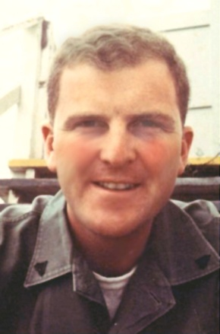 | Corporal Dan M. Davis  March 1969  Camp Pendleton  California

I was in charge of a platoon, being senior to almost everybody else. They were mostly 17 to 19 year-old kids, straight out of Boot Camp and Infantry training. I was proud of the fact that no one from my platoon went AWOL and we all got on the plane at Norton AFB, just east of L.A. I believe it was a Boeing 720, leased to transport troops, so we had flight attendants, airline meals and regular seats. When we stopped in Honolulu, I got off the plane first and made it into the bar for a Hawaiian beer, Primo. Just seconds later, the officers got there and they ordered the rest of the NCOs keep the all of the Marines from the plane from going into the bar.

On these flights, one thing was always true: your gear and duffle bag were all checked and the only thing you carried with you was your personnel record and your orders. The first man in line went to the end of the plane and took the window seat, next man right next to him, and so on. You had your seat number and you lined up in that order. You could fully load a 720 in about 60 seconds flat. I know regimentation has a bad name amongst the hippies, but it really is effective at getting the job done when loading an airplane. No arguments; no fumbling around; just get on and sit down.

For pictures of my year in Việtnam, try web page:
http://www.hpc-educ.org/Files/Nam_DMD_69-70/index.htm

We flew to Okinawa the middle of April 1969, crossing the International Date Line close to midnight on 17 April, so I could say I flew straight from the 17th into the 19th, skipping my 25th birthday on the 18th. I spent about a week on Okinawa; more processing, storing my uniforms, picking up jungle fatigues, and making sure that my will was in order. I was always an avid reader and my cryptologic buddies were also big readers. I had read and fallen in love with Michener’s Sayonara. The first morning in Okinawa, I awakened to the sound of temple bells. I was hooked on the romance of Japan. The other thing I remember is the incredibly refined, and very white, bread. It made the hamburgers taste so good. I was told it was so soft and refined because the Japanese used rice flour instead of wheat. The beer was, as you might guess, excellent!

While an enlisted man’s time in the Corps was usually very structured, Okinawa was one of those places where you could hang out for weeks. Nobody really seemed to know who was there and when you were supposed to get on the plane south. Thing was, everybody wanted to get on with it. You felt kind of at loose ends until you got to your unit. It was my good fortune to meet a friend from Pensacola there who advised me that I should not let anybody tell me where to go when I got to ‘Nam, as they would send me to the wrong place. One cryptologist had been sent to Saigon; they thought his "spook" orders meant he was assigned to embassy duty. My friend was right about the confusion and the willingness of the over-worked clerks to send you where THEY thought you should go.

I finally got a flight to Nam a couple of days later. It was an incredibly quiet flight in the plane. There was none of the usual Billingsgate jeering and catcalling. There were two or three officers on board, but very few NCOs. Most of the troops were privates and PFCs. We called them “snuffees.” That was the hip term for cannon fodder that were going to be snuffed out. Anyway, it makes one reflective, if you are 18 and you think you are going to Việtnam to die. It was VERY quiet.

So I went into Viêt Nam late in April on a chartered plane (Boeing 727 as I remember), landing at Đà Nẵng, up in the northern-most Corps Area, "I" Corps, pronounced 'Eye Core.' I had not yet been issued a weapon at that time and spent a couple of days at a receiving station in Đà Nẵng. It was kind of eerie riding around Đà Nẵng in a bus with chicken wire on the windows to keep out any grenades thrown at us. As we rode over one river bridge, somebody standing at the bridge rail let go with a burst of automatic weapons fire, probably shooting at flotsam in the river, just to make sure there was not somebody under it. It was a little disconcerting, just sitting there with only the Swiss Army knife, which Uncle Ed had given to me, for protection. I could not believe I was in this situation with no firearm. We were not allowed out into “the economy,” but stayed on base.

I studiously avoided the Admin people who “knew” I must belong to First MarDiv or Third MarDiv or First MAW or MAG 16 or one of the other big units. Nobody else had orders to a specific company. Got myself down to the local Marine transportation office on my own and showed them my orders for Co "L" and they let me get on a flight to Phú Bài. It was another old DC-3 variant called a C-117 and dated from the 1940s. It was an advanced version, by a few years, of the C-47s we had flown to California while I was on our NROTC trip.
USMC C-117D | 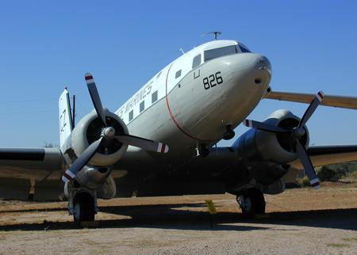

The one we were to fly up to Phú Bài on was parked out on the tarmac of the apron, just off the end of the Đà Nẵng runway. It seemed to be an area reserved for transports rather than the F-4s and other fighters. It was oppressively hot and we had to wait for the pilot. Several of us lounged under the wing of the old bird as it sat there. Half a dozen of us were U.S. and two were ARVN (Army of the Republic of Viêt Nam, “Arvins.”) I was not paying much attention to them, but when some F-4’s took off, they stopped and watched. Just when the pair of F-4s came abreast of us, the pilots cut in their afterburners, “rooaar - Ka-Boooom. ROOAARR!” “Hai Lam!” said the Arvins. Roughly translated that means “Wow!’ That was the first Việtnamese I translated in-country.

After about an hour, we finally saw a guy come out of the tent about fifty feet off to one side of the apron. I guessed it was the club for the area because the guy who came out looked a little unsteady on his feet. It turned out that he was our pilot. He flew beautifully though, up along the East coast of Viêt Nam at about a couple of thousand feet. We had a spectacular flight up to Phú Bài, which is the major airport in northern South Viêt Nam, just south of Hue.

Phú Bài
As we came into Phú Bài, I notice the land was marked everywhere with groups of perfectly round, two or three meter ground formations. I did not know whether these were graves or shell holes. It turns out later that they were old family graves. The Buddhist tradition of cremation was not invariable amongst either the Buddhists or the Catholics in Viêt Nam.

As we got down at Phú Bài, we could see there were bunkers, sand-bagged hangars and burnt-out hulks of old planes on the airfield. Helicopters were skittering in and out and I noticed that the field seemed abuzz. Everything was clearly much more combat-oriented than Đà Nẵng.

Map showing my major duty sites in Việtnam | 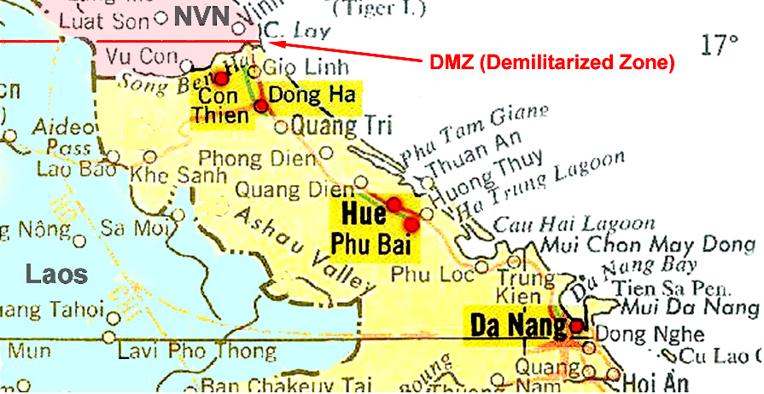

Phú Bài was on the coastal alluvial plain a few miles wide, bordered on the West by a row of hills that were on the order of 500 feet high. This plain was split down the middle by Highway One, which was one of the only paved roads in that area. Most of the other roads were gravel or dirt, a few with oil seal on them. Everywhere there were one-story “hootches,” which were small, olive drab buildings of about fifteen feet by twenty feet, covered with corrugated roofs. There were a few two-story buildings. There were some palm trees and some low shrubs, but mainly the ground was just the sandy, red soil of Phú Bài.

When I got there, I got on the phone with Company "L" and they sent a truck over for me. It was an old half-ton military truck (WWII vintage?) that they had "liberated" from the SeaBees and it had a straight pipe for a muffler. Any time you wanted to know where it was, you could just go out into the night and listen. I swear you could hear that thing for miles. They drove me over the Army's 8th Radio Research Field Station (RRFS), a base with maybe 1,000 people in it. Company “L” was a tenant command there.

In Company “L” operations, I was assigned duties as a linguist (2574), doing translations and transcriptions. The Company was split into three "Watch Sections" of about twenty each and then there were maybe another 20 support and command personnel. I worked eight hours a day, seven days a week on a schedule we called “Eve, Day, Mid, 32.” That is my section worked 4pm to midnight, off eight hours, 8AM to 4 PM, off eight hours, then midnight to 8 AM. Thing was, at 8AM of your mid-watch, you had other duty, usually working on building up the trench line and defensive perimeter, until about noon, then you had almost a day to recoup your sleep, clean your gear, ... then back to work.

I was issued a brand new M16-A1 rifle and, shortly thereafter, the M-60 Machine gunner left, so they gave me that and, best of all, an M1911-A1 .45 caliber pistol. The M16-A1 was so new it was still wrapped in paper, so it was like opening a Christmas present for me. I had to “bore-sight” it till I got to the range some weeks later. You had to carry a weapon when you went off-base, so having a pistol you could wear on your belt was much more convenient than toting around your M16. While I was well armed, my first firing in Vietnam was on a nearby "range," but I did not fire the other weapons for some time. Actually, I never fired the .45 the whole time I was there. While ammunition was very much controlled and accounted for in the US, in Vietnam, we all had all the ammo we could want and many wound up having possession of grenades: smoke, CS Gas and anti-personnel. These were more controlled, but were floating around. We had grenades in our bunkers on the defense lines but not in the barracks or on our web gear. So I had weapons from WWI, post-WWII and Viet Nam eras.

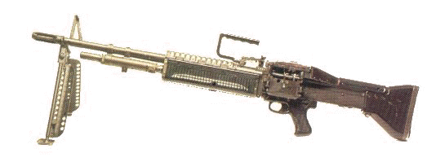 | Picture of the M-60 Machine Gun, which was  based on two German designs from WW II

While I fired them all frequently for practice and to ensure they were in good operating order, I never fired them at any specific person or known enemy location. The whole time I was at Phú Bài, we never got orders to fire at all, other than illumination rounds from mortars and "pop-up" flares. Sometime later, around Con Thien, we would get orders to do H&I fire (harassment and interdiction) where you would just shoot into areas believed to be occupied by the NVA. There were no (NO) civilians within twenty miles of Con Thien. H & I firing up there was mostly done by the mortars, howitzers, quad 50s, twin 40's and the like. They would also get fire missions when someone saw NVA troops crossing over from the DMZ.

During my whole tour of duty at Phú Bài, I was interested, willing, and anxious to get off base from time to time. As I was a linguist, I always could bluff my way through roadblocks by saying I was on a mission. I used to go out to Highway One, hitch a ride on a U.S. forces truck up to Hue and then catch a ride over to Tân Mў, (“Beautiful Beach,” and it was!) to swim and have drink in the SeaBees’ club. One time when we were up there, I was bumming around with my drinking buddy was John Lemandri, a young Corporal. The Việtnamese cleaning ladies were called Mama Sans, the Anglicized-Japanese word for such workers) and all of them thought he was the most dêp (beautiful) man they had ever seen.

Anyway, as we entered the Seabees' club, he forgot to take off his “cover” (hat.) All the clubs had the same rule, and frequently the same poem over the bar:

He who enters covered here,
shall buy the bar a round of cheer.

They usually have a bell that they ring on such occasions and this WAS one of those occasions. Bong! He was unable to fund such a fine, so we had to talk our way out of paying for everybody, which fortunately would have amounted to only a few dollars for half a dozen beers and Cuba Libra or two.

A Typical Watch Cycle

At about 1500 (Three PM), I would run by the chow hall which was about 200 to 300 yards from our barracks; more about the food later. It was a temporary building, made up of pushed-together trailer-like modules. The Army enlisted also lived in such structures. I would get an early dinner, then back to my barracks to pick up my gear: flack vest, helmet and M16, then off to work which was on the other side of the street from the chow hall. There I had to show my picture security badge to the MP guards and wear that badge the entire time I was in the building. The watch spaces were made up of a “bay” with about 12 radios, six along each wall and an old Underwood Comms typewriter at each station. Here the troops would pound out their work on six-ply Comms paper so you got an original and then five copies of that automatically. It was perforated fan-fold paper that came in boxes that sat behind each typewriter. Most of the Morse Ops were E3-5 (Lance Corporal, Corporal, or Sergeant.) The paper came pre-installed with single-use carbon paper, with perforations that allowed one to pull out with a single tear of the perforated sides. Each bay would be supervised by a Staff Sergeant.

I did not work in the bays, as I was the “Duty Linguist” so did my duty in the analysts’ room. This room was maybe thirty feet by thirty feet and one corner was set off with dividers for the CO (a Marine Major, O-4) and the XO (a Navy Lieutenant, O-3.) Also there were the Company First Sergeant, (a Master Sergeant), senior analysts (WO-3’s), Traffic Analysts and Cryptanalysts (Staff Sergeants), external communications guys (Corporals) and the like, so maybe ten desks and two teletype machines.

There were senior people who had the duty inside of the operations area if we were under attack. That meant that when the rockets came in and the sirens went off, the duty linguist would gather up his gear (flack vest, helmet and rifle) and stand by until relieved by the senior linguist. Then it was off to the trenches until the “All Clear” was sounded.

Every night, someone from our crew had to do a “burn”. That entailed picking up all the bags of classified document waste, e.g. carbon paper that had been used for classified reports, and take them out to an incinerator, burn them up and then stir them. If we got hit, an Emergency Burn was required and the Army did that for us. So, for the guys who hated getting ashes all over their uniforms, a rocket attack was a good thing.

The Linguists’ desk had a Racal Receiver and an old R-390 for our other tasks that required our having a direct conduit for speech, as opposed to translating the Morse work.

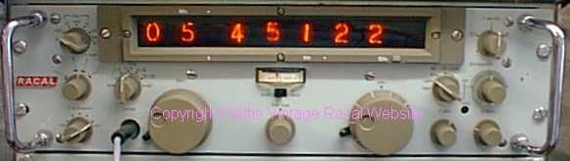  ← ~19 Inches → | 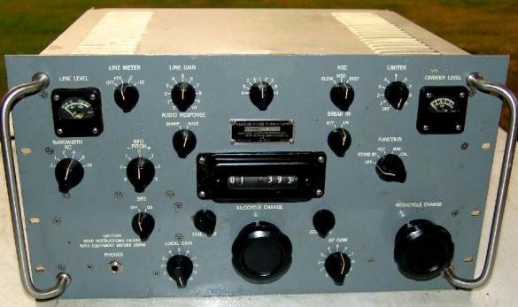
Racal RA 1218 (Similar to what we had) | Collins R-390 (Workhorse receiver from ‘50s

Our equipment rack also had an audio tape recorder. At the beginning of the Eve Watch, 1600, there was always a long scheduled piece of work recording and transcribing a half-hour long audio input, which consisted of both language and long recitations of numbers. Getting that all correct and typed up would take another hour or two, depending on the quality, length and complexity. The rest of the watch was taken up by translations of the Morse work. Often that would mean a busy night, but usually I only was doing something half the time. The rest of the Eve watch could be spent reading, talking with the Morse guys, making a hamburger run to an all-night Army kitchen about a mile off or just killing time. At 2400, we’d get off and hike back to the barracks for about six hours of sleep.

The members of the Corps think six hours is plenty, so it was easy to get up at 0700 the next morning. A quick shower, don the uniform (jungle utilities usually) and grab the gear, a quick breakfast and at "Ops" by 0800. Being even a minute late was considered quite a faux pas, but arrival times were not monitored by senior people. You were responsible to guy you were relieving. The exchange usually goes to what is "hot" and the like. Day Watches start with another audio session and record keeping. As it is a Day Watch, the CO and the XO were in most of the day, along with the analysts and the senior enlisted. No goofing off or horsing around with this crowd. If you're really not busy, you could take time to do lunch around noon. As the world was more active, there was usually more activity from the Morse bay, so there was more written work for the linguist to do as well. Due to our cryptologic “national” tasking, there was still a lot of time when there was little to do for the linguist. Come 1600 (4 PM), relief appears and you go to Supper at the chow hall. Now this is an awkward time; hard to get much sleep between 1800 and 2300, but one can get a little "shut eye."

You were either awake or you heard people in the barracks getting ready for the Mid Watch, so you were up by 2330 (11:30 PM) and grabbing your gear. "Mids" are different; very slow and lots of time to catch up on your reading, etc. One of our communications guys made up a teletype punch tape that generated the square "Battleship" grid to help pass the time. Another favorite was to generate two 28 letter series that using key words. Then the game was something like "Populate that series using the pairs as the first initials of movie stars (or authors, or book titles, or …). As the watch wore on, people got goofy. I remembered the line from Elmer Gantry, "… stayed up all night getting drunk on eloquence and coffee." In 'Nam, I saw it; I believe it. Come 0800, watch-standing is over for this series, but no rest for the wicked.

After a quick breakfast, it was trench-line maintenance duty for four hours. This mainly was digging, clearing out sand washed in by rain, filling new sand-bags, etc. For healthy young Marines who had just spent eight-on, eight off for a day and a half, doing stressful and non-physical work while jammed in a smoke-filled room, it was really a relief to be outside and working. Some time close to noon you would break for lunch then you had the rest of the day off and the next, 28 hours to relax, do your laundry, catch up on your sleep, take care of personal hygiene (haircuts, medical exams, etc.)

About once a month, there was a little disruption as you pulled perimeter defense duty. That means you spent the night in a bunker, a guard tower, or a command post on the outside perimeter. That was a nice break, but meant you missed most of a night's sleep on your day off. Another disruption was a trip to the range to zero-in your rifle or, one glorious day, Fam-Fire (Familiarization Fire) the M-60 machine gun. Sleep did become precious and most people who were in the service have an inordinate reverence for sleep. If a man was not needed to be alert, if he could sleep, you let him sleep. In a combat zone, you never know when you are going to get another chance.

When we were assigned outer perimeter defense duty, we helped the Army by manning the wire and bunkers that were the first line of defense. This line was located maybe a “click” (a thousand meters or five eighths of a mile) away from our interior compound perimeter. I had heard stories about guys on sentry duty letting their M16’s bolts fly home, making a very distinctive and threatening sound in the dark, intended to make someone think that there was an armed man out there who was about to shoot them. I knew the Army liked to do that, just to rattle the Sergeant of the Guard. One night, I was assigned that lofty post, because I had been recently promoted to Sergeant, while most of the Army guys on guard duty were Spec 4s and 5s, technical ranks in the Army that were supposed to be less leadership-oriented than corporals and sergeants of the equivalent pay grade. I knew that the guys pulling guard duty with me would also love to tease me by getting me to fall for the idea that they thought I was a VC and that they were locking and loading their M16s. I didn’t want any of that nonsense, so I said, “There are no VCs over six feet, and so if you lock and load on me tonight, I am firing back without warning.” I also told them, “If I come up on a bunker and everybody is asleep, I will immediately go get the Officer of the Day and you will go to jail.” There were no incidents that night.

While in Phú Bài, we got "hit" i.e. rockets or mortars were lobbed into our compound, about once a week for the first few months I was there. These were often fired from several miles off and were basically un-aimed. Usually just a few rounds would come in; “chunk-whunk”, (“outgoing” artillery was more “blam-wham”), then the siren, then other rounds coming in. One time one of the 144mm rockets hit a building (the Enlisted Club) in which I was standing, but no one in my unit was wounded or killed. The impact did have effects though; all kinds of stuff came flying from where the rocket had hit. There was dust and all manner of junk in the air. I had never been in a rocket attack before, so my first thought was, “Some Army guy is really going to get in ‘Dutch’ for setting off a grenade by accident!”. Then it struck me that we were under attack. As I started out the front door, I noticed I was stepping over people on the floor. It was most of the Army guys. At first I thought they were dead or wounded, but as I moved, it occurred to me that they were just lying down for cover.

The only real damage to the building that time was the front door, which had a couple of holes, and the out-side beer cooler which had some shrapnel holes in it. There were a couple of more rounds coming in that night and one soldier and several Navy SeaBees were wounded. I got to my position in the bunker where I set up my M60 and waited for the all-clear signal. The next day, I went to the same club for a beer. I told the bar tender, an off- duty Army enlisted man, that I was really upset with the VC, because “the dirty rats” (a line from a Bill Mauldin WW II cartoon) had hit the beer cooler. He got really offended and whined to me, “I was here last night and I could have been killed.” I had been there too, of course, but his whining just irritated me. I found that the secret to getting through stuff is just to let it pass. I thought he was dwelling on it too much.

Not that I was any kind of a hero. Once when I was on guard duty out on the perimeter, I had been given a job in the command bunker. As we whiled away the time, the local career-Army NCO’s pet dog started barking like crazy. It was pitch black outside and we couldn’t see anything. The bunker was in the middle of a mile long field that was flat and covered with two-foot high grass. I had my .45 with me as my only weapon. The Army Staff Sergeant who was in charge took his M16 and told me to go a couple of hundred meters in one direction and he would go the other. With promises not to shoot each other, we headed out into the darkness. We had already called a nearby bunker that had illumination flares, called “pop-ups.” These were hand-launched rockets that shot a parachute flare up in the air about a hundred yards. We told them to wait two minutes and then fire one up. I got out to my position and then waited. As I waited, it occurred to me that the .45 automatic pistol only has seven shots. As I looked around, it was clear that there could be an entire company of VC in that grass. Now what was I going to do if 50 VC jumped up and I’ve only got seven shots in my hand-gun?!? I waited and waited. It seemed like a century. I think my breathing stopped. It was absolutely quiet, save for the faint night sounds. I was still holding my breath. “SWOOOOSH!!! Pop!” went the flare. If there had been VC in the grass, I would have easily seen them because I jumped about three feet straight up in the air when that sucker went off. There wasn’t anything or anybody to be seen. Later we saw another dog wandering around, way off by the fence. In a Gary Larsonesque joke, our dog was far more interested in another dog than any VC.

We had a couple of guys pick up some minor injuries during these attacks, but they turned down Purple Hearts medals offered to them, saying that it would demean the Marines who got one for being killed in combat. Any injury suffered during an enemy attack warrants a Purple Heart, by regulation. One of our officers accepted the one that they had offered him, telling his people, "This is my career; I have to take it." In general, commissioned officers received medals, including Bronze and Silver Stars, for which enlisted men would get only oral complements or nice words in their annual fitness reports.

At Phú Bàil I lived in a one-story barracks complex that was not air conditioned, but we did have flush toilets and showers available. My “bunky” in the lower bunk was Sergeant Gary E. “Ole” Olsen from Belen, New Mexico. He and I got to be, and still are, great friends. He was a very good Morse Code operator and a natural-born leader. He was, to quote a famous Saturday Night Live routine, “a wild and crazy guy.” One of his better stunts was to flood a Club Board election with proxies of guys who were on watch and take over the local NCO club from the senior NCOs. The Officer who was the advisor to the club didn’t know that proxies are only allowed if they are agreed to before the election. Anyway, Ole was a great board member and we started getting service that was directed toward our needs. I could, and still do, always count on him. He dropped by to see my new grandson recently.

One night we were asleep when we got hit. A couple of rounds that hit out in our “antenna farm” woke us up, just after that, the sirens started. I got up and put on my gear, flak vest and helmet, and started out to our bunker. We had to walk along a trench line that ran from our barracks area out to the bunker. The trench was about five feet deep and ran for maybe a hundred yards. It was supposed to be manned by Marines with rifles and it had my bunker at the end where I was to set up my M60. The Marines were there that night, but there were also other guys lying in the bottom of the trench. I said, “Who the hell are you and what are you doing?” They were Army dudes and they said, “There’s an attack going on.” We had taken a couple of rounds about a kilometer off. The danger was almost non-existent. They had psyched themselves out. It was quite a revelation to me that they were more afraid than I. I didn’t feel particularly superior, just different. I really think that they had not thought it through. The chance of dying in a one-year tour in Việtnam was about one in eighty. That turns out to be the same odds of dying in a season of crab fishing off Alaska.

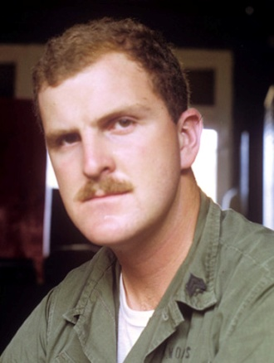 | Sgt. Dan Davis  in one of the  Marine Barracks  at Phú Bài

I also learned about the impact of Marines getting older and having a family. I was walking back from the trenches to our barracks one night after the “all clear.” I was walking with a couple of really fine Marines, both Staff Sergeants (E-6s) and both much braver than I was, I am quite sure. Without warning, another round came in late, “fsssh, KaBoom!” It hit about three blocks in front of us, with a fireworks-like burst of sparks and flash. “Wow, did you see that?!?”, I said. But, I was talking to myself. When I turned around, both the staff sergeants were halfway back to the trenches and making very good time. They had families to go home to. There is a reason that you enlist young men to fight wars. Not that I was young that summer of 1969, I was 25, unless you make allowance for my missed birthday crossing the International Date Line at midnight. .

Con Thien 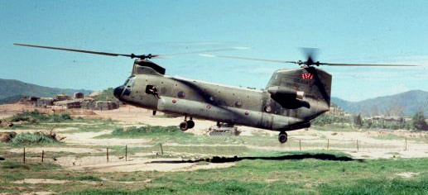

A Boeing CH-47 in Việtnam about 1969

After I had been there a month or so, I was ordered up to Con Thien, just south of the DMZ. Around the middle of May I flew up to Đông Hà in a CH-47 helicopter, where I was to be picked up by a two and a half ton truck for the trip up to Con Thien. The CH-47 and the Huey’s (UH-1) helicopters were the real workhorses of Việtnam.

Unlike the movie “Full Metal Jacket,” the door gunner in the helicopter did not shoot at people on the ground just for kicks. Such a thing would have been unthinkable within my experience. On the other hand, I must admit I do like the line the screenwriter gave his movie gunner as explanation for what he was doing. As is often the case, a good writer can make things much more interesting than the tedium that really characterizes most days in the service.

I stayed with a couple of old buddies from language school while at Đông Hà waiting for the truck to come and get me. On the way up to Con Thien, I passed through several firebases where I met some of the young “grunts” (infantrymen) who had gone through Staging with me. They said everybody was still OK, despite some heavy fighting. They said the combat wasn’t so bad, but all the work was terrible. Just like around Phú Bài, there was really very little evidence of the war, save for the presence of a lot of military equipment. No burned out buildings; no downed power lines; no wrecked bridges.

Con Thien was on a low hill, about two thousand meters south of the DMZ, about halfway west from the coast, along the northern border of South Viêt Nam. It had seen some heavy fighting earlier, but was quieter when I was there. It was manned by a couple of companies of grunts, two 8” howitzers, two 105mm self-propelled howitzers, two 40mm “Dusters,” a battery of 4.2 inch mortars and various other weapons. Patrols went out daily and fire missions there were executed every hour or so by all of the artillery. There was plenty of activity and lots to see. The weather was much like at Company "L", but the area had ostensibly been hit with Agent Orange and was more desert like with all of the vegetation gone.

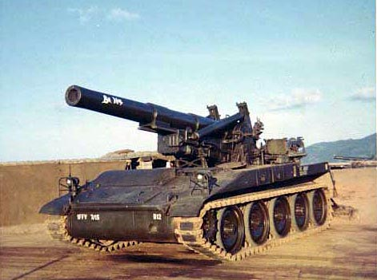  8” Howitzer | 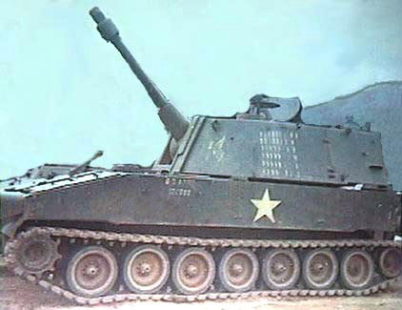  105mm Self Propelled Howitzer | 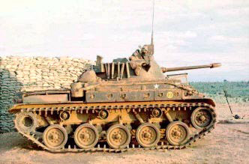  40mm Duster

There was a big bunker on top of the hill, facing north, sporting a huge night scope. They could see a vast sloping plain all the way down to the DMZ. At night, they would see company-sized units of NVA crossing the DMZ and they would call in the 8 inchers, which then did gruesomely effective work, often wiping our entire companies with one shot.

While there may have been a few inflated body counts elsewhere in Viêt Nam, I would guess that there were a lot of under-counted bodies out in those gullies. I often wondered about the pathetic NVA’s who died out there in the dark on that plain; un-mourned, un-buried, and un-noted. One minute they were walking along in the dark; the next moment they were just gone. This interest was not in any way an indication of either my cruelty or my sympathy. It was simply a matter of detached interest to me. I did meet cryptologists, mostly Army, who became emotional with either “gung ho” zeal or “bleeding heart” concern when discussing the enemy. My feelings toward the NVA seemed more professionally neutral to me, as was true with most of my Marine compatriots.

I was up at Con Thien for several weeks and, as there were only two linguists there on our “national tasking mission,” we worked "Port and Starboard," that is one of us was on watch all of the time. We decided to work 10 hours on and 10 hours off, so that our schedule rotated slowly. We had the only refrigerator on the little base and kept it full of beer. Our CO, Lt Hamm, did not object if we drank during the eve and mid watches, a great favor. One of our comms guys drank more than he should, so the Lieutenant, instead of killing the privilege for all of us, just transferred him permanently to day watches where there was no beer allowed. Now that is what I call a good officer.

I was really interested in watching the 8" Howitzers, 105mm Howitzers, 4.2 Inch Mortars and the twin 40's fire at the NVA coming across the DMZ. We took rockets, mortars, and small arms sniping while I was there, but we lived in bunkers, so it didn't bother us much. We had no flush toilets and had only a little bucket with holes in it for a shower. I shared a cot with the other linguist, as one of us was always on duty. One of my old buddies from language school, Corporal (later Sergeant) James Bernier was there and I enjoyed being with him again. He was of invariably good humor, a valuable trait when you are under pressure. He was working the local problem and when our special “National” mission got slow, we pitched in and helped him and his crew out.

We ran around dressed almost any way we wanted up there. I frequently wore civilian shorts and a tee shirt. I often wore civilian shoes; usually deck shoes with rubber soles. One day we were working on some timbers used to build bunkers and I stepped on an upturned spike. With the weight of the beam pressing down, the spike went all the way into my foot. Strange feeling, but it didn’t hurt that badly. I took off my shoe and sure enough, there was a bruise on top of my foot where the spike almost came out. Went to see the Navy medical corpsman and he just laughed, gave me a tetanus shot. As it was a combat zone and we were frequently under fire, he asked me if it was a result of enemy fire. Of course I said it was not. Unlike the aforementioned officer, my career did not depend on my having a Purple Heart.
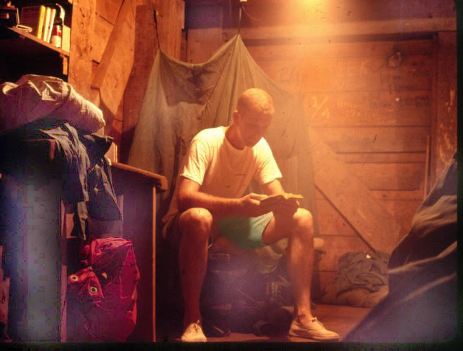 | Sgt. Dan Davis,  in Sleeping Bunker  Con Thien, Việtnam,  Summer 1969

As I said, unlike Phú Bài, there were no flush toilets at Con Thien. Our facilities were limited to an outhouse. It was built by digging a pit about four feet deep, placing an open 55-gallon drum in it, and placing an outhouse-shaped corrugated steel hut over it. Once a week, one member of the crew would move the building off to one side, pour in five gallons of diesel fuel and ignite it, thereby burning off the solids, flashing off the fluids and sanitizing everything. Naturally, our creative and ceremonially sophisticated Marines couldn’t let this go by casually, so they created an entire rite, the culmination of which was the selected man calling out with great dignity and drama. “Burn the sh..ter!”, accompanied by the applause by the usual crowd sitting on top of our bunker.

I noticed there was some damage to the door of our out house facilities and I asked what had happened. Seems one day a bunch of the guys were sitting on the bunker and one of them needed to use the “head.” No sooner had he sat down on the one-hole seat when “Whack”, something hit the shed. He didn’t say anything and after a few seconds, “Whack!” Another one. Assuming somebody was throwing rocks against the walls, he hollered out to his buddies, “Hey knock it off.” “It ain’t us; somebody’s shootin’.” The guy in the house looks up and sees two new .30 caliber holes in the door above his head. The guys on the bunker said they never saw anybody run so fast while buttoning up his trousers. Seems a sniper had seen him go in there and had decided to ding him inside. Fortunately for him, he was sitting down and not standing up taking a “leak.” I love that story.

While it may seem heartless now, I can remember very distinctly enjoying sitting on the top of our Ops-bunker and eating C-Rations while drinking beer watching the NVA get bombed several miles off. We were on the southern slope of the hill, so we were facing south and looking at a mountain, one of the dozens of “Tiger Mountains” in Việtnam. My memory was that it was about five thousand feet high and was located about five miles from us. It was occupied on the summit by NVA forces. Not being of strategic value, we did not make a concerted effort to dislodge them while I was at Con Thien. What we did do was bomb the area consistently. So there we would sit, watching first the A-4s come over and drop napalm. Then the F4s would come over and drop high explosives. We had knowledge that the bombing was effective. I often wondered if we had left them up there, just to be easy targets.

At night, sometimes we could see red tracers going up to the crest and green tracers coming down from the ridgelines of the mountain. My VERY BEST war story is about that mountain, but I have no knowledge that our work has been declassified, so I cannot and will not tell it here. One time we did see a B-52 strike on the mountain. We were all standing around on top of our Ops bunker looking north toward the DMZ and all of a sudden, we all swung around and looked at the mountain just in time to see two tracks of huge bomb explosions right next to each other and a third track, just off to one side and starting a little later. They ran up the North West ridge and across the crest. The impact was impressive. None of us could remember why we all spun around like that. It was so far off that the sound did not get to us for several seconds after we could see the bursts, and at that distance, you heard nothing. There were some secondary explosions, usually a very bad sign for the NVA.

We had a second string of interior “wire” around our classified cryptologic compound, which was maybe 50 meters square. There were signs up saying it was restricted, and most of the grunts were curious. As we had a refrigerator and the only 24-hour generator at Con Thien, we used to chip in and buy beer by the pallet load. When the grunts came in off of patrol, if they asked us, we would sell it to them at cost. It seemed like the least we could do. We really loved it when we could get the aluminum cans. It seemed to taste much better. Some of the beer was in steel cans and occasionally it was really bad, after having been out in the sun at 100 degree plus temperatures for months on some loading dock down in Đà Nẵng. Cokes were also plentiful, and they did better in the heat than beer.

Naturally, some of the grunts wanted to know what we were doing in our restricted area. Just as naturally, we could “… neither confirm nor deny…” any of their guesses. However, it seemed to be so obvious to us. Here we were, a bunch of Hanoi Dialect Việtnamese linguists, in a classified compound, topped-off by a log-periodic antenna, which looked like a big arrow, pointing due north. One day a rather young looking Marine came up to buy beer. He must not have been much over 18 but we didn’t “card.” Stopping to visit a while, he finally said, “I figured out what you guys are doing up here.” That brought us up short! We were now all on our guards. “I figured it out. You guys are listening to UFOs.”, says our young troop. Hmmm. “Sorry, we can neither confirm nor deny that fact.”

We drank a huge amount of beer. It was hot and dry and we had lots of time on our hands. The water was terrible, so we never drank that. Once a week, our driver would take the water tank trailer, called a “Water Buffalo,” down to a SeaBee camp where they ran a water sterilization plant. There they put so much chlorine in the water that it literally stung your eyes just to be around any water. We used it just for bathing. One week, a Corpsman came screaming up to our position in a Jeep and hopped out saying that we were all in danger because some tests showed the water that week was not potable. He wanted to know if anyone had gotten sick. We said no, because we never drank the stuff anyway. Incidentally, that is my practice in Mexico, as well, and it has been effective there too. Drink only beer.

One day when I was on watch when the sun came up, one of the grunts came up to our compound and stopped outside our security wire. He said he needed a Việtnamese linguist. I could not leave, because I was on watch. They went and got my buddy, CTI-2 Paul Palmeri out of bed. He went with them. He came back in about an hour, chuckling and in good humor. Seems when the sun came up, they looked out in the minefield and barbed wire; there was an NVA soldier with his clothes so badly hung up in the wire that he couldn’t get loose. They wanted Paul to tell him to not try to get away, to throw any weapons he had down, away from his body, and to not try to conceal any explosives. Paul told him that if he did not, he would bi giet, (suffer death). The guy complied and the Marines, most of them roaring with laughter, went out to the wire and cut the guy out and brought him into the base. Evidently he thought he could sneak in through the wire and throw a grenade. That gave everybody a tremendous laugh. I don’t know if the Geneva Convention covers the cruelty of laughing at a really “doofy” captured enemy or not.

They had set up a movie screen at one end of the base and every so often they would get movies in from Đông Hà and they would show them at night. The “grunts” in from patrol and the camp artillery guys would go down and sit on the artillery berms and watch movies, John Wayne being the most favorite. One night, I was sitting on the berm of the two Army units there, a 105 mm motorized howitzer battery. It was a really squared away outfit and had sand bags all around. I was sitting up on top of the berm and happened to be close to the turret door, so I just happened to overhear them getting a fire order. Everyone else was watching the movie, so I don’t think anyone heard them. The turrets traversed slowly across the night sky until they were pointing right out over the heads of the men watching the movie. I got down with my head between my knees and put my hands over my ears, “KA-BLAM!” Dust, gravel, and all manner of stuff flew down from top of the berm, blown off by the muzzle blast. Each concussion seemed to lift me off of the ground. The Marines down below the berm jumped up and began to scramble around, dispersing, not knowing for a second if we were getting hit or what. When they figured out what was happening, there was a tense moment. Most of these guys were really keyed up after weeks in the “bush” and all of them had loaded firearms with them. Not a good group on which to play a trick. I do not know why the battery did not give out some warning. It may have been just security rules. Everyone left and they did not finish the movie.

I really loved my time up at Con Thien. The work was good and I enjoyed working with Jim Bernier on local cryptologic problems as well. Turns out I was a very good cryptanalyst, even though I had not been trained at that specialty. I was, at best, just a tolerable linguist. There were a lot of times I would be stumped and Paul Palmeri would help me out. He always said he had a mentor, whose name I may have forgotten over the years, but Butch Hand seems about right, who would help him out as well. You have to remember, I had not known a word of Việtnamese a year and a half before. The written stuff wasn’t bad, but I would need Paul’s help with maybe one out of twenty oral transcription/translation assignments.

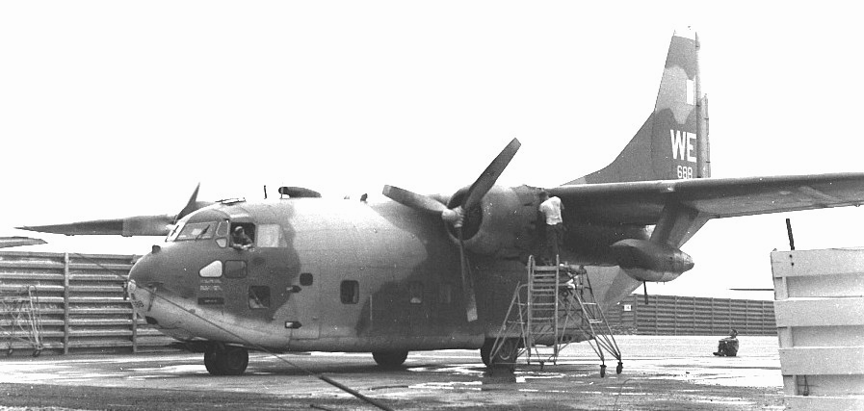 | A Fairchild C-123K  in Việtnam at  Tân Sơn Nhất Air Base  1969

I would have stayed at Con Thien if they let me, but it was time to go, as our mission was over. So we headed back to Phú Bài around mid-June, winding up in the Đông Hà airport building, wearing the most ungodly clothes, carrying some very sophisticated electronic gear and looking really weird and scruffy. We were all exhausted. A couple of brand new lieutenants got off a plane and were clearly very curious as to who we were. One asked and we said, “We can neither confirm nor deny our mission.” I would guess they were not impressed, but we were amused. We flew back to Phú Bài in a C-123K. The crewmen all wore hearing protection (note the booster jet pods under the wings), but we didn’t have any. Not a good feeling when you see a guy wearing protection that you don’t have.

More Duty at Phú Bài
Back down at Phú Bài, I went back on the duty roster and got my own bunk back. I took two R&Rs: one to Australia and one to Japan. Loved both of them! On my way to Australia in August, I went back through Đà Nẵng and then through Tân Sơn Nhất, (Literally, Airfield Number One) in Saigon.

While in Australia, I was treated very well by everybody. I loved it there, even though I was there in June, i.e. in their winter. I spent my whole time in Sydney. It was terrific. I was approached by one guy while I was walking in a park and he started off the way they all did: “You’re a Yank, ‘roight’?” He then proceeded to ask me about Viêt Nam. When he was done he said, “Why don’t you just use all that money and buy them a new country in Brazil?” Creative thinking at its best! I went into a steak place and had a really good steak, which the waitresses said was only mediocre. Then two of them just came and stood there while I ate the steak. They just visited. I never thought of myself as particularly attractive, but in retrospect, it occurs to me that they were not just being nice. They were waiting for me to ask them to do something with one of them. Maybe I’m flattering myself, but I really think I was dense and may have hurt some feelings. I wish I had it all to do over again. I would have been more alert to others’ feelings.

When I got back to Phú Bài, we had the monsoon rains. It really rained. I loved it, because, while it was not quite cool, it was at least cooler. It rained so hard that on one day, the guys all went out into the rain to shower. This is a lot of rain. During another day of the monsoon, I cannot remember exactly which day; we had 23.5 inches of rain in 24 hours. All of our trenches collapsed and it was a mess. I remember the tag line at the end of the article about it in Stars and Stripes. It said, “If you think it was bad on us, think what it did to “Charlie” living in the bush!” The NVA and the VC were so ineffectual (I lost more friends in the Corps to automobile accidents than to combat in Viêt Nam) that we often jocularly felt sorry for them, e.g. “Some poor guy spent the better part of a year “humping” (carrying) that rocket all the way down from Hanoi and all it did was blow a big hole in our baseball field.” By these comments I do not intend to diminish the horror some went through in Việtnam, but I will not desecrate their sacrifice by exaggerating my experiences; I only relate what it was like for me.

The day of the big storm, the rain created a wide stream right down the road that ran down from the main gate at the 8th (RRFS). The MPs on guard noticed a really crude “lung fish” half crawling and half swimming up that stream. The fish was maybe five inches long. They went out and caught it. Somebody took it into “Ops” and put it into a glass bowl that looked like an aquarium. It seemed to survive. Remember that, despite my caustic comments to the contrary, even the Army personnel were very high quality guys with good IQs and good educations. Anyway, one of them must have been an aquarist, because the fish thrived. They named it “Irving” and some wag even took a picture of it looking out of its aquarium and made up a badge for it with the name Irving on it and the Badge ID of 00000000. Not long thereafter, a martinet Army Major came along and said that was a misuse of official U.S. Government property and made them take it down. Oh, pooh.

After being up at Con Thien, Phú Bài seemed pretty calm to me and not as much fun. It was nice to have a warm shower and flush toilette again, but the watches were long and boring. If anybody ever says he can’t understand why military people tell so many war stories, it is certain he never stood any Mid Watches. With hours to kill and no way to go to sleep, it is amazing how much practice you get telling tales and recounting past adventures. Not unlike Twain and Conrad, some tales are told over and over. We all cared for each other and even the less productive were valued. Good groups take care of their own and for the first time that rang true to me in Viêt Nam.

As I mentioned before, people get a little goofy about three or four in the morning. One night, one of our Marines tried to lash an Army SSgt into his chair using toilet paper. Unfortunately, the SSgt had no sense of humor at all and wrote the poor guy up. That cost our miscreant $100. Frequently, when we were bored and there were no translations to do, we would volunteer to get a snack for everybody on watch. We would take orders and wind up calling the Army chow hall that stayed open all night over at the base just south of us. The orders would be like “25 hamburgers with everything, 10 cheeseburgers, 5 hamburgers with no onions, ….” The linguists and others with nothing to do would then get our noisy truck or walk over to the other base and get the bags and bags of burgers. Sometimes when we were out, we would go by the local bakery, run by the Army, and they would give us fresh bread right out of the oven. It was terrific. There is a secret to doing life right, and that is enjoying what you have, more than whining about what you are missing.

So, here I am in Viêt Nam and clearly among real Marines like Sgts. Oly Olson and Rich Jensen, and I felt like sometimes I loved the life more than they did. They did it because they were good at it. Most were athletes in school and jocks make the “real Marines”. I was carried away by the adventure of it. When we came up to 10 November, the Marine Corps birthday, and I found myself being much more involved than some of my friends, like Rich, who was far and away the smartest of us all. When asked to attend a get-together with a visiting Marine General to celebrate the day, he and his buddies, sans your correspondent, marched into the club in a lock step with hands on the shoulder of the Marine in front of the, like prisoners from an old Jimmy Cagney “Big House” movie.

I became almost obsessed with celebrating and not denigrating the Corps on this night. Several of my more Gung Ho friends and I drank beer and whiskey all night at the Army NCO club on the 8th RRFS and then we went over to MAG16’s club and drank ourselves silly on Wild Turkey. About midnight, I issued a challenge, later much regretted, to my few remaining “Semper Fi” buddies. “No balls to start drinking champagne!” I knew (KNEW) the rule about not mixing grape and grain, but I was not thinking. I can clearly remember firing corks all around the little hootch that was serving as the MAG 16 club. Wow, we really put away some champagne! The next morning, for the only time in my life, I got up and lost everything about half-way to the head. I don’t remember anybody talking to me much that day. But, we all survived the violation of the first rule of drinking. One wonders what would have happened if we had gotten a ground attack that night.

During that winter, two men from our company went on a courier run to Đà Nẵng in a helicopter and were killed. Both were older, ~37, and senior, an E9 (Master Gunnery Sergeant Edward Storm, USMC) and an E7 Chief (CTC Robert Gates, USN). That's when I found out that none of us was supposed to have been flying in helicopters. Top Storm and Chief Gates were our only two KIAs. Their names are on “The Wall,” a monument that most Việt Vets that I know do not like very much; it does not make us proud. It seems to celebrate the people who were against the war. Other than those two loses, away from Phú Bài, we were pretty lucky. We had a couple of WIAs while I was there and three or four just after I left, but none was life threatening. To the best of my knowledge, only one other cryptologic Marine or sailor was killed in Viêt Nam, a Captain who ran over a mine in his jeep.

Just before Christmas, John Lemandri built the unit a Japanese Torii, which he decorated with lights. It was a labor of love and I still have a picture of it. After the war, he went to work for the U.S. State Department and then retired to the tidewater area of Virginia.

Co. L Torii  Built by Cpl. John Lemandri | 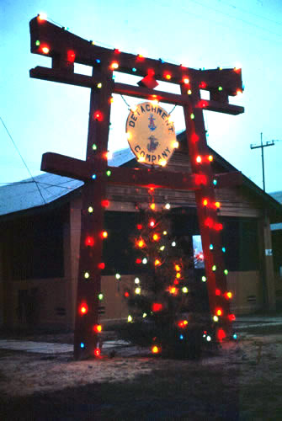

Before I got into the Corps, I always heard about how bad “Army food” was and I was surprised, starting with my NROTC experience, how good the food was everywhere I went. I had been on Air Force bases and their food was terrific. Navy and Marine chow was excellent. My first Army food was in Phú Bài, but clearly this was not fair, as we were in Viêt Nam. I found myself using condiments for the first time. The mess was run by Army NCOs and a lot of the work was done by Việtnamese, who smoked the most vile-smelling cigarettes. We had powdered eggs in everything, and they weren’t bad, but as scrambled eggs they needed a lot of ketchup. You could always recognize a Viêt Nam Vet because he would open a milk carton, then smell it before tasting it; taste it gingerly; then enjoy. We were told that it was re-constituted from powdered milk in Đà Nẵng, and augmented with peanut oil for fat. It tasted OK, unless it had gone sour.

For New Years, the Army had roast beef for us and it was really good. The next morning I woke up terribly sick. I threw up and threw up. Almost everybody in the barracks was the same. I kept wondering, “When would our officers come, find us so ill and get somebody to take care of us?”. I expected them to get the medics to make sure we were not going to die. I remember wondering whether the VC had poisoned all of us. The only guys who were not sick were those who had not eaten the roast beef. It was during this time when we were all unable to even stand up, that our Major had a memorial service for Top Storm and Chief Gates. None of us could even get up to go to that. We really just couldn’t get up. God help us if we had gotten seriously attacked at that time. Unfortunately for us, our Major had not heard of our plight, did not know we were sick, had not visited us and, ostensibly, did not care about us. What he did do, was get us all up in formation a day later and scream at us about not being at the memorial service.

My other good story about this particular Major was the night when we got hit but he didn’t show up in the command bunker. I was in Ops the next day when he came in.

LT. Davis, USN (No relation): “Good morning Major, we missed you last night.”
Major: “What do you mean?”
LT. Davis: “We got hit and when you didn’t arrive at the command bunker we were worried.”
Mumble, pause, then, unsteadily,
Major: “I don’t know. I was at the club, had a few drinks and then went to bed. I don’t remember anything after that.”

We all knew what that meant and it was not an image of the service I like to think about. We were all pretty committed to the Corps, so I was not going to be party to any “fragging,” but there was a common understanding that, if we REALLY got hit, we would look to a Top Sergeant named Scheidigger for leadership. He had been in the Corps since Korea and we knew he would get us through anything. Let me say no more. I think we were significantly more committed than the typical troops in Viêt Nam. In our units, there was no “fragging,” no dope, and no defections. Many people who did duty in Viêt Nam will not credit those facts, but we all knew we would lose our clearances if we did dope and we only got into this sensitive line of work because we had not used it prior to entering the Corps. With no prior history of use, we didn’t smoke pot there either. I know what pot smells like, having gone to school in Boulder, but, while I was with the Marine Cryptologists, I never saw anyone smoke pot, never smelled it and never heard anyone say they were doing it. It is amazing how, when people do something like smoking marijuana, they think everybody does. Tobacco smokers invariably over-estimate the percentage of tobacco smokers by a factor of two or more. Many Việt Vets will tell you “everybody” in Nam did it. Not us.

In early January 1970, I went to Japan for R&R. I spent all my time in Tokyo and Kyoto. I bought a Nikon F, with an Ftn finder, and a half-frame camera, an Olympus PenFT. I was there six days and shot six hundred slides. It was great. I loved the temples, the signs, the people, and the country. I rode the Bullet Train to Kyoto and took a guided tour to see as much as possible in a short time. After getting really sloshed on Kirin beer, I had a steak at the New Otani hotel in Tokyo, but I put the steak sauce on my salad, which seemed to really discombobulate my waiter. Tasted good to me. Ah, the ugly American strikes again. I went back to Viêt Nam ready to do my last three months. I showed my buddies my Japanese slides and they said, “You saw the phony Japan. The real Japan is bars, B-girls and pachinko parlors.” An insight - There are many “Real Japans” and I took pictures of the one I liked. I have noticed that bars, B-girls and gaming parlors around the world don’t differ much.

I remember one night back in Phú Bài that we took a couple of rounds, I cannot remember whether they were mortars or rockets, but most likely 122mm rockets. I saw one of them hit a couple of hundred meters off. Really pretty, but really threatening. Most of us just sat on out bunkers and watched the festivities. Try as I may, I cannot get myself in the mode of “Oh the horror of it all!” It may have been for some, but it wasn’t for me. As I noted before, your chances of being a KIA were about one in about eighty; WIA: one in ten. Anyway, the next morning after I saw the blast, out came the report the VC had taken out three TEAC tape decks at the local PX. Again, no apologies to my shaky Army bar tender, but - “The dirty rats!”

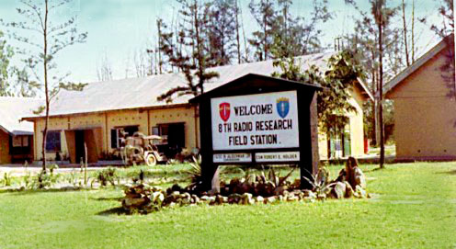 | 8th RRFS Headquarters  Phú Bài, Việtnam  1969

As I mentioned earlier, when we were on watch, we were to wait until the senior linguist got to Ops, then go to our defensive position, mine being the M60 bunker. I can remember being hit only once while I was on duty. The rest of the time I was asleep or doing something else, usually in the club. It is reflective of how much I drank over there. One day I did a 24-hour “sched,” i.e. I sat at a table for 24 straight hours drinking Cuba Libras. In any case, one night I was again in the NCO club, about 100 meters West of my barracks. I had not had too much to drink, so I was not at all tipsy. “Ka-chunk!” An incoming round hit the base. “Whooaaaaaahheeeeeeeeeeeeeeee!” came the alert siren. I got up, put on my flak vest, picked up my M16 and started off to my barracks to pick up my M60, before going to the trench line. I had to cross a field of about 50 meters. I can truly say that I didn’t get “my wind up” and I continued on to the barracks, but I got the distinct vision of a phenomenon that is frequently reported by people who have been under fire. We were taking mortar fire and you can hear them coming out of the tube, several thousand meters away. A very faint “Fwooomp!” I knew it was in the air. In my mind’s eye, I could “see” it making the arch at the top of its flight. I “knew” it was coming right down on top of my head. I also knew that this was just an illusion. In any case, I resolved not to break and run. I kept my pace and walked purposefully to the barracks. I kept walking as I waited. “Ka-chunk!” it hit about 100 meters off. Had you been watching, you might have noticed a little, but barely perceptible, skip in my step there, and then you would have seen that I walked on, at the same steady pace. Had you been closer, you would have seen my neck vertebra do a physics-defying trick of reducing their molecular separation and making my neck shorter. The sensation I had was that I had reacted my neck like a turtle and my head went “south” into my flak vest. I guess it is certain that my sense of molecular compression did not really occur. I do distinctly remember continuing on, mulling on the “coming right at me” phenomena, which I remember reading in accounts by authors such as Winston Churchill.

Another time I was in the club when we got hit. I had just ordered yet another Cuba Libra and was very much disinclined to leave it. Being at least partially Scottish (I remembered, Marti!) I didn’t want to leave my drink there. Not that they were very expensive. We paid on the order of 35 cents for a mixed drink at the club at Phú Bài. Anyway, I decided to take my drink with me when I left. The bar tenders, not being too interested in my activities, failed to enforce the rule on taking drinks out of the club, so no one stopped me as I walked out of the club carrying my Cuba Libra. I went on to my barracks where my M60 was, put my drink down, stored my M16, strapped on my M1911-A1, took out my M60 and picked up my drink again. I went off to my defensive position. When I got there, one of our really good officers, a Marine Gunner (Warrant Officer) stopped me. He said something along the line of, “Davis, I don’t get on your case about not running to the trenches when we are getting hit, but, for God’s sake, do you have to bring your mixed drinks with you?!?” I agreed that this was not conducive to presenting a proper military appearance while we were in a defensive posture and I pledged that I would refrain from coming to such serious business in so casual a manner in the future.

Back to “The World”
In April of 1970, I got orders home, having done my full 12-month tour (the Army usually did 13, for some reason). While in Đà Nẵng on my way home, we got hit again, but I did not even go to the bunkers this last time, figuring if they hadn't killed me yet, they wouldn't than night either. I woke up, told the guy in the bunk next to me that I was not going, heard him say he agreed, and we both went back to sleep. Not much bravado, as Đà Nẵng was a big place, maybe 100,000 people, so a couple of explosions, way off, didn't mean much. Like hearing gun fire in South Los Angeles.

Went down to the airfield the next day and got on the plane to “Oki.” (Okinawa). I had never learned to smoke, drink coffee, or drink much hard liquor. Almost everyone else smoked. When we took off from Việtnam, the Marines on my flight all lit up. I remember it well, looking back and not being able to see the rear of the 720 we were on, due to the heavy cigarette smoke in the cabin.

One of the Sergeants I met in the barracks was asked to escort a prisoner back. He had killed his First Sergeant over some disagreement. My new buddy said he would do it only if the guy wore leg chains and a “chastity belt” (a handcuff/belt combination that not only held your hands, but pinned them to your body.) The authorities agreed, but said he would have to take them off in the air. When he finally met the prisoner, he found he was the most likable and disciplined guy he had ever met. He took of the chains and they became good friends on the trip, with my new friend sympathizing with the guy.

Flew back to Okinawa, where I stayed for a week of picking up gear and catching a flight back to "The World." I was happy to be with some of my Language School buddies again, with whom I lashed up. I enjoyed the food and the carousing. Again, you could have stayed there for months, had you not been interested in getting on with your life. Unfortunately, there was some blatant antagonism in the ranks and some patent racial tension that detracted from the feeling that we were all in one Corps. We were told there were certain “Black” bars downtown where we could not go. Can you imagine the reverse being tolerated, had the white guys set up bars where blacks were not allowed?

I guess I was in Okinawa for about a week. Once I was called into the Sergeant Major’s office because I ran from one barracks to another without my “cover” (hat) on. He said he understood I had just been in the Hell of combat, but … I thought that he could not have been more wrong about what I had been through, but I was not about to argue with him.

Took off in a Trans-International Airlines charter with a really old (35-40?) flight attendant in charge. I asked her what she did to “deserve” this bad duty. She said it was really the best: everybody was physically able to care for themselves, no liquor, everybody just happy to be there, and officers on board if there was trouble. We did a stopover in Anchorage where I was able to get a beer in Alaska. I flew into the “lower 48” States and went home.

The entire time I was in Viêt Nam I did not commit, see, or countenance any atrocities or harsh treatment of South Việtnamese, NVA, VC, or anybody else. All the interactions I saw with allies and enemies alike were as professional and humane as I could imagine. I never saw or heard any evidence of any outrageous things, other than what I read in the U.S. newspapers, to which the public had access as well. I have heard people talk about such things since then, but when challenged, it has always been a "Well, a guy I met told me that he had heard another guy talking about a guy who he met who had talked to a guy who said that a guy in his unit told him that ...."

Same drill as urban legends. Something just under 5 Million Americans served in Viêt Nam. I am SURE some of them were horrible people and did horrible things, for which I am even more ashamed than I am of Charles Manson, Ted Bundy and any number of other Americans. But I was not part of it, it didn't happen in my units and I don't think it happened nearly as much as people say. When the anti-war nuts start whining about burning villages and sending snipers out to "ding" NVA and VC officers, I think that’s a time you can find some evidence. However, any objective person would have difficulty distinguishing those acts from that which we have always done in wars. Those are things for which the rules of war have traditionally allowed. Not pleasant tasks, I agree, but necessary at times. I am proud of the professionalism with which my buddies faced the enemy and performed their service and I thank God that I was personally not faced with more spirit wrenching moral quandaries, such as how do you interrogate a man when your buddies’ lives are at stake.

During my time in Việtnam, Linda had sent me chocolate cookies, letters, wine and the like; all this while other guys got “Dear John” letters. However, when I got home alive, which I had not expected to do, despite the good odds for survival, I did not call her right away. I swung by Washington DC on my way to my new duty station. Went by Linda’s apartment and her “roomy” was there. She said Linda was plenty “Pee-ed Off.” I asked the roomy if she thought I shouldn’t just keep moving along. She said no. I wonder if that girl has had sleepless nights since them because of that intervention, which led to a long-term, but contentious, relationship for her friend. One should not interfere with someone else’s Karma.

I was assigned to Camp Geiger down in North Carolina, part of the Camp LeJeune complex. I was training for duty in Morocco as a Morse Code Operator. I drove up to see Linda almost every weekend. Linda and I took a trip up to see my old High School buddy Chuck Remmel and his wife. I had all of my Việtnam pictures with me, but Chuck said that he and Cathy were not interested. I think Cathy especially was anti-military. I don’ think I have ever been so hurt in my life. Here I was, just home from the most exciting adventure of my life and my best friend didn’t want to hear about it. Linda and I had a wonderful time and I still remember the joy of just caressing her hand as we drove along. We went to Cape Cod and all along the coast, which we both loved..

Duty at Camp Geiger was pretty easy. One day we had to go through gas training. They took us in a building and set off a tear gas grenade. We all had to put on our gas masks and sing the Marine Hymn. By the time I got my turn, the gas was much dissipated and not very irritating. It was, as we said, no big deal. This time though, God must have thought I was a little too cocky. A big “deuce and a half” truck (2.5 tons) came by and offered us a ride back to take showers and get the gas out of our clothes. We all piled into the back of the truck bed, which had the standard canvas cover and the gas in our clothes started getting into the air. Every time he stopped to pick up a new Marine, the air got worse. By the time we got back to our barracks, it was worse in than the “gas chamber.”

Udorn Thani, Thailand
I was back in North Carolina, when I heard about a special opportunity to go back to SE Asia as a Việtnamese Linguist. They wanted several of us to go to Northern Thailand. I jumped at the chance, had one last weekend with Linda, stayed up late driving over to Raleigh-Durham, totaled the car, almost killed both of us, got formally punished via a Non-Judicial Punishment (NJP) proceeding for being more than 50 miles from duty station on over-night liberty, was sanctioned with a $100 fine, and flew out of country late summer.

I went to Thailand with two Staff Sergeants (I think a third joined us later), some whose names the years have erased from my memory and one other Sergeant, Mike Austin, also a Vietnamese linguist. Anyway, one of the Staff Sergeants (SSgt Lea) came from Atlanta, so we all went over to his father’s house. There, we could relax before the long trip and we where we were treated to Southern Hospitality and a cold beer. His Dad was an attorney and I was surprised at how modest his house was. Later, as an attorney myself, I found out that the median income for attorneys was not nearly as high as the media and popular culture would have people believe. In any case, he was very gracious to us and we enjoyed our stay there in Atlanta.

Then, off to Los Angeles and the connecting flight, which was a “’Round the World” flight that TWA had going. L.A. to Hawai‛i to Taiwan to Hong Kong to Bangkok to India to Lebanon to Europe and back to the U.S. Of course, we were only signed up to go as far as Bangkok, where the Marines had an admin office taking care of all the Marines in Thailand during the war. We all had Red (official business) Passports, instead of the Blue civilian ones. That got us really good treatment going through customs, but not as good as the Green ones, which had diplomatic immunity. As a young lad I would never have thought I would have an U.S. Official Business passport or be flying around the world on a special and classified mission.

One of our Staff Sergeants, Jim Park, was almost as tall as I was, so they put us up on the bulkhead with extra legroom. In the middle of the night, far out over the Pacific, I got up and walked back to the galley and was chatting up the flight attendants (Did we really call them stewardesses back then?) She asked me if I wanted a beer and gave me a Heineken. 25cents! Back in the “World”, that would have easily been a dollar at that time. I went back to my seat, kept my beer on the floor when I wasn’t drinking it, and was really enjoying my luck. My Staff Sergeant woke up and asked me what was wrong. I didn’t understand why he asked that. He said, “You keep bending over, straightening up and exhaling like you are in pain.” He thought I was sick. I gave him the good news: “25 cent Heineken in the galley.” He and I went back there and spent most of the time over the Pacific drinking and entertaining the ladies with stories and jokes. That’s a practice I follow today, until they throw me out or the “Seat Belt” light comes on.

Dan M. Davis,  Sgt. USMC  1970 Passport Photo | 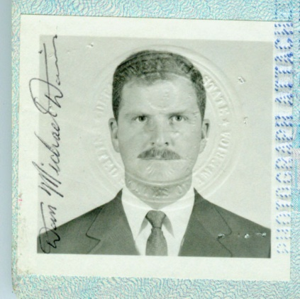

We flew commercial through Taiwan, on our way to Bangkok. We had a lay-over in Hong Kong for several hours due to a maintenance issue on one of the engines. TWA put us up in a hotel. That gave us time for showers, shopping, food, and looking around; then it was on to Thailand. When we got off the plane at the airport, it was like a scene out of “Year of Living Dangerously”. A great sprawling scene of swarms of people trying to get flights, a bunch of Thai soldiers in uniform and a few of us monsters looming over everybody. After a few days in a Bangkok hotel, we caught a plane, an Air Force C-130, up north to Udorn Thani where I was assigned to an Air Force base, Ramasun Station.

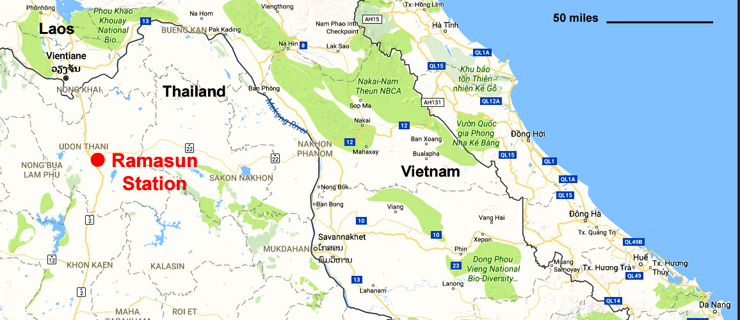

This was the 7th RRFS. We were just south of Vientiane, Laos and about 150 miles West of Con Thien in Vietnam. The large CDAA antenna and the base buildings were right next to a major north/south highway, which was two lanes and paved. All of the buildings were new, air conditioned and very nice. I worked Eve watches doing translations as part of an augmentation team for the Army Security Agency. Seven days a week, we worked from 1600 local (4PM for you civilians) till midnight, but usually were there another 3 or 4 hours finishing up our work; then the same thing all over again. The Army cryptologists were glad to have us and treated us very well.

After getting off watch, we would go over to the club and buy Heineken beer, again at 25 cents. We would drink until they closed in the early morning hours, five, as I recall. We would then buy half a dozen beers and sit out on the veranda until they re-opened about an hour and half later. Then we would get breakfast, scrambled eggs and hash browns and sausage and, of course, beer. To this day, when I drink beer and eat eggs, I am mystically and emotionally transported back to Udorn. One night they ran out of Heineken, and the only thing they had was Tuborg Dark. It was kind of like carbonated molasses and the next day we all felt really full and heavy, but it was good beer.

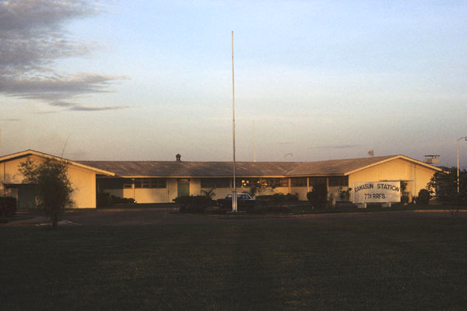 | Headquarters Building, Ramasun Station  Udorn Thani, Thailand, 1970

In many ways it was an idyllic life. As we were visitors, and much needed assistance at that, we were never given any kind of extra duty, like guard duty or ground care. We had house boys/mama-sans and there was a base laundry. The barracks were nice and cool and I read during all of my spare time, eschewing the physical fitness routine that would have been better for me and a good stress reliever too. So the drill was work, eat, drink beer, read books and repeat. Every so often, we would go downtown to one of the cafés or finer steak houses. It was just a break in routine. One Army Staff Sergeant and I went on a couple of picture taking forays, but the shots didn't amount to much. The land was more scruffy than tropical and most of the roads were unpaved and filled with variations of motorcycles, jitneys and bicycles. The buildings were uninteresting and unattractive.

We ate at the club or went down town. The Thais were wonderful, joyful and beautiful people. They had good food like Cao Pad (fried rice, variously Romanized as “Khao Pad” or “Kao Pad)”, we pronounced it like “cow paht”) and good beer (Singha). I learned a little Thai and enjoyed my time. We lived in good barracks and had good work. I did more translations every week in Udorn than I had done in a year in Viêt Nam. I got my stitches from the car accident taken out there, with an unsympathetic Army medic and a very sympathetic Army Doctor. Duke Hospital had put some kind of “glue” over the stitches and the medics had never seen it and had trouble getting the stitches out. I was tenser than the medic thought I should be, but the Doctor said: “Medic, you’re not the one getting this junk pulled off of your forehead. Leave him alone.”

One time, several of our buddies got sick., showing classic dysentery symptoms. The Command said they thought it was from eating “…on the economy” down town. Then some sharp person pointed out that all the guys eating downtown and at the club weren’t getting sick. That included my friends and me. The C.O. investigated the Army chow hall and, once again, found food poisoning. It turns out that the Thais, who worked in the scullery washing the dishes, figured out that they would be cooler if they turned off the steam to the dish sterilizer. That led to a really insidious local epidemic of low-grade food poisoning. Those of us eating downtown or in the club were doing fine.

We frequently went downtown to Udorn, maybe five miles or so south of our base. It was a town of maybe 100,000 people. It was a nice town with a couple of really good places to eat and hear Thai rock and roll bands sing “Lolling on the Liver.” I had a good time every night I went down there. Once when we were running around in a taxi, the driver pulled the old, “I am lost and you have to pay double for me to find the way.” My buddy Mike Austin, a “real Marine” started going berserk. I thought he would tear the cab apart from the inside. The driver decided he DID know the way and when we got there, we went inside to get exact change, so we could give him the fare and no tip.

Anyway, one night while I was on duty, a couple of my buddies were downtown without me. When they got into a cab this new driver got lost again. This time he said, “I find out. No extra charge.” The cabbie then stopped and asked another cabbie something, speaking Việtnamese. My best buddy, a very good Việt linguist, started talking to him. Turns out he was an NVA deserter. He had been stationed in Laos and was the battalion clerk. Surprise, surprise: he was upset because they made him cut his hair and he was always in trouble because he wanted to wear it long. So, one night when the battalion payroll was due, he found out that this time it was all to be paid in cash. He went to pick it up and figured, “I can get to Thailand and buy a cab with this much.” He took the payroll, swam the Mekong and wound up in Udorn. Once again, there is a universal camaraderie amongst the enlisted troops and my buddies really seem to have had a good time talking to him. I was not there that night, but I love that story and the guy who told it to me was not a "tall-tale" teller.

Along toward the end of my tour there, one of our good Army Cryptology buddies arranged a tour around the countryside. We got a bus and filled it up with beer. Every time we came to a Thai roadblock, we gave the Army personnel there who manned it a six-pack to enjoy. We were NOT stopped for lengthy inspections. We wound up in a restaurant north of Udorn, at Nong Kai. We had a great dinner in a wonderful room high up on a bluff above the Mekong, just southeast of Vientiane.

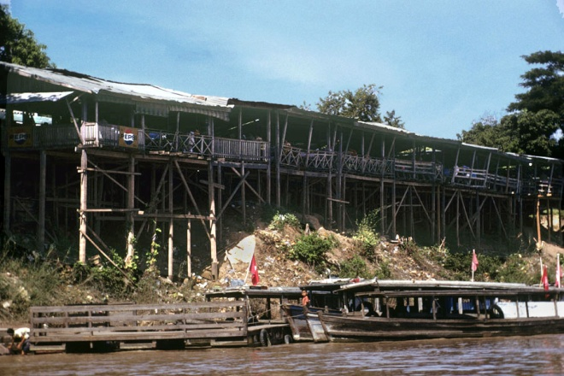 | Near Nong Kai, Thailand Restaurant where we ate  and view of boats on Mekong River  1970

After lunch, we were becoming drunker and drunker. We decided to go for a boat ride on the Mekong. As we got out on the Mekong, having had too many beers, our judgment was more and more impaired and our need to relieve our bladders was less and less bearable. So we had this “really good” idea: what we really needed was a trip to Laos! The boat driver was more than happy to oblige (we tipped very well,) so there we were, the flower of the American military, peeing all over the river bank in Laos. We suffered no KIAs, WIAs or MIAs. I found out later that one of my High School classmates died in Laos a year before: Captain Roger Helwig, USAF.

Life was good in Thailand. We formed into a very tight group in each watch section and took great pride in our commitment and our skill. I remember once we got a congratulatory message from higher up the chain of command, saying that our product was solely responsible for a major success and the destruction of an enemy headquarters. Some cheered at this news, a few bemoaned the loss of life, but I just felt like we did our job: no special joy, nor any particular grief. Everybody in the war knew the risks we were all taking on both sides. I didn’t feel any different about it there in the safety of Thailand than I had felt in the line of fire in Việtnam. On the other hand, I may have felt less guilty about it, as I had given the other side a chance to kill me and they had not done so. Having survived that, I may have felt more at peace with what we were doing. Most of the Army linguists had not been to Việtnam, and Ramasun would be their only tour in the theater. That was even more true about the Air Force linguist with whom we served.

From time to time, I would go down to have a drink or two at a bar just off the end of the runway at Udorn Thani and watch operations. I would sit there, drinking beer and watching the taxiways and the apron, on which Air America had several planes parked, all marked as belonging to the Royal Laotian Air Force. After a while, a young non-Asian guy in a civilian short sleeve shirt would come out and get into a T-28, loaded with a couple of 250 pound bombs and fly off north. If we were there long enough, he would come back with his wing mounts empty. Very exotic, exciting and romantic! I never found out where the pilots drank. I’m sure it would have been interesting to talk to them about what was going on. I assume they were well paid. Udorn seemed to be full of various kinds of “ex-pats,” many of whom looked pretty seedy. The pilots, on the other hand, all looked very clean cut and military. The aircraft were all very-well maintained and sounded very powerful as they took off. Perhaps someday we will know more of their efforts.

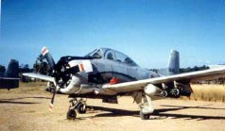 | A period photo of an Air America-flown, Udorn-based,  Royal Laotian Air Force, North American T-28

Working 12 hours a day, drinking all night, going downtown to party and churning out translations were our only activities. If we had any waking time to idle, it was spent reading. The vast majority of the cryptologists in Thailand were voracious readers, just like elsewhere. Remember, the GCT minimum score, roughly equivalent to I.Q. scores, was 120, so most of these guys were college bound when they got out. We did all of that for three months; I volunteered to stay, but our Staff Sergeants wanted to go back to Camp Geiger, perhaps to be close to home and to their wives. I was struck again by the ostensible waning enthusiasm for the mission and the increased orientation toward domestic needs that I saw in the married Marines. I can only quote the old saw that is given to you early in a Marine Corps career, “If the Corps wanted you to have a wife, they would have issued you one in your seabag.” I was to see that in myself when I made special arrangements to take my Wife on ACDUTRA tours in the Naval Reserve later, perhaps deflecting my focus on duty to some degree.

Finishing up my USMC Tour
I then went back to Camp Geiger in North Carolina for a couple of months. I did all of the “short-timer” stuff, taking tests and talking to advisors. They looked at my intelligence test scores and my manual dexterity test results and said, “You can be anything you want, but do NOT try to become a typist or do anything else that requires manual dexterity.” I got a “Project Transition” job in the Camp LeJeune photo lab and was good enough that they let me do all of the black and white developing. It was fun.

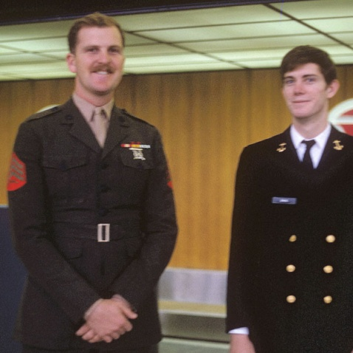 | Sgt. Dan Davis and his Brother, Midshipman Mark Davis,  from Duke University NROTC, on Leave in 1970.  Mark went on to become Naval Nuclear Power Officer on Submarines

I kept my head down; saw Linda a lot. I resisted the impulse to point out to the officers that, although I was fined at my NJP for being “…more the fifty miles from base on overnight liberty”, they never took that fine out of my pay. My pay records went with me to Thailand the day after my NJP and when I came back, a friendly pay clerk “forgot” to make the retroactive adjustment. After I got out, they sent me a bill, but a JAG officer friend of my Dad’s wrote a note pointing out the general order under which I was fined was subsequently cancelled, so justice would be served by calling it even. Nothing else was ever said.

I was mustered out early April of 1971, just as I became eligible for SSgt. I said fond farewells to my compatriots, lovingly packed up my uniforms and walked out of the most meaningful period of my life.

I went back to work at Abbott Labs, in Chicago and proposed to Linda. Got her up in the middle of the night over at Ed and Carole’s apartment, where she was staying. She accepted and we got married in Takoma Park, Maryland on 14 Aug 71. We immediately moved to Boulder where I went back to school. When I went up to see the counselors at C.U. about getting back in, they said there would be no problem. I was amazed and concerned, so I raised the issue about how bad my grades had been, how long I had been out of school, and how I had no idea whether I could do it or not. The counselor said, “We see this all the time. You will do fine, now that you are back from the military.” They were right. I went to school day and night, did nearly 120 semester hours in two calendar years, including the credit they gave me for my Việtnamese. Despite the heavy load, I got almost all “A”s.

When I got home to Colorado, they sent me my Staff Sergeant (E-6) promotion in the mail. I did a couple of years with USMC Reserves serving with the Denver Naval Reserve Security Group unit, transferred into the Navy as a Cryptologic Technician (I Branch) First Class (CTI-1) which was also an (E-6) By then I was in Law School, so I applied for a Direct Commission and was accepted as an Ensign, (O-1) USNR. It was my pleasure and glory to serve in the Ready Reserves for another 22 years, doing duty in Misawa (Japan), San Diego California, Washington (DC), Ft. Meade Maryland, Pensacola Florida, Norfolk Virginia, San Francisco California, Monterey California, Naples (Italy), and London (England). After a stint in the Standby Reserves, I retired as a Commander (O-5) in 2003.

Some of the tales of that time follow below.

The Naval Reserves
The best Storyteller in the Navy - CTRC Baughman

When I first got to the Denver Unit, the C.O. was Lieutenant Commander Pat McCourtney and the X.O. was LCDR George Lamb (CAPT Lamb, USN, Ret., passed away in October of 2019). They seemed real excited to have their very own Marine Cryptologist and I enjoyed being with the unit. I tried to get the USMC Reserve to acknowledge my participation for the two years I had left on my original six-year enlistment. Most Marines just went on to the inactive, Standby Reserve status for these remaining years. I needed a little extra cash and I missed the service. I kept being told there was a program to allow Marines to drill with Navy Cryptologic units, but it was not easy.

The reserve forces all had pretty much the same deal. First, you had to do some active duty, sometimes as short as six weeks, sometime as long as a couple of years. The Selective Service Act says that all able-bodied young men owe six total years. One typical breakdown would have been two years active, two years of Ready Reserve (drills and summer active duty required) and two years of Standby reserve (available for call up, but not required to drill, etc.) Another would be four years active, and two years Standby. The drills were usually one weekend a month, although they varied, and unless you are running for President (There was a big, but meaningless, flap about whether George Bush finished his drills.), there was a LOT of slack as to when and how many you did. As long as you got in some combination of drills and active duty adding up to the minimum, you were OK. If you didn’t, not much would happen. A few times, people who had not done much active duty (the six month tours), were threatened with involuntary recall to active duty if they did not come to drills or do their annual “summer” training. I never knew anyone who actually got called up. Most of our “flakes” were just put on inactive reserves for the rest of their time. If the reserves had been called up and somebody refused to report, that may have been an entirely different thing. Even then, if somebody really was going to get hurt by a call up, they were usually transferred to a unit that was not going to be called up.

Most of the guys enjoyed being with their buddies for the drills and enjoyed going away for the two weeks. In the Naval Security Group, we usually went on individual duty to stations like San Diego, London England, Pensacola, Naples Italy, or Japan. One of our really good deals was that we could go any time of the year that was convenient to us. The Army and Marines had to go when their unit was scheduled to go and usually they went to such garden spots as Killeen Texas, Fort Sill Oklahoma, Camp Cody Wyoming, or the like. While you might think there would be a lot of dalliances when these hot blooded young men were away from their wives, most of us were more than content to just enjoy being on active duty again, and to quote my mentor, “An affair just wasn’t worth the effort.” I, myself, was never disloyal to my wife on any tour of duty. Actually, she went with me on several and my Daughter Laurel went with us on two of them. So much for my being a “wild and crazy guy!”

While still in the Marine Corps Reserve I did no annual training tours and my duties at the Navy unit in Denver were rather undefined. They knew I wasn’t getting paid and seemed just to like having me there. In any case, the Marines floundered around and never did get me paid, so I enlisted in the Navy in April of 1973 as a Completed Active Duty Requirement Enlisted (CADRE) enlistee. They gave me a set of uniforms and I did about two years as an enlisted CTI-1. My next promotion would have been to Chief Petty Officer, CTIC, E-7.

People outside of the service have no idea how important Chief Petty Officers are to the Navy. Other servicemen don’t appreciate it as well. Most Commissioned Officers will tell you, “The Chiefs ARE the Navy.” It is, without question, the biggest promotion in any of the services. It is the time when sailor changed from the enlisted uniform to officer-style uniforms. That meant giving up the sailors’ traditional white hat for the officer-style hat with a bill. It is marked, not only by a promotion ceremony, but also by a several week-long initiation that is elaborate and meaningful. I have been invited to two initiation closing ceremonies, a costly affair for officers, as you are “fined” by the presiding Chief of the ceremony for all sorts of infractions, e.g. $20 for each stripe on the bottom of your coat sleeve. Therefore, a Lieutenant Commander would get a $50 fine for just being in the room. These used to be ribald and drunken affairs, following the traditional Navy form of celebration. I have heard that they are now all but outlawed. They involved all kinds of vicious pranks, which bordered on the injurious and reveled in the ridiculous. Think Frat Party with a vengeance. An endless stream of accusations, like not knowing the Navy Hymn or pretending to be a Chief before the presentation of the Chief’s hat at the end of the initiation. The punishments were often fines of tens of dollars and performing act of penance, such as eating or drinking gross food, walking a plank with rat traps on it etc. The intent was to clearly demark the ascension into this special group of U.S. Naval personnel.

The one incident I thought would get us all taken out and shot was one wherein the attention that was supposed to be focused on the Chief initiate, but was instead deflected upon another, as was surly this initiate's intent. The wrath of the crowd fell on his “Defense Counsel,” a really pretty, but petite blond female Lieutenant J.G. She was putatively the object of great scorn and derision. At one point, she failed to answer some query from the “Judge” with the alacrity that was satisfactory to him and he fined her another $20, at which juncture she said she, now being broke, was unable to pay the fine. “Well then,” intoned the Judge, “You’ll have to work it off.”, and he produces about a five-pound jar of Vaseline and puts it up on the table. She must have been a good sport, because after the laughter died down, she ignored the obvious, continued her spirited defense, and evidently did not report the Chiefs or any of us to anyone.

Other than just another excuse to get “sloshed.,” these initiations reminded the CPO’s that they were special and it did mark their transition into the Chiefs Mess. The Chiefs were commonly accorded the task of “brining up” young officers. It was the Chiefs who shepherded young Ensigns into leadership and management positions, showing them what really needed to be done and how to handle their people. When I was in NROTC, we were told, “During your first tour as an Officer, you WILL do everything your Chief suggests that you do.” Someone asked, “What if you get a bad Chief.” The response was that the Navy didn’t pick bad Chiefs very often, a C.O. would not assign a problematic Chief to a new officer, and that, as an Ensign, you should not rely on your own analysis about this important topic anyway. Later in my career, at a Navy Base where I did one of my two-week reserve training duty tours, an operational requirement forced them to send all their CPO’s to sea. Both the Chief’s Mess and the Wardroom told me they could see a dramatic decline in the ability of the new Ensigns to mature into “real officers.” Whenever you meet a Navy Chief, honor him, he is, de facto, a hero. Alas, I am told this tradition and important professional status is now much depreciated.

I took the exam for Chief Petty Officer once. I did well on it, but was “PNA’ed” (Passed, but Not Advanced.) That meant that I got a passing score on the test, but that others who were in the promotion zone had a better overall score, including points for length of service, time in grade and duty stations, and they got the limited number of promotions that were available for that cycle. Shortly after that, a window opened up for applications for a Direct Commission, and I was accepted and commissioned as an Ensign, (O-1) in April of 1973, my first year in Law School. Later in my career, when I was a senior officer, I loved to tell the Chiefs that I was “Too dumb to be a Chief, so they made me an Ensign.” That never failed to get a laugh and, not infrequently, a free beer or two.

Anyway, I wanted to tell you about the best storyteller I ever met: CTRC William Baughman. The Chief was nearly as tall as I was and very athletic, having been a minor league baseball player for a while. He was an R-Brancher, that is a Morse code operator, and he was terrific at that job. He could copy code from “underneath” static and other signals as well as any man I had ever served with. But his real skill was as a leader. He was a classic Chief, leading by example, enthusiasm, knowledge, and commitment. Always with a smile, he had more stories than Scheherazade and Mark Twain put together. He had done four years active duty in the Navy just after the Korean War, he had been a cop in L. A., he did a tour as a Jefferson County Colorado Deputy Sheriff, he was a Deputy U. S. Marshall and wound up his career as the security officer and body-guard for the CEO of Johns-Manville Corporation in Denver. Like Twain in his story of “Buck Fanshaw’s Funeral”, I will not try to convey the Chief’s style, but “… leave it to the reader to fancy what it was like …” One of my young enlisted men asked me once, “Do you think Chief Baughman’s stories are true?” After a brief pause, I replied, “You wouldn’t ask Mark Twain if there really had been a jumping frog in Calaveras County; you just enjoy the art of the story.”

Sitting around a table at lunch on Drill Days was a joy. We all pitched in and bought gallons of beer and ate burgers as we listened to the stories we all loved so much. Chief Baughman was at his best in this environment. He never was at a loss. Like Maury Amsterdam, who was famous for having a joke about everything, the Chief always had an anecdote relating to the topic under discussion. Like most Chiefs, his stories all had morals that were insightful. They related the best way to work with a body of sailors and reinforced the fact that the one rule that was above all else was “Love the Navy.” I cannot find the words to express the great privilege it was to serve with him. Some of his tales and adventures, to which I was a personal witness, must wait for telling at our meeting in the next life, for relating them to you now would betray the honor that shipmates have for keeping faith with their brothers and not embarrassing them in front of family or Nation.

One day at lunch, one of our favorite junior officers, Jim Amundsen, told the following story. He had been invited to a party at the United State Air Force Academy in Colorado Springs. He was told to come in uniform. It being summer, he wore his dress whites with shoulder boards. As an Ensign and a Line Officer, that meant he wore a single ½ inch gold stripe for O-1 and a Gold star, which indicated he was a Line Officer. He was prior enlisted, so was maybe on the order of 30 years old. Now, if you look at the epaulette design for an Air Force Brigadier General, you would note that it is characterized by a single decorative stripe and a single star. So, as is not unimaginable, Jim caused quite a stir at the party. He was the youngest “Admiral” anybody there had ever seen. He neither “confirmed nor denied” this misimpression. Finally an angry Air Force Colonel accosted him and made some pretty harsh statements about Jim’s masquerading as an Admiral, which he really had not been, and demanded to know Jim’s name. Thinking fast, albeit evilly, he immediately replied with the name of his best buddy, also a newly minted Ensign: “ My name is Spike Rumley.”

We were still laughing about his quick wit and good luck when we came back to the Reserve Center. It turns out that we were late and more than a little tipsy. We were met by a rather apologetic young officer who said that the Center C.O. had just ordered that all tardy lunchtime returnees had to be reported. They would then be identified for appropriate disciplinary action, probably an extra drill. The very first officer to sign was senior and one of our better jokesters, but he signed in. The clipboard was handed to the next guy and then the next. By the time it got to me, I noted that every one of the five officers had signed in as “Spike Rumley.” Not knowing how long the statute of limitations is for filing a false report and being drunk on duty, I will not speak to how I signed in or how steadily I was walking. By the way, Spike was safe on both accounts as he was not at the USAFA party and he was not drilling on the day he is reported to have returned from lunch late, several times in one lunch hour.

Duty at NCTC

After I enlisted in the Navy Reserve, but before I was commissioned, I did my first ACDUTRA, a two-week tour, back at Pensacola, Florida. On this tour, I went alone, as Linda went to see her folks in Washington. She later joined me and we drove home together. This was a really tough tour. The quality of the people at NCTC had declined terribly. This was the time right after the Việtnam War when the services suffered from the poorest quality enlistees getting into the military.

The C.O. at Pensacola came to an auditorium and spoke with all of the visiting Reservists. He said he was heartbroken. He told us that they had been forced to reduce the qualification scores needed to get into cryptology, they had had to loosen up the security investigation criteria, and the life at NCTC was now a real hell. There was no discipline and reservists and active duty personnel were all aghast at the anarchy in the barracks. Unlike the orderly barracks I had been used to, these places were a trash heap of rock music and filth. My barracks was so bad that I demanded to be transferred into a permanent personnel barracks so I could get some sleep. I was really upset.

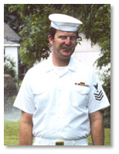 | CTI-1 Dan Davis,  Summer of 1974

The next tour I took was to Monterey, on break from my studies at Law School in Boulder. My duties at Monterey were for refresher training in Việtnamese, but I was way out of practice by then. That would have been in January 1975 and I had already been told I would be selected as an officer. I loved Monterey and read the entire Steinbeck Cannery Row series while I was there. The “Row” was sill abandoned and romantic, before the Yuppie renovation and invasion by the Gap and Beneton’s in the late 1970's. I spent most of my time in the NCO club up above Monterey Harbor. The back bar, instead of a mirror, had a wall-length picture window. It was wonderful; much better than the O-Club. You could sit there and drink whatever you enjoyed for a ridiculously low price, all the while enjoying the view of all of the boats in the docks below. I wrote a note to Linda every night on the bar napkins they had there. The waiters behind the bar all took good care of me and I enjoyed my time.

Commissioned as an Ensign
Red Snapper Fishing with the Wardroom

I was commissioned in April of 1975. My Dad, who had never resigned his reserve commission, swore me in and Linda pinned on my new bars. We had a party up at our house in Boulder that was a great success. I finally threw the last guys out about 4 AM.

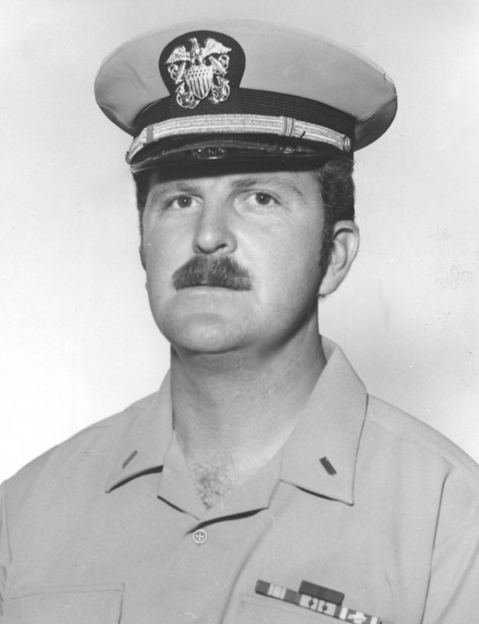 | Ensign Dan Davis  Summer 1975

Later that summer, the Navy, declared an interim fiscal year as they moved from 01 July to 01 October as the beginning of the Government FY. They announced an opportunity to do another ACDUTRA during a short fiscal year. Our C.O., Captain Linn, decided we should all go to Pensacola together. I was a newly-minted Ensign and I had a silver dollar to give to the first man to salute me. It was a great tour, and I drove down with Lieutenant Dave Granteer and LCDR George Lamb. We stayed in a cabin for five at a motel and fried burgers and drank beer every night for the first week we were there.

I was junior so I slept in the “living room” on a hide-a-bed. Our Admin Officer., Commander Bruce Henson, a journalism professor from the University of Oklahoma, was in one of the bedrooms, but stayed up with me every night and drank me silly. He was one of these little, gaunt guys who seemed to be able to drink forever without getting at all tipsy. He kept me up, night after night, telling me stories of being in command of ships and how you needed to lead men. He spoke often of the quiet, measure voice of command, but, unfortunately, I didn’t get it. The time with the officers was great fun. The training was pretty mundane, but we were having a good time partying.

On the Saturday of our two-week tour, most of us (with the exception of the C.O., X.O. and Admin Officer) went out on a 50 foot Red Snapper boat. We had our unit’s first female with us, I will call her ‘Shannon Evans.’ She was hotly pursued by our two wildest young petty officers, but she spent most of her time with one of our more senior officers, in, what I assumed to be, a mentor/mentee relationship. He was “light Commander,” very mature and not inclined to dalliances. I had heard someone salaciously wonder why she was spending so much time with him and I had opined that it gave her protection from our young hot bloods. However, I felt obligated to pass this rumor on to my superior. He immediately denied any interest at all in young Shannon, which affirmed my opinion. I suggested that I pass this exculpatory situation on to everyone. He concurred, knowing that it was quite an issue in the unit. I had told him that our young rakes were frustrated that her attentions seemed focused on this man, some fifteen years their senior. I was impressed with his mature view on this. Then he thought about it another minute and reconsidered. He then, with a twinkle in his eye, said, “On second thought, please don’t spend anytime squelching the rumor. It’s good for my image.” He followed that with a hearty, but evil laugh.

Now I will get back to the Red Snapper boat. We all got on board down at the Pensacola harbor. One of our favorite young Chiefs, Dan Pettit (he retired as a LCDR), came to see us off. He had been up all night, drinking and carousing, and he looked like it. We pulled out of the harbor and immediately ran into some modestly rough weather. Shannon was with us and she sat down outside on a bench that ran around the cabin. I thought she looked forlorn and tried to entertain her with chatter, as is my wont. She responded politely and we talked a while. I imagined that I was doing a good job of taking care of my troops and entertaining this non-fisherman. All of a sudden, she seemed to lose interest in my tales and became quiet. I was wondering what I had said wrong when, for the first time in my life, I noticed that a person can turn a very unnatural color. Shannon seemed to be literally greenish under her jaw. It occurred to me she was not feeling well. The sea got rougher and rougher. By then she was at the rail, leaning over.

Eventually we got to where they thought the Red Snapper were supposed to be. We were given stout poles with a heavy lead weight on the end of the line, two hooks, squid and fish parts for bait, and a large reel. You were supposed to let the weight out until it hit the bottom, and then reel it up three turns. After a while, you could feel the fish hit it, set the hook, and then reel it in. My best friend, Warrant Officer Sam Werner, was fishing next to me. He showed me the way to wait when you got one strike, not reeling it in, but waiting for the second strike, and then reeling up two fish. I tried it and, lo and behold, about half the time you did get two fish.

 | LCDR George Lamb  (Later CAPT, USN-Ret)  with ~20 Red Snappers,  flanked by two enlisted men  from the Denver Unit  August 1975

I think I reeled in about 35 fish that day. That was literally more fish than I had caught in my entire life, fly-fishing in Colorado. By then, all the “sailors” were sea-sick, probably because we had been out drinking all night. I was feeling fine, blessed again by my strong stomach. So here I was, the only member from the USMC on board, and the only one who never got sick.

When we got back to the dock at the end of the day, Dave Granteer sold about half of our fish to the people on the dock. I remember the negotiation, “Fo’ dollah fo’ all dem fish.” “Nope, twelve dollars.” “Uhhh, uh. Fo’ dollah.” “How about ten?” “Okay.” That was enough for beer for the rest of the week, beer being on the order of a buck fifty to two fifty a case at the PX. That was enough for four or five cases to last us for five days and for six people. George and another guy cleaned all of the fish. They said they would rather clean them than hear all the carping (sorry about the metaphor) from the rest of us. I had a toolbox in the car and sharpened a knife with it so they would have an easier time cleaning. We had Red Snapper, always baked in butter and beer, every night. It was wonderful. This was the first duty I did with a Lieutenant, new in our Unit, Ron Servis. Ron was also a lawyer and we had many, many fun times together later in Denver and Topeka Kansas.

Unlike most guys’ hobbies, like golf, hunting, and skiing, that cost them and their families a significant amount of money, my male-bonding activities earned me valuable funds for my wife and child. Sometimes this was the money we used to buy food. As for other benefits from the duty, I remember it like it was yesterday: Master Chief Weisenhorn was telling us, “Keep track of your retirement points, for one day you will want them.” I thought he was really off-base. I was only thirty; why did I care about retirement. I blinked once or twice and I was sixty and the retirement, all of a sudden, seemed like a really good deal. While only equal to about a week’s wages, it is a nice sum to make sure I don’t spend my retirement years out on the street corner with a sign. While the pay and the retirement benefits are nice, I would have done all that reserve duty for free. It was a wonderful time.

The Bus Driver

The God, who had so graciously shielded me during my High School years and assiduously protected me all through Việtnam, was not going to abandon me now. One night during a later tour at Pensacola, several of the young officers and I went to the little Officers’ Club at NCTC before we caught the base bus back across Pensacola to the Naval Air Station, where we were staying in the BOQ. As we were not driving our own cars, we got “royally sloshed.” Came time to get back to the NAS and we all staggered off to the Navy bus stop. Waiting in the waning, but ever enervating, humid heat of Florida, we were full of happy jokes and ribald stories. When the long Navy-grey school bus pulled up, we hauled ourselves aboard. The driver was a young female sailor, perhaps an E-3 or E-4. We good-naturedly ordered her to “drive on” and she started with a lurch. She stopped for a second and said that she was nervous because she had never driven so many officers before. I piped up, “Oh, don’t worry, we’re not real officers, we’re just reservists.” She demurred, however, and said she was still tense. Here the voice of my God was drowned out by the voice of Lucifer himself and I heard a voice, which sounded a lot like mine, say, “Well then, get up and I’ll drive.” Lucifer’s voice must have been in control of our young driver, because she did get up. I sat down, figured out what controls I needed and off we went. To the best of my memory, I did not hit anybody, nor did I drive into any ditch out of which I did not emerge, judging from the fact that we did get across town. When we got to the NAS, I surely had a Court Martial waiting for me if we had gotten stopped by the guard. That was a likely event, as you don’t see Navy Lieutenants driving busses around with enlisted people in the back very often. How we got through the gate I cannot remember, but there were no bullet holes in the back of the bus the next morning, so it must have been an orderly passage. On NAS, I stopped at our regular stop and turned the bus back over to its shaken, but thankful and unquestionably relieved, custodian. The only criticism I got from my Wardroom mates the next morning was that I had implied that reservists were not “real” officers. After what I had done, I could only respond: “QED!”

Shrimp off the boats

Linda went with me on one of these tours to Pensacola. We stayed at the Navy Lodge, a kind of Spartan-quality Motel run by the Navy Exchange system. It was new and clean, and, best of all, it had a little kitchenette and a playground for kids. Laurel was with us and it is a wonderful memory to me to have the vision of her “paddle footing” around in her little swim suits, with her pail and bucket, so busy with the sand. The lodge was on one of the bayous with a nice calm inlet. There was a place you could get down to the water, which was sea water. Her enthusiasm for the real surf at the real beach on the Gulf, was less than impressive. It seemed a lovely time to me. I loved being with the Navy and we had food and drink and peace. I always enjoyed being on bases and the additional security for my family. While it may have seemed oppressive to some, I was glad to know that Linda and Laurel were safe and would be looked after if there was trouble.

For a treat we would go down to the shrimp boats in the harbor and buy the shrimp when they brought them in. These were whole, live shrimp. When we got them home, they needed to be cleaned. My guess is that some people don’t know that the shrimp you buy in the market are just the tails. So there we would sit, pulling the tails off and plopping them in the bucket. Linda had the best way of steaming them with Chesapeake Bay Seasoning. We could eat a ton. Nothing ever tasted better and I will always treasure that idyllic time.

Convention at Rosey O’Grady’s

One night we arranged for a baby sitter through the Navy Lodge. Again, I felt safe doing this, as the baby sitter was a Navy kid and was blessed by the Navy Lodge, trained by the Navy Hospital staff, and monitored by the off-duty Navy personnel who ran the Lodge in the evening. Linda and I got Laurel settled and went down-town to my favorite Dixieland place, Rosie O’Grady’s, a consistent favorite of mine from nine years before. It was a great favorite of the pilots in training at NAS and the support people who worked there. Back in ’67, the best drummer had been a Navy musician who would sit in occasionally. I knew it was still open, so that’s where I wanted to go. Linda and I went in and ordered drinks. The music was wonderful but the crowd seemed really subdued. They were all in suits and were not reacting at all to the music. I got to thinking, “CPA convention?”, but that didn’t track. Most of the accountants I know are really very good partiers. Finally, I could not stand the suspense any more so I went up to one of them and asked. He seemed pleasant enough and was pleased to tell me they were from the South East Undertakers Association and they were in town for their annual convention. We stayed to enjoy the jazz, but the crowd remained “dead.”

It was about that time that we had a new C.O., probably one of the best commanders I ever had: Jim Mutton. He worked for Hughes Research in the Los Angeles area. We had a good unit then, but the most unusual thing was that we had a C.O. / X.O. team of CAPT Mutton and CDR Lamb.

A French Embassy Party in DC

A year or so later, I did a tour at Fort Meade Maryland. On this particular tour, three of the enlisted people from my unit went with me, two CTT-1s and one CTT-2. The CTT-1s were Marty Kaplan and George Hubert, and I did other tours with them as well. The Second Class was a young lady and was highly favored by the entire Wardroom as our next direct commission candidate, as she had just finished her Masters. We were off duty one day down on Wisconsin Avenue in Georgetown and it was time for lunch. Marty, George and I had all picked the place to eat on earlier days, so on this day we appointed our CTT-2 as the person in charge of selecting a restaurant. She picked a really cute place, with a décor she liked. I told everybody to pile out, go on in and order me a beer, and I would go park. Strangely enough, I found a place quickly, so was not too far behind them. I walked in and my eyes adjusted to the dim light of the room that was heavy with “artistic” ambiance. A man sitting at the table close to the front door looked up at me for a second, then back down at his menu. I knew that look. That’s the look a man gives a woman and it says, “Are you THE one for me?” Uh, oh! Anyway I sat down and our waiter minced over to take my order, which was the heartiest sandwich they had, turkey on a French bun with water cresses. All of a sudden, the young lady who picked this bistro said something about the décor’s being really creative and Marty pointed out to her that it was a gay place. She wanted to leave immediately, but we all said, “We came for lunch, not anything else. Let’s stay and enjoy our food.”

I had escorted her to an entertainment event to which she wanted to go earlier, but to which our two enlisted men had not wanted to go. It was a free concert by the Platters. I had no interest in her other than professional mentoring and as shipmates. We went and she seemed to appreciate my escorting her, as she would not have gone alone. In any case, while at NSA at Fort Meade, I got an invitation to a French Embassy party, featuring French opera music; the invitation included the phrase "… and guest." I thought this would be very good experience for an aspiring officer, so, after reaffirming the strictly professional nature of my invitation, I asked her if she would like to go to the party. She hesitated, then decided not to go, giving as a reason the fact that she did not know how to behave at such a party. I told her that I was sure she would be very comfortable and checked to see if she had appropriate clothes with her, thinking this might be the problem. She said she had a nice dress, but just was worried she would commit some kind of faux pas. I went alone and enjoyed it immensely. I cannot say that I could continue to support her candidacy for a commission after that.

It seemed to me that a commissioned officer should be able to handle an embassy party and should not be intimidated to the degree that it kept them from going to any such affair. I still feel that the officer corps should reflect an aristocratic capability, outlook, and confidence; and that may be impacted my feelings about this issue. I really felt her reactions were not indicative of what the Navy really wanted in an officer. Of course, if the reason she did not want to go was focused on the fact I invited her, I am not only an oaf, but I may have misjudged her officer-like qualities. As I have grown older, I am more aware that my judgment in such matters has been more often correct than misleading and I am much more likely to listen to my inner voices. Part of leadership is self awareness of one’s weaknesses via meta-cognitive analyses. But it should not lead one to the point of ineffectual paralysis. I just think, at age 30, she was still uneasy in formal situations and that is not officer material, at least in my view.

Having already mentioned my “Nipponophilia,” you will understand that I was gratified to hear that our unit in Denver was going to get new mobilization orders: Japan. While the Army and Air Force Reserve units were inclined to be functioning units that would get called up together, the Naval Reserve Security Group saw its reserve component as a personnel pool that could be called upon individually for their special talents. But now there was at least a modest change; the units were all to be mobilized to one active duty site. The theory being that they would better be able got get organized, help each other and build up a standing body of knowledge about how to get there, what it was like and who constituted the leadership in the receiving unit’s Wardroom and Chief’s mess. Not only that, but now all of our ACDUTRAs, save for special schools, were to be served at the receiving command, Misawa Japan in our case. As with most new initiatives, this too did pass.

Still no "Welcome Home"

About this time, I was still in the practice of law with my Dad, but I was very unhappy with being a lawyer. By then I was making pretty good money, earning more than the average Colorado lawyer, according to the Colorado Bar Association annual survey. But I still hated it, especially doing divorces. A want ad appeared in the Bar Association magazine seeking a litigation counsel for one of the big, well-known, insurance companies. The attorney was to reside Denver and do their litigation there. I went up to their offices in Denver and had a very good interview with a young woman, who was perhaps thirty-five, while I was forty. Near the end of the interview, she described the pace of insurance company litigation and emphasized the stress. Then she asked me: "What experience do you have that would indicate you could tolerate long periods of stress." No problem, thinks I, and I said, "I did a year in a combat zone in Viet Nam, working ten-hours every day and under frequent attack and constant professional stress to perform and make no mistakes." She just about exploded! With a red face and through clinched teeth she said: "I wouldn't be proud of serving in that war if I had been forced to serve over there!". She was so angry she could hardly talk. I responded as best I could: "I did not pick the war; I just used that as an example of how I handled stress.". I could tell she was not in the least assuaged. Needless to say, I did not get the job. If a client had asked me to sue on this case, I would have taken it in a heart-beat, but like most attorneys, I hate to sue, so I just walked away.

Getting Senior
I bet Commander George Lamb a six-pack of Kirin beer, which I still owe him, that none of us would get any actual ACDURA orders to Japan. After a few guys got orders, I finally got mine. Ron Servis, a Lieutenant Commander by now, had preceded me and had lots of good advice. I flew into Narita airport in Tokyo, spent the night at the Haneda Airport Hotel and flew All Nippon Airways up to Misawa the next day. The plane was relatively empty and the female flight attendant came back to visit with me. She said she could not get a job at JAL unless she could improve her English. I am afraid I didn’t help her very much. I got to Misawa and the duty officer sent a car for me. By now I was exhausted and was glad that when I got there they just put me up in some old Japanese Navy barracks from WW II and let me go to sleep. The doors were about 185 cms (Six feet) high, so I had to duck every time I went through one.

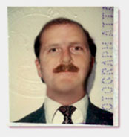 | Lieutenant Dan Davis, USNR-R  1982 Passport Photo

A bunch of us reservists went to up to a neighboring city, Aomori, with one of the old “Japan hands” and had a good time looking around. One of our "old salts" told us was that the problem with the Japanese was that they “big-deal” everything. I thought this rather quaint and charming. While in Aomori I went into a bank and gave them some travelers’ checks to cash. Yes, there was a time when you used travelers’ checks because there were no ATMs. My travelers’ checks and Navy ID were carried all over the bank while one official after another inspected them and added their stamp (chop) to the forms. I got my cash, but some several hours later, back at the Main Gate to Misawa, I could not find my ID. As we stood there, maybe 50 feet from the gate, one of the Japanese Defense Forces (pronounced JazDef) gate guards called out to us “Rieutenant Daybis! Rieutenant Daybis.” Seems the bank had called ahead to say they still had my ID and I could come back the next day and get it.

I noticed when the active duty Officers took me out to eat on the town, they took me to a restaurant serving Chinese food, which they characterized as the best Japanese food in town. The other thing that bothered me was that, while I always dressed like the Japanese I saw in these fine restaurants: coat and tie, the Regular Navy Officers who were stationed there, wore slacks and golf shirts because they hated ties. I thought that the Wardroom should be more sensitive and gentile than that.

I was over there a week, when Linda came over to spend the last week with me in Misawa, then we would take an easy tour south for a week and then fly home at the same time. I could not believe her courage. She just got on the plane and came on over. We worked out a deal with the base so she could get off and on and she slept with me in the BOQ in a single bed, with a chair pushed up against it to keep us from rolling off. The first day we walked off base together, we went into a bakery shop and I bought her a Napoleon pastry. The cute little Japanese girl took it reverently and placed it on a doily, put all that in a little box, wrapped the box with decorative cord and presented it to Linda with a bow. I think Linda was enchanted.

Linda and I both love trains, so we spent a lot of time riding around in the excellent Japanese trains. Here we enjoyed watching the countryside, observing the people and eating from the food servers in the trains. We especially enjoyed the Japanese children. They were so cute that we always said we wished one of ours would be a Japanese child. As they got beyond the infant stage, they seemed to be even cuter. When they hit the teenage years the boys became fiercely serious, but the little girls just kept giggling and having fun.

The grade school kids rode the trains in bunches of four to six. They would often watch us for minutes, and then one of the brave ones would come up to us and say, “Herr-oh.” To which we replied, “Hello.” Then came, “How ahr you?” “Fine. How are YOU?” Gales of giggles would come from both our interrogators and from the more timid crowd of tots standing back, but hanging on each word. Then, one last summoning up of courage, and they ventured the last question, “How old are you?” This last one we handled in many ways and we never got beyond that, the giggling being too contagious and too uncontrollable. Linda and I finally decided it must a line from a “dialogue” in a standard course in English. It would make sense that if you were making up conversation for third graders to include this, as children always want to know how old other children are. It didn’t really fit with a couple who were thirty-something. It was fun. We got to see Hachinohe, Aormori, Hirosaki, and Misawa.

When we were running around the downtown area of Aomori, we would walk under the ubiquitous canopies. As it is the northernmost province on Honshu, the Aormori Prefecture, it gets a huge amount of precipitation. In the winter there was snow beyond belief. The rest of the year you had rain, hence, the canopies in the shopping areas. As I walked down the sidewalk, the horizontal supports were about eye-level for my two-meter body, so I would have to duck under them. The Japanese, especially the more mature ones, were much shorter and had spent their entire lives bowing and returning bows. When they saw my head go down, they were conditioned, beyond their control, to respond. After ducking, as my head came up, I would be greeted with the sight of a dozen or so of those coming up the walk, bobbing their heads in response. It was very disconcerting, but I couldn’t figure out a way to stop doing it.

On Linda’s and my way south we left the cold of early spring, went through a band of budding sakura (cherry blossoms), through a band of early blossoms, then full bloom and finally, at the Imperial Palace in Tokyo, the fallen blossom stage (the saddest, but most romantic to the Japanese). On the way south, we stayed one night in what we now consider to be our town, Sendai. There was very little foreign influence there. While at Sendai, we went to a hotel and asked for a room. No one spoke English, and like the restaurants, they had pictures of their offerings with prices on them. Thank goodness, for when they went and got the guy who spoke “good English”, it was about to be about as good as our Japanese. Using the pictures to select it, we did get a wonderful room and we were happy to be back in a double bed. We took a tour boat ride out to Matsushima (the Pine Islands.) We took a nice little cruise around in the boat and it was absolutely mystical. All in all this was one of my best tours and I know Linda loved it.

My Status gets Questioned: “I was just checking to see if you guys were real reservists.”

My next ACDUTRA was much more mundane. I went to Imperial Beach, south of San Diego, with Sam Werner and another Warrant Officer, Joe Guerra. Joe was a member of the Spanish Aristocracy from Texas. His ancestors had been some of the original Grandees, those who held huge grants from the King of Spain. He and Sam were good company and we almost got a trip out to a carrier. We did get an opportunity to get a briefing from one of the local outfits that did classified work. We went down and were ushered into the Officer In Charge’s (OIC) office. He told us what he was doing and what they were working on. As is Sam’s and my invariable approach, we started asking questions and probing for the real thrust of his activity. After about half and hour he got up and said, “I’ll be right back.” About ten minutes later, he came back in a much better humor. He said, “I have been briefing officers for about a decade and you guys asked more intelligent questions in the last half hour than I have gotten in all that time. I got to thinking, “These guys can’t be reserves!” Most of the reserves sit through my briefing and never ask a single question. There has been a new security push around here and I thought you two might be plants trying to see if I’d overstep my restrictions. I was just checking to see if you guys were real reservists.” (By the way: I always told my troops before a briefing, “Everybody has to ask at least one question, otherwise they will think you are not interested.”).

The Navy invades Ensenada

It was on that trip that Sam, Joe and I went down to Ensenada. I had the car, so we got insurance for Mexico and drove it down, past Tijuana, Rosarita Beach and on to Ensenada. It actually is quite barren and lonely for most of the trip. I would not want one of my girls to be driving it alone. When we got to Ensenada, we found it better than Tijuana. Joe got us into a good hotel. We had a good time, just eating and hitting the bars. Every place we went, Sam and I, who dwarfed Joe, gave him all the deference, like we were his bodyguards. We called him, “El Patron.”

Miramar, 32nd Street and MCRD

Both weeks we were there we followed the same drill for parties. At the traditional Navy Officers’ Clubs, you must be either an Officer or an invited guest of an Officer. That means there were virtually no un-escorted women in the clubs. To cure this intolerable situation, three of the local clubs had one night a week where the Officer of the Day, (OOD) would stand his watch at the front door of the Club and admit any woman who came, assuming she looked presentable enough. Other than being around for emergencies, the OOD had very little to do in the evening, and everyone knew where to find him. He couldn’t drink, of course, but he was usually surrounded by the ladies, hoping to get in. The nights selected were Wednesday night at Miramar NAS (twenty minutes north of downtown), Thursday night at the 32nd Street Club downtown and Friday nights at MCRD by the airport. The drinks were cheap, there were live bands to dance to, there were tons of girls of every age and description, and the house was rocking. MCRD had three bands: rock, jazz and country.

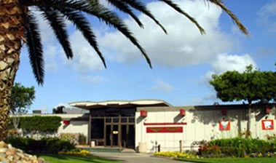
Miramar NAS (Now MCAS) Officers’ Club

Miramar was the best. The fighter pilots really knew how to party. The scenes in “Top Gun” were not exaggerated; although I think some of that movie's scenes had actually been shot in the O Club over at North Island NAS. The crowd ran to the size of a couple of hundred at all three clubs. I am told much of this has been toned down, especially after a Member of Congress was mocked with a papier maché statue at one of the parties. Ah well, if they don’t have sense of humor, ….

One night at Miramar, Sam, Joe and I were sitting at a table, enjoying the music and watching the dancing. There were about a fifty people in the bar area which was a plain room, maybe fifty feet by seventy feet. About half of one entire side of the room had sliding glass doors that opened out onto the pool area. There was a band indoors and they had a dance floor covering the middle third of the room. There were another hundred or so people, almost all Navy officers in flight suits, khakis or summer whites, out by the pool where they had steaks, hamburgers and hot dogs, all for free. The band took a break and the dance floor emptied. All the men there were either Navy or Marine, mostly aviators. In walks a very young Air Force First Lieutenant, who looked like McCauley Culkin. He was in uniform and he was still wearing his HAT! Bong, bong, BONG! The chatter dropped away in a second and then a howl went up, as if the steaks had just been thrown into the pen where the wolves were kept. He stood transfixed, not seeming to know what he had done. Someone was all too happy to tell him. He had to “stand the bar to drinks,” in this case around a hundred people. This wasn’t 1969 Việtnam and drinks were on the order of a couple of dollars apiece. He protested that he was broke, which explanation was naturally greeted with civility and understanding – NOT! Another howl went up, more derisive and blood-curdling than the last. Sam and I, being from Colorado Springs and having gotten to know the young USAFA Cadets, were going to intercede, but the young lieutenant fled in horror and disgrace, followed down the hall by the hoots and hollers of our pilot brethren. What Sam and I would have done, and what our young officer should have done, was to go over to the bar, bought half a dozen pitchers of beer for less than $30 and hoisted one for the Navy and then hid. Nobody would have bitched. I wonder if the poor kid ever went in an O Club for the rest of his life.

Taken for a “ringer,” twice, at Homestead

For our next ACDUTRA, Sam and I went down to Homestead Air Force Base, where there was a Navy detachment of cryptologists, working out of a Wollenweber site about twenty minutes south of the base. Homestead is just south of Miami and had an Air Force fighter squadron that was “pointed south,” toward Cuba. They were a crazy group and I had a good time at their club. The party was not as big as Miramar, but it went every night and was decorated like a WW I bombed out building and pilots’ quarters. The music was sometimes just a DJ and there were maybe twenty-five or so Pilots there. They were laxer than the Navy on the no guest rule, so there was usually a bevy of “townie” girls, looking for a date. I was not in that mode, but it was interesting to watch the pilots. Their approach seemed to be Neanderthal, which offended me, but Sam was much more understanding. He noted that all of the officers and all of the women were there of their own accord. These guys got roaring drunk every night, so we had multiple opportunities to see “Dead bug” which involved all the young pilots flopping on their backs with their hands and legs in the air, “Carrier Quals” wherein the guys would take turns running a few feet then diving on a row of beer-lubricated tables, and arm wrestling, the last being some kind of local favorite.

One of the local Warrant Officers told us that if we really wanted to pick up women, the best bet were the Air Force Officer Nurses from the big hospital on base. He said the trick was to introduce yourself as a cryptologist and make sure they knew you were not a pilot. Having to put up with big-ego physicians all day, they did not want to put up with big-ego fighter pilots all evening. Those "ego" phrases are often assumed to be redundant in both professions, but are expanded here for emphasis. It was a good time, except Marty and George couldn’t go with us. No fraternization, doncha know.

As reservists, we usually got a series of briefings and generally were treated like honored, but somewhat burdensome guests. When we got to Homestead, the X.O. told us they had been having some morale problems and asked us to let him know if we ran across anything. That was enough for us to really get something going. Marty Kaplan and George Hubert were with me again, so Sam and I went around and talked to everybody, and Marty and George massaged the data. We developed a standard set of questions and evaluations. The troopers really let it be known what their issues were. One night, we were working through the watch section and getting the usual complaints of poor leadership, sexual politics, favoritism, lack of motivation, and mutinous feelings. Just then, the C.O. came in and started to go around talking to his people. “How are things going?” “Just great, sir.” “Got any problems?” “No problems, sir.” Were these the same guys who were just bitching to us?!?

The next day we were all eating in the Wardroom when I got a really poor piece of roast beef. I don’t know that the entire roast was bad; maybe I just happened to get some gristle. The C.O. at the head of the table asked me how I liked Homestead. “Terrific.” I told him truthfully. “How’s the food.” “It’s all been very good, sir.” “How’s our roast beef today?” “Well, this slice is a little chewy.” Stunned silence!! Pause. I could tell I had done something terrible. “X.O., how’s your beef?” “Excellent, sir.” “Admin Officer?” “Perfect, sir.” “Ops Officers?” “Excellent, sir.”, and so on. Now I knew why we had witnessed what we saw the night before. Some C.O.s do NOT want to hear about problems.

That weekend, they had a Command Party. It was August, and hotter than hell, with typical South Florida humidity. It was an outdoor, all-day affair, with tons of food, beer forever and ever, and lots of sports. All the families were there, the Marine detachment, SeaBees, and everybody not on watch. Sam and I mainly “spectated,” but when the volleyball game came up, the X.O. came over and asked if we could join the Officers, as there was a tradition of the Officers and the Chiefs playing against each other. Sam and I were both pretty good, having played a lot and both being tall and good jumpers, we were decent middle-blockers. It turns out that the about half the Chiefs’ team were on the base volleyball team and there was usually a blow out in their favor at the “Chiefs vs. Officers” yearly match. Sam and I played our hearts out. It really does screw up the other side when two guys of 6’ 4” and 6’ 6” get to the net, jump up side-by-side and put their arms up in the air. The whole rhythm of the Chiefs was thrown off and they spent all their time trying to keep it away from Sam and me. One young female Officer got her lip split by the SeaBee Chief when they “met” under the net. I think we finally won it for the Wardroom, 29-27. I could hardly stand up. The word immediately went out that Sam and I actually were semi-pro volleyball players and that we had been specifically sought out and brought in as “ringers,” just to beat the Chiefs. Surely this was the only time in my life of non-athleticism that anyone thought that of me.

Over the last week, we finished up our interviews and Marty and George produced a wonderful and comprehensive statistical analysis using the detachment’s computer. Sam and I wrote up the text and we presented it to the X. O. during our exit interview. It really was a good piece of work, of which I am still proud some twenty years later, especially on behalf of all of our stalwart crew who worked so hard and produced such a good result. Sam was solid and committed. Marty and George were excellent computer programmers and did some really original work to produce the analysis they knew to be relevant. The X.O. seemed appreciative, we said goodbye to the C.O., and we picked up our orders and pay and left the Ops building. The Master Chief Petty Officer (E-9) of the Command walked us out to our car. He wanted to thank us for helping highlight some problems for the leadership. He also wanted to tell us that there was a rumor going around that we couldn’t be reservists. No one there had ever seen reserve Officers do anything like that before. He said that the smart money was being put down on the bet that we were actually trouble-shooters from the Department of the Navy, sent down there to investigate and we were just masquerading as reserves, complete with “dummy” orders. He wanted to know if that was true. “Sorry, Master Chief, we can neither confirm nor deny …”

The Detailers’ Shop and PhDs

On one of my ACDUTRAs, I got orders to Headquarters Naval Security Group, Assignment Detachment, Bureau of Personnel, USN, just up the hill from the Pentagon. Here a couple of officers and a handful of senior enlisted people make all of the duty assignments for the Naval Security Group, at that time comprised of about 500 Officers and 5,000 Enlisted. It was an amazing group of people and I enjoyed working with them. While there, I was consulted on a legal issue involving a female enlisted who had been brutally sexually assaulted by a foreign citizen at the remote site where she was stationed. She recovered physically, but there was a continuing issue with the command and whether she should stay on the island or be reassigned early. This issue broke along sexual lines. The males thought she should have her request for transfer granted; the females thought she should tough it out where she was. The C.O. refused to talk to her about it. Sex and the Navy were not up to this issue.

The Chiefs and First Classes who did the Enlisted detailing did it with an amazing sensitivity to professional relations, “He would work better for Chief X at Base Y than for Chief A at Detachment B.”, and to personal issues, “Jones’s ex-wife married Smith, so we would be very well-advised not to station them together for at least ten years.” I really got into the process and admired the depth and breadth of knowledge and judgment required to do a good job. As very junior E-3s and E-4s, we had jokingly assumed a seemingly insidious correlation in assignments that had us doing language training on the coast farthest from our hometowns. The only exception to that rule was a guy from Ohio who had a girl friend in San Francisco, so he got DLI-East Coast. Now, I would believe such considerations did have a part in our assignments. It was common to call to the assignees chain of command to check on such details. By the way, David Niven reports a similar tradition in the British Army, he made several requests for duty, including “… anything but …” a specific unit and, as you will well imagine, got assigned to that unit.

One day at lunch, I was talking about the then current ComNavSecGru, an Admiral who was a Russian language expert. I knew he had a PhD and I wondered how many other officers had PhDs. The senior officer detailer knew the answer; a total of 5 officers had PhDs. The enlisted detailer said, I think there’s more than that in the enlisted ranks. After lunch, I mean “noon chow”, we went back up to the office and checked. After checking, they came back and told me that the enlisted ranks had around 63 PhDs. Note that this is not only a higher number, but is a higher percentage, (5 out of 500, vice 63 out of 5,000). Almost all of them were language PhDs and all were held by very senior Chiefs. As to why more of these had not attained officer commissions, via the Warrant Officer, Limited Duty Officer or Direct Commission program, I do not know. I did not verify their numbers, but current data supports this kind of level, especially in such an intellectual rating as Cryptology.

I know in the Reserves we had a ton of enlisted who had advanced degrees. Many would have made fine Commissioned Officers, a few who were good troops but lacked that spark that would have made them a true leader. I may be a little too romantic in my view of officers and I certainly never thought of myself as a paradigm officer, but I know one when I see one. That is not unlike my ability to recognize a good Major League hitter; I couldn't hit a Major League curve ball, but I can recognize those who can. Command presence is a completely separate topic, but it is "real" and is highly desirable, as is erudition, vision, and composure under stress. All are hard to quantify, easy to identify.

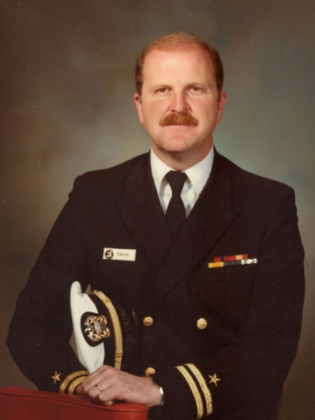
LT Dan M Davis, 1983

I later got an insight, however, into why some of these men did not pursue higher ranks. One of the absolute best, most capable leaders I ever knew in the US Navy was a reservist Michael Dean Widler, now CTACM Retired. He was a career manager in the Colorado Parks System and, for a while, ran a Bed and Breakfast in Pensacola. Were I President (or better, King), I would have no qualms about appointing him as CNO. At one time, he did look into his getting a commission or a Warrant for himself. He was disqualified, not for “gross ugliness,” as had been my worry, but for uric acid poisoning, more commonly known as gout. This is a condition completely controllable with oral medicine and largely ameliorated by sensible diet. It developed after Mike enlisted, so did not keep him out of the Navy. It was not serious enough to merit a medical discharge, but it did disqualify him from gaining a commission. If he had gotten a commission before it was diagnosed, he could have kept it. The seeming capriciousness of such rules at first perplexed, frustrated and angered me, but as I matured I could see the necessity of rules and standards and I recognized that they were more valuable than the damage they occasionally inadvertently did, such as in the Widler case. Vision deficiency was another area that kept many otherwise fine Navy leaders from becoming officers.

Naples, Italy
Naples and my best tour

My best reserve tour was Naples, and I happily am talking Italy, not Florida. We got word at the unit in Denver that there was a special opportunity to do a three-week tour of duty in Naples, Italy. I was able to schedule that much time off from work at Martin Marietta and went off on a TWA flight across the Atlantic. I could look down and see Paris, which is as close as I ever want to come to that city. I noticed a couple of other guys who “looked like” reserves and found out that they had the same orders I did. I had made Lieutenant Commander by then, and was getting pretty senior. We landed at Rome and got a bus for the ride downtown to the railroad station. The Rome station was much like Tijuana in that we were immediately and constantly besieged by poor and tattered waifs begging for money. After a brief pause, we got on the train down to Naples and noticed a few other guys who had that Navy look. By the time we got to the Naval Security Group Detachment Naples, we had assembled maybe ten of us. Without checking ranks, they all decided I would be in charge, that decision not being something that I understood or appreciated. I kept telling them that I didn’t think so and I really didn’t want to be in command.

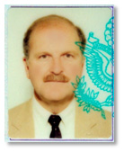 | Lieutenant Commander  Dan M. Davis, USNR-R  1989 Passport Photo

We were to act as an Operations department and replace the active duty operators and analysts who had gone to sea for a couple of months on a really big exercise. To replace them, the C.O. at Naples was open to Reserve replacements. There were to be three groups of reserves rotating through for three weeks each. We overlapped two days with each section. I was a Lieutenant Commander and we had three Lieutenants, a Senior Chief and about 21 Enlisted troops. I have never been much of a “leader of men” and I have neither the self-confidence, let alone the desire, to manage that is necessary to be truly effective. But, one of the things I have learned in life, when faced with something you cannot do, just pretend you can act like somebody else who is good at it! So, in Naples, I just “acted” like I was a good officer.

I told the Senior Chief to break the troops into three watch sections, dismissed my Enlisted to go take a coke break and announced “Khaki call,” a term taking cognizance of the fact that the Officers and the Chiefs wear the same style uniforms, the work uniform being Khakis, as opposed to the enlisted work uniform, in which they wear dungarees with “white hats.” So a “Khaki call” was a meeting of all Commissioned Officers, Warrant Officers and Chiefs. When I met with my three Lieutenants and one Senior Chief, it was not exactly like Henry the Fifth exhorting his Band of Brothers, but we did coalesce into an operating unit within a few minutes. I decided to create a watch schedule that would have the troops working Port and Starboard for twelve days, have six days off and then all report for the last few days. That gave everybody the best chance of seeing some of Italy and working their buns off the rest of the time. Only the Senior Chief and I were denied this pleasure, but we “loved it,” and were glad to be useful, so we were happy too. The Officers went off to organize their watch sections and I then turned to the Senior Chief and said, “I will be meeting every change of a watch, just to make sure we are covered. You and I will meet with everybody today and then start writing ‘Fit Reps” tomorrow. That is the way we did it.

It was a wonderful tour and I did get a little time off to go down town. The taxi drivers would say things like, “Me Communisto, but I love Americans.” And they did. I also got over to Capri and went into the Blue Grotto. A trip to Herculaneum was educational and right out of the Navy’s “See the World” brochure. One of our senior enlisted men was an Italian and spoke the language, so he took us downtown for a real, five-course, Italian meal. Most of all, I enjoyed working with the Senior Naval Officer there in the Security Section in Naples, Captain Evans, Royal Navy. They have been at this Navy business longer than we have, so his invariable approach to each issue was one of good humor with us and confidence in the outcome. I loved every chance I had to go up and meet with him.

We were across town from NATO Sud, and so there were a lot of other nations’ Officers around. We would go over to NATO Sud from time to time to eat at the Officers’ Club and just enjoy the exotic quality of service in Europe. One day, the Officers’ Club had a bazaar, put on by the Officer’s Wives Club. We were told it would be open to us, if we wanted to go over. When we went over there, we always went in summer whites, which were white trousers, open-necked white shirts with ribbons and shoulder boards, all topped off with the standard officers’ hat. We KNEW we looked good! When we got there, all of the other nations’ officers were also in similar uniforms, except the Italian Officers, the Caribinieri, who had worn their more formal uniforms and they “looked mahw-vel-lous.” It seems to me that the Europeans still see their Officers as members of the aristocracy. In any case, the British wives were very attractive in their tweed skirts and beautiful sweaters, the French were very stylish in their feminine dresses, the Germans were looking smart in their beautiful suits and the Italian ladies looked like princesses in their makeup, heels and sexy dresses. Then we got to the American table. There the cream of American womanhood sat in their sweatshirts, jeans and tennis shoes. We stopped by to talk and buy some jam for Navy Relief. The issue of dress came up and they proudly told us that they didn’t buy off on that “snobbish” dress-up stuff and they dressed the way they felt. I was ashamed for them, my country, and MY Navy.

We took a ride across town in the Navy van one day. The driver was a young female Petty Officer with whom we engaged in conversation. Thank goodness, I didn’t offer to drive! One of the things I have found in the service was that the people are good talkers. She was happy with her duty and enjoyed being in Italy. Did she date Italian men? Why yes, she did. She had met a “gorgeous” young Italian guy at a store where she shopped. He had first invited her out to a movie. When he arrived to pick her up at the Women’s Quarters, she came down in the traditional sweatshirt and jeans, ready to go. “No,” says he, “you are not dressed appropriately for a date. As you can see, I have dressed up in my best trousers and shirt to honor you. I would have expected you to wear a nice dress and heels to show that you honor me and the beginning of our relationship.” She was enchanted. A man who cared about her, how she looked, and what in meant to be on a date in Italy. She went back up and changed, never again to “dress down” for a date with him. She said she was deliriously happy with him. “And,” we asked, “what of your shipmates and their reaction to macho Italianos?” She said about half of the girls loved the Italian attitude and attentiveness to femininity, about half thought it was stupid and dated only American guys, with whom you could wear sweatshirts. I will state no position on the appropriate attire or attitudes for Enlisted on liberty and leave it to the reader as to which group had the richer experience in Italy.

Officer Selection and Books

While there for three weeks, I was one of the really few SecGru Officers left at NSG Naples, the rest being at sea with the fleet for the exercise. There arose a need to empanel an Officer Selection Board for a young CTT-1 who was a great favorite of the Command. He was a hard worker and quite bright, I was told. With two other LDCRs, we convened the Board in a small room in the Ops building. The three of us sat on one side of the table and the candidate sat on the other. He had a very unprestigious academic record, but sufficient for the regulations. I immediately liked him and was as supportive as I could be during the meeting. I asked a few questions, including two of my standards for such an event: “What is the book that has had the most impact on your life and why?” and “What book are you reading right now?” He was completely blank on the first and so I slid rapidly off to the second. Here he said, “I am not reading any book right now. I guess I spend all my time reading technical manuals.” Then later, he said, “I guess the book that has had the biggest impact on my life was the Bible.” I was too kind-hearted to ask him what his favorite Book of the Bible was and why? I am reasonably confident I would have gotten an embarrassing non-answer. After we broke, we met in camera to discuss his candidacy. My two fellow LCDRs said those two questions and his answers to them completely reversed their opinion as to their support of his becoming an Officer. They were especially negative about his “… only reading technical manuals.”, which they saw as more representative of a good technician than a good Officer. I do not know the final result of his application and, quite frankly, I have met many Officers with whom I would have had even less confidence. But history has shown, Officers are called upon to be more than just hard workers. They are both the bastion between the enemy at the gates and our peaceful society and the bastion between otherwise humane troops stirred to passion by combat and the outrageous inhuman acts of units who are unconstrained by moral imperatives. I did spend some time with the candidate after the meeting explaining where I thought he was strong and where he needed to better understand the goal of such a meeting and the impact of his answers. I think this constructive debriefing is ethically mandated for all such evaluation activities, but such debriefings are often, nay usually, avoided. Moral courage is a sine qua non of leadership and one manifestation of that courage is constructively telling troopers to their face when and why they have fallen short. I do not assert that I am particularly good at that, nor that I enjoy it, nor that I don’t often come up short of my own dictates. Your own shortcomings should be allowed to create a sympathy for others, but it cannot be allowed to let you lower the standards for selection to such critical positions.

My team did well at their assigned tasks. There were no real problems. I have one good story that will have to wait a couple of decades to tell, but we got good marks for our contributions. We had a great “good-bye dinner,” awards for all of the usual suspects, and we all got good marks as the most organized reservists to ever come through Naples. Most of the troops left immediately, but two of the Lieutenants and I were scheduled out of Rome a day later. We went up to Rome, spent the night at a really neat hotel and went to Leonardo DaVinci Airport the next day. Here a really gigantic and jovial Italian TWA ticket agent met us at the counter, where he took our ticket stubs, passports and the like. He looked up from the passports and said, “You Offissori?” “Yes we are.” “Offissori fly firsta class.” “No, we’re coach class. The U.S. Government won’t pay for first class.” He was not to be deterred. “No! Offissori fly firsta class!” And so we did fly first class; he upgraded all of us. I love the Italians!

Regular Reserve Duty
Showing off at TI and going to the Chief’s Club

While I never did get orders to San Francisco’s Skaggs Island or Treasure Island for two-week duty, I did arrange several TTY week-ends for the unit at T.I. We used to go with Ron Servis, Sam Werner, Bill Baughman, Jim Amundsen, Spike Rumley, Dan Petitt, Mike Widler and a host of others. It is The Best liberty port and we always enjoyed going to the Bay Area. Once when we were there, we were being trained in a technique that we already knew and my CTTs were really quite competent in it. I wanted the troops to run over to Skaggs Island, so they would see where it was, how to get there and what the work there would be like. Our hosts thought that we should stay at T.I., which is in the middle of San Francisco Bay, and practice. I was an Officer, therefore theoretically not a “worker-bee,” but I was always technically interested in our gear and reasonably competent, so I challenged the T.I. personnel by saying that if I could show them that even I was trained up on the issue, they should let us go. They seemed to accept that and identified for me a signal that I was to try to capture. I was able to do it, by the grace of God, in about half the time their expert had taken to do the same thing. We got to go to Skaggs.

T.I. had the most beautiful CPO Club. It was right down on the Bay, looking due East at San Francisco down town. At night it was perfect; another good reason for Officers to take VERY good care of their CPOs. You only can go if you get invited by a Chief and they are not inclined to invite very many. Officers who do get invited are often the ones who are seen as those who take care of their people. It was fun to go down to the Bay side every time we went to T.I. Sometimes we would stay in the BOQ over at Alameda, another NAS that is now closed. BOQs are often the best deal in town, as senior officers get pretty decent rooms, and if you are staying “Space A” (space available) in a BOQ, the linen charge is usually a tenth of what a hotel room of comparable quality would cost.

Shooting on the Range at Denver

I got to act as a Range Safety Officer in the Naval Reserve. One of our CWO’s found out we could requisition ammunition for M-16s and there was a range where we could shoot on the base at Buckley. At Denver we qualified nearly our entire unit on the M-16A1. Even our females who had never fired before were able to qualify under our instruction. Then somebody in DC sent out a query? “Why is the Denver Cryptologic Unit using more than half of the ammunition budget for the entire Naval Reserve every year? What are they doing out there that needs so many qualified marksmen?” Naturally, I was in favor of responding, “Sorry, Naval Security Group Units perform SI classified duties and cannot discuss their activities.”, and press ahead. The C.O. at the time (He retired as a Captain; I didn’t!) thought more prudently and killed the trips to the range.

Before the untimely end of our marksmanship efforts, we were serving under a District Officer in the Cryptologic Reserve program: a Captain who, when not drilling, worked for Colt arms, a major manufacturer of the AR-15/M16 weapons. He was visiting us in Denver one winter when CWO’s Werner and Pettit and I were taking a group to the range to qualify. The Captain was very excited about this and asked if he could go qualify as well. “Sure!” says I, always happy to help out a senior officer, as well as any prospective shooter. Loyalty flows both ways in the Navy. (Wouk, 1951) On the trip to the range, he tells us that he is a shooter with just a little experience, but that he had never shot on a range for record. Further, he opines that it would give him bragging rights back at the plant if he at least qualifies as a Marksman and even better if he qualifies as a Sharpshooter. No mention is made of his shooting Expert; he is, after all, a novice shooter. The day goes by and he is shooting well and it is time to fire for record. It is looking good for the Captain when Dan Pettit and I go down to the range to score the Captain’s target. The Range Officers go forward; the shooters stay on the firing line. Most of his shots are accounted for, but one is off the scoring circle completely; his score totals up to qualify as a Sharpshooter. Damn!! He is just a few points shy of Expert. CWO Pettit opines as follows: “Clearly this shot out in the blanks space of the target is so far off that it must be a hit from some fellow shooter’s weapon.”. “So,” says I, “Where is the Captain’s other round?”. Taking his ~0.25 inch diameter Cross pen, Dan says “Right here.”, and he puts the pen through a hole right in the middle of the bullseye. Had it been there before? Hmm-mmm.

I signed the score card: Expert. The Captain was ecstatic. I am not ashamed!

Lest you think this was another story of RHIP (Rank Has Its Privileges), I can tell you quite honestly, and the people involved agree, we all would have done the same for a Petty Officer Third Class who worked at Colt.

Other duties were, as they say, "… as assigned, …" working my way up: Admin Officer, Training Officer, Security Officer, and XO. I remained in a pay billet for this period of time. One of the duties to which I was often assigned was leading a ceremonial formation. My strong and "military" voice resounded in a way that others thought appropriate. The Navy command voice is more cultured and restrained, but the Marine Corps voice carries better in high noise areas, so that may have been the difference, and I am at peace in front of a crowd. We worked hard on weekends, but we had good people with us and that made the time enjoyable. I looked forward to my drills. Unfortunately, advancement means doing less and less cryptology and more and more paper work. Developing an effective composition style for official documents, Officer Fitness Reports, Enlisted Evaluations, and the like is important and a much under-appreciated skill amongst the ranks and the junior officers. Successful senior officers that I have known have mastered these important skills. When I brief young people, I always emphasize how important it is for them to start right now improving their writing, presentation and other communications skills. These have, and will, mean more than technical excellence in the vast majority of careers. | 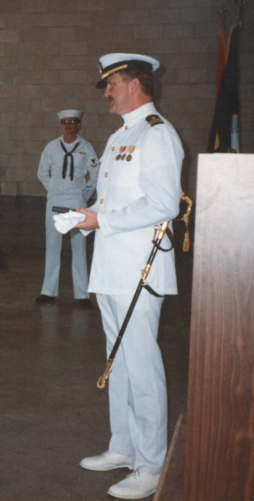  LCDR Davis  Awards Ceremony,  Denver 1985

Duty at NSG Headquarters

I did two tours of duty at Naval Security Group Headquarters on Nebraska Avenue in Washington D.C. It was located at a classically architected former girl’s school on Nebraska Avenue, up by Catholic and American Universities. The first tour had me assigned as an evaluator of people applying for an SCI clearance. I wrote a monograph on the impact of U.S. Bankruptcy filings on clearance eligibility. I had a good time and, as was often the case, was invited to the Chiefs’ Club, an honor that was accorded only one of the active duty Lieutenants. He turned out to be the Admiral’s aide, an Academy grad and a really terrific guy. He was thinking about getting out and I never ran on to him again, so he may have. This tour took place during the dawning of the age of the great push to involve more women and the SecGru seemed an attractive solution to part of this problem, being a Line outfit, but not combat-oriented, thereby avoiding some of the issues pilots, submariners and surface warfare officers had. In any case, I was a Lieutenant Commander and the active duty person to whom I was reporting was also an LCDR. When I checked in, a retired Chief took me under his wing and showed me how to review files. I asked to see my host, but she was “unavailable.” After a week, I checked again and, again, she was unavailable. I asked my retired Chief, “WTFO?” He said she was really quite shy and worried that new officers would figure out she did not know much about cryptology. Having reviewed my record, she intimated to him that she had a concern that I would challenge her in areas where she was unsure of herself. I finally got in to see her to say “thank you” for the efforts her staff had expended in my training, to give her an outline of what I had accomplished, and say good-bye. You can imagine my dismay that my Navy had fallen on such hard times. This was not invariably true of all of the female officers, as two of the best Cryptologic Officers I knew were women. The distribution I noticed was that the women were appropriately represented at the top of the quality curve, but much too heavily represented on the bottom of the curve.

A mark on my neck in Norfolk

One of the short tours of duty I did was at the NSG Detachment down at Norfolk Virginia. I wasn’t there too long and I quickly found that their little O Club was only about a five-minute walk from the concrete-block BOQ where I was sleeping. One night, I got really quite sloshed and walked back to my room. It was the middle of the summer and quite hot and humid n the Virginia Peninsula. As I got to the outside door to my room, there bugs were flying all round the light by the door. I ducked my head and walked through the bugs to open my door. As I unlocked the door, one of the bugs lit on my neck on the left side. I reached up to brush it off, only to be greeted by some of the most intense, burning pain I had ever felt. I staggered through the door and groaned in pain. The only thing I could think was that I had been bitten by a fatally poisonous insect. I fell on the bed and remember distinctly thinking, “If I am going to die, it’s gonna’ be right here, because I am too hammered to get up.” The next morning, the pain had subsided, but there was a really nasty, one-inch welt on the left side of my neck. By the time I got home and told my wife about this misadventure, it looked just like a “hicky” and I am quite sure she never was too comfortable with my story. This is my life in a nutshell: I never got “any,” but I always was in trouble. Later, a Southerner told me this was undoubtedly a blister bug, a type of flying beetle that has an acidic coating on their shell that is quite painful, even if trod on with toughened feet, let alone a sensitive neck.

London and Calais

A memorable trip was an ACDUTRA in London. It was more fun because of the liberty we had than the work did. We were working a European Command exercise to see how to handle the invasion of the Command area by “Red Forces”. There were questions about how to handle units about to be “over-run.” One of the things I did note was that when we had to make decisions in an exercise, the Reserve Officers were a lot bolder than the permanent personnel. At one point, we jointly had to decide whether to let a unit that was in hypothetical peril, remain in place or evacuate the unit members. It was a party-line, reserves vs. regulars, vote. We reservists felt that both they and we knew the danger and had accepted the risks, so they should stay and do their job. The regulars wanted to pull their friends out, if there was any danger at all. There is a theory the U.S. won WW II because there were so many draftees and reservist in the service that they wanted to win and go home, over-riding the regulars’ hesitancy and caution.

Linda was with me on this tour. I had already been selected for Commander and was getting a regular paycheck from Martin Marietta, so we could enjoy it. Like most of the Navy Reserve Officer on duty at NRSG London, we stayed at the Sherlock Holmes Hotel on Baker Street. It was all so British. We went to plays at night and she toured during the day. One afternoon, while Linda was off to some museum, I went out at lunch to buy her a scarf with her family tartan on it, as she was a McDuff. The extremely reserved lady waiting on me was perhaps a decade older than I was and was very proper and very helpful. At some point, I said something I thought was humorous, to which she replied steadily, but not icily: “Oh, you must be Walsh.”. “Why, yes I am, my name is Davis and we are Welsh. How did you know?”, I asked. “They’re terrible teases, don’t you know!”.

On an off day, we bopped over to Calais on the hover-craft. There we were treated rudely by the natives; no surprise to us, as we had been forewarned. I got a chance to try out my high-school French. At a restaurant where we finally ate, the waiter was actually very attentive and most helpful. When it came time to ask for the bill, I could not remember the word for it. I finally said, “Le Checque, si’l vous plait.” (Translated literally, “The bank check, please.”) The waiter looked up, startled, and ran out the door onto the street. I could see the headline in my imagination, “International incident caused by gaff spoken by Naval Reserve Officer in France.” It turns out that the word for a restaurant bill is “L’addition.” Fortunately, the waiter had just run out onto the street to speak to the driver of a car. Obviously he had recognized him through the front window of the restaurant. After just a few seconds, he came back in and figured out that I just wanted to pay and go back to England. Despite everything, it was a beautiful day.

The Commanding Officer
C.O. of two units:

Topeka:

After years in Denver, I finally got orders to a new unit, this one in Topeka Kansas. As I was senior enough to afford to fly to drill, it was fine to be down there, where I was X.O. under Ron Servis. I loved it there and the people took to me. Almost the entire crew was from outside of Topeka; mostly from Kansas and the other plains states. That meant that we were all in it together; nobody had families to go home to at night. The standard drill wound up being: arrive Friday for evening chow. Lash up with everybody at the motel the Navy reserved for us, get dinner, and go partying at clubs till midnight. That put us “in the rack” by one or so, up five hours later to make it to drill at 0700. Same routine for Saturday night, drill Sunday then fly home Sunday night. They had great bands in the Topeka area and one I really liked. It was a typical group: lead and bass guitars, drums, keyboard, trumpet and sax/flute. Of course, they mainly played Country and Rock music. One night somebody had a request for one of these really good bands. They played an absolutely marvelous rendition of “String of Pearls.” Really good musicians can play anything.

We had a really excellent, active duty, Center C.O. He had one “problem child,” a very incompetent Second Class. The C.O. got me aside one day and told me the sorry tale. This guy never could do anything. He was friendly, but totally incompetent. The C.O. pulled his Fit Reps from previous commands and was dismayed to see that he had top-notch marks from all of them. In despair, he called some of his fellow center C.O.’s to see what he might be doing wrong and what he could try to motivate this guy. The other C.O.s told him, “Oh, he was worthless when I had him too.” “Huh?” said our effective C.O., “Why did you give him such good marks?” “Ah, well. He was such a nice guy, I didn’t have the heart to be honest about him.” As I noted before, uprightness and moral fortitude is a sine qua non of real Officers. Signing a fit rep just to get rid of a non-performer is neither upright nor courageous.

My unit had no such problems. I loved the troops and we seemed to do our jobs well. I brought in fruit for everybody in the morning, having found that doughnuts just made me sluggish when I ate them early in the day. The other trick I learned was when we had someone who could not “produce” a sample for the mandatory urine tests for illegal drug use, a quick trip to the “7-11” for a 44 oz. Coke would ease the flow of the situation. We passed our inspection the year that I took over as a C.O., thanks to an excellent administrative staff more than to a good Commanding Officer, but I was happy to get the passing grade anyway.

Denver:

Having improved one unit enough to get them through an inspection, I was assigned to the much larger unit in Denver. We had from 60 to 80 personnel and a Wardroom of about a dozen. The first Gulf War occurred while I was there. Most of my “Khaki” wanted to go, but the Commander, Naval Security Group wanted to show everyone that they did not need the Reserves. This caused problems for our troops when they went to our ACDRUTRA sites, because when they got to those sites on Active Duty for Training after the war, the permanent personnel said, “We were working Port and Starboard for months. Where were YOU guys?” Our saying, “We wanted to be there.”, like John Wayne in “She Wore a Yellow Ribbon”, just didn’t cut it. There is a mistaken impression in the civilian world that all the reservists don’t want to go into a combat zone. That impression is reinforced and exaggerated by the journalists who love to interview little “Mary Reservist”, who has been drawing reserve pay for years, but now does not want to leave her baby and ailing parents when her unit gets called up.

All of my Wardroom asked me to get them on active duty. As the NSG wouldn’t have us, I went down the hall to the Denver Naval Intelligence unit and asked them if they could take us. They had mobilized nearly 80% of their Officers for round one of the six month tours and they would soon be facing round two. They didn’t have “another 80%” and most of those who did not go the first time had reasons for not particularly wanting to go: business, family, health, … So, they agreed to take us. My entire Wardroom “volunteered” and were getting ready to go to the Middle East when General Schwarzkopf ended the war early. Oh, pooh.

Commander Dan M. Davis,  Change of Command Denver 1990  Laurel, Linda, Corinne, Dan,  Andrea, and Evelyn Davis | 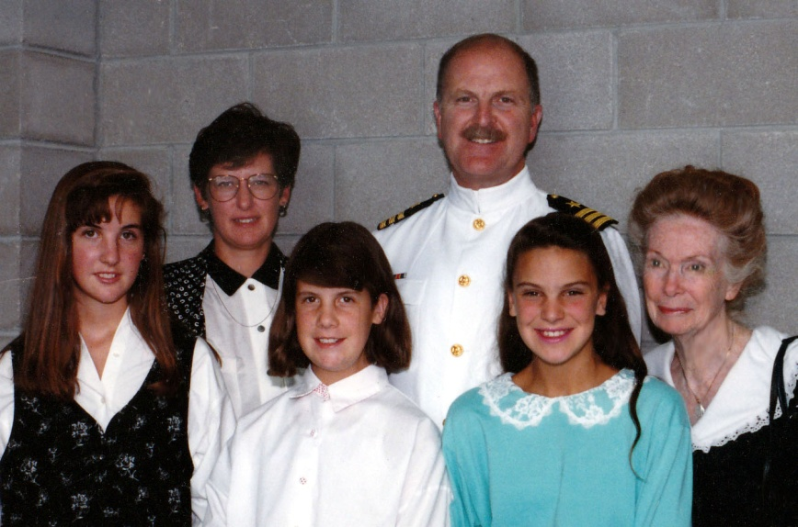
A Senior Officer in Japan

For my last real tour, I went once again to Japan, now as a Commander. There I met up with an old friend, still on active duty, Senior Chief Howard Spaulding, first seen as Lance Corporal (“…just call me Lance”) Howie Spaulding in Language School. The Command in Misawa “gave” me an Ensign to drive me around in a car. I was the second most senior Officer on base. Clearly, I had risen too far in the ranks. There must be a “Peter’s Plateau” for the military and I had floated above that. The Japanese country was still beautiful and there were still people to mentor, but it was time to quit. This ACDUTRA saw the breaking of a perfect string of my having never met an Officer from the US Naval Academy who was anything less than excellent. This was the time and base where the Chiefs were all at sea and there was trouble breaking in the new Ensigns, especially this one. Everybody liked her, but she had “no fire in the belly.” Both the senior officers and the Chiefs told me she would never make it. The theory was that she would never have gotten out of the Academy, had she been a male. I do not know if this was true, but can report this was widely thought by her peers. She herself admitted to me that she “… just was not cut out for officer duty.” This analysis was concurred in by one of the two really excellent female Cryptologic Officers I mentioned earlier, who was stationed there. I did enjoy the tour, seeing Howie again, meeting his wife and seeing Misawa one more time. It was a good twilight overseas tour.

I did one more uneventful ACDUTRA at NSA at Fort Meade. We tried to get the officers there to recognize the need to really incorporate, motivate and utilize the visiting reservists, but there was little enthusiasm for raising the level of acceptance above their manifest disdainful tolerance of reserves.

In 2003, after having no drilling location and being on Standby Reserve Status for about a decade, I retired as a Commander (O-5.) In retrospect, I wish I had accepted non-pay orders to an LA or a San Francisco unit and gotten my act together to make Captain. I had a really good record as a Commander, so I had a shot at it. But, I was in California and all my Girls were in High School or starting College, so I was really focused on them and on my career. In 1992 I got appointed as the Assistant Director at the Center for Advance Computing Research at The California Institute of Technology (Caltech) and was leading a big research project doing very large-scale battlefield simulations. As is often the case in civilian research, I was the only veteran on the team.

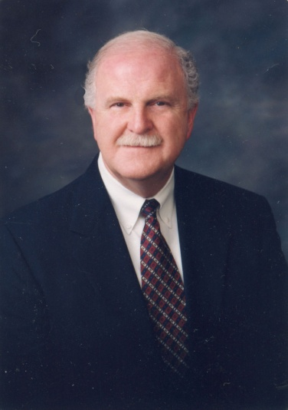 | Dan M. Davis, CDR,  USNR-Ret.  2002

Even today, I would be glad to go, if called upon. Of course I would go at a significantly slower pace than when I was in boot camp these many years ago. My good friends from the Corps and the Navy are of one mind with me. I recently asked several of them: "If the Commandant (or CNO) issued an order today saying all former members of the Naval Services are to report to the nearest reserve center and draw weapons, ammunition and uniforms for duty, would you report?". All answered with an enthusiastic "Yes!", with one exception, who responded, "If the situation had degraded to the point that such an order would be considered, I would already be there demanding they pass out the weapons and ammo, putting me back in ranks.". As for me, I have often dreamed that they would need an instructor for one of the NROTC units and would recall me to teach Naval History. I am ready to go today. The times do wear upon you, however. I find that more and more of my high school classmates are gone and many are now infirm. My warranty has expired, cf. Psalm 90:10

Military Demeanor, While in Drill Status and After

After I had been retired for about ten years, twice in one year, out of the blue, a person waiting on me in a retail situation asked me in which of the armed forces I had served, without even asking if I had served. (In DC it was a thickly-accented sub-continent Asian owner of an Indian Restaurant; then six months later in Seattle, a middle-aged clerk in a Safeway.) I really haven’t a clue as to what they saw, as our conversations were short and I did not use, to the best of my memory, any military jargon, e.g. “… does the unit head get cleaned every day at 0500 or does the s..t hit the bulkhead when some snufee goes AWOL at muster and there is a SNAFU before morning chow call?”.

About fifteen years before that, I gave a speech, at a Coalition of Academic Supercomputing Centers, after which the organization’s Treasurer, a CPA, turned to our Chairman and asked, “Was he in the Marine Corps?”. It always struck me I was the least likely looking member of the Corps and a pretty sad example of a Real Navy man. The talk to the Supercomputing audience was technical one, so would not have given me a lot of opportunity to use MilSpeak. The retail people got only greetings, “I am here to pick up the order for Davis.”, and “Just needed some cereal and milk for breakfast, as I am up here from LA to visit my daughter.”.

I mentioned this phenomenon to my boss at work and he, a PhD EE with no military service, said he often sees me chair meetings and it has occurred to him that I “seem military.” He sees my whole demeanor as that of a unit commander, citing the use of a calm and commanding voice and the giving precise of instructions on what to do. One time, he said I raised my voice over a chattering crowd and started a meeting with the phrase. “Gentlemen, it’s time to begin.”, and he remembered thinking, “It sounded like a Colonel in a briefing scene from a movie.”

But one of my brothers, a Navy Officer veteran, thought that the more likely general factors in the cases I had mentioned above were physical deportment, the way veterans walk through doors and the way other people are treated. He suggested that people with military backgrounds seems to have more of a “You have your role, I have my role and I honor both.” attitude to transactions. This leads to a certain expectation of following the script, rather than casual or denigrating attitude. It probably comes across more as a formality, even if a military man is being friendly or conversational with a store clerk. Also, often it involves more respect for the individual. He said some of us march rather than stroll. Of course, they say “ladies of the evening” can detect military bearing and assess the rank of individuals at a glance. I tried hard not to be too prideful about being singled out as “military,” but was not very successful. It IS a group with whom I am very proud to be associated, even if illegitimately.

Hard Lessons and Aphorisms
So, what’s it all about? I will spare you the hundred aphorisms I would like to pass along, but here are a few that I will list for your consideration:

- Gird up your loins and go for it; the faint heart lost more than just a fair lady
- How you look and what you wear IS important
- Voice tone and quality is a much under-appreciated characteristic: slow down and modulate
- Sometimes you may be wrong about people, but listen to your inner-voices and be wary
- Don’t count on people to remember that you did something good for them
- Never let the above advice keep you from doing something good for anybody you can
- Praise in public and criticize in private
- Read, read, read.
- Being where you are “supposed to be” will keep you out of a lot of trouble
- Always keep your troops in your thoughts and take care of them
- Surround yourself with talent, especially ones smarter than you
- Pretend that you are the kind of boss that you only wish you were
- If a person does something good, tell his boss; if he does something bad, tell him
- Tradition is a wonderful thing, cherish it
- Learn to listen actively, it takes practice and discipline but it WILL pay off
- Keep your libido under control, it will destroy your opportunities and effectiveness
- I know lots of people who got into trouble for talking too much, none for talking too little
- If you are in charge, LEAD!
- If something has worked well for thousands of years, be careful before you tinker with it
- If you never get challenged and you never lose a tough one, you are playing it too safe
- Fear is the only chance you get to develop courage
- Learn to think like the “other” person
- Never admire a member of the opposite sex in front of another member of that sex
- No woman has ever been in love with me; a few have enjoyed having me be in love with them
- Pray not for self-serving miracles, but for guidance, strength and personal peace.
- A manager’s primary obligation is to find the most productive position for each of his people
- If you can’t give me a number, don’t even talk to me
- Civility makes life tolerable; discipline makes life productive; vision makes life meaningful.

As an epitaph for myself, I would suggest,
“He was given more than he deserved;
He gave more than he had;
He fell short of what was expected.”

Epilogue
As is not uncommon, I ponder from time to time about what my experience really means and whence I primordially come. A few decades after my birth, I was to have the chance to wander the abandoned Navy airfields of Florida and walk the beaches at North Island Naval Air Station in San Diego. I would be overcome with a sense that I had trod these grounds before. I was emotionally suffused with the faint echoes of roaring piston engine aircraft, military commands, and excited billingsgate calls, all filled with anticipation and tainted with apprehension. I could hear them well, even though they had long since faded away. I could feel the mixture of hope, dread and longing of the men who had been there. The question that obsessed me: Was I especially feeling the presence some particular person, whose life history was to be violently cut short and whose spirit I would assume and whose life-line I would carry on?

My sensation of that reincarnation event was so strong and so consuming that I could not evade it. I remember distinctly wondering to whom I could pose a very practical question: “If I am the reincarnated instance of a person who died in World War II, would I have been born at the time of his death, or is there some finite delay?” I had to virtually shake myself, to get back to reality. Or, was I shrinking back from some other, even truer, reality?

But even as a retiree, the romance of the Navy stays with me. One phrase always guaranteed to bring back nostalgic memories of good times with service friends is the allusion of going to sea, once more, in the Navy-Gray ships: “Haze gray and underway.” I get very emotional about all of this, despite the fact that I have never done sea duty.

Sometimes service men stick together in ways “silly-villians” will never know. I am still in touch with a few of my old Marine Corps buddies and a slug of my Naval Reserve friends. I still love to reply to the standard question “What do your friends call you?”, with “My friends call me Commander.”, because so many of my friends are my Navy “ship mates”, and they know that I like to be called Commander.

I was hurrying up to Pasadena the one day in 2006 to see my oncologist, headed north on the Arroyo Parkway. I came to the intersection with Del Mar and needed to turn left (west) to get to the Doctor's office. There is a new commuter train line running parallel with the parkway, just a half block west of it. As the crossing guard comes down from time to time, they had some new LED-lit “No Left Turn” symbols that come on when the train is there and the way is blocked. Clearly it was intended to keep people from piling up at the crossing and sticking back out into the south-bound lane of the Arroyo Parkway and blocking south-bound traffic.

Anyway, I was really cutting it close for my appointment and there was no one in the slot, so I could tell there was plenty of room for me to make the turn and not be in anybody's way. Not wanting to miss a light cycle, I went for it. Just after I made the turn, the gate went up and I started off across the tracks, prematurely congratulating myself on my smooth move.

“Whoop, whoo-ooup!”; a motorcycle officer was right behind me with lights flashing.

In California that invariably means ~$400 in fine and traffic school costs, plus one day out of your life doing traffic school. Not only that, but now I would be really late to the oncologist and, as the phrase goes, it would ruin my whole day.

I pulled over to the side of the street and stopped by the curb. A cop about as big as, and of the same race as, the NFL Linebacker Rosey Grier came up to my passenger side and said “License and registration!” in a voice tone that would go well with “FREEZE! Mother .......!”

As I pulled out my driver's license, several cards came with it. My USC ID, grocery store shopping card and USNR ID fell out onto my thigh and the passenger seat.

He grumbled: “Gimme that pink card!”

I handed over my Navy ID and he asked me: “You Navy?”, about as ‘pleasantly’ as saying it as if he were saying “You the one who killed my mother?”

I replied: “Yes. Cryptologic specialty, 24 years.”, trying to sound calm.

His voice softened not one whit, but he said: “Haze gray and underway. Go ahead.” and he pitched all my IDs back in the car, executed a very presentable about-face and walked back to his bike.

I made my appointment with several seconds to spare, no ticket to pay, but with a barely perceptible tremor in my hands.

God, I love the Navy!

To everyone who served in Việtnam,
Welcome Home!

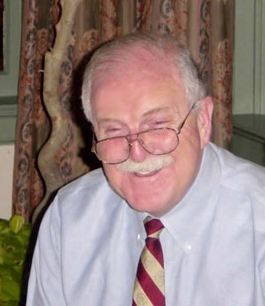
SEMPER FI!

Ribbon Breakout  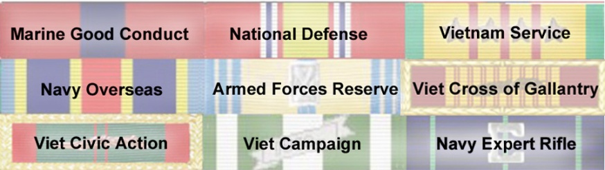  TimeLine  Apr '67 Reported: MCRD San Diego CA, Boot Camp, Pvt  Aug '67 Infantry Training Rgt Camp Pendleton, CA, PFC  Sep '67 Morse Code training, NCTC Pensacola, FL, Cpl  Mar '68 Vietnamese Lang-H Course DLIEC, Wash DC  Mar '69 Viet Staging Battalion, Camp Pendleton CA  Apr '69 In Transit Okinawa (Apr ‘70 on way to US)  Apr '69 Co L, MarSptBn, Phu Bai Vietnam, Sgt  Apr '70 First Radio Bn, Camp Lejeune, NC  Sep '70 7th RRFS, Udorn Thani, Thailand  Dec '70 1st Radio Bn Camp Lejeune, NC | Apr '71 Separated from Active Duty  Apr '73 USMCR, non-pay Completing  6 year Military Service Obligation, SSgt  Apr '73 Enlisted in the USNR as a CTI-1;  May '75 Commissioned, USNR, 1615 ENS  Apr '93 Transfer to IRR (Indiv Ready Res)  May '03 Retired USN after 19 years Ready Reserves and ten years in IRR, as a CDR  Reserve ACDUTRA's: NCTC Pensacola  FL (3 times); DLIWC, in Monterey, CA; NSGA Imperial Beach San Diego CA (3 times); NSA, Fort Meade MD (3 times); NSGA in Homestead AFB, FL; NSGA Little Creek VA; NSG HQ, Washington DC (2 times); NSGA Misawa Japan,  (3 times); NSGA London, UK; NSGA Naples, Italy; & HQ USN, Pentagon  Commanding Officer of Topeka KS  and Denver CO NRSG Units

