Ribbon Breakout  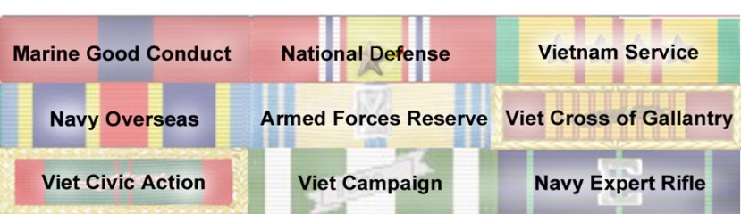  TimeLine  Apr '44 Born in Carbondale, IL Father CPA, LTJG USNR  Aug '44 Moved to Buffalo, NY, Father's new duty station  Sep '46 – Apr '49 lived in Champagne IL Dad in Law Sch.  Apr '50 – January '56 Lived in Carbondale IL K – 6th grade  Jan '56 – Aug '62 Lived in Colo. Spgs., CO 6th – 12th grades  Sep '62 – Aug '64 Went to Univ. of Colo.; had to drop out  Sep '64 – Dec '66 Worked at Abbott Labs, No. Chicago IL  Jan '67 Enlisted in USMC, ordered to a three month delay  Apr '67 Reported: MCRD San Diego CA, Boot Camp, Pvt  Aug '67 Infantry Training Rgt Camp Pendleton, CA, PFC  Sep '67 Morse Code training, NCTC Pensacola, FL, Cpl  Mar '68 Vietnamese Lang-H Course DLIEC, Wash DC  Mar '69 Viet Staging Battalion, Camp Pendleton CA  Apr '69 In Transit Okinawa (Apr ‘70 on way home)  Apr '69 Co L, MarSptBn, Phu Bai Vietnam, Sgt  Apr '70 First Radio Bn, Camp Lejeune, NC  Sep '70 7th RRFS, Udorn Thani, Thailand  Dec '70 1st Radio Bn Camp Lejeune, NC  Apr '71 Separated (Hon) from USMC  Apr '72 – Aug '72 Abbott. Labs IL  Aug '72 Married in Maryland  Aug '72 Re-admitted to CU | Apr '71-73 USMCR non-pay, Completing  six year Military Service Obligation, SSgt  Apr '73 Enlisted in USNR-R as a CT(I)-1  Aug '73 BA degree, Psych, Univ of Colo  Sep '73 Admitted to Law School at CU  May '75 Commissioned, USNR, ENS  '75 – '93 LTJG, LT, LCDR and CDR  Dec '75 JD Degree, Univ. of Colorado  March '76 Pass Bar Exam in Denver CO  Admitted to Colo & Fed Dist Cts; 10th Cir  Oct '82 Admitted to US Supreme Court  Dec '84 Father died from colon cancer  Jun '85 left the practice of law, never was  suspended and had no malpractice suits  Jun '85 – Oct '88 Martin-Marietta, Denver  Oct '88 – May '91 Classified project at JPL  Jun '92 – Aug 99 Asst. Dir. CACR, Caltech  Apr '93 Transfer to IRR (Indiv Ready Res)  Aug '99 – May '02 Assoc. Dir., ISI at USC  May '02 – Aug '03 Dir, MHPCC, on Maui  May '03 Retired USN after 19 years Ready  Reserves and ten years in IRR, as CDR  Aug '03 – Sep '10 Dir. JESPP Proj., USC  Oct '10 - … Consultant, USC (Part-time)  Reserve ACDUTRA's: NCTC Pensacola  FL (3 times); DLIWC, in Monterey, CA; NSGA Imperial Beach San Diego CA (3 times); NSA, Fort Meade MD (3 times); NSGA in Homestead AFB, FL; NSGA Little Creek VA; NSG HQ, Washington DC (2 times); NSGA Misawa Japan,  (3 times); NSGA London, UK; NSGA Naples, Italy; & HQ USN, Pentagon  Commanding Officer of Topeka Kansas  and Denver Colorado Naval Reserve Security Group (NRSG) Units

