27 April 2015
Gunnery Sergeant Fernando Cervantes
Chief Instructor
MCRD San Diego
1600 Henderson Ave.
San Diego, CA 92140-5001

Gunnery Sergeant Cervantes,

Subj: Letter of status and expression of gratitude

Having achieved my “three score and ten,” I am driven to acknowledge those who have had a major impact on my life. Chief amongst them are my drill instructors, but I have long since lost any contact with them. I submit the following to you for your disposal and use as you see fit, but I would be most appreciative if you could somehow forward this message to Gunnery Sergeant F. Leonard Green, Platoon Commander, and the Sergeants Carter, Maynor, D. J. Bonnette, and L. K. Smith, Drill Instructors for Platoon 353, April – June, 1967 (all ranks as of the Spring of 1967).

GySgt. Green, Sgt. Carter, Sgt. Maynor, Sgt. Bonnette and Sgt. Smith,

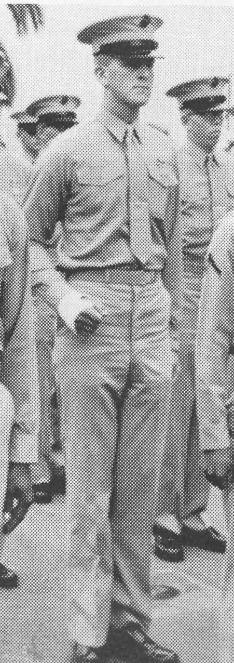
I would like to thank you for your efforts to train me in the Spring of 1967 and to report to you of that training’s enduring impact on me. As eloquence eludes me, as does athleticism, I will just give you a status report on my activities since you last saw me, nearly a half century ago. As the Sergeants Carter and Maynor were reassigned mid-way through our training, I will begin at about the time they separated from the unit.

You will almost certainly not remember me, having so many recruits within your charge, but my most distinguishing feature was my height (I measured six feet, six and a quarter inches at my enlistment physical and was told I was too tall, 1-Y and could avoid the draft; I stooped down a bit, got re-measured and got in). I include a photo from graduation day, in case that will help you remember me.

As you may recall, I was older than the typical recruit, having my 23rd birthday in Boot Camp, singularly un-athletic, and reasonably bright. My lack of upper body strength was a real challenge for me (around age 40, I was diagnosed with very low thyroid, a major impact of which was the underdevelopment of muscle mass), but I never fell out of a run and was able to keep up with everything except pull-ups and rope climbing. In any case, about a week before the end of Boot Camp, I broke my wrist during a pugil-stick bout (which I won) but the next day I went to Balboa and got the cast you can see in the photo. Platoon Commander Green “hid” me in the Quonset Hut for the week and graduated me anyway, at a significant peril to his own career, I am sure.

I was assigned as an Assistant to a Chaplain’s Assistant at MCRD till my arm healed, then in August was off to ITR, where I picked up PFC and was the ramrod for my platoon there. Then down to Pensacola for Morse Intercept Operator School which lasted till March of 1968. While there I was advanced to LCPL and then Corporal. I graduated there with really good grades and took the Foreign Language Aptitude Test, receiving orders to DC to take a 37 week course in Vietnamese. I was billeted at the DC Navy Yard and took classes in a civilian school downtown, about three blocks from the Whitehouse. I was there until March of 1969. So basically, I was in the Corps for two years and not yet had an operational duty assignment; I had spent it all in training and schools.

I got orders to Phu Bai in Viet Nam and did my staging training at Camp Pendleton, where again I was the platoon leader, being the only NCO, with almost everybody else being a grunt E-1/E-2. My boast was that no one in my unit went AWOL; we all got on the plane. I did a year in Nam, being stationed mainly at Phu Bai (flush toilets and air conditioned club) where we got lots of rockets and mortars, but our trench line was never attacked. I was the M-60 gunner. Two names from my unit are on The Wall (Ed Storm and Bob Gates), but they probably did not die from enemy action, being lost in a helicopter crash out in the boonies. I got assigned to some interesting duty at Con Thien, up on the DMZ and spent part of the Summer up there. I was more surprised by than proud of the fact that I behaved very well during rocket attacks. They really did not get my “wind up” at all. I made Sergeant the summer of 1969, about two years and three months after enlisting. (You’ve GOT to be kidding me!! Sergeant Davis??)

I met a girl during language school in DC, so wanted to go back to the World and did not extend to stay in Viet Nam, which I would have otherwise done. Got orders to Camp Geiger in North Carolina, where we mainly caused trouble and trained. The Army needed some Viet-linguistic help at Udorn in Thailand, so I got orders over there for a 90 day TDY; it was great duty. Back to North Carolina, there was a short tour in the Base Photo Lab as part of Project Transition, and then out (only one NJP on my record: more than 60 miles from duty station on overnight liberty - $100, later dismissed).

I went back to college at the University of Colorado in Boulder, and during the Summer of 1971the Corps sent me, via certified mail, a warrant for Staff Sergeant. Can you believe that?!? I tried to get some cryptologic duty in the Marine Reserves, but they did not have any units that did that in Denver. The Arty unit there offered me a spot, but, that didn’t sound like the right place for a cryptologist/linguist. After I completed my total six-year USMC obligation, I enlisted in the Naval Reserve as a CTI-1 and started to drill and receive reserve pay, which was useful, as I was married and in Law School in Boulder by then. Just before I graduated from Law School, I took the Chief’s exam, passed, but was not advanced. About a month later, I was given a direct commission as an Ensign, Cryptologic Specialty. I got a lot of free beers at the CPO clubs after that with the line, “I was too stupid to be a Chief, so they made me an Ensign.” My wife and I had three daughters, one each in ’74, ’77 and ‘80.

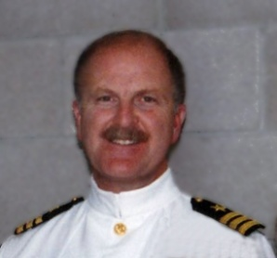
I practiced law with my Dad in Colorado Springs for about a decade until he died, enjoying my life in the Reserves much more than my time practicing Law. After Dad died, I got a job at Martin Marietta in Denver doing classified defense work. Rising through the ranks steadily, I wound up my Navy career as CO of two units, both of which failed inspections before I got them, but passed under my command. I did wonderful two and three week tours in San Diego, Pensacola, DC, Fort Meade, London, Naples and Japan. A feature of my units is that we burned up almost the entire Naval Reserve ammo budget every year qualifying everybody on the M-16 (there was Hell to pay when somebody figured out how much we were spending on the range). Another thing was that we were the most travelled unit on the country. I arranged week-ends away for training in San Diego, San Francisco, Chicago, Fort Meade, … about twice a year. I finally retired as a Commander in 2001. In civilian life I have worked at Universities doing DoD research: http://www.hpc-educ.org/

While never a jock, I have kept myself in good shape. I am up at 0500 every day and take a two mile brisk walk, (30 minutes), thinking “Gunny Green would be ashamed of me if I don’t keep in shape.” I weigh about eight pounds less than I did in Boot Camp and several people have guessed that I was in the Corps just based on my demeanor. No one ever guesses I was in the Navy. I still rise when they play the Marines’ Hymn and sing whenever I can. I am careful not to call myself a Marine, usually answering the questions “Were you a Marine?” with the answer, “I was a Staff Sergeant in the Marine Corps.”. I figure I really should not call myself a Marine as I didn’t legitimately graduate from Boot Camp; fortunately, Gunny Green seemed to think the Corps would find some use for me, even though I did not measure up during Boot Camp. I surely would have not survived being assigned to the Medical Platoon for six weeks and then having to start Boot Camp all over again (three back-to-back Boot Camps.)

I have lost contact with my one buddy from Boot Camp, Pete Yost. He also went into cryptology and I saw him in Viet Nam as a Morse Code Intercept Operator. On the other hand, I do hear daily from many Maine and Navy buddies. My “Bunkie” in Viet Name, Sgt Gary Olsen, was just now on the hook. My eMail spool is full of messages from service friends from all over the country, Navy and Marines. My military bio is on-line at: http://www.hpc-educ.org/Files/bios/DDavis-MilitaryBio.pdf

All of my good times were in the service. Best year of my life: Viet Nam; best three months of my life. Thailand; best month of my life: OIC of reserve detachment in Naples Italy; best week in my life: duty at NSGA Homestead, Florida and best day in my life: Graduation Day, MCRD, June 1967. Graduation from College and Law School, admission to the Bar in Colorado, commission as an Officer, admission to the US Supreme Court, publication in myriad conferences and journals, … all these pale compared to the proudest day of my life, Boot Camp Graduation.

Thank you for the lessons you taught me, for the examples you set for me and for the goals with which you challenged me. Any success I have had is directly attributable to you and what you gave us all. I can never fully repay you, but I keep paying on account every day I try to act like a Marine.

Semper Fi,



Dan M. Davis
Commander, USNR-Ret
eMail: dmdavis@acm.org
Cell Phone No: 310 909-3487
Web URL: http://www.hpc-educ.org
6275 E. 6th St, Long Beach CA 90803

