Facilitating V-Model Analyses:
Useful Computational Tools for Test and Evaluation

Dan M. Davis, Daniel P. Burns and Robert F. Lucas
Information Sciences Institute and Institute for Creative Technologies
University of Southern California, Los Angeles

E. Philip Amburn,
Computer Science Department
University of Arizona, Tucson

The classic V-Model is critical to Systems Engineering. This paper will examine the special data visualization needs and challenges presented by Test and Evaluation (T&E) and their use of visualization to serve the V-Model. The rapid and insightful analysis of the masses of data collected during the test and evaluation cycle has become one of the grand challenges of this community. The authors assert that newly developed capabilities utilizing emerging capabilities can and should be implemented to assure the T&E analysts are given the information they need most, when they need it, and in a form that will produce the correct outcome. The paper recounts and alludes to historical examples of the difficulties in effectively conveying information within the chain of command, supporting the notion that these problems are neither unique to simulation or T&E nor are they issues that can be ignored. Special emphasis will be put on new ways to convey the range of analytic solutions and alternative conclusions and communicate the relative likelihood of future performance, durability and safety. The T&E community is also faced with the need to convey the insights contained in the data in enlightening and compelling ways to both analysts and end-users. A survey of associated topics like causal modeling and behavioral science insights will be presented along with analysis as to their contribution to better exploitability. The paper concludes with recommended approaches for studying, evaluating and implementing the most promising techniques and technologies.

Key Words: Data Visualization, Data Management, V-Model, Systems Engineering

T

his paper is an analysis of the current state of information-transfer procedures used to convey the insights gleaned from data collection, analysis and simulation of battlespaces for two traditional purposes for such simulations: Analysis and Evaluation, which are a critical part of the right side of the V-Model. It comes in many variants, but all of these focus on the orderly transition in articulable steps from concept to operational use. Figure 1., A US Government V-Model, shows a common example of the V-Model.

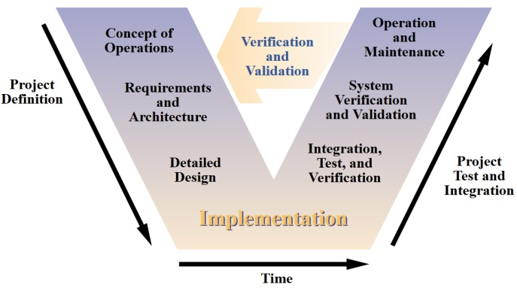
Figure 1 A US Government V-Model
The other important traditional use is for training, also important for the last stage of this process, but one we will not cover here.

T&E must marshal a wide range of resources: live, virtual and constructive. These, in turn, often include all the personnel needed for the test: both combatants and non-combatants. The focus here is on the requirements and challenges flowing from the use of the immense data sets generated by large-scale tests and complex evaluations, but the lessons learned and the technologies discussed are obviously applicable to analogous situations in other contexts. The authors identify, characterize and analyze the problems of effectively visualizing test data and discuss those problems’ amenability to emerging techniques and technologies.

Simulations are traditionally recognized as tools that can be used to provide training, analysis, and evaluation. Their use in all three present issues both in their utility to the T&E community and in verification and validation of the systems themselves to assure the testers and the users that the test environment is valid. As an aside, they have also recently been proposed as having a potential for “look-ahead” capabilities to support situation awareness. With mission success and personnel lives at stake, and with the exorbitant cost of live fire training exercises, the pressures on military leaders are intense, so this predictive use is vital, but fraught with potential break-downs in the computer/human interface.

All of these uses are expected to increase in prevalence and to grow in importance, thereby becoming pervasive. There is an inherent cost savings that can be gained by culling out system and component failures that would cost valuable resources in exercises, not mention lives in actual combat. Like the corporeal muscle memory that is reinforced in a gym setting, brain muscle memory can be taught via simulations. Any and all gains yielded from repetitive training will decrease the cost, resources and expenditures consumed in live fire training exercises and in actual combat.

The paper continues with a section setting forth a description of the central issue at hand and presenting some historical context for some of the more vexing problems. It will then review the impact that computer simulations have had, focusing especially on the authors’ experience with large-scale military simulations that were enabled by distributed high performance computing. These implementations began in earnest with the SF Express project early in the 1990’s. That and follow-on initiatives have generated so much information that two meta-challenges have arisen: data management and data visualization, i.e. effectively recognizing and conveying the insights from that data to the consumers.

The next major section will treat the nature and extent of the challenges that have been observed in the data communications area. Both problems from operational experience and the issues experienced during large-scale simulations will be described and analyzed, as well as their relation to the T&E environment.

In addition to these observed and named needs, the paper will raise and discuss several new opportunities to aid the T&E professionals to better utilize the data that is available. The manner in which data is presented is a major thrust of this paper. This field is usually referred to as data visualization. There is extant a term: “visulation,” which was coined to represent the combining of the simulation and data visualization functions. To accent the utility of visualization for T&E, simulation, and live combat, this term will not be emphasized.

Several new technologies and techniques will be discussed in the “Emerging Technologies” section, applying experience from previous large scale simulations and on-going intelligence operations to assess the potential of these emerging capabilities in T&E.

The paper will conclude with a discussion of the future that lays ahead, the most promising research approaches and the need for closer liaison between the computer science community and the T&E profession.

Background

As long as there has been warfare, there have been efforts to better prepare for the literal life and death struggles that will inevitably occur. As long as combat preparation has been practiced, surely there have been the questions as to whether or not these efforts have been germane, practicable, and efficacious. Clearly a major issue is whether the equipment to be used, the lessons and skills sought to be imparted, and the tactics to be employed are effective. Computation science has delivered an entirely new set of tools for the preparation, test, capability-transfer, and evaluation segments of these evolutions, as well as helping assess their validity.

The authors were all engaged in teams that implemented high-performance computing and communications to enable expanded and enhanced modeling and simulations capabilities.

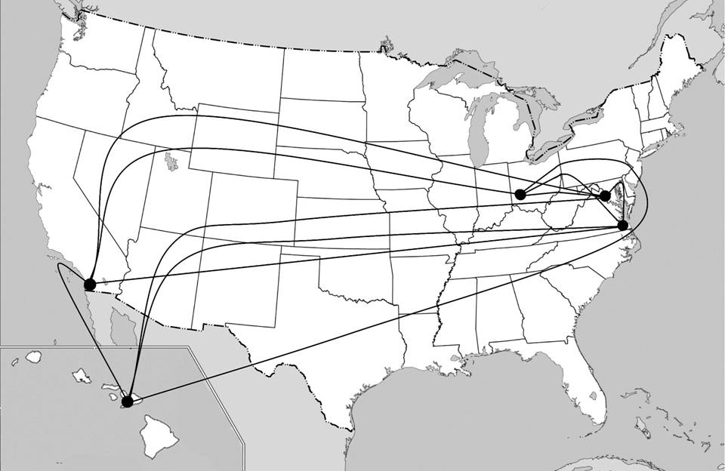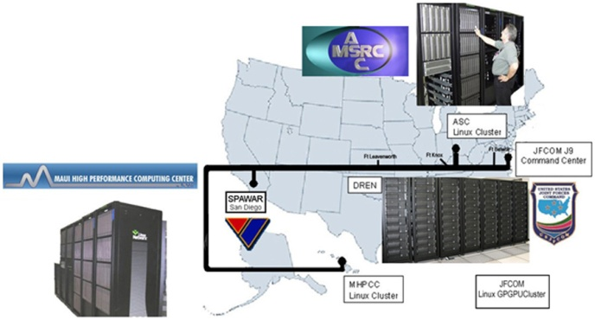

Figure 2 - Advanced Broad Bandwidth Communications Network for Joint Urban Ops and HPCMP
Linux Cluster Meta-Computing for JFCOM Urban Resolve Experiments

In most test settings and in live operations, there are analogous issues: How does a person effectively communicate results, convey intelligence, give direction or conduct analysis within the chain of command? A historical example of this perplexing issue is taken from the middle of World War II. In early June of 1944, Gen. Eisenhower was faced with an almost paralyzingly critical decision: When to launch the invasion of France. Two major parameters were weather and sea-state. Ike had to rely on his chief weather forecaster, Group Captain James M. Stagg, to brief him on this issue. Group Captain Stagg had been in meteorology for two decades and he faced a critical, but not uncommon, conundrum: How to distill twenty years of technical experience down to usable nugget so that a commander under stress could make a rational, or preferably optimal, choice. Thousands, if not tens of thousands of lives depended on making the best decision. The meteorological analysis itself was essentially stochastic; the forecast based on a certain amount of intuition. Group Captain Stagg’s projections were clearly subject to varying degrees of uncertainty. How many words, charts and maps were sufficient to enlighten the decision makers? How many were too many, encumbering the decision makers with data that would clutter their ability to make the best choice.

Staying with operational settings for the moment, John Keegan describes the different styles of order writing of the Duke of Wellington and U.S. Grant, but notes the effectiveness of both. However, General Lew Wallace complains of receiving an ambiguous order from Grant’s messenger at the Battle of Shiloh]. Few would argue that these issues do not remain open and hotly debated: “How does a commander direct his subordinates without confusing them or sapping their initiative?”

Given those operational issues, there is also a need to consider how data are communicated to the test participants, analyzed after the test or demonstrated to the cognizant authorities and how the insights from this evolution could be most effectively communicated to the T&E professional for future enhancements.

The earliest computer-generated simulations were often single platform/vehicle simulators, e.g. cockpit trainers and tank turret mock-ups and were used primarily for training, but occasionally were used for evaluation of both equipment and personnel readiness.

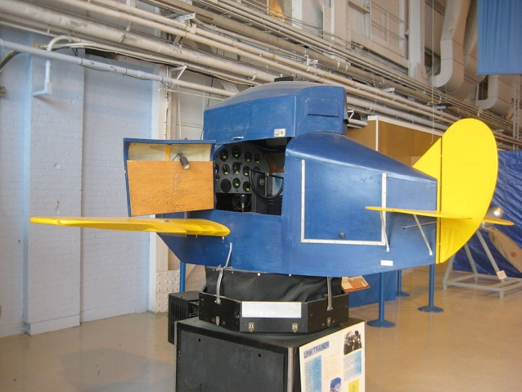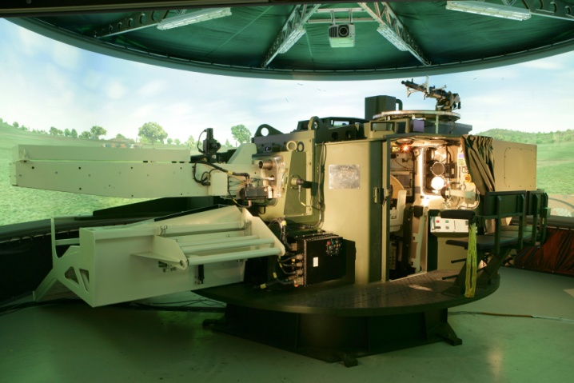

Figure 3 - Link Flight Trainer circa 1943 and KMW Tank Turret Trainer circa 2005 .

Because of the small numbers of trainees, analyses of participant performance, training achievements and equipment design were not too difficult. Late in the 20th century, efforts were made to link many of these individual platforms and “vehicles” together to provide interactive and team training.

This led to a desire to have even more constructive entities available via simulation, an effort in which several of this paper’s authors were intimately involved. Continued pressures for even more entities resulted in the further growth of simulations sizes. These successes of consistently simulating more up to ten million entities created huge amounts of data. A single exercise could easily generate a terabyte of data, even after all “non-essential data” was discarded. Early attempts at visualizing the distilled simulation insights centered on tabularization of the data.
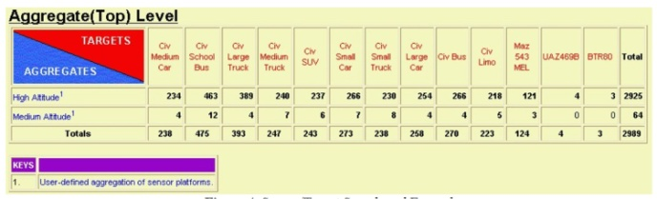
Figure 4 - Sensor Target Scoreboard from
JFCOM Experiment
While this was relatively easily programmed, it fails to convey in a graphic and easily grasped way the salient correlations that are important. Tabular data in particular, require time to contemplate and analyze. This is a luxury that may be available to small-scale simulation analysts and to officers in non-combat environments; however, it presents way too much data for effective analysis of large-scale live or virtual test situations and would of course impose unacceptable burdens on officers experiencing the stress of combat. These hurdles to exploiting these prolific sources of data have been personally experienced by many in the T&E community. While these observations are still anecdotal, they appear to be so pervasive as to warrant the assertion that better visualization is mandated.

Other disciplines have attempted to provide more easily comprehended alternative projections of events in a way that intuitively conveyed the range of futures considered likely. One of these is the creation and dissemination of what is colloquially referred to as meteorological “spaghetti charts” showing the potential paths of dangerous storms.
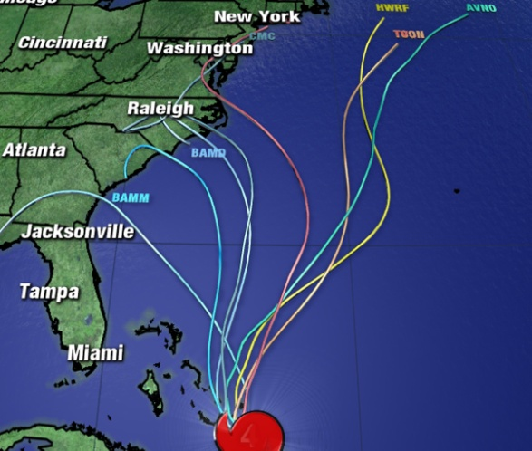
Figure 5 – Hurricane track “Spaghetti Chart”

Challenges

One of the problems with the above type of data visualization is that it does not convey the historical, analytical or individual idiosyncrasies of each of the predicted tracks, something an experienced meteorologist might have developed over decades of professional practice. But, given the existence of such professional expertise, consider again the Stagg/Eisenhower situation. How do the technical experts convey the subtleties of their analyses to the test evaluation authority without abrogating that professional’s function of making the final judgment? Perhaps more importantly, how often should they fully elucidate the issues, but either do not or cannot?

Another challenge is that of presenting the data in structured layers in a way that the evaluators can invoke their own discretion as to how deeply they wish to probe the experts’ analyses. Computers and hyper-text have created easy ways to present written data in printed text with easily selected links to more in-depth data, but even this poses a new challenge: that of deciding which data to put in the original text and which to make accessible via hyper-text links. The non-electronic analog to these issues is the traditional oral briefing by staff officers followed by questions from the briefed senior being the drill-down.

Voice tone and emphasis provide additional ways to convey certainty, importance, and relevance. Text and even computer-generated voice lack these refinements. When test outcomes and program futures are at stake, every communication tool becomes more vital.

A third challenge is in representing multi-dimensional data via electronic means. While there are a number of immersive and 3-D display techniques available in the laboratory setting, the vast majority of analysts and commanders have only two-dimensional flat screens. A common technique is to represent this data in a “3-D format”, but these do not always convey the insights from the material.
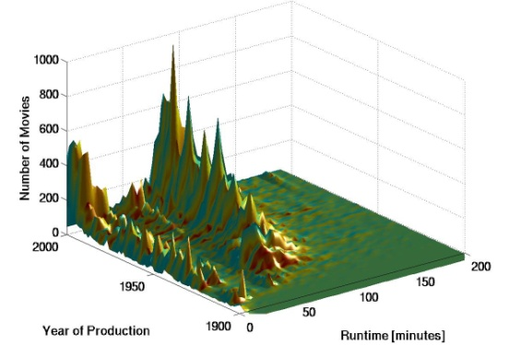
Figure 6 - 3-D Histogram via Mat Lab
In more advanced presentation, this type of chart can be rotated about all three axes for better viewing and analysis. But even on this issue, there often is the need to accurately and cogently represent dimensional data with four or more important dimensions.

Another challenge is the representation of analytic data on imagery or diagrammatic displays of the test environment and equipment features under test and its relation to an active battlespace.

The last challenge to be mentioned here is the one of individualizing content and presentation to the intended recipient. Good teachers, briefers and advocates all tailor their delivery to their audience based on pre-ascertained knowledge as well as observed body-language, attire, questions and other cues. Computers tend to have a unitary approach to communication. Were a user to type in a topic at the Wikipedia search site, that user would get the same article, no matter what the age, education, proclivities or interest. Entering “Quantum Mechanics”: the first sentence reads, “Quantum mechanics (QM, also known as quantum physics, or quantum theory) is a fundamental branch of physics which deals with physical phenomena at nanoscopic scales where the action is on the order of the Planck constant.” There is one other option known to a few: the Simple English Wikipedia, where the same search produces a first line of, “Quantum mechanics (‘QM’) is the part of physics that tells us how the things that make up atoms work.” However, this requires foreknowledge of the choice and an affirmative act on the part of the data seeker. Both are good articles, no doubt, but directed at two different audiences: one comfortable with the Planck constant; one not so much.

Capabilities now exist for a computer analysis of the user and adjustment of the nature of the presentation to match the user’s reaction. Using on computer cameras trained on the user, the system can deter facial expressions, body language and voice quality. Then, adjustments can be made to respond to the user.

Opportunities

In addition to the recognized challenges mentioned above, there are a number of opportunities to dramatically alter the way the information is presented to the T&E community. These are not seen as challenges by most test engineers; they represent a new set of opportunities. Many of them are based on emerging technologies to be discussed below. In any case, they represent a vision of what can now be done to improve test analysis and reduce evaluation errors. The newer tools provide a methodology for direct feedback to the system programmers for visual enhancements that will improve the participants’ analytic capabilities. One very revolutionary technology is Quantum Computing. There are now a few operating quantum computers in the US, one of which is at the University of Southern California’s Information Sciences Institute.
Table 1. Proposed Uses of Quantum Annealing
Data Mgt. | Behaviors | Analysis
Labeling  Images | Extracting Test  Summaries | Creating/ Testing  Hypotheses
Finding  Anomalies or  Correlations | Natural Language | Detecting Imagery  Objects
Correlating  Bio-Informatics | Factor  Analysis of Reports | Verifying  Computer Codes

This last issue (Verifying Computer Codes) is an interesting one that is becoming more and more salient. Lockheed-Martin is faced with debugging and verifying huge computer code bases. Entire systems can be devastated with even one small error. They posit that they will be able to create a unique tool to check and verity the code with the Quantum Annealer. The authors further assert that they are nearing the point of being able to test their Verification and Validation (V&V) system on realistic model examples. That issue will be covered more fully in another paper presented at this conference.

These all raise interesting new avenues research into data visualization. The question is being posed: “Will quantum computing and its output require a new paradigm in data visualization?” Quantum results may require an entirely new way to understand what the computer can produce. With advance data computation and communications, humans already complain they are overwhelmed by the data torrent emerging from high performance Computers (HPC). The authors are closely following the advances by both the USC-Lockheed machine and its sister computer being used by Google. A clear vision has not yet been advanced as to what problems in visualization will be presented and what solutions will be developed.

In another area of development, data visualization based on learning styles is now a possibility. There are two commonly recognized models for learning style differences, one posited by Kolb, the ELM model and one posited by Fleming, the VARK model. Both models contain useful insights into the way humans acquire knowledge. While their work is couched in terms of academic instruction, their insights could be useful both in test and in evaluation.

Another opportunity lies in the area of individual personality differences. Once the test data is encoded, archived and organized, it can easily be retrieved and visualized in a number of ways, depending on the intended use by and impact of the data on the end-user. .Sometimes this will be specified in the contractual documents and sometimes it will depend on the person to be briefed. The questions of some importance will be “Are they risk averse?” or “Are they likely to want to see where the bold can take advantage of a situation?”.

Due to limitations in computing assets and lack of familiarity with artificial intelligence (AI), simulations have heretofore relied largely on the slavish execution of doctrinal direction reissued to the various forces by their senior commanders. This is arguably even more troubling in asymmetric warfare, where there is no established doctrine and the opposing forces intentionally look for ways to circumvent defenses designed for more conventional forces. “Information becomes a weapon and not an enabler, and the Navy {And all of the Department of Defense} must learn how to operate and field systems that allow for maneuvering in cyberspace.” \ In addition, recent findings by the behavioral economists have highlighted the irrational application of reason by ostensibly rational human beings, During one of the large-scale simulations at JFCOM, one of the entity models was exhibiting unexpected and unusual behavior, so there was a discussion about making it behave rationally. At that point, one of the participants, having had some actual combat experience, quipped, “What makes you think humans behave rationally in combat?”

Emerging Technologies

The focus is now on emerging technologies and techniques that may address the challenges and enable exploitation of the opportunities listed. These technologies and techniques are in varying stages of development and acceptance in many different disciplines. They all have been sufficiently validated to warrant a general interest in what they could contribute to the defense of the nation.

Look-ahead simulation

Since the earliest days of battlefield simulation, there have been spirited discussions on the possibility of intelligent agent simulations being so valid and reliable that they could act as good predictors of potential outcomes on the live battlefield. Validity was not formally assessed at that time, but face validity was a bench-mark often applied. With an occasional disconcerting result like a flying tank model or a mark-time-marching deceased soldier avatar, even face validity eluded the simulation team from time to time. As both simulation techniques and computational science improved, the vision of a reliable predictive value from simulations gained credence. One of the efforts to which that led was the DARPA Deep Green initiative. That project was designed to give enhanced views of combat situation awareness for use by commanders.

As the simulations upon which this vision relies are stochastic, there is a highly desirable practice of running the simulation multiple times to observe and record the varying outcomes that are likely. Also impacting the utility of this technique is the issue of creativity of the combatant, as has been previously discussed. Doctrine only goes so far in controlling the actions of warfighters in combat. Some deviate intentionally and some do it mistakenly, but in both cases, the lack of adherence would call into question any simulation that ignores those contingencies.

Quantum computing

One potential solution to the demands of running large-scale simulations for many iterations is the promise of quantum computing. Proposed in early theoretical papers by Nobel Laureate Richard Feynman, the use of quantum phenomena rather than electronic switches would present computer power heretofore unavailable to the computer scientists. Adherents of this approach continue to be enthusiastic, saying things like: “… quantum computers could, in principle, be staggeringly powerful, taking just a few minutes to work out problems that would take an ordinary computer longer than the age of the universe to solve .” One of the features of quantum computing is its ability to assess several alternative states simultaneously.

Recent advances have made the use of this power seem increasingly imminent. The D-Wave Quantum Annealer at the University of Southern California has been stable and productive and the larger machine (around a thousand Qubits) is expected in 2015, at which time some of the potentials of the technology may actually be realized. Many of the classes of problems for which these speed-ups are projected are of interest to the T&E, simulation and intelligence communities.

Even though they are still early in their development, quantum computers have demonstrated significant utility in areas of interest to the topics covered in this paper. There are some areas within the domain of computer generated forces (CGF) that are seen as having the greatest potential for significant advances in the overall performance of CGF systems. As CGF are used in many test scenarios, this line of development should be closely watched. There still is significant work to be done in the development of the quantum computing systems and considerable ground that needs to be covered in both the conceptual approach to programming and in the orderly creation of a programmers’ culture. The authors have seen this evolution in parallel programming for scientific clusters. While it may be several years before significant breakthroughs are readily available to the day-to-day DoD user, early recognition of the revolution this will accrue to the benefit of those who will be prepared for the future.

Causal modeling

A new area of emphasis of potential interest to the T&E community is causal modeling in which the focus is on causal factors, clearly a matter of interest to the product developers, the intelligence analyst and the battlefield commander. The computational aspects of this sub-discipline have been explored and advocated by well-regarded academics. While computationally demanding, the programming paradigm is well described and application to large-scale test data analysis should be straightforward. The benefits that can be expected from this implementation should include a heightened awareness within the analysts of the most important factors in the chain of causality, allowing both assurance of success of the test protocols and suggesting the most efficacious identification of the source of problems.

Behavioral science insights

The fields of behavioral economics and game theory have effectively characterized some hitherto inexplicable reactions of the perception of ground truth. This speaks both to the findings of the analysts and the perception of the end-users.. The behavioral science insights are directly applicable to the accomplishment of the tests themselves, as the test results are relatively meaningless unless the right people understand their import.. One of these is the ability to better realize a projection of human behavior based on even irrational choices, as further discussed below.

Other insights relate to the nature of nascent leadership in groups in which it was observed that leadership rose or fell on the appearance of meeting a societally perceived threat, even after that perception was debunked by subsequent experience. Leaders, once they were seen as failing to rise to a challenge that they personally saw as false, were abandoned by their alarmed followers. Surprisingly, the deposed leader were not reinstated, even after they were proven to be right and more sagacious. The study further showed that in an apparently combative environment, merely rallying two potential combatants to meet a new foe or mustering both sides to achieve a mutual goal could reduce antagonisms. These insights have historical precedents that are analogs, e.g. the rapid a frequent changing of allegiances during the Moorish al-Andalus period in Spain and the Reconquista .

Irrationality analysis

The field of behavioral economics has provided substantiation of irrational behaviors long observed by students of military history; ; and . More saliently, Professor Ariely has focused on the predictability of even this irrationality. This provides an opportunity for behaviors to be observed, characterized and logged in test data analysis, in large-scale simulations, and in actual combat operations. Unhampered by preconceived biases and consistent in analytic objectivity, the computer program can ferret out behavioral trends which would otherwise defy logic and escape serious consideration by humans.

Further, training of test personnel, analysts and commanders alike can help to counteract the tendency to assume that friends and foes will act as anticipated. Care can be, and should be, taken to program systems not to extrapolate observed behaviors into dictates so invariable as to be misleading. Knowing the speed with which armies move, the Germans underestimated the time it would take General Paton to swing his Third Army North and relieve Bastogne. Again, the approach should be to convey the typical, with an additional graphical representation of the physically possible. The analysts and procurement authorities need to be reminded that in the stress of battle, soldiers can do things thought impossible.

Data visualization advances

Presentation of test data using 3D graphics has long been a component of analyzing trial results, a logical and valuable extension of wall charts and numeric tables. Visualizing error and uncertainty is a research topic in scientific visualization that needs to be considered here as well. For example, the volume of data generated in these tests often requires a statistical analysis. When multiple tests are performed and the results vary, statistical analysis is again often needed. These situations allow a calculation of averages, variances and possibly something we could identify as outliers or even errors.

Significant work has been done is visualizing error and uncertainty, and techniques and lessons learned from this research should be applied to 3D visualization of the battlespace. One example would be adding the representation of the uncertainty of weather data to test analyses. For situations such as the use of micro UAVs, where wind speed and direction are important, the weather variability could be displayed not just as an area where the wind speed is less than a particular speed, but add a representation of the uncertainty of that analyzed value.

One of the outstanding figures in computer sciences, Professor Fred Brooks has been a leading researcher in the field for decades. He was the PhD advisor for one of the authors. His review of some advanced techniques is now being implemented for DoD simulation work . Another team, at Brown University, has asserted that three dimensional displays like “caves” can be very useful. Other teams, one just up the road from Fred’s UNC Campus, are more enthusiastic about head mounted and “fish tank” displays with haptic interfaces, all of which have their benefits and constraints. An example of the images and of the equipment used is shown in Figures 7 and 8 .

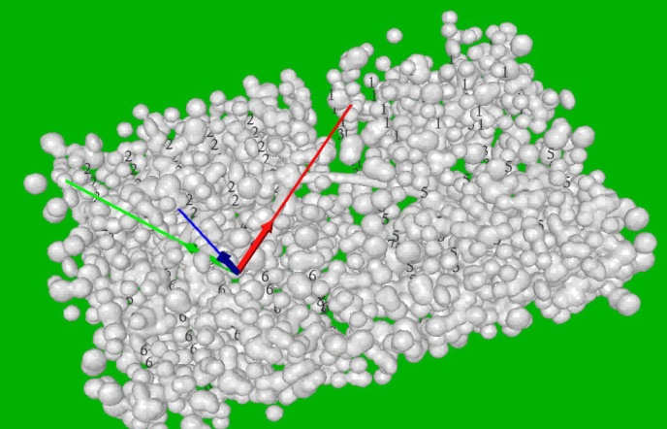
Figure 7 - Right eye image for head mounted display.
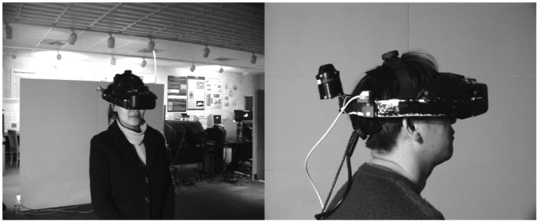
Figure 8 – Head-mounted haptic display. (Now smaller)
The field of visualization continues to grow in both applications and impact. The use of data visualization to help the test personnel and the analyst to better understand and grasp the importance of information so as to make optimal use of abstract and voluminous data, should be enabled by current and emerging technologies. But, as others observe, there is an open challenge here: how to optimally match the visualization approach to the specific issues confronting the T&E personnel who are faced with demanding choices.

Evolutionary Computing

While it has proven very useful in a number of areas, evolutionary or genetic computing is nevertheless very under-utilized in T&E and analysis. Personnel behaviors are typically based on doctrine or observed actions. They usually do not learn, morph, or evolve, which sets them apart from the humans for whom they are avatars. The command structures of most modern armies have been accused of training to fight the “last war,” and the rapid advances in technology make this practice even more dangerous, hence, impermissible. Asymmetric warfare also heightens the hazards of not considering the complete range of possibilities of new strategies and tactics, e.g. flying commercial aircraft into tall buildings. Randomly seeded evolutionary computing may take both the test designer and the analyst down roads they otherwise would never have conceived.

However, there are hurdles to this use. Evolutionary computing is based on treating data that is sparse and behaviors that are spare in order to run the sufficient numbers of iterations to get the benefits of evolution. With tests of complex systems, each sub-system with complex parameters, implementation of evolutionary computing will require thoughtful, innovative and efficient program codes. A prenascent capability that may soon be available is the use of Quantum Computing to enable evolutionary modules to generate entity “learning” in the simulation code base.

Conclusions

Since the history of combat was first written, the fog of what will happen, what is happening and what happened has contributed to the quandary for both commander and historian alike. New generations of sensor, new systems of data management and new channels of communications have often more overwhelmed than assisted in this quest. More for want of will than lack of technology, this condition persists today. The preceding sections have outlined where we were, where we are and where we may go, using the best that technology has to offer.

What certainly is lacking is sufficiency in human factors research, implementation efforts, focus on the warfighter, and careful review. Some technologies are productively implementable as this is written; some are emerging and will need time for testing and evaluation. All will need validation in their use in the test environment and acceptance in the caldron of combat.

In addition to visualizing uncertainty and error, we advocate for battlefield commanders to serve as subject matter experts in tests. In their capacity as experts they would participate in formal user studies to evaluate the effectiveness of a variety of visualization techniques. The results of well designed, formal user studies would provide invaluable insight into the usefulness of various representations of the data including specific events and statistical data collected during the tests.

Using the most advanced visualization to help both analyze and communicate the T&E outputs should facilitate the conformance to V-Model practices. Increasing both the speed and the insightfulness of the findings can go far to bringing the systems engineers vision of project progress to fruition.

PHILIP AMBURN, is an Adjunct Lecturer in the Computer Science Department of the University of Arizona. Earlier, he was a Research Assistant Professor at Mississippi State University and also was an Adjunct Faculty member, Air Force Institute of Technology (AFIT). Then he was the SAIC Forces Modeling and Simulation on-site HPCMP advisor. His research interests are constructive and virtual simulation, interactive 3D graphics, and visualization. A retired Lieutenant Colonel, USAF, Dr. Amburn received his BS degree in Physics from Emporia State University, (formerly Kansas State Teachers College), his Computer Science MS from AFIT, and his Ph.D. from the University of North Carolina, Chapel Hill.

DAN DAVIS is a consultant for the Information Sciences Institute, University of Southern California, focusing on large-scale distributed simulations. There, he led the JESPP project for a decade. As Assistant Director of CACR at Caltech, he managed Synthetic Forces Express, introducing HPC to DoD simulations. He was the Chairman of the Coalition of Academic Supercomputing Centers and has taught at the collegiate level. Dan started writing FORTRAN programs in 1971 on Seymour Cray’s CDC 6500’s. He served in Vietnam as a USMC Cryptologist and retired as a Commander, U.S.N.R. He received B.A. and J.D. degrees from the University of Colorado.

DANIEL P. BURNS is a lifelong Systems Engineer, first with the Active Duty Navy, then SAIC, and small business. He served as Naval Chair and Professor of Practice in Systems Engineering at the Naval Postgraduate School (NPS). Captain Burns served as the as the Military Associate Dean and as acting Dean of the Graduate School of Engineering and Applied Sciences at NPS. His research interests center on analyses of both human and resource utilization in defense efforts. Captain Burns received a BS degree from the US Naval Academy and an MS from the Naval Postgraduate School. He is currently finishing his dissertation for a Ph.D. from Southern Methodist University.

ROBERT F. LUCAS is a Deputy Director of the Information Sciences Institute at the University of Southern California and leads the Computational Sciences Division. He is a Research Associate Professor in the USC Department of Computer Science. At ISI he manages research in computer architectures, VLSI, compilers, and other software tools. Prior to joining ISI, he did tours as the Director of High Performance Computing Research for NERSC, the Deputy Director at DARPA's, and a researcher at the Institute for Defense Analyses. Dr. Lucas earned BS, MS, and PhD degrees in Electrical Engineering from Stanford University.

Clarus Concept of Operations. Publication No. FHWA-JPO-05-072, Federal Highway Administration (FHWA), 2005
P Messina, D. Davis, et al., (1997a) "Synthetic Forces Express: A New Initiative in Scalable Computing for Military Simulations." in the Proceedings of the Simulation Interoperability Workshop, Orlando, March 1997.
D. M. Davis, R. F. Lucas, G. Wagenbreth, D. W. Roberts & C. Brewton, (2010), “The Future Uses for the GPGPU-Enhanced Cluster at JFCOM”, in the Proceedings of the HPCMP Users Group Conference, Schaumburg, Illinois & M. Zyda, M. Spraragen, , Ranganathan, , Arnason, B., & Landwehr, P. (2010). Designing a Massively Multiplayer Online Game/Research Testbed Featuring AI-Driven NPC Communities. In Proceedings of the Sixth AAAI Conference on Artificial Intelligence and Interactive Digital Entertainment. Palo Alto, California
D. Davis, K-T. Yao, R. , Lucas, , Wagenbreth, G. & Gottschalk, T., (2005),"Enabling 1,000,000-Entity Simulations on Distributed Linux Clusters," WSC05-The Winter Simulation Conference, Orlando, Florida.
P.S. Brooks, (2006), “PAINT Program BAA, ProActive INTelliegence”, U.S Air Force Research Laboratory Broad Agency Announcement, BAA-07-01-IFKA, Rome, New York
Cyclocane.com, (2014), “Spaghetti Models from NCAR, Tropical Storm Daniel Track and Intensity”, retrieved from internet on 17 December 2014, from http://www.cyclocane.com/daniel-spaghetti-models/
D-Day Museum, (2014), “Allied and German Casualties on D-Day”, retrieved on 18 December 2014, from http://www.ddaymuseum.co.uk/d-day/d-day-and-the-battle-of-normandy-your-questions-answered#casualities
J. Keegan, (2988), “The Mask of Command”, New York: Viking Press.
U. S. Grant, (1885). “Personal Memoirs”, New York: C.L. Webster, 1885–86 Feynman, R., (1982), "Simulating Physics with Computers", International Journal of Theoretical Physics 21 (6–7): 467–488.
H.E. Lowood, , (2003), “Virtual Reality (VR)”, in the Encyclopædia Britannica, retrieved on 25 December 2014, from http://www.britannica.com/ EBchecked/topic/630181/virtual-reality-VR/253104/Education-and-training & Kraus-Maffei Wegmann (KMW), Turret Trainer, retrieved from internet on 26 December 2014, from: http://www.kmweg.com/home/training-simulation/gunnery-and-combat-training/turret-trainer/product-information.html
P. Messina, , Brunett, S., D. M. Davis, Gottschalk, T., Curkendall, D., & Seigel, H., (1997b) “Distributed Interactive Simulation for Synthetic Forces”, in the Proceedings of the 11th International Parallel Processing Symposium, Geneva, Switzerland.
T. D. Gottschalk, Yao, K-T., Wagenbreth, G. & D. M. Davis M., (2010), “Distributed and Interactive Simulations Operating at Large Scale for Transcontinental Experimentation”, in the Proceedings of the IEEE/ACM Distributed Simulations and Real Time Applications 2010 Conference, Fairfax, Virginia.
K.T. Yao, , Lucas, R. F., Ward, C. E., & Wagenbreth, G., (2009), “Data Analysis for Massively Distributed Simulations”, in the Proceedings of the Interservice/Industry Simulation, Training and Education Conference, Orlando, Florida, 2009
R. J. Graebener , , Rafuse , G., Miller, R. & Yao, K.- T., (2003), “The Road to Successful Joint Experimentation Starts at the Data Collection Trail”, in the Proceedings of the Interservice/Industry Simulation, Training and Education Conference, Orlando, Florida, 2003
Cyclocane.com, (2014), “Spaghetti Models from NCAR, Tropical Storm Daniel Track and Intensity”, retrieved from internet on 17 December 2014, from http://www.cyclocane.com/daniel-spaghetti-models/.
stackOverflow, 2014 Greenland, S. & Brumback, B., (2002), “An overview of relations among causal modeling methods”, International Journal of Epidemiology, 2002; 31(5):1030-1037.
stackOverflow, 2014 Greenland, S. & Brumback, B., (2002), “An overview of relations among causal modeling methods”, International Journal of Epidemiology, 2002; 31(5):1030-1037.
Simple English Wikipedia, (2014), “Quantum mechanics”, Retrieved on:18 December 2014, from http://simple.wikipedia.org/wiki/Quantum_mechanics
ICT, (2015b), Video of Technology for SimCoach. Retrieved on 27 June 2015 from https://youtu.be/iDixyOQYdMA?list=PLBF277FAE78E8CB39
Lockheed-Martin, (2015). . Quantum Computing Approach to V&V of Complex Systems Overview. Retrieved on 06 July 2015 from : http://www.mys5.org/Proceedings/2014/Day_3_S5_2014/2014-S5-Day3-09_Elliott.pdf
D. A. Kolb (1984). “Experiential Learning: experience as the source of learning and development”, Prentice-Hall, Upper Saddle River, New Jersey, USA..
N. Fleming, (2012), “Introduction to VARK”, Retrieved on 16 September 2014, from http://legacy.hazard.kctcs.edu/VARK/introduction.htm .
W. K. Vaneman, and Budka, R. (2013), “Defining a System of Systems Engineering and Integration Approach to Address the Navy's Information Technology Technical Authority”. INCOSE International Symposium, 23: 1202–1214.Keegan, J., (2988), “The Mask of Command”, New York: Viking Press
D. Ariely, (2011), “The Upside of Irrationality: The Unexpected Benefits of Defying Logic”, New York: Harper Perennial,
R.F. Lucas, & D. M. Davis, "Joint Experimentation on Scalable Parallel Processors," (2003), in the Proceedings of the Interservice/Industry Simulation, Training and Education Conference, Orlando, Florida, 2003.
J. Surdu, & Kitka, K., (2008) “Deep Green: Commander’s tool for COA’s Concept”, in the Proceedings of the 2008 Computing, Communications and Control Technology Conference (DDT). Orlando Fl.
R. Feynman, , (1982), "Simulating Physics with Computers", International Journal of Theoretical Physics 21 (6–7): 467–488.
C. C. Lo, & Morton, J. J. L., (2014), “Will Silicon Save Quantum Computing? ”, IEEE Spectrum, Retrieved from the internet on 12 Sep 2014 from: http://spectrum.ieee.org/ semiconductors/materials/will-silicon-save-quantum-computing.
T. Lanting, and Przybysz, A. J. and Smirnov, A. Yu. and Spedalieri, F. M. and Amin, M. H. and Berkley, A. J. and Harris, R. and Altomare, F. and Boixo, S. and Bunyk, P. and Dickson, N. and Enderud, C. and Hilton, J. P. and Hoskinson, E. and Johnson, M. W. and Ladizinsky, E. and Ladizinsky, N. and Neufeld, R. and Oh, T. and Perminov, I. and Rich, C. and Thom, M. C. and Tolkacheva, E. and Uchaikin, S. and Wilson, A. B. and Rose, G., (2014), “Entanglement in a Quantum Annealing Processor”, Physical Review X, 4. 02104 (2014.
R.F. Lucas, Tran, John. J. J., Wagenbreth, G., Pratt, D. & D. M. Davis M. , (2013), “Practical Adiabatic Quantum Computing: Implications for the Simulation Community,” in the Proceedings of the Interservice/Industry Simulation, Training and Education Conference, Orlando, Florida, November, 2013
K. D. Anthony, (2006), “Introduction to causal modeling, Bayesian theory and major Bayesian modeling tools for the intelligence analyst”, USAF National Air and Space Intelligence Center (NASIC), Wright-Paterson Air Force Base, Ohio.
J. Pearl, (2000), “Causality: models, reasoning and inference” (Vol. 29), Cambridge: MIT press.
P.S. Brooks, (2006), “PAINT Program BAA, ProActive INTelliegence”, U.S Air Force Research Laboratory Broad Agency Announcement, BAA-07-01-IFKA, Rome, New York.
D. Ariely, (2008), “Predictably Irrational: The hidden forces that shape our decisions”, New York: Harper Perennial.
O. J. Harvey, White, B. J., Hood, W. R., & Sherif, C. W., (1961), “Intergroup conflict and cooperation: The Robbers Cave experiment” (Vol. 10). Norman, OK: University Book Exchange.
T.F. Glick, , (1979), “Islamic and Christian Spain in the Early Middle Ages: Comparative Perspectives on Social and Cultural Formation”; Princeton University Press, Princeton.
D. Ariely, (2011), “The Upside of Irrationality: The Unexpected Benefits of Defying Logic”, New York: Harper Perennial.
D. Kahneman, , (2011), “Thinking, fast and slow”, New York: Farrar, Straus and Giroux.
M. Gladwell, , (2008), “Outliers: The story of success”, New York: Little, Brown and Co.
Brooks, F. P., Jr., M. Ouh-Young, et al. (1990). Project GROPE - Haptic displays for scientific visualization. Computer Graphics: Proceedings of SIGGRAPH '90, Dallas, Texas.
Demiralp, Cagatay, et al. "Subjective usefulness of CAVE and fish tank VR display systems for a scientific visualization application." Proceedings of the 14th IEEE Visualization 2003 (VIS'03). IEEE Computer Society, 2003. Qi, Wen, et al. "A comparison of immersive HMD, fish tank VR and fish tank with haptics displays for volume visualization." Proceedings of the 3rd Symposium on Applied Perception in Graphics and Visualization. ACM, 2006.
D.P. Tegarden, (1999), “Business Information Visualization”, Communications of AIS, Volume 1, Article 4. Wikipedia, (2014), “Quantum mechanics”, retrieved on 18 December 2014, from http://en.wikipedia.org/wiki/Quantum_mechanics
H. Doleisch, Gasser, M., & Hauser H., (2003), “Inter-active feature specification forcus+context visualization of complex simulation data”, In Proceedings of the 5th Joint IEEE TCVG - EUROGRAPHICS Symposium on Visualization (Vis-Sym 2003), ACM Press,
D. Fogel, (1995), “Evolutionary Computation”, New York: IEEE Press.

