Advanced Technologies to Enable Simulation of
Life-Cycle Sustainment of Weapon Systems

CAPT Daniel P. Burns, USN (Ret.)
Home Ports Solutions, LLC
125 East 44th Street
Savannah GA 314051
831 915-1212
{daniel.p.burns@homeportsolutions.net}

Lynn J. Petersen
Office of Naval Research
875 N Randolph St.
Arlington, VA 22217
703 696-5031
{lynn.j.petersen@navy.mil.}

Jerrrell Stracenor
Southern Methodist University
PO Box 750339
Dallas, TX 75275-0339
214 768-1535
{jerrell@engr.smu.edu}

Ke-Thia Yao
Information Sciences Institute
University of Southern California
4676 Admiralty Way
Marina Del Rey, CA 90292
310 449-9297
{kyao@isi.edu}

Keywords: Markov analysis, martingale analysis, systems engineering, quantum computing, life-cycle sustainment

Abstract: The authors have witnessed and been part of the development of the burgeoning complexities of weapons systems. They have focused some of their research on the need to analyze the life-cycle sustainment of these systems. This sustainment analysis has similarly grown in complexity and sophistication. To be optimally useful, the results and insights from these analyses need to be accessible long before the systems are fielded and before sustainment parameters can be established and sustainment data collected from live implementations. This strongly supports the need to employ both constructive and virtual simulations to provide pre-deployment “experience” with systems. These simulations must be programmed to include the various input and output parameters of the system-engineered sustainment model. The size of modern weapons systems and the wide geographical dispersion of such systems calls for significant computational capabilities; this need is exacerbated by the current focus on simulating operations in large urban areas, fully populated by red, blue and civilian populations, all suitably programmed to act in a demographically appropriate way. Because a major factor of sustainment is maintenance and that maintenance is dramatically impacted by environmental factors, the modeling of these factors, along with verifiable functions representing their impact on hardware and personnel, must be modeled as well. There is a long history of using high performance computing to enable and enhance large-scale simulations and some of the authors have been part of that development process since 1995. Further, new advances in computing now offer to create a new computational paradigm for high performance computing, e.g. the innovations at the University of Southern California, Quantum Computing Center. As Systems Engineering has co-evolved with these computational advances, it has made good use of Markov and martingale analyses, and one of the authors is currently developing a model that relies on this sub-discipline of analysis to better characterize the sustainment of weapons systems. Serendipitously, this line of inquiry is well situated to make excellent use of the quantum annealer at USC, as Markov processes are the foundation of the annealer’s operations, This paper will briefly describe the need for and the current state of the art of sustainment analyses, lay out the need for improved and expanded simulation techniques, and discuss the path to facilitating the implementation these across the entire spectrum of the simulation community. Alternative approaches, interoperability challenges, and future developments will be suggested, outlined and documented.

- Introduction

There is a broadening of the capabilities of simulation for the DoD. Advanced technologies and more sophisticated analytical techniques are expanding the scope of the dual simulation trilogies of modality: Live, Virtual and Constructive and utilization: Training, Evaluation and Analysis. This paper will focus on the needs and possible contributions of the Systems Engineering community, the impact of the parameterization of life-cycle analyses using Markov, Hidden Markov and martingale analyses, and the contributions of the High Performance Computing discipline, most particularly, the emergence of quantum computing as an emerging technology. On-going research and early findings will be reported as they are made available.

  - Background

Since the earliest days of warfare, leaders have sought to understand and prepare for combat through simulations of one kind or another. Early athletics often evolved as competitive test of combat skills in a non-combat arena [1]. Many games such as chess were centered on abstracting and emulating combat [2]. More complex and realistic simulations evolved over the centuries, but they all had in common trying to train people to behave well in combat, trying to see if some new weapon would be effective, or trying to better predict the outcome of an impending operation [3]. Within the professional experience of the authors, simulations have expanded their capabilities along several axes, including: geographical area, resolution of simulated objects, richness of behaviors, duration of simulations, speed of performance (e.g. computer generated constructive simulations can be run at significantly faster than real time), and sophistication of analytic tools to better understand the large amounts of data collected [4]. Many of these advances have been enabled by the use of High Performance Computing (HPC) [5]

  - Current Practice

It has been the authors’ experience that battlefield simulations rarely take heed of system degradation over time and they can think of no occasion when the Systems Engineering parameters surrounding life-cycle sustainment were incorporated into the functions of the simulation code. This impacts all three of the simulation modalities and all three of the uses of simulation in two ways: it makes the simulations less valid and it deprives the Systems Engineers of valuable insights into life-cycle sustainment issues.

- New Approach

Half a page describing how we can marshal capabilities to meet otherwise daunting challenges.

  - Systems engineering and Simulation

One paragraph to half a page on SE

    - Requirements

One or two paragraphs on whar SE needs from simulations

    - Contributions

One or two paragraphs on how S#E can make sims better

    - Application

One or two paragraphs on where this would be helpful

  - Life-Cycle Sustainment Analyses

One or two paragraphs on how SEs look at sustainment

  - Markov Analyses

One or two paragraphs on why Markov is useful

  - Hidden Markov Analyses

One or two paragraphs on how this may be the right model for simulations

  - Martingale Analyses

One or two paragraphs on why this makes better sense

- Early Findings

One or two paragraphs on Burns’ dissertation theses

  - Merging Simulation and Systems engineering

One or two paragraphs on what it would take to better integrate SE and simulation

  - Use of High Performance Computing

Mandates for DoD research closely follow the vagaries international events. The rapidly changing geopolitical environment imposes a rapidly changing research agenda. [6]. The High Performance Computing (HPC) professionals are in the forefront of these groups being impacted by those changes. They are tasked with projecting the future of US weapons, systems, tactics and strategies. Using HPC for battlefield simulation leads to experiments in which warfighters in uniform are staffing the consoles during interactive, HPC-supported simulations. Experiments to model and simulate the complexities of urban warfare use well-validated entity-level simulations, e.g. Joint Semi-Automated Forces (JSAF) and the Simulation of the Location and Attack of Mobile Enemy Missiles (SLAMEM). These need to be run at a scale and resolution adequate for modeling all the convolutions of urban combat.

There is a long lineage of entity-level synthetic battlefield codes. They consist of representations of terrain that are populated with intelligent-agents representing: friendly forces, enemy forces and civilian groups. Experience has shown that to produce their behaviors in at timely manner, significant compute resources are required [7]. Much of this is true because a major computational load is imposed in the performance of line-of-sight calculations between the entities. The inherently onerous “n-squared” growth-characteristics of an all-see-all program have been identified previously [8]. If several thousand entities need to interact with each other in an urban setting with vegetation and buildings obscuring the lines of sight, inter-node communications chaos and failure are often observed. This situation has been successfully ameliorated, but only partially so, by the use of an innovative interest-managed communication’s architecture [9].

Increasingly, DoD simulators required an enhanced Linux clusters of adequate size, power, and configuration to support larger and more sophisticated simulations, especially when there is a requirement for more than 2,000,000 entities within high-resolution insets on a global-scale terrain database. The cluster has been used occasionally to interact with live exercises, but more often has been engaged interactively with users and experimenters while generating only virtual or constructive simulations. [10] It had to be robust to reliably support hundreds of personnel committed to the experiments and it had to be scalable to easily handle small activities as well as larger global-scale experiments with hundreds of live participants, many distributed trans-continentally, as shown in Figure 1 below.

Creating a standing experimentation environment that can respond immediately to DoD time-critical needs for analysis is one of the major, but difficult to achieve, goals. The operators must operate in a distributed fashion over the Defense Research and Engineering Network (DREN), at a scale and level of resolution that allowed dispersed participants to conduct experimentation on issues of concern to combatant commanders, who have participated in the experiments themselves. This provided the requisite simulation federations, software, and networks, joined into one common computer infrastructure that was supporting experiments. Quantitative and qualitative analysis, flexible plug-and-play standards, and the opportunity for diverse organizations to participate in experiments were all mandated by DoD needs.

To order to meet these goals, a team from the Information Sciences of the University of Southern California helped design and develop a scalable simulation code that has been shown capable of modeling more than 1,000,000 entities. This effort is known as the Joint Experimentation on Scalable Parallel Processors (JESPP) project [11]. The dedicated compute power provided additionally allows for the easy identification, collection, and analysis of the voluminous data from these experiments, enabled by the work of Dr. Ke-Thia Yao and his team [12].

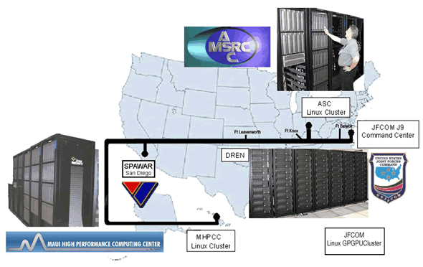
Figure 1
JFCOM’s Experimentation network:
MHPCC, SPAWAR, ASC-MSRC,
TEC/IDA and JFCOM

Even using these powerful computers, the JFCOM experimenters were constrained in a number of dimensions, e.g. number of entities, sophistication of behaviors, realism of various environmental phenomenology, etc. While the scalability of the code would have made the use of larger clusters feasible, a more effective, efficient, economical and elegant solution was sought. The end of the Moore’s Law speed and power improvements decreed that eventually JFCOM would need to seek new ways to deliver their services to increasingly sophisticated users with increasingly complex and geographically diverse conflict environments. One approach is the use of more powerful clusters, especially a GPU-enhanced cluster.

The use of existing DOD simulation codes on advanced Linux clusters operated by JFCOM was the implementation method chosen as being most efficient. This effort supplanted the previous JFCOM J9 DC clusters with a new cluster enhanced with 64-bit CPUs and nVidia 8800 graphics processing units (GPUs). Further, the authors were able to modify a few legacy codes. As noted above, the initial driver for the FMS use of accelerator-enhanced nodes was principally the faster processing of line-of-sight calculations. Envisioning other acceleration targets is easy: physics-based phenomenology, CFD plume dispersion, computational atmospheric chemistry, data analysis, etc. The computer was given the Joshua, the Hebrew commander.

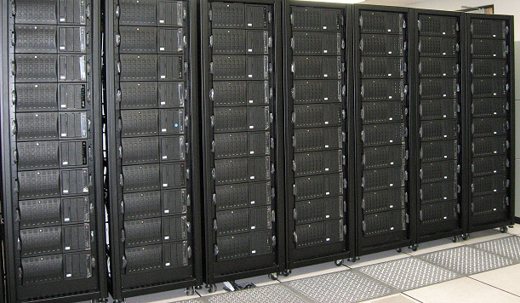

Figure 2
Joshua

While great strides were made in the number of entities to be simulated, the research implications of this achievement, albeit expected, were a dramatic reaffirmation of the value of HPCs. Most notably, on 14 December 2007, the Joint Forces Command Personnel, under the leadership of Rich Williams simulated a full ten million CultureSAF entities on the Baghdad terrain database. This was accomplished as is visualized in Figure 3 below:

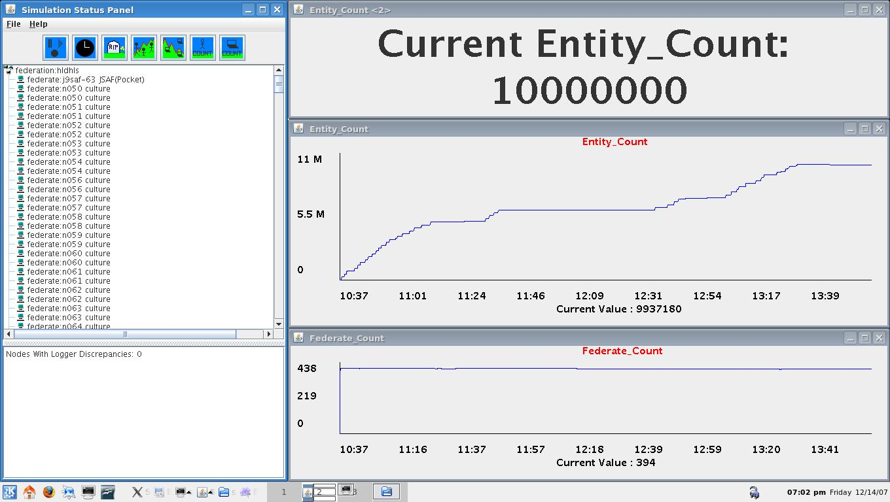

Figure 3
Graph of Entity Count Grow by Time on 14 Dec 07

  - Introduction of Quantum Computing

Members of the simulation community are often seeking new capabilities to enhance their computational power. The growth of transistor density, and the related capability of traditional digital computing, postulated by Moore's Law [13] is approaching its limits asymptotically. Hence the need to more seriously reevaluate new computing paradigms. One of the most often discussed paths is quantum computing and its first practical incarnation, adiabatic quantum annealing [14]. This section focuses on issues of concern to the test and evaluation application developers. It presents an overview of quantum computing, a review of some early work on a D-Wave quantum annealer at the University of Southern California and a discussion of the applicability of this technology to simulation. It is not a learned treatise on the theoretical and mathematical intricacies of quantum computing nor does it advocate some specific resolution of the many issues that arise with the introduction of any new technology. Instead, the authors rely on decades of experience in high performance computing and DoD simulations to offer aid to the test and evaluation community in assessing the potential utility of this advance.

According to Gordon Moore himself, the end of Moore's Law is nigh. It is increasingly daunting to continue on the current transistor-based path for increasing the traditional digital computing capability that can be applied to test and evaluation and other national security challenges. The capability growth of individual processors is stagnating and the number of such cores needed is now increasing exponentially in high performance computing systems. Size and power demands now often constrain the computational power that can be brought to bear on defense problems. In this environment, there is a growing interest in alternatives to commercial, off-the-shelf (COTS) technology, which would have seemed inconceivable for most of the last two decades. In many ways, this may be the reemergence of the purpose built systems of earlier decades. New installations include specialized systems such as the Anton at D. E. Shaw Research [15][16] It performs certain biomolecular simulations nearly two orders-of-magnitude faster than the largest general purpose computers. Others are looking beyond CMOS to exploit other physical phenomenon, e.g. quantum computing.

There has sprung up a considerable body of proffesional interest in Quantum Computing beginning with a ground-breaking paper from the Nobel Laureate Richard Feynman in 1982 [17], in which he said “… with a suitable class of quantum machines you could imitate any quantum system, including the physical world.”. The authors are unaware of any such “general purpose” quantum computer that is even nearing operation. However, a more manageable adiabatic quantum annealing device has been conceived, designed, produced, and delivered to the University of Southern California. Figure 4 shows the D-Wave Two, as installed in the USC – Lockheed Martin Quantum Computing Center (QCC) at the Information Sciences Institute (ISI) in Marina del Rey (ISI, 2015)
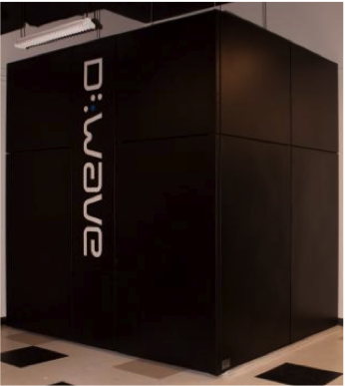

Figure 4
USC QCC D-Wave 2

In recent years, other authors have touted quantum computing’s ability to produce more power, using terms like “magic” to stir the imagination and whet the appetites of the user community. [18]. They point out that the capability of quantum computers arises from the different way they encode information. Digital computers represent information with transistor-based switches having a state of 0 or 1, labeled a bit. In contrast, the basic unit of quantum computer operation, the quantum bit or qubit, can exist simultaneously as 0 and 1, with the probability of each being given by a numerical coefficient, a condition physicists call “superposition”. The quantum computer can act on all these possible states simultaneously.

The authors have witnessed and participated in the development of high performance computing for several decades and have developed a significant body of experience with newly introduced technologies. They were engaged in the very early introduction of parallel computing and aware of its rivalry with sequential computing and with vector computing. They heard the detractors of parallel computing argue the limits of parallelism [19] and the proponents [20] who argued that it could be used more universally. While acknowledging there are many problems that have remained outside of the easily parallelized arena, it is evident that the majority of all large-scale computational problems are now run in parallel. This is due to the application of new techniques to decompose both data and computation in effective ways [21]. Such technology has proven very useful to the simulation community [22] [23] and which may very well have a revolutionary impact as its abilities to resolved currently intractable problems.

The D-Wave Quantum Annealers have demonstrated acceptable evidence that they are operating as a quantum device, but the high levels of performance gains are yet to be achieved were anticipated. This may indicate just the issues that always have arrived with any new technology [24], or it may reflect some fatal flaw in the approach. Current work at USC and at Ames seems likely to resolve this issue in the upcoming months. Nevertheless, it should be remembered that this will not be the general purpose quantum computer envisioned by Feynman, but a quantum annealer, capable of many analytic and optimization analyses of vital interest to the simulation community.

  - Quantum Computing and Markov/Martingale Analyses

Half a page on how QA can enable these anslyses

  - Potential for further Collaboration

One or two paragraphs on what this might mean for community

- Analysis

One or two paragraphs on the need to organize

  - Mapping a Future Course

One or two paragraphs on who and what to engage

  - Understanding the Problems

One or two paragraphs looking at pitfalls and risks

  - Reacting to new Requirements

One or two paragraphs considering new extensibilities

  - Coding Challenges

One or two paragraphs on programmers’ problems

- Conclusions

One or two paragraphs on reiterating the theses

  - Uses of Systems engineering

One or two paragraphs on impact on defense

  - Benefits of Parameterization

One or two paragraphs on why quantification is good

  - Investment Required

One or two paragraphs on cost benefit analysis of idea

- Acknowledgements

Dan M. Davis, formerly of the Information Sciences Institute, University of Southern, California, suggested and contributed several sections of this paper relating to the use of High Performance Computing and Battlefield Simulations. The views expressed in this article are the authors' own and do not necessarily reflect the views of their military organization, their service branch, the Department of Defense, or the U.S. government.

- References

[1] Iacobini, Paul. "Importance Of Theoretical And Scientific Preparation In Combat Sports Training." Marathon 5.2 (2013): 153-160..

[2] Smith, Roger. "The long history of gaming in military training." Simulation & Gaming (2009).

[3] Thompson, Trena N., Meredith B. Carroll, and John E. Deaton. "2 Justification for Use of Simulation." Human factors in simulation and training (2008): 39.

[4] Yao, Ke-Thia, Lucas, R.F., Ward, C E., Wagenbreth, G. and Gottschalk, T.D. "Data analysis for massively distributed simulations." Interservice/Industry Training, Simulation, and Education Conference (I/ITSEC)(2009).

[5] Gottschalk, Thomas D., Yao, K-T., Wagenbreth, G. & Davis, D. M., “Distributed and Interactive Simulations Operating at Large Scale for Transcontinental Experimentation”, in the Proceedings of the IEEE/ACM Distributed Simulations and Real Time Applications 2010 Conference, (2010).

[6] CRA, The Change at DARPA, Computing Research Policy Blog, retrieved from the internet on 13 May 2010 from: http://www.cra.org/
govaffairs/blog/2010/03/the-change-at-darpa/ (2010)

[7] Messina, P. C., Brunett, S., Davis, D. M., Gottschalk, T. D., Distributed Interactive Simulation for Synthetic Forces, In Mapping and Scheduling Systems, International Parallel Processing Symposium, Geneva(1997)

[8] Brunett, S., & Gottschalk, T.D. A Large-scale Meta-computing Framework for the ModSAF Real-time Simulation, Parallel Computing:, V24:1873-1900, Amsterdam (1998)

[9] Barrett, B. & Gottschalk, T.D., , Advanced Message Routing for Scalable Distributed Simulations, in the Proceedings of the Interservice/Industry Training Simulation and Education Conference, Conference, Orlando, Florida (2004)

[10] Ceranowicz, A. & Torpey, M), Adapting to Urban Warfare, Journal of Defense Modeling and Simulation, 2:1, January San Diego, CA, (2005).

[11] Lucas, R., & Davis, D., , Joint Experimentation on Scalable Parallel Processors, 2003 Interservice/Industry Training Simulation and Education Conference, Orlando, FL(2003)

[12] Yao, K-T., Ward, C. & Wagenbreth, G., , Agile Data Logging and Analysis, 2003 Interservice/Industry Training Simulation and Education Conference, Orlando, FL(2006)

[13] Moore, G. E. Cramming More Components onto Integrated Circuits, Electronics, Vol. 38, No. 8. (19 April 1965), pp. 114-117

[14] Anthony, S., , “First Ever Commercial Quantum Computer Now Available for $10 Million,” Extreme Tech Website, (2011) News announcement retrieved from http://www.extremetech.com/computing/84228-first-ever-commercial-quantum-computer-now-available-for-10-million, on 05 May 2015.

[15] Shaw, D.E.; Deneroff, M.M.; Dror, R.O.; Kuskin, J.S.; Larson, R.H.; Salmon, J.K.; Young, D.; Batson, B.; Bowers, K.J.; Chao, J.C.; Eastwood, M.P.; Gagliardo, J.; Grossman, J.P.; Ho, C.R.; Ierardi, D.J.; Kolossváry, I.; Klepeis, J.L.; Layman, T.; McLeavey, C.; Moraes, M.A.; Mueller, R.; Priest, E.C.; Shan, Y.; Spengler, J.; Theobald, M.; Towles, B.; & Wang, S.C.,. "Anton, A Special-Purpose Machine for Molecular Dynamics Simulation". Communications of the ACM (ACM) 51 (7): 91–97(2008)

[16] Shaw, D.E.; Dror, R.O.; Salmon, J.K.; Grossman, J.P.; Mackenzie, K.M.; Bank, J.A.; Young, C.; Deneroff, M, M.; Batson, B.; Bowers, K. J.; Chow, E.; Eastwood, M.P.; Ierardi, D. J.; Klepeis, J. L.; Kuskin, J.S.; Larson, R.H.; Lindorff-Larsen, K.; Maragakis, P.; Moraes, M.A.; Piana, S.; Shan, Y. and Towles, B., "Millisecond-Scale Molecular Dynamics Simulations on Anton," Proceedings of the Conference on High Performance Computing, Networking, Storage and Analysis (SC09), New York, NY: ACM (2009)

[17] Feynman, R. P. “Simulating Physics with Computers,” International Journal of Theoretical Physics, Vol 21, Nos. 6/7, (1981)

[18] Gershenfeld, N. & Chuang, I, “Quantum Computing with Molecules,” Scientific American, (278), pp. 66-71, (1998)

[19] Amdahl, G.M., “Validity of the single-processor approach to achieving large scale computing capabilities,” In AFIPS Conference Proceedings, vol. 30. AFIPS Press, Reston, Va.; pp. 483-485. (1967)

[20] Fox, G., Williams, R.; & Messina, P. “Parallel Computing Works!”, Morgan Kaufman, New York, NY (1994)

[21] Gottschalk, T.; Amburn, P. &Davis, D, "Advanced Message Routing for Scalable Distributed Simulations," The Journal of Defense Modeling and Simulation, San Diego, California, (2005)

[22] Messina, P.; Brunett, S.; Davis, D.; Gottschalk, T.; Curkendall, D.; & Seigel, H. "Distributed Interactive Simulation for Synthetic Forces," in the Proceedings of the 11th International Parallel Processing Symposium, Geneva, Switzerland, April, (1997)

[23] Lucas, R.; & Davis, D.,"Joint Experimentation on Scalable Parallel Processors," in the Proceedings of the Interservice/Industry Simulation, Training and Education Conference, Orlando, Florida, 2003

[23] Christensen, Clayton. The innovator's dilemma: when new technologies cause great firms to fail. Harvard Business Review Press, 2013.

Authors’ Biographies

CAPT Daniel P. Burns, USN (Ret.) is a life-long Systems Engineer first with the Active Duty Navy, then with a Fortune 250 Company and small business as well as in Academia. He formerly served as the Naval Chair and a Professor of Practice in the Department of Systems Engineering at the Naval Postgraduate School (NPS) in Monterey California. He is a Captain in the United States Navy and has served as the as the Military Associate Dean and as acting Dean of the Graduate School of Engineering and Applied Sciences at NPS. For eight years he directed research as a senior executive at SAIC. His research interests center on analyses of both human and resource utilization in defense efforts. Captain Burns received a BS degree from the U.S. Naval Academy and an MS from the Naval Postgraduate School. He is currently finishing his dissertation for a PhD in Systems Engineering from Southern Methodist University.

Lynn J. Petersen manages ONR’s Basic and Applied Research in power electronics, electromagnetism, energy harvesting, wide band gap semiconductor development and reliability, and adaptive and machinery controls. After leaving Active Duty, he affiliated in the Navy Reserve and holds the rank of Captain. He led projects supporting Navy Electric Drive and authored several papers and reports on electrical propulsion, conversion, generation and distribution. In 2002, he became the Deputy to the Submarine Science and Technology Officer. In 2012, He was the Director for Systems Engineering and Policy for the Deputy Assistant Secretary of the Navy. He returned to ONR in 2014. He is a member of the Acquisition Professional Community. Captain Petersen received a B.S. in Mathematics from the U.S. Naval Academy, an M.S. in Mechanical Engineering from the Naval Postgraduate School and is a Systems Engineering PhD candidate at Southern Methodist University

Jerrell T. Stracenor is Professor of Practice and founding Director of the Southern Methodist University (SMU) Systems Engineering Program. He teaches graduate-level courses: probability and statistics, systems reliability and supportability analysis, integrated logistics support (ILS), and supervises PhD students. He is Lead Senior Researcher, Systems Engineering Research Center (SERC). Prior to joining SMU in 2000, Dr. Stracener was employed by LTV/Vought/Northrop Grumman where he conducted and directed systems engineering studies and analysis, and systems reliability and supportability projects and was ILS program manager, on many of the nation’s most advanced military aircraft. Jerrell served in the U.S. Navy and was co-founder and leader of the SAE Reliability, Maintainability and Supportability (RMS) Division (G-11). He is an SAE Fellow and AIAA Associate Fellow. Dr. Stracener earned PhD and MS degrees in Statistics from SMU and a BS in Math from Arlington State College (now the University of Texas at Arlington).
Ke-Thia Yao is a Research Scientist and Project Leader in the University of Southern California Information Sciences Institute, where he leads a section of the JESPP project. That project has the goal of supporting very large-scale distributed military simulation involving millions of entities. He is a widely published author and lecturer on data management and teaches an undergraduate course on the topic at USC. Within the JESPP project he is developing a distributed data management system, the Scalable Data Grid, and a suite of monitoring/logging/analysis tools to help users better understand the computational and behavioral properties of large-scale simulations. He teaches a course in data mining at USC. He received his B.S. degree in EECS from UC Berkeley, and his M.S. nd Ph.D. degrees in Computer Science from Rutgers University.

