The Title Should Be Set in 14 pt Times New Roman, Bold, and Centered [“Title” Style]

[“Author Names” Style]
Anthony A. Adams Barbara B. Brown Acme Associates, Inc.
[“Author Address” Style] 111 Ash Avenue
Anchorage, AK 99508
907-555-1234, 907-555-5678
aadams@acme.com, bbrown@acme.com

Col. Charles C. Cromwell
U.S. Development Command Snowshoe Ridge Outpost Tuluksak, AK 99551
907-555-3456
cromwelc@remote.af.mil

[“Keywords” Style] Keywords:
Times New Roman, 10 pt., and centered.

ABSTRACT: [Apply the “Abstract” Style, and manually Bold and un-italicize the Abstract title by selecting the word “ABSTRACT:” then pressing Ctrl-b, Ctrl-i] This is an example containing instructions for the preparation of the SISO SIW Conference final papers. Please follow these guidelines as closely as possible. Your paper must be submitted electronically to the SISO Conference Web site. The maximum number of pages is twelve. Use of Times New Roman font is strongly encouraged throughout the paper. Abstract text should be typed using 10-point italics, fully justified. Please note the setting of the word “ABSTRACT'' at the beginning of the paragraph (bold, upper case, non-italics). The title, authors, and affiliation, are all centered on the page.

- This is a Section Title [“Heading 1” Style]

[Text is “Normal” Style]

Section Titles should be set in Times New Roman 12- point bold, numbered as shown. Upper case should be used for the first letter of every major word.

Body paragraphs (like this one) should be set in Times New Roman 10-point, and fully justified. Insert one blank line between paragraphs. Do not indent.

  - This is a subsection title [“Heading 2” Style]

Subsection titles should be set in Times New Roman 10- point bold, numbered using decimal notation as shown.

Equations should be set in Times New Roman, 10- point italic, size, and horizontally and vertically centered. A
slightly smaller font may be used for equations, subscripts, and superscripts.

Preferably, figures should be inserted in the text, soon after they are referred to. They may be sided to fit one column, or the full page width, as appropriate to their complexity. The same applies to Tables.

References should be numbered in the order in which they are cited in the text, using numbers in square brackets. For example, see references [1], [2], and [3].

Figures, tables, equations, and references should be cited using decimal notation, such as Figure 1.1.

Please do not number your pages. Include your assigned paper number in the file name (e.g., 06F-SIW-001.pdf)

Reminder

The electronic version of your paper must be submitted via the SISO SIW Conference Web page by the date indicated above.

References

References should be set using “hanging indents,” as shown [Apply the Reference Text Style, which includes numbering]:

[1] A. Author(s) name(s): “This is the Title of the Paper” Journal Name, Vol. 39, pp. 531-548, July 1992.

[2] A. Author(s) name(s): “This is the Book Chapter Title” Book Title, McGraw-Hill, New York 1990.

[3] More Author(s) name(s): Book Title, Peter Peregrinus, London 1992.

Author Biographies

This section of the paper should contain a brief one- paragraph biographical sketch of each author. The section heading is Author Biography, or Author Biographies, and is not numbered. Start the paragraph devoted to each author by typing the author’s name, without indentation, in boldface FULL CAPITALS. If there are multiple authors, separate each biography by one blank line. For example:

PAMELA BLECHINGER is an Operations Research Analyst at the TRADOC Analysis Center, Ft. Leavenworth, KS. She is the analytical user representative for ModSAF development activities and wrote the original Authors’ Guide for the first SISO Simulation Interoperability Workshop (SIW).

[Manually bold the author’s name in this section.]

Other headings

    - Heading 3

[Headings 3-9 are not specified, and were configured as Times New Roman 10 pt, Regular font, legal-numbered.]

Table 3.1. [“Caption Table” Style].

Column 1 | Column 2 | Column 3
[“Table column Heading” Style]
1.1 | 2.1 | 3.1
1.2 | 2.2 | 3.2
1.3 | 2.3 | 3.3
[“Table Text” Style]

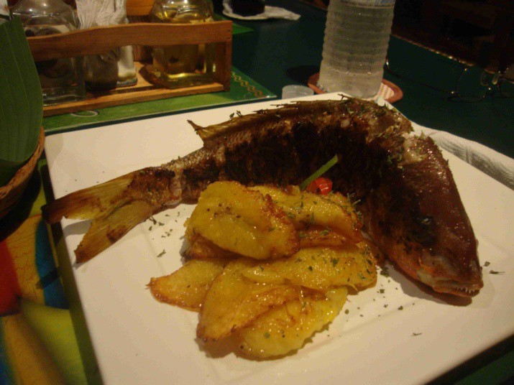
[“Graphic Inline” Style]

Figure 3.1. [“Caption Figure” style].

2 + 2 = 4 [“Equation” Style]

Editorial Guidelines

◊ Balance and circumspection. Write the paper as if you are addressing a diverse group of colleagues. Strive for accuracy and clarity above all else. Acknowledge the possibility that other viewpoints may exist.

◊ Readability. The paper should have a clear structure and useful graphics. It should be concise and clear. Use the introductory paragraph to clearly state the objectives and motivation for writing the paper. The introduction should provide a context for the discussion in the body of the paper. The concluding paragraph should provide a neat summary of the main discussion of the paper.

◊ Paper discussion. Statements of fact should be supported by appropriate research or data. Unsupported assertions should be clearly labeled as hypotheses.

◊ Usefulness. The subject matter of the paper should be directly applicable to the SISO community. When using a narrow case to extrapolate a broader point, it must be clear that the abstract problem space may not be completely covered.

◊ Originality of material. Any material that has been provided by a previous author, or been published in another source, must be referenced and acknowledged. Footnotes and the use of an adequate bibliography is not optional in cases where the author is borrowing concepts or ideas from another source.

◊ Audience focus. You should clearly identify and address your chosen audience. Do not attempt to address both technicians and Program Managers simultaneously.

◊ Writing style. To achieve an effective writing style, you should follow certain basic rules. Write simply, using an active voice. Use simple phrases and avoid long sentences. The main objective is to effectively communicate your ideas to your audience.

Guidelines for Authors of Papers Selected for Form al Presentation

Authors will be notified of the Conference Committee’s decisions regarding publication and presentation of their paper after the electronic version of the paper is submitted to the web site on 17 June 2015.

Some authors will be notified that their paper was selected to be published, but not to be presented, due to conference time and space constraints (Publish, No Presentation). The recommended format for all presentations is Microsoft PowerPoint. You are
welcome to the use PowerPoint template for your presentation that is posted on the SISO Web site at http://www.sisostds.org/Workshops/UpcomingWorkshops/2015FallSIW.aspx (note: you are not required to use this template). Authors are encouraged to submit their PowerPoint Presentation by 14 August 2015 so that the presentations can be checked using the actual projection system.

AUTHOR WORKSHOP ATTENDANCE: All
workshop attendees are expected to pay the appropriate registration fee. At least one of the authors of each accepted paper must register (and pay the appropriate registration fee) for the Workshop, even if none of the authors plans to attend the workshop. Contact the 2015 Fall SIW manager at markmccall@sisostds.org if you have any questions.

PREPARATION: The Conference Committee appreciates your taking the time to prepare a paper and presentation for this Workshop. Quality expectation levels are high at the Workshop, and the attendees expect a first-rate presentation. If you do not properly prepare your presentation, you will be shortchanging yourself as well as your audience.

KNOW YOUR AUDIENCE: Establish a frame of reference for your audience, using what you know about who your audience will be. For example, if you are presenting a paper about the Federation Development Process to the Analysis Forum, they may be more interested in discussions of data collection than training applications.

SUMMARIZE YOUR MAIN POINTS: Your
audience cannot absorb every detail of your paper in the 20-25 minutes you will have available. Stress the principal concepts and approaches rather than the details, which should be used to underscore the main ideas.

TIME ALLOCATION: You should spend the most time in your presentation on the most important topics. The majority of presentations are allotted a 30 minute time frame.

CONTENT: Use abbreviations sparingly and be sure to define them during your presentation. Do not use terms that may be unfamiliar to your audience. Don’t insult your audience by reading the slide to them. You may assume that all of the attendees at the conference can read for themselves.

QUALITATIVE INSIGHTS: An exhaustive presentation of tables of data will not communicate your ideas as well as fully supported qualitative insights.

AUDIENCE INTEREST: Your audience’s interest will peak at the beginning and end of your presentation. Use this knowledge to underscore major points at the beginning of your presentation and to emphasize important points during the conclusion.

SLIDES: Evaluate the quality of your slides by reviewing them in sequence and determining if your major themes are covered with no spoken words. Your audience will be absorbing your presentation through both sight and sound, and neither the spoken word nor slides alone will carry your message. Also, have a good reason for showing each slide. Endless streams of data on table after table is better represented on a single slide that communicates the important data values.

READABILITY: In a large room, letters less than 24 pt are difficult to read. 20 pt may be acceptable in a smaller room. Use a simple, plain background. Black letters on a white background should be the norm. Dark blue or dark red letters may be used sparingly for variety and/or emphasis.

RELATIONSHIPS TO OTHER WORK: Credit
other authors and presenters when your ideas and insights are supportive of others. Likewise, if your ideas differ from others, acknowledge that, too.

COPYRIGHT: Permission is granted to SISO members and sponsors to quote any of the material herein, or to make copies thereof, for personal or internal organizational purposes, as long as proper attribution is made and this copyright notice is included. All other uses, including resale and/or redistribution for commercial purposes, are prohibited without written permission from SISO, Inc.
PRACTICE YOUR PRESENTATION: Practice
your talk, but do not try to memorize it. If you read your presentation directly from a script, the spontaneity will be lost. Consider your presentation to be a talk with your audience, rather than a scripted oration. Again, focus on emphasizing your most important points.

Please be sure to bring an electronic copy of your presentation with you on site.

COMPUTER EQUIPMENT: Each room will have a screen, projector, and laptop computer. Each laptop will have a CD ROM, floppy drive. The following software will be pre-loaded onto each of the laptops:

      - Windows 2007 /Office 10
      - Quick Time
      - Real Player
      - Media Player

Please contact the 2015 Fall SIW manager at markmccall@sisostds.org if you have any hardware/software questions or special requests.

NO EXCUSES: Excuses are a turn-off to the audience. They are not interested in why you are not well organized, or why your slides are too dark, or how sick you are today. You automatically lose credibility when you present to the audience a reason to discount your work.

BEST WISHES: These guidelines are meant to assist you in presenting your paper in the best way. Good Luck!

