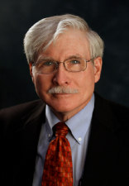
Jerrell Stracener is Professor of Practice and founding Director of the Southern Methodist University (SMU) Systems Engineering Program. He teaches graduate-level courses in engineering probability and statistics, systems reliability and supportability analysis, integrated logistics support (ILS), and supervises PhD student research. He is the SMU Lead Senior Researcher in the U.S. DoD-sponsored Systems Engineering Research Center (SERC). Prior to joining SMU full time in January 2000, Dr. Stracener was employed by LTV/Vought/Northrop Grumman where he conducted and directed systems engineering studies and analysis, and systems reliability and supportability projects and was ILS program manager, on many of the nation’s most advanced military aircraft. Jerrell served in the U.S. Navy and was co-founder and leader of the SAE Reliability, Maintainability and Supportability (RMS) Division (G-11). He is an SAE Fellow and AIAA Associate Fellow. Dr. Stracener earned PhD and MS degrees in Statistics from SMU and a BS in Math from Arlington State College (now the University of Texas at Arlington)

