SMU PhD Topic

A Methodology for Sustainment in Assessing Critical Defense Systems.

Blanchard on Sustainment….3 papers.
SMU PhD Dissertation Materials

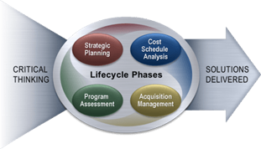

Alterations
- Put requirements to the left.
- Sustainment in middle or right
- Critical Thinking on bottom of the Circle

