Patent Law and Defense Technology:
Original Intent and Current Practice

Mark C. Davis | Douglas W. Robinson | Nicholas J. Kaimakis & Dan M. Davis
Computer Engineer | Lenovo Group Ltd. | University of Southern California
Mooresville, North Carolina | Morrisville, North Carolina | Los Angeles, California
davismc@ieee.org | drobinson1@lenovo.com | kaimakis@usc.edu & dmdavis@acm.org

ABSTRACT

The protection of inventions and other intellectual property (IP) is provided for in Article I of the U.S. Constitution, but the passage of time and the evolution of society has clouded the original goals and obfuscated the vision of promoting progress. Using diverse points of view, the authors present the history and the current impact of the patent system on the development and deployment of technology, especially as these relate to national defense issues. This paper begins with a quick review of the inherent need for the protection of IP, the founders’ intent, and the ways in which the legal processes have altered over the decades. They justify their assertion that not all of these changes have been salutary and discuss times when they have become impediments to or destructive of progress. Some feel that protection of the lone inventor has given way to providing weapons for organized interlopers and requiring defensive tactics by large corporations. Patent grants have exploded to unimaginable levels. Data will be presented on the number and complexity of patents. The paper will follow that with an analysis of the pressures that have caused that drift from the original goals. There is a review of thought concerning the current practice and future changes to encourage creative endeavors from the point of view of legal, technical and academic participants. A brief outline is given of international issues and the impact of various countries’ approach to this problem and steps that the U.S. might take to enhance the rule of law and the global protection of IP. This is discussed in relation to its being necessary for a strong defense environment for the nation and its allies. The paper closes with possible areas of future change.

ABOUT THE AUTHORS
Mark C. Davis, Ph.D. is currently retired after careers in the US Navy and as a computer design engineer for both IBM and Lenovo. Rising to the level of Distinguished Engineer at Lenovo, he was responsible for the design of laptop computer cross-disciplinary technology, including PC architecture, imbedded systems, open source and virtualization. Previously he worked with IBM in the areas of software development and the architecture involved with security, storage and virtualization. Dr. Davis has been granted over fifty patents that were filed during his service at both companies. He is a graduate of the Duke University NROTC program and was commissioned as an Ensign, then attended nuclear power school, and served as a Submarine Officer for twelve years before leaving the service as a Lieutenant Commander to pursue a PhD. Mark holds a BSEE degree from Duke University and a PhD in Computer Science from the University of North Carolina, where his advisor was Professor Fredrick P. Books.
Douglas W. Robinson is the Executive Director of Patent Prosecution at the Lenovo Group Ltd. Lenovo is one of the world’s largest computer manufacturers. Prior to that he was Corporate Counsel for Infineon Technologies North America Corp. Previously he was a partner in Banner & Witcoff, Ltd., an IP law firm in Raleigh, North Carolina. During his academic years and for the three decades since, his entire career has been focused on patent law. He holds a number of computer software patents in his own name. Mr. Robinson received a BSEE degree from the Rensselaer Polytechnic Institute in Troy New York and a JD Degree from the Benjamin N. Cardozo School of Law, Yeshiva University in New York City.
Dan M. Davis is a consultant for the Institute for Creative Technologies, University of Southern California, focusing on large-scale distributed DoD simulations. Before retiring, he was the Director of the JESPP project at USC for a decade. As the Assistant Director of the Center for Advanced Computing Research at Caltech, he managed Synthetic Forces Express, bringing HPC to DoD simulations. He also served at the Maui High Performance Computing Center as the Director of Contracts and Finance and at the Jet Propulsion Laboratory and Martin Marietta. He has served as the Chairman of the Coalition of Academic Supercomputing Centers and has taught at the undergraduate and graduate levels. As early as 1971, Dan was writing programs in FORTRAN on one of Seymour Cray’s CDC 6500’s. He saw duty in Vietnam as a USMC Cryptologist and retired as a Commander, Cryptologic Specialty, U.S.N.R. He received B.A. and J.D. degrees from the University of Colorado in Boulder.
Nicholas J. Kaimakis is active in research at the Institute for Creative Technologies of the University of Southern California. His current research thrusts are in the use of computer generated avatars or video clips, animated and directed by natural language optimized Artificial Intelligence (A/I) programs that present a life-like dialogue capability to interact with remote users via the internet. His current project is funded by the U.S. Navy and is designed to help improve knowledge of STEM fields across varied demographics, with the development of an interactive interface that makes STEM information more accessible on-line. He is an undergraduate student studying Computer Science within the Viterbi School of Engineering at the University of Southern California.

Patent Law and Defense Technology:
Original Intent and Current Practice

Douglas W. Robinson | Mark C. Davis | Nicholas J. Kaimakis & Dan M. Davis
Lenovo Group Ltd. | Computer Engineer | University of Southern California
Morrisville, North Carolina | Mooresville, North Carolina | Los Angeles, California
drobinson1@lenovo.com | davismc@ieee.org | kaimakis@usc.edu & dmdavis@acm.org

Introduction

Paper Organization

This paper describes the need for the protection of intellectual property, the ways in which this protection is vital to defense efforts and the ways the decades have eroded the original intent of the framers of the U.S. Constitution. Then potential effects on the defense posture of the nation and potential changes in the future are discussed. Supporting references are introduced at the appropriate times to support the authors’ assertions and provide opportunities for further information for those interested. The paper does not aspire to be a learned legal treatise submitted to a law journal or legal advice, but is offered as a guide to the warfighter, defense manager and researcher as an introduction to a critical, but often overlooked, issue in the assessment of the strengths and weaknesses of the nation and its allies. In the interest of readability, the authors have cited important cases by referencing academic articles discussing their importance vice case law.

History

The need for protection of an inventor’s right to control his own product has been recognized for centuries. Solid documentary evidence that the Venetians of the renaissance sought and received such protection from the ruling Senate of Venice in the mid fifteenth century (Ladas, 1975) and some say that evidence exists of such a right as far back as classical Greece. The basic concept was one of fairness: a person should be able to enjoy the fruits of their own labor, be it a harvest from their own field or the product of their own mind. Several ancillary purposes evolved, and not without abuse and controversy, over the intervening three centuries when the U.S. Constitution declared in Article I, Section 8, Clause 8 that the Congress had the power to grant protection.

Figure 1 – Article I, Section 8, Clause 9: “To promote the Progress of Science and useful Arts, by securing for limited Times to Authors and Inventors the exclusive Right to their respective Writings and Discoveries;”
A second goal of patent protection for innovators was the encouragement of that creative process. More than just being fair to the individual, the mercantile societies in Italy and Great Britain saw a societal good in encouraging innovation and the increase in trade that would bring, all adding to the power of the state. A third rationale of the early patent systems was to disseminate the new technologies throughout the realm and not have them be kept secret behind the doors of a guild hall. So, the bargain that was struck was the sovereign would protect the inventor for a short period of years and grant unto him the absolute monopoly over the use and sale of this technology, but the price required was the full disclosure of the technology so that, after the termination of the protected period, the knowledge would become public property and available to all. This had the desired effect on the commerce of the glass blowers of Venice and the clock makers of Great Britain. This was the state of affairs when the founders of the United States penned the words above.

The first statute was passed by Congress: The Patent Act of 1790. Thomas Jefferson was one of the first commissioners on the U.S. Patent Board, because the act delegated these duties to a board made up of the Secretary of State, Secretary of War and the Attorney General. The costs of these early filings have been calculated to be on the order of $200 in 2017 dollars. The application process often required an examination determining the usefulness and the lack of prior knowledge or use of the subject of the patent. All this was onerous upon both the patentee and the commissioners, who had other pressing duties. In the first three years, only sixty-one patents were issued, none was of particular note. A subsequent fire destroyed virtually all of the supporting documentation, so all that is known of these first patents is their titles, hence, their general subject matter.
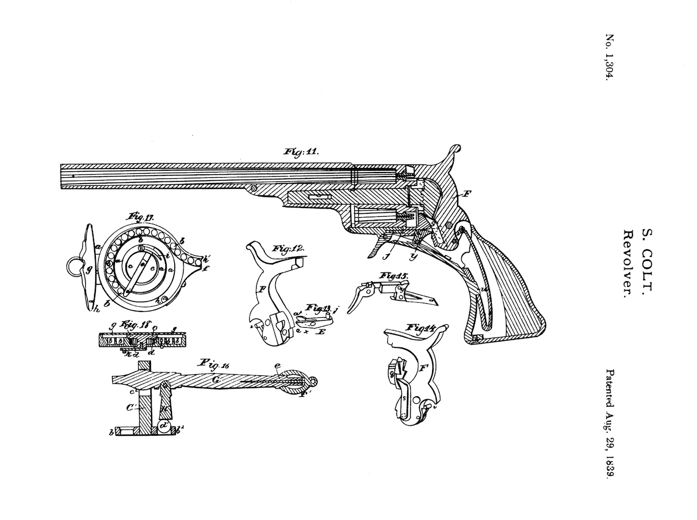
Figure 2 – Patent drawing for the Colt Paterson, USPTO drawing.
The weaknesses of the first act led to the passage of the more detailed Patent Act of 1793. Among other things, this act called for more specificity in the patent description, stream-lined the examination process and established the criteria for application that is still in use today. The Secretary of War was no longer involved and Secretary of State and the Attorney General were given more specific duties. This act was the law of the land for four decades. Despite a growing bureaucracy of patent experts in the Secretary of State’s Department, the Secretary was hard-pressed to keep up with the ten thousand patents issued over the life of this Act, an increase in volume of about 15 times. This increase reflects the onset of the industrial revolution. Eli Whitney’s cotton gin was granted a patent under this new regime. Also, one of many 19th century firearms patents was granted to a Samuel Colt for a revolving side arm, see Figure 2. These weapons were popular in the upcoming Civil War.
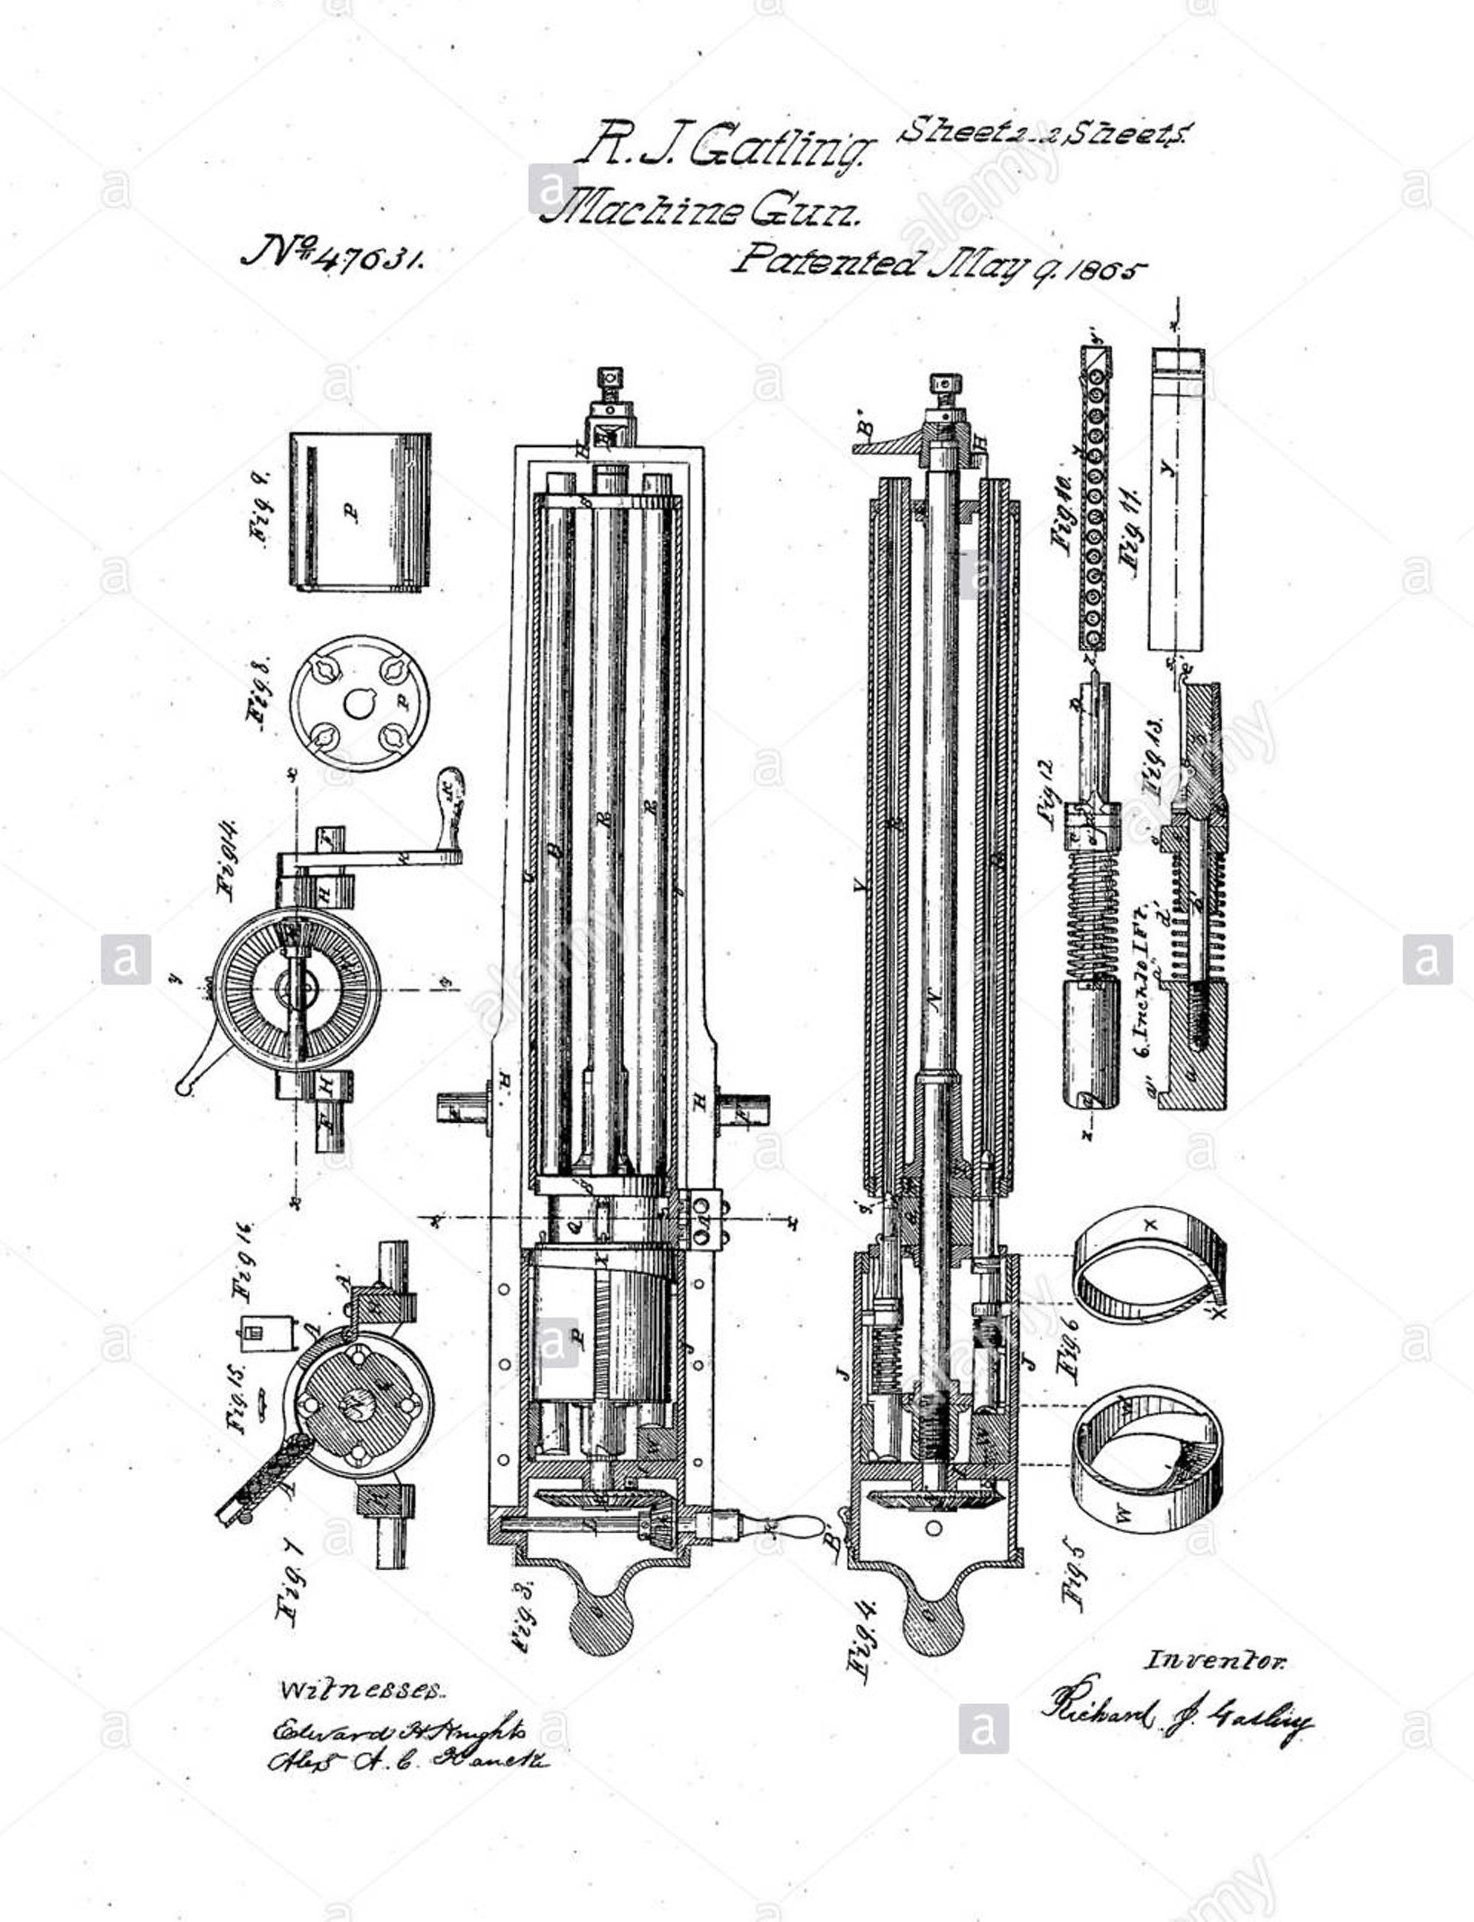
Figure 3 – Dr. Richard Gatling’s famous gun, patented in the last year of the Civil War, 1865. USPTO Drawing.
The Patent Act of 1836 was largely organizational, establishing the Patent Office within the State Department to relieve the over-burdened Secretary of these duties. Bureaucratic enhancement enabled the doubling of patents at a fortuitous time, as this was the heart of the industrial revolution. Under this act, John Ericson patented 40 new inventions to be used in the USS Monitor, a presage of the move from single device patents e.g. the cotton gin, to the tens of thousands of patent applications that may be generated by a new car design today. A doctor from North Carolina named Richard Gatling developed a way to manually fire a rotating series of rifle barrels in order to lay down a rain of fire upon the enemy. His weapon required a series of patents, a drawing for one of which is shown in Figure 3 on the left. In 1849, the Patent Office was transferred to the Interior Department. In 1925, it was moved to its home today, the Department of Commerce. The volume of patent applications continued to rise throughout the 19th Century. See Figure 4.

Another harbinger of a shift in the patent environment came early in the 20th Century. Daimler and Benz in Europe led the move to automobile transportation. However, an auto pioneer did not secure a U.S. patent, but rather a patent lawyer, George Selden, who had never put a working automobile into production. He had a patent granted early in 1895 for the use of a two-stroke engine, which he had seen at a Philadelphia Exposition, on four-wheel drive vehicles. When his later foray into electric cars failed, he turned to using his patent as a revenue source, seeking to get all the productive automobile manufacturers to pay him a royalty. This went fairly well for him and his Association of Licensed Automobile Manufacturers until they ran into the entrepreneurial innovation and obstinacy of Henry Ford. He could not absorb the fees that were being paid by the custom car builders. Ford persisted. When taken to court, prevailed at the Appellate Court level on a basis that did not refer to the issue of the issue of Mr. Selden’s contribution of Mr. Selden to technology. It rested on the fact that his two-stroke design was not the same as Ford’s, and virtually all others’, four-stroke designs. (Byers, 1940) However, the fact that Mr. Selden was not a manifest contributor to the automobile revolution was a sub-text of the case. During the trial itself, the Ford attorney, gesticulated out the window and said, “I see Studebakers; I see Cadillacs; I see a lot of Fords, but I don’t see a single Selden!”. The numbers of patent applications and grants continued to rise. By 1870, the number of patents had broken one hundred thousand, and by 1911, a million had been issued. There were a number of changes made, both to the underlying law and to the organizations itself, over the decades, but the next Patent Act was not passed until 1952.

The Patent Act of 1952 established the U.S. Patent and Trademark Office (USPTO) and further defined and streamlined the processes for seeking and enforcing a patent. Much of the litigation concerning patents is now handled at the level of administrative law hearings before panels of Patent Law Judges and Appeals from U.S. District Court cases are now heard by the U.S. Court of Appeals for the Federal Circuit (CAFC), whose judges are appointed as being more technically proficient and well-practiced in patent law than the other circuit benches.
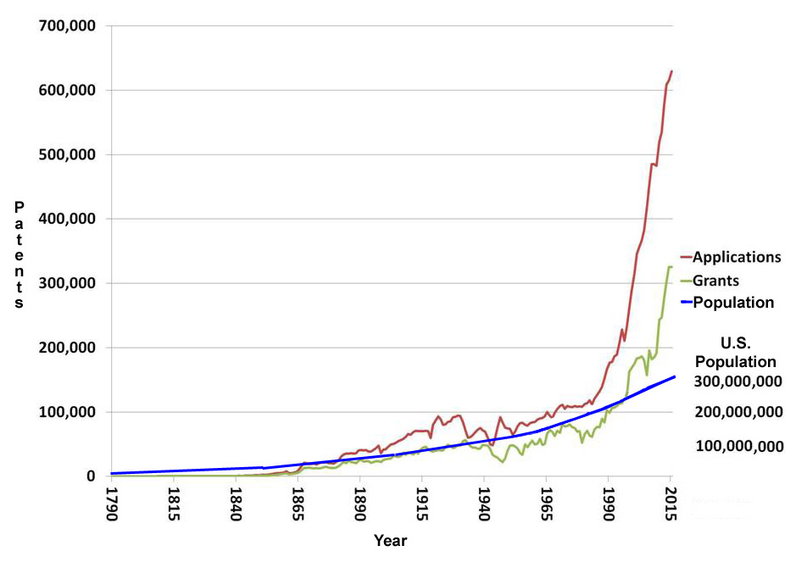Figure 4 - Graph of Patents and Population by Year
based on USPTO data (USPTO, 2017)

The number of patents granted and the number of applications filed continues to grow at rates that are hard to conceive. The growth of patents seems to have been understandable up until about 1980, growing at about the same pace as the population, as is represented in Figure 4. There are a number of reasons explain this dramatic increase (~3 fold) could have happened.in patients from 1980 to the present. One author, an economist, asserted that the increase could be ascribed to the creation of the CAFC, the statutory and judicial strengthening of patentee rights, and the expansion of the disciplines amenable to patenting. (Hall, 2009)

The latter part of the 20th century saw the re-emergence of the old Gatling concept, now driven by high-speed electric motors and requiring a specialized locking and feed mechanism. Commonly known as the Vulcan weapon system it was used for a range on purposes from anti-personnel to anti cruise missiles. One of the patents granted is represented in Figure 5 to the left. One other possible reason that this increase in patents is the result of the onset of the information age and the concomitant acceleration of technological innovation. Good data supports that theory. (Nonaka & Nishiguchi, 2001) Another possible explanation is that the entire rationale for filing a patent has changed. The protection of the rights of an inventor is now significantly altered by the fact that the pace of invention often means that the patent becomes meaningless long before the duration of the protection is terminated. A new technology today is not like the cotton gin, that will be used, basically unaltered for decades. Technological breakthroughs are both ephemeral, as they are often over-shadowed by subsequent advances doing the same thing, and they are often easily cloned in a way that makes the new invention enough different to escape the protective powers of a patent (echoes of the Ford/Selden two stroke/four stroke dichotomy). Often, they are often better protected by industrial secrecy. Therefore, some now argue that the vast majority of patents are filed for defensive purposes. This view comports with the author’s personal experience. If one has a new process or approach that is patentable, then one is prudent to file such a patent to maintain an upper hand over those who might recognize that patentability and file their own patent, followed by a claim for royalties from the true originator for all items sold using that technology. These opportunists have become known as “patent trolls.” More polite language designates them as “non-practicing entities.”
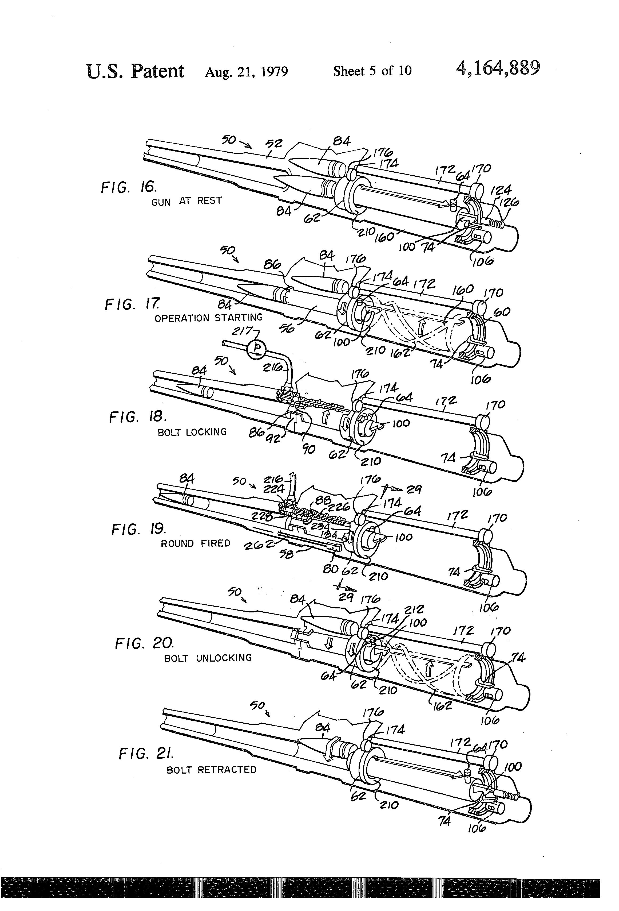
Figure 5 – A detail of the barrel and chamber design for the Vulcan weapons systems. USPTO Drawing

One of the major reasons for this self-protection activity is the increasingly heavy burden of virtually any law suit. There is a high cost incurred, whether it is in the loss of revenue due to a patent troll prevailing with an exploitive patent, in the cost of successfully defending against such a suit, or in the cost of filing an unproductive excess of patents, just to prevent such a legal assault. It is finally that public that must bear that cost. This misallocation of the nation’s resources is a critical issue, but not the focus of this paper. It is articulated here so as to identify what pressures are being brought to bear on the intellectual property system in this country and may have a future impact on the defensive posture of the nation.

To bring the situation up to date, one should refer to the many attempts at patent reforms over the last few years. The most promising was the activity on HR 2795 in 2009. Some form of this bill got by both houses, but then it died in committee. Its reforms seem to the authors to be more organizational than paradigm-shifting. Some of its provisions would have adopted the implementation provisions moving the “first to invent” standard to “first to file”, elimination of the subjective “best mode” requirement, requirement of a duty of openness and good faith on patent litigants, constraints on the scope of willful infringement, limits on patentees’ ability to obtain injunctions, authorization to regulate continuation applications, establishment of a new post-grant opposition system, and allowance of members of the public to introduce new information.

In 2011, the Leahy-Smith America Invents Act was passed by both houses of Congress and signed by President Obama (Act, 2011). This act contains some significant movement toward the first-to-file standard, As the name implies, it had bipartisan support (Patrick Leahy, D-Vermont and Lamar Smith R-Texas) and was in many ways similar to the aforementioned Patent Reform Act of 2009 (Bui, 2016). While lauding its attempts at reform, the authors hold that it does not address many of the defense-critical changes they see as desirable. One of the targets of the reform was the inhibition of patent monetization firms, previously referred to as “patent trolls.” They were consuming huge amounts of private and government resources, comprising around 40% of case activity in patent law (Feldman, et al., 2012). The goals of the act may not have been met in this area, as in 2015, other authors were suggesting better responses to this problem (Wright & Ginsberg, 2015). A number of subsequent articles reported problems with the act or inconclusive evidence the act was having any significant effect (Case. 2013 & Lerner et al., 2015). It is the authors’ experience that there has been little change in the threats posed by patent trolls.

However, in the judicial third of the government, there has been significant activity of note. As this conference is more interested in technology than in machinery, it may be appropriate to start with an early case involving Samuel F.B. Morse. He tried to assert a virtually limitless right to all technology that was developed from the telegraph, but in the 1853 case of O’Reiley v. Morse, the court held that such a broad claim was not intended by the Constitution, which later rulings expanded to hold that abstract ideas were not patentable (Bessen & Hunt, 2007). In 1980, the opinion in Diamond v. Chakrabarty held that life forms, if created by humans, could be patented (Robinson & Medlock, 2005). Then there is KSR v. Teleflex of 2007, in which the U.S. Supreme Court took a new and less structured approach to determination of the quality of “obviousness,” holding that an ordinary practitioner of the art in question would have found that the proposed implementation had reasonable expectation of success (Duffy, 2007). A more complex case addressed whether the patent exhaustion doctrine applied to methods as well as products. In Quanta Computer, Inc. v. LG Electronics, Inc, in 2008, the U.S. Supreme Court held that methods were also covered by this doctrine and that a subsequent buyer of a product could practice the methods sold to it by a party that was interposed between the patent holder and the last purchaser (Hungar, 2008).

While a rational analysis is not possible in this short paper, there are many who note that the above-cited cases, and a plethora of similar ones, are not the best way to make national policy for the protection of intellectual property. Other critics would note that the congress has been similarly unable to implement a coherent policy due to an inability to find a reasonable compromise that satisfies all of the diverse parties, e.g. different industries (Hall, 2009). The rulings may seem arcane to the average citizen, but it is still a matter of some concern that this level of effort is being expended in areas that seem so far different than that which was intended by the framers of the Constitution and the goals of the patent law reformers of today.
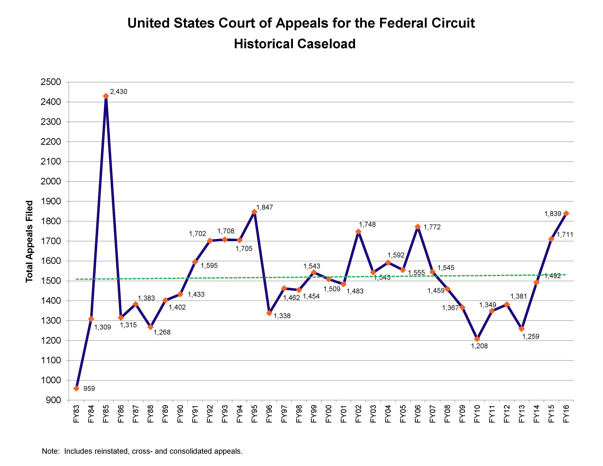
Figure 6 Case load of Court of Appeals for the
Federal Circuit1983 – 20116 (CAFC, 2107a)

This lack of legislative specificity, inclination to litigiousness and the burgeoning number of patent applications has imposed a cost that may have detrimental impacts on defense. There are a range of studies that have been conducted by members of the legal profession and those outside of the bar, trying to find the impact of these issues and the best resolution to seek in redressing the negatives.
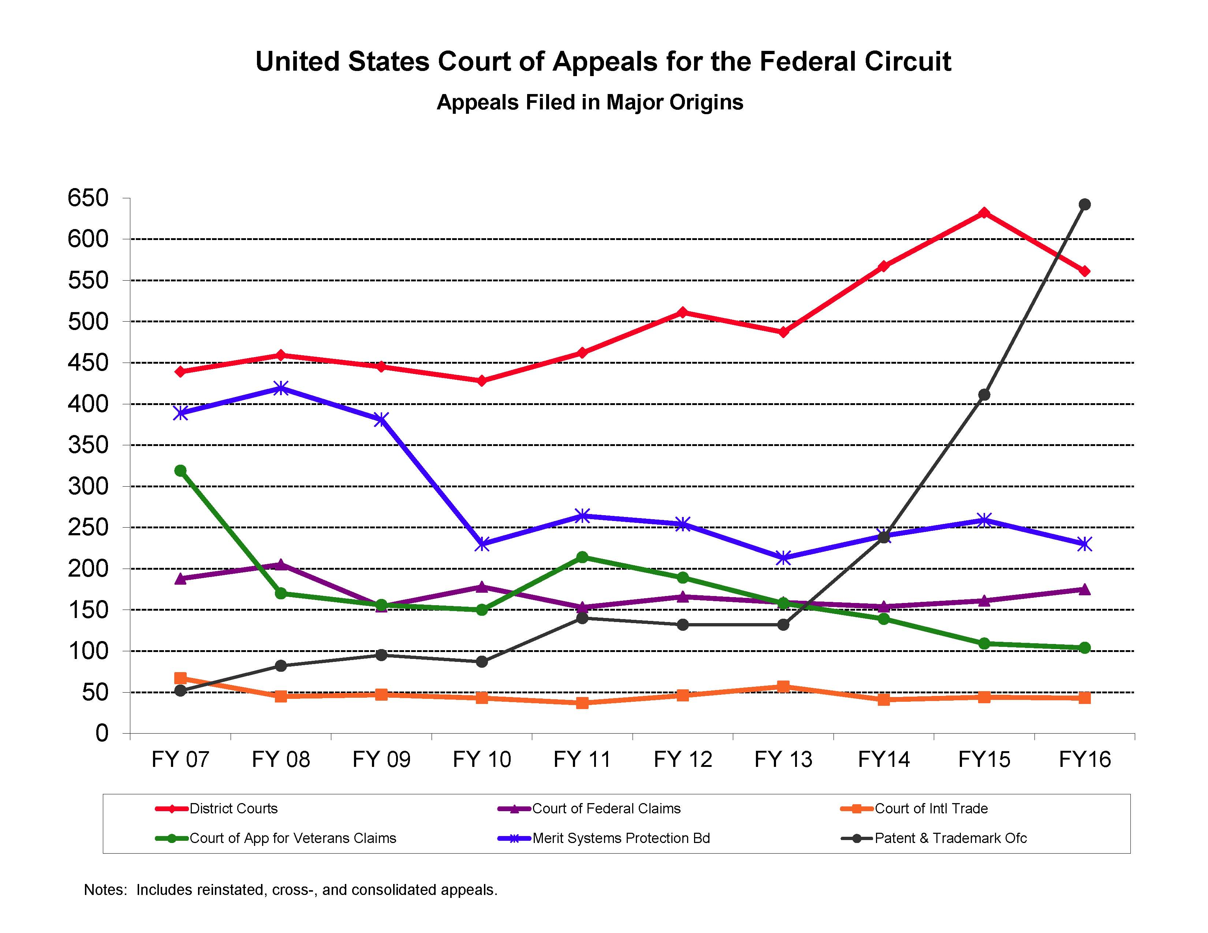
Figure 7 – Appeals to CAFC Graphed
by the Jurisdictional Origin (CAFC, 2017b)

The courts are heavily burdened at all levels with resolving all of these issues, meaning that many cases are not resolved as rapidly as would be propitious, but an increasing number are in favor of the patent holder (Lerner, 1995). The number of cases heard by the CAFC has been holding steady since 1983, save one spike in 1985, as is shown in Figure 6 above, but there is a recent upswing since 2013 that is almost entirely attributable to the increase in patent law cases, as is shown above in Figure 7. It should be noted that not all of the CAFC cases involve patent law, others include: international trade, government contracts, certain money claims against the United States government, federal personnel, veterans' benefits, and public safety officers' benefits claims (CAFC, 2017). Many of these contribute but a few cases to the Court’s case load of more than a thousand. Nevertheless, this load still seems overly burdensome on both the litigants and on society. The case load of CAFC is now dominated by patent law and this trend may continue

One of the jurisdictional origins in Figure 4 may benefit from some further explication: District Courts, shown here in red. While to authors could find no official statistics on the breakdown of the case load that category presents to the court, that jurisdiction is limited to:
- Patents, including appeals arising from an action against the Commissioner of Patents and Trademarks under 35 U.S.C. § 145
- The Little Tucker Act, 28 U.S.C. § 1346
- Section 211 of the Economic Stabilization Act of 1970;
- Section 5 of the Emergency Petroleum Allocation Act of 1973;
- Section 523 of the Energy Policy and Conservation Act of 1975; and
- Section 506(c) of the Natural Gas Policy Act of 1978

But, more critical to this discussion is the fact that the majority of these District Court cases originate from the first criterion: patent law suits. A former clerk at the CAFC told one of the authors that, in his entire tenure at the CAFC he never saw a single District Court case that was not in the patent law area (Davis, 2017). Accepting that as a general rule, then approximately two thirds of the cases at the CAFC derive from patent disputes of one kind or the other. Coupled with the fact that the other case loads are basically flat, these data support the contention that the patent administration and adjudication processes are heavily burdened and still growing. This is having and will have significant societal and defense impacts.

Current Practice

Before describing current practice, some patent basics are reviewed here. A patent consists background and references, but the important section of the patent is the claims section. The claims describe the important aspects of the patented device. Discoveries and algorithms are not patentable. As a result, a new substance may not be patented, but the process to manufacture the process can be patented. Similarly, a software patent’s claims describe a device that the software enables. Claim language is very precise and generally must be written by a skilled patent attorney, thus contributing to the cost of filing a patent.

By 2010, a device such as a smart phone could have tens of thousands of patents that apply (RPX, 2011). Companies hold large patent portfolios (Lim, 2014) covering their products. There have been some important court cases recently. While it is a copyright case, not a patent law case, Oracle vs Google is illuminating. Oracle asserted that Application Programming Interfaces (API’s) can be copyrighted and only their code could implement their API’s. Google had written alternative code based on that approach. The jury found that this was fair use, and copyright protection did not rule out this development by Google. This case is still under appeal, but it does illustrate that the boundaries of protections continued to be challenged and defined (Samuelson 2012). A common characteristic of these litigations is expense. Legal expenses of $20 to $30 million are common (Schwartz, 2012) and with preparation and appeals taking years.

To avoid litigation and take as much advantage of fast changing markets, companies use their large patent portfolios to negotiate cross licenses with their competitors. With large manufacturing companies such as Apple and Samsung having portfolios of thousands of patents, litigation over one patent is no longer a viable alternative, since the target company may have many patents that apply which are in use by the initiator. Instead, negotiating a cross licensing deal with reasonable compensation for the differences in portfolios is in the interest of both companies.

Additionally, there is strong incentive to pool patents in standards committees such as PCI, HDMI, MPEG and USB. (PCI, 2017; HDMI, 2017; MPEGLA, 2017; USB, 2017). Unlike the automotive patents discussed above, these organizations normally have low licensing fees and may couple them with logo requirements and other marketing programs.

Filing and maintaining patents has risen in cost. In addition to the inspiration and development work by the inventor, legal costs to file the patent may run from $6000 to $20,000 in the 21th century (Gallini 2002). Companies). Because of these high costs, companies simply desiring defense against competitor patents may also publish inventions in various venues. Making the invention public prevents others from patenting the invention but does not protect the inventor from competitors adopting it for their own use.

Software development over the last 30 years has been influenced by the open source concept, wherein the contributors to the product all agree to eschew IP protections and make their product available to all without charge. Large quantities of important functional software, such as Linux (Hertel et al., 2003) have been contributed by numerous authors and this software constitutes critical components for devices such as Android and Apple smartphones. The relevance to this discussion is that most open source licenses such as the GPL (GPL 2007) prevent patenting technology that is incorporated in open source.

Although patents have high value, the system does suffer several problems as described above: large numbers of patents apply to modern devices, patents are expensive to create and even more expensive to defend and non-practicing entities continue to threaten the profitability of companies that actually produce products.

Impact on DoD

The authors maintain the position that the operation of patent law in the United Sates has three major impacts on the defensive posture of the nation.
- IP protection is a mainstay of the economic strength of the country, upon which defense must rely
- In an economy where innovation largely comes from private sources, patent rights encourage invention
- Patent enforcement may have a curtailing effect of delaying adoption of technologies by others
Naturally, counter arguments could be made and the authors do not advance their assertions as unsupported givens the, but will expand on them below. The importance of a good technology policy has been discussed in terms of overall national policy (Eargas, 1987)

The first of the authors’ major points may actually be the most important. The ability of a nation to defend itself is generally accepted as being closely tied to its economic power (Boezer et al., 1991). Recent experience as varied as World War II, the Cold War, and the Gulf Wars has shown the economic power of the U.S., coupled with a committed military, has prevailed. In World War II, the industrial strength of the nation had been fueled by competition, but carefully guided and nurtured by patent law. Recently hobbled by the Great Depression, the economic power of the U.S. enabled them to equip and field anan eight-million-man army, to build nearly 300,000 airplanes for the service air forces, and build nearly 7,000 ocean-going vessels. That industrial production capability was central to Allied success, as is shown in Table 1. More recently, that same industrial engine was the major weapon in the Cold War and the U.S. dominance in that area made it untenable for the Soviet Union to remain in the fight. In subsequent years, intellectual ascendancy has been aided by the immigration of those with intellectual prowess into the United States, thereby deprive potential enemies from benefiting from their own nation’s innovation assets.
Table 1 – US Economic Power in WWII
(Harrison, 1998)
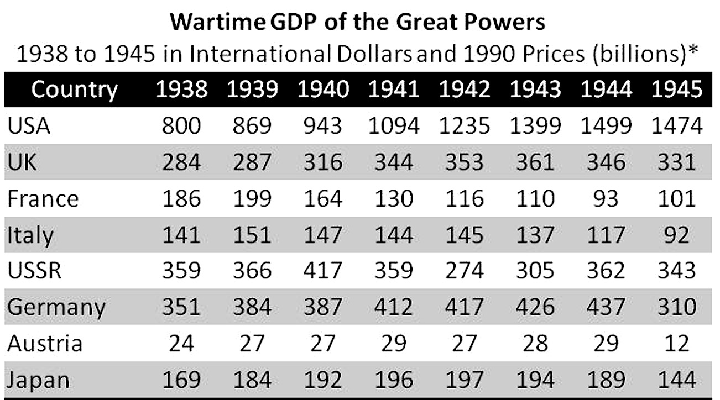

These all present that defense contractor with a critical decision: should new concepts be protected by patents, carefully protected by industrial security methods, or by seeking security classification of the concepts. This paper does not intend to try to resolve, or even to counsel, the resolution of these issues, but the authors do urge all defense personnel to be aware of the existence and criticality of them and suggest early discussions with corporate or university IP counsel.

The U.S. and its close allies are still the international source of virtually all of the innovation in the information age. This has become increasingly important under the defense “offset strategy.” That term first gained currency when it was used by Harold Brown to discuss the use of technology to achieve parity with other nations (Brown, 1983) who fielded larger armies and had a tradition of sustaining casualties that the U.S. would find daunting, e.g. World War II armies of the USSR lost around ten million service deaths (Erlikman, 2004) compared to the U.S. Army’s loss of around a third of a million (U.S. Army, 1953). The difference in the percentage of the army personnel killed was also staggering: 25% versus 2.8%. So many, including Dr. Brown (PhD in Physics from Columbia), posited that the U.S. had to “offset” the Soviet advantage in Europe with Nuclear power. That offset led to the Pax Nuclear which eventually resulted in the collapse of the Soviet Union, which had virtually bankrupted itself trying to maintain parity with the U.S.

The next offset occurred after the Vietnam War when an war-weary U.S. populace and economic constraints caused a radical decline in staffing strength of the U. S. Force, which had to become more focused on new technologies and operational practices (Tomes, 2006). Now, more than just raw manufacturing muscle, the defense of the nation rested on an unquenchable need for more sophisticated technologies. In these days of stealth, cruise missile, drone, and information technology, the need for a motivated innovative class was paramount to U.S. interests both at home and abroad. The proof of the validity of this approach came at the very end of the 20th century and beginning of the 21st Centuries, as the U.S. obtained incredibly one-sided battlefield victories with casualty rates a small fraction of what was suffered by the opposing forces and of what had been suffered by U.S. service personnel in past wars.

Similarly, there is a third offset that also depends heavily on technology. In this offset, the targets of technology for U.S. and allied scientists are the challenges of fielding effective remotely controlled vehicles, robotics, and artificial intelligence, This offset also strives to retain data manipulation ascendancy via high performance computing and deep learning. Because the third offset is underway as this is written, it seems uncertain just what this offset may entail, but its reliance on technology seems guaranteed. Secretary of Defense Ash Carter identified six areas of emphasis in a speech in 2016: anti-access and area-denial, guided munitions, undersea warfare, cyber and electronic warfare, human-machine teaming, and wargaming and development of new operating concepts. (Eaglin, 2016)

Many authors have discussed the importance of the rule of law, the protection of property rights, and the acknowledgement of the individual rights of citizens as a cornerstone of societal advance and industrial productivity. Even in this new world of rapidly evolving technology, it is argued that these rights must be central to the societal norms or progress will not occur (Friedman, 2005). Some have even seen it as dichotomizing the world into two new sets of antagonists: those committed to the rights of society and human advance versus those who seek benefit for a lawless elite and who find regression to tribalism as desirable (Barnett, 2004). Others, taking a much longer view of human history have analyzed the importance of governmental and societal impacts on development and sustainment of productivity assets that are closely tied to defensive capabilities (Murray, 2003).

The authors hold that government personnel should be increasingly sensitive to all such central regulatory impacts on defense. Often, it has been observed that technical personnel are not well versed in this area and it may be the government program manager who can identify and urge consideration of IP issues for the creator of the new technology. The authors’ experience in both industry and academia is that technical personnel do not recognize the dangers are much as history indicates they should.

The patent system clearly impacts the development and availability of technology in several ways. Formerly, technology discoveries were rare and concentrated within geopolitical boundaries. As a result, it was possible for an invention to be classified and patenting to be delayed for many years. On example of this would be the invention of public key cryptography. The patent was not issued many years after it was filed. Because the development of technology is now so much spread worldwide and companies are highly incented to file patents to protect themselves and their platforms, classification and delayed granting of patents is much less likely. As a result, a nation’s exclusive access to their own technology for many years will likely become less common.

While the defense industry may be open to government control, non-defense firms surely will be unwilling to give up potential patent advantages solely to support DoD work, yet this is where a lot of vital innovation is occurring. The authors feel the nation must effectively address this area.

International IP and National Security

The development of the World Wide Web led to significant pressure around cryptography. Although cryptographic technology is a National Security asset, it is also critical to the operation of the web to enable privacy and authentication needed for commerce (Schneier 1996). Also, the rapid development of compute power has resulted in computing needs for smart phones that surpass supercomputers of only 30 years ago. To promote commerce and recognize realities export restrictions on many critical technologies have been relaxed in the last 25 years. One other consequence of the developing global economy is that many critical components are not manufactured in the US. This is mentioned in this paper because the international patent systems, as well as economic realities, contribute to this. (Friedman, 2005)

There have been continuing efforts to obtain consistent protection of IP across national boundaries. As nations have become more economically interdependent, the recognition of property rights of every kind has become key issues in virtually all traded negotiations. This interdependence has had a pacifying effect on the antagonisms of the major powers. Any significant conflict would drastically impact the economic well-being of all of the combatants. While recognition of international patent rights is useful for commerce, it holds no sway in the restriction of critical technology being subverted foot use by potential foes.

Survey of Potential Changes and Solutions

As stated before, this nation’s patent law and practice has far-reaching and wide-spread impacts on U.S. defense posture. (Patent Progress, 2017) While many of the suggested remedies for current problems may at first seem distant from direct implications for defense, the underlying strength of the economy is still a critical factor in defense. However, rather than just parroting others’ calls for reform, this section will cover recommendations that will constitute a direct connection to DoD activities. The authors assert that a conversation is mandated in this area and they are willing to start that conversation by advancing a few ideas, more as strawmen than committed positions. It seems clear that enacting many of the below listed suggestions may be difficult, as indicated by earlier attempts to do so. A strong push by agency personnel might be necessary to get both congressional and executive action on all of these fronts. Time will better show what action is required, but the paper presents some ideas below.

The first of these is a conundrum familiar to the Intelligence Community (IC): intelligence that is not made available to decision makers and warfighters is of little use, but wide dissemination incurs increased risk of compromising sources and methods. That may eradicate the future use of that exploitable data stream, not to speak of the potential threat to clandestine personnel who may have been responsible for its collection in the first place. In the instant case, the conundrum is: technological advancement is accelerated by the most open and pervasive knowledge of new insights and approaches, but the general knowledge of these techniques makes it available to the potential enemies as well. Classification of new techniques will typically preclude patent applications. This both leaves the inventor open to future law suits and deprives the inventor’s industry colleagues from sharing in his advances. The authors believe this may be an area amenable to the government’s indemnifying the inventor against such post hoc problems. Notwithstanding current events’ revelations of breaches, the dissemination of classified technology within the secure community of cleared contractors may be a compromise choice. This limits the dissemination of technology to those who are most likely to make good use of it for U.S. benefit.

Similarly, the suggestion of some authors to substitute publication as a preventative measure to preclude prosecution by patent trolls, might well be met with some kind of government protective agreement. Such an agreement could protect the inventor from such aggression in return for the inventor’s not publishing in a way that would allow the nation’s antagonists to gain easy access to important information It is recognized that many government contracts call for the government’s retaining the rights to products and methods developed, but much of the technology in use by the military today has not been funded by the DoD and is the intellectual property of the inventor. By making it known that the inventor will be suitably compensated and reliably protected, the DoD can induce more technology to be developed and made available for defense use.

Noting the continued success of the open publication policies of many academic communities, the U.S. should consider hosting, perhaps through the UPSPTO, an open access submission site where inverters could easily and precisely describe their new inventions which would constitute presumptive claims of origination for the inventor, without open publication of the concept. Such a facility could be provided for a cost of less than a staff year and could be programmed with deep learning capabilities to scan incoming pre-nascent ideas for originality, with a response to the submitter that a certain number of other inventors had preceded them in filing. It could also do a preliminary sorting for analyses by the nations’ scientific and intelligence communities who are sure to be interested in what the levels and trends in innovation are. The government then would have an ability to review all new inventions for potential defense use prior to public release, appropriately compensating any inventers for new technology they found to be of national security importance that required government control and security classification. Such an unfettered opportunity to check and record the novelness of one’s thought might well encourage otherwise recalcitrant inventors to pursue formalization their nebulous visions to the point of being able to articulate the path forward to their realization. The cyber-security aspects of such a concept are important, but beyond this paper’s scope.

The funding of such agencies as the Defense Advance Research Project Agency and the Intelligence Advance Research Project Agency should continue to encourage small and independent researchers as well as the defense industry. While major research universities and large defense contractors are well represented in the technical environment, there may be “hidden” talent out there that is slipping away and their contribution may be critical. Sponsoring technology innovation fairs and conferences could be coupled with assurances of government indemnification and protection for these budding inventors as well, as most have neither the knowledge nor the resources to retain competent IP counsel.

Another, more administrative, function recommended by the authors of this paper is the assignment of DoD and IC representatives to every major gathering considering changes to the patent law and IP protection statutes and regulations. As more than pure commerce is at stake, the presence and counsel of defense personnel at the meetings considering the next patent law reform act might be critical to 21st Century defense capabilities. Due to the existence of and technical emphasis at the service academies and ROTC programs, the services are well stocked with highly competent and creative technical personnel who could provide useful counsel to any such meeting.

Patents and other IP protection must be a major consideration for providers and acquirers of technology for national defense. Although the original goals of the patent system do not appear to conflict with the security goals of the nation, the current implementation degrades the use of technology as an advantage. This occurs because the patent system promotes sharing information that is critical to a nation’s security. Consequently, policy makers should be aware of the impact on developers and be alert to policy changes that may improve or exacerbate the situation. The authors recommend supporting high priority changes such addressing suits from non-practicing entities (“trolls”) and accommodating classified inventions. The alternative is to give up on the “offset strategy” and have U.S. warfighters fight future conflicts on an unnecessarily reduced advantaged playing field.

One concept that is already available, theoretically, is the punitive award of damages against those filing unsubstantiated claims (Roberts, 1988.) The sense that patent trolling is a form of frivolous actions could go a long way toward reducing the negative impacts of this practice. Rule 11 of the Federal Rules of Procedure already gives the courts powers to assess cost and legal fees against the losing party if they find the case was frivolous and dilatory. These costs can be levied on the offending attorney, as well as his client, but the rule is rarely implemented as it was envisioned by Congress. Some real impetuous to enforce the rule is needed. Perhaps making such an award the default and making the offending parties prove their case was NOT a troll would have the desired impact. A legal presumption that the practice of trolling was frivolous could be written into the act with ease. For this to work, the definition of frivolous trolling must be clear and operable. For example, the revised statute could specify that if the plaintiff has not shown any ability or effort to manufacture a product, then there is no loss and the suit would be frivolous.

Conclusions

Patents and other IP protection must be a major consideration for providers and acquirers of technology for national defense. Although the original goals of the patent system do not appear to conflict with the security goals of the nation, the current implementation degrades the use of technology as an advantage. This occurs because the patent system promotes sharing information that is critical to a nation’s security. Consequently, policy makers should be aware of the impact on developers and be alert to policy changes that may improve or degrade the situation. The authors recommend supporting high priority changes such addressing non-practicing entities (“trolls”) and accommodating classified inventions. The alternative is to give up on the “offset strategy” and have U.S. warfighters fight future conflicts on an unnecessarily reduced-advantaged playing field.

Acknowledgements

The authors wish to thank the Honorable Garth D. Baer, Administrative Patent Judge with the U.S. Patent and Trademark Office for his encouragement and willingness to respond to many procedural and practice questions for some of the authors who have virtually no experience with the practice at the USPTO or at the CAFC level, where Judge Baer clerked for the Honorable Raymond C. Clevenger III, Circuit Judge. While all of the authors sought counsel from many in this field, the opinions expressed herein are the authors’ own and do not necessarily represent opinions or positions of their employers, their colleagues or the experts from whom they sought assistance, nor should they be construed as being the official views of any military service in which the authors may have served.

References
Act, A. I. (2012). Leahy-Smith America Invents Act. Public Law, 112(29), 1.
Barnett, T. P. (2004). The Pentagon’s New Map: War and Peace in the 21st Century. New York: Putnam.
Bessen, J., & Hunt, R. M. (2007). An Empirical Look at Software Patents. Journal of Economics & Management Strategy, 16(1), 157-189.
Boezer, G., Gutmanis, I., & Muckerman, J. E. (1997). The Defense Technology and Industrial Base: Key Component of National Power. Parameters: U.S. Army War College Quarterly, 27(2), 26. Retrieved from the internet on 13 May 2017 from: https://www.hsdl.org/?view&did=569
Bui, H. H. (2011). Navigating the Leahy-Smith America Invents act including effective dates for patent reform. J. Pat. & Trademark Off. Soc'y, 93, 44
Brown, H. (1983). Technology, Military Equipment, and National Security. Parameters, 13(1), 15.
Byers, J. H. (1940). The Selden Case. J. Pat. Off. Soc'y, 22, 719.
CAFC, (2017). Court Jurisdiction. United States Court of Appeals for the Federal Circuit, Washington, D.C. retrieved from the internet on 09 May 2017 from: http://www.cafc.uscourts.gov/the-court/court-jurisdiction
Duffy, J. F. (2007). KSR v. Teleflex: Predictable Reform of Patent Substance and Procedure in the Judiciary. Michigan Law Review First Impressions, 106(1), 34-38.
Eaglin, M. (2016). What is the Third Offset Strategy?. Real Clear Defense. 16Feb16. Retrieved on 13 May 2017 from: http://www.realcleardefense.com/articles/2016/02/16/what_is_the_third_offset_strategy_109034.html .
Ergas, H. (1987). The Importance of Technology Policy. Economic Policy and Technological Performance, Cambridge University Press, Dasgupta & Stoneman, eds. 51-96
Erlikman, V. (2004). Потери народонаселения v XX веке: справочник (~ A Compendium of 20 Century Populations Losses). Moscow, 2004
Friedman, T. L. (2005). The World is Flat: A Brief History of the Twenty-First Century. London,: Macmillan.
Gallini, N. T. (2002). The Economics of Patents: Lessons from Recent US Patent Reform. The Journal of Economic Perspectives, 16(2), 131-154.
GPL, (2017). Gnu General Public License. The Free Software Foundation. Retrieved from the internet on 16 May 2017 from: https://www.gnu.org/licenses/gpl.html
Hall, B. H. (2009). Issues in and Possible Reforms of the US Patent System. In conference on 21st Century Innovation Systems for the United States and Japan: Lessons from a Decade of Change, sponsored by the National Academies, NISTEP of Japan, and the Institute of Innovation Research of Hitotsubashi University.
Harrison, M, (1998). The Economics of World War II: an Overview. in Mark Harrison, ed., The Economics of World War II: Six Great Powers in International Comparison, Cambridge UK: Cambridge University Press.
Hertel, G., S. Niedner, and S. Herrmann. 2003. Motivation of Software Developers in Open Source Projects: An Internet-Based Survey of Contributors to the Linux Kernel. Research Policy 32, no. 7: 1159–1177.
HDMI, (2017). HDMI High Definition Media Interface, HDMI Licensing Administrator, Inc. Retrieved from the internet on 15 May 2017 from: http://www.hdmi.org/index.aspx
Hungar, T. G. (2008). Observations Regarding the Supreme Court's Decision in Quanta Computer, Inc. v. LG Electronics, Inc. Idea, 49, 517.
Ladas, S. P. (1975). Patents, Trademarks and Related Rights: National and International Protection. Cambridge, Massachusetts: Harvard University Press. pp. 6–7
Lerner, J. (1995). Patenting in the Shadow of Competitors. The Journal of Law and Economics, 38(2), 463-495.
Lim, D. (2014). Standard Essential Patents, Trolls, and the Smartphone Wars: Triangulating the End Game, 119 Penn St. L. Rev. 1 (2014).
MPEGLA, (2017). Revolutionizing Intellectual Property Rights Management, MPEGLA. Retrieved on 15 May 2017 from http://www.mpegla.com/main/Pages/About.aspx
Murray, C. (2003). Human Accomplishment: The Pursuit of Excellence in the Arts and Sciences, 800 BC to 1950. New York: Harper Collins.
Nonaka, I., & Nishiguchi, T. (2001). Knowledge Emergence: Social, Technical, and Evolutionary Dimensions of Knowledge Creation. Oxford, UK: Oxford University Press.
PCI, (2017). PCI-Peripheral Component Interconnect. PCI Special Interest Group. Retrieved from the internet on 15 May 2017 from: https://pcisig.com/
Roberts, J.H., (1988). The New and Improved FRCP Rule 11: Lawyers Beware. The Journal of the Legal Profession. 13: 319-326
Robinson, D., & Medlock, N. (2005). Diamond v. Chakrabarty: a retrospective on 25 years of biotech patents. Intellectual Property & Technology Law Journal, 17(10), 12.
RPX. (2011). US Securities and Exhange Commission, Form S-1, Registration Statement, Business Overview, RPX Corporation, filed on 02 September 2011, 57 Retrieved from the internet on 15 May 2017 from: https://www.sec.gov/Archives/edgar/data/1509432/000119312511240287/ds1.htm#toc226103_11
Samuelson, Pamela, (2012), Oracle v. Google: Are APIs Copyrightable?. Communications of the ACM, 55(11) 2012; UC Berkeley Public Law Research Paper No. 2171447. Retrieved from the internet o 17 May 017 from: https://ssrn.com/abstract=2171447
Schneier B., (1996). Applied Cryptography . New York, NY: Wiley.
Schwartz, D. L. (2012). The Rise of Contingent Fee Representation in Patent Litigation. 64 Alabama Law Review 335 (2012)
Tomes, R. R. (2006). US Defense Strategy from Vietnam to Operation Iraqi Freedom: Military Innovation and the New American War of War, 1973-2003. London, U.K.: Routledge.
U.S. Army, (1953). Army Battle Casualties and Nonbattle Deaths in World War II. Statistical and Accounting Branch Office of the Adjutant General, United States Army, (June 1, 1953).
USB, (2017). Universal Serial Bus, USB Implementers’ Forum. Retrieved from the internet on 15 May 2017 from: http://www.usb.org/home
USPTO, (2017). U.S. Patent Activity Calendar Years 1790 to the Present. U.S. Patent and Trademark Office, Retrieved on 09 May, 2017 from: https://www.uspto.gov/web/offices/ac/ido/oeip/taf/h_counts.htm

