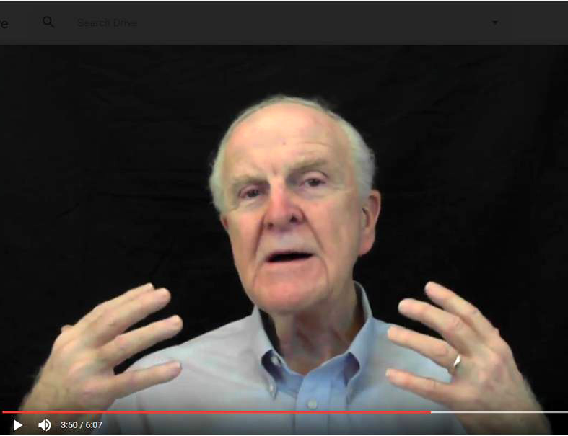

Figure 1 - Live Video Clip

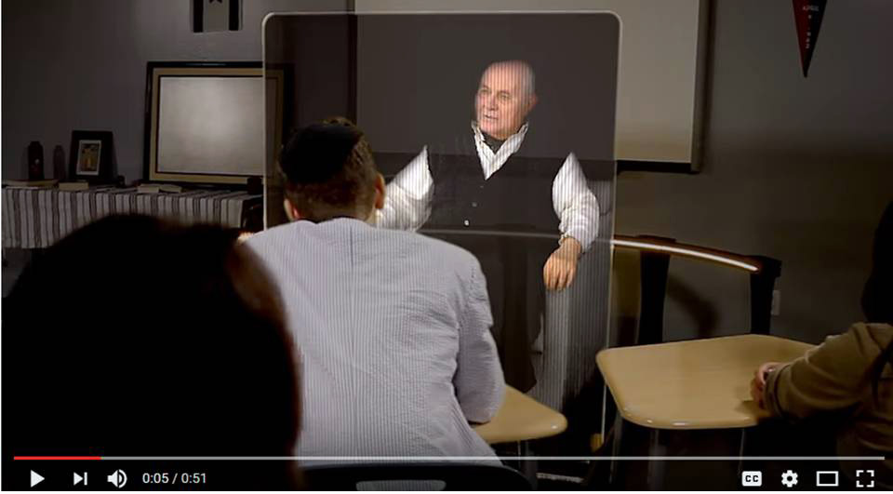
Figure 2- Video-taped speaker
rendered in a holographic display

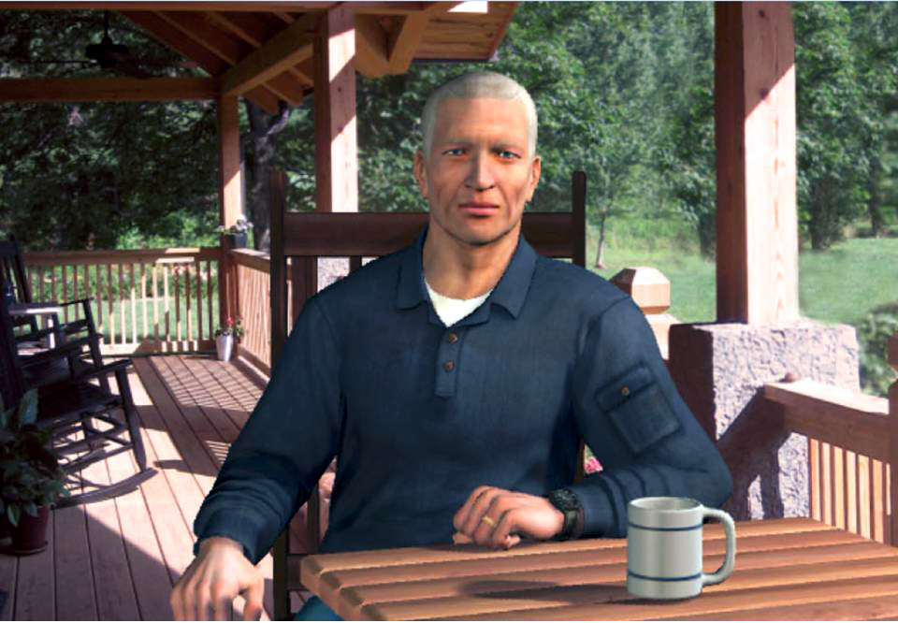

Figure 3- Fully Animated CGI

