Informing and Promoting Technical Career Choices:
Roadmaps for the Future

Dan M. Davis, Julianne M. Nordhagen & John J. Lazzeroni | Frederica J. Stassi
University of Southern California | Science Education Analyst
Los Angeles, California | Lompoc, California
dmdavis@acm.org & {nordhage, lazzeron}@usc.edu | frjstassi@gmail.com

ABSTRACT

The issue addressed by this paper is that of providing the nation sufficient technically qualified personnel to maintain national economic strength and defense ascendency. Considered first is the current need and prospective shortfall in Science, Technology, Engineering and Math (STEM) personnel. The genesis of the false impressions that many students have about STEM professions is documented. These are often based on media and popular culture; the negative impacts are outlined. Two approaches are reported and analyzed: 1) the use of on-line “conversational avatars” to act as mentors for individuals choosing careers and 2) staging public gatherings for young people to visit with actual STEM personnel. In the case of the on-line solution, there is a brief discussion of the University of Southern California (USC)/Office of Naval Research MentorPal project. Its focus is on target populations that have little access to STEM professionals to act as mentors due to geographical remoteness or Socio Economic Status (SES) disadvantage. Then, the bulk of the paper describes the authors’ participation in a STEM Fair organized by Professor Andrea Armani of USC. It is provided so students in the Los Angeles Basin can have direct contact with vital, engaging and compelling researchers. The authors cover how important decisions were made about: what the ultimate goals were, who should present science at the fair, which groups to target for invitations, ways to convey the science via posters, how to quantify attendance, and in what ways to best characterize the impact on the attendees. Preliminary data is adduced concerning all of these aspects of the effort. The materials are presented in a way that should enable other institutions to more effectively implement programs of their own. Future research plans are described and evaluated.

ABOUT THE AUTHORS
Dan M. Davis is active as a consultant at the Institute for Creative Technologies, University of Southern California (USC), focusing on large-scale DoD simulations and avatar uses. Prior to retirement, he was the Director of the JESPP project at USC for a decade. As the Assistant Director of Advanced Computing Research at Caltech, he ran Synthetic Forces Express, bringing HPC to DoD simulations. He also served as a Director at the Maui High Performance Computing Center and at the Jet Propulsion Laboratory and Martin Marietta. He was the Chairman of the Coalition of Academic Supercomputing Centers and has taught at the undergraduate and graduate levels. As early as 1971, Dan was writing programs in FORTRAN on one of Seymour Cray’s CDC 6500’s. He saw duty in Vietnam as a USMC Cryptologist and retired as a Commander, U.S.N. He received B.A. and J.D. degrees from the University of Colorado in Boulder.
Julianne M. Nordhagen is an Ensign in the U.S. Navy and is attached to the NROTC unit at USC, where she is assigned to collaborate on research at the Institute for Creative Technologies (ICT). As an Industrial and Systems Engineering (ISE) student, Julianne cultivated the analytical and technical skills required for this project, including optimizing the performance of large scale systems and applying computational methods for scheduling and forecasting. She has professional experience using integrated planning software like SAP and NetSuite ERP. She was selected to be one of the mentors for ICT’s MentorPal project for the Office of Naval Research. Next April, she will begin her Naval Aviator training at the Naval Air Technical Training Center in Pensacola Florida. Ensign Nordhagen earned an ISE B.S. degree from the University of Southern California.
John J. Lazzeroni is an Electrical Engineering student in the Viterbi School of Engineering at the University of Southern California. He is currently serving as a Research Assistant and Project Manger in the Armani Research Laboratory there. His research interest flow in many directions, but he is interested in the need to attract more young people to the technical fields. His duties in the lab include organizing the EngX STEM Fair to try to provide a background for students of all Socio Economic Statuses. He is a Midshipman, First Class in NROTC at USC, where he has been selected as the Battalion Commander for the midshipmen. MIDN 1/C Lazzeroni was commissioned in the US Navy as an Ensign this spring. ENS Lazzeroni received orders to Nuclear Power training, after he received a BS in Electrical Engineering from USC in June.
Frederica J. Stassi. Ed.D. is a Science Education Analyst, working in the Central Coast of California. Her background includes research for the National Science Foundation in which she was funded to study pedagogies and efficacy in U.S. Science museums. This research involved museums from the East Coast to O‛ahu in Hawai‛i. Her doctoral research was conducted under the guidance of Professor William McComas and focused on the development of science standards for the State of California. She received a BA degree from Tabor college, as well as an M.A. Degree in music performance and an Ed.D., both from the University of Southern California.

Informing and Promoting Technical Career Choices:
Roadmaps for the Future

Dan M. Davis, Julianne M. Nordhagen & John J. Lazzeroni | Frederica J. Stassi
University of Southern California | Science Education Analyst
Los Angeles, California | Lompoc, California
dmdavis@acm.org & {nordhage, lazzeron}@usc.edu | frjstassi@gmail.com

Introduction
There is a recognized shortfall in the number of Science, Technology, Engineering, and Math (STEM) professionals, for which many hypotheses have been advanced (Smith & Anderson, 2014). These include negative images of technical fields in the media, lack of awareness of the range of STEM careers, and mistaken notions of the actual working environments of both technical and non-technical professional fields. In many cases this is exacerbated by the lack of easy student accessibility to technical personnel, especially among students who are younger, who come from lower socio-economic-status (SES) households, and those living in communities that are geographically remote from centers of technical activity (e.g., rural areas).
This paper discusses an activity where two complementary types of STEM outreach were combined. Specifically, a prototype STEM career mentor technology called MentorPal was set up as a booth during a to a person-to-person outreach event on a major university campus in an urban setting, in this case the University of Southern California (USC) in downtown Los Angeles. Through both the use of the technology and by explaining the technology, researchers sought to increase the students’ awareness of the range of activities that STEM personnel perform, about the wide variety of personalities of technical personnel, and about the paths that lead to various technical careers.
This paper first discusses the technology, reviewing some of the background research that informs MentorPal and how mentors are recorded and converted into computer-based interactive mentors. Next, it discusses insights from the STEM fair event, in terms of student reactions and interaction dynamics in that context. Finally, the paper discusses research in progress and potential future directions that might increase the effectiveness of this approach.

Related Work

The MentorPal project draws from earlier approaches using some of the same underlying natural language dialog technology, known as NPCEditor (Leuski & Traum, 2011), which specializes in question-answering agents. NPCEditor is one of the two methods used by MentorPal in selecting the best video clip to respond to the users questions. An early use-case for NPCEditor technology was for an exhibit at the Boston Museum of Science called The Twins, where visitors interacted with dialog-based virtual agents who could answer questions about computer science and about how they worked (Swartout et al., 2010). Follow-up research adapted the underlying dialog technology to reproduce the experience of having an experience with Holocaust survivors, by delivering recorded video clips of the survivors as responses, as opposed to driving virtual characters (Traum, et al., 2015). These systems identified a variety of interactions and social dynamics, with a typical presentation including a facilitator who would work help a group of visitors take turns asking questions from the system. However, compared to these prior systems, MentorPal has been designed with a strong emphasis on lower cost, smaller question sets and one-on-one dialog, thereby limiting testing with groups of simultaneous users.
In terms of placing this system in the broader literature on intelligent mentoring, the focus of MentorPal is on emulating the experience of an informational interview, such as the kind a student would have with a mentor at a career fair. This can be contrasted against mentoring systems that are designed to help students working on a specific project, such as AutoMentor (Wang et al., 2013). It can also be contrasted against intelligent mentor agents who support metacognition as part of an open learner model (Dimitrova & Berna, 2016). Compared to these systems, MentorPal is not intended to build skills. Even among mentoring agents who also handle question asking and familiarization, such as the SimCoach system (Rizzo et al., 2011)., MentorPal is distinct due to its focus on subjective experiences. Instead of a general description of STEM careers or fields, it is intended to help learners identify a mentor whose experiences resonate with them and that enables them to explore realistic visions of careers that they might pursue.
Due to significant differences in content and changing familiarity with technology by users since earlier work with NPCEditor and similar systems, this STEM fair exhibit offers a different perspective on interactions with this kind of system. In particular, for the STEM fair it was not certain if students would find the system novel, due to greater availability of engaging virtual assistants. Prior testing with MentorPal was conducted with one-on-one use i.e., a student sitting at a computer, so it was uncertain how differently students would interact with the system as part of groups and parent-child dyads.

Approach: Building an Interactive Virtual Mentor

This section lays out our current methodology for asking questions, turning questions into transcripts, cleaning transcripts, feeding these into dialog models, and improving these models by classifying new paraphrases/aliases for questions (see: Figure 1). Building out an interactive virtual mentor from recorded videos takes up to approximately 20 hours of video footage to provide a broad coverage of responses, with approximately 60 hours of additional time for later processing: about 40 for preprocessing transcripts and 20 for post-processing dialog models. Because a long-term goal of this project is to enable recording any person as a mentor, without researcher intervention, improvements to the current pipeline are noted when discussing each step of the process.
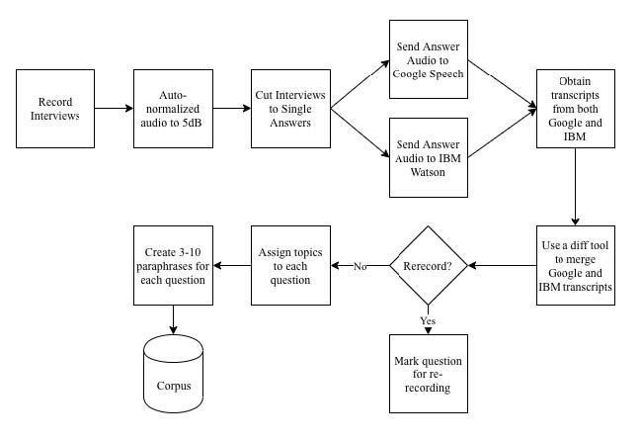
Figure 1. Mentor Digitization Process

Question Set and Recording
Our current question set consists of four types of questions: 1) preset questions that are asked for all mentors (˜70% of questions), 2) mentor-specific questions related to their career or life experiences (˜10% of questions), 3) follow-up questions identified during the interview that seem relevant to responses given by a specific mentor (˜10% of questions), and 4) mentor-specific common questions observed from chat logs by students with a mentor (˜10% of questions). The preset questions span a variety of topics detailed in Table 1 (below). Each mentor was recorded across recorded across at least five sessions, each about three hours long, to cover the question set. These sessions have a mix of these topics, with a follow up section for each session. After the initial sessions, re-recording sessions are held to record new answers to bad video clips or to record answers to common questions that were not recorded, i.e., the fourth type of question. Each follow-up session typically lasts for about 45 minutes to an hour. These follow-ups are important because they assist with creating a more natural conversational ﬂow, by enabling the mentor to answer questions that are likely to be asked after a student has heard a particular response.
Recording currently involves calibration with help from project staff in order to ensure that the recordings are consistent and the responses are appropriate to chunk into useful videos. Standardization includes ensuring that the mentor maintains a resting position 3 seconds before and after the question is answered. The resting position should be in the same spot throughout the recordings, to avoid “jumping” where a mentor’s next statement has a totally different head or body position. In addition to this, the mentor is recommended to try to use emotion, smiles, stories, and hand motion to provide engagement. So far, each recording has been standardized by using the same low-cost equipment setup, consisting of professional quality webcam, microphone, and backdrop, which is shipped to mentors who are located remotely. After recording, either the mentor or the research staff upload the session files to cloud storage for post-processing. Overall, this approach has worked effectively, with the quality of recordings and transitions significantly higher than was initially anticipated. Sound quality has occasionally suffered, however: mentors have forgotten to activate the provided microphone (laptop internal microphone used instead) or used the microphone incorrectly (facing the wrong way for a directional microphone).
Table 1. Examples of Questions by Topic
Topic | Example Question
Biographical | Where did you grow up?
Rapport | What qualifications/experience, do you value when selecting new people in this field?
Career Advice | When you were my age, what did people tell you that you wished you had heeded?
Lifestyle | How can I work smarter?
Navy Speciﬁc | Why should someone choose to be a part of the Navy?
Motivation | What makes you proud?
STEM Speciﬁc | What STEM positions are available in the military?
Stories | What struggles did you overcome to get where you are?
Social | Can you date while on a ship?
Future | What sorts of changes are occurring in your occupation?
Education | What factors should I consider when deciding where I want to study?
Miscellaneous | How do I pay for education?

An area of improvement for this part of the methodology would be to try and move this to a standalone process where the mentor could record follow up questions themselves. This is challenging, because it is hard for a mentor to predict what follow-up questions a student might ask. An automated mechanism to help detect likely follow-up questions, e.g., detecting uncommon proper nouns, might help a mentor self-record more effectively.

Preprocessing for Transcripts
This part of the pipeline turns each individual questions answer into transcriptions and video chunks. In order to prepare the sessions to run through our preprocessing python script, the answer to each question start time and end time are manually annotated. The python script then takes each .mp4 file and audio normalizes it with ffmpeg-normalize, chunks it up according to the timesheet document, converts the chunks into sound files (.wav) and then makes a call to IBM Watsons Speech-To-Text API. The call to the Speech-To-Text API takes around 1 hour to complete for 18 hours of footage. However, the bottleneck for this process is the manual cleanup of the transcription. The number of errors is significant enough to warrant cleanup, at least if learners are meant to read the transcripts, which is important for deaf learners, users in high-noise areas, or users without sound. Moreover, the errors tend to be systematic: they happen most frequently for domain-specific terms about a career, for words that a mentor says with a regional accent, or where sound quality was poor. As a result, transcripts are manually edited by listening to the audio from the recordings. This process takes twice as long as recording, over 40 hours to edit 20 hours of video.

This part of the pipeline has the potential for the most improvement, given the magnitude of time cost. Currently, research is being done if other Automatic Speech Recognition services like Google ASR would be an alternative or complement to IBM Watson, which is an ensemble model approach. Initial research on this has not yet produced positive results, but is still ongoing. In addition to changing the ASR, improvements on the translation cleanups could make better use of the translation confidence to define a threshold to detect answers that need to be manually edited. In regards to improving the editing workﬂow, text diff tools (ﬂagging differences) that could identify disagreements between two different transcripts. Alternatively, audio-aligned text editors could be used to more rapidly parse transcripts, as opposed to searching for the part of the video that matches a poor transcription.

Post Processing for Dialogue Models
An ensemble model classifier chooses an answer from the two classifiers. Currently, it sends it to both the NPCEditor and a python classifier based on a neural network to get two alternate answers. Of these, the NPCEditor answer is used if it has high confidence (since it is faster) while neural network classifier is used otherwise. Further description of these processes is contained in (Nye, et al., 2017). This section describes how the data for these models is created. As shown in Figure 1, question and answer text pairs are used to produce neural-network classifier data, NPCEditor data and metadata (Leuski & Traum, 2011, and Nye, et al., 2017). The initial paraphrase sets are generated manually based on based off of other ways that we think other people would ask the question. We also manually tag each question with topics from a bank of 40 predefined topics that cover all broad categories of questions. Topics are used in order to generate random questions by topic and are also added to the neural network classifier data as a sparse vector for each question. It then dumps all this data into files for use by the neural network classifier. The NPCEditor reads an analogous file generated from the same data, which contains only the paraphrases/aliases of the same questions.
Research is ongoing to continue improving these processes. A particular issue with the classifier was the desire to enable oﬄine mode on tablet devices. Unfortunately, the word vector models employed are typically too large to work on device in memory: the Google News Word2Vec model is 3.5 GB, for example (Mikolov, et al., 2013). To address this, our ensemble makes use of a systematically pruned version of Google's Word2Vec model described more fully in a workshop paper (Kaimakis, Davis, Beck & Nye, 2018).

Example in Practice: EngX STEM Fair

The present version of the MentorPal system was tested with two mentors at an event called the EngX 2018 STEM Fair. The fair is part of a series of STEM events conducted over the last four years, led by the Armani Lab at the University of Southern California (USC). This year’s fair was attracted a broad range of students aged from eleven to eighteen years old. It was a full-day fair, running from 8 AM until 4 PM and was held on a Saturday in March on an open quadrangle on the USC campus and attracted several hundreds of students, parents and teachers. EngX contained about 20 booths and the majority of exhibits were not computer-based, but were instead physical: water-powered rocket cars, pipe mazes with miniature robots, mirror-based holograms, and similar demonstrations.
Students arrived in varying-sized of groups to the various booths and some came alone, most in small groups and some were closely attended by one or more adults/parents. They were observed to be of varying socio-economic status, but tended to be above the mean of the spectra. Like many grade school students they seemed more attracted to interesting new experiences than sober contemplation on the career choices they were about to make. As such, in addition to using the system, many visitors were curious about the goals of the work and how it related to the students’ own interests in research or technical work.
Turnout for the booth was high, with approximately 50% of passing groups stopping for a significant span of time. This was likely partly due to being the primary AI-relevant exhibit, as well as due to a large banner poster (see images of the EngX fair in Figure 2). Three distinct types of interaction emerged when exhibiting MentorPal in this context: 1) group briefings on work with large screen display, made up of typically two or more students accompanied by an adult or two, 2) individual interactions with MentorPal on individual tablet computers, who were almost always students, and 3) individual discussions about the work and technical careers, more often initiated by parents than students. About one in ten groups went on to other booths, and then returned to ask more questions. Figure 2 is made up of two images showing the banner used to attract students and their parents and a typical group being briefed by the MentorPal project’s Principal Investigator.
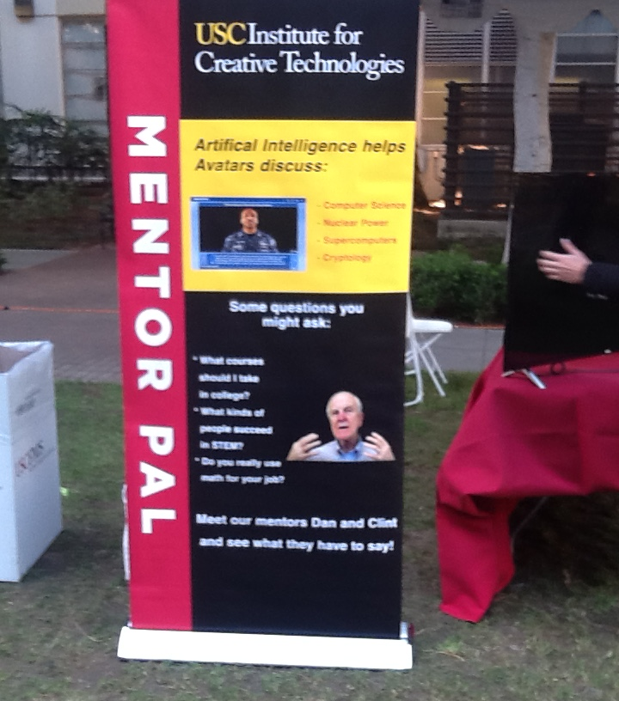

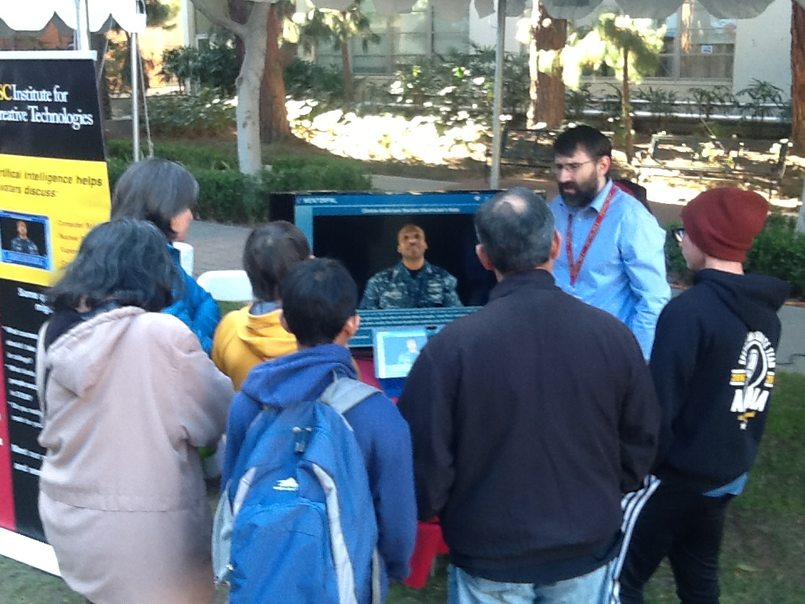
Figure 2. EngX Fair MentorPal Setup
This exhibit reaﬃrmed findings from single-user pilot testing where students often were unable to think of any useful questions for MentorPal, e.g., freezing or asking questions unrelated to careers). This was particularly relevant for students accompanied by parents. However, students were more productive when they used a menu that allowed generating questions from topic categories the team thought the students should be asking. In this fallback mode, rather than entering free-text questions, they clicked on the topics to see suggested questions to ask. While the menu-based experience resulted in a more traditional question and answer, dialog, there are advantages to this mode: students may learn from reading the question suggestions and it sidesteps classification errors. By comparison, MentorPal appeared to respond to free text questions with reasonable answers about two-thirds of the time, while in other cases answered inaccurately or had no answer. This is apparent accuracy is higher than the actual accuracy: leave-one-out testing found only about 50% for hold-out paraphrases matched their equivalent question (Nye, et al., 2017). However, the performance of the classifier appeared higher in practice, since many “misses” still result in MentorPal replies that are reasonable to the user. Individual misses that were noted by learners did not seem to break engagement, but multiple in a row appeared to reduce interest. Overall, while classification accuracy might be beneficial, the larger issue appears to be that students struggle to ask productive questions.

For students using the system individually, they were content to ask questions from MentorPal for fairly long periods of time, approaching fifteen minutes. However, it should be noted that these students were self-selecting. As the intent of the project was to create a conversational easiness with the student that would encourage the mentor-mentee relationship, one of the areas in which the team was most interested was the students’ view of their dialogue with the mentor. Since this usage was as an exhibit, rather than as a research study, no formal survey was done of their views. However, to help gather feedback about how to improve the system and know visitor reactions, a straw poll was offered to students and adults who spent substantial time interacting with the mentors, either individually or as part of a group. The results of this straw poll are summarized in Figure 2. To note, the age shown was the median age. Adults were more likely to complete the straw poll, while students were more likely to leave without filling out a poll. Overall, less than half of visitors who stopped for at least a minute took the straw poll. 44 completed it, implying a lower bound of 80 visitors and likely more than 100. Reactions were positive overall for those who completed the poll, with 77% agreeing that the answers were conversational and 84% enjoying the experience. With that said, this sample is inherently biased: those who used the system for less time would likely also skip the poll, so this sample likely represents more motivated users.

One new insight emerged from the MentorPal participation in EngX in terms of its potential impact on the prospective users. That was the interaction between the parents and the students. On the one hand, the booth crew reported that the parents were much more focused on the career choice facing their students. This seemed to drive productive questions from MentorPal on career selection and planning. However, this also caused the students to become more withdrawn and incommunicative (e.g., the parents talk, the students stand). While this is not hard evidence of such a trend, all of the booth crew reported the same impression. By comparison, one-on-one interactions between a student and the virtual mentor tended to separate the parent as an intermediary. The tradeoff of this case was that students varied significantly in how focused their questions were, e.g., more off-topic or asking about biographical details such as family members, rather than career focused.
Since students likely benefit more from the one-on-one interactions, e.g., can ask their own questions, research is now looking into dialog techniques that help steer them toward more productive questions. Different strategies are being considered, which include the importance-weighting and politician responses. Importance weighting would consider the research team’s assessment of the quality of the answer during the selection process, e.g., rather than answer the “best match” from the classifier, instead use a weighted mixture that considers the content value. This should be particularly useful for vague questions, which are common for free text questions, e.g., “What do you like?”.
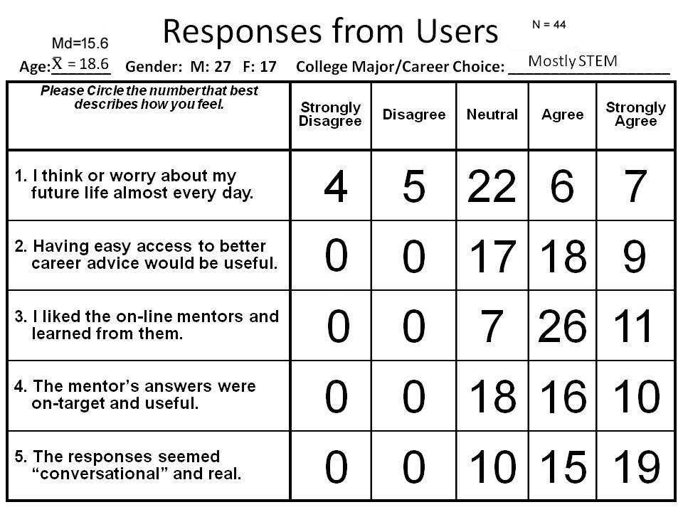
Table 2. Straw Poll Results

Research Directions: Potential Solutions to Limitations

Based on the results from testing with students so far, a number of possible approaches have been identified to improve the experience and information shared during a brief virtual mentoring session using this technology.

MentorPanel: Presenting Answers from Multiple Mentors
One challenge to virtual mentors is that learners are likely to talk to only one virtual mentor, particularly if they feel they did not find that mentor interesting. A series of one-on-one chats also makes it hard to see contrasting experiences. One approach to solve these issues is to consolidate mentors into a panel, where students can hear answers from several agents (see Figure 3). Each agent responds to the question and the most relevant and accurate answer is displayed. Students can then listen to the other mentors’ responses to get a wider variety of experiences and opinions. Students may also lock a mentor to engage in one-on-one dialog with that agent.

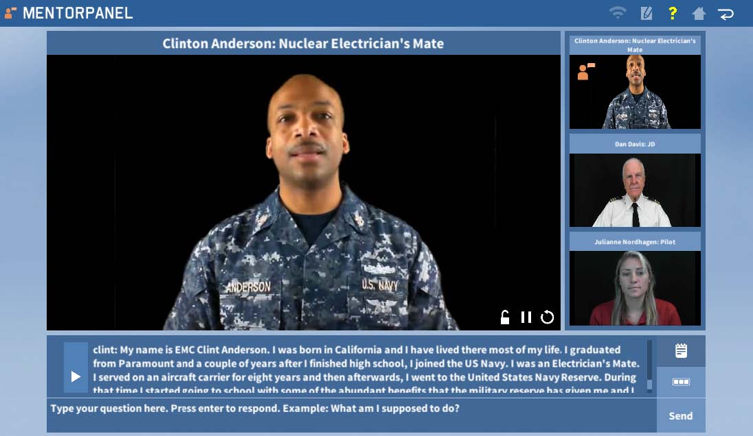
Figure 3. MentorPanel Prototype
The main benefit of this approach is that students hear from professionals spanning multiple STEM careers and see how those fields differ from each other. Students who lack exposure to STEM careers may not know which fields they can explore, and this approach will give them an overview of several different career paths. They can then dive into a specific career or mentor that interests them. Having multiple mentors should also reduce misses and vague answers, as mentors with irrelevant or low-scoring answers can be ignored in lieu of those with better responses (i.e., mentors without a good answer are grayed out).
A limitation of the panel dialog is the inability of mentors to interact with one another. The mentors are recorded separately so they cannot react to or discuss with other mentors. This makes conversations comparably one-dimensional and less engaging than they could be with a live panel. While some consideration has been made about how to approach the issue of non-interacting panelists, it would be fairly challenging to do using video-recorded mentors. However, virtual agent mentors (or a virtual agent moderator) could potentially be used to prompt mentor interactions such as opposing viewpoints.

Lesson Plans: Framing the Dialog
While the first mentors to be recorded addressed STEM careers with answers that fairly were cogent and compelling, users’ ability to ask good questions was a primary limiting factor. This suggests that there is a pedagogical issue which must be addressed. For example, when piloting this research with the Next Generation Leaders mentoring program, their instructors preceded the interaction with a brief exercise where students discussed their biggest role models and the kinds of questions that they would want to ask them. After the interaction, they then reinforced lessons-learned by having a discussion about what was most interesting and about what parts of careers the virtual mentor helped them think about. This was a novel interaction, and the research team is interested in seeing how different teachers might integrate this kind of technology into larger lesson plans for their students.
This strategy might also be possible for virtual mentors to follow. This would require the virtual mentor to pose significant questions and respond meaningfully to those responses. This situation brings us a whole new area of conceptualization and communication. At least for small question progressions, this might be accomplished even with video-based mentors. This could be done with limited recording time with a small set of standardized questions like “Who are mentors in your life?”, “What are you worried about for your career?”, or “What parts of a career do you think are most important?” While processing these would require careful attention to the scope, question asking has been done using this technology if kept well-bounded.

Conclusions

While a variety of improvements are possible, the system shows promise as a mentor amplifier: allowing an engaging set of mentors to communicate with a broader population of students. The experience at the STEM fair indicated that students engage more effectively with this sort of system one-on-one, but with a suitable introduction to the goals and interactions with the system. While the amount of time for such interactions is only moderate (e.g., up to 15 minutes), even for a small booth with five tablet computers students spent many cumulative hours speaking with the mentors (many more than the booth staff would have been able to accomplish alone). Given the limited availability of mentors and the desirability of instant access to a mentor on-demand, this particularly indicates that an on-line delivery system for mentors would be ideal, as the current version runs on-device.
A second point that is likely a strength of this model is the opportunity to capture particularly-engaging and compelling human mentors (even those who might no longer be available). For example, the case of Jaime Escalante, the renowned high school teacher of calculus. There are those who argue his skills were literally unique ones based on charisma and personal characteristics which cannot be readily taught or transferred to other teachers or role models (Jesness, 2002). Such mentors could communicate concepts for classroom instructor who would not have the same skill set.
A final issue is the reception of this approach from the teachers and community centers. It could be argued that the most effective implementation of this approach can only be realized with the support of the teaching community and existing networks for STEM mentors (Smith & Anderson, 2014). Such institutions are as a source for recruiting and recording mentors and as venues for encouraging interaction with virtual mentors. They would be the best suited to know who represent effective mentors for their student groups, where an ideal case might be to capture a highly-impactful real-life local mentor who is expected to become unavailable, e.g., move away, new family responsibilities. Toward that end, there is a strong interest in identifying how to help teachers and similar leaders record and refine mentors.

ACKNOWLEDGEMENTS

This work was supported by grants from the Office of Naval Research from the ONR STEM Program: N00014-16-1-2820. The statements and views in this paper are the views of the authors alone. Additionally, many thanks to the Armani Lab at the University of Southern California who organized the EngX STEM fair where MentorPal was exhibited.

REFERENCES

Dimitrova, V., and Brna, P. (2016): From Interactive Open Learner Modeling to Intelligent Mentoring: Style-OLM and Beyond. International Journal of Artificial Intelligence in Education 26(1), 332–349
Jesness, J. (2002): Stand and Deliver Revisited. Reason 34(3), 34–39
Kaimakis, N., Davis, D., Breck, S., Nye, B. (2018, Pending): Domain-specific Reduction of Language Model Databases: Overcoming Chatbot Implementation Obstacles. In: Proceedings of the ModSim World Conference.
Leuski, A., Traum, D. (2011): NPCEditor: Creating Virtual Human Dialogue using Information Retrieval Techniques. AI Magazine 32(2), 42–56
Mikolov, T., Sutskever, I., Chen, K., Corrado, G.S., Dean, J. (2013): Distributed representations of Words and Phrases and their Compositionality. In: Advances in Neural Information Processing Systems. pp. 3111–3119
Nye, B., Swartout, W., Campbell, J., Krishnamachari, M., Kaimakis, N., Davis, D. (2017): MentorPal: Interactive Virtual Mentors Based on Real-life STEM Professionals. In: Proceedings of the Interservice/Industry Simulation, Training and Education Conference (I/ITSEC). No. 17263, Springer
Rizzo, A., Lange, B., Buckwalter, J.G., Forbell, E., Kim, J., Sagae, K., Williams, J., Difede, J., Rothbaum, B.O., Reger, G., et al. (2011): Simcoach: an Intelligent Virtual Human System for Providing Healthcare Information and Support. International Journal on Disability and Human Development 10(4), 277–281
Smith, A., Anderson, J. (2014): AI, Robotics, and the Future of Jobs. Pew Research Center 6
Swartout, W., Traum, D., Artstein, R., Noren, D., Debevec, P., Bronnenkant, K., Williams, J., Leuski, A., Narayanan, S., et al ,Piepol, D.,. (2010): Ada and grace: Toward Realistic and Engaging Virtual Museum Guides. In: International Conference on Intelligent Virtual Agents. pp. 286–300. Springer
Traum, D., Jones, A., Hays, K., Maio, H., Alexander, O., Artstein, R., Debevec, P., Gainer, A., Georgila, K., et al. Haase, K., (2015): New Dimensions in Testimony: Digitally Preserving a Holocaust Survivors Interactive Storytelling. In: International Conference on Interactive Digital Storytelling. pp. 269–281. Springer
Wang, J., Li, H., Cai, Z., Keshtkar, F., Graesser, A., Shaﬀer, D.W. (2013): Automentor: Artificial Intelligent Mentor in Educational Game. In: International Conference on Artificial Intelligence in Education. pp. 940–941. Springer

