Virtual Mentors in a Real STEM Fair: Experiences, Challenges, and Opportunities *
Samuel Breck¹, Kayla Carr¹, Dan M. Davis², Julianne Nordhagen³, and Benjamin D. Nye⁴
¹ University of Southern California
{breck, kcarr}@usc.edu
² High Performance Computing in Education
ddavis@hpc-educ.org
³ University of Southern California Naval Reserve Oﬃcers Training Corps
nordhage@usc.edu
⁴ University of Southern California, Institute for Creative Technologies 12015 Waterfront Dr., Playa Vista, CA 90084
nye@ict.usc.edu
Abstract. Students in primary school often encounter a limited range of careers which are one or two degrees separated from their parents and schools. This means that students’ exposure to STEM careers is often limited to people who live nearby, often with a restricted range of socio-economic status and experiences. As a result, high socio-economic students are more likely to ﬁnd STEM role models and ﬁrst-hand knowledge about STEM career requirements and opportunities. The Mentor-Pal project is building a virtual version of a career fair where students can have a dialog with virtual agents, where each is constructed from videos of a real human STEM mentor. In a recent STEM event, approximately 80 students interacted with two interactive mentors. This demonstrated advantages to this approach, such as high engagement, drawing in students, and an apparent improvement in question quality for successive questions. However, it also showed limitations, which included the inability of the virtual mentor to ask the student questions, problems with mentor response misses (misunderstanding a question) and usefulness (giving a reasonable but less-informative answer to a vague question), and the diﬃculty for students to start asking questions initially. Potential solutions to these problems are outlined, such as a more advanced dialog system, employing a panel of multiple mentors, embedding the activity into a larger teacher-led lesson plan, and a structured activity led by the virtual mentor to ask questions from the student.
Keywords: Intelligent Agents · Mentoring · Virtual Agents · Natural
Language Processing
*
This work was supported by grants from the Oﬃce of Naval Research from the ONR STEM Program (N00014-16-1-2820). The statements and views in this paper are the views of the authors alone. Additionally, many thanks to the Armani Lab at the University of Southern California who organized the EngX STEM fair where MentorPal was exhibited.
S. Breck, K. Carr, D.M. Davis, J. Nordhagen, B.D. Nye
1 Introduction
There is a recognized shortfall in the number of Science, Technology, Engineering, and Math (STEM) professionals, for which many hypotheses have been advanced (Smith, 2017). These include negative images of technical personnel depicted by the media, lack of awareness of the range of STEM careers, and missing or mistaken notions of the actual working environments of both technical and non-technical professional ﬁelds. In many cases this is exacerbated by the lack of easy student accessibility to technical personnel, especially among students who are younger, who come from lower socio-economic-status households (SES), and those living in communities that are geographically remote from centers of technical activity (e.g., rural areas).
This paper discusses an activity where two complementary types of STEM outreach were combined. Speciﬁcally, a prototype STEM career mentor technology called MentorPal was set up as a booth during a to a person-to-person outreach event on a major university campus in an urban setting (i.e. the University of Southern California (USC) in downtown Los Angeles). Through both the use of the technology and by explaining the technology, researchers sought to increase the students’ awareness of the range of activities that STEM personnel perform, about the wide variety of personalities of technical personnel, and about the paths that lead to various technical careers.
This paper ﬁrst discusses the technology, reviewing some of the background research that informs MentorPal and how mentors are recorded and converted into computer-based interactive mentors. Next, it discusses insights from the STEM fair event, in terms of student reactions and interaction dynamics in that context. Finally, the paper discusses research in progress and potential future directions that might increase the eﬀectiveness of this research.
2 Related Work
The MentorPal project draws from earlier approaches using some of the same underlying natural language dialog technology, known as NPCEditor [4], which specializes in question-answering agents. An early use-case for NPCEditor technology was for an exhibit at the Boston Museum of Science called The Twins, where visitors interacted with dialog-based virtual agents who could answer questions about computer science and about how they worked [9]. Follow-up research adapted the underlying dialog technology to reproduce the experience of having an experience with Holocaust survivors, by delivering recorded video clips of the survivors as responses, as opposed to driving virtual characters [10]. These systems identiﬁed a variety of interactions and social dynamics, with a typical presentation including a facilitator who would work help a group of visitors take turns asking questions from the system. However, compared to these prior systems, MentorPal has been designed with a strong emphasis on lower cost (e.g., smaller question sets) and one-on-one dialog (e.g., limited testing with groups of users). Due to signiﬁcant diﬀerences in content and changing familiarity with technology by users (e.g., greater availability of useful virtual assistants), this STEM fair exhibit oﬀers a diﬀerent perspective on interactions with this kind of system.
In terms of placing this system in the broader literature on intelligent mentoring, the focus of MentorPal is on emulating the experience of an informational interview, such as the kind a student would have with a mentor at a career fair. This can be contrasted against mentoring systems that are designed to help students working on a speciﬁc project, such as AutoMentor [11]. It can also be contrasted against intelligent mentor agents who support metacognition as part of an open learner model [1]. Compared to these systems, MentorPal is not intended to build skills. Even among mentoring agents who also handle question asking and familiarization, such as the SimCoach system [7], MentorPal is distinct due to its focus on subjective experiences. Instead of a general description of STEM careers or ﬁelds, it is intended to help learners identify a mentor whose experiences resonate with them and that enables them to explore realistic visions of careers that they might pursue.
3 Approach: Building an Interactive Virtual Mentor from Recorded Videos
This section lays out our current methodology for asking questions, turning questions into transcripts, cleaning transcripts, feeding these into dialog models, and improving these models by classifying new paraphrases/aliases for questions (see: Figure 1). Building out an interactive virtual mentor from recorded videos takes up to approximately 20 hours of video footage to provide a broad coverage of responses, with approximately 60 hours of additional time for later processing: about 40 for preprocessing transcripts and 20 for post-processing dialog models. Because a long-term goal of this project is to enable recording any person as a mentor (without researcher intervention), improvements to the current pipeline are noted when discussing each step of the process.
3.1 Question Set and Recording
Our current question set consists of four types of questions: a) preset questions that are asked for all mentors (˜70% of questions), b) mentor-speciﬁc questions related to their career or life experiences (˜10% of questions), c) follow-up questions identiﬁed during the interview that seem relevant to responses given by a speciﬁc mentor (˜10% of questions), and d) mentor-speciﬁc common questions observed from chat logs by students with a mentor (˜10% of questions). The preset questions span a variety of topics detailed in Table 1. These questions are recorded across at least 5 sessions (each about 3h long) that have a mix of these topics, with a follow up section for each session. After the initial sessions, re-recording sessions are held to record new answers to bad video clips or to record answers to common questions that were not recorded (i.e., the fourth type of question). Each follow-up session typically lasts for about 45 minutes
S. Breck, K. Carr, D.M. Davis, J. Nordhagen, B.D. Nye
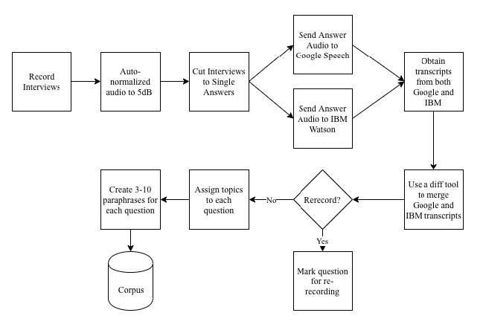
Fig. 1. Mentor Digitization Process
to an hour. These follow-ups are important because they assist with creating a more natural conversational ﬂow.
Recording currently involves calibration with help from project staﬀ in order to ensure that the recordings are consistent and the responses are appropriate to chunk into useful videos. Standardization includes ensuring that the mentor maintains a resting position 3 seconds before and after the question is answered. The resting position should be in the same spot throughout the recordings, to avoid “jumping” where a mentor’s next statement has a totally diﬀerent head or body position. In addition to this, the mentor is recommended to try to use emotion, smiles, stories, and hand motion to provide engagement. So far, each recording has been standardized by using the same low-cost equipment setup (webcam, microphone, backdrop), which is shipped to mentors who are located remotely. After recording, either the mentor (if remote) or research staﬀ upload the session ﬁles to cloud storage for post-processing. Overall, this approach has worked eﬀectively, with the quality of recordings and transitions signiﬁcantly higher than was initially anticipated. Sound quality has occasionally suﬀered, however: mentors have forgotten to activate the provided microphone (laptop internal microphone used instead) or used the microphone incorrectly (facing the wrong way for a directional microphone).
An area of improvement for this part of the methodology would be to try and move this to a standalone process where the mentor could record follow up questions themselves. This is challenging, because it is hard for a mentor to predict what follow-up questions a student might ask. An automated mechanism to help detect likely follow-up questions (e.g., detecting uncommon proper nouns) might help a mentor self-record more eﬀectively.
Topic | Example Question
Biographical | Where did you grow up?
Rapport | What qualiﬁcations, experience, do you look for when interviewing new people in this ﬁeld?
Career Advice | When you were my age, what did people tell you that you wished you had heeded?
Lifestyle | How can I work smarter?
Navy Speciﬁc | Why should someone choose to be a part of the Navy?
Motivation | What makes you proud?
STEM Speciﬁc | What STEM positions are available in the military?
Stories | What struggles did you overcome to get where you are?
Social | Can you date while on a ship?
Future | What sorts of changes are occurring in your occupation?
Education | What factors should I consider when deciding where I want to study?
Miscellaneous | How do I pay for education?
3.2 Preprocessing for Transcripts
This part of the pipeline turns each individual questions answer into transcriptions and video chunks. In order to prepare the sessions to run through our preprocessing python script, the answer to each question start time and end time are manually annotated. The python script then takes each .mp4 ﬁle and audio normalizes it with ﬀmpeg-normalize, chunks it up according to the timesheet document, converts the chunks into sound ﬁles (.wav) and then makes a call to IBM Watsons Speech-To-Text API. The call to the Speech-To-Text API takes around 1 hour to complete for 18 hours of footage. However, the bottleneck for this process is the manual cleanup of the transcription. The number of errors is signiﬁcant enough to warrant cleanup, at least if learners are meant to read the transcripts (important for deaf learners or users without sound). Moreover, the errors tend to be systematic: they happen most frequently for domain-speciﬁc terms about a career, for words that a mentor says with a regional accent, or where sound quality was poor. As a result, transcripts are manually edited by listening to the audio from the recordings. This process takes twice as long as recording, over 40 hours to edit 20 hours of video.
This part of the pipeline has the potential for the most improvement, given the magnitude of time cost. Currently, research is being done if other Automatic Speech Recognition services (e.g., Google ASR) would be an alternative or complement to IBM Watson (e.g., an ensemble model approach). Initial research on this has not yet produced positive results, but is still ongoing. In addition to changing the ASR, improvements on the translation cleanups could make better
S. Breck, K. Carr, D.M. Davis, J. Nordhagen, B.D. Nye
use of the translation conﬁdence to deﬁne a threshold to detect answers that need to be manually edited. In regards to improving the editing workﬂow, text diﬀ tools (ﬂagging diﬀerences) that could identify disagreements between two diﬀerent transcripts. Alternatively, audio-aligned text editors could be used to more rapidly parse transcripts, as opposed to searching for the part of the video that matches a poor transcription.
3.3 Post Processing for Dialogue Models
As shown in Figure 1, question and answer text pairs are used to produce neural-network classiﬁer data, NPCEditor data and metadata [4, 6], obtains the sparse topic vectors and dumps all this data into pickle ﬁles for use by the classiﬁer and topic neural network classiﬁer. The NPC Editor reads in data from NPCEditor data in order to handle diﬀerent paraphrases/aliases of the same questions, this model is used to handle diﬀerent direct matches. We manually create the paraphrases/alias based oﬀ of other ways that we think other people would ask the question. We also manually tag the classiﬁer and NPCEditor data from a bank of 40 predeﬁned topics that cover all broad categories of questions used in order to generate random questions by topic. An ensemble model classiﬁer chooses an answer from the two classiﬁers. Currently, it sends it to our NPC Editor Interface and our classiﬁer script to get answers from NPCEditor and the classiﬁer. Further description of these processes is contained in [6].
Research is ongoing to continue improving these processes. A particular issue with the classiﬁer was the desire to enable oﬄine mode on tablet devices. Unfortunately, the word vector models employed are typically too large to work on device in memory: the Google News Word2Vec model is 3.5 GB, for example [5]. To address this, our ensemble makes use of a systematically pruned version of Google’s Word2Vec model described in an upcoming workshop paper [3].
4 Example in Practice: EngX STEM Fair
The present version of the MentorPal system was tested with two mentors at an event called the EngX 2018 STEM Fair. The fair is part of a series of STEM events conducted over the last four years, led by the Armani Lab at the University of Southern California (USC). This year’s fair was attracted a broad range of students aged from eleven to eighteen years old. It was a full-day fair (8 AM -4 PM) held on a Saturday in March on an open quadrangle on the USC campus and attracted several hundreds of students, parents and teachers. There were over 20 booths, each with diﬀerent exhibits. The majority of exhibits were not computer-based, but were instead physical: water-powered rocket cars, pipe mazes with miniature robots, mirror-based holograms, and similar demonstrations.
Students arrived in varying-sized of groups to the various booths and some came alone, most in small groups and some were closely attended by one or more adults/parents. They were observed to be of varying socio-economic status, but tended to be above the mean of the spectra. Like many grade school students they seemed more attracted to interesting new experiences than sober contemplation on the career choices they were about to make. As such, in addition to using the system, many visitors were curious about the goals of the work and how it related to the students’ own interests (e.g., in computer science, or AI).
Turnout for the booth was high, with approximately 50% of passing groups stopping for a signiﬁcant span of time. This was likely partly due to being the primary AI-relevant exhibit, as well as due to a large banner poster (see images of the fair in 2). Three distinct types of interaction emerged when exhibiting MentorPal in this context: 1) group brieﬁngs on work with large screen display (typically 2 or more students per adult), 2) individual interactions with MentorPal on individual tablet computers (always students), and 3) individual discussions about the work and technical careers (more often initiated by parents than students). About one in ten groups went on to other booths, and then returned to ask more questions.
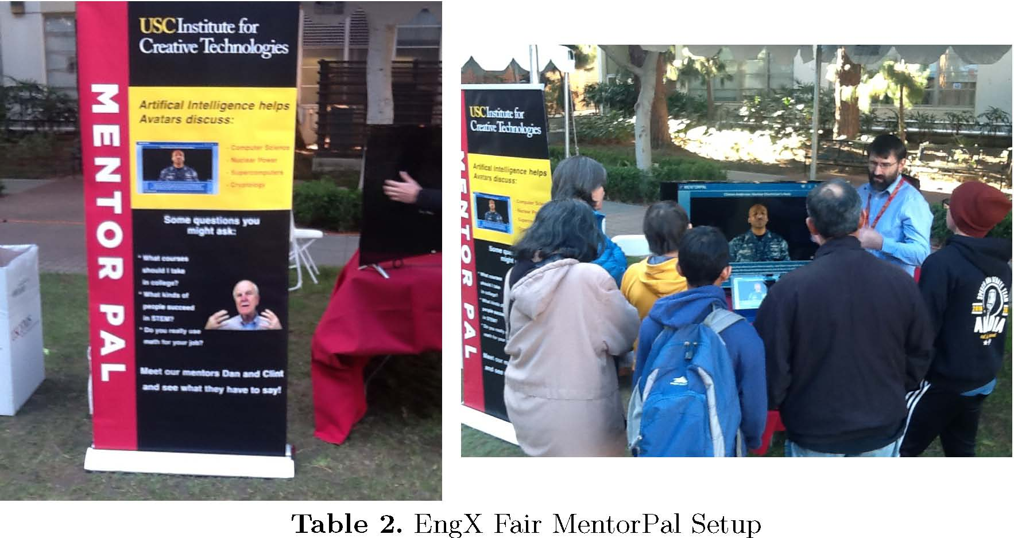
This exhibit reaﬃrmed ﬁndings from previous pilot testing where students often were unable to think of any useful questions for MentorPal (e.g., freezing or asking questions unrelated to careers). This was particularly relevant for students in a group setting where they were accompanied by parents. However, students were more productive when they used a menu that allowed generating questions from topic categories the team thought the students should be asking, as shown in Fig 2. In this mode of interaction, rather than entering free-text questions (or telling them to research staﬀ to type), they clicked on the topics to see suggested questions to ask.
For students using the system individually, they were content to ask questions from MentorPal for fairly long periods of time, approaching ﬁfteen minutes.
S. Breck, K. Carr, D.M. Davis, J. Nordhagen, B.D. Nye
However, it should be noted that these students were self-selecting. As the intent of the project was to create a conversational easiness with the student that would encourage the mentor-mentee relationship, one of the areas in which the team was most interested was the students’ view of their dialogue with the mentor. Since this usage was as an exhibit, rather than as a research study, no formal survey was done of their views.
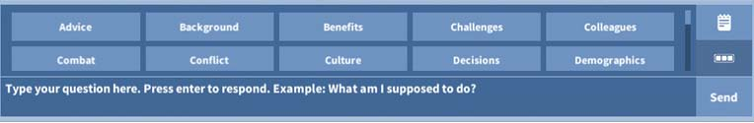
Fig. 2. Topic Selection Bar
However, to help gather feedback about how to improve the system and know visitor reactions, a straw poll was oﬀered to students and adults who spent substantial time interacting with the mentors (either individually or as part of a group). The results of this straw poll are summarized in Figure 3. To note, the age shown was the median age. Adults were more likely to complete the straw poll, while students were more likely to leave without ﬁlling out a poll. Overall, less than half of visitors who stopped for at least a minute took the straw poll (44 completed it, implying a lower bound of 80 visitors and likely more than 100). Reactions were positive overall for those who completed the poll, with 77% agreeing that the answers were conversational and 84% enjoying the experience. With that said, this sample is inherently biased: those who used the system for less time would likely also not spend time taking the poll, so this sample likely represents more motivated users.
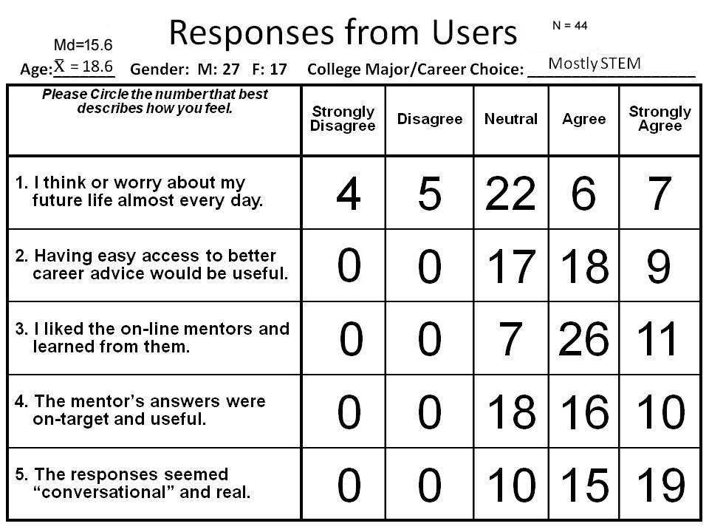
Fig. 3. Straw Poll Results
One new insight emerged from the MentorPal participation in EngX in terms of its potential impact on the prospective users. That was the interaction between the parents and the students. On the one hand, the booth crew reported that the parents were much more focused on the career choice facing their students. This seemed to drive productive questions from MentorPal on career selection and planning. However, this also caused the students to become more withdrawn and incommunicative (e.g., the parents talk, the students stand). While this is not hard evidence of such a trend, all of the booth crew reported the same impression. By comparison, one-on-one interactions between a student and the virtual mentor tended to separate the parent as an intermediary. The tradeoﬀ of this case was that students varied signiﬁcantly in how focused their questions were (e.g., more oﬀ-topic or asking about biographical details such as family members, rather than career focused).
Since students likely beneﬁt more from the one-on-one interactions (e.g., can ask their own questions), research is now looking into dialog techniques that help steer them toward more productive questions. Diﬀerent strategies are being considered, which include the importance-weighting and politician responses. Importance weighting would consider the research team’s assessment of the quality of the answer during the selection process (e.g., rather than answer the “best match” from the classiﬁer, instead use a weighted mixture that considers the content value). This should be particularly useful for vague questions, which are common for free text questions (e.g., “What do you like?”)
5 Research Directions: Potential Solutions to Limitations
Based on the results from testing with students so far, a number of possible approaches have been identiﬁed to improve the experience and information shared during a brief virtual mentoring session using this technology.
5.1 MentorPanel: Presenting Answers from Multiple Mentors
One challenge to virtual mentors is that learners are likely to talk to only one virtual mentor, particularly if they feel they did not ﬁnd that mentor interesting. A series of one-on-one chats also makes it hard to see contrasting experiences. One approach to solve these issues is to consolidate mentors into a panel, where students can hear answers from several agents (see Figure 4). Each agent responds to the question and the most relevant and accurate answer is displayed. Students can then listen to the other mentors’ responses to get a wider variety of experiences and opinions. Students may also lock a mentor to engage in one-on-one dialog with that agent.
The main beneﬁt of this approach is that students hear from professionals spanning multiple STEM careers and see how those ﬁelds diﬀer from each other. Students who lack exposure to STEM careers may not know which ﬁelds they can explore, and this approach will give them an overview of several diﬀerent career paths. They can then dive into a speciﬁc career or mentor that interests
S. Breck, K. Carr, D.M. Davis, J. Nordhagen, B.D. Nye
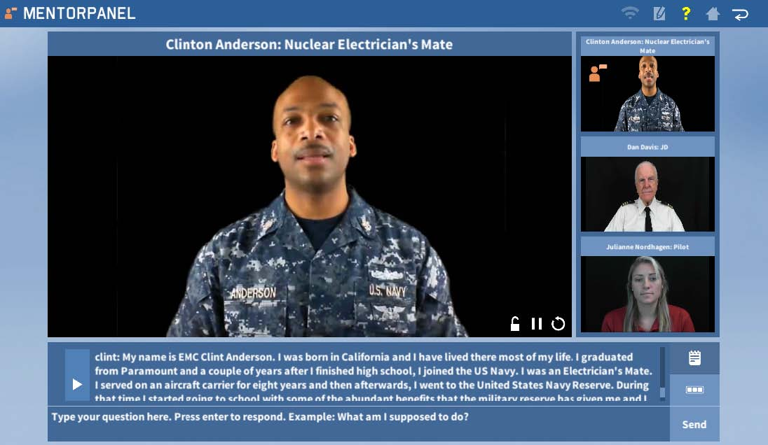
Fig. 4. MentorPanel Prototype
them. Having multiple mentors should also reduce misses and vague answers, as mentors with irrelevant or low-scoring answers can be ignored in lieu of those with better responses (i.e., mentors without a good answer are grayed out).
A limitation of the panel dialog is the inability of mentors to interact with one another. The mentors are recorded separately so they cannot react to or discuss with other mentors. This makes conversations comparably one-dimensional and less engaging than they could be with a live panel. While some consideration has been made about how to approach the issue of non-interacting panelists, it would be fairly challenging to do using video-recorded mentors. However, virtual agent mentors (or a virtual agent moderator) could potentially be used to prompt mentor interactions such as opposing viewpoints.
5.2 Lesson Plans: Framing the Dialog
While the ﬁrst mentors to be recorded addressed STEM careers with answers that fairly were cogent and compelling, users’ ability to ask good questions was a primary limiting factor. This suggests that there is a pedagogical issue which must be addressed. For example, when piloting this research with the Next Generation Leaders mentoring program, their instructors preceded the interaction with a brief exercise where students discussed their biggest role models and the kinds of questions that they would want to ask them. After the interaction, they then reinforced lessons-learned by having a discussion about what was most interesting and about what parts of careers the virtual mentor helped them think about. This was a novel interaction, and the research team is interested in seeing how diﬀerent teachers might integrate this kind of technology into larger lesson plans for their students.
This strategy might also be possible for virtual mentors to follow. This would require the virtual mentor to pose signiﬁcant questions and respond meaningfully to those responses. This situation brings us a whole new area of conceptualization and communication. At least for small question progressions, this might be accomplished even with video-based mentors. This could be done with limited recording time with a small set of standardized questions like “Who are mentors in your life?”, “What are you worried about for your career?”, or “What parts of a career do you think are most important?” While processing these would require careful attention to the scope, question asking has been done using this technology if kept well-bounded.
6 Closing Thoughts
While a variety of improvements are possible, the system shows promise as a mentor ampliﬁer: allowing an engaging set of mentors to communicate with a broader population of students. The experience at the STEM fair indicated that students engage more eﬀectively with this sort of system one-on-one, but with a suitable introduction to the goals and interactions with the system. While the amount of time for such interactions is only moderate (e.g., up to 15 minutes), even for a small booth with ﬁve tablet computers students spent many cumulative hours speaking with the mentors (many more than the booth staﬀ would have been able to accomplish alone). Given the limited availability of mentors and the desirability of instant access to a mentor on-demand, this particularly indicates that an on-line delivery system for mentors would be ideal (the current version runs on-device).
A second point that is likely a strength of this model is the opportunity to capture particularly-engaging and compelling human mentors (even those who might no longer be available). For example, the case of Jaime Escalante, the renowned high school teacher of calculus. There are those who argue his skills were literally unique ones based on charisma and personal characteristics which cannot be readily taught or transferred to other teachers or role models [2]. Such mentors could communicate concepts for classroom instructor who would not have the same skill set.
A ﬁnal issue is the reception of this approach from the teachers and community centers. It could be argued that the most eﬀective implementation of this approach can only be realized with the support of the teaching community and existing networks for STEM mentors [8]. Such institutions are as a source for recruiting and recording mentors and as venues for encouraging interaction with virtual mentors. They would be the best suited to know who represent eﬀective mentors for their student groups, where an ideal case might be to capture a highly-impactful real-life local mentor who is expected to become unavailable (e.g., move away, new family responsibilities). Toward that end, there is a strong
S. Breck, K. Carr, D.M. Davis, J. Nordhagen, B.D. Nye
interest in identifying how to help teachers and similar leaders record and reﬁne mentors.
References
1. Dimitrova, V., Brna, P.: From Interactive Open Learner Modelling to Intelligent Mentoring: STyLE-OLM and Beyondand beyond. International Journal of Artiﬁcial Intelligence in Education 26(1), 332–349 (2016)
2. Jesness, J.: Stand and deliver revisited. Reason 34(3), 34–39 (2002)
3. Kaimakis, N., Davis, D., Breck, S., Nye, B.: Domain-speciﬁc reduction of language model databases: Overcoming chatbot implementation obstacles. In: Proceedings of the ModSim World Conference. Springer (In Press)
4. Leuski, A., Traum, D.: NPCeditor: Creating virtual human dialogue using information retrieval techniques. Ai Magazine 32(2), 42–56 (2011)
5. Mikolov, T., Sutskever, I., Chen, K., Corrado, G.S., Dean, J.: Distributed representations of words and phrases and their compositionality. In: Advances in neural information processing systems. pp. 3111–3119 (2013)
6. Nye, B., Swartout, W., Campbell, J., Krishnamachari, M., Kaimakis, N., Davis, D.: Mentorpal: Interactive virtual mentors based on real -life stem professionals. In: Proceedings of the Interservice/Industry Simulation, Training and Education Conference (I/ITSEC). No. 17263, Springer (2017)
7. Rizzo, A., Lange, B., Buckwalter, J.G., Forbell, E., Kim, J., Sagae, K., Williams, J., Difede, J., Rothbaum, B.O., Reger, G., et al.: Simcoach: an intelligent virtual human system for providing healthcare information and support. International Journal on Disability and Human Development 10(4), 277–281 (2011)
8. Smith, A., Anderson, J.: Ai, robotics, and the future of jobs. Pew Research Center 6 (2014)
9. Swartout, W., Traum, D., Artstein, R., Noren, D., Debevec, P., Bronnenkant, K., Williams, J., Leuski, A., Narayanan, S., Piepol, D., et al.: Ada and grace: Toward realistic and engaging virtual museum guides. In: International Conference on Intelligent Virtual Agents. pp. 286–300. Springer (2010)
10. Traum, D., Jones, A., Hays, K., Maio, H., Alexander, O., Artstein, R., Debevec, P., Gainer, A., Georgila, K., Haase, K., et al.: New dimensions in testimony: Digitally preserving a holocaust survivors interactive storytelling. In: International Conference on Interactive Digital Storytelling. pp. 269–281. Springer (2015)
11. Wang, J., Li, H., Cai, Z., Keshtkar, F., Graesser, A., Shaﬀer, D.W.: Automentor: artiﬁcial intelligent mentor in educational game. In: International Conference on Artiﬁcial Intelligence in Education. pp. 940–941. Springer (2013)

