Reduction of Language Model Data Bases:
Overcoming Chabot Implementation Obstacles

Nicholas J. Kaimakis & Samuel Breck | Dan M. Davis
ICT/Univ. of Southern California | HPC-Education/USC
Los Angeles, California | Long Beach, California
{kaimakis,breck}@usc.edu | dmdavis@acm.org

ABSTRACT

This paper addresses optimization of language model data bases for use in Chatbots. The manifest utility and resultant proliferation of Chatbots is based on their users’ ability to conversationally interface with computational assets. However, there is a concomitant pressure to reduce the size and increase the speed of client side devices. The currently widespread and rapidly growing acceptance of Chatbot approaches and the possibility of their implementation in DoD applications make this area vital to many who are engaged in Defense work. Not only is natural language processing a computationally expensive task, but storing language data takes up a sizeable amount of storage space and data base sizes do have an effect on search and retrieval times. A Chatbot must be able to understand and respond to a variety of unique user inputs and do so within the limits of conversationally tolerable latencies. The difficulty comes in trying to balance an effective chat agent while optimizing storage for peak performance. This paper discusses various methods of reducing language models, focusing on the Google News Word2vec model. Various methods were implemented in attempts to allow domain-specific analyzation and communication without the storage overhead of the significantly larger comprehensive models. We will document and analyze the history of improvements in similar efforts, set forth potential approaches, discuss our solutions within our environment, quantify impacts of the implementation of the selected approaches, outline future applications, and suggest topics for further research on the subject. The paper closes by offering the ways in which others can adopt this approach to their own efforts.

ABOUT THE AUTHORS
Nicholas Kaimakis is active in research at the Institute for Creative Technologies of the University of Southern California. His current research thrusts are in the use of computer generated avatars or video clips, animated and directed by natural language optimized Artificial Intelligence (A/I) programs that present a life-like dialogue capability to interact with remote users via the internet. He has demonstrable success designing efficient project structures, teaching programming, and managing multi-faceted teams. His current project is funded by the Navy and is designed to help improve knowledge of STEM fields across varied demographics with the development of an interactive interface that makes STEM information more accessible on-line. He is an undergraduate student studying Computer Science (CS) within the Viterbi School of Engineering at the University of Southern California.
Dan M. Davis is a consultant for the University of Southern California, focusing on large-scale distributed DoD simulations. Pre-retirement, for a decade he was the Director of USC’s JESPP project for JFCOM. As the Assistant Director of the Center for Advanced Computing Research at Caltech, he managed Synthetic Forces Express, bringing HPC to DoD simulations. Prior experience includes serving as a Director at the Maui High Performance Computing Center and as a Software Engineer at the Jet Propulsion Laboratory and Martin Marietta. He has served as the Chairman of the Coalition of Academic Supercomputing Centers and has taught at the undergraduate and graduate levels. As early as 1971, Dan was writing programs in FORTRAN on one of Seymour Cray’s CDC 6500’s. He saw duty in Vietnam as a USMC Cryptologist and retired as a Commander, Cryptologic Specialty, U.S.N.R. He received B.A. and J.D. degrees from the University of Colorado in Boulder.
Samuel Breck is a Research Assistant at the Institute for Creative Technologies of the University of Southern California. His major research interests are any platforms involved with natural language processing and the upcoming infrastructural challenges smart cities will face. He has been an intern at several tech companies including PlayStation and lives in the Bay Area. He anticipates receiving a BS degree in Computer Science from the Viterbi School of Engineering, University of Southern California in May 2019.

Reduction of Language Model Data Bases:
Overcoming Chabot Implementation Obstacles

Nicholas J. Kaimakis & Samuel Breck | Dan M. Davis
ICT/Univ. of Southern California | HPC-Education/USC
Los Angeles, California | Long Beach, California
{kaimakis,breck}@usc.edu | dmdavis@acm.org

Introduction
1 page (Dan)
Enhancements in Artificial Intelligence (A/I) and Natural Language Processing (NLP) have now reached the stage that large-scale implementations are increasingly seen as imminent challenges (Traum et al., 2015). That, coupled with the iniquitousness of hand-held devices such as tablets, MP3 players and smart-phones has brought to the fore the issue of not over-burdening these limited resources with data storage and data transfer obligations that would tax their memory storage limits and bandwidth constrictions. The Institute for Creative Technologies (ICT) of the University of Southern California (USC) has been engaged by the Office of Naval Research to conduct research on producing a computer-generated mentor capable of sustaining a conversational series of responses to secondary students who seek mentorship in making their choices of careers, especially those who may be amenable to a selecting a career in one of the STEM (Science, Technology, Engineering, and Math) disciplines. The Navy has, for reasons not driven by this project, decided this capability should be provided by the MicroSoft Surface® line of tablet computers. With no further direction, USC assumed that they should make their program function on one of the smaller memory configurations and on several generations of the MS Surface line. The constrained power, RAM and secondary memory of these small portable devices mandates optimal sizing of all processes and data storage and transfer (Nye et al., 2017).

The basic objective of the project is to provide a proof-of-concept version of career mentoring to student who may otherwise have no or severely limited access to an advice or mentoring as they face the daunting task of selecting a career. The final goal is to increase the number of technically trained personnel for duty in the uniformed services of the Department of the Navy and civilian researchers for the DoD. To accomplish this, prospective career candidates may make other choices if they do not have someone to whom to speak who is experienced in and feels positively toward the desired careers. Especially negatively impacted will be those students who, for want of access to a technical professional, may not consider and therefore not select a STEM career. The reason for such lack of access may be due to a number of reasons, the two most prevalent of which the authors hold to be: geographic remoteness and low Socio-Economic Status (SES) (Crisp, 2009). The authors spoke with a school counselor from a small city in Colorado, population 16,000, and she confirmed that her experience was that virtually no STEM professionals were available to her students in this remote area, the economy of which was based on agriculture and tourism. Similarly, one of the authors spoke to a low SES high school biology class in the Los Angeles Basin. He was told by the staff there that they had had little success in recruiting high-achieving STEM professionals to come to their school to speak and mentor students.
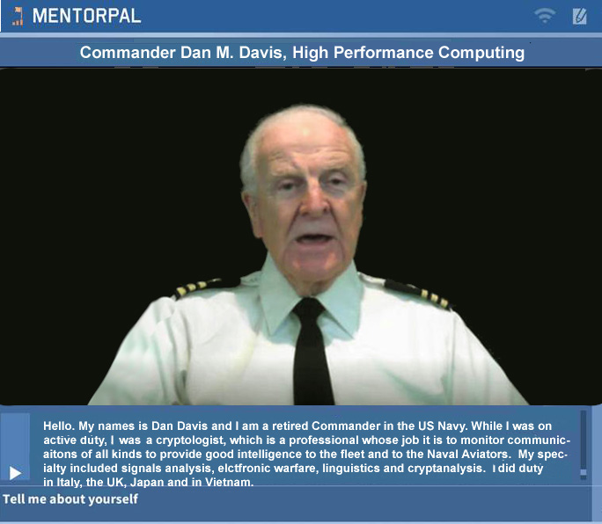
The solution advance by ICT, and the focus of this paper, was to produce a computer-generated mentor to be available via any Windows operating system with the appropriate software installed. The student user would be presented with a computer screen interface via which he could engage a mentor in a conversation-like exchange about issues of concern. Input from the student would be via text entry on a keyboard or speech recognition software via an attached microphone. This mentor was designed to be both compelling and engaging. The major raison d’être for ICT was its coordination with the creative community in the LA Basin and the scholastic expertise available from USC’s schools that provided education for the leadership of that community. ICT advanced the position that the mentors would be most compelling and engaging if they were real people, recorded live and demonstrated the unquantifiable qualities of screen presence and personal charisma.
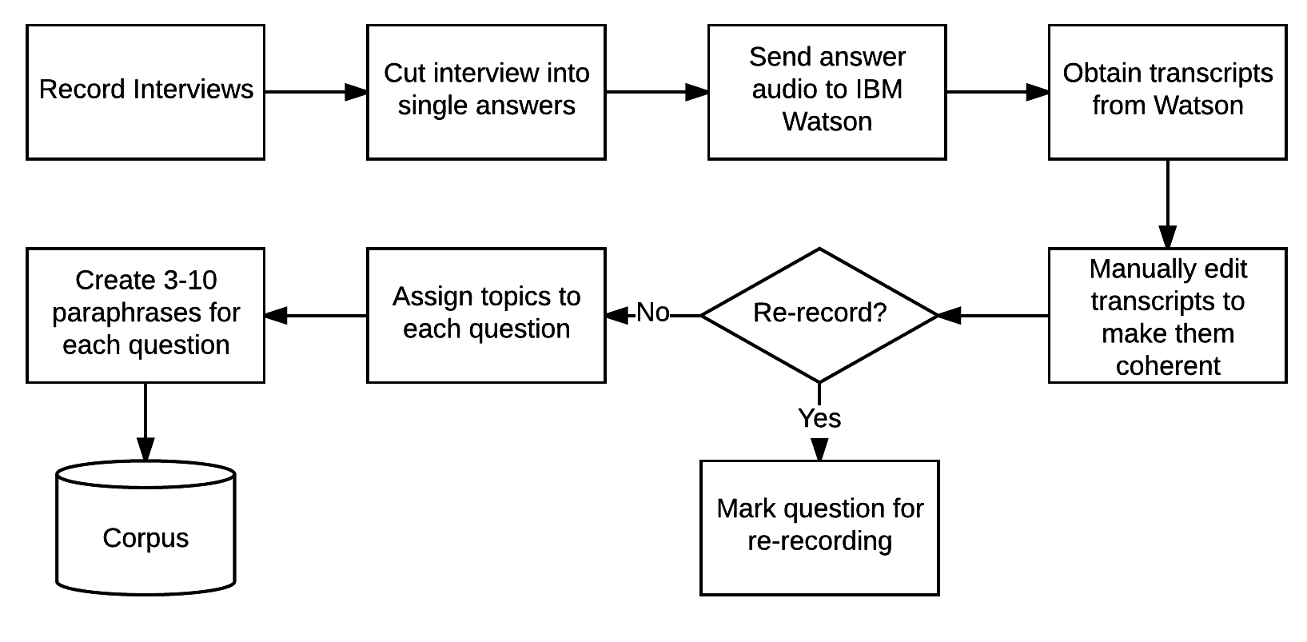
Figure 2 – Developing the Questions (Nye et al., 2017)
First, a long (500 -1500) questions would be generated. This requires a certain knowledge of both the questions that are relevant to the profession of the mentor and to the questions the target users are likely to ask. In MentorPAL, the team got input from several members who had technical and Navy experience to generate a long list of questions. A previous paper discussed this process at greater length and provided the flow diagram in Figure 2. It reveals some of the detailed steps in characterizing the answers and providing paraphrased questions to which this answer would also pertain. This process is somewhat lengthy and requires a significant amount of staff and mentor commitment.

The mentors would then record a large (~500) video clips relating to their experience in the Navy and their background in their own STEM professions. These clips are then stored in a well ordered data base. When the student user poses a question, e.g. “Are you happy with your career in the STEM field of your choice?”, the program uses technology previously developed at ICT and relying on NLP to select the most appropriate clip to play. This must be done very rapidly to sustain the desired “conversational” effect of the exchange. The clips were designed to be on the order of 90 seconds or less. This technology rests on previous research into the use of Virtual Humans acting as program interfaces in counseling (SimCoach cite) and in history capture (Artstein et al., 2013) The members of the Mentor PAL research team have fallen into the imprecise habit of referring to the videotaped mentors as Virtual Humans. While they are actually real people, for the remainder of this paper, we will expand the term Virtual Human to include our quasi-Virtual Human mentors, thereby sparing the reader’s having to differentiate the artifice of an acronym like “qVH” from the more virtual entities.

With significant effort and input from ICT professionals and several student Research Assistants, the program was implemented and made ready for Alfa Testing. The site selected was a local educational counseling and tutoring entity named Next Generation Leaders of Culver City California. This site provided access to pre-college students from middle and upper SES families who were committed to collegiate education and careers. The students who participated were all asked to use both the question entry method and to select pre-loaded sample questions from a menu. This latter function was added after early testing and personal experience of the authors indicated that many high school students have very little idea of what questions were important to resolve in choosing a career. After adding this function, it was observed that most of the users preferred the method of selecting off of the suggestion list to typing in their own questions. An expansion of this capability is being explored.
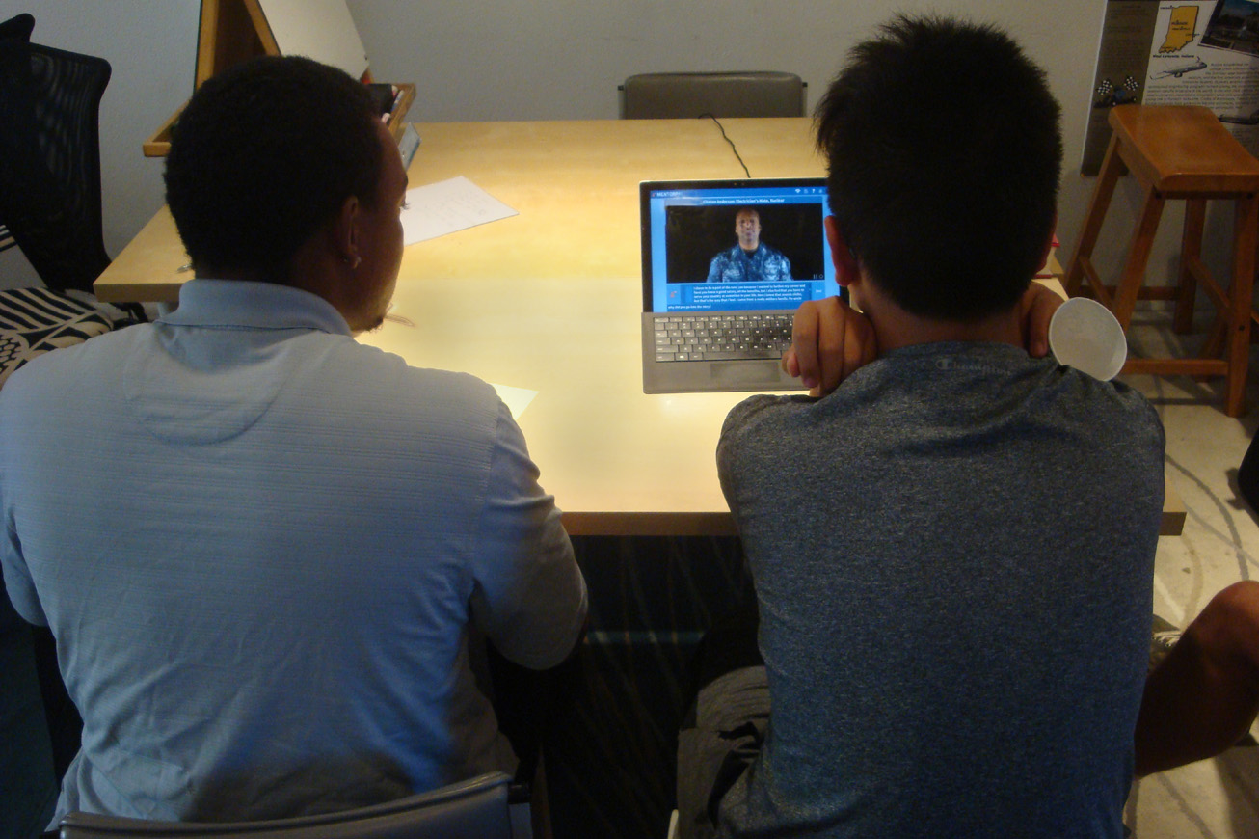

Current Impediments
1-2 Pages(Dan)

Hindrances

The Alfa Tests and bench mark testing quickly reviewed several issues. The first of these was instability and the second was significant and disruptive delays in the responses being cued up and played for the user. The initial joint wisdom of the programming team was that the large data bases being used could be causing both of these failures, due to the limited capacities of the hardware that was chosen for the target platform. There were interim changes made to the program to try to ameliorate these problems and some progress was perceived, but could not be verified without subsequent testing. Now the imprecise definition of Alfa and Beta testing comes into play. The authors assert that these subsequent tests were really a series of Alfa Tests and that the code has not yet achieved enough of the desired capability to constitute a useable product and justify a Beta test. These remediation processes included bug fixes, additional algorithm training, and benchmarking to establish progress.

There are three major modules in Mentor PAL’s code: 1) the NPCEditor was used and it is an ICT program developed which provides a spoken language interface enabling virtual humans to engage with users. (Leuski and Traum, 2011), 2) the neural network classifier is domain-specific and it is designed to match the user’s question with an appropriate answer, and then 3) a module that combines numbers 1 and 2, by making a choice as to the optimal mentor response clip to play to the user. There are also functions to take appropriate actions to make the process seem more “conversational, e.g. the student’s not asking a question for an awkward amount of time, or using profanity. Sometimes the students ask off-topic questions and this needs a sophisticated analysis based on ICT’s focus on narrative and conversational flexibility. While not critical for career decisions, many students ask questions like “Did you ever kill anyone in the military?” or “What kind of dancing do you like?”. The issue is: Do these merit an answer to establish the humanity of the mentor or are they disruptive and require a “… let’s get back to careers ...” retort? The third module is basically a script that acts as the system controller and monitors for user inputs. The NPCEditor and the classifier are charged with selecting the answer which they think is the best response and quantifying their confidence in that choice. The NPCEditor gets the first cut at a choice and that is used if the confidence is sufficiently high. If confidence is low, the system defaults to the classifier. NPCEditor can act as the final filter for issues such as repeated questions or profanity if these are not filtered out earlier. Preliminary testing indicated a current correct response rate of about 50%, but many students report that even some of the “wrong” answers were interesting and useful. The action that did cause frustration, and was manifestly demotivating, was any instance of several “I don’t know.” responses in a row. A remedial filter for this problem has been conceived and set to be implemented in the future.
Data
One of the major issues noted was the retrieval of data from a series of very large databases. Any data evolution has three major parameters: size, search time, and bandwidth (Zhang 2014). Any negative impacts from the first two of these, size and retrieval time, are the ones most amenable to software amelioration. They are also the two that are most constrained by hardware constraints in small, portable computers. As rapid response is a sine qua non of conversational Virtual Humans, optimization of data flow to mitigate any delays occasioned by both of these parameters is central to the success of Mentor PAL. Many of the data bases elements were not of sufficient use to the program to retain them in the limited space available. Naturally the fear was that removing them would decrease the percentage of the correct and useful response to the questions posed by the students. This then, is the central issue addressed by this paper: How can data and the flow thereof be disciplined in a way that gave the best performance without sacrificing either utility or conversational quality.
Other Overheads
Of course, data size was not the only parameter of interest. There were several ancillary functions that impacted the programs performance on small tablets (Forman & Zahorjan, 1994). Many of these were also critical to program efficiency. Early decisions involved off-loading many functions on to a remote server, with the concomitant need to provide communication control and to minimize data and instruction transfers that would tax CPU capabilities, I/O controllers and bandwidth limits. The team discussed many solutions including: using more powerful platforms, making the entire process web-based, and reducing functionality to make the program “fit” on the MS Surface platform. As with any system, any change in the system must be made in the light of the impact that change will make on the entire system. It must then be tested with users to find if the intended effect was realized and no unanticipated problems were created by the change.

Model Reduction Needs
1 page (Nick)

Previous approaches
1-2 pages (Nick)

New approach and resulting models
2-3 pages (Nick)

Further impact and future research
opportunities 1-2 pages (Dan and/or Sam)
The authors assert that these observations and this research portend future impacts in two dimensions: 1) the expansion of the use of the technology of the underlying research project, MentorPAL, i.e. the provision of conversational avatars to replace or augment human mentors or advisors; 2) the extension of the process of optimizing or minifying data bases for other uses, particularly where computing assets are limited for one reason of the other. Discussion of these items will be presented seriatim.
The concept of a conversational interface in a computer is familiar with most people in the industrial world. The last few decades of the 20th Century was replete with fictional representations of such interfaces, albeit with out a video representation of the avatar. Two of the most familiar are the HAL computer in Arthur C. Clark’s 2001, A Space Odyssey (Kubrick & Clarke, 1968)and the device addressed simply as “Computer” in the Star Trek series (Rodenberry, 1966-69). Voice recognition and response generation have now caught up with the earlier science fiction vision of computers with whom one can talk. These are most familiar in terms of Alexa, Siri et alii (Hoy, 2018). The above cited research goes significantly farther, achieving a more conversational exchange and providing a more “human” sensitivity and constructive advice. The authors feel that, as costs and decreasing availability of qualified personnel constrain the provision of these two important factors in life, there will be a expansion of the use of computers to provide them. The above project focuses on academic and career counseling, but other projects have focused on delivering patient-centered counseling for PTSD patients (Moibini et al., 2012) and on capturing the memories of holocaust survivors (Traum, et al., 2015). The need for mentoring in many fields has also been established, particularly in the services (Dougherty & Dreher, 2007). Other types of counseling and therapies come readily to mind. Were these to be made manifest and ported to increasingly small personal computing devices, the need for optimization of data usage seems patently obvious, even when advances in hardware are considered. There will very likely be a concomitant increase in demand for more extensive, facile and efficient data capabilities. On-going future research is anticipated in the all of the areas addressed above.
Within this project, the future is here already. At weekly team meetings, there is a consistent drum beat relating to the necessity for more answer alternatives, more germane answers, better understanding of context, and more variability to serve the individual user’s needs and proclivities. This is addition to the ever-present need for more speed (users are uncomfortable with awkward latencies) and an evolving dynamic of a responsiveness to the change in context depending on what has already been said. Another area of growth is the ability to recognize body language symbology, voice tone, and facial expression of the user and response modification to best address those issues. These are all inputs that are important to live mentors or counselors. But they will require additional data resources, all of which could be enabled by the minification work discussed above. Also there is the area of realistic modification and projection of the mentor and their setting. There is a field of research that would seek out the possible impacts of the appearance of the mentor (age, SES, language, accent, gender, ethnicity, etc.) and the nature of the surrounding background (office, workplace, casual rest area, etc.). All of these are indicia that there will be an unending need for efficacy in the data manipulation discipline.

Future research
opportunities 1 page (Sam)

Conclusion

Acknowledgements

(Nick)
The authors want to acknowledge the leadership and support from the two co-Principal Investigators, William Swartout, PhD and Benjamin Nye, PhD. Their counsel for us and patience with us were invaluable. They contributed ideas and data that were included in the data listed above. Much of the work described above was conducted in response to Office of Naval Research contract: Mentor PAL: Growing STEM Pipelines with Personalized Dialogs with Virtual STEM Professionals, N00014-16-R-FO03. The opinions expressed herein are the authors’ own and do not necessarily reflect those of the Department of the Navy or the U.S. Government.

References

Artstein, R., Traum, D., Alexander, O., Leuski, A., Jones, A., Georgila, K. Debevec, P, Swartout, W. & Smith, S. (2014, February). Time-offset interaction with a Holocaust survivor. In Proceedings of the 19th international conference on Intelligent User Interfaces (pp. 163-168). ACM.
Crisp, G., Nora, A., & Taggart, A. (2009). Student characteristics, pre-college, college, and environmental factors as predictors of majoring in and earning a STEM degree: An analysis of students attending a Hispanic serving institution. American Education Research Journal, pp 924-942.
Dougherty, T. W., & Dreher, G. F. (2007). Mentoring and Career Outcomes. The Handbook of Mentoring at Work: Theory, Research and Practice, 51-93. Sage Publications, Thousand Oaks, California.
Forman, G. H., & Zahorjan, J. (1994). The challenges of mobile computing. Computer, 27(4), 38-47. (April, 1994)
Hoy, M. B. (2018). Alexa, Siri, Cortana, and More: An Introduction to Voice Assistants. Medical reference services quarterly, 37(1), 81-88.
Kubrick, S., & Clarke, A. C. (1968). 2001, A Space Odyssey. United States of America: Metro-Goldwyn-Meyer. Culver City, California
Leuski, A., & Traum, D. (2011). NPCEditor: Creating virtual human dialogue using information retrieval techniques. AI Magazine, 32(2), 42-56.
Morbini, F., Forbell, E., DeVault, D., Sagae, K., Traum, D. R., & Rizzo, A. A. (2012, July). A mixed-initiative conversational dialogue system for healthcare. In Proceedings of the 13th Annual Meeting of the Special Interest Group on Discourse and Dialogue (pp. 137-139). Association for Computational Linguistics.
Nye, B., Swartout, W., Campbell, J., Krishnamachari, M., Kaimakis, N. and Davis, D. (2017). "MentorPal: Interactive Virtual Mentors Based on Real -Life STEM Professionals ." in the Proceedings of the Interservice/Industry Simulation, Training and Education Conference, Orlando, Florida, 2017
Roddenberry, G. (Writer), (1966-60). Star Trek. : Norway Productions and DesiLu Productions (Producers). Los Angeles California: National Broadcasting Company.
Traum, D., Jones, A., Hays, K., Maio, H., Alexander, O., Artstein, R., Debevec, P., Gainer, A., Georgila, K., Haase, K., Jungblut, K., Leuski, A., Smith, S., & Jungblut, K. (2015, November). “New Dimensions in Testimony: Digitally Preserving a Holocaust Survivor’s Interactive Storytelling.” In International Conference on Interactive Digital Storytelling (pp. 269-281). “Springer International Publishing.
Zhang, S., Yang, Y., Fan, W., & Winslett, M. (2014). Design and implementation of a real-time interactive analytics system for large spatio-temporal data. Proceedings of the VLDB Endowment, 7(13), 1754-1759.

