D-Wave upgrade: How scientists are using the world’s most controversial quantum computer
Scepticism surrounds the ultimate potential of D-wave machines, but researchers are already finding uses for them.
- Elizabeth Gibney
24 January 2017
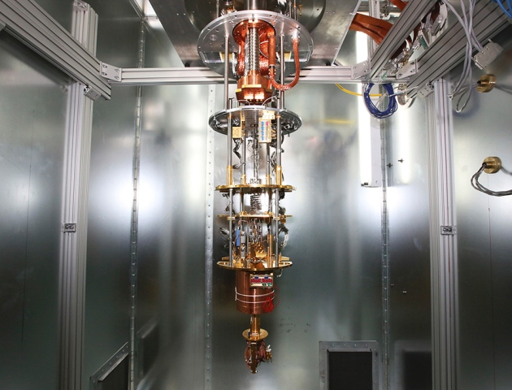
Kim Stallknecht/The New York Times/eyevine
D-Wave’s latest processor has 2,000 qubits — far surpassing the capacity of previous models.
The company that makes the world’s only commercially available quantum computers has released its biggest machine yet — and researchers are paying close attention. Named 2000Q after the number of quantum bits, or qubits, within its processor, the machine, made by D-Wave of Burnaby, Canada, has almost twice as many qubits as its predecessor. Many researchers remain sceptical about the long-term potential of such machines, whose approach differs from that of other nascent quantum computers. But others are already booking time on D-Wave’s computers to explore challenges from machine learning to cybersecurity.
Moreover, improvements to 2000Q, the company’s fourth-generation machine, are largely a result of researchers’ feedback.

“We’re providing guidance as a community of scientists,” says Davide Venturelli, a physicist at the NASA Ames Research Center. Venturelli manages a scheme run by the non-profit Universities Space Research Association (USRA) in Washington DC that lets external researchers access a joint NASA–Google D-Wave machine.
D-Wave is also working on a fifth model, which it hopes will answer critics by providing even greater capacity and connectivity and a closer fit to scientists’ needs. Likely to launch within two years, the machine will again double the number of qubits, to around 4,000. Crucially, it will also provide more-complex connections between qubits, allowing it to tackle more-complicated problems.
“Changing the underlying connectivity is going to be a game-changer,” says Mark Novotny, a physicist at Charles University in Prague, who is exploring a D-Wave machine’s applications to cybersecurity. “I’m basically drooling hoping for it. It’s very exciting.”

Related stories
- Quantum computers ready to leap out of the lab in 2017
- Inside Microsoft’s quest for a topological quantum computer
- Quantum computer makes first high-energy physics simulation
More related stories

Related stories
- Quantum computers ready to leap out of the lab in 2017
- Inside Microsoft’s quest for a topological quantum computer
- Quantum computer makes first high-energy physics simulation
More related stories
D-Wave machines have attracted scepticism as well as excitement since they went on sale six years ago. So far, researchers have proved that, for a problem crafted to suit the machine’s abilities, the quantum computer can offer a huge increase in processing speed over a classical version of an algorithm (V. S. Denchev et al. Phys. Rev. X 6,031015; 2016). But the computers do not beat every classical algorithm, and no one has found a problem for which they outperform all classical rivals.
D-wave’s qubits are much easier to build than the equivalent in more traditional quantum computers, but their quantum states are also more fragile, and their manipulation less precise. So although scientists now agree that D-wave devices do use quantum phenomena in their calculations, some doubt that they can ever be used to solve real-world problems exponentially faster than classical computers — however many qubits are clubbed together, and whatever their configuration. The uncertainty hasn’t stopped the number of users growing: last September, around 100 scientists attended D-Wave’s first users’ conference in Santa Fe, New Mexico.
Existing D-Wave computers are located in the United States, but researchers globally can access them remotely, including through schemes such as the USRA’s. The machines are attracting new kinds of researcher, says Venturelli, who uses one of them to try to find the best way for rovers to autonomously schedule operations and manage time. “Universities with nothing to do with quantum physics are now trying their algorithms,” he says.
Unlike other quantum computers, D-Wave is suitable only for solving certain tasks, known as optimization problems. To find optimal solutions, researchers first put qubits, made of superconducting loops, into their lowest energy state, in which each is in a quantum superposition of both ‘on’ and ‘off’. Magnetic fields that represent the problem then gently nudge this state towards a new one — a process known as quantum annealing. The state evolves while maintaining its low energy such that when it eventually ‘collapses’, it should leave qubits in the best configuration for solving that problem. Because the system sifts every possible answer at once, in theory it could be a faster way to resolve problems that, when solved classically, get exponentially harder with each added variable. But posing research questions in a form that the machine can handle often means using several qubits to represent a single variable, limiting the size of the problems it can handle.
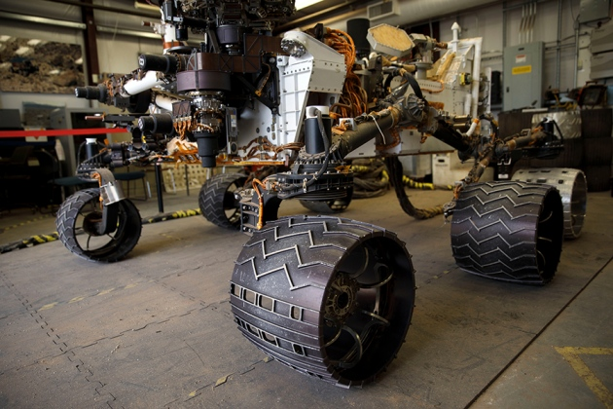
Patrick Fallon for Nature
A D-Wave machine is exploring how planetary rovers can autonomously manage schedules and time.
“Quantum computing is a new tool,” says Novotny. “So, part of what we’re doing is just trying to figure out how we can use it.” He works on machine-learning algorithms known as Boltzmann machines, used to study patterns in online traffic and identify cyberattacks. So far, for small examples, his group has been able to show that D-Wave’s machines can be more efficient than their classical counterparts, detecting likely attacks more quickly, he says.
D-Wave’s latest iteration includes an upgrade that Novotny has been clamouring for. The feature gives more control when different groups of qubits go through the annealing process. In at least one case, D-Wave has shown that this can speed up certain calculations 1,000-fold. For Novotny, the feature is crucial because it will allow his team to “sample” qubits during the process, which opens the door to D-Wave exploring a different type of machine-learning algorithm that could learn to recognize much more complex patterns of cyberattacks.
But researchers want greater connectivity. Currently, each qubit in the processor can ‘talk’ to only six others, says Scott Pakin, a computer scientist and D-Wave scientific and technical lead at the Los Alamos National Laboratory in New Mexico, which has had a D-Wave computer since August. “The richer the connections, the easier and faster it is to get problems onto the D-Wave. So that’s top of my wish list.”
D-Wave is redesigning its fifth processor to increase connectivity significantly, says Jeremy Hilton, the company’s senior vice-president responsible for technology. And because this upgrade involves a hardware overhaul, it will have an additional benefit: allowing the firm to expand beyond the 10,000-qubit limit imposed by the current processor’s design in future machines, he adds.
D-wave machines are a long way from showing the exponential speed increase over classical computers that their advocates hope to see. But in a paper posted on 17 January and not yet peer-reviewed, a D-Wave team claimed the 2000Q could find solutions up to 2,600 times faster than any known classical algorithm (J. King et al. Preprint at arXiv https://arxiv.org/abs/1701.04579; 2017). Now the onus will be on sceptics to try to find a faster classical algorithm. “All I know is that, in the now two or three previous cases where we were in this same situation, it did turn out that a different classical solver eliminated the claimed gap,” says Scott Aaronson, a computer scientist at the University of Texas at Austin.
Hilton thinks that, this year, D-Wave will demonstrate a computation that would be impossible for even the most powerful classical supercomputer, a goal that competitors call “quantum supremacy”.
“We’ve achieved some results,” he says, “and are working with outside collaborators to review those and see if they hold up.”
Nature
541,
447–448
(26 January 2017)
doi:10.1038/541447b

