**Enhancements for Homeschooling and ADL:**

**Virtual Humans, Technologies and Insights**

|  |  |  |
| --- | --- | --- |
| **Dan M. Davis** | **Nancy L. H. Young** | **Mark C. Davis** |
| **ICT, Univ. of Southern California** | **Home Schooling Advisor** | **Wood Duck Research, Inc.** |
| **Los Angeles, California** | **Vienna, Virginia** | **Mooresville, North Carolina** |
| **dmdavis@acm.org** | **youngnlh@aol.com** | **davismc@ieee.org** |

# ABSTRACT

Homeschooling and DoD Advanced Distributed Learning (ADL) have many goals in common, so increasing the collaborative research and collegial information exchange between their respective communities would be mutually advantageous. The emerging capabilities of virtual humans provide a useful prototype of how both homeschooling and ADL can benefit from emerging technological advances. This paper begins with an examination of the home schooling movement in the United States, including a review of its foundations, demographics, results and trends. In examining the goals of homeschooling parents, the four major reasons cited by at least half of those parents are considered and explicated: desire to find environment most compatible to users, provision of ethics foundations, inclusion of accountability instruction and dissatisfaction with other pedagogical approaches. Also meriting review are the hurdles faced by homeschool teachers and students, followed by an item-by-item comparison with analogous challenges for ADL provisioners and learners. A short analysis of the constraints on the two communities focuses on similarities and differences between family limitations and defense organization restrictions. The authors then present data on the current scope, instantiations, and achievements of the two efforts. Many of the technologies currently in use are reviewed and discussed, concentrating on computer-aided education and distributed learning. Emerging technologies based on artificial intelligence, natural language processing, and virtual humans are described and considered. Their uses in various contexts provide sufficient data to quantify the impact on subjects and the authors adduce findings from research to support their thesis that increased use of these technologies would be beneficial both to homeschooled students and to DoD Learners. The paper closes with an evaluation of the arc of current research, the recognition of prenascent capabilities (*e.g.* quantum computing), the burgeoning needs of both communities, and the need to nurture a synergistic exchange between homeschool advocates and ADL architects.

# ABOUT THE AUTHORS

Dan M. Davis is a consultant for the University of Southern California, focusing on large-scale distributed DoD simulations. Prior to his retirement, for a decade he was the Director of USC’s JESPP Project for JFCOM. In the ‘90’s, as the Assistant Director of Caltech’s Center for Advanced Computing Research, he managed Synthetic Forces Express, bringing HPC to DoD simulations. Prior experience includes serving as a Director at the Maui High Performance Computing Center and as a Software Engineer at the Jet Propulsion Laboratory and Martin Marietta. He has served as the Chairman of the Coalition of Academic Supercomputing Centers and has taught at the undergraduate and graduate levels. As early as 1971, Dan was writing programs in FORTRAN on one of Seymour Cray’s CDC 6500’s. He saw duty in Vietnam as a USMC Cryptologist and retired as a Commander, Cryptologic Specialty, U.S.N.R. He received B.A. and J.D. degrees from the University of Colorado in Boulder.

Nancy L H. Young is an experienced Home Schooling Consultant, advisor and practicing Home Schooler. Among her many qualifications are the home schooling of two children one of whom has already graduated from Carnegie Mellon University as a Chemical Engineer and the other is currently applying to various institutes of tertiary education. She also has a nearly ten years’ experience with many aspects of home schooling techniques and problems. She is an experienced educator in both organizational and community health environments in the Washington D.C/Northern Virginia. area. She practiced as both a Registered Nurse and a nursing trainer. Nancy earned a B.S.N. degree from Duke University and is ABT in a M.S.N (Administration) program at the George Washington University.

Mark C. Davis, Ph.D. is currently retired after careers in the US Navy and as a computer design engineer for both IBM and Lenovo. Rising to the level of Distinguished Engineer at Lenovo, he was responsible for the design of laptop computer cross-disciplinary technology, including PC architecture, embedded systems, open source and virtualization. Previous work was with IBM in the areas of software development and architecture involving security, storage and virtualization. Dr. Davis has been granted well over fifty patents that were filed during his service at both companies. He is a graduate of the Duke University NROTC program and was commissioned as an Ensign, attended nuclear power school, and served as a Submarine Officer for twelve years, including one duty tour as a classroom instructor. He left the service as a Lieutenant Commander to pursue a PhD. Mark holds a BSEE degree from Duke University and a PhD in Computer Science from the University of North Carolina, where his advisor was Professor Fredrick P. Books.

**Enhancements for Homeschooling and ADL:**

**Virtual Humans, Technologies and Insights**

|  |  |  |
| --- | --- | --- |
| **Dan M. Davis** | **Nancy L. H. Young** | **Mark C. Davis** |
| **ICT, Univ. of Southern California** | **Home Schooling Advisor** | **Wood Duck Research, Inc.** |
| **Los Angeles, California** | **Vienna, Virginia** | **Mooresville, North Carolina** |
| **dmdavis@acm.org** | **youngnlh@aol.com** | **davismc@ieee.org** |

# Introduction

This paper addresses the need for and technology supporting the use of modeling and simulation in several training and education implementations under that are under the purview of the Department of Defense. Most specifically it analyzes the insights from the home-schooling movement and the applicability of those insights in defense environments. Parents who decide to educate their children at home are driven by different motivations, but they largely face issues that are faced by defense educators and trainers: irregular schedules, lack of access to experts in specific areas, students distracted by youthful infatuations, need to meet individual capabilities, and unpredictable "teachable moments." A further connection is the increasing numbers of dependent children in the service community and the issues raised by those children as they face the many relocations mandated by their parents' military life style. A section on home schooling is provided for those who are not, for one reason or another, familiar with this growing movement. Then there is a short review of the DoD education and training environment, focusing on some the issues that modeling and simulation can have or have had a significant effect. This will be followed by a section analyzing the overlap of the home-schooling and DoD environments. This leads to a survey and analysis of the technologies that can be implemented. This is followed by a hard look at emerging technologies. A joint approach is postulated and justified.

# Background

## Home Schooling in the United States

Education is a valuable national and defense asset. Today’s highly educated and technically competent work force and military personnel are as important as the phalanx was to Alexander, the long bowmen to Henry the Fifth, the artillerymen to Napoleon, and the mechanically adept G.I.’s were to Paton. While it takes years to train a foot soldier, it takes decades to educate and then train an information specialist. Additionally, the technology upon which Alexander relied lasted centuries; today’s technologies will be supplanted by tomorrows within a year or two and effective weapon systems are often met with countermeasures from asymmetric foes before the systems can be fully deployed. The authors maintain that these factors make education both a necessary foundation for national strength, but also they mandate a continuing education of the work force and the warfighters themselves. Based on these assumptions, changes in education take on even more national importance.

Home schooling seems to many of us who are of the "baby boomer" generation assume that people were always educated at schools. Julius Caesar (PBS, 2019), George Washington (Smith Nat'l. Lib., 2019) and Abraham Lincoln (Bartelt, 2019) were principally educated at home. According to many sources, public schooling in the US was not common until the early 19th century (Chen, 2017, Lynch, 2018, & Bartelt, 2008). Mark Twain's novels report it as being common before the Civil War (Twain, M., 2011). The ensuing years and the advent of the industrial revolution saw the increasing prevalence of mandatory schooling and one of the authors lived through that the post-World War II era that was marked by social pressure during which home schooling was almost unheard of.

The advent of the current rapid growth of homeschooling springs from changes in the law and in public attitudes, beginning in about 1970 (Davis, A.A., 2011). The right to home school in the United States has been upheld by the US Supreme Court in a series of cases. (Cooper, 2017) This trend continues and the latest reports from the Department of Education indicate that approximately 3.4% of the students in the US are home schooled. This may be stated in a different way, as many parents who prefer home schooling for the Kindergarten through Sixth Grade (K-6) opt for some form of school-house environments for the high school years. The authors estimate that this means some 5% of the student population has home schooled from one time to another.

Table 1 - Motivations for homeschooling in the US: 2011-2012 (NCES, 2015)

|  |  |
| --- | --- |
| **Motivation** | **Percentage** |
| A concern about the school environment | 91% |
| A desire to provide moral instruction | 77% |
| A dissatisfaction with academic instruction at other schools | 74% |
| A desire to provide religious instruction | 64% |
| Provide a nontraditional approach to education | 44% |
| Other reasons | 37% |
| Child has special needs | 16% |
| Child has a physical or mental health problem | 15% |

This is not only a significant percentage of the population who are home schooled students, but it also equates to a significant number of students, something on the order of two million (DoEd, 2014). This fact naturally leads to a substantial support effort and growing infrastructure. This also creates a sub-population of enough size to be statistically relevant. The above cited sources also show a significant growth in this approach: nearly a fourfold increase since the beginning of this century. The reasons given for home schooling cover a broad range but are shown in Table 1. This data tends to support that fact that home schoolers are most often driven by academic issues and a desire to protect their children from the coarsening and bullying that are often seen as common in public schools. Data from the same study cited above shows that, while the education level and Socio-Economic Status (SES) of the parents does not vary significantly from that of public and private school parents, there is a slightly higher level of home schooling among non-urban parents.

In the military services, there is another large community, the members of which are trying to educate their students in an environment that is also characterized by student isolation, less regular study periods, more individual focus, and intrinsic self pacing capabilities. Two of the authors have combined military careers of more than forty years and they assert that these characteristics have much in common with the educational needs and environments found in the defense forces. This environment has led to the DoD’s interest in an Advanced Distributed Learning (ADL) effort (Curda, 2003). The ADL initiative reports it's mission as being "… to encourage collaboration, facilitate interoperability, and promote best practices for using distributed learning to provide the highest-quality education, training, informal learning, and just-in-time support …" (ADL, 2019). While there are exceptions, much of the education of service personnel must be done alone or in small groups, away from the formal classroom, during time snatched from operational requirements, and often interrupted by long periods of critical operations that will not admit of any interruption to maintain studies. One of the things that is necessarily absent in both the home-schooling setting and in the DoD environments is the active interchange with s scholar/tutor, which the authors hold is distinct from the parent child relationship.

All the while, there is a steady drum beat of discontent from the consumers of the students being educated via the standard classroom methods. A Vice President at a major US State university has stated that he must provide remedial education for a large portion of his incoming freshmen, as they are not capable of writing (Davis, D.M, 2010). Similarly, an executive of one of the largest software firms in the country recently stated in a briefing to the faculty of a top-twenty engineering school that he now had instituted a corporate policy of issuing the well-know English style guide, Strunk & White, (Strunk, 1959) as “… you are doing a good job teaching them calculus, but they can’t write English!”. The other major complaint the authors hear from academics, industry leaders, and military commanders is that the students they receive have very poor critical thinking skills (Davis, D.M., 2018).

## Pedagogies and Problems

A short review of currently discussed pedagogies may be in order here. Education in the US is almost invariably accomplished through a lecture-based pedagogy. The educator stands before maybe twenty elementary school children or a professor stands in front of a thousand undergraduates and tells them what they need to know to pass the test to be given later. Much of the effectiveness of this process is based on the personality of the person delivering the lecture. A truly classical approach differs: the Socratic Method. In this approach the educator challenges the student to take a position and then questions them with a series of objections to their stance, forcing the students to learn on their own. A more modern departure from the lecture-based approach is that of constructivism or guided discovery learning (Casad & Jawaharlal, 2012) which as had DoD implementations (US Army, 2019). In the constructivists’ class, the students are given problem and the educator is present to coach and to facilitate, but does not provide the answer to the problem. As with lecture-based instruction, both the Socratic Method and Constructivism are most effective with a very capable instructor who can facilitate the learning process without succumbing to the temptation of telling the student what they should do. Experience in the classroom has shown that many instructors are not comfortable in either the Socratic or the Constructivist mode.

Looking at these three pedagogies, it is perhaps useful to consider the slightly different goals of education and training in both the homeschooling and military contexts. For the purposes of this paper, the following will be assumed: training is focused on the inculcation of specific skills, while education seeks to prepare the individual for future challenges, as yet undefined. Both homeschooling and ADL should make optimal use of the most appropriate pedagogy.

A little more on the pedagogy issues may be in order here.

The most salient issue today is that lecture-based pedagogies are being challenged by constructivist pedagogies. Also in use is the ancient, but manifestly effective, Socratic method. As that method is used today almost exclusively in post-graduate education, it may be of little interest. The lecture-based teaching method is the most familiar didactic approach in the US. The instructor simply tells the students what is to be learned and they incorporate that into their knowledge base. The issues are that the passive nature of the learning is poorly retained, ineffectively applied to the real world, and does not stimulate innovative or inquisitive approaches. Constructivists, on the other hand, do not teach directly, but carefully identify educational goals, organize effective environments for discovery of the identified insights, monitor the progress of the students and facilitate the processes as the discovery unfolds.

The constructivists’’ method addresses three of the most often cited failures of current public school education, as it is asserted that Constructivism: enhances critical thinking, demonstrates the connection to real-world issues, and encourages better communications in professional environments. However, it requires very motivated and sensitive instructors, small class sizes, innovative curricula, and instructor self-restraint. .

The Socratic method is most often used today in law schools in the United States and other English-speaking Universities. Following the lead of the 5th Century BC philosopher Socrates, it involves the questioning method of analysis by means of the instructor’s asking the students a series of questions in driving their understanding by probing their assumptions, statements, and conclusions.

The Socratic method is manifestly less well suited to K-12 education and to instruction in the physical sciences, mathematics, and other rigorously quantified studies. Constructivist approaches are also less common, but for different reasons. The increased burdens accompanying and unfamiliarity with Constructivism has been shown to be hurdles that many lecture-based teachers are disinclined to overcome. Any implementation of Constructivism would necessitate even more careful selection of teaching personnel.

## ADL and the Education Environment in the Department of Defense

The military history is replete with examples of major powers losing their hegemony due to their reliance on the methods that produced their early successes. In the past, the slow evolution of technologies would make this process so glacial that empires could last of centuries without serious challenge. Today the progress of science is so rapid that industries are faced with the problem of how they need to be continuously recruiting new graduates to keep up with new skill requirements and human relations departments are taxed with the burdens of recycling or off-loading the technical people they hired a decade before. In the Department of Defense, there is a pressure to rely more on lower and lower levels of seniority to exhibit high levels of independent thought and engage in critical thinking without much immediate supervision, *e.g*. a squad leader may be expected to not only know how to deploy his troops, but to be able to handle sophisticated interactions with native peoples in alien environments. This has led to the DoD’s recognition of the need for effective and on-going education, in addition to the necessary training required to their personnel. This education process was vexed by several limiting challenges: increasing operations tempos restricted the time available for education, emerging technologies mandated more time be committed to training, deployments interrupted cohesive scheduling and the all-volunteer force was heavily recruited by industry, which resulted in many leaving the service to advance their careers. A new initiative was created just before the turn of this century, Advanced Distributed Learning, to address some of these issues. (Schrader, 1999)

Rather than moving the service member to the schoolhouse, the concept was to make the school house available to the service members no matter where they were located. A review of the papers presented at a recent conference indicates that the focus of much of this effort has been on infrastructure, standards, and credentialing. (iFEST, 2018) The environment in which this learning must take place is one of high stress, frequent interruption, constant churning of both learners and educators, and limited physical space. The authors experience is that both training and education are most effective if teams or study groups can work together and develop mutual support bonds.

# Emerging Capabilities

## Technologies to Meet Challenges

Many of the challenges faced by both homeschooling and DoD education can and have been addressed by technologies that have emerged over the last few decades. There has been a burgeoning is on-line instruction of various types. In the homeschooling context, expertise is now available to to supplement the parents own limited skills, assistingr them in virtually any discipline in which they find themselves less well-prepared. Not only that, but these delivery modes benefit the student in many different ways: they expose them to different role-models, they provide a variety of stimulating interfaces, and they maintain energy levels that the parents may find hard to sustain.

These technologies do address some of the issues faced by both military commanders and homeschooling parents. As in life in general, it is necessary to do a rigorous analysis of the goals of a major activity such as an educational program. While it may be cynical, many parents see classroom schooling as being most important as a publically supported child care program more than a character-building effort and there may be military commanders who see education programs for the regulars as more a retention tool than a future leader incubator. To be implemented, accepted, and sustained, all major goals should be addressed.

## Current Instantiations

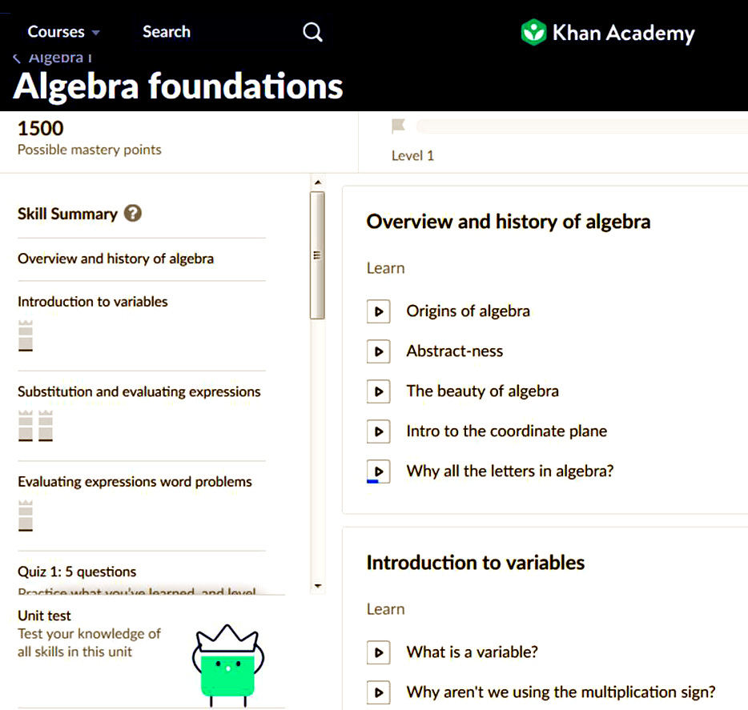

Figure 1 – Khan Academy Algebra Menu (Khan, 2019b)

One need not go far to participate in the early adoption of internet instantiations of on-line education. Most are didactic and present formatted data, either orally or video visualizations. The nature of the presentations will vary, but most are implementations of the lecture-based pedagogy that emulates a classroom experience, *e.g*. the Kahn Academy style of instruction. (Khan, 2019a) Some are just video tapes of live classroom lectures. There have been a few excursions into interactive programs for training, *e.g*. America's Army is a serious game that almost accidentally found its way into the training toolbox (Zyda, 2003), having been originally designed as a recruiting tool, but most of the educational programs are not interactive. Unlike the many chatbots or artificial assistants now in use, *e.g*. Alexa, the educational programs present lesson-plan designed lectures in a formal way with a menu choices. (Khan, 2019b) Figure 1 shows the top level choices the student can pick, and then the video is shown and ends with a button for the subsequent video, as well as links to self-test evaluations.

More formal and certified programs are available in many states. Many of these use either live video tapes or animated avatars. Modeling and simulation often have a role in the visualization of the concepts or to make the lectures more interesting. These programs can lead to high school diplomas that are recognized by tertiary education and by future employers. The noted education critic, John Taylor Gatto asserts that home schooled students have a better graduation success rate in college than do either public or private school graduates. This is made more meaningful when one considers the consistent prevalence of homeschooling across almost all of the family income groups, all around 3.5% of the nation's student population. The only notable exception to this is the wealthiest, only 2% of the over $100,000 families home school, vice the 3.8% level of all the rest (NCES, 2015).

## Producing a Virtual Conversation

One thing that most of these systems lack is a realistic interactive capability to engage in a conversation-like interchange of information. The authors assert that, for both the home-schooled and for the remotely assigned DoD student, this exchange of views, questions, and understanding is necessary for optimal learning. This section lays out some of the capabilities of Natural Language Processing (NLP) as was utilized in the University of Southern California's Institute for Creative Technologies (ICT) project for the Office of Naval Research. The project was called MentorPal and it was designed to provide on-line advice for young people who are contemplating a technical career in the DoD (Davis, D.M., 2019). There is a growing body of capability in NLP which allows the rapid analysis of spoken or typed words and a virtually instantaneous germane response by the computer. Chatbots such as Apple's Siri, Google's "Hey, Google", and Amazon's Alexa are commonly known examples of such devices. Implementing extensions of such technology, the ICT team produced a large (~600) video clips of advice by DoD technical professionals to respond in a conversational way to the student's inquiries.

## MentorPal's current operations data flow.

Inputs can be written text, spoken words or suggested question, then the data flow is as shown in Figure 2. It is a succession of switches and filters which select and cue up the most appropriate answer. Recording a large library of short video-clips requires a significant amount of time and forethought (Nye, 2018). The process requires drafting and asking questions, transcribing questions into text, editing transcripts, inputting these into dialog models, and expanding these models by establishing new paraphrases/aliases for questions. Creating an interactive virtual mentor from previously recorded videos can take up to 20 hours of live video sessions to provide a broad enough coverage of useable responses, with approximately 60 hours of additional time for video production completion. That consists of: about 40 hours for generating the transcripts and 20 hours for post-processing of the dialog videos. Another long-term goal of this project is to enable the easy recording of any person as a mentor, without researcher or video-producer intervention. This work will be accomplished in a recently proposed project named MentorStudio.

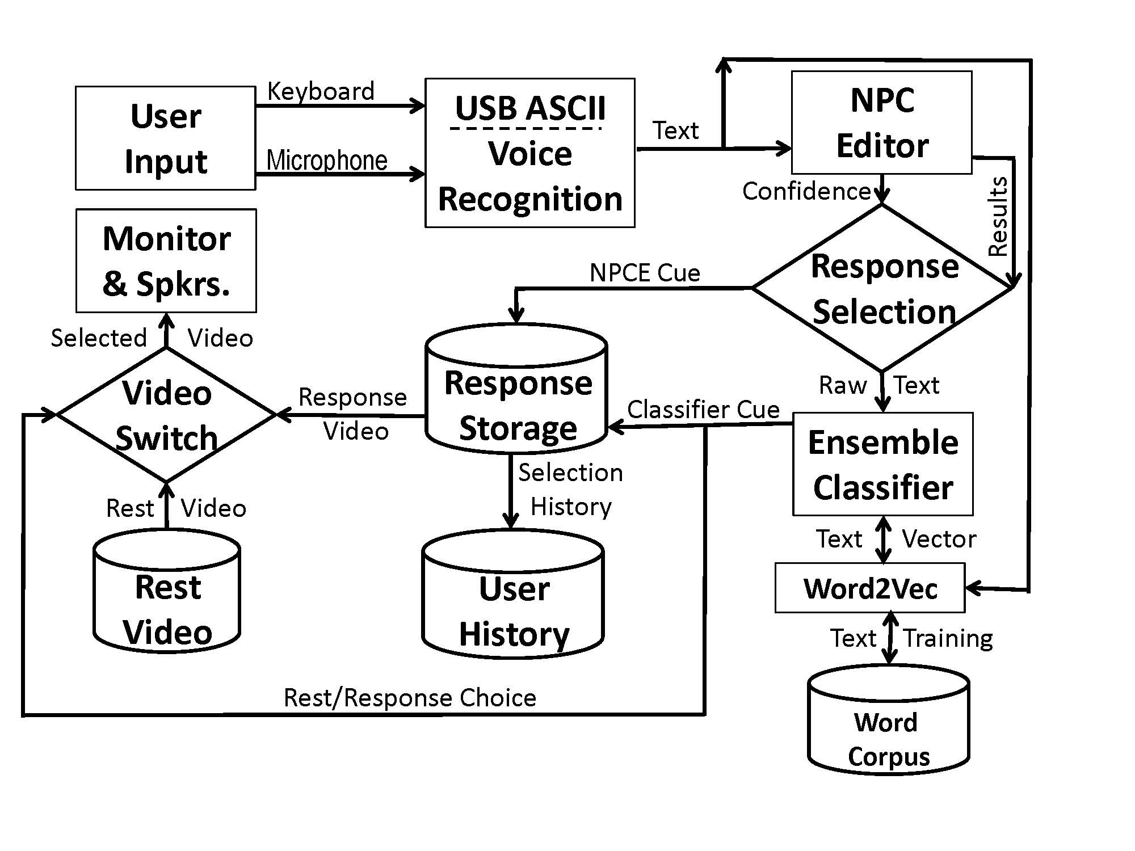

Figure 2 .MentorPal Conceptual Flowchart

## Creating the Mentor Database of Video Clips

Typically a subject was video-taped for at least six sessions, each about three hours long, to cover the entire question set. Mixes of all of these topics were used in order to avoid fatigue and tedium. Re-recording sessions were held as required. These consisted of recording new answers to video clips with technical glitches or to recording answers to common questions that arose during a review of the original clips. Follow-up sessions typically lasted for about 60 minutes. This was important because it assisted in the creation of a more natural conversational ﬂow.

Careful review and control, was required along with monitoring from ICT staff in order to ensure that the recordings were consistent and the responses were appropriate to "chunk" into useful responses. Standardization included ensuring that the mentor returned to a resting position for approximately three seconds before and after the question was answered. The required rest position was necessary to ensure the mentor was going to be in the same screen location throughout the recordings, to avoid “jumping” during the transition from clip to clip. This disruption could occur if a mentor’s next statement was delivered from a totally different head or body position on the screen.

Mentees were directed to react with vivacity and were evaluated by the production staff. The video-taping process included making sure that the recording had been standardized by using the same production equipment: videotaping cameras, professional microphones, and cloth backdrops. These had been shipped to any mentors who were located remotely. Following the videotaping, the video clips were uploaded to centrally located storage for further processing. The quality of audio signals, the video images and the rest-answer-rest transitions were all better than anticipated. Later, users reported that they found the quality and transitions did not disrupt the impression of a conversation. The resultant output is interfaced as shown in Figure 3 below.

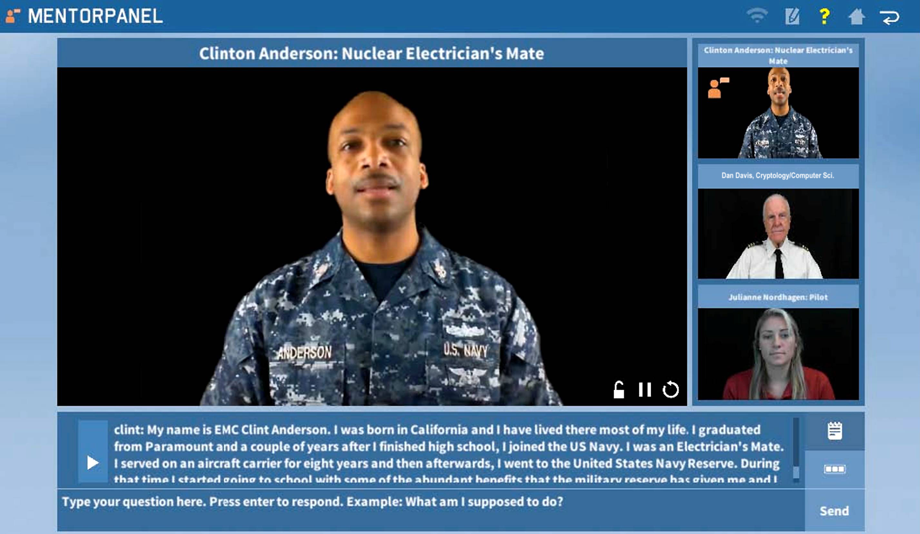

Figure 3 – On-line Instantiation of MentorPal (ICT, 2018)

## Further Production Activities to Produce Conversations

The NLP algorithms in the program select the best fit answer from the two different classifiers, as is shown in Figure 2 above. Currently, it sends the question to both the NPCEditor and a Python classifier based on a neural network to and that produces two alternate answers. Then the NPCEditor answer is used if it has high confidence (since it is faster) while neural network classifier is used otherwise. Further description of these processes is contained in the paper cited earlier (Nye, 2017).

In further processing steps, the questions, with the live mentor answers to them, are used to generate classifier data, NPCEditor data and metadata (Leuski, 2011 & Nye, 2017). The collected and characterized sets are generated manually based on based on alternative ways that the reviewers assume that other people would ask the questions. Each question is also manually tagged with topics from a bank of 40 predefined topics that cover all broad categories of questions. An ordering of questions resulted in generating topics, which are used to create random questions associated with those topics. These are also added to the MentorPal classifier data, where it is represented as a vector for each question, using many dimensions. It then stores this data into files for use by the classifier.

Creation of such a conversational Virtual Human (VH) mentor involves a number of steps, in addition to the development and refinement of the software code that makes the program function. Much has been written about how to manage and design large computer programs, running all the way from general, almost philosophical approaches, *e.g*. Professor Fred Brook's book The Mythical Man Month (Brooks, 1995) to more detailed and didactic tomes. Project personnel, basing their approach on lessons learned from previous ICT efforts, knew they needed to optimize a process for the production of the videos.

There is more to be done in order to characterize and to improve these processes across the NLP community. One issue with the classifier was the requirement to enable oﬄine mode on tablet devices. Unfortunately, the word vector models otherwise employed are typically too large to work on device in memory: the Google News Word2Vec model is 3.5 GB, for example (Mikolov, 2013) The MentorPal ensemble makes use of a systematically pruned version of Google's Word2Vec model. That process merits a paper of its own and that is described more completely in a workshop paper: Domain-specific Reduction of Language Model Databases: Overcoming Chatbot Implementation Obstacles (Kaimakis, 2018).

# Applicability to Home Schooling and ADL

## Addressing Needs and Meeting Goals

A review of some earlier issues is warranted at this point. First it should be remembered what the goals of both homeschooling and DoD continuing education may be. For the purposes of this paper, it will be assumed that the critiques of the current products of the educational process need to provide graduates more capable of communicating and of critical thinking. Keeping in mind the *sub rosa* goals, *e.g*. child care for parents and retention for DoD leadership, the following analysis will focus on fostering articulate critical thinkers. Second, the pedagogy most likely to enable the development of such an evolution would appear to be a constructivist approach, as it both demands and produces more independent thought and increased ability to work as a team, with the concomitant emphasis of intra-group communications, not for artistic, but for organizational purposes. (Lunenburg, 2011)

To enable a constructivist approach, access to an experience and insightful facilitator is required. The constraints in both homeschooling and in the DoD continuing education environments make it infeasible to provide a qualified expert as a facilitator. The DoD case is exacerbated by the transient nature the warfighter; the homeschooling case is exacerbated by both budgetary and privacy concerns. As computing advance allow, providing such a facilitator/tutor electronically, driven by artificial intelligence and NLP would be a welcome capability.

MentorPal and New Dimensions in Testimony (Artstein, 2017) has shown the facility with which a large body of video clips can be accessed fast enough to create the illusion of a conversation with a "live" person. This was fairly effective in counseling and a historical talk environment, but in both contexts, the system lacked the capability of choosing a topic or asking a question. One can envision an extension to current technology that would enable a holocaust survivor to ask question of a museum audience or probe the issues of concern to a young person seeking career advice. Further, experience has shown that, despite human uniqueness, after a number of evolutions, a pattern emerges of what a good approach to a number of individual situations might be.

Assuming that is true, a synergistic approach using artificial intelligence, deep learning, and new quantum computing technologies, a very capable constructivist computer generated instructor might be implemented. For instance, quantum computing is touted as being able to find concept connections and develop dialog answers with more sophistication and in real-time. This would additionally have very salutary impacts on a range of other modeling and simulation systems. Such a system would be accessible by students at home, even in remote areas, or service personnel, no matter where they were stationed. They would be available twenty four hours a day, seven days a week. They would be easily interruptible without disruption and could be programmed to assist in picking up where the session left off. This would be critical in the military context where watch-standing often yields an opportunity to study, but aperiodic interruptions must be attended to immediately. Group activities could be facilitated by commonly available video-conferencing tools and nearly ubiquitous availability of the internet.

Much of the technology necessary will be developed by the digital community in any case and can be adopted at little cost. Some of the technology would be beneficially pursued to accelerate the capabilities that are patently needed at this time. The major focus that is apparently not being too hotly pursued is the NLP and A/I necessary to have a "creatively assertive" questioner to probe and facilitate the students. Many major organizations are capable of pursuing this thread of research. Some of the issues that will come up are:

* Can a computer recognize which students require encouragement, which require more focus, *etc*.?
* Can a computer correctly detect sarcasm, humor, insults, emotional states, security issues, *etc*.?
* Can an A/I help isolate and identify new areas for generation of an appropriate response?
* Would the stochastic nature of the emerging capabilities in quantum computing help?
* Are there heuristics that can generate acceptable substitutes for any of the above?
* What would be the most illuminating metrics for the success of such a system?

The development cost would be easily defrayed by the long-term savings in training and education personnel, but the benefits of better communicating and better critical thinking is difficult to envision, let alone quantify. One of the major benefits to such a system is its scalability. The DoD has suffered in all of its wars by virtue of the fact that it takes time to recruit, induct or train personnel to train and educate the influx of line personnel destined for the fleet or the combat arms divisions. With a computer virtual-conversational capable agent, scalability is simply a matter of making more servers available. Training and educational activity network bandwidth requirements can be relegated to very low priorities and use existing operation circuits. Experiments at USC showed the feasibility of both distributed simulation and high performance computing via existing internet capabilities (Gottschalk, 2010). It is the position of this paper that NLP, simulation, virtual humans and A/I will continue to develop apace.

One technology that is a real candidate for radically changing the modeling and simulation community is quantum computing. Its impact had been discussed in previous papers (Yao, 2018). Nearing the end of the Moore’s Law growth of digital computing, many simulation professionals are concerned with solving the grand challenges set forth above. One of the alternatives frequently mentioned is Quantum computing. It has hopefully been considered an extension of computational capability since the Nobel Laureate Richard Feynman presented the seminal paper in 1982. In that paper he held that: “… with a suitable class of quantum machines you could imitate any quantum system, including the physical world.” (Feynman, 1982). The authors have assiduously followed the development of such a machine and those devices still are, as near as can be ascertained, almost entirely at the test-bench phase. There seem to be no such “general purpose” quantum computer that is even nearing operation. There is one operational design in the quantum world: while not a general purpose quantum computer, it relies on very cold temperatures (15 milliKelvin) to create a useable quantum effect. (Lucas, 2013)

This adiabatic quantum annealing device has been conceived, designed, produced, and delivered to the University of Southern California. It has been in operation since 2012. In its current configuration, D-Wave computers have a design providing approximately 2,000 qubits. The “approximate” figure is required as some delivered machines have some fraction of these qubits turned off and a small number of the qubits (~ 1%) are not stable after the processor reaches the target 15. D-Wave Two is installed in the USC-Lockheed Martin Quantum Computing Center (QCC) at the Information Sciences Institute (ISI) in Marina del Rey. There is another in the San Francisco Bay area in a joint Google and NASA project, and one has putatively been ordered by the DoD’s High Performance Computing Modernization Program. Others are in varying stages of procurement and delivery.

In recent years, other authors have touted quantum computing ability to produce more power, using terms like “magic” to stir the imagination and whet the appetites of the user community. They point out that the capability of quantum computers arises from the different way they encode information. Digital computers represent information with transistor-based switches having a state of 0 or 1, labeled as a bit. In contrast, the basic unit of quantum computer operation, the quantum bit or qubit, can exist simultaneously as 0 and 1. A quantum bit, called a qubit, might be represented by an atom in one of two different states, which can also be denoted as 0 or 1. Two qubits, like two c1assical bits, can attain four different well-defined states (0 and 0, 0 and 1, 1 and 0, or 1 and 1). But unlike classical bits, qubits can exist simultaneously as 0 and 1, with the probability for each state given by a numerical coefficient. Data in a two-qubit quantum computer thus requires four coefficients. In general, n qubits demand 2n numbers, which rapidly becomes a sizable set for larger values of n. For example, if n equals 50, about 1015 numbers are required to describe all the probabilities for all the possible states inside the quantum machine. That large number exceeds the capacity of the largest digital computer. A quantum computer should demonstrate incredible computational power because it can be in multiple states at once, a condition called “superposition.” Also, perhaps more importantly, it can act on all its possible states simultaneously. The quantum computer can evaluate a series of optima that would be beyond the power of the largest digital cluster (Gershenfeld, 1998). Evaluating a large number of parameters to “learn” patterns and behaviors is at the heart of Virtual Human enhancement.

The authors have witnessed and participated in the development of high performance computing for several decades and have developed a significant body of experience with newly introduced technologies. They were engaged in the very early introduction of parallel computing and aware of its rivalry with sequential computing and with vector computing. They heard the detractors of parallel computing argue the limits of parallelism and the proponents who argued that it could be used more universally. While acknowledging there are many problems that have remained outside of the easily parallelized arena, it is evident that the majority of all large-scale computational problems are now run in parallel. This is due to the application of new techniques to decompose both data and computation in effective ways. Such technology has proven very useful to the simulation community, which has many issues identical to the test and evaluation environment. By using super-cold processors, the D-Wave has been able to demonstrate accepted quantum computing. Even if the projected speed-ups are not realized on this design, it is a workable and verifiable quantum computing device.

It has been observed that home schooling and ADL "live" in two very separate communities, but have many issues in common. These two communities might find it mutually supportive to attend conferences from the other community and review professional literature to see if there are methods and expertise that might develop more effectively and rapidly with joint pursuit of the goals they do have in common.

# Conclusions

Two communities are in need of assistance in meeting their educational goals: the home schoolers and the DoD warfighters. Current programs, while well-intentioned, continue to produce students whose capabilities fall short of what is desired by "consumers" of graduates in academia, industry, and the DoD. Pedagogies exist that could address these educational challenges, but they are constrained by cost, availability of individuals capable implementing the new pedagogies, logistics of making them available, and security issues. There are emerging technologies that should enable the implementation of a computer generated virtual conversation-capable recorded human agents to initiate, monitor, facilitate, and evaluate a constructivist approach to education for home schooled and deployed DoD personnel. Both the homeschooling and ADL communities would be well-advised to be open to advances in the other community, as their goals and techniques often overlap.

# ACKNOWLEDGEMENTS

The authors would like to acknowledge that assistance and advice of Laurel K. Davis of the Next Generation Leaders educational facilitation and research organization; about half of NGL's students are home schooled. Her data and insights into homeschooling were invaluable.

# REFERENCES

ADL, (2019). *The Advanced Distributed Learning Initiative*, US Department of Defense, Alexandria, Virginia, Retrieved from: https://adlnet.gov/about

Artstein, R., Gainer, A., Georgila, K., Leuski, A., Shapiro, A., & Traum, D. (2016). New dimensions in Testimony Demonstration. In Proceedings of the *2016 Conference of the North American Chapter of the Association for Computational Linguistics: Demonstrations* (pp. 32-36).

Barlow, M. L. (1967). *History of Industrial Education in the United States* (p. 119311). Califronia: Bennett.

Bartelt, W. E. (2008). *There I Grew Up: Remembering Abraham Lincoln's Indiana Youth.* Indianapolis: Indiana Historical Society Press.

Brooks, F., (1995). The Mythical Man - Month. Anniversary Edition, Boston, MA: Addison-Wesley Professional.

Casad, B. J., & Jawaharlal, M. (2012, June). Learning through guided discovery: an engaging approach to K-12 STEM education. In *2012 ASEE Annual Conference & Exposition* (pp. 25-886).

Chen, G. (2017), A Relevant History of Public Education in the United States, *Public School Review*, NY , NY

Cooper, B. S., & Sureau, J. (2007). The politics of homeschooling: New developments, new challenges. Educational policy, 21(1), 110-131.

Curda, S. K., & Curda, L. K. (2003). Advanced distributed learning: A paradigm shift for military education. Quarterly Review of Distance Education, 4(1), 1-14.

Davis, A.A., (2011). Evolution of Homeschooling. *Distance learning*, 8(2), 29.

Davis, D.M. (2010), Discussions with the Vice President for Research at a major state university, who prefers not to be cited by name, Dan M. Davis notes from 2010.

Davis, D.M. (2019). *MentorPal, Virtual Conversations to Enhance STEM Career Selection*, Retrieved on 21 January 2019, from: http://www.hpc-educ.org/MentorPal/Web/MntPal_Index.html

DoEd, (2014). *Statistics About Non-Public Education in the United States*. US Department of Education. February 11, 2014.

Feynman, R., (1982), Simulating Physics with Computers, *International Journal of Theoretical* *Physics* 21 (6–7): 467–488.

Gershenfeld, Neil, and Isaac L. Chuang. (1998) Quantum computing with molecules. *Scientific American* 278.6 (1998): 66-71

Gottschalk, T. D., Yao, K-T., Wagenbreth, G. & Davis, D. M., (2010), “Distributed and Interactive Simulations Operating at Large Scale for Transcontinental Experimentation”, in the Proceedings of the IEEE/ACM Distributed Simulations and Real Time Applications 2010 Conference, Fairfax, Virginia

ICT, (2018). *ICT Photo: MentorPal, On-line Image of MentorPanel*, Institute for Creative Technologies, University of Southern California, Playa Vista, California

iFEST, (2018), *Federal E-learning Science and Technology*, National Defense Industrial Association, Arlington Virginia, Retrieved on 21 January 2019, from: https://adlnet.gov/iFest18%20Agenda%20FINAL.pdf

Kaimakis, N., Davis, D., Breck, S., Nye, B. (2018). Domain-specific Reduction of Language Model Databases: Overcoming Chatbot Implementation Obstacles. In: Proceedings of the *ModSim World Conference.*

Khan, (2019a). *Overview*, The Khan Academy, Mountain View, California. Retrieved from the internet on 21 January 2019, from: https://www.khanacademy.org/about

Khan, (2019b). *Algebra Foundations*, The Khan Academy, Mountain View, California. Retrieved from the internet on 21 January 2019,https://www.khanacademy.org/math/algebra/introduction-to-algebra

Leuski, A., and Traum, D. (2011). NPCEditor: Creating Virtual Human Dialogue using Information Retrieval Techniques. *AI Magazine* 32(2), 42–56.

Lucas, Robert F., Gene Wagenbreth, John J. Tran, David R. Pratt, and Dan M. Davis. (2013) "Practical Adiabatic Quantum Computing: Implications for the Simulation Community."  in the Proceedings of the Interservice/Industry Simulation, Training and Education Conference, Orlando, Florida, 2013

Lunenburg, F. C. (2011). Critical Thinking and Constructivism Techniques for Improving Student Achievement. In *National Forum of Teacher Education Journal* (Vol. 21, No. 3, pp. 1-9).

Lynch, J. (2018), The Surprising History of the 18th Century’s Educational Influence, *The Advocate,* Retrieved 12 Feb 2019 from: https://www.theedadvocate.org/surprising-history-18th-centurys-educational-influence/

Mikolov, T., Sutskever, I., Chen, K., Corrado, G.S. & Dean, J. (2013). Distributed representations of Words and Phrases and their Compositionality. In: *Advances in Neural Information Processing Systems*. p. 3111.

NCES, (2015), *Home Schooling and School Choice*. National Center for Educational Statistics, Washington, DC, Table 206.10.

Nye, B., Swartout, W., Campbell, J., Krishnamachari, M., Kaimakis, N., Davis, D. (2017). MentorPal: Interactive Virtual Mentors Based on Real-life STEM Professionals. In: Proceedings of the *Interservice/Industry Simulation, Training and Education Conference (I/ITSEC)*.

PBS, (2019), *The Roman Empire in the First Century*, Retrieved from the internet on 20 January, 2019 from: .https://www.pbs.org/empires/romans/empire/patricians.html

Schrader, J., Lewis, L., & Brown, R. A. (1999). *Quadrennial Defense Review Analysis (QDR) Analysis A Retrospective Look at Joint Staff Participation.* National Defense Research Institute, The RAND Corporation, Santa Monica, California. RAND DB-236-JS

Smith Nat'l Lib (2019), George Washington Biography, Retrieved from the internet on 20 January, 2019 from: https://www.mountvernon.org/george-washington/biography/

Strunk, W., & White, E. B. (1959). *The Elements of Style*/by William Strunk; with Revisions, an Introduction and a New Chapter on Writing by EB White. Macmillan.

Twain, M. 2011), *Huck Finn and Tom Sawyer among the Indians: and other Unfinished Stories* (Vol. 7). University of California Press, Berkeley.

US Army, (2019). *Guided Discovery Learning*. Center for Army Leadership. Retrieved on 13 February 2019 from the Internet from: https://rdl.train.army.mil/catalog-ws/view/100.ATSC/512386F1-0282-42C4-94B6-F6A65727FBC0-1435170299189/L04T03P020.html.

Zyda, M., Mayberry, A., Wardynski, C., Shilling, R., & Davis, M. (2003, April). The MOVES Institute's America's Army Operations Game. In Proceedings of the *2003 Symposium on Interactive 3D Graphics* (pp. 219-220). ACM.

Yao, K-T., Davis, D. M., Liu, J. J., & Kaimakis, N. J. (2018). "New Technologies to Enhance Computer Generated Interactive Virtual Humans ". In the Proceedings of the SISO Fall Simulation Innovation Workshop, Orlando, Florida: SISO