Pedagogical Tools to Enhance Analytic Skills:
Interactive Virtual Tutorial Environments

Dan M. Davis | Christi L. Phelps | Frederica J. Stassi
Univ. of Southern California | Sato Academy of Mathematics & Science | Science Education Analyst
Los Angeles, California | Long Beach, California | Lompoc, California
dmdavis@acm.org | CPhelps@lbschools.net | frjstassi@gmail.com

ABSTRACT

This paper examines the use of literature studies to enhance communication and critical thinking skills in technical students through the application of emerging Virtual Reality (VR) technologies to enable that pedagogical approach. The current state of analytic skills among students in Science, Technology, Engineering and Mathematics (STEM) tracks are outlined, focusing on the critical years in secondary schools. Their prospective needs as they advance into tertiary education and the needs of the technical community for improvement are presented. The requirements flowing from that analysis will be discussed in the light of programs implemented at the Sato Academy, with reports of both successes and missteps. In some detail, the use of the study of literature is described and discussed. The authors present their case for constructivist and Socratic approaches to fully engage and effectively inculcate communication proficiency, including conformance with standards, e.g. Next Generation Science Standards (NGSS). These results are then compared to the demands of college and professional leaders who are currently being burdened with having to provide disruptive remedial efforts. The methods found to be successful are considered, both in terms of their application and their extensibility to other fields. Also highlighted will be areas in which time and personnel constraints hindered achievement. A number of possible responses to these impediments will be presented, evaluating the feasibility of each. The paper will then focus on the advances in virtual humans and conversational avatars. Recent research into using large libraries of video-clips to create engaging on-line virtual tutorial conversations will be presented. Data as to the receptivity of students to conversing with computer-generated interlocutors is presented, along with a discussion as to how this technology is applicable to teaching the analysis of literature. The benefits of and the barriers to virtual tutorial environments are outlined and analyzed.

ABOUT THE AUTHORS

Dan M. Davis is active as a consultant at the Institute for Creative Technologies, University of Southern California (USC), focusing on large-scale DoD simulations and avatar uses. Prior to retirement, he was the Director of the JESPP project at USC for a decade. As the Assistant Director of Advanced Computing Research at Caltech, he ran Synthetic Forces Express, bringing HPC to DoD simulations. He also served as a Director at the Maui High Performance Computing Center and in computer research roles at the Jet Propulsion Laboratory and Martin Marietta. He was the Chairman of the Coalition of Academic Supercomputing Centers and has taught at the undergraduate and graduate levels. As early as 1971, Dan was writing programs in FORTRAN on one of Seymour Cray’s CDC 6500’s. He saw duty in Vietnam as a USMC Cryptologist and retired as a Commander, U.S.N. He received B.A. and J.D. degrees from the University of Colorado in Boulder.

Christi L. Phelps is an educator and currently teaches at the Sato Academy of Mathematics and Science in Long Beach California. Her primary interests have been in studying the role of literature in the development of communications capabilities, with and emphasis on using literature as a set of stimuli to develop critical thinking skills among technical students. Her training has been in the behavioral sciences and she applies the insights from that background to both her teaching methodology and to her research into pedagogical efficacy and organizational behavior implications for curricula development and implementation. Ms. Phelps received a B.A. in Psychology from the California State University, Long Beach and is currently pursuing an M.Ed. in Curriculum and Instructions with an emphasis in Linked Learning from California State University, Long Beach.

Frederica J. Stassi. Ed.D. is a Science Education Analyst, working in the Central Coast of California. Her background includes research for the National Science Foundation in which she was funded to study pedagogies and efficacies in U.S. Science museums. This research involved museums from the East Coast to O‛ahu in Hawai‛i. Her doctoral research was conducted under the guidance of Professor William McComas and focused on the development of science standards for the State of California. She received a B.A. degree from Tabor College, as well as an M.A. Degree in music performance and an Ed.D., both from the University of Southern California.
Pedagogical Tools to Enhance Analytic Skills:
Interactive Virtual Tutorial Environments

Dan M. Davis | Christi L. Phelps | Frederica J. Stassi
Univ. of Southern California | Sato Academy of Mathematics & Science | Science Education Analyst
Los Angeles, California | Long Beach, California | Lompoc, California
dmdavis@acm.org | CPhelps@lbschools.net | frjstassi@gmail.com

INTRODUCTION

Academics, employers and military leaders all call for improved critical thinking and communication skills in their admittees, employees and inductees. Many useful approaches have been conceived, tested, and advanced as responsive to those calls. There are a wide range of hurdles to general implementation of many of these approaches. Emerging technologies and techniques may provide a way to overcome these hurdles. This paper first discusses and substantiates the existence of these problems and the criticality of resolving these issues. The efficacies of some of the many pedagogical solutions proffered are then considered and documented. The obstacles to those are then laid out in more detail. In response to that group, the advances in modeling and simulation technologies such as conversational computer agents and virtual tutors are reported. Then the specific ability of the virtual conversational environments developed at the University of Southern California to enable the widespread implementation of the aforementioned techniques is asserted. The paper closes with a rigorous analysis of potential roadblocks to adoption of this synthetic approach. This is not an exhaustive survey and analysis of all of the educational acivities in the United States today, but an offering of some of the major inspirations for the research in which we engage.

Background

We all live in a society in which required skills are most often centered around two basic sets of abilities: the ability to think critically and the ability to communicate effectively. The very existence of the nation depends on there being a wide distribution of these capabilities throughout the population. And yet, neither of these areas is mentioned in an iconoclastic speech by a former New York State Teacher of the Year in his famous "The Seven Lesson School Teacher" (Gatto, 2019). He list Confusion, Class Position, Indifference, Emotional Dependency, Intellectual Dependency, Provisional Self-Esteem, and One Can't Hide. One would note that many of the lessons he says he was directed to teach were actually antithetical to the encouragement and growth of both critical thinking and communications. Many have read his objections and studied his suggested remedies, which he asserts were very effective.

Lest one think that his was the voice crying in the wilderness, in the late 1980's an innovative Professor of Computational Neuroscience at The California Institute of Technology (Caltech), became enamored of the idea of introducing computer technology into the K-12 classrooms to assist in the teaching of scientific thought and method. What he found was that science is not being taught in the schools; science facts and history are being taught. (Bowers, 19..) His efforts were recognized with the foundation of CAPSI (CAltech Precollege Science Initiative) that developed a new approach to science education, focusing more on underlying philosophy and methodology. However, this method was not easily understood by the K-12 instructional staff.

More germane to communication skills, a college instructor in English Composition was recently approached about the state of communications instruction at the college level. His response was that the problem had been solved; some years ago, the Writing Across the Curriculum project was formed in 19.. specifically tasked with improving technical writing skills among college graduates, especially technical personnel.

In each of the cases above, a problem was identified, money was spent, and victory was often claimed. And yet, industry leaders and college executives complain today that there is a wide gap between what they expect from the new acquisitions and what they find. While on the staff at Caltech, one of the authors had countless tenured professors complain to him about the lack of independence and critical thinking amongst their undergraduate and graduate students. Many of the more senior professors said that they noted a significant decline in the qualities of creativity and drive in their students. The decline they noted began in the last few decades of the twentieth century. Another issue came up during an informal seminar at the University of Southern California. The discussion was centered on the qualities of creativity and vision amongst professionals with PhD's. One of the anecdotes related was that recounted by a non-technical participant of the seminar. He stated that he was amazed at how many PhD's in his organization came to him and asked him for ideas on which they should be working. He noted that he grew up believing that PhD's were all blessed with a surfeit of ideas they wished to pursue, had they the funding. However what he found was that there were a number of PhD with no significant vision or drive to pursue ideas of their own. Two of the more erudite PhD's at the meeting suggested that it was their experience that only 20% or so of the PhD's they had met were suffused with the energy and enabled by the vision to fashion their own research. The rest, they said, were just very intelligent lab technicians. As you may imagine, they would prefer not to be cited by name.

Added to that are the continuing complaints from both industry and academia about the lack of both critical thinking and communications fundamentals. Anyone who had read through the papers submitted and sat through the public presentations thereof would say that anyone has a basis for asserting that critical thinking and communications skills are rampant in the technical community.

One suggestion for that failing is that the nation is in an area for which there is no precedent and that the pace of changed and the acceleration of technical obsolescence is not challenging the Darwinian concepts of evolution and its ability to adapt and adopt a new environment. It is an often asserted analysis that the current education system was effectively and manifestly successfully designed to take a young farm hands out of the fields or young housekeepers out of domestic service and condition them to accede to the schedule demands and disciplinary rigor that was required for the production line or the garment factory sweat shop. These techniques, albeit successful in that context, are not optimized for creating critical thinking or articulate conveyance of ideas. The same can be said of the warfighters; the lock-step advance into the muzzles of Napoleonic cannon are a far cry from today's NCO's' need to be diplomat, ethicist, and community organizer in a foreign culture, as well as an effective tactician and disciplinarian. And yet, education is one of the most conservative communities. In the midst of the Renaissance, who was popular? Not the current stars, but the philosophers of old: the central figures of the classics.

Taken that as a possible insight, consider once again the seven lessons of the New York teacher of the year. Most of his lessons would not only be useful on the assembly line or in the woolen mill, they would be necessary. But, the future does not await the nation; it is upon us now. Foes, both asymmetric and hegemonic nation-states vie for technical, military and political ascendency over the US. So a solution is not only desirable, it may be existentially obligatory.

As to the claims of those who tout successes, it would be prudent to investigate metrics. Specifically, in the case of Writing Across the Curriculum (WAC), the English instructor noted above provided a cite to the following article: Assessing Writing across the Curriculum: Diverse Approaches and Practices. Perspectives on Writing: Theory, Research, Practice. Volume 1. (Yancy, 1999) When analyzed, it mainly focuses on methods. When it came to results, it offered participation metrics, : How many campuses served, how many WAC officers, how much spent, … Missing are: how much it changed abilities, how satisfied graduate schools are with new admittees' writing skills, how many employers are pleased … WAC began 34 years ago, and yet the complaints seem to be the same today as they were then. One may wonder if that is a matter of a sampling mistake or reporting paucity. Yet personal anecdotal evidence is present. One need only ask: What was the quality of the last professional paper that one has read? How many of the presenters at the last conference attended were good speakers? This paper asserts that the issues of critical thinking and competent communications are still present and debilitating.

Alternative Approaches

The intuitive directness of the lecture method is so intuitive that there is little doubt that it has been widely employed since the beginnings of human language. Certainly from early in the written history there are stories of teachers speaking to groups about things they needed to know. It was not much longer after that when the approach of questioning the student to help them focus in on the truth on their own made its appearance. This method is most often referred to as the Socratic Method. In the United States, this method is employed in classroom settings most often in Law Schools. For those who did not attend a law school, a very realistic version of the application of this method can be found in the film: The Paper Chase (Paul, 1973).

Much later, in the late 19th century, a Finn named Uno Cygnaeus developed a craftsman-based approach to woodworking entitled Educational Sloyd that was a progenitor much of the current pedagogical approaches to learning. He and his adherents like Otto Salomon maintained that this experience oriented learning, in which the teacher acted only as a facilitator, was a more natural and more deeply absorbed way of learning that would naturally transfer over to other academic pursuits. (Thorsteinsson, G., 2014). These methods have been used in the US and are still mandatory in some countries of Scandinavia and are popular in the UK. (Wood, 2011)

The concept of the teacher, as a facilitator only, finds the most common expression in the Constructivist pedagogy. Finding its underpinnings in the writings and theories of the Swiss psychologist Jean Piaget, Constructivism purports to inculcate self-efficacy in its students by posing a challenge that requires mastery of the subject of study and letting the student proceed without detailed direction. (Alt, 2015) They begin by identifying which skills need to be mastered to achieve their goal and then master them. This approach putatively addresses several of the issues mentioned above: focus on topics, real-life relevancy, communication skills, analytic approach, and progress feed-back loops.

A common factor in all of these pedagogies is that they require a very well prepared class leader, a very disciplined instructor who can resist the temptation to show the students the "right" way to do something, and a significant amount of space to engage in individual experimentation and development. Many of these factors seem to explain the reason that these methods have not been more widely adopted and are often abandoned, despite good outcomes being observed.

This paper holds that when most people think of critical thinking training, they think of Science, Technology, Engineering and Mathematics (STEM) topics. Herein lies a different problem: STEM topics require a significant amount of learning before the Socratic or Constructivist approaches make much sense. One cannot let students take the time to create their own system of Calculus, develop their own taxonomies for Biology, bring order to their own periodic table for Chemistry, and derive their own explanation for Planetary Motion. That means that, to a very large degree, time must be devoted to teaching the basics via the lecture method, with precious little time left over for the more interactive and socially germane learning of the advanced pedagogies. One could argue that the reason the Socratic Method is still the pedagogy of choice in the study of the Law is that the basics, reading English text with a paucity of jargon, is a given at the level of a holder of a bachelors' degree from a top level university.

The nation's commitment to these problems is set out in Next Generation Science Standards (NGSS),
(NGSS Lead States, 2913). An analysis of that set of standards reveals that It is important to understand that all scientific methodology include the critical thinking and communication skills that STEM practitioner will need for career success and the non-STEM professional will need at a lower level for active participation in an environment driven by advances in and products enabled by science and technology. These STEM techniques are founded on the expertise that scientists and engineers employ regularly in the industrial, academic and military environments. This is not just a matter of passing qualifications, it is requisite for everyday accomplishments of tasks assigned, yet the lecture based school house typically does not have the kind success imperative that the graduate will find after they settle in on their life's work. NGSS wants to convey the sense that both the background information and the learned skills are interwoven, (Lee, 2014)

Major Theses

Which brings us to the first major thesis of this paper: Critical thinking can best be taught in the pre-college educational environment of K-12 education by teaching critical thinking, analytic and communication skills via the studies of English and literature. It is nearly universally true in the US that students, even those entering the first grade, are quite well versed in spoken English and many of those from middle and upper SES households, enter the first grade with rudimentary reading abilities. That provides a readymade laboratory in which to develop analytical thinking. The remaining issue is the logistics, instructor skills, individual pacing, and individualized training foci to optimize the impact on the class.

Which brings us to the second major thesis of this paper: Modeling and Simulation (M&S) afford the best and most sustainable prospect of achieving the continued ascendency of this society. To accomplish this, M&S must be able to provide appropriate training, in the school house, the workplaces of industry, and the duty stations of the military warfighters. M&S must present the best didactic skills of its premier teachers and do so at a pace that best suits each student. Further advances can be made if the topic of the materials at the heart of each students study matches the proclivities of that student, a feat rarely achieved in a classroom of thirty students and one instructor. This will require a range of capabilities and alternatives which will be identified and discussed below.

Technologies to Enable Critical Thinking and Communications

There are two major high-level approaches to improving Critical Thinking and Communications skills. One is encouraging and refining critical thinking by recursively challenging the student to improve and defend their choices and assumptions. A second is the establishment of a rubric-like set of rules or procedures to ensure critical thinking. Both of these may profit from a concomitant exposure to meta-cognitive theory to inculcate a continuous self analysis function as a check on critical thinking procedures. One of the questions implied or raised explicitly below is which of these technologies would yield a better result, not on the test, not as evaluated by the instructor, and not to justify more funding, but instead, a resultant graduates who are prepared to utilize their intellectual abilities to the best advantage for themselves, their organization and the nation at large.

There are many sources for classroom instruction guides to teaching analysis in the English classroom. While some may be formulaic, they all require careful attention to individual students, preferably without exposing them to the ever-present fear of peer ridicule. While this issue may need to be addressed eventually, it is not the subject of the current paper. This paper asserts that three characteristics of effective instruction are in short supply, largely because of the time constraints on the teacher. However, there are three large areas of technical advances that may speak to ameliorating this constraints and augmenting the classroom instructor: large-scale distributed simulations, virtual humans or conversational computer agents and A/I analyses of topics, goals, and student input.

Large Scale Distributed Simulations
The issue addressed here is the need to provide simulation and analytic capabilities to the local classroom without overly taxing the computer assets and technical expertise needed to optimize simulation in which students can freely express themselves and experiment without peer derision. Bandwidth issues when the accessing of remote servers is required to allow centralization of both hardware and human expertise assets. One could envision a national repository of either virtual humans or libraries of pre recorded video clips to allow computer-generated virtual conversations with a computer agent.
With the geographic distribution of the computers and the human-in-the-loop participants, as shown in the map below (Figure 1), a team at the University of Southern California (USC) had to reduce long-haul communications as much as possible
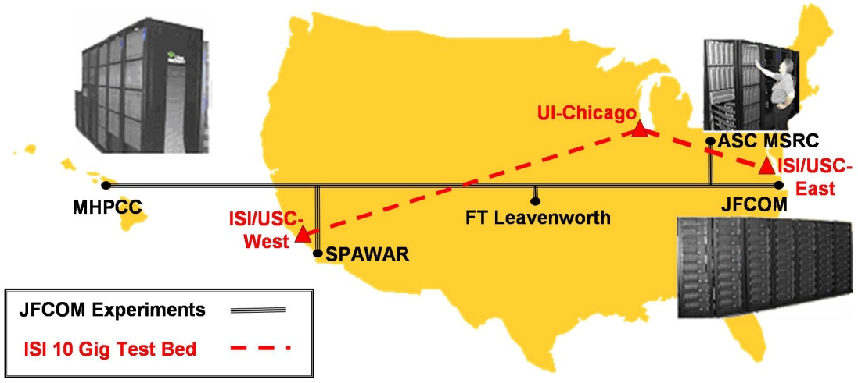

Figure 1 USC Experimentation System and ISI 10 Gig/Sec. Test Bed

Virtual Humans and Conversational Computer Agents

Augmenting the classroom teacher effectively with a computer generated substitute is difficult, but current advances have made great strides in enabling such and approach. At USC and any number of other research universities, capabilities have been growing steadily. This computer generated tutors can be made up of either virtual humans (animated characters with no real existence in the flesh) or the careful selection out of a library of video prerecorded video clips (taped in sessions with live human teachers). These techniques have proven effective in museum settings, local networked study areas or over the internet.

A virtual human is a virtual reality creation in which an avatar is created, often based on a real person, and attempts to recreate the appearance, voice, feel, and interaction that a live human would produce. With the advancement of several new technologies, including but not limited to natural language processing, virtual reality (VR), computer generated imagery (CGI), machine learning, and virtual learning, the uses, as well as the limits of virtual humans, are becoming evident. As a premier research institute with specialization in virtual affairs, the Institute for Creative Technologies (ICT) provides a home for myriad projects which consider virtual reality to be their primary focus. Researchers at ICT have developed with this purpose in mind and generated SimCoach, New Dimensions in Testimony (NDT), PAL3, and others generalized under learning sciences, medical VR, mixed reality, narrative, social stimulation, virtual humans, and vision and graphics. The field of knowledge available here is immense, and we utilized countless resources in earning expertise in the promising field that comprises virtual humans. The user interface can take many forms, as in Figures Below.
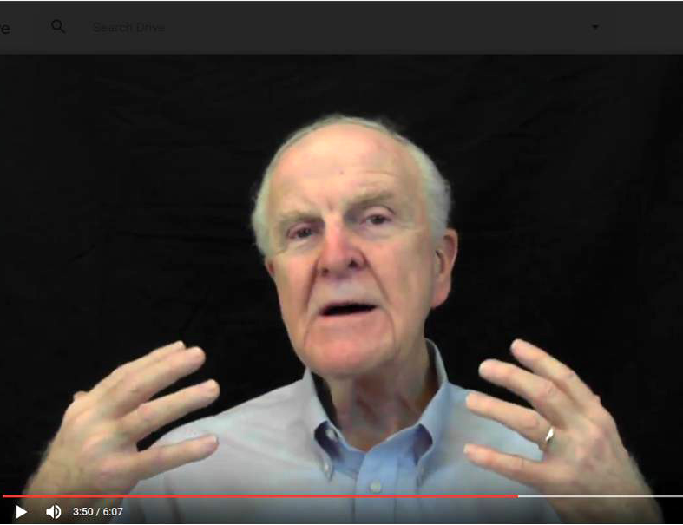
Figure 2 – Recorded video clips

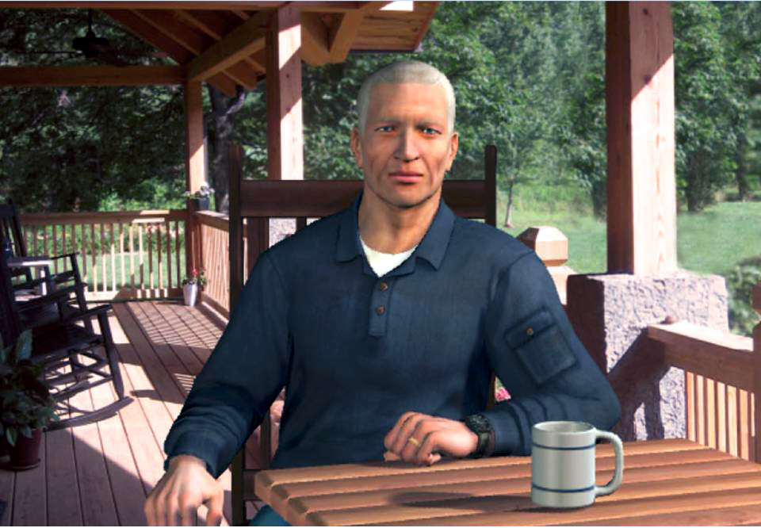
Figure 3- Fully Animated CGI
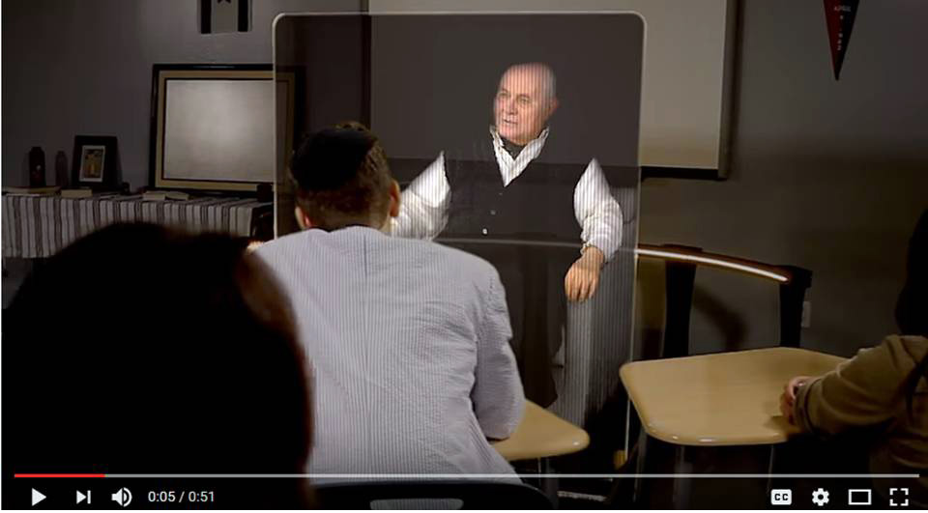
Figure 4- Video-taped speaker
rendered in a holographic display

Although a virtual human seems as simple as taking remodeling a human using CGI, it turns out that it takes much more brain power-and computing power-to do so effectively. The essential elements that go into the creation of a virtual human with lifelike abilities include natural language processing, machine learning, VR, CGI, and social stimulation. Natural language processing (NLP), will be the main focus of this discussion, though the same argument concerning the limits of virtual humans can be made with several of the other components. Natural language processing composes “an area of research and application that explores how computers can be used to understand and manipulate natural language text or speech to do useful things” (Chowdhury, 2003).Using this definition within the context of virtual environments, NLP tools allow computer technology to recognize voice input, analyze voice tone, provide lifelike conversation, retrieve information, and many other applications in combination with machine learning. Recent developments in NLP have made amazing bounds like “a single convolutional neural network architecture that, given a sentence, outputs a host of language processing predictions: part-of-speech tags, chunks, named entity tags, semantic roles, semantically similar words and the likelihood that the sentence makes sense (grammatically and semantically) using a language model” (Collobert & Weston, 2008).

Multitudes of applications through interpretation of language have been quickly advanced by the many researchers focusing their studies on the field. At ICT alone, progress has been made in training/learning environments (Kenny et al., 2007), multi-party dialogue (Traum & Rickel, 2002), ethics and cooperation (Allwood & et al., 2000), health applications (Rizzo et al., 2011) , and representation and reasoning (Swartout et al., 2006). Although automated speech recognition (ASR) is far from perfect, some of the best software, “Google achieved 73.3% of exact recognized phrases with a 15.8% [Word Error Rate]” (Kudryavtsev et al., 2008), and the technology will continue to improve. It is also important to note that many of the errors in ASR are caused by slurred speech, cultural slang, and context, stemming from a “lack of consistent units of speech that are trainable and relatively insensitive to context” (Lee, 1988). Although this causes problems when comparing these transcriptions with global data, models can be trained locally to a particular person’s voice or a low resource language using software such as CMU Sphinx from Carnegie Mellon University as applied to languages such as Arabic (Satori, et al., 2011). Although these customizations and build-your-own languages can be more accurate, they take time to implement and often require increased local processing power. The primary issues with natural language processing as it stands now include machine translation, precision, data storage, efficiency, and computation power-the focus of this paper. All of these will continue to improve with time, as hardware, software, and data storage and availability are areas within which research is eminent and directly valuable. Specifically, the speed and application of quantum computing will engender significant advancement in NLP and its applications: one of which is the impactful area of virtual humans.

Virtual humans constitute-and will continue to constitute-a major role in virtual learning, virtual storytelling, VR/AR, and gaming. Within the military context, virtual learning environments provide useful mechanisms for initial training as well as lifelong training. An example of this in implementation can be found in PAL3; “the PAL3 system was designed to accompany a learner throughout their career and mentor them to build and maintain skills” (Swartout, et al., 2016). Modern learning calls for new methods of information transfer. Online tools like Khan Academy, YouTube, Coursera, Lynda, and other massive open online courses (MOOCs) are growing in popularity, and the trend does not seem to be slowing down.
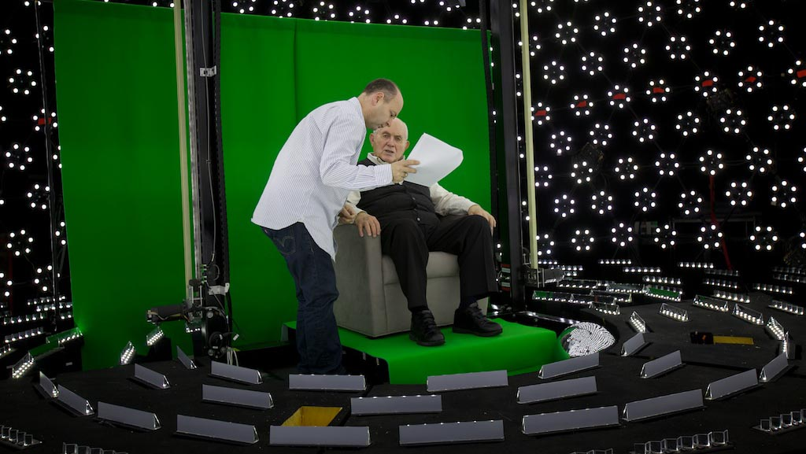
Figure 5 – Subject receiving direction in light stage
used for generating 3-D imagery for holographic display

Storytelling and gaming are also important facets of the virtual field. The New Dimensions in Testimony project “allows people to have an interactive conversation with a human storyteller (a Holocaust survivor) who has recorded a number of dialogue contributions (Figure 5), including many compelling narratives of his experiences and thoughts” (Traum et al., 2015). The project’s important mission of preserving the stories of Holocaust survivors can be applied to endless amounts of other important persons and tales. Advances in gaming allow for utilization in learning, entertainment, healthcare, and lifelike training for things like combat and critical thinking. The SimCoach system experience aims to “motivate users to take the first step – to empower themselves to seek advice and information regarding their healthcare” [13]. These virtual systems have been shown to have more success, generating deeper levels of confidence with patients than even live healthcare interactions (Rizzo, et al., 2011). The successes of these operations so far foreshadow abundant uses in the near future.

The benefits of virtual environments include making the most skilled instructors and resources available, exciting and new learning environments, confidentiality, and global accessibility. Some of the negatives of virtual learning are the difficulties of personalizing learning, live question handling, different learning styles, and similar limits to NLP and other processor and data heavy systems. Future fields of focus will come in streamlining the creation of such virtual environments and interaction. For example, imagine a system which takes in a live recorded interview with a president, or other prominent or knowledgeable figure, and generates an interactive environment in which a user can experience the interview by asking the questions themselves. Or a true virtual assistant that mitigates the need for a secretary might be a radical shift in the way the population functions. Such things are already in existence, and they will only become more prominent and powerful. However, the need for extensive processing power, efficiency, and data storage and transfer remains a limiting factor for such developments. We believe that the aforementioned applications call for considerable further exploration and research and propose a quantum annealing approach to deep learning its virtual applications.

Artificial Intelligence Capabilities

In order to support advanced techniques like generating germane and productive questions for the student, some advances in technology are required. These include both algorithmic innovations to properly assess the goals, language input and other sensor data to evaluate the best response or question. The state of the art, as discussed above, gives very good results in responding to questions or other querying inputs from the student, but a grand challenge in simulation is the generation of appropriate questions for the student.

One of the more interesting areas of improvement in computation is the fielding of operational quantum computers. According to Gordon Moore himself, the end of Moore's Law is nigh. It is increasingly daunting to continue on the current transistor-based path for increasing the traditional digital computing capability that can be applied to test and evaluation and other national security challenges. The capability growth of individual processors is stagnating and the number of such cores needed is now increasing exponentially in high performance computing systems. Size and power demands now often constrain the computational power that can be brought to bear on defense problems. In this environment, there is a growing interest in alternatives to commercial, off-the-shelf (COTS) technology, which would have seemed inconceivable for most of the last two decades. In many ways, this may be the reemergence of the purpose built systems of earlier decades. New installations include specialized systems such as the Anton at D. E. Shaw Research, It performs certain biomolecular simulations nearly two orders-of-magnitude faster than the largest general purpose computers. Others are looking beyond CMOS to exploit other physical phenomenon, e.g. quantum computing.
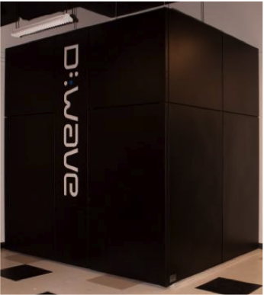

Figure 6. USC-LMC D-Wave
Quantum computing has been considered a promising extension of computational capability since the seminal paper from the Nobel Laureate Richard Feynman in 1982 (Feynman, 1982), in which he said “… with a suitable class of quantum machines you could imitate any quantum system, including the physical world.”. The authors are unaware of any such “general purpose” quantum computer that is even nearing operation. However, a more manageable adiabatic quantum annealing device has been conceived, designed, produced, and delivered to the University of Southern California. Figure 6shows the D-Wave Two, as installed in the USC – Lockheed Martin Quantum Computing Center (QCC) at the Information Sciences Institute (ISI) in Marina del Rey

In recent years, other authors have touted quantum computing’s ability to produce more power, using terms like “magic” to stir the imagination and whet the appetites of the user community. . They point out that the capability of quantum computers arises from the different way they encode information. Digital computers represent information with transistor-based switches having a state of 0 or 1, labeled a bit. In contrast, the basic unit of quantum computer operation, the quantum bit or qubit, can exist simultaneously as 0 and 1, with the probability of each being given by a numerical coefficient, a condition physicists call “superposition”. The quantum computer can act on all these possible states simultaneously.
.
The solution space of these types of problems can conceptually be thought of as a three-dimensional landscape. Various solutions are depicted as peaks and valleys. In the classic minimization problem, the challenge is to find the highest, or in this case, lowest of these, and not be misled by local minima. If the landscape is big enough, one cannot simply evaluate all of the locations to find the minimum. There is a metaphor that may make this clearer. Imagine there is a table-top model of this three-dimensional problem landscape, with countless peaks and depressions representing the extrema, that is the maxima and minima of the solution.

If there were numerous such peaks and valleys, similar to the simple peak and valley shown in Figure 2, marbles could be dropped on the complex space, and watched as they rolled downhill. They might get stuck in local mini-mum, with one or more hillsides standing between them and the true, global minimum. A technique to improve this method would be to shake the table whenever a marble comes to a stop. If the marble is in a shallow valley, the shaking may cause the marble to roll uphill out of the valley, and then go downhill until it reaches another, lower minimum. The combination of dropping thousands of marbles and shaking the table in a controlled fashion is akin to the process know as simulated annealing. Shaking the table is equivalent to increasing the metaphorical temperature.

Quantum annealing represents an even more powerful heuristic, in which a mechanism is provided that is capable of "tunneling through" the walls which separate local minor minima from the global minimum . No longer is it necessary to climb the walls and traverse the surface of an optimization function, as required by classical annealing algorithms. Of course, real problems usually contain a surface with many more than three dimensions. An N dimensional surface where N is much larger than three is difficult for most to visualize, but the annealing described above, can be used to find the minimum value of a surface representing a solution.

D-Wave is a small company that makes an adiabatic quantum annealing device which operates at a temperature of below 20 milliKelvin. This is barely above absolute zero or -273.15° Celsius, the temperature at which entropy stops, eliminating thermal energy. Published papers are available to detail the technical issues faced and overcome to produce an operating quantum annealer. This paper will not dwell on that here. A good compendium of detailed technical papers is to be found at http://www.dwavesys.com/ en/publications.html .
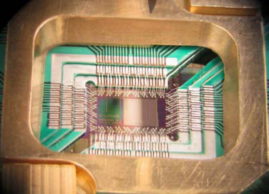

Figure 7 - D-Wave Qubit Processor
As early as 2007, D-Wave was demonstrating an operating 28 qubit machine. In 2011, D-Wave announced the 128 cubit D-Wave One , and Lockheed Martin acquired one for the USC – Lockheed Martin Quantum Computing Center (QCC), at USC’s Information Sciences Institute (ISI). This has since been upgraded to a 2048 qubit system. Small manufacturing variations and trapped flux in the superconducting circuits resulted in just under that number.. While this size is capable of generating interesting results, it is not yet big enough to set world records against gargantuan clusters. Figure 3 depicts the chip used in the D-Wave One.

One of the interesting issues raised by skeptics has been whether the D-Wave is actually doing anything “quantum” in its operation. USC and Lockheed Martin are now performing enough calculations at the USC- Lockheed Martin Quantum Computing Center to answer that question and explore the potential of adiabatic quantum annealing. The scientists there, together with their colleagues, have independently verified that the D-Wave is in fact an adiabatic quantum annealer .

There is on-going study of the physics of the D-Wave device, among other things, trying to ascertain its performance relative to classical computers. The NP-hard problems that the D-Wave machine is designed to solve are in general, too hard to solve exactly in any reasonable amount of time on a normal computer. Instead, heuristics are used that will hopefully get the solution, or a close enough approximation, in a short period of time. Simulated annealing is such a heuristic in that there is no guarantee that one will not get trapped in a local mini-mum. Quantum annealing is too. So, a straight up comparison of the relative performance of quantum annealing to a practical alternative is to benchmark it against simulated annealing.

The annealing process typically identifies a set of local minima, the smallest of which is likely the global minimum. The D-Wave returns a histogram of solutions it finds, and most of them will be at, or near, the global minimum. If the global minimum is the only answer of interest, these other data may be discarded. In the case of decision support for the battlefield commander, the location of the local minima across the solution sets may be of significant interest. The quantum annealer can produce output establishing the location of these minima in the n-dimensional solution space. The analyst would then be able to equate varying outcomes with varying input parameters, e.g. strength of forces engaged, plans of attack, terrain, weather, etc. After all, given ambiguity in the inputs provided, the global minimum may not in fact be the desired outcome. The authors’ experience in combat zones would suggest most commanders would prefer knowing a list of probable outcomes and possible surprises for a proposed course of action instead of a single oracle-like pronouncement.

Conclusions

There is widespread interest in, but little to for, improving both the critical thinking and the communication skills in US students. Well considered ideas and ideals are clearly set forth in many of the standards of the day (NGSS and Common Core), yet those working with students after graduation continue to complain about how well these recent products perform. Alternatives to the lecture based pedagogy are well known and much espoused but the actual capability is reported to be missing still. Modern M & S technology can effectively augment that classroom instructor. Further algorithm development and hardware advancement will come.

ACKNOWLEDGEMENTS

This paper would not have been possible save for the time and effort of Judith Jacobus, Erik Elstad, Laurel Davis and Johna Walsh, all experienced teachers who work in the Los Angeles Basin in Southern California. Also the support and encouragement from Professor William McComas engendered the sustaining interest in these topics..

REFERENCES

Allwood, J., Traum, D., & Jokinen, K. (2000). “Cooperation, dialogue and ethics.” International Journal of Human-Computer Studies, 53(6), 871-914.
Alt, D. (2015). Assessing the Contribution of a Constructivist Learning Environment to Academic Self-efficacy in Higher Education. Learning Environments Research, 18(1), 47-67.
Chowdhury, G. G. (2003). “Natural language processing.” Annual review of information science and technology, 37(1), 51-89.
Collobert, R., & Weston, J. (2008, July). “A unified architecture for natural language processing: Deep neural networks with multitask learning.” In Proceedings of the 25th international conference on Machine learning (pp. 160-167). ACM.
Feynman, R.. (1981), Simulating Physics with Computers, International Journal of Theoretical Physics, Vol 21, Nos. 6/7
Kenny, P., Hartholt, A., Gratch, J., Swartout, W., Traum, D., Marsella, S., & Piepol, D. (2007, November). “Building interactive virtual humans for training environments.” In Proceedings of i/itsec (Vol. 174).
Kudryavtsev, Andrey. "Automatic Speech Recognition Services Comparison." Grid Designer's Blog. N.p., 11 Jan. 2016. Web. 20 Apr. 2017. Available: <http://blog-archive.griddynamics.com/2016/01/automatic-speech-recognition-services.html>.
Lee, K. F. (1988). “Automatic speech recognition: the development of the SPHINX system” (Vol. 62). Springer Science & Business Media.
Lee, O., Miller, E. C., & Januszyk, R. (2014). Next generation science standards: All standards, all students. Journal of Science Teacher Education, 25(2), 223-233.
NGSS Lead States. (2013). Next Generation Science Standards: For states, by states. Washington, DC: The National Academies Press.
Paul, R. & Thompson, R. (Producer) & Bridges, J. (Director). (1973). The Paper Chase [Motion Picture]. USA: 20th Century Fox
Rizzo, A., Lange, B., Buckwalter, J. G., Forbell, E., Kim, J., Sagae, K., ... & Parsons, T. (2011). “SimCoach: an intelligent virtual human system for providing healthcare information and support.” International Journal on Disability and Human Development, 10(4), 277-281.
Rizzo, A., Lange, B., Buckwalter, J. G., Forbell, E., Kim, J., Sagae, K., ... & Parsons, T. (2011). “SimCoach: an intelligent virtual human system for providing healthcare information and support.” International Journal on Disability and Human Development, 10(4), 277-281.
Rizzo, A., Lange, B., Buckwalter, J. G., Forbell, E., Kim, J., Sagae, K., ... & Parsons, T. (2011). “SimCoach: an intelligent virtual human system for providing healthcare information and support. International Journal on Disability and Human Development, 10(4), 277-281
Satori, H, Harti, M., & Chenfour, N. (2007). “Introduction to Arabic speech recognition using CMU Sphinx system.” arXiv preprint arXiv:0704.2083.
Swartout, W. R., Gratch, J., Hill Jr, R W., Hovy, E., Marsella, S., Rickel, J., & Traum, D. (2006). “Toward virtual humans.” AI Magazine, 27(2), 96.
Swartout, W. R., Nye, B. D., Hartholt, A., Reilly, A., Graesser, A. C., VanLehn, K., ... & Wang, L. (2016, March). “Designing a Personal Assistant for Life-Long Learning (PAL3).” In The Twenty-Ninth International Flairs Conference.
Thorsteinsson, G., & Ólafsson, B. (2014). Otto Salomon in Nääs and his first Icelandic students in Nordic Sloyd. History of Education, 43(1), 31-49.
Traum, D., & Rickel, J. (2002, July). “Embodied agents for multi-party dialogue in immersive virtual worlds.” In Proceedings of the first international joint conference on Autonomous agents and multiagent systems: part 2 (pp. 766-773). ACM.
Traum, D., Jones, A., Hays, K., Maio, H., Alexander, O., Artstein, R., ... & Jungblut, K. (2015, November). “New Dimensions in Testimony: Digitally preserving a Holocaust survivor’s interactive storytelling.” In International Conference on Interactive Digital Storytelling (pp. 269-281). “Springer International Publishing.
Wood, R., (2011). What is Sloyd?, Robin Wood, MBE, Derbyshire, UK, Retrieved from the internet 20 January 2019 from: http://www.robin-wood.co.uk/wood-craft-blog/2011/02/28/what-is-sloyd/
Yancey, K. B., & Huot, B. (1999). Assessing Writing across the Curriculum: Diverse Approaches and Practices. Perspectives on Writing: Theory, Research, Practice. Volume 1. Ablex Publishing/JAI Press Inc., 100 Prospect Street, PO Box 811, Stamford, CT 06904-0811.

