Real-time Self-driving Car Experience:
M&S and Self-driving Standards Synergy

Mark C. Davis
Wood Duck Research, Inc.
129 Wood Duck Loop
Mooresville, NC 28117
davismc@ieee.org

Daniel P. Burns
Home Ports Solutions, LLC.
125 East 44th Street
Savannah, GA 31405
daniel.p.burns@homeportssolutions.net

Jennifer H. Nolan & Dan M. Davis
Catholic Polytechnic University
1028 N Lake Ave MC 207
Pasadena, CA 91104
{ jnolan & ddavis } @catholicpolytechnic.org

Judith L. Jacobus
Education Counselor/Therapist
1564 Merion Way.
Seal Beach, CA 90740
stately07@dslextreme.com

Keywords:
Self-driving Automobiles, Simulation & Operational Standards, AI, Emerging Metrics, Figures of Merit

ABSTRACT: The extensibility of the methodologies, insights and standards of the Modeling and Simulation community have a lot to offer to the burgeoning "self-driving automobile"(SDA) efforts and, concomitantly, a lot to learn from the emerging body of data collected by the SDA users. Currently, the two communities, while fully aware of the others, are falling prey to the well documented "siloing" tradition of academic departments. They may be seen as slowing progress in both communities and, even worse, the very real prospect of a catastrophic cataclysm in one or both disciplines. New technologies are emerging to quantify and record data from many sources, as well as analytic techniques to rapidly recognize and analyze petabytes of information daily. This paper briefly surveys the current status of both efforts, indentifies the intersection of interests, and suggests the existence of data of common interests. The need for standards for the interchange of critical data has long been recognized in the M & S community. The authors suggest ways in which these lessons learned may say time, effort and lives in the SDA community's drive to early adoption. They record the historical events that sometimes set advancing technologies back decades, if not causing a permanent abandonment of otherwise promising technologies. The authors adduce both recorded records and personal experience in both M&S and SDA implementations and uses. They use that experience to proffer several views of possible futures for uses of M&S in SDA's and vice-versa. They introduce some coordinating techniques from the Systems Engineering (SE) discipline as a viable vehicle for improving both community efforts. SE strives to ensure consistency and coverage across the salient disciplines to better understand and evolve these disparate concepts. Future actions and research are envisioned for the communities at-large to consider autonomous robotics and valid simulations on the battlefield.

Introduction

This paper reports on a series of observations that call of more extensibility of the Modeling and Simulation Standards (M&SS) community procedures, expertise and experience. One issue that seems to stands in the way is ubiquitous, immutable and eternal: groups tend to focus inwardly and shut out others. This is often called "siloing" in academic environments. There are many times that this is more irritating than actually meaningful.

However, significant advances in inter-disciplinary research have been successful. This is especially true when lives are at stake, e.g. combat or driving an automobile. In the issues called out in this paper, it is our major contention that the M&SS offers to the burgeoning "self-driving automobile"(SDA) efforts a significant body of learning. Also, the M&S community and the defense communities may have even more to learn from the emerging body of data collected by the SDA users. This, the authors argue, is the time to avoid siloing, lest that slow progress in both communities and, even worse, facilitate the very real prospect of a catastrophic cataclysm in both areas of concern. They are both major cause of loss of life among the young people of today's society.
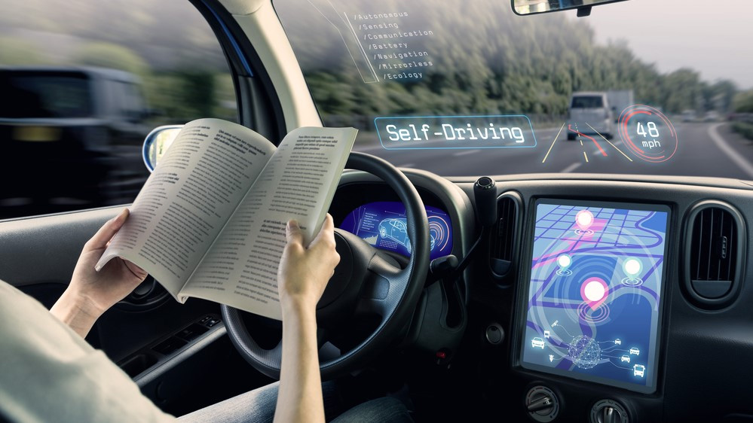
Figure 1 Artist's Conception of an SDA interior (CarTech Photo)

New technologies are emerging to quantify and record vast amounts of digitized data, which makes it ripe for analytic techniques to rapidly recognize and analyze the basic issues and anomalous behaviors to be avoided or minimized. To begin, it is necessary to assess the current status of M&SS and SDA's, then indentifies the intersection of interests. Then the need for standards for the interchange of critical data is reviewed. This alone may say time, effort and lives in the SDA community and its drive to early adoption by large segments of the populous. The authors are so bold as to envision research needed by both of the communities Also, the paper addresses the impact of autonomous robotics in combat and valid simulations on the battlefield. The paper reports that incipient volume of SDA records the operational events that are already being amassed by that discipline.

A failure to do so may be detrimental to both communities, as experience has shown that improper collaborations will sometimes set advancing technologies back decades. The authors adduce both recorded records and personal experience in both M&SS and SDA. They use their experiences to proffer several views of possible futures for uses of M&SS in SDA's and vice-versa. The paper sets forth coordinating techniques from the Systems Engineering (SE) discipline as a viable vehicle for improving this perilous situation. SE strives to ensure consistency and coverage in multi-disciplinary efforts, be they research or production programs.Future actions and research across both areas will be articulated.

This paper will speak to various aspects of the interaction between real-time data being generated by "self-driving autos" and the Modeling and Simulation standards communities. The first item(s) will be a review of the significant backgrounds for both communities, to set the stage for later discussion. Commonality of interests will be a major focus. There then will follow a set of analyses of the potential interactions between the two communities, as the SDA's and the autonomous military vehicles become more and more prevalent. The Simulation Standards committee will have the two environments with whom they will have to contend, producing effective standards to ensure both the efficacy of the simulations and the real time feed-back of insights they can inculcate back into the communities based on their closeness to the practitioners of the respective professions. Another issue will be the cross-organizational collaboration with other standards agencies, e.g. SAE International (the current title for the Society of Automotive Engineers).

  - Background

The history of self-driving cars is a amazingly long. [1] It seems that people were working on self-driving almost as soon as automobiles were invented. That may be a reflection of the observation that major transportation modes prior to automobiles were various uses of horses for motive power. In all of those cases, the person controlling the direction, speed and course taken could reliably turn those duties over to the horse with some reasonable anticipation that the horse would get them both back to home or wherever the horse was regularly fed. A couple of methods that were seen as precursors of today's efforts could more legitimately be called remotely driven automobile [2]. These early attempts bring to mind some important concepts in standardization. The first is the desirability of a careful analysis if when standards should be developed and instantiated. Too early may find the standards being overcome by events, as the technology takes a sudden turn, leaving the standards community having invested time, effort and credibility only to find their participation valueless or worse, embarrassing. Too late in articulating and proposing standards leaves the researchers, implementers and users without direction or goals they would otherwise profit from having had earlier. An ancillary effect of delay would be the production of competing standards. The second is the necessity of early operational consensus on terminology.

  - Self Driving Automobile Basics

Considering a century of automobiles is now behind us and the authors have a combined quarter of a millennium of driving experience, there is good cause to accept the following as basic requirements of an SDA:
- Route identification, optimization and modification
- Speed control and power consumption monitoring
- Collision avoidance and safety enhancement
- Lane selection and turn execution
The reader is invited to consider these functions and their analog in live, constructive and virtual combat. This may be especially critical if one remembers and heeds the old military adage: "No battle plan survives first contact with the enemy!".

One form or level of self-driving all drivers have had for decades is the automatic speed control mechanisms. These have become more reliable, more easily set and, of late, more responsive to collision avoidance by automatically slowing down when a car in the same lane is going slower than the set speed of the speed control. One author set the time of first practicable speed control as around 1950 [3]. The concomitant advent of limited-access "freeways" made these devices practicable. Since the '50s, the devices have given an increasingly useful relief to drivers, but the steady improvement in control does create a need for differentiating various levels of self-driving sophistication.

The advent of route planning was enabled by increasing sophistication in analysis (often called "the travelling salesman" problem), computer capability and the Global Positioning System. This might be seen as a classic disruptive technology as was most famously identified and characterized by Clayton Christiansen[4]. It is noteworthy that this disruptive technology spawned a new industrial base for automobile navigation that lasted only about a decade before being displaced with virtually ubiquitous availability of the same capabilities in SmartPhones and on-board programs in the automobiles themselves. These trends may impact standards and uses, so should be taken under advisement by the standards community.

The SAE has promulgated a series of definitions in J3016 Levels of Driving Automation [5] and the current one was updated in April of 2021. The base level is basically no additional assistance from the vehicle in maintaining safe and comfortable operation. The higher levels are basically concerned with the adequate sophistication to continue to operate well in degrading conditions. In a situation that is mirrored in DoD simulations, there often seems to be and assumption that all people will react similarly in a given set of circumstances. This is not at variance with the experience of both designers of battlefield simulations and the engineers of operational equipment. One might note that J3016 does not speak to user feedback, alert functions or machine failure anomaly reaction.
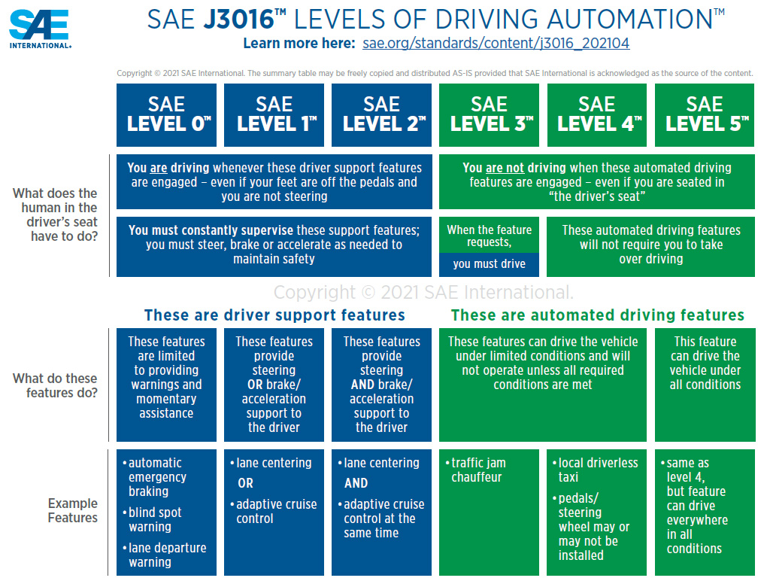
Figure 2 SAE Standard J3016 [6]

  - Autonomous Combat Vehicles

The simulation community has significant history in user situation awareness and the need for consistent machine/user communication. Another cross disciplinary asset may be the aircraft cockpit, with its well-known use for automating operations while maintaining instantaneous human interference when called for. Whether in the civilian's driving context or the battle field's autonomous vehicle use, another dimension may be manual or artificial-managed machine behavior modification.

However, the authors assert that it is not just the autonomous vehicle developers and war-fighter users who would benefit from the study of the impacts of SDA experience. Even the traditional roles of both simulation of and training for human participants in combat may find insights, otherwise not recognized, from analysis of the implementation of SDA's. It is noted that during the advent of massive parallel computing in the 1990's, many first-time practitioners of parallel processing techniques reported significant optimization of what they had previously seen as well-refined code after the parallelization effort. There were unforeseen issues that arose in that process that could then lead to more effective serial code.

The use of autonomous combat vehicles is expanding rapidly. UAV's, cruise missiles, autonomous naval ships, and self-diving ground vehicles are already in the field. Their use it being analyzed in many different fora considering simulation of their impacts, including a significant Chinese interest. [7 Simulations for training, analysis and evaluation of these vehicles is currently on-going [8]], but the authors have noted a significant lack of manifest interest in the human behavior issues that are going to emerge as people long-accustomed to dealing with other humans are now faced with burgeoning autonomous systems that have an ability to modify their own behaviors automatically and at a rate that may be unfamiliar to their human collaborators.

The range of vehicles is great, with the accompanying wide range of degree of human control and potential for catastrophic damage if the electronic directions either fail or are compromised by hostile forces.
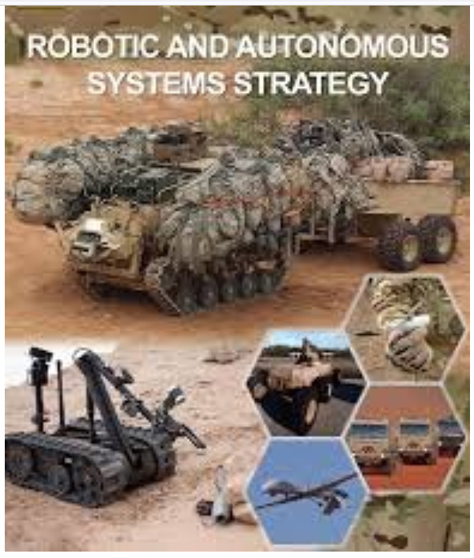
Figure 3 Autonomous Combat Vehicles [9]

All of these computer/user interfaces may similar to the issues currently being faced, in real-time, but the drivers of SDA's The number of fielded SDA systems is hard to assess, but the authors estimate it must be in the thousands who are operating at least at the SAE J3016 Level 3. That level requires one to maintain an indicium of attention (eye focus or hand on steering wheel sensor) and often requires the driver to take over SDA functions due to change in either traffic flow or environmental conditions. One incident observed by one of the authors (M.D. Davis) was the instruction to the driver to take command which was issued by a self-driving enabled Tesla. The ostensible reason therefor was a large and dense spray of a puddle struck by a truck going at a high rate of speed. This rendered both the dirver and the SDA sensor temporarily "blind."

- Observations from Early Experience with SDA's

Some data has already been collected, anecdotally by the authors and in a more rigorous manner by the entities that are fielding SDA's. The latter entities are very competitive, so they are hesitant to release their data. One of the authors heard an oral presentation at a share-holders' meeting of the Tesla corporation that stated 400,000 self-driving Teslas were on the road. It has been estimated that nearly that number are also being fielded by other developers. If these numbers are correct, something on the order of a million SDA's are on the roads already.

Based on the heat of the rhetoric on-line, the authors feel safe in assuming that the differences in approach of the various companies covers quite a range of both hardware and software. Most have a wide range of sensors for lane control and collision avoidance. One notable hold-out has been Elon Musk and Tesla. They began relying on cameras in the visible light spectra, with an initial input of ultra-sonic sensors. That lower frequency sensor was then deprecated. Then recently, Tesla announced that they may now add a radar sensor. [10] While some commentators took that as an admission of abandonment of the "camera only" policy, members of the simulation standards community have the experience with the ebbing and flowing of technology that may be of use to the emerging SDA standards. An underlying approach of trial and error may result in success and failures not anticipated during the process. One of the insights from the work of Professor Christensen was that the experts in the technology being disrupted often fail due to the constraints of both their technical vision and their currently profitable business model. The innovators are not bound by either of these hobbles. It is a widely held principle within Tesla that: "The best part is no part.".
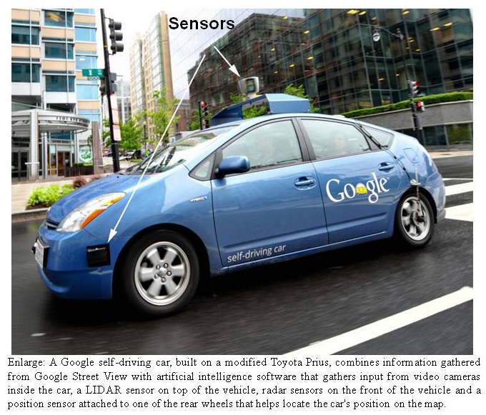
Figure 4 – Google SDA Showing Sensors [11]
One of the issues facing all of the developers is the placement of the sensors on the vehicle. This must be done with care to insure the effectiveness the safety devices. However, there are also issues of protection for damage, reduction of wind resistance, and moderation of noise from disruption of air flow. Additionally, in a subjective dimension not often found in military simulations: style and attractiveness must be considered. Many of these considerations will impact current development efforts and future decisions.

- Discussion

Within the lifetimes of many professionals in the STEM fields, a series of enormous leaps have been made. New alternate realities allow for many simulations to provide a random set of outcomes, dependent on a range of independent random events within the time frame of the operations. their own problem.

- Analysis
  - Realities

One of the most important issues in standardizing research, development and adoption is the consensus as to
With such important needs, each of these communities has a vested interest in stemming the flow of engineering and "hard science" majors into the liberal arts departments.

  - -

Illus

Studies have consistently shown that the defense forces of the United States are seen by their personnel as severely lacking in adequate mentoring.
This has allowed a considerable improvement in utility of these programs.

- New Technology Contributions
With personal tales of travails, the mentor could reassure the faltering spirit that most students go through that as well.

  - Metrics and Standards

A STEM researcher should never let personal enthusiasm cloud professional obligations to be objective. In
compared. A series of periodic mid-career could be automatically sought, recorded and analyzed.

- Conclusions

Technical work has created a society that needs even more technical workers. Serendipitously, the successes of earlier graduates may have provided the means of ameliorating the shortfalls occasioned by the number of students who originally eschew or subsequently abandon pursuing a STEM degree. There are demonstrable successes with emerging capabilities to field computer-generated mentors. These are more available geographically, available at any time, none-judgmental, selected to be engaging, represented via different genders and ethnicities, and distinctly congenial. Metrics and Standards could be developed to evaluate the efficacy of this endeavor.

- Acknowledgements

The authors wish to thank all of the simulation professionals with whom they have worked over the last three decades. This discipline is blessed with a fine group of creative and productive career scientists. We should also note that much of the work cited was supported by grants from the Office of Naval Research's STEM Program (ONR N00014-16-1-2820) and by research assistants supported by the National Science Foundation Research Experience for Undergraduates program (NSF 1560426). Nevertheless, the positions taken in the paper are the authors’ own and do not represent in any way the views of the Department of Defense or the US Government.

- References

- Badue, C., Guideline, R., Carneiro, R. V., Azevedo, P., Cardoso, V. B., Forechi, A., ... & De Souza, A. F. (2021). Self-driving cars: A survey. Expert Systems with Applications, 165, 113816.
- The Atlantic (2016). Your Grandmother's Driverless Car. Retrieved on 18 Dec 22 (published in 2016) from the internet using the URL: https://www.theatlantic.com/technology/archive/2016/06/beep-beep/489029/.
- Holloway, E. R. (1966). An Automatic Speed Controller for Automobiles. (Doctoral dissertation, Georgia Institute of Technology).
- Christensen, C. M. (2013). The innovator's dilemma: when new technologies cause great firms to fail. Harvard Business Review Press. Cambridge, Massachusetts, USA.
- SAE (2022). J3016 – Levels of Driving Automation. SAE International. Warrendale, Pennsylvania. USA. Retrieved from on 18Dec22: https://www.sae.org/binaries/content/assets/cm/content/blog/sae-j3016-visual-chart_5.3.21.pdf
- SAE (2022). SAE Standards News: J3016 automated-driving graphic update. SAE International. Retrieved from the internet on 18Dec22: https://www.sae.org/news/2019/01/sae-updates-j3016-automated-driving-graphic
- Fan, J. R., Li, D. G., Li, R. P., & Wang, Y. (2020). Analysis on MAV/UAV cooperative combat based on complex network. Defense Technology, 16(1), 150-157; Beijing, China.
- Cox, J., DeRosier, S., Howell, A., Jones, J., & Thompson, B. (2022). Developing Requirements to Validate Autonomous Ground Vehicle Simulations.
- US Army Training and Doctrine Command (TRADOC). (2017). US Army Robotics and Autonomous Systems Strategy. Ft. Eustis Virginia, USA.
- Elecgtrek, (2022), Tesla says it is adding radar in its cars next month amid self-driving suite concerns. Retrieved on 12 Dec 22 from: https://electrek.co/2022/12/06/tesla-radar-car-next-month-self-driving-suite-concerns/

- –
- –
- –
- –
- –
- –
- –
- –
- –
- –
- –
- –
- –
- –
- –
- –
- –
- –
- –
- –
- –
- –
- –
- -:

Author Biographies

DAN M. DAVIS is a Research Associate Professor at Catholic Polytechnic University (CPU) and is also active as a consultant at the Institute for Creative Technologies, University of Southern California (USC). He is currently focusing on large-scale DoD simulations and virtual human implementations. Prior to retirement, he was the Director of the JESPP project at USC for more than a decade. As the Assistant Director of Advanced Computing Research at Caltech, he ran Synthetic Forces Express, bringing HPC to DoD simulations. He has also served as a Director at the Maui High Performance Computing Center and in computer research roles at the Jet Propulsion Laboratory and Martin Marietta. He was the Chairman of the Coalition of Academic Supercomputing Centers and has taught at the undergraduate and graduate levels. As early as 1971, Dan was writing programs in FORTRAN on one of Seymour Cray’s CDC 6500’s. While in the Marine Corps, he saw duty in Vietnam as a Cryptologist and retired in 2002 as a Commander, U.S.N. He received B.A. and J.D. degrees from the University of Colorado in Boulder.

JENNIFER H. NOLAN, PH..D. is the President of Catholic Polytechnic University and Professor of Psychology in their College of Arts and Sciences. Her earlier work specialized in memory, dementias, stroke and insulin resistance. She is a brain plasticity specialist and certified Cogmed provider. Previously, she was the C.O.O. and co-founder of a stroke and brain injury rehabilitation center. Dr. Nolan has taught university courses at the University of California Irvine, Loyola Marymount University, and Glendale Community College. She has conducted local and nationwide clinical trials, and published in both scientific journals and popular magazines. She received a BA in Psychology from Loyola Marymount University, Los Angeles and a Ph.D. in Psychology from the Dept. of Cognitive Science at the University of California, Irvine.

MARK C. DAVIS, PH.D. is the Chief Technical Officer at Wood Duck Research, Inc, and is semi retired after careers in the US Navy and as a computer design engineer for both IBM and Lenovo. Rising to the level of Distinguished Engineer at Lenovo, he was responsible for the design of laptop computer cross-disciplinary technology, including PC architecture, embedded systems, open source and virtualization. Previous work was with IBM in the areas of software development and architecture involving security, storage and virtualization. Dr. Davis has been granted well over fifty patents that were filed during his service at both companies. He is a graduate of the Duke University NROTC program and was commissioned as an Ensign, attended nuclear power school, and served as a Submarine Officer for twelve years, including one duty tour as a classroom instructor. He left the active duty as a Lieutenant Commander to pursue a PhD. Mark holds a BSEE degree from Duke University and a PhD in Computer Science from the University of North Carolina, Chapel Hill, where his advisor was Professor Fredrick P. Books.

JUDITH L. JACOBUS is retired from conducting speech therapy as a Speech and Language Specialist for more than two decades. Her experiences were in public schools settings in Orange County. California. She also previously taught for 12 years as a classroom teacher in multi-cultural communities there. Judith currently volunteers her professional skills for a local police department, so has extensive experience with dysfunctional adults and children in a variety of both every-day and traumatic situations. Her participation in amateur theatrics has more fully familiarized her with the characteristics of human behavior as they are projected via verbal, facial and body-language cues. This experience has also exposed her to the skill and art of the selection of appropriate persons for specific on-screen roles. Judith holds a lifetime Special Education Credential in Speech and Hearing Therapy, K-12 from the State of California. She earned a B. A. Degree in Speech Communications from the California State University Long Beach and an M. A. Degree in Teaching and Teacher Leadership from the Grand Canyon University in Glendale, Arizona.

