Populating a Virtual Conversation Database:
Community Data Collection and Analysis

Dan M. Davis | Brian L. Morgan & David H. Barnhill
ICT, Univ. of So. Calif. | US Naval Postgraduate School
Los Angeles, California | Monterey, California
dmdavis@acm.org | {blmorgan, david.barnhill}@nps.edu
Daniel P. Burns | Mark C. Davis
Homeports Solutions | Wood Duck Research, Inc.
Eastchester New York | Mooresville, North Carolina
daniel.p.burns@homeportsolutions.net [daniel.p.burns@homeportsolutions.net] | mark@woodduckresearch.org

ABSTRACT

This paper addresses the issues faced when populating a set of questions that may be posed to mentors, in order to reliably create a large database of video-taped responses, which will be used to answer questions during on-line virtual conversations. The authors relate their experiences in indentifying and selecting the topics that often arise during mentoring. The goal is to create a Natural Language Processing (NLP)-enabled computer agent to respond to questions from mentees, focusing on issues like establishing command relationships and ameliorating early career stresses from family relocations. The paper describes the inception and the goals of the research, and then relates the early conception of the types issues to be included. They report on preliminary evaluations of these results and analyze the perceived adequacy of the impacts. Then, the approach to obtaining a more inclusive range of data is detailed. One part of this approach was the creation of an on-line survey, intended to ethnographically characterize the target population’s concerns. The data from this ethnographic survey are presented as an example of how this approach was useful in creating the range of necessary issues to be addressed. With the anticipated exponential growth in both the sophistication and the utilization of Artificial Intelligence and Virtual Humans, this paper will focus on methods and techniques that may be useful in similar situations. The discussion closes with an evaluation of the utility of such approaches, uses to which they may be put, and emerging technologies that may dramatically impact future capabilities.

ABOUT THE AUTHORS
Dan M. Davis is active as a consultant at the Institute for Creative Technologies (ICT), University of Southern California (USC), focusing on large-scale DoD simulations and avatar uses. Prior to retirement, he was the Director of the JESPP project at USC for a decade. As the Assistant Director of Advanced Computing Research at Caltech, he led Synthetic Forces Express, bringing HPC to DoD simulations. He also served as a Director at the Maui High Performance Computing Center and in computer research roles at the Jet Propulsion Laboratory and Martin Marietta. He was the Chairman of the Coalition of Academic Supercomputing Centers and has taught at the undergraduate and graduate levels. As early as 1971, Dan was writing programs in FORTRAN on one of Seymour Cray’s CDC 6500’s. While in the Marine Corps, he saw duty in Vietnam as a Cryptologist and retired in 2002 as a Commander, USNR. He received B.A. and J.D. degrees from the University of Colorado in Boulder.
Brian L. Morgan, CAPT, USN, Ret. is currently listed as a member of the Faculty at the Naval Postgraduate School in Monterey California has over six years of experience in the practical application of operations research at the Service headquarter level while assigned to the Assessment Division (OPNAV N81) in the Pentagon. He is a Naval Flight Officer with innumerable hours in E-2s, including duties as an instructor, Chief of Operations Test and Evaluation Branch, National Military Command Center, and Commanding Officer, VAW-117. He is active with his research colleagues at the Naval Postgraduate School in Monterey, Calif. Brian received a BS in Aeronautical Engineering from the University of Virginia and an MS in Operations Research from the Naval Postgraduate School.
Daniel P. Burns, CAPT, USN, Ret. is a lifelong Systems Engineer, first with the Active Duty Navy, then SAIC, and small business. He served as Naval Chair and Professor of Practice in Systems Engineering at the Naval Postgraduate School (NPS). Captain Burns served as the as the Military Associate Dean and as acting Dean of the Graduate School of Engineering and Applied Sciences at NPS. His research interests center on analyses of both human and resource utilization in defense efforts. He successfully facilitated \ the creation of a new program for Air Force Officers who seek post-graduate degrees. Captain Burns received a BS in Resource Management from the U.S. Naval Academy, an MS in Security Affairs from the Naval Postgraduate School and an MS in Systems Engineering from Southern Methodist University. He is currently working with Portland State University on a Ph.D.
David H. Barnhill, LCDR, USN, is enrolled the US Naval Postgraduate School (NPS), in Monterey California. He is a student there in the Operations Research Department. He is particularly interested in the analysis of human behavior and command relationships of defense personnel. A topic of immediate concern is the imminent adoption of various levels of robotic and artificial intelligence-controlled weapons on unit cohesion and command functions. He is a Naval Aviator, and has flow rotary-wing aircraft from both land and vessel platforms. David has served in flying status leadership positions and has performed staff officer duties. He graduated from the US Naval Academy with a BS and is scheduled to complete an MS in Operations Research at NPS in the spring of 2021.
Mark C. Davis, Ph.D. is the Chief Technical Officer at Wood Duck Research, Inc, and is semi retired after careers in the US Navy and as a computer design engineer for both IBM and Lenovo. Rising to the level of Distinguished Engineer at Lenovo, he was responsible for the design of laptop computer cross-disciplinary technology, including PC architecture, embedded systems, open source and virtualization. Previous work was with IBM in the areas of software development and architecture involving security, storage and virtualization. Dr. Davis has been granted well over fifty patents that were filed during his service at both companies. He is a graduate of the Duke University NROTC program and was commissioned as an Ensign, attended nuclear power school, and served as a Submarine Officer for twelve years, including one duty tour as a classroom instructor. He left the active duty as a Lieutenant Commander to pursue a PhD. Mark holds a BSEE degree from Duke University and a PhD in Computer Science from the University of North Carolina, where his advisor was Professor Fredrick P. Books.

Populating a Virtual Conversation Database:
Community Data Collection and Analysis

Dan M. Davis | Brian L. Morgan & David H. Barnhill
ICT, Univ. of So. Calif. | US Naval Postgraduate School
Los Angeles, California | Monterey, California
dmdavis@acm.org | {blmorgan, david.barnhill}@nps.edu
Daniel P. Burns | Mark C. Davis
Homeports Solutions | Wood Duck Research, Inc.
Eastchester New York | Mooresville, North Carolina
daniel.p.burns@homeportsolutions.net [daniel.p.burns@homeportsolutions.net] | mark@woodduckresearch.org

INTRODUCTION

This paper focuses on the issue of topic selection for a large (>300) collection of question that might or should be asked of Naval service mentors. The paper opens with a brief outline of the genesis of the underlying project to create an on-line virtual conversational mentor to respond to junior officers (JO’s). the first major section then deals with the need for such an asset, some issues now plaguing the facilitation of mentors, and the ways in which an on-line virtual mentor may alleviate the impediments observed. The next section will lay out some early attempts to generate a list of potential questions and the increasingly focused methods of establishing the data base of questions. An informal ethnographic survey was conducted and the results from and utility of the data derived therefrom will be presented. The penultimate major section deals with some of our analyses of the work and presents some conjectures about the meaning thereof. The final major section is a recitation of conclusion to which the authors are both willing and anxious to append their names. Many of the assertions presented herein are the observations and opinions of the authors that will not be further justified or formally cited. It is noted here that all of the authors are commissioned United States Naval officers, with a total of 111 years of service, including five individual tours as Commanding Officers of units in the warfare communities of Aviation, Surface Warfare, Submarine Warfare, and Cryptology.

BACKGROUND

The preparation, advancement and retention of personnel to defend their country have been major goals throughout history. Part of that process has been mentoring of junior officers. Within the US Defense establishment, there have been myriad studies and no small number of programs designed to facilitate and enhance that process. Despite that, there continue to be evidence that such program are more honored in the beach than in the compliance. It has been the author’s observation that their wardroom mates more often complain about those programs than they praise them. To respond to some of these un-met needs, the Navy has authorized a project to present an on-line virtual mentor. This program utilizes an artificial intelligence (A/I) approach called Natural Language Processing (NLP) that can characterize a mentee’s question and match it with a pre-recorded mentor’s answer, cue it up on web interface and play it within a 500 millisecond time frame, which is an acknowledged delay that is considered typical in face-to-face conversations. The issue to which this paper addresses itself is the questions that need to be in the storage location for mentor responses. To adequately address these issues, it would be beneficial to establish the mentoring process and environment.

Mentoring In the Military Environment

In the Odyssey, Mentor was a friend of Odysseus. When Odysseus left for the Trojan War, he placed Mentor and his foster-brother Eumacus in charge of his son Telemacus and his house. Odysseus directed Mentor to ‘tell him all you know.’ Because of his relationship with Telemacus and the disguised Athena’s encouragement and practical plans for dealing with personal dilemmas, the name Mentor has been adopted as a term meaning someone who imparts wisdom to and shares knowledge with a less experienced person. (Homer & Fitzgerald, 1990)

The first recorded modern usage of the term is in a 1699 book entitled Les Aventures de Telemague by the French author Francois Fenelon. (de La Mothe, 1997) Today, the term mentor usually implies a relationship over a significant period of time.

Mentors pass their art on to others. The word is synonymous with sensei, which literally means “one who has gone before.” In other words, mentoring is age teaching youth. This definition suggests a similarity with coaching. In practice and many business settings, coaching is used interchangeably with mentoring. However, many see distinctness. Coaching seeks the improvement of performance and development of skills through some form of instruction and practice. In contrast, mentoring involves the acquisition of knowledge germane to a specific consideration or longer-term development of decisions necessary to achieve a goal. Thus, it takes a broader view of the person.

This relationship provides timely clarity, awareness of risks and rewards, choices (of action), alternatives, feedback, and assessment. The purpose is not to find the ‘right’ or ‘optimal’ answer but to create and list all relevant alternative courses of action.

In a military organization context, this paper differentiates mentoring from coaching, peer review, performance evaluation, and situations where junior personnel (in a hierarchical organization) provide knowledge or guidance to senior personnel. In an informal poll to be introduced below, many of the respondents did not adhere to this careful delineation, but referred to almost any professional advisory relationship as a mentor/mentee linkage. For this latter circumstance, examples include a division leading chief petty officer providing guidance to a newly reporting junior officer or a command’s senior enlisted advisor providing their perspective to the commanding general/flag officer. In addition, the authors are inclined to prefer to not include a mentor-mentee relationship where a direct or indirect senior-subordinate relationship exists because it inhibits the mentoring relationship, albeit observing that many in uniform cite former Commanding Officers as a paradigm for a good mentor.

It is acknowledged that this restriction places a narrower definition on mentoring than many authors. The authors also note that in practice, many junior officers will say that mentoring by their first commanding officer had the most profound impact on their career decisions and early understanding of “Big Navy” institutions and actions. The most common example being BUPERS and the detailing (assignment) processes, respectively. While a junior officer’s first or possibly second commanding officer often has a disproportionate impact on their Navy career decisions, this paper prefers to use the for term guidance for this type of professional development from evaluating senior. Specifically, it is career planning and goal setting.

See Figure 1 for an illustration of professional development opportunities for service personnel.

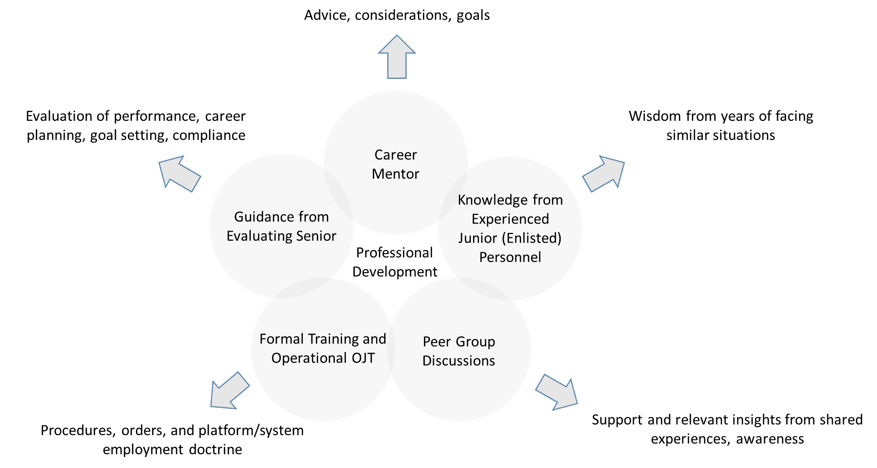
Figure 1 Depiction of five different means for providing professional development.

As previously defined, a mentor is a trusted counselor or guide who provides advice and considerations applicable to a decision or long-term objective. The authors do not place the restriction of the advice being positive. Hothe authors ver, the information provided must be accurate for the mentor-mentee relationship to be effective. This provision necessitates that the mentor is a higher-level manager or executive with extensive experience in the same organization, career field, or subject area on the decision being considered by the mentee. Counter-intuitively, a mentor does not need a track record of success. Why? If the mentor upholds their end of the discussion, the burden of execution is with the mentee. To build self-belief, the mentee must understand that their success is due to their own efforts.

The benefit of self-belief is one of many associated with a healthy, effective mentor-mentee relationship. As previously described, mentorship can provide awareness and responsibility in the short term for achieving a task or longer term guidance for a better quality of service and/or transition to a post-military career. The mentor may also be able to open doors to otherwise out of-reach opportunities.

Now that the authors have defined the term mentor and presented the benefits he/she can provide, the authors explore the characteristics of the mentor-mentee relationship. It may be an enduring relationship that lasts for a number of years. Alternatively, it can be more informal with interactions taking place as and when the mentee needs advice, guidance, or support.

The most challenging aspect of professional development is establishing the mentor-mentee association. Often, to the junior professional, looking from the outside, the barrier to entry appear formidable. Fortunately, there are multiple available avenues. Based on our experience, the most promising avenue for establishing the mentor-mentee relationship is membership in a professional society. Why? First, the members all share a common interest. Second, members have a wide range of experience and expertise. Third, the members are invested in the health of the society and mentors see mentees as the next generation of the society’s leadership. Fourth, in-person interactions at society events can provide precise feedback on whether the mentor-mentee relationship is a good fit. Lastly, participation in a professional society allows for communication that would otherwise be precluded by more formal affiliations associated with an organizational chain of command or professional stature. It should be noted that membership in a professional society may be necessary to gain full benefit of their mentorship opportunities.

Closely related to membership in a professional society, is attending or presenting at a professional conference. If the opportunity presents itself, ask the speaker a question and then personally greet the speaker after the presentation. One of the authors, when serving as a Commanding Officer, would order each of his JO’s to ask any unit briefer at least one question at the end of the briefing. Most individuals will be happy to give several minutes of their time and offer the opportunity for additional professional dialogue. While this example appears to be better described as networking, a personal connection has to first be established before the mentor-mentee relationship.

A third avenue to develop a mentoring relationship is utilizing one of the other four professional development opportunities depicted in Figure 1. For example, when receiving a performance evaluation, the person could ask their reporting senior (i.e. boss) to recommend potential mentors.

Now that you know several paths to developing a mentor-mentee relationship, the authors explain prospects and opportunities that should be avoided. Most critically, a person who could be in competition for the same professional goal is not a good mentor. The rationale is clear. In addition, a mentor should not be in a person’s chain of command, i.e. a direct or indirect senior-subordinate relationship. If a mentor were in their mentee’s chain of command, suggestions of alternatives would confound the line of authority. In addition, it would put the mentee in the untenable position of having their mentor formally evaluating their performance. At an absolute minimum, the restrictive nature of a command may block open, unfettered dialogue. Thus, the authors conclude that a commanding officer cannot control all aspects of the efficacy of a command mentor program.

Any attempt to evaluate a commanding officer or senior enlisted advisor on their command’s mentorship program will only serve to corrupt the establishment of healthy, enduring mentor-mentee relationships. Commanding officers will become disenfranchised knowing that their performance will be judged on a criterion that they cannot control. It is illogical for a commanding officer to order their personnel to have a mentor and the fluid nature of when a person could benefit from a mentor makes any assessment of a mentorship program highly subjective. The authors note that in the private sector, a person would not want to have their end-of-year performance review contingent on the actions of a person or organization that they cannot control. For example, have three articles published in a peer review journal. On the surface it sounds like a reasonable objective. However, the individual cannot control the editor’s review process.

What qualities does a good mentor possess? There are many related terms and a few are listed below:

• Patient
• Supportive
• Interested
• Good listener
• Perceptive
• Aware
• Attentive
• Retentive

Just as it is important to know the qualities of a good mentor, it is critical to know what a mentor does not do. They do not dictate action; the burden of the decision and subsequent action rests with the mentee. In addition, they do not appraise an action. However, they may elicit aspects a self-assessment from the mentee.

A person may ask the following question – Can mentorship skills be taught? This paper asserts that the answer is yes. The necessary skills include techniques for effective questioning, active listening, explaining how there is no one right way to achieve a goal, and exploring the many different avenues to establish the relationship.

The authors conclude our exploration of mentoring by presenting the mentor’s and mentee’s responsibilities. In review, the mentor does not necessarily provide answers. He/she provides considerations or elicits considerations. Specifically,

• Although the mentor does not provide any particular answer, they may find that the demand for an answer is essential to compel the mentee to think, to examine, to look, to feel, to be engaged.
• The answers sought should be descriptive and not judgmental.
• A mentor can act as a “sounding board” without jeopardizing a person’s self-esteem.
• A mentor could energize their professional network when the mentee requires guidance outside their area of expertise or to gain an appreciation of alternative courses of action.
• A mentor may be able to diminish external obstacles; could also eliminate internal obstacles
• A mentor should not provide advice, per se. If they do and it fails, the mentee will often blame the mentor and the relationship may be inhibited.

The primary responsibility of the mentee is accountability for their thoughts and actions. Specifically,

• Be motivated and feel empowered to plan and manage the direction of their professional career.
• Take responsibility for their development, learning, and professional growth.
• Participate as an active listener when receiving guidance.
• Maintain confidentiality within the mentoring relationship.

Question-set DATABASE CREATION

Please do not number your pages as it is done automatically in the footer. However, you should replace the “nnnn” in the footer with your paper ID number. A running header that identifies the paper as being from MODSIM World 2014 is included at top of each page. Also, a footer including your paper number is displayed at the bottom of each page. Please do not remove or change the position of the header/footer and do not add other information.

Major headings should be set in 10-point bold, capitalized text as shown above and preceded by 2 blank lines except when starting a new page. Body paragraphs (like this one) should be set in acceptable style 10-point font, and fully justified (block style). Insert one blank line between paragraphs and between paragraphs and subheading. Do not indent.

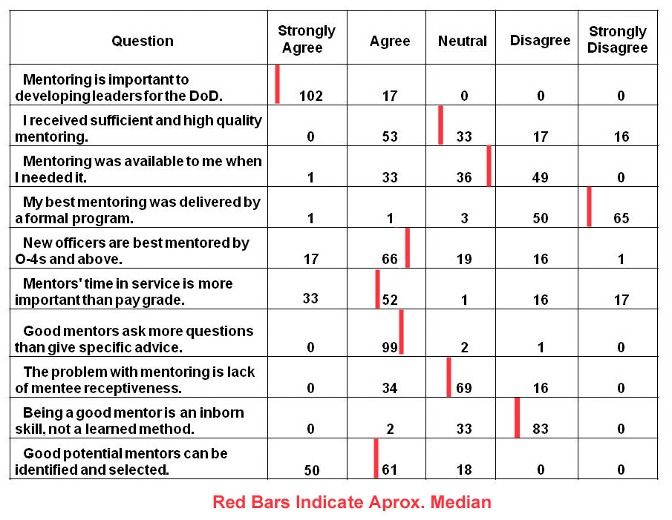

Subheading Example

Subheading titles should be set in acceptable style 10-point font that is boldfaced and uses initial capitals. As mentioned above, insert one blank line between paragraphs and subheadings.

DATABASE VALIDATION

Major headings should be set in 10-point bold, capitalized text as shown above and preceded by 2 blank lines except when starting a new page. Body paragraphs (like this one) should be set in acceptable style 10-point font, and fully justified (block style). Insert one blank line between paragraphs and between paragraphs and subheading. Do not indent.

Subheading Example

Subheading titles should be set in acceptable style 10-point font that is boldfaced and uses initial capitals. As mentioned above, insert one blank line between paragraphs and subheadings.

ANALYSIS

This project focused on mentorship of junior officers (JOs). The primary way JOs obtain information and guidance about the naval profession is through the experience of officers that have come before them. While the US Navy employs many informational programs focusing on procedural aspects of a naval career, maturity of formal mentorship programs is lacking. While every command or naval activity is required to nominally institute a mentorship program, oversight is sub-par, usually given as a collateral duty, and subject to an activity’s operational or, if not operational, general work, tempo.

In general, employing seasoned officers to provide experiential input provides this project data that otherwise might be compartmentalized to a certain command, community, or small group. Further, experiences oftentimes transition easily across communities. While a ‘sea story’ might be specific to an aviation experience, it is easy to visualize a similar experience occurring in a different community. In micro, personal experience highlights nuances that are not easily gleaned or understood if researchers are not directly part of the organization they are studying. By including naval officers in this study, researchers are accumulating and concentrating pointed data for use by any junior officer in any naval organization.

One of the major challenges and, indeed deficiencies, junior officers face is professional writing skills or lack thereof. These officers will find themselves writing all types of professional documents throughout their career, most important of which are personnel evaluations and fitness reports. Lack of understanding on the gravity of these documents goes far beyond the writing. Little emphasis is given on the effect an officer’s words and the way they are conveyed has on the careers of themselves and, more importantly, their subordinates. Largely, these skills are developed through on-the-job training, which, while important, means the officers are operating at a professional deficiency. Early intervention by superior officers, acting as mentors, can accelerate development of these skills as well as the understanding that the impact of a leader’s words can significantly impact the career of a subordinate.

Along with writing skills, junior officers will find themselves presenting material to all types of audiences early on in their careers. The ability to speak cogently, concisely, and specifically to their topics is essential to personal and professional development as an officer. While some communities build this skill into training programs (e.g. aviation; flight briefs) many others do not and the personnel accept poor verbal communication as the modus operandi for young officers. Without proper focus from superiors on these skills, young officers run the risk of a chronic failure to convey and emphasize information. On a personal level, proper and professional speaking skills simply increase the likelihood of an officer being taken seriously. It is clear when mid-grade officers have not been given an emphasis on their speaking skills early in their career they suffer later.

Detailing is a constant ordeal while in the military. Early on in an officer’s career, there can be little interaction with the detailer. Indeed when it is time for an individual officer to approach their detailer about orders, it can be a daunting experience. Few know what questions need to be asked and what options they have. Good ‘front offices’ are responsible for some liaisons with detailers in order to give input as to where an individual should go. If a front office does not do this, then the individual is solely responsible for looking out for themselves. However, formal information does not do an appropriate job of preparing young officers for this possibility. Mentorship from superiors, usually mid-grade, pre-command officers can guide these junior officers and give them input as to how to interact with detailers and the specifics of the detailing process.

At all levels, an experienced officer leading a team is an invaluable resource to those working with or subordinate to them. Their experiences show in how they handle the team and what skills they use to lead the team. Oftentimes the problems they are seeking to solve are not new. The value in this type of officer is that they can direct the team’s attention in specific areas that they know need to be the focus. This is a function of previous experience and is huge driver in the success of any team. A hypothetical team with inexperienced leadership can find itself exploring several different focus points that are not pertinent to the task at hand and not know it. This is simply a function of leadership without proper experience.

Subheading Example

Subheading titles should be set in acceptable style 10-point font that is boldfaced and uses initial capitals. As mentioned above, insert one blank line between paragraphs and subheadings.

CONCLUSIONS

Major headings should be set in 10-point bold, capitalized text as shown above and preceded by 2 blank lines except when starting a new page. Body paragraphs (like this one) should be set in acceptable style 10-point font, and fully justified (block style). Insert one blank line between paragraphs and between paragraphs and subheading. Do not indent.

Subheading Example

Subheading titles should be set in acceptable style 10-point font that is boldfaced and uses initial capitals. As mentioned above, insert one blank line between paragraphs and subheadings.

ACKNOWLEDGEMENTS

The acknowledgements section is optional. If included, it appears after the main body of text and before the references. This section includes acknowledgements of help from associates, credits to sponsoring agencies, etc. Please try to limit acknowledgements to no more than a three or four sentence paragraph.

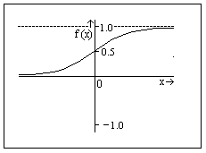Tables and figures should be embedded in the submitted paper and inserted in the body text as soon as possible after they are referenced (see Figure 1).
Figure 1. Example of a Half Page Figure

They may be sized to fit half the width of the page, or the full-page width. Captions should follow APA guidelines such that Figure captions are placed below the figure. In some cases, you may need to insert a text box and group the caption with the figure. If this approach is taken, you may also need to set the “text wrapping” properties to “square”.

Table captions (see Table 1) are placed above the Table.

Table 1. Example of a Single Column Table

 | Processing Time (in 10⁻⁵ seconds )
 | Speed | Heading | Total | DR
Min | 6.89029 | 6.19888 | 13.08981 | 2.2888
Mean | 7.77692 | 7.47008 | 15.24700 | 2.7974
Max | 20.5993 | 29.7999 | 50.3992 | 6.35981
A sample of a figure spanning the entire width of the page may be seen in Figure 2. Color graphics may be used.

Figure 2. Example of Figure Caption

Equations should be numbered and centered. A slightly smaller font may be used for equations, subscripts, and superscripts. Use Symbol or Lucida for mathematics as shown in equation 1.

(1)

REFERENCES

de La Mothe, F. D. S. (1997). The Adventures of Telemachus, the Son of Ulysses (Vol. 10). University of Georgia Press.
Homer & Fitzgerald, R. (1990). The Odyssey. New York: Vintage Books..
Alt, D. (2015). Assessing the Contribution of a Constructivist Learning Environment to Academic Self-efficacy in Higher Education. Learning Environments Research, 18(1), 47-67.
Artstein, R., Gainer, A., Georgila, K., Leuski, A., Shapiro, A., & Traum, D. (2016). New dimensions in testimony demonstration. In Proceedings of the 2016 Conference of the North American Chapter of the Association for Computational Linguistics: Demonstrations (pp. 32-36).
Behar-Horenstein, L. S., & Niu, L. (2011). Teaching critical thinking skills in higher education: A review of the literature. Journal of College Teaching & Learning, 8(2), 25-42.
Bower, J. M. (1996). Science education reform: How can we help?. Issues in Science and Technology, 12(3), 55-60.
Bazerman, C., Little, J., & Bethel, L. (2005). Reference Guide to Writing Across the Curriculum. Parlor Press LLC.
Cohen, S. (1968). The Industrial Education Movement, 1906-17. American Quarterly, 20(1), 95-110.
Chowdhury, G. G. (2003). Natural language processing. Annual Review of Information Science and Technology, 37(1), 51-89.
Collobert, R., & Weston, J. (2008, July). A unified architecture for natural language processing: Deep neural networks with multitask learning. In Proceedings of the 25th International Conference on Machine Learning (pp. 160-167). ACM.
Davis, D.M. (1999). Conversations with members of the tenured faculty staff at the Californian Institute of Technology in the years 1992 through 1999.
Davis, D.M. (2106). Conversations with several senior PhD dissertation advising Professors at the University of Southern California, Los Angeles, California in 2016.
Feynman, R., (1981), Simulating Physics with Computers, International Journal of Theoretical Physics, Vol 21, Nos. 6/7
Finger, M. (1995). Adult Education and Society Today. International Journal of Lifelong Education, 14(2), 110-119.
Gottschalk, T. D., Yao, K-T., Wagenbreth, G. & Davis, D. M., (2010), Distributed and Interactive Simulations Operating at Large Scale for Transcontinental Experimentation, in the Proceedings of the IEEE/ACM Distributed Simulations and Real Time Applications 2010 Conference, Fairfax, Virginia
Halpern, D. F. (1998). Teaching Critical Thinking for Transfer Across Domains: Disposition, Skills, Structure Training, and Metacognitive Monitoring. American Psychologist, 53(4), 449.
ICT, (2019). Virtual Humans, Retrieved 17 February 2019 from: http://ict.usc.edu/groups/virtual-humans/
Jesness, J. (2002). Stand and Deliver Revisited. Reason, 34(3), 34-39.
Kenny, P., Hartholt, A., Gratch, J., Swartout, W., Traum, D., Marsella, S., & Piepol, D. (2007, November). Building interactive virtual humans for training environments. In Proceedings of Interservice/Industry Training, Simulation and Education Conference (Vol. 174).
Kudryavtsev, Andrey. Automatic Speech Recognition Services Comparison. Grid Designer's Blog. N.p., 11 Jan. 2016. Web. 20 Apr. 2017. Available: <http://blog-archive.griddynamics.com/2016/01/automatic-speech-recognition-services.html>.
Lee, K. F. (1988). Automatic speech recognition: the development of the SPHINX system. (Vol. 62). Springer Science & Business Media.
Lee, O., Miller, E. C., & Januszyk, R. (2014). Next generation science standards: All standards, all students. Journal of Science Teacher Education, 25(2), 223-233.
Lee, S. T. (2009). Examining the Relationships between Metacognition, Self-regulation and Critical Thinking in Online Socratic Seminars for High School Social Studies Students. PhD Dissertation. University of Texas.
MentorPal, (2019). Mentor Pal: Virtual Conversations to Enhance STEM Career Selection, Retrieved from the net 17 February 2019 from: http://www.hpc-educ.org/MentorPal/Web/MntPal
NGSS Lead States. (2013). Next Generation Science Standards: For states, by states. Washington, DC: The National Academies Press.
Paul, R. & Thompson, R. (Producer) & Bridges, J. (Director). (1973). The Paper Chase [Motion Picture]. USA: 20th Century Fox
Rahman, M. M. (2010). Teaching Oral Communication Skills: A Task-Based Approach. ESP World, 9(1), 1-11.Rizzo, A., Lange, B., Buckwalter, J. G., Forbell, E., Kim, J., Sagae, K., ... & Parsons, T. (2011). SimCoach: an intelligent virtual human system for providing healthcare information and support. International Journal on Disability and Human Development, 10(4), 277-281.
Satori, H, Harti, M., & Chenfour, N. (2007). Introduction to Arabic speech recognition using CMU Sphinx system. arXiv preprint arXiv:0704.2083.
Swartout, W. R., Gratch, J., Hill Jr, R W., Hovy, E., Marsella, S., Rickel, J., & Traum, D. (2006). Toward virtual humans. AI Magazine, 27(2), 96.
Swartout, W. R., Nye, B. D., Hartholt, A., Reilly, A., Graesser, A. C., VanLehn, K., ... & Wang, L. (2016, March). Designing a Personal Assistant for Life-Long Learning (PAL3). In The Twenty-Ninth International Flairs Conference.
Tetlock, P. E., & Gardner, D. (2016). Superforecasting: The Art and Science of Prediction. Random House.
Thorsteinsson, G., & Ólafsson, B. (2014). Otto Salomon in Nääs and his first Icelandic students in Nordic Sloyd. History of Education, 43(1), 31-49.
Traum, D., & Rickel, J. (2002, July). Embodied agents for multi-party dialogue in immersive virtual worlds. In Proceedings of the First International Joint Conference on Autonomous Agents and Multiagent Systems: part 2 (pp. 766-773). ACM.
Traum, D., Jones, A., Hays, K., Maio, H., Alexander, O., Artstein, R., ... & Jungblut, K. (2015, November). New Dimensions in Testimony: Digitally preserving a Holocaust survivor’s interactive storytelling. In International Conference on Interactive Digital Storytelling (pp. 269-281). Springer International Publishing.
Wood, R., (2011). What is Sloyd?, Robin Wood, MBE, Derbyshire, UK, Retrieved from the internet 20 January 2019 from: http://www.robin-wood.co.uk/wood-craft-blog/2011/02/28/what-is-sloyd/
Yancey, K. B., & Huot, B. (1999). Assessing Writing across the Curriculum: Diverse Approaches and Practices. Perspectives on Writing: Theory, Research, Practice. Volume 1. Ablex Publishing/JAI Press Inc., 100 Prospect Street, PO Box 811, Stamford, CT 06904-0811.
Zigler, E. F., Kagan, S. L., & Hall, N. W. (1997). Children, Families and Government: Preparing for the

