**Populating a Virtual Conversation Database:   
Community Data Collection and Analysis**

|  |  |
| --- | --- |
| **Dan M. Davis** | **Brian L. Morgan & David H. Barnhill** |
| **ICT, Univ. of So. Calif.** | **US Naval Postgraduate School** |
| **Los Angeles, California** | **Monterey, California** |
| **dmdavis@acm.org** | **{blmorgan, david.barnhill}@nps.edu** |
|  |  |
| **Daniel P. Burns** | **Mark C. Davis** |
| **Homeports Solutions** | **Wood Duck Research, Inc.** |
| **Eastchester, New York** | **Mooresville, North Carolina** |
| **daniel.p.burns@homeportsolutions.net [daniel.p.burns@homeportsolutions.net]** | **mark@woodduckresearch.org** |

# ABSTRACT

This paper addresses the issues faced when populating a set of questions that may be posed to mentors, in order to reliably create a large database of video-taped responses, which will be used to answer questions during on-line virtual conversations.The authors relate their experiences in indentifying and selecting the topics that often arise during mentoring.The goal is to create a Natural Language Processing (NLP)-enabled computer agent to respond to questions from mentees, focusing on issues like establishing command relationships and ameliorating early career stresses from family relocations.The paper describes the inception and the goals of the research, and then relates the early conception of the types of issues to be included.They report on preliminary evaluations of these results and analyze the perceived adequacy of the impacts.Then, the approach to obtaining a more inclusive range of data is detailed.One part of this approach was the creation of an on-line survey, intended to ethnographically characterize the target population’s concerns.The data from this ethnographic survey are presented as an example of how this approach was useful in creating the range of necessary issues to be addressed.With the anticipated exponential growth in both the sophistication and the utilization of Artificial Intelligence and Virtual Humans, this paper will focus on methods and techniques that may be useful in similar situations.The discussion closes with an evaluation of the utility of such approaches, uses to which they may be put, and emerging technologies that may dramatically impact future capabilities.

# ABOUT THE AUTHORS

**Dan M. Davis** is active as a consultant at the Institute for Creative Technologies (ICT), University of Southern California (USC), focusing on large-scale DoD simulations and avatar uses. Prior to retirement, he was the Director of the JESPP project at USC for a decade. As the Assistant Director of Advanced Computing Research at Caltech, he led Synthetic Forces Express, bringing HPC to DoD simulations. He also served as a Director at the Maui High Performance Computing Center and in computer research roles at the Jet Propulsion Laboratory and Martin Marietta. He was the Chairman of the Coalition of Academic Supercomputing Centers and has taught at the undergraduate and graduate levels. As early as 1971, Dan was writing programs in FORTRAN on one of Seymour Cray’s CDC 6500’s.While in the Marine Corps, he saw duty in Vietnam as a Cryptologist and retired in 2002 as a Commander, USNR. He received B.A. and J.D. degrees from the University of Colorado in Boulder.

**Brian L. Morgan, CAPT, USN, Ret.** is currently listed as a member of the Faculty at the Naval Postgraduate School in Monterey California. He has over six years of experience in the practical application of operations research at the Service headquarter level while assigned to the Assessment Division (OPNAV N81) in the Pentagon. He is a Naval Flight Officer with over 3,700 hours in the E-2C Hawkeye and served as Commanding Officer, VAW-117. His military assignments also include service on the Joint Staff as Chief of Operations Test and Evaluation Branch, National Military Command Center. Professionally, he is President-Elect, Military Operations Research Society and a Council Member, INFORMS Military and Security Society. Brian received a BS in Aeronautical Engineering from the University of Virginia and an MS in Operations Research from the Naval Postgraduate School.

**Daniel P. Burns, CAPT, USN, Ret.** is a lifelong Systems Engineer, first with the Active Duty Navy, then SAIC, and small business. He served as Naval Chair and Professor of Practice in Systems Engineering at the Naval Postgraduate School (NPS). Captain Burns served as the as the Military Associate Dean and as acting Dean of the Graduate School of Engineering and Applied Sciences at NPS. His research interests center on analyses of both human and resource utilization in defense efforts. He successfully facilitated \ the creation of a new program for Air Force Officers who seek post-graduate degrees. Captain Burns received a BS in Resource Management from the U.S. Naval Academy, an MS in Security Affairs from the Naval Postgraduate School and an MS in Systems Engineering from Southern Methodist University. He is currently working with Portland State University on a Ph.D.

**David H. Barnhill, LCDR, USN,** is enrolled the US Naval Postgraduate School (NPS), in Monterey California. He is a student there in the Operations Research Department. He is particularly interested in the analysis of human behavior and command relationships of defense personnel. A topic of immediate concern is the imminent adoption of various levels of robotic and artificial intelligence-controlled weapons on unit cohesion and command functions. He is a Naval Aviator, and has flow rotary-wing aircraft from both land and vessel platforms. David has served in flying status leadership positions and has performed staff officer duties. He graduated from the US Naval Academy with a BS and is scheduled to complete an MS in Operations Research at NPS in the spring of 2021.

**Mark C. Davis, Ph.D.** is the Chief Technical Officer at Wood Duck Research, Inc, and is semi retired after careers in the US Navy and as a computer design engineer for both IBM and Lenovo. Rising to the level of Distinguished Engineer at Lenovo, he was responsible for the design of laptop computer cross-disciplinary technology, including PC architecture, embedded systems, open source and virtualization. Previous work was with IBM in the areas of software development and architecture involving security, storage and virtualization. Dr. Davis has been granted well over fifty patents that were filed during his service at both companies. He is a graduate of the Duke University NROTC program and was commissioned as an Ensign, attended nuclear power school, and served as a Submarine Officer for twelve years, including one duty tour as a classroom instructor. He left the active duty as a Lieutenant Commander to pursue a PhD. Mark holds a BSEE degree from Duke University and a PhD in Computer Science from the University of North Carolina, where his advisor was Professor Fredrick P. Books.

**Populating a Virtual Conversation Database:   
Community Data Collection and Analysis**

|  |  |
| --- | --- |
| **Dan M. Davis** | **Brian L. Morgan & David H. Barnhill** |
| **ICT, Univ. of So. Calif.** | **US Naval Postgraduate School** |
| **Los Angeles, California** | **Monterey, California** |
| **dmdavis@acm.org** | **{blmorgan, david.barnhill}@nps.edu** |
|  |  |
| **Daniel P. Burns** | **Mark C. Davis** |
| **Homeports Solutions** | **Wood Duck Research, Inc.** |
| **Eastchester New York** | **Mooresville, North Carolina** |
| **daniel.p.burns@homeportsolutions.net [daniel.p.burns@homeportsolutions.net]** | **mark@woodduckresearch.org** |

# INTRODUCTION

This paper focuses on the subject of topic selection for a large (>300) collection of question that might or should be asked of Naval service mentors. The paper opens with a brief outline of the genesis of the underlying project to create an on-line virtual conversational mentor to respond to junior officers (JO’s). The first major section then deals with the need for such an asset, some issues now plaguing the facilitation of mentors, and the ways in which an on-line virtual mentor may alleviate the impediments observed. The next section will lay out some early attempts to generate a list of potential questions and the increasingly focused methods of establishing the database of questions. An informal ethnographic survey was conducted and the results from and utility of the data derived therefrom will be presented. The penultimate major section deals with some of our analyses of the work and presents some conjectures about the meaning thereof. The final major section is a recitation of conclusion to which the authors are both willing and anxious to append their names. Many of the assertions presented herein are the observations and opinions of the authors that will not be further justified or formally cited. It is noted here that all of the authors are commissioned United States Naval officers, with a total of 111 years of service, including five individual tours as Commanding Officers of units in the warfare communities of Aviation, Surface Warfare, and Cryptology.

# BACKGROUND

The preparation, advancement and retention of personnel to defend their country have been major goals throughout history. Part of that process has been the mentoring of junior officers (Pratt, 1950). Within the US Defense establishment, there have been myriad studies and no small number of programs designed to facilitate and enhance that process (Johnson et al., 2010). Despite that, there continue to be evidence that such programs are more honored in the beach than in the compliance (Carter, 2016). It has been the author’s observation that their wardroom mates more often complain about those programs than they praise them. To respond to some of these un-met needs, the Navy has authorized a project to present an on-line virtual mentor. This program utilizes an artificial intelligence (A/I) approach called Natural Language Processing (NLP) that can characterize a mentee’s question and match it with a pre-recorded mentor’s answer, cue it up on web interface and play it (Nye, 2017) within a 500 millisecond time frame, which is an acknowledged delay that is considered typical in face-to-face conversations. The topic to which this paper addresses itself is the questions that need to be in the storage location for mentor responses to adequately address these issues. It would be beneficial to establish the mentoring process and environments look back at history.

The use of NLP to deliver “conversational” mentoring has been more fully covered in previous publications by the ICT group (ICT, 2019). Vectorizing the text of both a transcript of the database clip entries and the questions posed by the mentors, the optimal match between them can be sought and cued up in less than 500 milliseconds, thereby maintaining the illusion of a conversational pace. The notional flow chart shown in Figure 1 shows the various steps in the process. As reported in the earlier papers referred to above, the process was then evaluated by administering the “mentoring” to various groups of subjects to record the efficacy of the approach. Again, the results were reported in the earlier publications and were very positive in terms of “conversationality.” Longer term longitudinal studies were not funded, so mentoring efficacy was evaluated using attitudinal surveys. These results will be more fully explicated in a pending article to be published in a well-recognized journal in the discipline of educational technology. The intent of all of this approach is to provide a conversationally adept mentoring experience that can be available on-line, globally accessible, and regarded as helpful by potential mentees in the military environment.

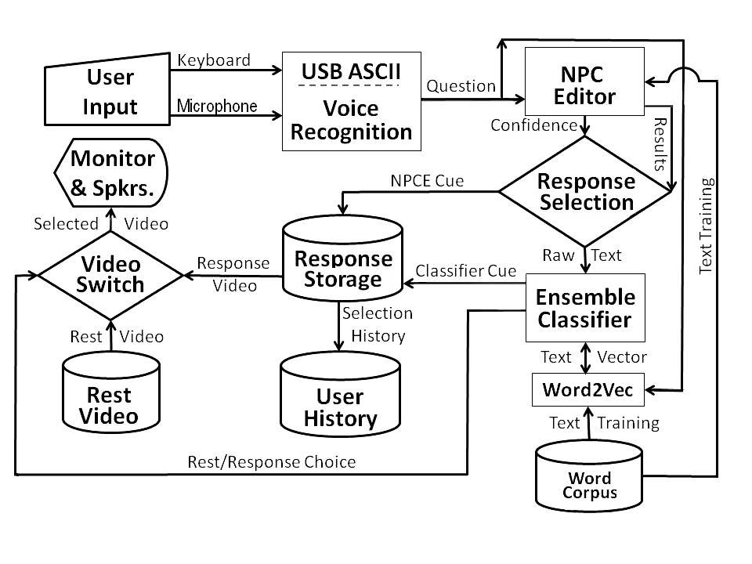Figure . Notional Diagram of MentorPAL Information Flows and Processing Steps

**Mentoring In the Military Environment**

In the Odyssey, Mentor was a friend of Odysseus. When Odysseus left for the Trojan War, he placed Mentor and his foster-brother Eumacus in charge of his son Telemacus and his house. Odysseus directed Mentor to ‘tell him all you know.’ Because of his relationship with Telemacus and the disguised Athena’s encouragement and practical plans for dealing with personal dilemmas, the name mentor has been adopted as a term meaning someone who imparts wisdom to and shares knowledge with a less experienced person (Homer & Fitzgerald, 1990).

The first recorded modern usage of the term is in a 1699 book entitled *Les Aventures de Telemague* by the French author Francois Fenelon. (de La Mothe, 1997) Today, the term mentor usually implies a relationship over a significant period of time. This relationship provides timely clarity, awareness of risks and rewards, choices (of action), alternatives, feedback, and assessment. The purpose is not to find the ‘right’ or ‘optimal’ answer but to create and list all relevant alternative courses of action.

In a military organization context, this paper differentiates mentoring from coaching, peer review, performance evaluation, and situations where junior personnel (in a hierarchical organization) provide knowledge or guidance to senior personnel. In an informal poll to be introduced below, many of the respondents did not adhere to this careful delineation, but referred to almost any professional advisory relationship as a mentor/mentee linkage. For this latter circumstance, examples include a division leading chief petty officer providing guidance to a newly reporting junior officer or a command’s senior enlisted advisor providing their perspective to the commanding general/flag officer. In addition, the authors are inclined to prefer to not include a mentor-mentee relationship where a direct or indirect senior-subordinate relationship exists because it inhibits the mentoring relationship, albeit observing that many in uniform cite former Commanding Officers as a paradigm for a good mentor.

It is acknowledged that this restriction places a narrower definition on mentoring than many authors. The authors also note that in practice, many junior officers will say that mentoring by their first commanding officer had the most profound impact on their career decisions and early understanding of “Big Navy” institutions and actions. The most common example being BUPERS (Bureau of Personnel) and the detailing (assignment) processes, respectively. While a junior officer’s first or possibly second commanding officer often has a disproportionate impact on their Navy career decisions, this paper prefers to use the term guidance from evaluating senior for this type of professional development. Specifically, it is career planning and goal setting.

As previously defined herein and elsewhere (Haggard *et al*., 2011), a mentor is a trusted counselor or guide who provides advice and considerations applicable to a decision or long-term objective. The authors do not place the restriction of the advice being positive. However, the information provided must be accurate and relevant for the mentor-mentee relationship to be effective. This provision necessitates that the mentor is a higher-level manager or executive with extensive experience in the same organization, career field, or subject area on the decision being considered by the mentee. Counter-intuitively, a mentor does not need a track record of success. Why? If the mentor upholds their end of the discussion, the burden of execution is with the mentee. To build self-belief, the mentee must understand that their success is due to their own efforts.

See Figure 2 below for an illustration of professional development opportunities for service personnel.

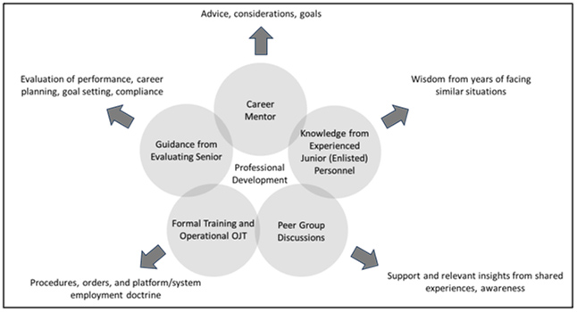

Figure 2. Depiction of five different means for providing professional development.

The benefit of self-belief is one of many associated with a healthy, effective mentor-mentee relationship. As previously described, mentorship can provide awareness and responsibility in the short term for achieving a task or longer term guidance for a better quality of service and/or transition to a post-military career. The mentor may also be able to open doors to otherwise out of-reach opportunities.

The most challenging aspect of professional development is establishing the mentor-mentee association (Hunsinger, 2004). Often, to the junior professional, looking from the outside, the barriers to entry appear formidable. Fortunately, there are multiple available avenues. Based on our experience, the most promising avenue for establishing the mentor-mentee relationship is participation in a professional society. Why? First, the members all share a common interest. Second, members have a wide range of experience and expertise. Third, the members are invested in the health of the society and mentors see mentees as the next generation of the society’s leadership. Fourth, in-person interactions at society events can provide precise feedback on whether the mentor-mentee relationship is a good fit. Lastly, participation in a professional society allows for communication that would otherwise be precluded by more formal affiliations associated with an organizational chain of command or professional stature. It should be noted that membership in a professional society may be necessary to gain full benefit of their mentorship opportunities.

The authors now explain prospects and opportunities that should be avoided. Most critically, a person who could be in competition for the same professional goal is not a good mentor. The rationale is clear. In addition, a mentor should not be in a person’s chain of command, *i.e*. a direct or indirect senior-subordinate relationship. If a mentor were in their mentee’s chain of command, suggestions of alternatives would confound the line of authority. In addition, it would put the mentee in the untenable position of having their mentor formally evaluating their performance. At an absolute minimum, the restrictive nature of a command may block open, unfettered dialogue (Feldman, 1999). Thus, the authors conclude that a commanding officer cannot control all aspects of the efficacy of a command mentor program.

Any attempt to evaluate a commanding officer or senior enlisted advisor on their command’s mentorship program might only serve to corrupt the establishment of healthy, enduring mentor-mentee relationships. Commanding officers will become disenfranchised knowing that their performance will be judged on a criterion that they cannot control. It is illogical for a commanding officer to order their personnel to have a mentor and the fluid nature of when a person could benefit from a mentor makes any assessment of a mentorship program highly subjective. The authors note that in the private sector, a person would not want to have their end-of-year performance review contingent on the actions of a person or organization that they cannot control. For example, have three articles published in a peer review journal. On the surface it sounds like a reasonable objective. However, the individual cannot control the editor’s review process.

In the authors’ view, what qualities does a good mentor possess? There are many related terms (Batty *et al.*, 1999) and a few are listed below:

* Patient
* Supportive
* Interested
* Good listener
* Perceptive
* Aware
* Attentive
* Retentive

Just as it is important to know the qualities of a good mentor, it is critical to know what a mentor does not do. They should not dictate action; the burden of the decision and subsequent action rests with the mentee. In addition, they do not appraise an action. However, they may elicit aspects a self-assessment from the mentee.

A person may ask the following question – Can mentorship skills be taught? This paper asserts that the answer is yes. The necessary skills include techniques for effective questioning, active listening, explaining how there is no one right way to achieve a goal, and exploring the many different avenues to establish the relationship.

The authors conclude our exploration of mentoring by presenting the mentor’s and mentee’s responsibilities. In review, the mentor does not necessarily provide answers. He/she provides considerations or elicits considerations. Specifically:

* Although the mentor may not provide a particular answer, they may find that the demand for an answer is essential to cause the mentee to think, to examine, to look, to feel, to be engaged.
* The answers sought should be descriptive and not judgmental.
* A mentor can act as a “sounding board” without jeopardizing a person’s self-esteem.
* A mentor could energize their professional network when the mentee requires guidance outside their area of expertise or to gain an appreciation of alternative courses of action.
* A mentor may be able to diminish external obstacles; could also eliminate internal obstacles
* A mentor should not provide advice, *per se*. If they do and it fails, the mentee will often blame the mentor and the relationship may be inhibited.

The primary responsibility of the mentee is accountability for their thoughts and actions. Specifically:

* Be motivated and feel empowered to plan and manage the direction of a professional career.
* Take responsibility for their development, learning, and professional growth.
* Participate as an active listener when receiving guidance.
* Maintain confidentiality within the mentoring relationship.

# Question-set DATABASE CREATION

A number of the reported issues with mentoring in the services today have been reaffirmed in the informal survey described below. Some of the most often cited are: reduced access due to ops tempos, lack of a broad selection of potential mentors and feelings of hesitancy in relating openly to another officer. The MentorPal project purports to address many of these issues (Davis, *et al*., 2018) by selecting insightful, articulate and engaging mentors, recording their advice in short video clips and presenting them to the mentees in a way that convincingly emulates a live conversation. This technique has proven useful in other context, *e.g*. counseling for PTSD (Post Traumatic Stress Disorder) patients (Rizzo, *et al.,* 2012) and advising high school seniors of technical careers in the Navy (Beck, *et al*., 2018). The goal of the current project phase is to create a mentor panel of several officers who can respond to typed or voice-recognition audio questions on-line. It follows that the first priority would be to assemble a database of two question sets: “What do young officers ask mentors?” and “What should young officers ask mentors?”. One of the first issues to be aired was the dichotomy between the academics on the team and the Navy veterans on the team as to where the greater repository of useful data would be found: Either from young officers or from seasoned officers who know what they “should have known?”. That issue is not fully resolved, but, as with all good teams, adherents of both views were open to contributions from both input streams.

The discussions above led to a six step process:

1. Input from young officer trainees
2. Review by senior officers, both active duty and retired
3. Input from the reviewing officers
4. Collation of a draft question set
5. An informal survey of > 100 seasoned officers and enlisted personnel
6. Use of questions in a group of four mentors, with concomitant logging of suggestion

The young officer trainees were Cadets from the United States Military Academy (USMA) in West Point. They met together and created a list long enough to be used. An interesting research thread may have been the reasoning behind certain questions they asked did and how might that further shape future training in those contexts. This process took on the order of two weeks and produced around 300 items. That number appeared sufficient for the “proof of concept” nature of the MentorPal project (Kaimakis *et al*., 2018), but it should be noted that a parallel project, New Dimension in Testimony (Artstein, 2017), that was focused on creating a conversational record of Holocaust survivors had a question set of closer to 1,500, as it was a production project for classroom and museum use.

The review of that question set by team members required a significant amount of editing, on the order of a staff-week. Some of it was correcting grammar and syntax, others included re-writing the questions into Navy terminology, *e.g*. an Army Division (~10 to 15 thousand) is three orders of magnitude larger than a Navy Division which often only a few tens of personnel in size. It was at this time that the difference in focus first really appeared, as the Cadets were more focused on becoming grounded in leadership identity, while the veterans were aware of the growth needed in the areas of Evaluation/Fitness Report drafting, relationships with “detailing officers,” and how to manage both up and down the chain of command.

A typical subset of these questions appears below in Figure 3:

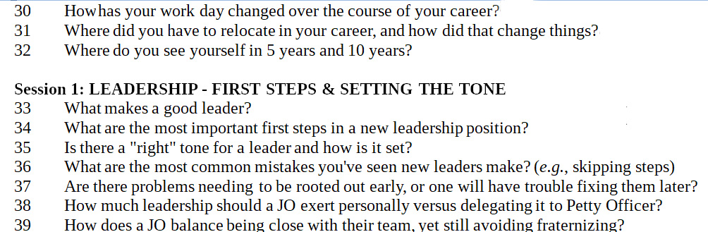

Figure 3. Typical Question Set from MentorPal Database

Then, upon suggestions from the team veterans, both enlisted and officers, additional questions were added. Many of these had to do with commonly overlooked aspects of Naval service. They dealt with housing, moving, behavior at new commands, relationships with seniors and other topics not envisioned by the junior personnel. This broader sweep was also observed in the high-school student advising. Younger people often have not had enough life-experience to know what is important.

At that time, the team decided there was enough material to draft a complete set for presenting to the volunteer mentees. To create the videos, various command personnel were approached and were asked to nominate potential volunteer subjects for video-taping. These volunteers were selected by a manifest mentoring demeanor and engaging personality. A draft set of questions was collated and forwarded to them for their perusal. Despite the team’s experience that military personnel are among the very best story-tellers, the questions that were reported by the volunteers as being the most difficult were the ones that asked the mentor to “... tell a story about …”.

There was a concern that the insights were limited because of the small number of officers on the team (two). There was no budget for a separate research project to formally ascertain Navy-wide attitudes, so one of the team members constructed an informal ethnographic poll to broaden the base of the question generation process. This survey was then offered to a range of officers of the team’s acutance and took on the aspect of a “snowball” survey, i.e. each participant was asked to invite others to participate. In the end, there were 119 respondents, from all services and ranging in rank from E-5 to O-9, but the four Flag/General Officers directed specifically that their data NOT be included for reason they did not articulate. Several of those officers contributed significantly to the team’s insights and goal assessments outside of the format of the survey.

The survey was posted on line and about twenty of the officers military friends from the Navy and from the Marine Corps were informed of its presence and invited to participate. The “snowball” nature of the survey’s distribution resulted in input from all of the services. On its face, the survey contained a request for the participants to invite others they thought would have both insights and a willingness to contribute. Figure 4 below shows the first page of the survey and also shows the URL (http://www.hpc-educ.org/NavMnt/Survey/MentorrSurvey.htm), should any reader be inclined to opine. There are no current plans to take the site down, all input is valued, and the program monitoring the site alerts the authors via eMail when new data is entered.

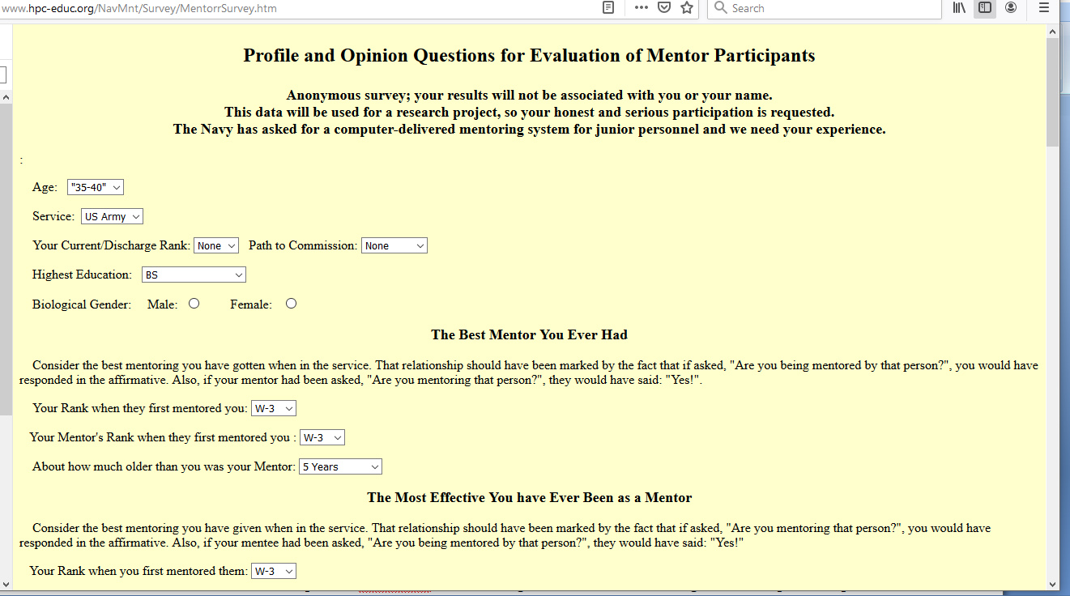

Figure 4. Opening page of the web-based “snowball” survey seeing Mentor question inputs.

The data collected was very useful in three ways:

* First, it largely confirmed the question set originally formulated by the authors and reaffirmed that their service experience was not atypical and was of significant interest to officers across three generations of Naval Officers through at least four distinctly named “War Eras.”: Korea, Vietnam, Afghanistan and Iraq.
* Second, the responses offered a few areas that the authors found very useful, but of which they had not personally thought. This allowed the inclusion of several new topics of interest and the addition of about 5% new questions to the original database.
* Third, it informed the language used to describe certain activities and approaches, as there is a frequent alteration in jargon and directive advice that needs to be honored in the questions and observed in the answers. A good example of this is the rapidly changing directives on how to handle sexual harassment, abuse and assault and a plethora of new acronyms, e.g. SAPRO (Sexual Assault Prevention and Response Office) was a new term to some of the senior officers, now retired.

Before discussing the team’s use of the data, the authors want to reassert their position that this was not a fully-funded, carefully crafted and statistically valid survey intended to prove a particular thesis. It was an informal and ethnographic survey to provide the team with additional ideas for mentor questions. The data is presented to show the type of input that might be useful in future work directed to similar goals. The authors understand that those familiar with more formal uses of statistically validated surveys will find this approach antithetical to their more formal use. In , in this case, it was very useful and the authors, without urging its use in similar circumstances, feel they would be well-advised to report how effectively it contributed here.

Part of the survey was devoted to the review of questions mentors should answer. The authors also had a range of questions dealing with what a broader set of officers experienced with mentoring and how the term was used. As noted above, there were differing opinions as to whether a mentor could be a reporting senior in the mentees chain of command and there were questions as to how many had good mentors, via formal programs or spontaneously. Some of this data was sought via a Likert Scale like set of question, with the levels running along a range across Strongly Agree, Agree, Neutral, Disagree and Strongly Disagree (Allen & Seaman, 2007). Again, the utility sought was not to prove any thesis, but insightful input for the author’s use in designing a productive question set.

Table 1. Data Collected from an On-line Informal Survey.

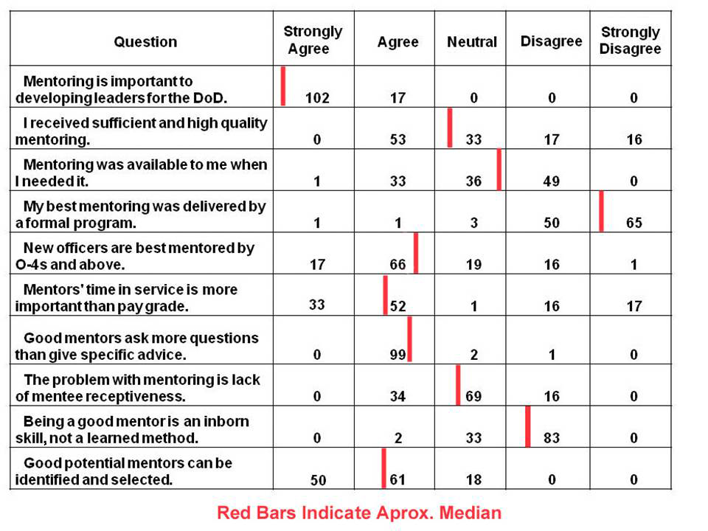

This data was incorporated into the questions to be asked and four officers and one Senior Chief were interviewed for ~ 12 hours each:

* A Male Lieutenant, Surface Warfare Officer of a minority group NROTC Commission
* A Female Lieutenant, Surface Warfare Officer of a different minority group NROTC Commission
* A Male Lieutenant Commander, Aviation Officer of European Descent USNA Commission
* A Male Retired Captain, Surface Warfare Officer of European Descent USNA Commission
* A Male Senior Chief Petty Officer, an EOD specialist, who is Hispanic

Several of them contributed significantly to the question set with new suggestions or with validation inputs. Two of the recording sessions were done in person and two were done remotely, with the interviewer reading the questions from USC’s Institute for Creative Technologies which is located just North of Los Angeles Internationals Airport and the interviewees located elsewhere, one as far away as Upstate New York.

# DATABASE VALIDATION

Following the lead of people who focus on measurements, (Doerr, 2018) the authors looked at a number of the over-arching goals of the project. Then they considered the issues of what measures of validation in which contexts really mattered. A few of the major areas considered were:

* Capturing the issues foremost in the mentees mind
* Covering the issues the best Navy mentors felt important
* Reflecting important issues not conceived by either of the above
* Addressing future issue, unknown to any

Another set of goals was considered, albeit beyond the penumbra of this project. One can convincingly argue that the real validation of the question set would be:

* Increased performance
* Improved mission completion
* Extended personnel retention
* Improved quality of service
* Reduced casualty rates

While we all agree these are laudable metrics, they are way beyond the period of performance constraints of the current project. A longitudinal study would be useful but the decision needs to be made now (Rajulton, 2001).

Upon achieving a working consensus of those, the team then assiduously reviewed he question database looking for face validity in each of the identified areas. More rigorous validation techniques could have been applied, but the project was not funded at that level and the team decision was that the level of validation conducted was sufficient for this proof of concept demonstration.

# ANALYSIS

As part of the analytic process for this project, the authors considered issues that they missed and were later added into the database.

This project focused on mentorship of junior officers (JOs). The primary way JO’s obtain information and guidance about the naval profession is through the experience of officers that have come before them. While the US Navy employs many informational programs focusing on procedural aspects of a naval career, maturity of formal mentorship programs is arguably lacking. While every command or naval activity is required to nominally institute a mentorship program, the authors have been told that oversight is sub-par, often given as a collateral duty, and subject to an activity’s operational or, if not operational, general work, tempo. The informal poll above does little to disabuse one of those conclusions. The authors see the virtual mentoring environment as an opportunity to gain initial professional knowledge and to suggest avenues to establish a formal mentoring relationship. **T**he authors assert that the Navy’s current mentorship program is lacking, junior officers don’t know where to look for professional development. They conclude with suggesting a virtual mentoring environment as a helpful start.

## In general, employing seasoned officers to provide experiential input provides this project data that otherwise might be compartmentalized to a certain command, community, or small group. Further, experiences oftentimes transition easily across communities. While a ‘sea story’ might be specific to an aviation experience, it is easy to visualize a similar experience occurring in a different community. In micro, personal experience highlights nuances that are not easily gleaned or understood if researchers are not directly part of the organization they are studying. By including naval officers in this study, researchers are accumulating and concentrating pointed data for use by any junior officer in any naval organization.

## The more senior officers on the team recognize what the Cadet did not, *e.g.* writing is not the stuff of young officers’ dreams, but it is the hallmark of a good officer corps. One of the major challenges and, indeed deficiencies, junior officers face is professional writing skills or lack thereof (Likaj, 2015). These officers will find themselves writing all types of professional documents throughout their career, most important of which are personnel evaluations and fitness reports. Lack of understanding on the gravity of these documents goes far beyond the writing. Little emphasis is given on the effect an officer’s words and the way they are conveyed has on the careers of themselves and, more importantly, their subordinates. Largely, these skills are developed through on-the-job training or worse simple observation, which, while important, means the officers are operating at a professional deficiency. Early intervention by more experienced officers, acting as mentors, can accelerate development of these skills as well as the understanding that the impact of a leader’s words can significantly impact the career of a subordinate.

## Along with writing skills, junior officers will find themselves presenting material to all types of audiences early on in their careers. The ability to speak cogently, concisely, and specifically to their topics is essential to personal and professional development as an officer (Glaser, 1981). While some communities build this skill into training programs (*e.g*. aviation; flight briefs) many others do not and the personnel accept poor verbal communication as the modus operandi for young officers. Without proper focus from superiors on these skills, young officers run the risk of a chronic failure to convey and emphasize information. On a personal level, proper and professional speaking skills simply increase the likelihood of an officer being taken seriously. It is clear when mid-grade officers have not been given an emphasis on their speaking skills early in their career they suffer later.

## Another issue JO’s overlook is the assignment process. Detailing is a constant ordeal while in the military. Early on in an officer’s career, there can be little interaction with the detailer. Indeed when it is time for an individual officer to approach their detailer about orders, it can be a daunting experience. Few know what questions need to be asked and what options they have. Good ‘front offices’ are responsible for some liaisons with detailers in order to give input as to where an individual should go. If a front office does not do this, then the individual is solely responsible for looking out for themselves. However, formal information does not do an appropriate job of preparing young officers for this possibility. Mentorship from superiors, usually mid-grade, pre-command officers can guide these junior officers and give them input as to how to interact with detailers and the specifics of the detailing process.

## At all levels, an experienced officer leading a team is an invaluable resource to those working with or subordinate to them (Keegan, 2011). Their experiences show in how they handle the team and what skills they use to lead the team. Oftentimes the problems they are seeking to solve are not new. The value in this type of officer is that they can direct the team’s attention in specific areas that they know need to be the focus. This is a function of previous experience and is huge driver in the success of any team. A hypothetical team with inexperienced leadership can find itself exploring several different focus points that are not pertinent to the task at hand and not know it. This is simply a function of leadership without proper experience.

# CONCLUSIONS

As this paper focuses more on relating the lessons learned from a development process than a formal investigation of a previously advance thesis, the conclusions match this theme.

## A Question Data Set for a Virtual Human is a Multi-Phase Process

The time allotted for the creation of a question set on previous Virtual Conversation Projects was on the order of one and a half staff weeks or 60 staff hours. The authors most involved with the process think this is too small by a factor of two. While 60 hours may be sufficient for an initial first pass, at least that much time will have to be invested later to make the additional edits in content, language and formal directives. This should involve a thoughtful multiphase plan for:

* A “brain-stormed” initial draft
* A thoughtful review with seniors
* An edited and scrubbed updated cut
* A test-run during videotaping sessions
* A “final” revision based on mentor input

## A Broad Range of Mentor Question Contributors was a Useful Strategy

Based on the authors’ own experience and on the responses from the survey, the authors assert that a broad range of Naval Personnel should contribute to a mentor program for the Navy. This bigger group makes the process longer and it could make it more open to internal dissension, but is a necessary commitment to ensure the final question set is optimal. The reader should be aware that the times cited above were for a very small question set of less than 300 questions. Some efficiencies of scale would arise from a larger set, so one should not assume as 600 question set would take twice as long. The other side of that efficiency of scale insight is the reminder that more emotionally involved questions open to more disagreement among mentors might double the time suggested herein. As most of the officers are no longer on active duty, they did have to form a team in more informal environments than would be typical if they had still been in uniform. The authors’ can recommend to readers who likewise are not formally organized that there are many useful insights in the work of Professor Bruce Tuckman of Ohio State University (Tuckman, 1977).

## Mentor Models being Questioned are Good Sources of Enhanced and Enlarged Question Sets

One of the best contributions of input came from the mentors being interviewed. This then suggest that the crew present at the interview should be at least two experienced people, preferable one of them should be a veteran who is both familiar with Navy Jargon and sensitive to civilian lack of familiarity with that jargon, e.g. Naval personnel refer to what civilians call “stairs” as “ladders.” A civilian unfamiliar with that usage would have an erroneous vision of what a Navy mentor means by saying: “If I were going up a ladder behind someone ...”. In addition, they might not know enough to ask for clarification. However, personnel cost are the most costly part of this technique and doubling the videotaping crew is a significant cost. Those conducting the interviews have found that they are fully tasked and hard pressed to monitor the interviewee’s language and to make notes of insights the interview has based on the interview process. A second person could relieve much of this intellectual over-load and to be a check for proper operation of the recording equipment.

# ACKNOWLEDGEMENTS

Nearly all of the work involving Virtual Humans reported in this paper came from a series of research projects of which the Principal Investigator was Dr. Benjamin D. Nye, Director of Learning Sciences at ICT. Without his technical vision and unflagging support, none of this would have taken place. The various projects mentioned were supported by a range of DoD organizations and, while this paper reports insights gained during that work, which was not the focus of the research. Nevertheless, the positions taken in the paper are the authors’ own and do not represent in any way the views of the Department of Defense or the US Government.

# REFERENCES

Allen, I. E., & Seaman, C. A. (2007). Likert Scales and Data Analyses. *Quality Progress*, 40(7), 64-65.

Artstein, R., Gainer, A., Georgila, K., Leuski, A., Shapiro, A., & Traum, D. (2016). New Dimensions in Testimony Demonstration. In Proceedings of the 2016 *Conference of the North American Chapter of the Association for Computational Linguistics: Demonstrations* (pp. 32-36).

Batty, J., Rudduck, J., & Wilson, E. (1999). What Makes a Good Mentor? Who Makes a Good Mentor? The Views of Year 8 Mentees. *Educational Action Research*, 7(3), 365-374.

Beck, S., Carr, K., Davis, D. M., Nordhagen, J. N., & Nye, B. D. (2018). Virtual Mentors in a Real STEM Fair: Experiences, Challenges, and Opportunities. In *Third International Workshop on Intelligent Mentoring Systems* (IMS 2018) Proceedings.

Carter, S. P., Dudley, W., Lyle, D. S., & Smith, J. Z. (2016). *The Effects of Mentor Quality, Exposure, and Type on Junior Officer Retention in the United States Army*. National Bureau of Economic Research.

Davis, D. M., Predovich, K.B., Stassi, F.J., Spaulding, H., Shaw, K & Nye, B.D. (2018). Enhancing Menteeship: Improving Career Selection for Potential DoD Personnel. In the *Proceedings of the SISO Fall Simulation Innovation Workshop*, Orlando, Florida: SISO

de La Mothe, F. D. S. (1997). *The Adventures of Telemachus, the Son of Ulysses* (Vol. 10). University of Georgia Press.

Doerr, J. (2018). *Measure What Matters: How Google, Bono, and the Gates Foundation Rock the World with OKRs*, Portfolio Publishers, New York, New York

Feldman, D. C. (1999). Toxic Mentors or Toxic Protégés? A Critical Reexamination of Dysfunctional Mentoring. *Human Resource Management Review*, 9(3), 247-269.

Glaser, S. R. (1981). Oral Communication Apprehension and Avoidance: The Current Status of Treatment Research. *Communication Education*, 30(4), 321-341.

Haggard, D. L., Dougherty, T. W., Turban, D. B., & Wilbanks, J. E. (2011). Who is a Mentor? A Review of Evolving Definitions and Implications for Research. *Journal of Management*, *37*(1), 280-304.

Homer & Fitzgerald, R. (1990). *The Odyssey*. New York: Vintage Books.

Hunsinger, N. (2004). Mentorship: Growing Company Grade Officers. *Military Review*, *84*(5), 78.

ICT (2019), *Conference and Workshop Publications in which MentorPAL capabilities were featured or cited*, Retrieved 18 November 2019 from http://www.hpc-educ.org/MentorPal/Web/MentorPalPapers.html

Johnson, W. B., & Andersen, G. R. (2010). Formal Mentoring in the US Military: Research Evidence, Lingering Questions, and Recommendations. *Naval War College Review*, 63(2), 113-126.

Kaimakis, N.J., Davis, D.M., Breck, S. & Nye, B.D. (2018). Domain-Specific Reduction of Language Model Databases: Overcoming Chatbot Implementation Obstacles. In the *Proceedings of the MODSIM World Conference*, Norfolk, Virginia.

Keegan, J. (2011). *The Mask of Command*: A Study of Generalship. Random House.

Likaj, M. (2015). Teaching Writing through Communicative Approach in Military English. *Journal of Education and Practice*, 6(20), 102-107.

Nye, B., Swartout, W., Campbell, J., Krishnamachari, M., Kaimakis, N. & Davis, D. (2017). MentorPal: Interactive Virtual Mentors Based on Real-Life STEM Professionals. in the Proceedings of the Interservice/Industry Simulation, Training and Education Conference, Orlando, Florida, 2017

Pratt, Fletcher (1950). *Preble's* *Boys: Commodore Preble and the Birth of American Sea Power*. William Sloane Associates.

Rajulton, F. (2001). The Fundamentals of Longitudinal Research: An overview. *Canadian Studies in Population* [ARCHIVES], 169-185.

Rizzo, A., Forbell, E., Lange, B., Galen Buckwalter, J., Williams, J., Sagae, K., & Traum, D. (2012). Simcoach: an Online Intelligent Virtual Human Agent System for Breaking Down Barriers to Care for Service Members and Veterans. *Healing War Trauma A Handbook of Creative Approaches*. Taylor & Francis.

Tuckman, B. & Jensen, M. "Stages of Small Group Development. " *Group and Organizational Studies*. Vol 2, pp 419-427. 1977.