One the major differences in operating unmanned vehicles is the simple fact that the operator is not ‘present’ with the vehicle in its ‘real-time’ location. This illuminates a number of challenges that are perhaps manifest in manned operations but are now largely ancillary. (Callahan, 2014) Using manned aircraft as an example, the pilot is the ultimate arbiter or what they decide to act upon. The use of situational awareness to make informed decisions is a key tenet in the operation of any aircraft. However, in operating unmanned aircraft, at best a pilot’s situational awareness is muted, at worst it is significantly degraded. Throughout flight school, student pilots are told to rely on their instruments. They must not rely solely on their kinesthetic sense because a pilot’s body and mind are easily misled. However, the sensory indications that pilots feel as they fly aircraft are essential to build situational awareness in order to evaluate what the aircraft is “telling” them. A short example: a caution light illuminates; the pilot sees it and immediately references gauges associated with the light. Once the gauges are evaluated, the pilot may evaluate the feel of the aircraft (i.e. vibrations, sounds, smells). Ultimately, a decision is made. The senses help build the extra information necessary to make informed decisions. All of this happens, usually, in a matter of seconds.
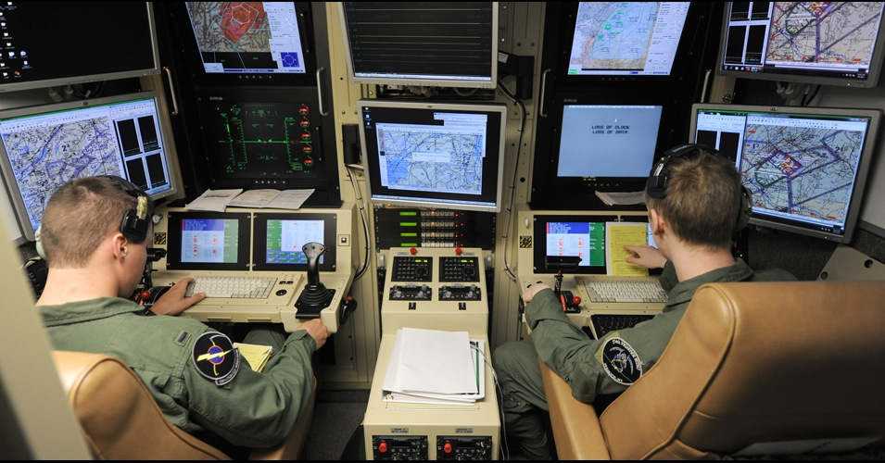

Figure 1. US Reservists staff a Drone Control Console (US Air National Guard Photo)

The aforementioned example is largely absent in unmanned operations. The operator will get a visual indication on a problem, but the sensory indicators are absent. Evaluation is hampered due to the sensory deprivation and oftentimes, the only option is to direct the vehicle or drone to return to its base of operations. There is little troubleshooting that an operator can do to fix a remote problematic situation.

This is further exacerbated by the filter of technology. In most cases, an unmanned operator is operating two systems in series. They sit at a console or some sort of control station that takes inputs and then feeds the information to the vehicle. Likewise, the flow returns. While this is necessary, this ‘filter’ means that there are two separate pieces of equipment that can have problems and, again, detract from the operator’s ability to properly and efficiently evaluate situations whether it be mission or aircraft-related. This “filtering” idea is further compounded by the communications latencies associated with unmanned operations. Again using aviation as an example, if a pilot moves his hands to manipulate aircraft controls, the aircraft responds almost instantaneously. By contrast, the operator at a control station makes a control input, the control station sends the input via communication link and the unmanned system responds. The idea of “real time” action is not yet possible in the unmanned or autonomous systems.

This leads inevitably to further discussion on what unmanned aircraft should be “allowed” to do. In a military context, decisions using drones are not taken at face-value. Drone usage has often been confined to environments that allow them to be there. There is no threat to their being destroyed or shot down. To put it simply, there is no appreciable threat to their destruction. However, implementation of drones in a real-time combat situation will require careful evaluation of the Law of Armed Conflict (LOAC) (Green, 2018) and associated governing directives. If a force is not actively putting its own personnel at risk (i.e. death, maiming), are they adhering to the tenets of LOAC if the other force is? This idea of mutual risk has been the major tenet of LOAC and made it acceptable. If we risk nothing but machinery, is it still armed conflict? Or is it something else? Also the issue of the emotional impact on the operator may be different than that of the live pilot in a cockpit.

On a less philosophical level, consideration must given to how much do humans trust unmanned assets to help them make time-critical informed decisions. Regarding the idea of latencies, the information received via drone (in the current construct) will always be less timely than if a human passes that information (Hoppe et al., 2019). Part of this distrust is resultant from the fact that a decision maker cannot easily ask further questions of a drone like they might of a human. Basically, the limited sensor data one see from a drone is often constrained. Analysis is left up to those at the base who may be significantly detached emotionally, for good or for ill. A more human interface might make these issues more amenable to current training, skills, and practice. In the time it took for the information to get from the drone to the operator to the staff to the decision maker, things may have changed. Having a virtual human as the communications interface might reduce human reaction latencies enough to counter communication latencies. If this were to be possible with humans-in-the-loop, there might be faster updates and more clarification.

In order for unmanned systems to execute more than rudimentary functional military tasks, the interaction between operator and remote vehicle must resemble that of a typical human experience. Interfaces must allow for greater situational awareness that allows the operator to “feel” the drone as it operates (Knierim et al., 2017). While technology is a force multiplier, its complexity can prevent the operator from effectively and efficiently using their vehicle. The filter, while likely ever-present, must be reduced in scope such that time-lag is as small as possible. Information passage must be of high fidelity such that real-time analysis is possible and answers inevitable questions of clarification. This list of necessary changes is not exhaustive and simply represents a starting place for better human-machine interactions. To make progress this is where one must begin.

Callahan, A. L. (2014). Reinventing The Drone, Reinventing The Navy. Naval War College Review, 67(3), 98-122.

Green, L. C. (2018). The contemporary law of armed conflict. Manchester University Press; 3 edition (May 1, 2008)

Hoppe, M., Kosch, T., Knierim, P., Funk, M., & Schmidt, A. (2019, May). Are Drones Ready for Takeoff? Reflecting on Challenges and Opportunities in Human-Drone Interfaces. 1st International Workshop on Human-Drone Interaction, Ecole Nationale de l’Aviation Civile [ENAC], May 2019,Glasgow, United Kingdom

Knierim, P., Kosch, T., Schwind, V., Funk, M., Kiss, F., Schneegass, S., & Henze, N. (2017, May). Tactile drones-providing immersive tactile feedback in virtual reality through quadcopters. In Proceedings of the 2017 CHI Conference Extended Abstracts on Human Factors in Computing Systems (pp. 433-436).

