Virtual Conversationality Requires Emerging
Meta-Discipline to Enable "Human Discourse"

Dan M. Davis & Benjamin D. Nye | Brian L. Morgan & Ana Veronica Y. Badua | Mark C. Davis
Univ. of Southern California | Naval Post Graduate School | Wood Duck Research, Inc.
Los Angeles, California | Monterey, California | Mooresville, North Carolina
dmdavis@acm.org &  nye@ict.usc.edu | blmorgan@nps.edu &  ana.badua@gmail.com | davismc@ieee.org

ABSTRACT

This paper lays out critical choices surrounding the creation of more interactive and human-like conversations generated by computer simulations. It asserts the criticality of what the authors see as an emerging meta-discipline centered on simulations. Observation: it is insufficient to merely acknowledge and include a range of other disciplines; the effort would be more effectively driven by the inclusive and meaningful inclusion of those disciplines. The current advances of computers generated convincingly "human" conversations and interactions are reviewed. Supporting research and observations are adduced substantiating the current state of the art and significant impediments to progress are identified. Two theses are then advanced: 1) existing products will soon be seen as unattractive and primitive by the DoD simulations users, who are increasingly unimpressed. This will especially hinder those programs currently successful at addressing mentoring, suicide prevention and psychotherapies. The capabilities of more credible and conversational computer agents to meet DoD needs are presented based on the authors' research and on their service in the armed forces, noting current hurdles to achieving these goals. 2) The next major thesis is that a broader implementation approach, incorporating several types of computer-generated reality and developing innovative channels of human-like behavior, are needed to achieve engaging interfaces between humans and machines. Also, current cross- or multi-disciplinary efforts will be augmented by a higher order approach. The authors' observations of complex human behaviors and computer simulations are noted. A few of the most critical emerging technologies will be described and the issues hindering their timely adoption set forth. The concept of a more effective meta-discipline is advanced. The terms and metrics associated with a meta-discipline are identified and the authors' efforts in this area are set forth. Data is presented from the authors' ethnographic research into mentoring topics, which probed uniformed service personnel via a meta-disciplinary instrument. Extensibility into other fields is considered.

ABOUT THE AUTHORS
Dan M. Davis, CDR. USN, Ret. is active as a consultant at the Institute for Creative Technologies, University of Southern California (USC), focusing on large-scale DoD simulations and avatar uses. Prior to retirement, he was the Director of the JESPP project at USC for a decade. As the Assistant Director of Advanced Computing Research at Caltech, he ran Synthetic Forces Express, bringing HPC to DoD simulations. He also served as a Director at the Maui High Performance Computing Center and in computer research roles at the Jet Propulsion Laboratory and Martin Marietta. He was the Chairman of the Coalition of Academic Supercomputing Centers and has taught at the undergraduate and graduate levels. As early as 1971, Dan was writing programs in FORTRAN on one of Seymour Cray’s CDC 6500’s. While in the Marine Corps, he saw duty in Vietnam as a Cryptologist and retired in 2002 as a Commander, U.S.N. He received B.A. and J.D. degrees from the University of Colorado in Boulder.
Benjamin D. Nye, Ph.D. is the Director of Learning Science at the University of Southern California, Institute of Creative Technologies (USC-ICT). Ben's research tries to remove barriers development and adoption of adaptive and interactive learning technology so that they can reach larger numbers of learners. Dr. Nye's research has been recognized for excellence in intelligent tutoring systems (1rst Place ONR ITS STEM Grand Challenge; Nye, Windsor, et al., 2015; Nye et al., 2014), cognitive agents (BRIMS 2012 best paper; Nye & Silverman, 2013; Nye, 2012), and realistic behavior in training simulations (Federal Virtual Worlds Challenge; Silverman et al., 2012). His research is on scalable learning technologies (Nye et al., 2014).This research has led to 20 peer-reviewed papers, 11 book chapters, and 5 open-source projects. Ben is the membership chair for the International of Artificial Intelligence in Education (IAIED) Society and holds memberships in Educational Data Mining Society (EDM), and Association for the Advancement of Artificial Intelligence (AAAI).
Brian L. Morgan, CAPT, USN, Ret. is currently active as a member of the Faculty at the Naval Postgraduate School in Monterey California. He has over six years of experience in the practical application of operations research at the Service headquarter-level while assigned to the Assessment Division (OPNAV N81) in the Pentagon. He is a Naval Flight Officer with over 3,700 hours in the E-2C Hawkeye and served as Commanding Officer, VAW-117. His military assignments also include service on the Joint Staff as Chief of Operations Test and Evaluation Branch, National Military Command Center. Professionally, he is President, Military Operations Research Society. Brian received a BS in Aeronautical Engineering from the University of Virginia and an MS in Operations Research from the Naval Postgraduate School.
Ana Veronica Y. Badua, LT, USN, is currently serving as Surface Warfare Officer. Her previous military assignments include tours onboard the USS Cape St. George (CG 71) and USS Michael Murphy (DDG 112). Her primary research interests are quantitative analyses of management and leadership in naval operations. Her Master's Thesis at the Naval Postgraduate School (NPS) was entitled "Prototype Scheduling Management Aid for Risk Tracking (SMART) Tool for the USN Surface Fleet." Ana earned a BS in Biology from Drexel University, an MS from NPS in Operations Research and a Human Systems Integration Certificate from and a Joint Professional Military Education Phase One Diploma from the United States Naval War College.
Mark C. Davis, Ph.D. is the Chief Technical Officer at Wood Duck Research, Inc, and is semi retired after careers in the US Navy and as a computer design engineer for both IBM and Lenovo. Rising to the level of Distinguished Engineer at Lenovo, he was responsible for the design of laptop computer cross-disciplinary technology, including PC architecture, embedded systems, open source and virtualization. Previous work was with IBM in the areas of software development and architecture involving security, storage and virtualization. Dr. Davis has been granted well over fifty patents that were filed during his service at both companies. He is a graduate of the Duke University NROTC program and was commissioned as an Ensign, attended nuclear power school, and served as a Submarine Officer for twelve years, including one duty tour as a classroom instructor. He left the active duty as a Lieutenant Commander to pursue a PhD. Mark holds a BSEE degree from Duke University and a PhD in Computer Science from the University of North Carolina, Chapel Hill, where his advisor was Professor Fredrick P. Books.

Virtual Conversationality Requires Emerging
Meta-Discipline to Enable "Human Discourse"

Dan M. Davis & Benjamin D. Nye | Brian L. Morgan & Ana Veronica Y. Badua | Mark C. Davis
Univ. of Southern California | Naval Post Graduate School | Wood Duck Research, Inc.
Los Angeles, California | Monterey, California | Mooresville, North Carolina
dmdavis@acm.org &  nye@ict.usc.edu | blmorgan@nps.edu &  ana.badua@gmail.com | davismc@ieee.org

Introduction

Facing escalating operations tempos, the DoD is increasingly seeking to augment many functions with computer simulations, notably those using various human-like computer agents. This advance into issues more traditionally addressed by the behavioral science disciplines which are often outside of the computer simulation community has suggested the need for a new approach. This paper focuses on two theses: 1) the user's familiarity and comfort with computer agents is rapidly opening up new areas of use of computer agents to provide "human" support in innovative ways, but this familiarity is also increasing the challenge for computer architects and programmers to satisfy the users' demands for increasing realism and 2) this dynamic evolution is and will be in need of a broader spectrum of skills and insights than can be optimally served by too-commonly academic disciplines, e.g. computer science alone. To highlight these issues, the paper reports current efforts (Ney et al., 2020) to use virtual human conversational agents in the form of avatars, video-clips and 3D holographic images, to create a connection between the computer and its users. Examples will be given of where a broad spectrum of both academic skills and military/naval operational experience was required to produce the desired interactions with the user.

In the early sections of the paper, the obstructions faced, as well as both the challenges and opportunities that remain will be described and substantiated, both in the form of anecdotal observations and statistical data. The paper then turns to organizational issues and gives examples of both the successes and the shortcomings of efforts to engage a sufficiently all-encompassing effort to produce advances with enough speed and efficacy to serve the needs of the DoD. A new approach is identified, that which is identified as a Meta-Disciplinary structure, that is not only more inclusive of disparate disciplines, but the paper will lay out how it may be more effectively used to make sure effective user engagement can be improved. All of this may help to ensure that needed technologies are adopted in a manner that has the desired impact on the target issue. Also discussed are the definition of goals and the validation of metrics. The paper concludes with a look at the way forward to retain the requisite focus and to the assess achievement of improving the defense of the nation.

The defense simulation community operates in a research environment that is similar the rest of the disciplines. That environment has been plagued for centuries with the conceptual siloing of expertise, with each discipline being inclined to an almost guild-like exclusivity. For purposes of this paper, three terms will be used to highlight the impact this has on simulation research by using the following terms: Multi-Disciplinary and Cross-Disciplinary to which the authors add a third: Meta-Disciplinary.

Multi-Disciplinary approaches are defined for use herein as approaches that acknowledge the need for and include the contribution of more than one discipline, operating with a minimum of understanding of or collaboration with the other disciplines. An example of this might be the Manhattan Project, which, for security reasons, employed a vast and geographically dispersed array of disciplines with little or no knowledge of the others' activities (Bird & Sherwin, 2005). One of the authors' grandfathers was a construction supervisor and related the waste of the US Government in 1943, in their retaining him to build several huge water tanks in an area that had plenty of water in lakes, ponds and rivers and they had virtually no population near a small, backwoods town in Tennessee: Oak Ridge.

Cross-Disciplinary is defined here as an approach that engages several disciplines that work in concert together to achieve a single goal, with frequent periodic meetings to facilitate achievement of a common goal. These activities are characterized by close and synergistic collaboration and mutual respect. However, they are often initiated by one discipline's view of the issues to be faced and a recognition within the team that this initiating discipline has "invited" them to join in the common endeavor. The research background of the Principle Investigator is often a major indicia of what kind of project the effort really is and which disciplines are adjuncts to the project.

Meta-Disciplinary approaches are defined by the authors herein as a holistic vision of the goal of the project, with a clear recognition of a common objective and in which each needed discipline is recognized, has an equal voice, and is included at every stage of the undertaking. This nomenclature is intended to break the observed tendency to give lip service to inclusivity, without commitment to full integration of insights. The organization's processes are more kept orderly, rather than dictated to, by the leader, who acts more like a committee chair than a corporate executive or commanding officer. The Meta-Disciplinary approach to DoD simulation development is not seen as presenting an alternative to the ostensibly emerging new academic area of Simulation as its own discipline, but more as an adjunct to and effective tool for such a discipline, should it become part of the academic canon.

The following sections rely on an ongoing and successful DoD-funded research project charged to implement effective virtual human interfaces in military simulations. The team's focus was on the need for and an ex tempore attempt to implement a Meta-Disciplinary approach to better meet that project's goals. The issues are suggested that would be more optimally met with this methodology than with a Multi-Disciplinary or Cross-Disciplinary method.

Background

Simulation in the DoD

Since the earliest days of warfare, leaders have sought to understand and prepare for combat through simulations of various kinds. Early athletics often evolved as competitive test of combat skills in a non-combat arena (Icobini, P., 2013). Many games such as chess were centered on abstracting and emulating combat (Smith, R., 2009). More complex and realistic simulations evolved over the centuries, but they all had in common trying to train people to excel in combat, trying to see if some new weapon would be effective, or trying to better predict the outcome of an impending operation (Thompson, T.N., 2008). Early simulations were often metaphorical, e.g. chess was a combat and strategy simulation. These early simulations were not uncommonly multi-disciplinary, e.g the wood carver making chess pieces rarely had any involvement in the design or need he even understand the concept of the game.
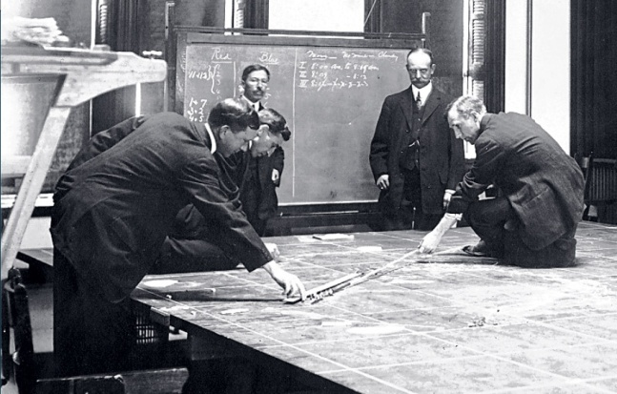Figure 1. Naval War College Game 1905

The next phase was more on the order of creating a simulated scenario that was conceptually played out on a map or a "sand-box" recreation of the area of interest. This required a more Cross-Disciplinary approach, as it was found that the cartographer, ship model-maker and "sand-box" technician needed to have a have a good understanding of what the user of the "game" had in mind and a good working relationship with the Subject Matter Experts (SME's). This environment would be more likely classed as a Cross-Disciplinary effort. Figure 1 shows a war game with small ship models being manipulated with long sticks on a large map.

In the mid-20th Century, various simulators were developed and became increasingly mechanized and finally digitized in the latter part of that century. Within the professional experience of the authors, simulations have expanded their capabilities along several axes, including: geographical area, resolution of simulated objects, richness of behaviors, duration of simulations, speed of performance (e.g. computer generated constructive simulations can be run at significantly faster than real time), and sophistication of analytic tools to better understand the large amounts of data collected (Yao, et al., 2009. Many of these advances have been enabled by High Performance Computing (HPC) (Gottschalk et al., 2010), General Purpose Graphics Processing Units (GPGPU's) and Quantum Computing, (Davis, D.M. et al., 2018)
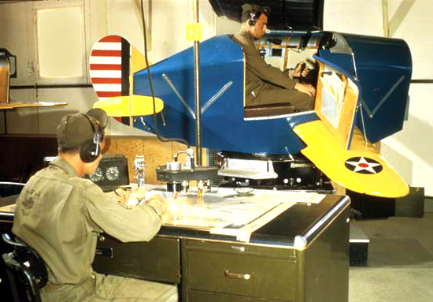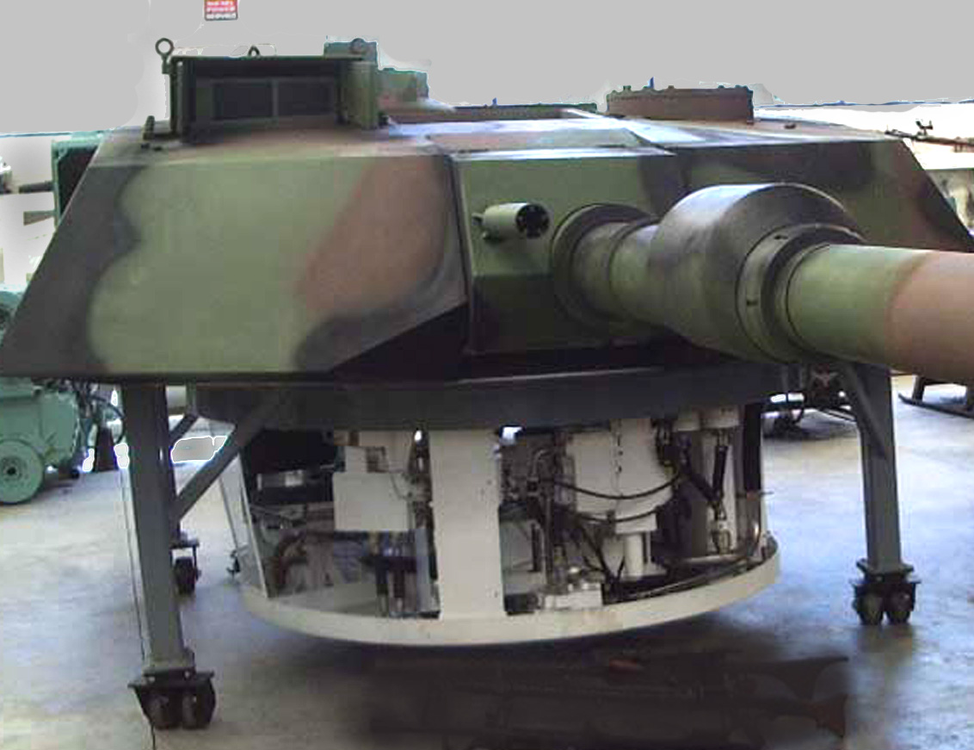
Figure 2. - Link Trainer ca 1943 and Tank Turret Simulator ca 2010.

It has been the authors’ experience that battlefield simulations rarely take adequate heed of the human behavioral factors which were involved. Several large scale simulations from the 1990's and 2000's invoked and imposed strict adherence to both Blue and Red Forces behaviors (Lucas et al, 2003), over the objections of team members who had done duty in combat zones and knew that doctrinal edicts were often more honored in the breach than in the compliance thereof. These simulations still got high face validity marks from the SME's. Within the author's experience, these complex battlefield simulations can be used for training of personnel, evaluation of new capabilities, and analysis of likely outcomes. They are, at the same time, both increasingly capable of realistic performance and faced with increasingly sophisticated users who are used to high levels of human-like interactions with computers and with an evident intolerance for any insufficiency of interesting and arresting materials.

One issue surfaced during this innovative era that bears considering in the context of this paper: the increasing interactivity of the simulation platform with the user. One of the authors observed training on a 1950's vintage technology anti-submarine trainer at the University of Colorado, in which the submarine's actions were preset and did not react to the trainee's actions. With early 21st century technology like that shown in Figure 3, both red (opposing) and blue (US forces) are fully capable of independent actions, interacting with each other and with the trainee. This induces several new factors into the simulation, many of which require another layer of additional disciplinary expertise beyond the SME content provider and the display technology implementer. Human behavior, education, physiology, communications, linguistic and engineering expertise is required to augment the SMEs' inputs. To deliver the most realistic and most reliably valid simulations requires complex and sophisticated technologies and timely planning (Brooks, 1996). This is needed in order to minimize difficult and expensive retroactive modifications. Having necessary expertise added to the team in a nominal way or at a late developmental stage can and has proven suboptimal in projects on which the authors worked.
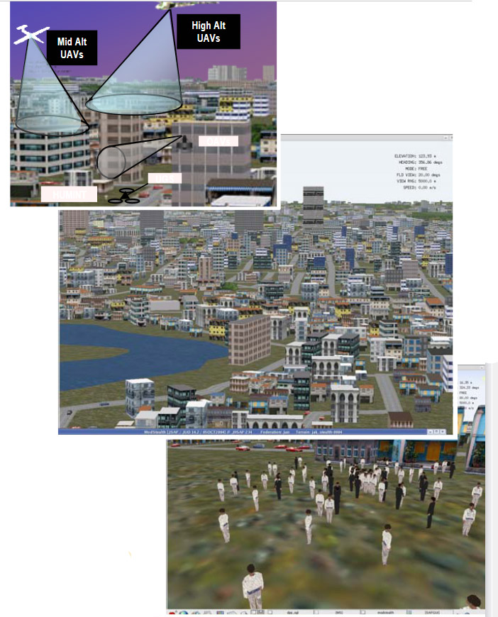
Figure 3. Computer-Generated Battlespace

Virtual Human Conversations

In order to respond to some of the DoD's unmet needs, the services have turned to the concept of a very human-like interactive interface between the computer and the user. These programs utilize an artificial intelligence (AI) approach called Natural Language Processing (NLP) that can characterize a user’s question, render it into a series of quantified vectors, match these vectors with an appropriate response that has been similarly vectorized, and respond with an animated figure on screen or match it with a pre-recorded live expert’s answer. This response is then cued up on web interface and presented within a 500 millisecond time frame (Nye et al., 2017), which is an well-accepted delay that is considered typical in face-to-face conversations. These programs report very encouraging evaluations by the users as to the programs' conversationality which they find engaging. These efforts find an even greater need for a fully engaged method to maximize use of many disciplines at each stage of the programs' development.

Emerging Technologies

It should be noted that virtual conversations require an even broader reach of technologies to effectively engage the user in a virtual conversation at globally distributed locations. In order to implement this technique successfully, developers have used parallel computing advances (Davis & Lucas, 2006), they have reduced latencies via use of GPGPU's (Wagenbreth et al., 2010), enabled a broader range of data by virtue of new data management (Yao, et al., 2011), made responses more accurate with the use of advanced artificial intelligence algorithms (Kaimakis et al. 2018), and they have investigated the improvement of human-like behavior by using Quantum Computing, (Lucas, et al., 2013), and many other advances. This range of expertise runs from human behavior to theoretical linear algebraic matrix analyses. It has been observed that these are academic disciplines that are not often even found within the same schools at a university, nor are they likely to attend a single disciplinary conference together.

Evolving User Expectation

One of the driving forces in the evolution of the conversational interfaces is the expectation of the continually growing familiarity and concomitant contempt of the users. This was the result of commercial realistic game visualizations and the implementation of nearly ubiquitous vocally responsive computer agents e.g. Apple's Siri and Amazon's Alexa. Considering the complexity, visual resolution, engaging qualities, and other advances, it is hard to grasp how far this set of capabilities has come from 1972's Pong up to today's World of Warcraft. Similarly, it is hard to overstate how this has created in the users an expectation of intense action, realistic rendering, emotional engagement, and fast pace. The challenge for the training, simulation and education profession is to prevent the user from losing interest, when offered other ways to spend time. The success of America's Army in attracting users, thereby improving training and readiness, is an example of an effective use of this technology (Zyda, et al., 2003).

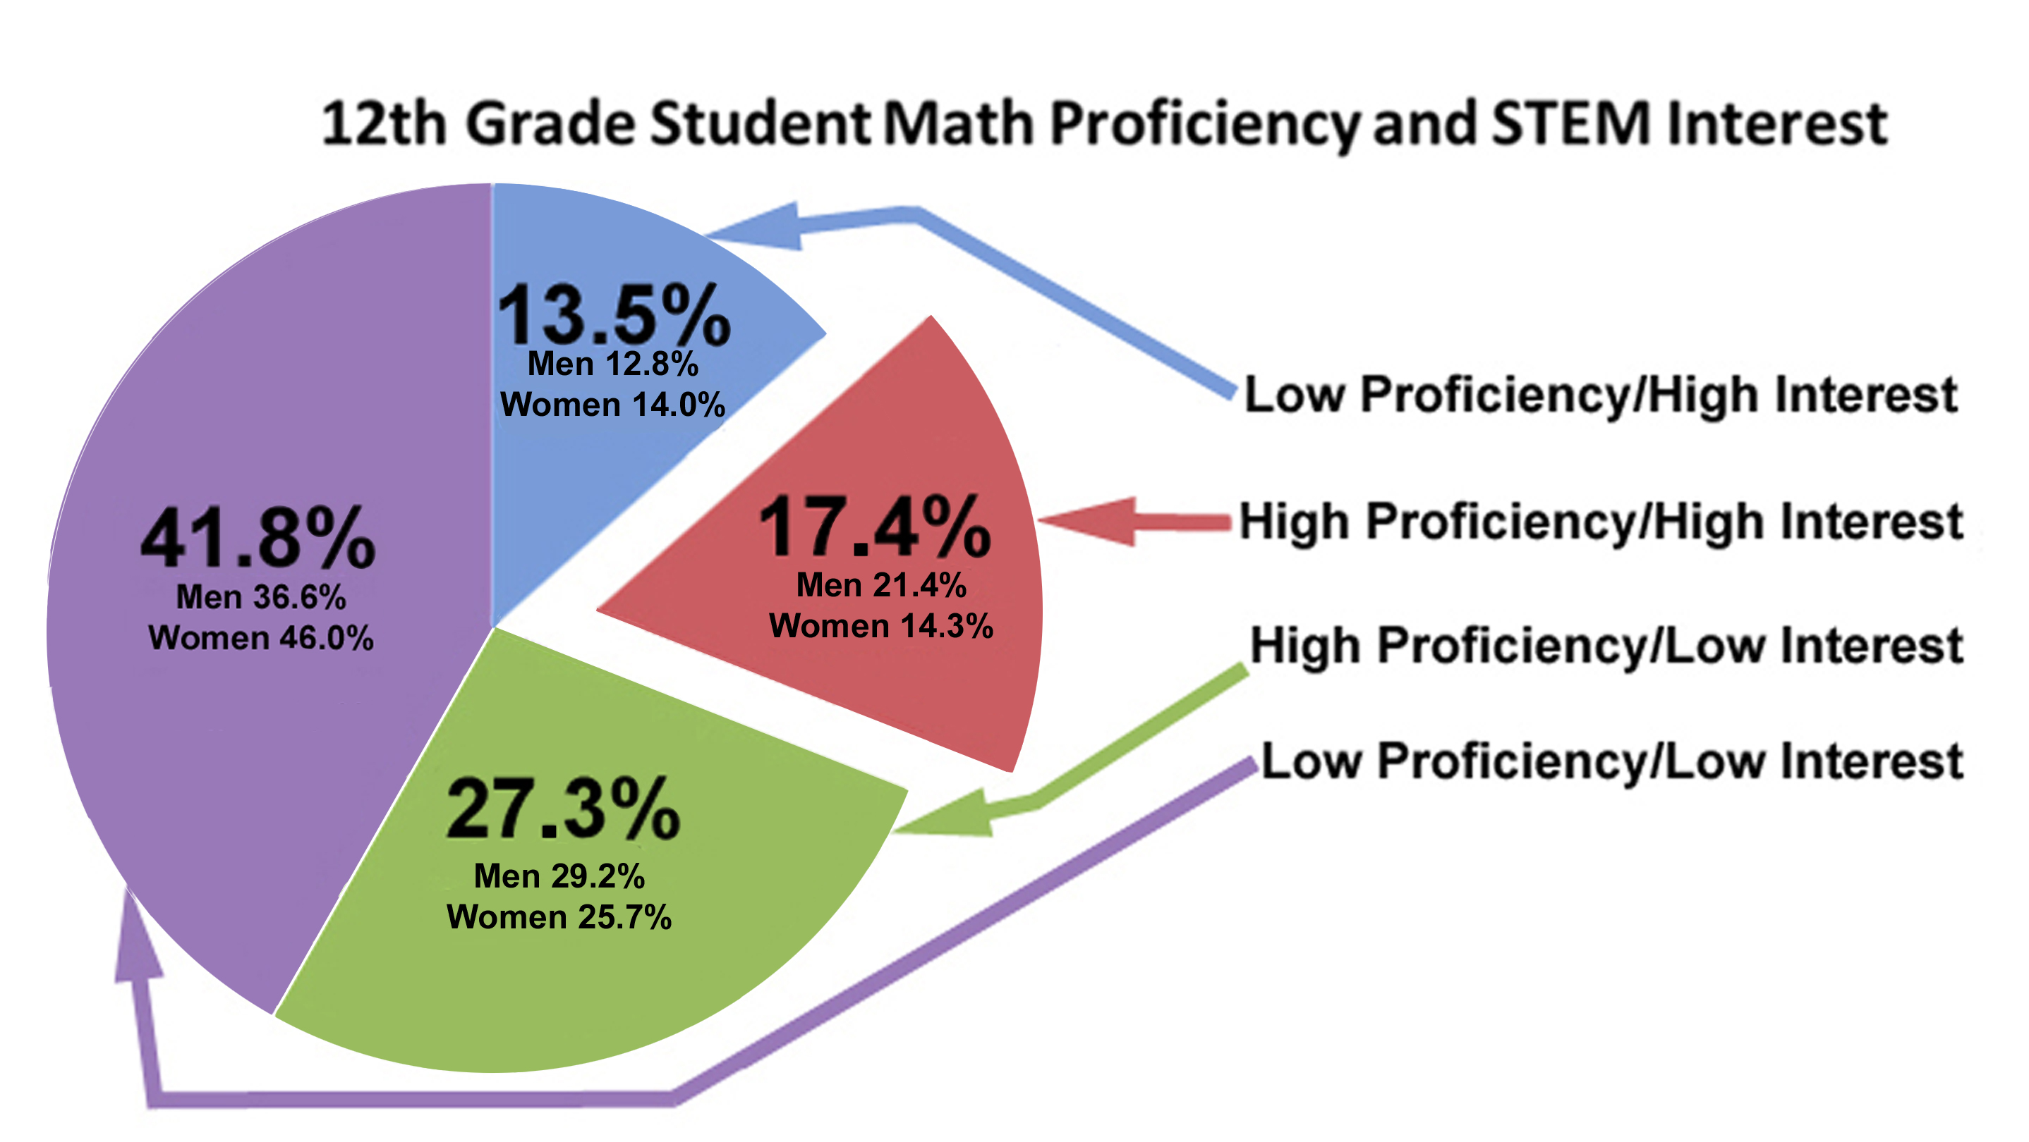
Figure 4. STEM Data from the Business
Higher Education Forum (BEHF, 2018)

Current Approach and Research

STEM Needs, Current Shortfalls and Virtual Mentors

A need to increase the available population of Science, Technology, Engineering, and Mathematics (STEM) professionals motivated the Navy to seek a way to make such professions more attractive to young people. The need for this is characterized in Figure 4. Declining budgets, increasing operations tempos, and under-staffed conditions continue to constrain the amount of time that experienced DoD personnel have available to train, advise, and mentor those who follow them (Gould, 2017). Those same conditions create an increased need for such counseling to maintain readiness, improve morale, and enhance retention (Payne & Huffman, 2005). The authors contend that a method for standardizing and disseminating such advice globally and at any time, would make it more effective.

A virtual conversation is a creation in which a human-like agent is implemented, in this case based on real persons. It attempts to recreate the appearance, voice, feel, and interactions that a live human conversation would produce. Enabled by new technologies, including natural language processing, virtual humans, computer generated imagery (CGI), machine learning, and virtual learning, the uses of virtual reality are spreading across the DoD. With a specialization in VR programming, projects have been developed: SimCoach, New Dimensions in Testimony (NDT), PAL3, MentorPal, and in the learning sciences, medical, mixed reality, narratives, social and virtual humans.

An effective approach is needed to engage many disciplines, in creating a virtual human. That may seem as simple as remodeling a human using CGI; it turns out that it takes significant study and effort to implement an effective Virtual Conversation. The essential elements that go into the creation of a virtual conversation with lifelike abilities include natural language processing, machine learning, VR, CGI, and engaged humans by computers. NLP was a major focus of the Meta-Disciplinary project, although the same arguments concerning its use could be made in virtually any research effort. Natural language processing is comprised of the decomposition of language to allow the computer to do useful communications (Chowdhury, 2003). Recent developments in NLP have made significant advances, including breaking down sentences into: parts-of-speech tags, chunks, entity tags, semantic roles, similar words, and the grammatical and semantic elements of a sentence that generate meaning (Collobert & Weston, 2008).

The interactive visualization for the user can take many forms, as are shown in Figures 5-7, all are ICT USC photos.
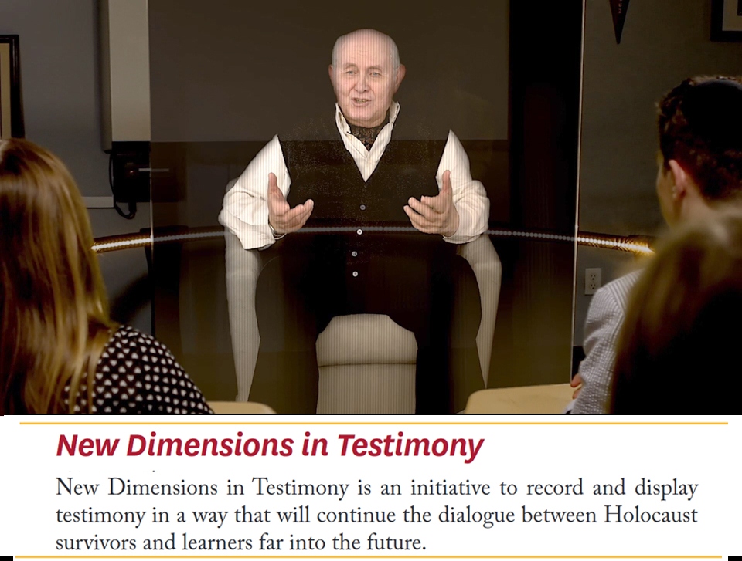
Figure 5. – Video of NDT speaker
shown in 3-D holographic display

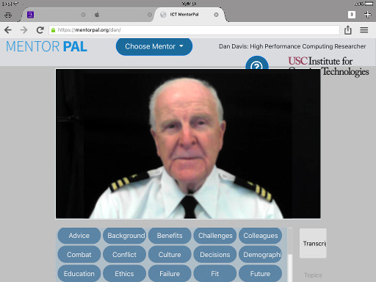
Figure 6. – MentorPAL video
clip presented on a 2-D monitor

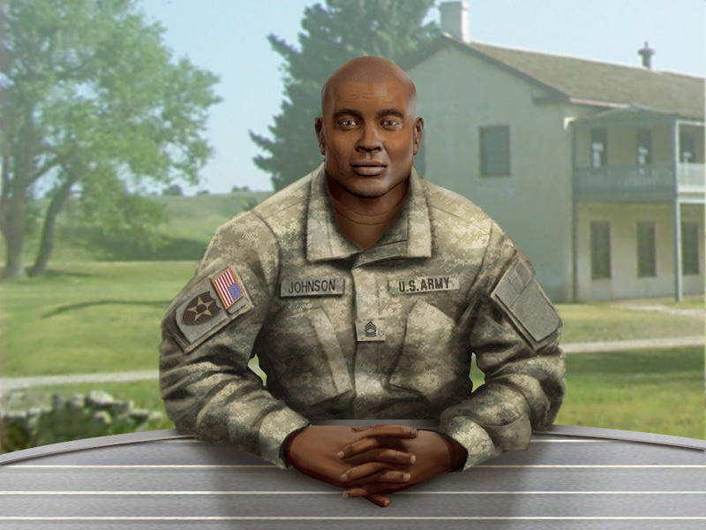
Figure 7. – SimCoach in
Fully Animated CGI

Now, progress has been made in training and learning environments (Kenny et al., 2007), multi-party dialogues (Traum & Rickel, 2002), ethics and cooperation (Allwood, Traum, & Jokinen, 2000), health applications (Rizzo et al., 2011), and representation and reasoning (Swartout et al., 2006). Although automated speech recognition (ASR) is far from perfect, prime software makes Virtual Humans practicable. For instance, Google achieved nearly 75% exact recognition of phrases, with only a 16% word error rate (Kudryavtsev, 2017), and the technology will continue to improve. It is also important to note that many of the errors in ASR are caused by slurred speech, cultural slang, and context, stemming from inconsistent definitions and in variability of contexts (Lee, 1988). Although this causes problems when comparing these transcriptions with global data, models can be trained locally to a particular person’s voice or a low resource language, using software such as CMU Sphinx from Carnegie Mellon University as has been applied to languages such as Arabic (Satori, Harti & Chenfour, 2007). Clearly, more and more disciplines are being involved in what this community is now doing and what it will be doing in the future.

PAL3-Mentor

The next challenge came from a Navy organization that sought a new tool to improve a long-standing function of Naval leadership: mentoring new leaders. Studies have shown that a high percentage of young commissioned officers and newly career-oriented petty officers reported a lack of sufficient mentoring to both enable their personal growth and to improve retention in the Navy. With a different tack, this once again significantly increased the numbers of disciplines involved in the project, as it now included such things as Operations Research, Management, and Diversity concerns. Building on both the experience and on the newly requisite disciplinary breath available at major research universities the technologies and methods developed by the Mentor PAL project were instantiated.
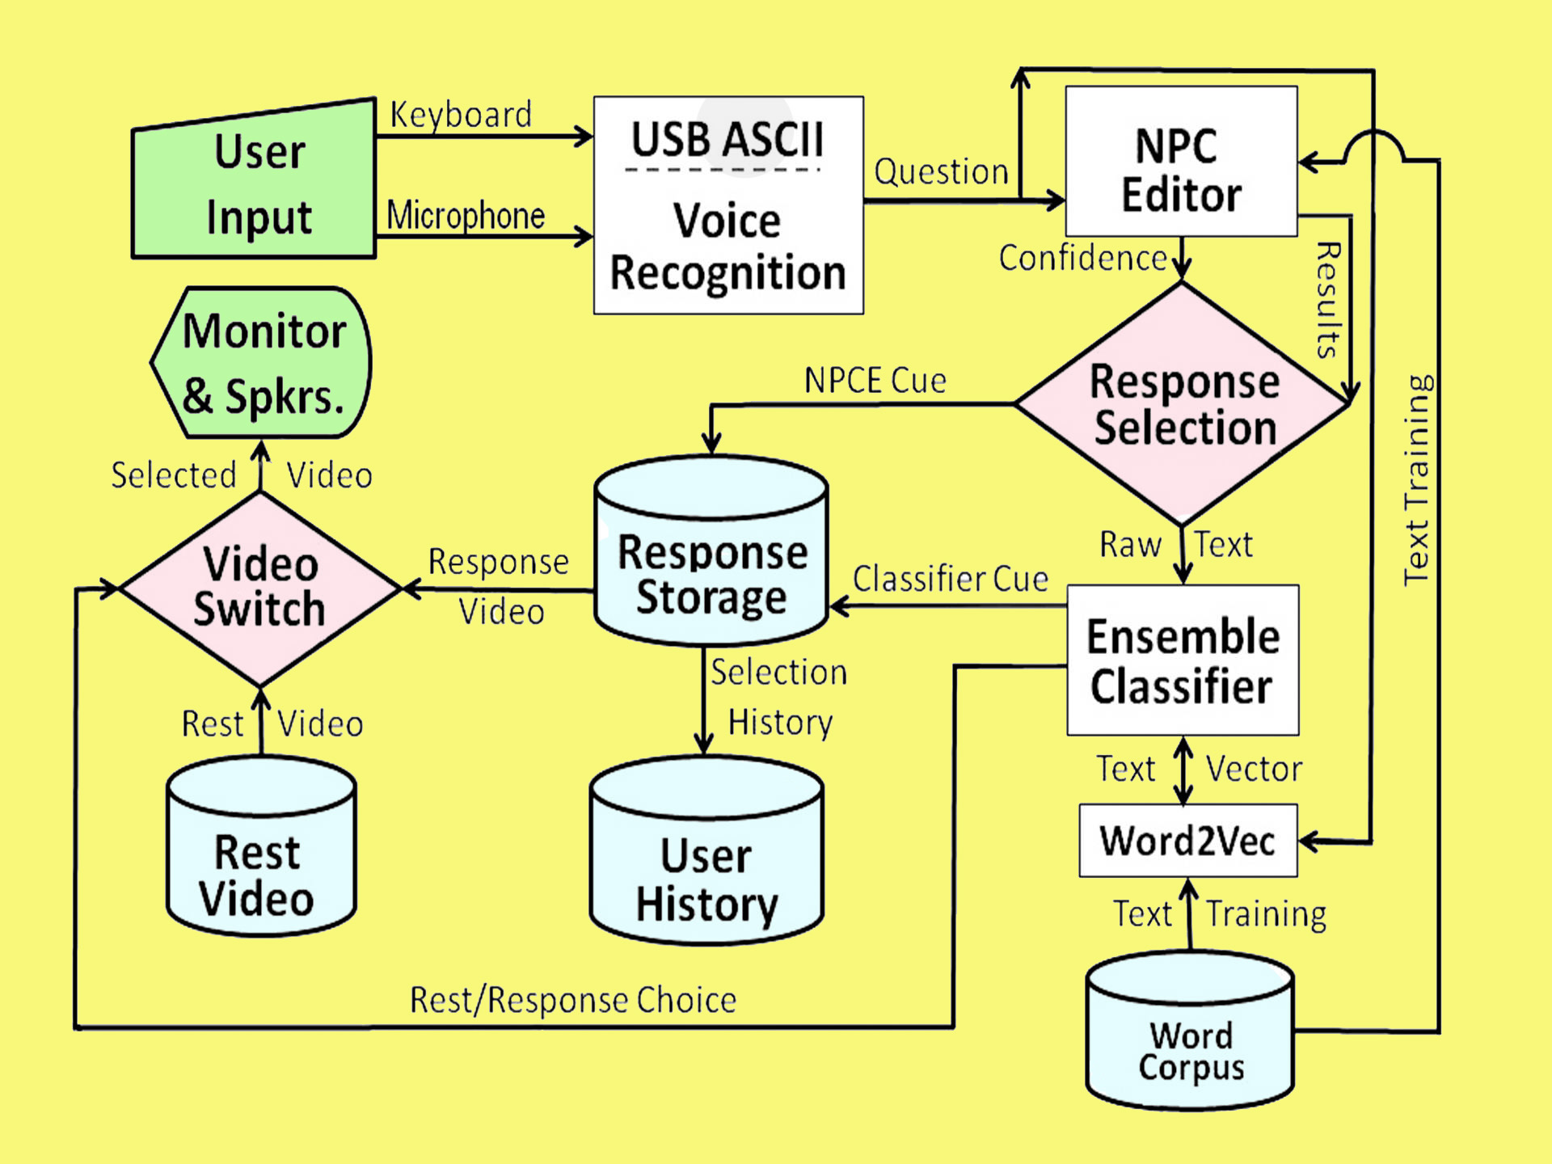
Figure 8. Notional Diagram of PAL3 Mentor Information Flows and Processing Steps
The process notional flow chart shown in Figure 8 to the right, shows the various steps in the process. As was discovered in previous research efforts, the process was then evaluated by administering the on-line “virtual mentoring” to various groups of subjects to record the reaction to the approach. Neither time nor limited funding allowed a longitudinal study of actual impact of the mentoring. Again, the results were reported in the earlier publications and were very positive in terms of “conversationality.” In lieu of this more rigorous method, mentoring efficacy was evaluated using attitudinal surveys. These results will be more fully explicated in a pending article to be published in a well-recognized journal in the discipline of educational technology. The intent of all of this approach is to provide a conversationally adept mentoring experience that can be available on-line, globally accessible, and regarded as helpful by potential mentees in the military environment.

One critical challenge faced by the veterans and managers on the team was the creation of a cogent and comprehensive list of questions to ask the project's model mentors, all of whom were volunteer US Naval personnel, active, reserve and retired. Some of the reported issues with mentoring in the services today have been reaffirmed in the informal survey described below. Some of the most often cited issues are: reduced access to mentors due to ops tempos, lack of a broad selection of potential mentors and feelings of hesitancy to relate needs openly to another officer. The MentorPal project purports to address many of these issues (Davis, et al., 2018) by selecting insightful, articulate and engaging mentors, recording their advice in short video clips and presenting them to the mentees in a way that convincingly emulates a live conversation. Many of these issues also relate to suicide prevention efforts.

This technique has proven useful in other context, e.g. counseling for PTSD (Post Traumatic Stress Disorder) patients (Rizzo, et al., 2012) and advising high school seniors of technical careers in the Navy (Beck, et al., 2018). The goal of the current project phase is to create a mentor panel of several officers who can respond to typed or voice-recognition audio questions on-line. It follows that the first priority would be to assemble a database of two question sets: “What do young officers ask mentors?” and “What should young officers ask mentors?”. One of the first issues to be aired was the dichotomy between the academics on the team and the Navy veterans on the team as to where the greater repository of useful data would be found: Either from Junior Officers (JO's) or from seasoned officers who know what they “should have known?”. That issue is not fully resolved, but, as with all good teams, adherents of both views were open to contributions from both input streams.

The discussions above led to a six step process:
- Input issues from JO trainees
- Review by project staff senior officers
- Incorporate suggestions from the reviewing officers
- Collate, edit, organize and document a set of draft question
- Survey about 100 seasoned officers and enlisted to assess value
- Submit questions to model mentors, with logging of their suggestions

The research team included senior retired military officers, which facilitated their ability to productively host young officer trainees who were Cadets from the United States Military Academy at West Point. They met together and created a question list long enough to be used. An interesting future research thread may have been the reasoning behind certain questions asked and how might that further shape future training in various contexts. This process took on the order of two weeks and produced around 300 items. That number appeared sufficient for the “proof of concept” nature of the MentorPal project (Kaimakis et al., 2018), but it should be noted that a parallel project, New Dimension in Testimony (Artstein, 2017), that was focused on creating a conversational record of Holocaust survivors had a question set of closer to 1,500, but it was a production project and for classroom and museum use.

A multi-disciplinary review of that question set by the diverse team members yielded a significant amount of editing, requiring on the order of one staff-week. Some of it was devoted to correcting grammar and syntax, others included re-writing the questions into Navy terminology, e.g. an Army Division (~10 to 15 thousand) is three orders of magnitude larger than a Navy Division which often only a few tens of personnel in size. This kind of organic team knowledge of military organizations was an example of needing diverse discipline participation It was at this time that the difference in focus first really appeared, as the Cadets were more focused on becoming grounded in leadership identity, while the veterans were aware of the growth needed in the areas of Evaluation/Fitness Report drafting, relationships with “detailing officers,” and how to manage both up and down the chain of command.

A typical subset of these questions, as created by all of the project's disciplines, appears below:
" …
30 How has your work day changed over the course of your career?
31 Where did you have to relocate in your career, and how did that change things?
32 Where do you see yourself in 5 years and in 10 years?

Session 1: LEADERSHIP - FIRST STEPS & SETTING THE TONE
33 What makes a good leader?
34 What are the most important first steps in a new leadership position?
35 Is there a "right" tone for a leader to use and how is it set?
36 What are the most common mistakes you've seen new leaders make? (e.g., skipping steps)
37 Are there problems that need to be rooted out early, because one will have trouble rectifying them later?
38 How much personal leadership should JO's exert themselves versus delegating it to Petty Officer?
39 How do JO's balance being close with their team, yet still avoiding fraternization?
40 What are some main things that JO's must learn and how do they make necessary adjustments? …"

After review by the various disciplines on the team of initial mentor responses, additional questions were added. Many of these had to do with commonly overlooked aspects of Naval service. They dealt with housing, moving, behavior at new commands, relationships with seniors and other topics not envisioned by the junior personnel. This lack of mentee sensitivity to major career success parameters was also observed in the high-school STEM student advising. Younger people did not have enough life-experience to know what is important and this highlighted age diversity as another important element of an effective team.

Unmet Needs for Operations Research/Behavioral Science

One of the major theses of this paper, as noted above, is that the increasing need and opportunity for more human-like interfaces may slowly shift the focus of this community from seeking raw simulation power to making sure the human behaviors are manifested by the computerized agent behaviors and that the computers can recognize the human input communications in all of their modalities: spoken word recognition, emotional content of words, voice tone, sarcasm, humor, and body language. Computer agents need to consider organizational dynamics (e.g. appropriate interfaces depending on rank dichotomies, size of group being addressed, shift in goal of communication); These will need to be identified and considered, leading to an increasing emphasis of Operations Research (OR) and behavioral economics. The latter is critical because current simulations have been observed to adhere closely to ideal human sensory accuracy (Ariely, 2010 & Kahneman, 2011) and appropriate reaction to physical stimuli. More disciplines will require more effective incorporation of them in the research team.

Collecting and Validating Community Perspicacity in a Meta-Disciplinary Way

Even though the aforementioned MentorPAL project did not have as a goal the delivery of a "shrink-wrapped" product, the intent was to examine and illuminate what the development of such a product might look like. In keeping with the thrust of the Meta-Discipline vision, the team itself was made up of a variety of personnel who were not just advisors, but participated and bore the responsibility for the project's outcome. Nevertheless, there was a concern that the insights were limited because of the small number of commissioned officers on the team.

There was no budget for a separate research project to formally ascertain Navy-wide attitudes, so one of the team members, a behavioral science major, constructed an informal ethnographic poll to broaden the base of the question generation process. This survey was then offered to a range of officers of the team’s acutance and took on the aspect of a “snowball” survey, i.e. each participant was asked to invite others to participate. In the end, there were 119 respondents, from all services and ranging in rank from E-5 to O-9, but the four Flag/General Officers directed specifically that their data NOT be included for reason they did not articulate. Several of those officers contributed significantly to the team’s insights and analysis outside of the format of the survey.

The survey was initially posted on line and about twenty of the research team military colleagues were informed of its presence and invited to participate. The instrument contained a request for the participants to invite others to contribute; those they thought would have both insights and willingness. This “snowball” nature of the survey garnered input from all five of the services. Figure 9 below shows the first page of the survey and also shows the URL (http://www.hpc-educ.org/NavMnt/Survey/MentorrSurvey.htm), should any reader be inclined to opine.

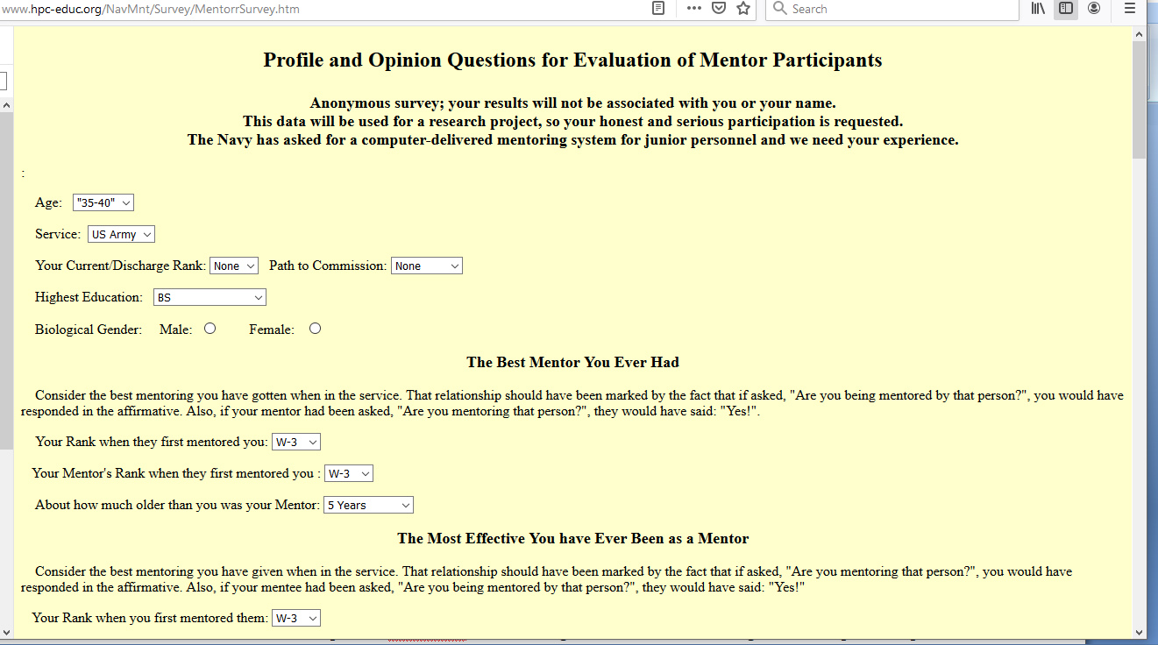
Figure 9. Opening page of the web-based “snowball” survey seeing Mentor question inputs.
While the results continue to be received, at the time of this writing, some concepts are emerging:
- First, the responses largely confirmed that the question-set originally formulated by the authors and the comments reaffirmed that the drafters' service experience was not atypical and the subject matter and project goals were of significant interest to officers across three generations of commissioned through at least four distinctly named “War Eras.”: Korea, Vietnam, Afghanistan and Iraq.

- Second, the responses offered a few new conceptual areas that the authors found very useful, but which they had not personally conceived. This facilitated the inclusion of several new leadership topics of note and the addition of new questions that amounted to about 5% of the original database.

- Third, in accordance with the broadening inclusivity of this initiative, the responses informed the language used to describe certain activities and approaches, as there is a on-going creative production of jargon and an updating of mentoring advice that needs to be reflected in the questions and honored in the taped answers. A good example of this is the rapidly changing directives on how to handle sexual harassment, abuse and assault and a plethora of new acronyms, e.g. SAPRO (Sexual Assault Prevention and Response Office) was a term that has come into use in this century.

Before discussing the team’s use of the survey data, the authors want to reassert their understanding that this was not a fully-funded, carefully crafted and statistically valid survey intended to prove a particular thesis. It was an informal and ethnographic survey to provide the team with additional ideas for mentor questions. The data is presented to show the type of input that might be useful in future work directed to similar goals. The authors understand that those familiar with more formal uses of statistically validated surveys will find this approach antithetical to their more formal use. In this case, it was very useful and the authors, without urging its use in similar circumstances, feel they would be well-advised to report how effectively it contributed here. (Wyatt, 2000)

Part of the survey was devoted to the review of questions mentors should answer. The authors also had a range of questions dealing with what a broader set of officers experienced with mentoring and how the term was used. As noted above, there were differing opinions as to whether a mentor could be a reporting senior in the mentees chain of command and there were questions as to how many had good mentors, via formal programs or spontaneously. Some of this data was sought via a Likert Scale like set of question, with the levels running along a range across Strongly Agree, Agree, Neutral, Disagree and Strongly Disagree (Allen & Seaman, 2007). Again, the utility sought in Table 1 was not to prove a thesis, but insightful input for the author’s use in designing a productive question set.
Table 1. Data Collected from an On-line Informal Survey.
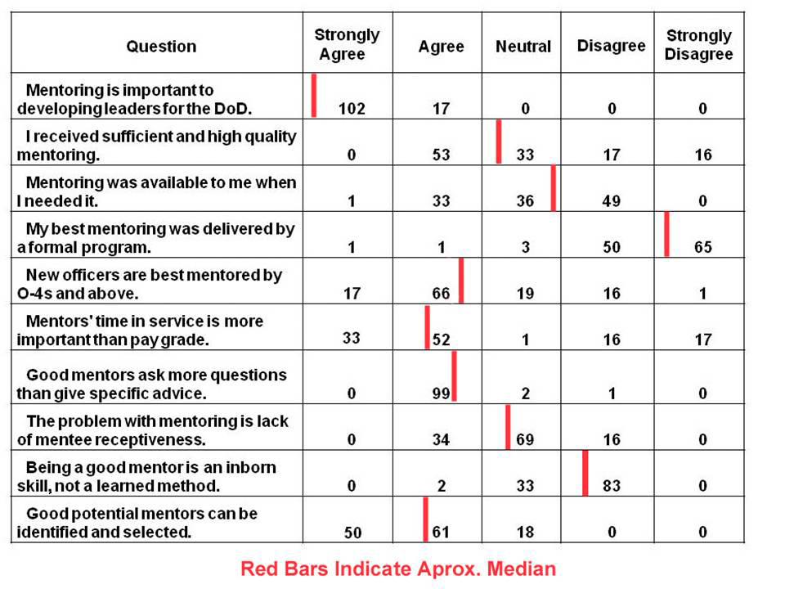

This data was incorporated into the questions to be asked and four officers and one Senior Chief were interviewed for ~ 12 hours each, approximately reflecting the current gender and ethnic diversity of the US Navy: Several of them contributed significantly to the question set with new suggestions or with validation inputs. Two of the recording sessions were done in person and three were done remotely, with the interviewer reading the questions from a laboratory which is located inj Los Angeles and the interviewees located elsewhere, East Coast and Japan.

Organizational Issues CALLING FOR A NEW APPROACH

Early Attempts at Multi-Disciplinary and Cross-Disciplinary Research

Much has been written and said about multi-disciplinary, cross-disciplinary and inter-disciplinary research, but, it has not been obvious to the authors of this paper. This is not a critique or complaint about those analyses and efforts, as it has always been hard to get disparate groups to work together and even harder get them to synergize. Some have studied the topic and there are collections of articles on various topics (Hall, et al., 2019).

Capabilities and Risks from the Limits of Training, Education and Mandates for Change

While the authors have not conducted any research to quantify or substantiate their anecdotal observations, they feel safe in suggesting that it is conceivable that the effort to improve a more effective use of multiple disciplines would not justify the benefits conferred thereby. It has been observed that many top researchers, but not all, really are polymaths and can fulfill the duties needed to meet the goals set forth above. Counter to that is the often observed tendency for high achieving personnel to fall short in optimally manifesting their intellectual ascendency (Hyman, 2008). On the other end of the spectrum, is the Dunning Kruger effect, which posits that it is low achievers who typically over-estimate their competency, but suggests such a problematic self-evaluative style can be countered by correct therapeutic methods (Jensen, et al., 2021). In either case the age-old adage, oft disputed that "None of us is as smart as all of us.!", is also supported by some research, but still hotly debated (White, et al., 2001). No conclusions are reached, but it is offered that further consideration may be warranted in assessing the malleability of the important characteristics that would need to be identified to enhance current performance. It is the collective experience of the authors that a broadly-based team that is given full membership in the decision making process bears many fruits.

Potential Confusion in the Concept of a Meta-Disciplinary Approach

The term Meta-Disciplinary previously has had great deal of discussion, but not in the area of technical research such as computer-generated simulations for defense. The research seems to indicate is in largely within the purview of the theology and philosophy. The term was adopted for this paper before discovering its use in other venues. The name was taken by the researchers on the projects cited above to represent something beyond the standard concept of a discipline. The theologians used the term differently as being reflexive back on to the core discipline, rather than transcending beyond it. In any case, this paper is not defending the choice of a term, but advocating this community's considering a new look at how to best use all of the intellectual assets available to any project and using them on a timely basis, not seeking counsel when the die has been cast with limited results. The projects cited above were very broadly based with disciplines of many branches, military experience in different eras and different warfighter specialties, degrees of varying levels (one paper generated by this research had four co-authors holding doctoral degrees, all four of which were different.) and undergraduate training from similarly diverse backgrounds. This set of lessons learned was seen as potentially important to the training, simulation and education community.

Anticipate Risks and Requisite Commitments for Success

With the vast majority of innovative endeavors, there are risks associated, and pursuing a Meta-Disciplinary approach is no different. The risks envisioned are that too broad a range of disciplinary outlooks will paralyze the decision-making process (Stoycheva and Lubart, 2001). It has been observed that often committee processes hinder creativity. Further, the more people who are actively engaged in decison-making, the higher likelihood is that disruptive interpersonal friction will arise. While no recognized psychometric instruments were found to evaluate who possesses the correct skills, it seems intuitive to accept that some personalities will be more amenable to the meta-disciplinary approach than others. The more one's psyche is open to contributions from others, the more likely such and approach will succeed. As was experienced in the research efforts above, a carefully crafted, fully implemented inclusivity can bring about astounding advances in the engagement of the users. Invoking the training initiatives advanced by some of the authors cited in the references is additionally a hopeful sign. These will be required to overcome the hurdles of making the virtual humans more capable of initiating conversation.

Analysis of Enabling Future Emerging Technologies

Benefits Anticipated Based on Preliminary Findings

The major thesis of this paper is that the accelerating pace of new technology development may be driving a more broadly based organizational technique to enhance national defense by being quicker to adopt and adapt some of the emerging technologies mentioned herein or those as yet unknown to us. This will enhance the ability to meet the expanding expectations of the users. A variant of a Meta-Disciplinary approach has been a hallmark of the current work described above. In many ways it was not entirely implemented by academically certified personnel, but by an openness to input from every level of the research team and willingness by all members of the team to reach out to university, service and industry colleagues.

The above stated issues are not merely "academic" This sort of effort is more commonly found in societies under great threats. In the present case, this has allowed the team to make excellent progress, but they now face several challenges that, if properly met, can lead to revolutionary advances in virtual human conversations. Some of the benefits that are sought are: an ability for a conversational virtual human to initiate rational conversations, to ask cogent questions at appropriate times, to recognize sarcasm and humor, and to respond to the emotionality of the user. There are deep learning, user sensor inputs and situation analyses that the implementation of which would be highly improbable without some of the emerging technologies identified above. They may require a new research management approach to optimize and accelerate the efficacious adoptions of these technologies.

Communities Impacted by a Meta-Disciplinary Approach to Virtual Humans

If the above methodologies do succeed, the most important communities may be the suicide prevention teams, those supporting mentoring but disappointed in several generations of trying to stimulate that tradition, may find help is on the way. The ability of a virtual human to provide and 24 x 7 x 365 counseling by an engaging virtual human counselor might be paradigm-shifting in not only suicide prevention, but may reinforce the preliminary finding that situations seeking a judgment-free counselor actually do better and talk longer with a computer generated virtual human, as has been reported internally by the research staff (Davis, 2021). This would also open up the possibility of using virtual humans as counselors as has been previously reported (Shaw et al., 2019). This effort would require careful planning and precautions to insure ethical, privacy and safety concerns were adequately addressed.

Evaluation and Metrics Observed and Planned

The progress anticipated here will be of little consequence if it cannot be substantiated by quantified results. In order to accomplish that, thought will have to be invested in establishing valid and unassailable metrics for success. They need to be measurable by professionals not associated in any way with the project and have sufficient face validity to be accepted by leadership and rank and file personnel. Many a fine scientific initiative has failed due to poor communication rather than technical insufficiency. A meta-disciplinary team would be well advised to incorporate a psycho-metric specialist, from the beginning to plan an assessment strategy, one not crafted to provide the correct answer, but to provide the best assistance to the warfighter. Earlier work was carefully quantified. (Nye et al., 2020)

Conclusions

Many important capabilities depend on emerging technologies. Those capabilities may very well depend on the simulations' communities being open to new inclusivity of personnel not usually part of simulation projects as the emphasis toms more to recognizing, characterizing and responding to human behavior. Using the observations and cited research set forth above, a potential implementation of this concept, supported by initial experience in current projects and needs for future advances is envisioned something like this: 1) more human-like conversation requires recognition of humor and sarcasm, 2) identifying such subtle and loosely-defined behaviors putatively requires a Deep Learning A/I approach, 3) such high-order behaviors are characterized by many facets, which humans facilely employ. to detect them, may only be enabled by the unique non-deterministic power of Quantum Computing, and 4) such an effort will rely on a considerable range of disciplines that must be employed effectively at each and every stage of the development. Using an over-arching approach to incorporating all the cognizant disciplines which may be central to the initiative may not be a sine qua non, but not using it may cause unfortunate delays and a delay in adoption of new capabilities in the DoD context may cost missions, lives and treasure. This paper asserts that this approach is available might justifiably be entitled Meta-Disciplinary.

ACKNOWLEDGEMENTS

The authors would like to thank William Swartout for his support and guidance. Much of this work was supported by grants from the Office of Naval Research's STEM Program (ONR N00014-16-1-2820) and by students supported by the National Science Foundation Research Experience for Undergraduates program (NSF 1560426). Nevertheless, the positions taken in the paper are the authors’ own and do not represent in any way the views of the Department of Defense or the US Government.

REFERENCES

Allen, I. E., & Seaman, C. A. (2007). Likert Scales and Data Analyses. Quality Progress, 40(7), 64-65.
Allwood, J., Traum, D., & Jokinen, K. (2000). Cooperation, Dialogue and Ethics. International Journal of Human-Computer Studies, 53(6), 871-914.
Ariely, D., & Jones, S. (2010). Predictably irrational. Harper Perennial
Artstein, R., Gainer, A., Georgila, K., Leuski, A., Shapiro, A., & Traum, D. (2016). New Dimensions in Testimony Demonstration. In Proceedings of the 2016 Conference of the North American Chapter of the Association for Computational Linguistics: Demonstrations (pp. 32-36).
Beck, S., Carr, K., Davis, D. M., Nordhagen, J. N., & Nye, B. D. (2018). Virtual Mentors in a Real STEM Fair: Experiences, Challenges, and Opportunities. In Third International Workshop on Intelligent Mentoring Systems (IMS 2018) Proceedings.
Bird, K., & Sherwin, M. J. (2005). American Prometheus: the triumph and tragedy of J. Robert Oppenheimer. Knopf.
BEHF, (2011), Creating the Workforce of the Future: The STEM Interest and Proficiency Challenge. Retrieved 20 April 2021 from https://www.bhef.com/sites/default/files/BHEF_2011_stem_inerest_proficiency.pdf
Brooks Jr, F. P. (1995). The mythical man-month: essays on software engineering. Pearson Education.
Chowdhury, G. (2003). Natural language processing. Annual review of information science and technology, 37(1), 51-89.
Collobert, R., & Weston, J. (2008, July). A Unified Architecture for Natural Language Processing: Deep Neural Networks with Multitask Learning.” In Proceedings of the 25th International Conference on Machine learning (pp. 160-167).
Davis, D. M., Predovich, K.B., Stassi, F.J., Spaulding, H., Shaw, K & Nye, B.D. (2018). Enhancing Menteeship: Improving Career Selection for Potential DoD Personnel. In the Proceedings of the SISO Fall Simulation Innovation Workshop, Orlando, Florida: SISO
Davis, D.M., & Lucas, R.F. (2006). Joint Experimentation, Data Management and Analysis Enabled by Trans-Continentally Distributed Linux Clusters. HPCMP Users' Group Conference. Denver, Colorado. June, 2006
Davis, D.M. (2021). Private conversation with members of the SimCoach team in 2015. (Rizzo, A., Lange, B., Buckwalter, J. G., Forbell, E., Kim, J., Sagae, K., ... & Kenny, P. (2011). SimCoach: an intelligent virtual human system for providing healthcare information and support. Int J Disabil Hum Dev 2011;10(4):277–281)
Gottschalk, Thomas D., Yao, K-T., Wagenbreth, G. & Davis, D. M. , (2010). Distributed and Interactive Simulations Operating at Large Scale for Trans-continental Experimentation. in the Proceedings of the IEEE/ACM Distributed Simulations and Real Time Applications 2010 Conference.
Gould, J. (2107). Military chiefs warn of force-readiness struggles, Defense News, Retrieved 18 April 2021 from: https://www.defensenews.com/congress/2017/02/07/military-chiefs-warn-of-force-readiness-struggles/.
Hall, K. L., Vogel, A. L., & Croyle, R. T. (Eds.). (2019). Strategies for team science success: Handbook of evidence-based principles for cross-disciplinary science and practical lessons learned from health researchers. Springer Nature.
Hyman, R. (2008). Why and When Are Smart People Stupid?. In Why smart people can be so stupid (pp. 1-23). Yale University Press.
Iacobini, Paul, (2013). Importance of Theoretical And Scientific Preparation In Combat Sports Training. Marathon.
Jansen, R. A., Rafferty, A. N., & Griffiths, T. L. (2021). A rational model of the Dunning–Kruger effect supports insensitivity to evidence in low performers. Nature Human Behaviour, 1-8.
Kaimakis, N.J., Davis, D.M., Breck, S., & Nye, B.D. (2018). Domain-Specific Reduction of Language Model Databases: Overcoming Chatbot Implementation Obstacles. In the Proceedings of the ModSim World Conference. Norfolk, Virginia
Kahneman, D. (2011). Thinking, fast and slow. Macmillan.
Kenny, P., Hartholt, A., Gratch, J., Swartout, W., Traum, D., Marsella, S., & Piepol, D. (2007). “Building Interactive Virtual Humans for Training Environments.” In Proceedings of the Interservice/Industry Simulation, Training and Education Conference, Orlando, Florida, 2007 (Vol. 174).
Kudryavtsev, A. (2016). Automatic Speech Recognition Services Comparison. Grid Designer's Blog. N.p., 11 Jan. 2016. Retrieved 20 Apr. 2017 from: http://blog-archive.griddynamics.com/2016/01/automatic-speech-recognition-services.html.
Lee, K. F. (1988). Automatic speech recognition: the development of the SPHINX system (Vol. 62). New York, NY.: Springer Science & Business Media.
Lucas, Robert F., Gene Wagenbreth, John J. Tran, David R. Pratt, & Dan M. Davis. (2013). Practical Adiabatic Quantum Computing: Implications for the Simulation Community. In the Proceedings of the Interservice/Industry Simulation, Training and Education Conference. Orlando, Florida, 2013
Nye, B. D., Davis, D. M, Rizvi, S, Z., Carr, K., William Swartout, W., Thacker, R. & Shaw. K. (2020). Feasibility and Usability of MentorPal, a Framework for rapid Development of virtual Mentors. Journal of Research on Technology in Education.
Nye, B., Swartout, W., Campbell, J., Krishnamachari, M., Kaimakis, N., & Davis, D. (2017). MentorPal: Interactive Virtual Mentors. Based on Real-Life STEM Professionals. In the Proceedings of the Interservice/Industry Simulation, Training and Education Conference. Orlando, Florida, 2017
Payne, S. C., & Huffman, A. H. (2005). A longitudinal Examination of the Influence of Mentoring on Organizational Commitment and Turnover. Academy of Management Journal, 48(1), 158-168.
Rizzo, A., Forbell, E., Lange, B., Galen Buckwalter, J., Williams, J., Sagae, K., & Traum, D. (2012). Simcoach: an Online Intelligent Virtual Human Agent System for Breaking Down Barriers to Care for Service Members and Veterans. Healing War Trauma A Handbook of Creative Approaches. Taylor & Francis.
Rizzo, A., Lange, B., Buckwalter, J. G., Forbell, E., Kim, J., Sagae, K., ... & Parsons, T. (2011). “SimCoach: an Intelligent Virtual Human System for Providing Healthcare Information and Support.” International Journal on Disability and Human Development, 10(4), 277-281.
Satori, H, Harti, M., & Chenfour, N. (2007). Introduction to Arabic Speech Recognition using CMU Sphinx System. arXiv preprint arXiv:0704.2083.
Shaw, K., Davis, D.M., Rizvi, S.Z., & Davis, M.C. (2019). Quantum Computing: Evaluating Potential Quantification of Projective Psychological Test Scoring. In the Proceedings of the ModSim World Conference. Norfolk, Virginia
Smith, Roger. (2009). The long history of gaming in military training. Simulation & Gaming.
Stoycheva, K. G., & Lubart, T. I. (2001). The nature of creative decision making. In Decision making: Social and creative dimensions (pp. 15-33). Springer, Dordrecht.
Swartout, W. R., Nye, B. D., Hartholt, A., Reilly, A., Graesser, A. C., VanLehn, K., ... & Wang, L. (2016, March). Designing a Personal Assistant for Life-Long Learning (PAL3). In The Twenty-Ninth International Flairs Conference.
Thompson, Trena N., Meredith B. Carroll, and John E. Deaton. (2008). Justification for Use of Simulation. Human factors in simulation and training.
Traum, D., & Rickel, J. (2002). Embodied Agents for Multi-party Dialogue in Immersive Virtual Worlds. In Proceedings of the first International Joint Conference on Autonomous Agents and Multi-agent Systems: part 2 (pp. 766-773). ACM.
Wagenbreth, G., Davis, D. M. & Lucas, R. F. (2010). GPGPU Programming Courses: Getting the Word Out to the Test and Evaluation Community. at the ITEA Annual Technology Review. Charleston, South Carolina
White, H. D., Zhang, X. Z., Belknap, B., & Cartwright, S. (2001, January). Are two heads better (or worse) than one?. In Biophysical Journal. (Vol. 80, No. 1, pp. 79A-79A).
Wyatt, J. C. (2000). When to use web-based surveys.. Journal of the American Medical Informatics Association, Volume 7, Issue 4
Yao, Ke-Thia, Lucas, R.F., Ward, C E., Wagenbreth, G. and Gottschalk, T.D. (2009)"Data analysis for massively distributed simulations." Interservice/Industry Training, Simulation, and Education Conference (I/ITSEC).
Yao, K-T., Davis, D. M., Liu, J. J., & Kaimakis, N. J. (2018). New Technologies to Enhance Computer Generated Interactive Virtual Humans. In the Proceedings of the SISO Fall Simulation Innovation Workshop. Orlando, Florida:SISO
Yao, K-T., Ward, C. E., & Davis, D. M. (2011). Data Fusion of Geographically Dispersed Information: Experience with the Scalable Data Grid. The ITEA Journal of Test and Evaluation Fairfax Virginia. 32(4)
Zyda, M., Hiles, J., Mayberry, A., Wardynski, C., Capps, M., Osborn, B., ... & Davis, M. (2003). Entertainment R&D for defense. IEEE Computer Graphics and Applications, 23(1), 28-36.

