Conversationally Adept Virtual Humans Technologies:
Autonomous Combat Team Members’ “Incarnation”

Mark C. Davis | Ke-Thia Yao & Dan M. Davis | David H. Barnhill
Wood Duck Research, Inc. | Univ. of Southern California | Naval Postgraduate School
Mooresville, North Carolina | Marina del Rey, California | Monterey, California
mark@woodduckresearch.org | kyao@isi.edu & dmdavis@acm.org | david.barnill@nps.edu

ABSTRACT

This paper addresses the technological opportunities and organizational needs for the Modeling and Simulation (M&S) community to facilitate the extension of emerging M&S capabilities into non-human warfighters. The authors posit that these non-humans might take various forms, the nature of which is left to the passage of time to reveal. The various existing forms of autonomous devices and the degree of their autonomy are surveyed. The next section briefly reviews the rapid and accelerating progress in virtual human behavior and adduces evaluative comments from users in the authors’ research projects into virtual humans. Based on their operational and research experience, the future of such technology trends is extrapolated. A scenario is advanced in which various non-human operational entities would be infused with doctrinal guidance and controlled locally by a human with back-up, The man/machine interfaces are suggested and analyzed in light of current on-going research in which some of the authors are participating. The benefits of using non-humans for dangerous tasks is considered, as are the ethical and societal risks of loosing machines with lethal weapons into the confusion and tumult of the modern, often urban, warfare. The beneficial interface impacts of making the non-human entities respond to human control and appear human, via augmented reality, to human controllers would be major human factors research goals, which the paper will outline, and pursue in the abstract. They will discuss the avenues of research in Artificial Intelligence that will surely be applicable and raise issues of checks on learned behaviors becoming violative of civilized standards or US humanitarian mandates. These issues are considered in a way that should be extensible into other areas with similarly conundrumal issues, e.g. valuable unique critical benefits, but significant risks. The paper closes with an articulation of the needed community support and contributions.

ABOUT THE AUTHORS
Mark C. Davis, Ph.D. is the Chief Technical Officer at Wood Duck Research, Inc, and is semi retired after careers in the US Navy and as a computer design engineer for both IBM and Lenovo. Rising to the level of Distinguished Engineer at Lenovo, he was responsible for the design of laptop computer cross-disciplinary technology, including PC architecture, embedded systems, open source and virtualization. Previous work was with IBM in the areas of software development and architecture involving security, storage and virtualization. Dr. Davis has been granted well over fifty patents that were filed during his service at both companies. He is a graduate of the Duke University NROTC program and was commissioned as an Ensign, attended nuclear power school, and served as a Submarine Officer for twelve years, including one duty tour as a classroom instructor. He left the active duty as a Lieutenant Commander to pursue a PhD. Mark holds a BSEE degree from Duke University and a PhD in Computer Science from the University of North Carolina, Chapel Hill, where his advisor was Professor Fredrick P. Books.
Ke-Thia Yao is a Project Leader and Research Scientist in the Computational Systems and Technology Division of the University of Southern California (USC) Information Sciences Institute (ISI). His primary research interest is in under-standing large complex systems and data sets. He teaches data management classes at USC’s Viterbi School of Engineering. He is part of the team investigating uses for USC’s 2,000 Qubit Quantum Annealer. Dr, Yao was one of the leads on the JESPP project where he analyzed the computational and behavioral properties of large-scale simulations. That project had the goal of supporting very large-scale distributed military simulation involving millions of virtual and constructive entities. He received his B.S. degree in EECS from UC Berkeley, and his M.S. and Ph.D. degrees in Computer Science from Rutgers University.
Dan M. Davis is active as a consultant at the Institute for Creative Technologies, University of Southern California (USC), focusing on large-scale DoD simulations and avatar uses. Prior to retirement, he was the Director of the JESPP project at USC for a decade. As the Assistant Director of Advanced Computing Research at Caltech, he ran Synthetic Forces Express, bringing HPC to DoD simulations. He also served as a Director at the Maui High Performance Computing Center and in computer research roles at the Jet Propulsion Laboratory and Martin Marietta. He was the Chairman of the Coalition of Academic Supercomputing Centers and has taught at the undergraduate and graduate levels. As early as 1971, Dan was writing programs in FORTRAN on one of Seymour Cray’s CDC 6500’s. While in the Marine Corps, he saw duty in Vietnam as a Cryptologist and retired in 2002 as a Commander, U.S.N. He received B.A. and J.D. degrees from the University of Colorado in Boulder.
David H. Barnhill, LCDR, USN, is enrolled the US Naval Postgraduate School (NPS), in Monterey California. He is a student there in the Operations Research Department. He is particularly interested in the analysis of human behavior and command relationships of defense personnel. A topic of immediate concern is the imminent adoption of various levels of robotic and artificial intelligence-controlled weapons on unit cohesion and command functions. He is a Naval Aviator, and has flow rotary-wing aircraft from both land and vessel platforms. David has served in flying status leadership positions and has performed staff officer duties. He graduated from the US Naval Academy with a BS and is scheduled to complete an MS in Operations Research at NPS in the spring of 2021.

Mark C. Davis | Ke-Thia Yao & Dan M. Davis | David H. Barnhill
Wood Duck Research, Inc. | Univ. of Southern California | Naval Postgraduate School
Mooresville, North Carolina | Marina del Rey, California | Monterey, California
mark@woodduckresearch.org | kyao@isi.edu & dmdavis@acm.org | david.barnill@nps.edu

Introduction

Combat is really hard. Finding a technology that can improve has been a centuries long quest (cite Gatling). Technology has brought its own problems: Information overflow and efficient control. The solutions is to improve the interface between a trusted human and multiple efficient mechanical henchmen

Background

First, let’s review the technologies available today and in the near future.
- Remotely Piloted Aircraft (MQ-1, MQ-9)
- Fire and Forget weapons (anti-tank, anti-aircraft, torpedoes)
- Autonomous automobiles

Development and deployment of autonomous weapons has proceeded since WW II. The introduction of radar detonated anti-aircraft shells <ref> and self-guided torpedoes <ref> progressed to more sophisticated fire and forget weapons. These developments were straight forward because the target was designated before the weapon was fired. All of the ethical decision concerning correctness and rightness of the target were made before weapon launch. There information exchange between launcher and weapon was limited to minor adjustments in position. Even if information flow failed, the consequence was rarely more than the target was not destroyed.

Technology has progressed to enable more capable autonomous vehicles. Much of the work required for autonomous automobiles such as image recognition, route strategy and emergency response is directly applicable to combat machines. We will show later the type of scenarios that are now enabled by this technology.

Using this technology in combat situations faces two major obstacles. The first is that we as humans don’t want to cede life-and-death control to non-human entities <Bieri>. The second is that the information flow from the autonomous entity has now dramatically increased.

To maintain the ethical control required by society, the autonomous entity capability must be limited, and a human supervisor must control the lethal actions of the entity. For a remotely piloted aircraft, the interface can parallel an existing aircraft and few additional problems are introduced. But a combat infantry drone is another matter. Although the nature of the controlling interface for such a drone is not clear, the dramatic increase in information flow is clear and will certainly be a problem.

Information flow and specifically too much information has been a major and well-studied problem. It is widely acknowledged that information overflow can be deadly to warfighters <Shankar>, <Bateman>. In high technology areas such as piloting fighter aircraft, getting the right information has been a problem under study for many years <Hettinger>.

Current Remote Control Expeience
Human experience operating drones:
- Significant degradation in situational awareness because you are not ‘in the medium’ like you are with manned aircraft.
- Time lag. You see an event happen perhaps with your camera (on the drone) and then you have to transmit what you see via voice comm assuming there is no video downlink to decision makers (current state of the art in the Navy).
- Technology. When operating a drone you are actually operating two systems. The vehicle and the control station. Those that maintain one do not maintain the other. Operators typically do not possess requisite skill to fix anything with the station. If it goes down, then you have a problem if you are at sea….
What can I do….
- Any sort of troubleshooting. Usually, we get indications of a problem beyond just a light on a console. We feel things and see things. We note differences in how an aircraft is supposed to work.
- With drones, you do not get those feelings. All you see is a light. The sensory deprivation means all you can really do is (hopefully) bring the drone back home to maintenance.
Issues:
- Law of Armed Conflict. We note that drone operations is still a grey area when talking about LOAC. Because one side is not really putting itself in proportional danger (that is human loss), is this truly ‘combat’ in the traditional sense? Bradley Strawser at NPS has written about this.
- Training. The ability to train is limited strictly to simulation with few exceptions. The strictures in place for drone operations is prohibitive so when we deploy, we send people that ‘sort of’ know what they are doing. The simulators are strictly garbage in garbage out and are predictable in how they react to human-induced problem (read: it is always the same).
- Loss consideration. Is losing a drone the same as using a human life (no)? However, is it the same as losing a manned aircraft if we normalize for the human life? It depends. How reliant are you on the drone? Is it critical? We often think that the best things about drones is that they can be lost without loss of life but that is sort of flippant. If you lose one have you lost a critical capability? Can you replace a $10 million drone easily?
- Using the full capability is hampered by human distrust of drones. Interestingly this is a typical way of thinking for helicopter pilots: always thinking their aircraft is going to fail.
Physiology
- Putting it succinctly, not being able to use your senses matters. Not having a ‘seat of the pants’ feeling is detrimental when we talk about vertigo in manned aircraft, but its absence in drone flying means you lose external cues that you rely on.
- OODA loop. Much slower. Observe is more difficult to evaluate and people consider it less reliable because it is higher technology. Orient is driven by observe in our case (though Boyd didn’t mean it to be). Unlike the original idea of OODA it is harder to enter at any point on the loop. Observe is way more difficult to evaluate. All else follows.

Vision of the concept
Throughout history, militaries have hone command and control to assure that combat meets the strategic and ethical objectives of organizational leadership. <Sun Zu>. Rather than create a totally new approach to warfare, a logical development is to integrate the autonomous entity into existing military command relationships with minimal changes. By limiting the ethical decision making to well trained, trusted warriors in control. The relationship between this trusted human and the autonomous entity would then resemble the relationship between a Corporal and Private.

Arguably, an autonomous private should not have all of the ethical responsibilities of a human private. This change in role is not a dramatic and the ethical requirements of a fighter pilot so the modification in role should be achievable. Similarly, in many combat teams’ minor revisions to duties, responsibilities and ethics of the roles would enable autonomous entities to server in that capacity.

One advantage of this approach is that it leverages all of the existing military training and thought. All levels of command would continue to use the commands and concepts they have already learned to use this new technology. The impact to training organizations and operations would thus be minimized.

The vision is to place autonomous entities into the existing military hierarch with minimal changes. In particular, the command and control language and semantics should be as close to existing practice to take advantage of the thousands of years of experience represented.

The elements of this concept include
- A mechanical device capable of physical tasks necessary for a combat mission
- An artificial intelligence to operate the device and support the interface with the command structure
- As command structure utilizing the function of the device including a human designated to control the device
- An optimal user interface to efficiently use the abilities of the device and the human controller

The interface for this task may be Virtual Humans.

<< Dan, insert here description mentor pal, et all >>

Current Advances and Emerging Technologies in Virtual Humans
One accepted, but emerging, technology is that of Virtual Humans. As that term is used in this paper, a wide range of virtuality is accepted, including using computer-selected video clips of a live human. It a creation in virtual reality portrayed by an avatar which attempts to recreate the appearance, voice, feel, and interaction that a live human would produce. Using the advances in several new technologies, including but not limited to natural language processing (NLP), virtual reality (VR), computer generated imagery (CGI), machine learning, and virtual learning, live teachers can be presented. The uses, as well as the limits of these tools are becoming evident. Researchers at ICT have developed programs that have been shown to be effective, e.g. SimCoach, New Dimensions in Testimony (NDT), PAL3, and others (ICT, 2019). These are generalized under learning sciences, medical VR, mixed reality, narrative, social stimulation, virtual humans, and vision and graphics. The field of knowledge available here is immense, and countless resources and expertise are now becoming available in this promising field. The user interface can take many forms, as in Figures 1, 2, & 3 below.

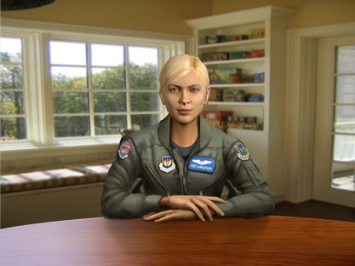 |  | 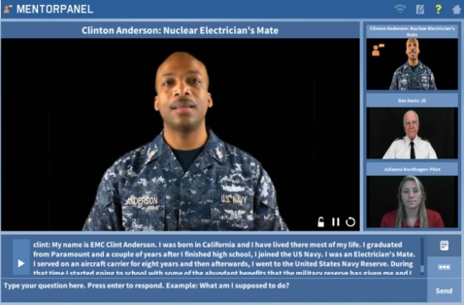
Figure 1 - Fully Animated CGI SimCoach advises PTSD Vets | Figure 2- Holocaust Survivor with guests in 3D holographic display | Figure 3 – Recorded video clips are used to Mentor STEM Student

Natural language processing composes “an area of research and application that explores how computers can be used to understand and manipulate natural language text or speech to do useful things” (Chowdhury, 2003).Using this definition within the context of virtual environments, NLP tools allow computer technology to recognize voice input, analyze voice tone, provide lifelike conversation, retrieve information, and many other applications in combination with machine learning. Recent developments in NLP have made amazing bounds like “a single convolutional neural network architecture that, given a sentence, outputs a host of language processing predictions: part-of-speech tags, chunks, named entity tags, semantic roles, semantically similar words and the likelihood that the sentence makes sense (grammatically and semantically) using a language model” (Collobert & Weston, 2008).

Applications of interest in cross reality, as a synthesis of several vitalities and reality, can use developments in the interpretation of language which have been recently enhanced by the many researchers focusing their studies on the field. At ICT alone, progress has been made in training/learning environments (Kenny et al., 2007), multi-party dialogue (Traum & Rickel, 2002), ethics and cooperation (Allwood & et al., 2000), health applications (Rizzo et al., 2011) , and representation and reasoning (Swartout et al., 2006). Although automated speech recognition (ASR) is far from perfect, some of the best software, “Google achieved 73.3% of exact recognized phrases with a 15.8% [Word Error Rate]” (Kudryavtsev et al., 2008), and the technology will continue to improve. It is also important to note that many of the errors in ASR are caused by slurred speech, cultural slang, and context, stemming from a “lack of consistent units of speech that are trainable and relatively insensitive to context” (Lee, 1988). Although this causes problems when comparing these transcriptions with global data, models can be trained locally using software such as CMU Sphinx from Carnegie Mellon University as applied to languages such as Arabic (Satori, et al., 2011). All of these will continue to improve with time, as hardware, software, and data storage and availability are areas within which research is eminent and directly valuable. Specifically, the speed and application of quantum computing will engender significant advancement in NLP and its applications: one of which is the impactful area of virtual humans.

Effective Conversational Interfaces
The SimCoach system (see image 1 above) experience aimed to “motivate users to take the first step – to empower themselves to seek advice and information regarding their healthcare” . These virtual systems have been shown to have more success, generating deeper levels of confidence with patients than even live healthcare interactions (Rizzo, et al., 2011). The successes of these operations so far foreshadow abundant uses in the near future.
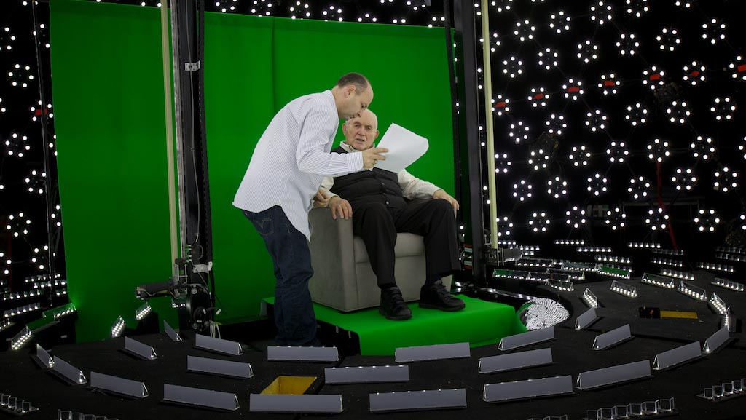
Figure 4 – Subject receiving direction in light stage
used for generating 3-D imagery for holographic display

A closer analog may be found in the area of storytelling and gaming. The New Dimensions in Testimony project “allows people to have an interactive conversation with a human storyteller (a Holocaust survivor) who has recorded a number of dialogue contributions (Figure 44), including many compelling narratives of his experiences and thoughts” (Traum et al., 2015). The project’s important mission of preserving the stories of Holocaust survivors can be applied to endless amounts of other important persons and tales. Advances in gaming allow for utilization in learning, entertainment, healthcare, and lifelike training for things like combat and critical thinking.
Critical thinking training in the English Language Arts area will require the use of virtual environments that make the most skilled instructors and exciting resources available. Some of the current negatives of virtual learning are the difficulties of personalizing learning, handling live question, accommodating different learning styles, and similar issues which are often mirrored in the classroom instructors’ lack of time for thirty individuals in a class. Future fields of focus will come in increased sophistication in such virtual environments and interaction. For example, imagine a system which takes in a live recorded interview with a president, or other prominent or knowledgeable figure, and generates an interactive environment in which a user can experience the interview by asking the questions themselves. Such things are already in existence, and they will only become more prominent and powerful. However, the need for extensive processing power, efficiency, and data storage and transfer remains a limiting factor for such developments. We believe that the aforementioned applications call for considerable further exploration and research.

One of the issues facing both the previous work on MentorPal and the projected future work on the incarnation of the robotic warfighter is the identification, assessment and ranking of various scenarios and environments. The prior experience of the selection of issues to be addressed will be critical as we face the problems of effectively controlling the virtual battlefield superimposed on the real battlefield. In previous work, the authors had ot ascertain the corpus of questions to be asked. They developed useful techniques for ascertaining this corpus.

A number of the reported issues with mentoring in the services today have been reaffirmed in the informal survey described below. Some of the most often cited are: reduced access due to ops tempos, lack of a broad selection of potential mentors and feelings of hesitancy in relating openly to another officer. The MentorPal project purports to address many of these issues (Nye et al., 2017j Davis, et al., 2018) by selecting insightful, articulate and engaging mentors, recording their advice in short video clips and presenting them to the mentees in a way that convincingly emulates a live conversation. This technique has proven useful in other context, e.g. counseling for PTSD (Post Traumatic Stress Disorder) patients (Rizzo, et al., 2012) and advising high school seniors of technical careers in the Navy (Beck, et al., 2018). The goal of the current project phase is to create a mentor panel of several officers who can respond to typed or voice-recognition audio questions on-line. It follows that the first priority would be to assemble a database of two question sets: “What do young officers ask mentors?” and “What should young officers ask mentors?”. One of the first issues to be aired was the dichotomy between the academics on the team and the Navy veterans on the team as to where the greater repository of useful data would be found: Either from young officers or from seasoned officers who know what they “should have known?”. That issue is not fully resolved, but, as with all good teams, adherents of both views were open to contributions from both input streams.

The discussions above led to a six step process:
- Input from young officer trainees
- Review by senior officers, both active duty and retired
- Input from the reviewing officers
- Collation of a draft question set
- An informal survey of > 100 seasoned officers and enlisted personnel
- Use of questions in a group of four mentors, with concomitant logging of suggestion

The young officer trainees were Cadets from the United States Military Academy (USMA) in West Point. They met together and created a list long enough to be used. An interesting research thread may have been the reasoning behind certain questions they asked did and how might that further shape future training in those contexts. This process took on the order of two weeks and produced around 300 items. That number appeared sufficient for the “proof of concept” nature of the MentorPal project (Kaimakis et al., 2018), but it should be noted that a parallel project, New Dimension in Testimony (Artstein, 2017), that was focused on creating a conversational record of Holocaust survivors had a question set of closer to 1,500, as it was a production project for classroom and museum use.

The review of that question set by team members required a significant amount of editing, on the order of a staff-week. Some of it was correcting grammar and syntax, others included re-writing the questions into Navy terminology, e.g. an Army Division (~10 to 15 thousand) is three orders of magnitude larger than a Navy Division which often only a few tens of personnel in size. It was at this time that the difference in focus first really appeared, as the Cadets were more focused on becoming grounded in leadership identity, while the veterans were aware of the growth needed in the areas of Evaluation/Fitness Report drafting, relationships with “detailing officers,” and how to manage both up and down the chain of command.

A typical subset of these questions appears below in Figure 5:

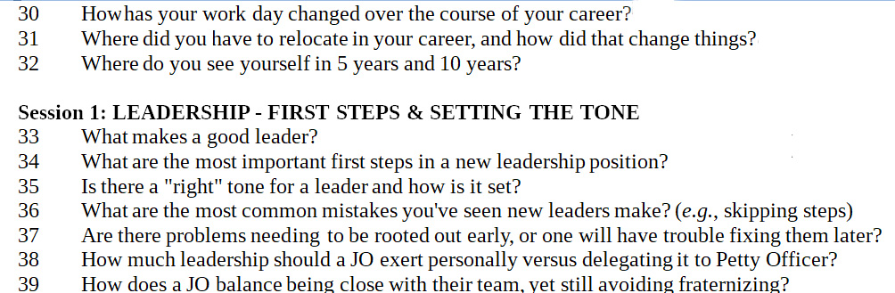
Figure 5. Typical Question Set from MentorPal Database

Then, upon suggestions from the team veterans, both enlisted and officers, additional questions were added. Many of these had to do with commonly overlooked aspects of Naval service. They dealt with housing, moving, behavior at new commands, relationships with seniors and other topics not envisioned by the junior personnel. This broader sweep was also observed in the high-school student advising. Younger people often have not had enough life-experience to know what is important.

At that time, the team decided there was enough material to draft a complete set for presenting to the volunteer mentees. To create the videos, various command personnel were approached and were asked to nominate potential volunteer subjects for video-taping. These volunteers were selected by a manifest mentoring demeanor and engaging personality. A draft set of questions was collated and forwarded to them for their perusal. Despite the team’s experience that military personnel are among the very best story-tellers, the questions that were reported by the volunteers as being the most difficult were the ones that asked the mentor to “... tell a story about …”.

There was a concern that the insights were limited because of the small number of officers on the team (two). There was no budget for a separate research project to formally ascertain Navy-wide attitudes, so one of the team members constructed an informal ethnographic poll to broaden the base of the question generation process. This survey was then offered to a range of officers of the team’s acutance and took on the aspect of a “snowball” survey, i.e. each participant was asked to invite others to participate. In the end, there were 119 respondents, from all services and ranging in rank from E-5 to O-9, but the four Flag/General Officers directed specifically that their data NOT be included for reason they did not articulate. Several of those officers contributed significantly to the team’s insights and goal assessments outside of the format of the survey.

The survey was posted on line and about twenty of the officers military friends from the Navy and from the Marine Corps were informed of its presence and invited to participate. The “snowball” nature of the survey’s distribution resulted in input from all of the services. On its face, the survey contained a request for the participants to invite others they thought would have both insights and a willingness to contribute. Figure 4 below shows the first page of the survey and also shows the URL (http://www.hpc-educ.org/NavMnt/Survey/MentorrSurvey.htm), should any reader be inclined to opine. There are no current plans to take the site down, all input is valued, and the program monitoring the site alerts the authors via eMail when new data is entered.

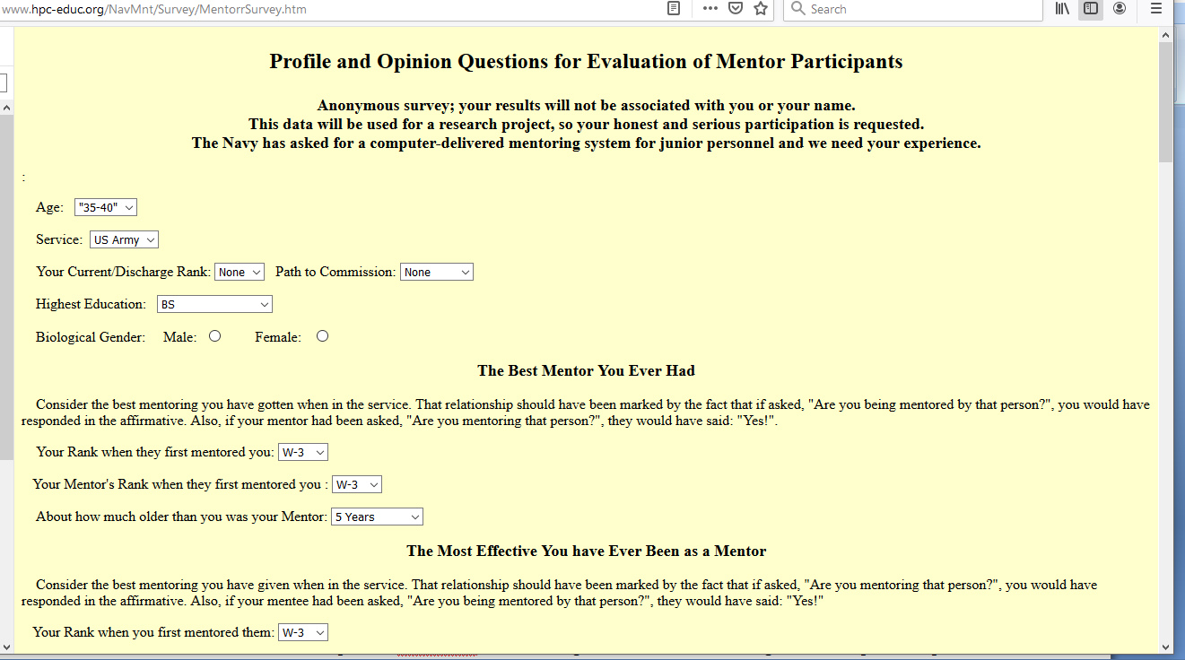
Figure 6. Opening page of the web-based “snowball” survey seeing Mentor question inputs.

The data collected was very useful in three ways:

- First, it largely confirmed the question set originally formulated by the authors and reaffirmed that their service experience was not atypical and was of significant interest to officers across three generations of Naval Officers through at least four distinctly named “War Eras.”: Korea, Vietnam, Afghanistan and Iraq.

- Second, the responses offered a few areas that the authors found very useful, but of which they had not personally thought. This allowed the inclusion of several new topics of interest and the addition of about 5% new questions to the original database.

- Third, it informed the language used to describe certain activities and approaches, as there is a frequent alteration in jargon and directive advice that needs to be honored in the questions and observed in the answers. A good example of this is the rapidly changing directives on how to handle sexual harassment, abuse and assault and a plethora of new acronyms, e.g. SAPRO (Sexual Assault Prevention and Response Office) was a new term to some of the senior officers, now retired.

Before discussing the team’s use of the data, the authors want to reassert their position that this was not a fully-funded, carefully crafted and statistically valid survey intended to prove a particular thesis. It was an informal and ethnographic survey to provide the team with additional ideas for mentor questions. The data is presented to show the type of input that might be useful in future work directed to similar goals. The authors understand that those familiar with more formal uses of statistically validated surveys will find this approach antithetical to their more formal use. In , in this case, it was very useful and the authors, without urging its use in similar circumstances, feel they would be well-advised to report how effectively it contributed here.

Part of the survey was devoted to the review of questions mentors should answer. The authors also had a range of questions dealing with what a broader set of officers experienced with mentoring and how the term was used. As noted above, there were differing opinions as to whether a mentor could be a reporting senior in the mentees chain of command and there were questions as to how many had good mentors, via formal programs or spontaneously. Some of this data was sought via a Likert Scale like set of question, with the levels running along a range across Strongly Agree, Agree, Neutral, Disagree and Strongly Disagree (Allen & Seaman, 2007). Again, the utility sought was not to prove any thesis, but insightful input for the author’s use in designing a productive question set.

Table 1. Data Collected from an On-line Informal Survey.
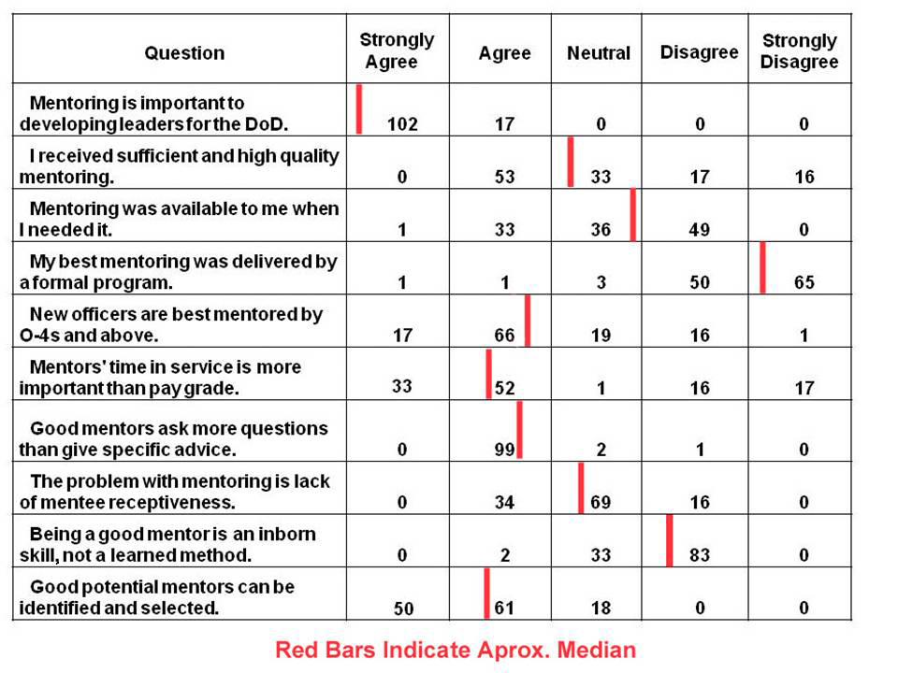

This data was incorporated into the questions to be asked and four officers and one Senior Chief were interviewed for ~ 12 hours each:
- A Male Lieutenant, Surface Warfare Officer of a minority group NROTC Commission
- A Female Lieutenant, Surface Warfare Officer of a different minority group NROTC Commission
- A Male Lieutenant Commander, Aviation Officer of European Descent USNA Commission
- A Male Retired Captain, Surface Warfare Officer of European Descent USNA Commission
- A Male Senior Chief Petty Officer, an EOD specialist, who is Hispanic
Several of them contributed significantly to the question set with new suggestions or with validation inputs. Two of the recording sessions were done in person and two were done remotely, with the interviewer reading the questions from USC’s Institute for Creative Technologies which is located just North of Los Angeles Internationals Airport and the interviewees located elsewhere, one as far away as Upstate New York.

All of these techniques could find immediate implementation opportunities in addressing the issues noted above and many will find extensions of their approach in new, heretofore unimagined uses that will emerge in future research. Both program design and issue formulation will be guided by previous analyses, research achievements and conceptual developments.

We showed in an earlier paper <Davis, Stasi and Davis> that this interface could assist information flow

Here are some examples of this concept. Privates in a infantry unit could be replaced by autonomous privates. Various functional teams on a warship could be replaced by entities. A flight of autonomous attack aircraft could be controlled by a single human flight commander.

For the example of an infantry squad, the human leader would take the role of Corporal commanding his privates. The squad would stay in close proximity autonomously, but tactics and use of lethal fire would be employed only at the verbal command of the squad leader. The autonomous privates would communicate orally and using avatars along with real time data such as video and audio.

An entire submarine may be run by a single Captain. AI’s running the propulsion, weapons, sensors and fire control systems would communicate with the Captain similar to the function of all human crews.

Attack Flight scenario TBD

conclusions
Using more technology to fight will have advantages in efficiency and safety for the warriors. Using advances in autonomous technology can be implemented by representing the new entities as virtual humans. This interface will allow efficient control of the autonomous fighters and reduce the training time for the humans.

Further research studying these scenarios in detail will lead to better solutions.

Acknowledgements

The authors would like to thank the work done by the ICT team on virtual humans showing the applicability of this technology to a wide variety of problems.

References

Nye, B.D., Swartout, W., Campbell, J., Krishnamachari, M., Kaimakis, N. and Davis, D.M. MentorPal: Interactive Virtual Mentors Based on Real -Life STEM Professionals. In the Proceedings of the Interservice/Industry Simulation, Training and Education Conference. 2017.

… Control
Bieri, M., & Dickow, M. (2014). Lethal Autonomous Weapons Systems: Future Challenges. CSS Analyses in Security Policy, 164.

,,, virtual humans and information flow

Davis, M.C., Stassi, F.J. & Davis, D.M. (2018). "Innovative Education Technologies: Optimizing Future Information Comprehension Capabilities". In the Proceedings of the SISO Fall Simulation Innovation Workshop, Orlando, Florida:SISO

Gervits, F., Thurston, D., Thielstrom, R., Fong, T., Pham, Q., & Scheutz, M. (2020) Toward Genuine Robot Teammates: Improving Human-Robot Team Performance Using Robot Shared Mental Models. In the Procedings of the 19th International Conference on Autonomous Agents and Multiagent Systems. (AAMAS 2020, Auckland New Zealand),

… Information overflow for pilots including combat

Shanker, Thom and Richtel, Matt (2011). In New Military, Data Overload Can Be Deadly. New York Times, January 16, 2011. P 16

Hettinger, Lawrence J. and Haas, Michael W (2000).
Multisensory Interface Design for Complex Task Domains: Replacing Information Overload With Meaning in Tactical Crew Stations. In The International Journal of Aviation Psychology.

… Information overflow for combat
Bateman III, R. L. (1998). Avoiding information overload. Military Review, 78(4), 53.

Allen, I. E., & Seaman, C. A. (2007). Likert Scales and Data Analyses. Quality Progress, 40(7), 64-65.

Allwood, J., Traum, D., & Jokinen, K. (2000). Cooperation, Dialogue and Ethics. International Journal of Human-Computer Studies, 53(6), 871-914.

Artstein, R., Gainer, A., Georgila, K., Leuski, A., Shapiro, A., & Traum, D. (2016). New dimensions in testimony demonstration. In Proceedings of the 2016 Conference of the North American Chapter of the Association for Computational Linguistics: Demonstrations (pp. 32-36).

Chowdhury, G. G. (2003). Natural language processing. Annual Review of Information Science and Technology, 37(1), 51-89.

Collobert, R., & Weston, J. (2008, July). A unified architecture for natural language processing: Deep neural networks with multitask learning. In Proceedings of the 25th International Conference on Machine Learning

Davis, D. M., Predovich, K.B., Stassi, F.J., Spaulding, H., Shaw, K & Nye, B.D. (2018). Enhancing Menteeship: Improving Career Selection for Potential DoD Personnel. In the Proceedings of the SISO Fall Simulation Innovation Workshop, Orlando, Florida: SISO

ICT, (2019). Virtual Humans, Retrieved 17 February 2019 from: http://ict.usc.edu/groups/virtual-humans/

Kaimakis, N.J., Davis, D.M., Breck, S. & Nye, B.D. (2018). Domain-Specific Reduction of Language Model Databases: Overcoming Chatbot Implementation Obstacles. In the Proceedings of the MODSIM World Conference, Norfolk, Virginia.

Kaimakis, N.J., Davis, D.M., Breck, S. & Nye, B.D. (2018). Domain-Specific Reduction of Language Model Databases: Overcoming Chatbot Implementation Obstacles. In the Proceedings of the MODSIM World Conference, Norfolk, Virginia.

Kenny, P., Hartholt, A., Gratch, J., Swartout, W., Traum, D., Marsella, S., & Piepol, D. (2007, November). Building interactive virtual humans for training environments. In Proceedings of Interservice/Industry Training, Simulation and Education Conference (Vol. 174).

Lee, K. F. (1988). Automatic speech recognition: the development of the SPHINX system. (Vol. 62). Springer Science & Business Media.

Rizzo, A., Forbell, E., Lange, B., Galen Buckwalter, J., Williams, J., Sagae, K., & Traum, D. (2012). Simcoach: an Online Intelligent Virtual Human Agent System for Breaking Down Barriers to Care for Service Members and Veterans. Healing War Trauma A Handbook of Creative Approaches. Taylor & Francis

Satori, H, Harti, M., & Chenfour, N. (2007). Introduction to Arabic speech recognition using CMU Sphinx system. arXiv preprint arXiv:0704.2083.

Rizzo, A., Lange, B., Buckwalter, J. G., Forbell, E., Kim, J., Sagae, K., ... & Parsons, T. (2011). SimCoach: an intelligent virtual human system for providing healthcare information and support. International Journal on Disability and Human Development, 10(4), 277-281

Swartout, W. R., Nye, B. D., Hartholt, A., Reilly, A., Graesser, A. C., VanLehn, K., ... & Wang, L. (2016, March). Designing a Personal Assistant for Life-Long Learning (PAL3). In The Twenty-Ninth International Flairs Conference.

Traum, D., & Rickel, J. (2002, July). Embodied agents for multi-party dialogue in immersive virtual worlds. In Proceedings of the First International Joint Conference on Autonomous Agents and Multiagent Systems: part 2 (pp. 766-773). ACM.

Traum, D., Jones, A., Hays, K., Maio, H., Alexander, O., Artstein, R., ... & Jungblut, K. (2015, November). New Dimensions in Testimony: Digitally preserving a Holocaust survivor’s interactive storytelling. In International Conference on Interactive Digital Storytelling (pp. 269-281). Springer International Publishing.

