Disseminating Standards Effectively:
Conceptualizing Communications Plans to Enhance Adoption

Dan M. Davis
for the University of Southern California
5916 Bixby Village Dr, Ste. 88
Long Beach CA 90803
310 909-3487
dmdavis@acm.org

Milton Rosenberg
Inst. for Creative Technologies, USC
12015 Waterfront Drive
Playa Vista, California
rosenberg@ict.usc.edu

CAPT Daniel P. Burns, USN, Ret.
Home Port Solutions, LLC
Savannah, Georgia
daniel.p.burns@homeportsolutions.net

Keywords:
Communications Plans, Simulations, Multi-Disciplinary Research, Cultural differences, Dissemination Validation

Abstract: The standards community should have a well-conceived, clearly-documented, and ubiquitously-practiced communications skill-set, structure and system. Research has found that one of the most insidious failures in technical work is the pernicious absence of effective communication of the findings and analysis of the effort. This paper opens with a brief review of formal, informal and anecdotal evidence of the dearth of effective communications that is not transferring the research insights and emerging technical capabilities. A short transition section will discuss the applicability of these observations into the efforts of the standards community and the multi-national alliances and the conduct of combined operations. This section will identify and discuss the impact of technical, metrical, and cultural differences across the globe and across the various degrees of industrial development. The next section will outline the Organization Behavior disciplines of Communications Management and Systems Engineering to refresh the readers' familiarity with terms and concepts of those two academic subjects. The underlying theoretical foundations, rubrics, heuristics and practices will be itemized and considered. Some major actions will be addressed: 1. Establish Goals, 2. Define Audiences, 3. Identify Messages, 4. Create Dissemination Strategy, 5. Develop Materials, 6. Set Timeline and 7. Communicate to Users. Then the paper turns to the needs for standards in research and the quantification of the results obtained. Then a more extensive section presents early observations of this issue within the community and offers a "straw-man" description of what such a plan may look like. This section is not presented as a formal proposal or even as a validated plan, but as a starting point for consideration of developing and validating such a plan in the immediate future. The final major section will be an analysis of the impact such a communications management plan could have on the concerned professionals, from basic researchers, through developers, to implementers, via early-adopters and finally to the users in general. In each case a cost-benefit analysis will consider both the benefits of the approach and the costs imposed in funds, focus and physical effort. Also included is a suggestion as to how such a plan could be produced and realistic look at what impact that may have on the community, based on decades of experience with similar efforts. The conclusory section will consist of a review of the underlying fundamentals, observed current conditions and the futures with or without such an effort.

- Introduction

This paper addresses the critical need to respond to the current operations tempos that have generated a very fluid organizational restructuring on a recurrent basis. Combined operations with allied nations further exacerbate the challenges of rapid development of team cohesion. The forces simulation community and the emergence of virtual human technologies such as Natural Language Processing (NLP) hold out the promise of a computer-aided assistance to organizational behavior optimization. The paper first examines the theoretical underpinnings of and research into team formation, especially those espoused by the late Professor Bruce Tuckman. The application of these insights into the realm of national defense is then discussed, relying largely on the personal observation of the authors, who amongst all of them have accumulated nearly a century of service in the United States Military. A report follows on recent advances in various technologies and techniques under the authors' purview that will be applicable in enabling a more optimal facilitation of team formation, focusing on the use of Virtual Humans (VHs) to mentor junior people during stressful evolutions. Then the issue regarding consistency in terminology and standards in simulation and virtual humans is outlined and concern therefor is justified. The paper closes with a summary of conclusions and an analysis of a vision for the future.

  - Background

Team formation is critical to success in virtually all fields of major endeavor in the 21st Century [1]. The authors hold this is particularly true in the defense of the nation, i.e. in the US Military forces. This importance has attracted the attention of leaders, managers, and commanders and it has led to research in the dynamics of team formation [2]. This has become a major item of research in several related disciplines: social psychology, organizational behavior, management, and operations research [3]. In the mid-1960's a professor at The Ohio State University, Dr. Bruce W. Tuckman, advanced the theory that the process of work group formation should be broken into four stages [4]. In the latter part of the article he entitled his four stage of development as: Forming, Storming, Norming and Performing, which he revisited some dozen years later [5]. His work is now highly regarded and often cited; one compilation of academic research records references to his original paper reporting on his work at the Naval Medical Research Institute in Bethesda and lists more than 8,000 citations by other researchers [6].

  - Tuckman's Phases or Stages [7]

Forming: According to Tuckman, most teams begin with a process of orienting themselves. Tasks and goals are identified. This they do by evaluating team capabilities and contributions. These evaluations serve to delineate the boundaries between personnel areas and among the tasks that will require attention. Coincident with testing in the interpersonal realm is the establishment of dependency relationships with leaders, other team members, or preexisting standards. It may be said that orientation, testing, and dependence constitute the team process of “Forming.”
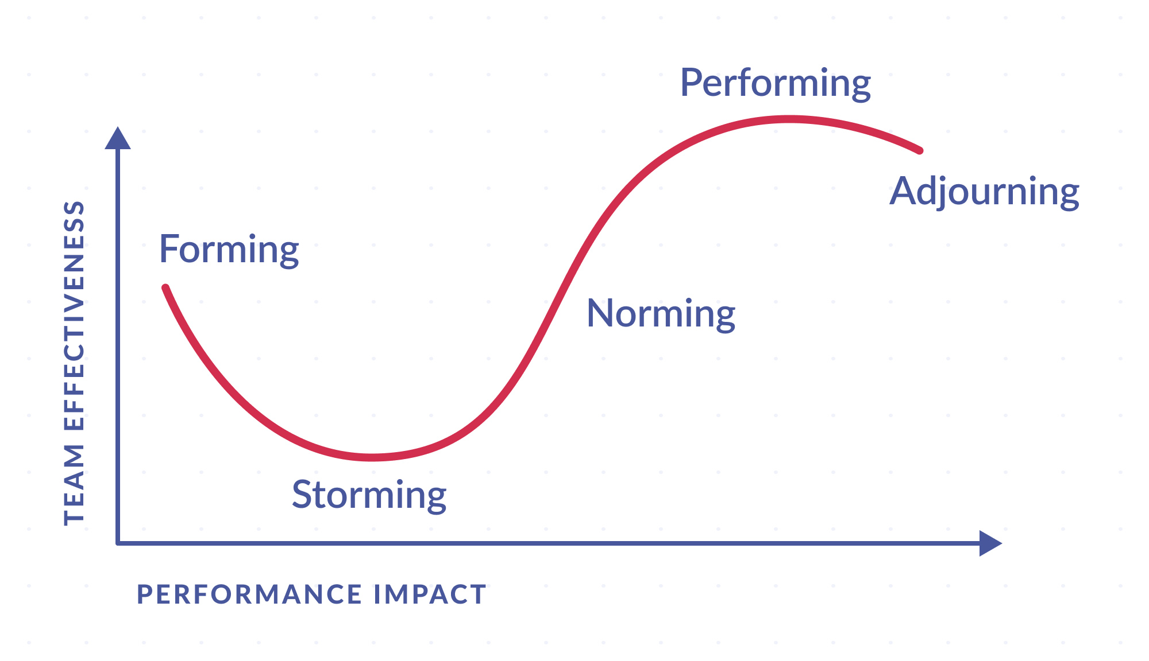
Figure 1.1 Tuckman’s Team Dynamics [5]

Storming: Tuckman sees the second phase in his model as being characterized by tensions and resolutions of interpersonal issues, all the while moving forward on task accomplishment. These behaviors are counter-productive and detrimental to team cohesion. They are a hindrance to task accomplishment, so he labeled this phase as “Storming.” See Figure 1.1 above for the Storming nadir.

Norming: Most of these thatTuckman observed are ameliorated in the third stage. Team feelings and cohesiveness develop, and group standards achieve consensus. Meanwhile, task accomplishment moves forward, allowing previously sensitive personal feeling to be expressed. “Norming” was the title Tuckman chose for this phase.

Performing: The last of Tuckman's stages is the one in which the evolved organizational and social structure has developed to be the enabler of task accomplishment. Capabilities and assignments have not only been accepted, they are now sufficiently flexible and efficient that the team can focus on performance and effectively respond to new challenges. The team is now at relative peace with the structure.. This phase was entitled "Performing" by Prof. Tuckman.

The Tuckman model has been reviewed and there are some that, while acknowledging the impact the model has had, do see its limitations in terms of theory [8]. Some have been creative enough to also add a few stages that Tuckman did not address [9]: Transforming, Adjoining and Mourning are examples of suggested additions. The model is commonly used by management personnel and it utility during implementation has been assessed [10].

  - Military Context

The authors see a significant difference in the military organizational issues, as opposed to that of industry, non-governmental organizations and academia. These issues may be articulated alone, but they are synergistic in their impact on the issues addressed above. As in all human behavior, observations may be insightful, but should usually not be taken as being either universal or dispositive.

The first of these is the formalization and visible manifestation of the control structure. The military is rigidly hierarchical and this hierarchy is trained, enforced, and detailed down to the “date of rank” level. The relative position in that hierarchy is easily recognized across all of the US Armed Forces by way of rank insignia, clearly visible on the uniforms of all of the services. Issues of date of rank and specialty designators, e.g. a Navy Restricted Line Officer like a cryptologist might conceivably out-rank an Unrestricted Line Officer, but would have to defer to him as to who was in charge on a Navy ship. But, outside these rare issues, it is obvious to everyone in the service immediately knows “who is in charge.” Another difference is the assumption of duty assignments. The military is distinguished by a very atypical understanding of and mutual appreciation of job boundaries. The team duty roster is much more ingrained and accepted than in civilian life. The third item upon which the authors agree is that the military personnel come with a much more deeply ingrained sense of oneness. This may be most clearly typified in the Marine Corps insistence on not having hyphenated Marines: One is not a Reserve-Marine, a Woman-Marine, an Asian-Marine, a Cryptologic-Marine, or an “Anything-Else”-Marine: one is a “Marine” or not. Even unit patches are not common on Air Force, Navy and Marine Corps uniforms. The fourth and last issue is that of team development. As opposed to some civilian industries, e.g. the motion picture industry, new team creation and formation are rarer in the Department of Defense (DoD). Most teams one joins are already functioning and have achieved a personality of their own that often outlast even major changes of command structure. The forming evolution may be significantly shorter in the military context.

This is not to say that teams do not get “stood up” spontaneously. One of the authors flew to NATO Sud in Naples with no foreknowledge of his duty upon arrival, only to find that he was the Officer in Charge of a group of some 24 sailors, one Senior Chief and four Lieutenants, virtually none of whom had ever met any other member of this ad hoc detachment. They had come to augment the permanent personnel in the process of a major NATO exercise and were tasked with forming their own organization, with their own watch schedule, their own evaluation administration and their own mustering functions. This occasion would not have been unfamiliar to most DoD personnel.

Another issue with which most DoD personnel would be very familiar is the recognition of and adherence to the military job training and assignment principles. The authors have all seen how personnel trained and certified in one occupational specialty, but manifesting a much greater skill in another needed capability, will be informally and exclusively assigned to duties for which they are neither trained not certified. That tradition even finds its analog in the command structure. There are times in the military when, while retaining the position of the titular head of a unit, a wise commander will designate much of the day-to-day operation of the unit to a more compelling and effective leader. Again, the widespread regard for mutual respect for position and hierarchy is invariably reflected in the junior’s strict adherence to deference to the senior, albeit the exercise of the command functions delegated to him from that senior. All of these issues keep the Tuckman insights in play, even in the military context.

In addition to that, in the military, when a new unit is “stood up,” it is very likely that all of the personnel will not have ever met the others in the unit. In the civilian experience, it is often the case that new teams are made up of a majority of members who have been on similar teams with the members of the new team. Again referring to the motion picture industry, a producer usually has a reasonably free rein on the professionals he employs and some experience with the personalities of those candidates, e.g. it was well-known in the Southern California film industry that hiring David Niven would entice other actors to join the cast, as he was famous for his civil congeniality that made every film of his a happy production experience [11]. Military commanders have virtually none of that freedom in selecting their own crews.

One major issue that the officers who are also co-authors herein see is the geographical separation of prospective team members. The first several stages of the Tuckman analysis require personal contact and face-to-face experience. The authors maintain that this is also best accomplished with a mediating senior being present. Falling once again on the motion picture industry, there are often protracted face-to-face negotiations as to team composition and duties prior to the first day of team formation.

The most salient difference could be the differences in goals. A slow or mal-forming team in civilian life may lead to loss of money or competitive market advantage. In the military context, the same delay or misbegotten effort in team formation may very well result in, not only equipment and monetary losses, but in mission failure or loss of life.

The authors assert that many of the above issues can be successfully, and perhaps only, addressed by the effective application of computational science and global network communications.

- Virtual Humans Research

One area of rapid growth in the computational sciences is the area of Virtual Humans and Natural Language Processing. As the world has recognized, early predictions of virtual human simulations and other advances in this arena have not matched the predictions. Some areas have sprung ahead in ways not envisioned. Dick Tracey's wrist watch phone has been put to shame by current models of smart watches that not only provide instant communications anywhere in the world, but also sense an unexpected fall and summon medical care on their own [12]. On the other hand The "HAL 9000" fully conversational, sentient and self-aware computer from the movie Space Odyssey is still a significant ways off [13]. However, great strides have been made at USC's Institute for Creative Technologies and elsewhere.

  - Advances at The Institute for Creative Technologies
Artificial Intelligence (A/I) and Natural Language Processing have now achieved the stage in which personal conversational interfaces are possible. Acceptance of these means that large-scale implementation issues are increasingly seen as imminent challenges [14 ]. That, coupled with the popularity of hand-held devices such as tablets, MP3 players, and smart-phones has brought to the fore the issue of not over-burdening these limited resources with data storage and data transfer requirements that would tax their memory storage limits and bandwidth constrictions. The Institute for Creative Technologies (ICT) of the University of Southern California has been engaged by the Office of Naval Research to conduct research on MentorPal, a computer-generated mentor capable of sustaining a conversational series of responses to secondary school students who are considering careers, especially careers in one of the Science, Technology, Engineering, and Math (STEM ) disciplines. An early version is shown in Figure 2.1 above. The prototype for this interactive mentor targeted the Microsoft Surface® line of tablet computers. The limited power, RAM and secondary memory of these small portable devices mandates optimal sizing of all processes and data storage and transfer [15].
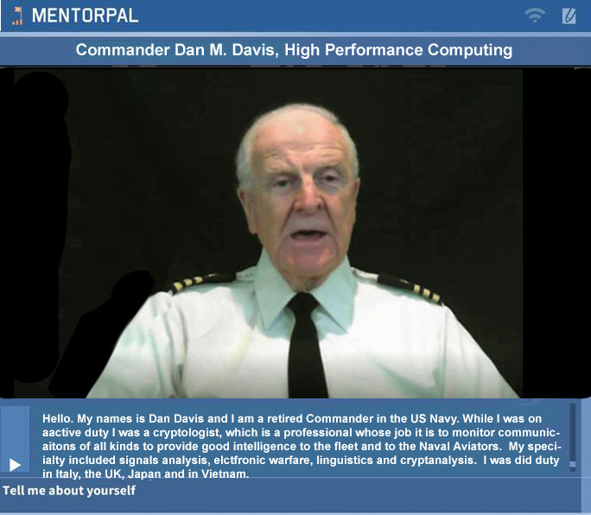
Figure 2.1 – ICT's MentorPal Display

The authors assert that the insights gained and the techniques employed apply to model reductions in practically any specific domain, rather than only to chatbots. Part of this assertion is recognizing the need to prepare for operations under conditions of limited computational power and data capacity, while at the same time designing code to make it amenable to scaling if a less constricted environment is available. This would allow computer assistance for team formation, no matter where the team members were stationed prior to the teams converging. These constrained environment issues are known to be common in much of the work currently being conducted at ICT [16].

The basic objective of the Mentor PAL project was to provide a proof-of-concept version of career mentoring to students who may otherwise have no, or severely limited, access to advice or mentoring as they face the daunting task of selecting a career. The ultimate goal is to increase the number of technically trained personnel available. They might be used in the uniformed services or as civilian researchers for the DoD. To accomplish this, prospective career candidates may make other choices if they do not have someone to whom to speak who is experienced in and feels positively toward the desired careers. The authors envision a similar mentoring process in the team formation scenarios of the future. Users, who do not otherwise, have access to a mentor, may benefit from a virtual mentor. The reason for such lack of access may be due to a number of reasons, the two most prevalent of which the authors hold to be: geographic remoteness and poor network connectivity [17].

The solution advanced by ICT was to produce a computer-generated mentor to be available via any system with the appropriate software installed. The user would be presented with a computer screen interface via which he could engage a mentor in a conversation-like exchange about issues of concern. Input from the user would be by text entry or audio speech recognition software. This mentor was envisioned as being both compelling and engaging. ICT advanced the position that the mentors would be most compelling and engaging if they were real people [14] recorded live and exhibiting a demonstrated screen presence.

  - The Implementation Process

Initially, a list of germane questions would be drafted. Depending on the topic, this might total a thousand or so items. The creative process requires a broad knowledge of both the questions that are a part of the mentor’s experience and represent the questions that the target users are likely to ask. In the previous projects, the team considered input from several members who had professional and Navy experience in order to generate a thorough list of questions. A previous paper [15] discussed this process at greater length.

The next step is to have the mentors record a varying number of video clips relating to their experience in the service and their duty in their own profession. These clips are then stored in a standardized database. When the user poses a question the program selects the most appropriate clip to play. This must be done very rapidly to sustain the desired “conversational” effect of the exchange. Based on the team’s experience with briefing users, the clips were designed to be on the order of 90 seconds or less. This technology rests on previous research into the use of Virtual Humans acting as program interfaces in counseling [18] (Morbini, et al., 2012) and in history capture [19](Artstein et al., 2014). The team found that these videotaped mentors are difficult to classify easily: sometimes being referred to as Virtual Humans, but they are actually intelligent agents that sequence and present recordings of real people. This has been termed “time-offset interaction” in some related work. There still needs to be a substantial corpus of carefully collected questions and answers available to the system that can be answered within the latency limits that circumscribe the feel of conversational dialogue.

In Figure 2.2, the flow begins at the top left and proceeds clockwise through the process. The icons are notional only and should not deceive the reader as to their importance, weight or size, e.g. the storage icons approximately the same image-on-page size, whereas, in physical fact they differ by three orders of magnitude in data size. The important steps are the data flows from the storage locations into and out of the computational functions.

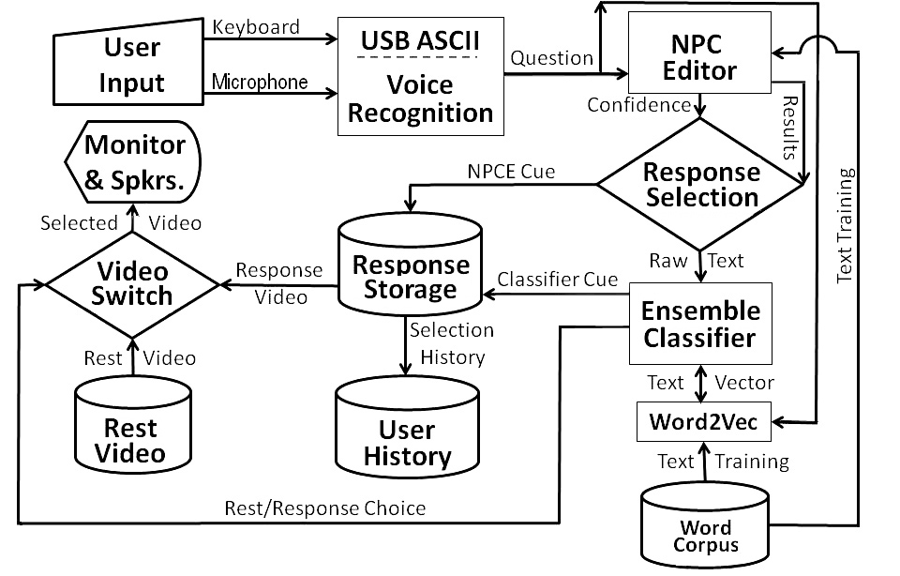

Figure 2.2 - MentorPal Notional Flow Chart
ICT's Virtual Mentor Implementation

- Implementation Strategies

Based on what the authors have observed in their professional careers and on what Professor Tuckman has developed with his research and several decades of further observation, the authors now turn their attention to problem areas that may be amenable to computer-enabled intervention. This paper takes the position that there are basically four areas in want of additional assistance:
- Providing guidance, counsel, and stress relief during the Tuckman Second Stage – Storming'
- Articulating acceptable "field expedients" featuring a more free-form skills assessment and assignment;
- Helping to bridge the communications gap for personnel assigned around the globe.
- Reiterating the imperatives mandated by the national goals and the lives that are in the balance.

  - 24 Hour Mentor Access

Using the technologies described above, it is possible to design, implement and field a set of mentors who are focused on assisting the prospective team members get through the roughest stages of new team formation. Some enhancements to current capabilities would be useful, but just implementing what is already been proven will have a markedly beneficial impact.

  - Implementing a Virtual New Team Formation Facilitator

It is now possible to create a Virtual New Team Formation Facilitator. A number of choices need to be made, but the decision is just a search of optimum effect and a wrong choice would impact efficacy, but would not be fatal to the concept. And example of such a choice would be an animated literal virtual human, speaking with synthesized voice driven by text. This is what was done in the ICT project called SimCoach. The other option, which was discussed above, is the utilization of a thousand or so video clips of live humans. This technique is often also called a "virtual human," but the purest point out the subject is not "virtual" at all, but a real, live human. This terminology difference will be addressed later.

There are two known hurdles to this vision. First: studying, evaluating, and collating the appropriate question data set. The authors have submitted a paper on this topic to another conference on how such a data set was created for the current project, called PAL3, A/I. A read-ahead copy should be available by the time of the SIW conference in February. Please contact Dan Davis, if you would like to read it [21]. Second, it has been the authors' observation that much of good mentoring is asking the salient questions. The second is that NLP is very good at answering direct inquiries, but it would be a new investigating effort to identify, draft, implement and validate a series of germane questions or probes to get the users to discuss and analyze their issues on their own, as well as a bank of considered suggestion to resolve common issues that are "bound" to come up.

It is envisioned that part of the solution will be to urge the participants to set up and schedule regular video conferencing meetings. There are now a range of video conferencing programs available to the public at no direct cost. Most of them now support multi-user sessions and various forms of document sharing. The one issue that I think has yet to be resolved would be the participation of those relying in satellite connections: remote sites in areas not served by cable and ships at sea The latencies imposed by the round trip to geostationary satellites can result in 900 to 1500 milliseconds, which makes conversation problematic, and just the speed of light limits adds at least 550 milliseconds to the response time [22] and that is just enough delay to cause some minor disruptive interference to the normal flow of conversation. Even so, it could be a very effective tool for resolving some of the counter-productive impacts of the Tuckman “Storming” stage.

  - Standardizing Terminology

In an emerging technology such as Virtual Humans, one of the issues that continually hampers the achievement of consensus as to progress and the discovery of the optimal path for future research is the lack of consistency in both the terms used to describe the various techniques and the absence of carefully considered quantification of performance. As mentioned above, the term Virtual Humans is used in the technical vernacular to refer to any human avatar, be the image a true animation object portraying a Virtual Human or a really just a computerized delivery of a real live human. Comparative studies are needed to show the relative costs, time constraints, performance, and impacts of both implementations.

The call for more studies on performance brings to light the need to better quantify many factors now left to subjective assessments like face validity and anecdotal reports. The human behavior disciplines, e.g. social psychology, systems engineering and operation research rely on quantified measures of merit in order to produce the analyses that would facilitate future analyses and enable more optimal pursuit of goals that would result in actual benefit to the Warfighter.

The simulation community may be able to make good use of the experience of the standards discipline in managing the standards for various physical and process operation. Just this professional expertise could help the simulators in creating and promulgating and new lingua franca for Virtual Human research.

- Conclusions

While there is yet much to be accomplished, the early progress in Virtual Human implementations has shown both the promise and the problems in this simulation discipline. This paper has attempted to lay out these by using the work of Professor Tuckman as an exemplar of the issues before the researchers.

  - Team Creation is both Essential and Fraught with Peril

Both the research of Professor Tuckman and the experience of the authors support the proposition that team formation in large organizations is essential to the achievement of organizational goals. The fusion of disparate personalities, often initially located in site remote from each other, is critical to success. There appears to be a significant lag in team efficacy and this lag may be significantly different in civilian and in military environments.

  - Emerging Technologies and Capabilities in Simulation and Virtual Humans may be Effective

In virtually every human endeavor, there is a need for mentoring and mediation in order to optimize both the timely achievement of goals and the optimal efficiency in that achievement. This is especially true in the military where goals have national survival implications and costs are human lives. Operations schedules and funding constraints may make the use of computer-generated human avatars more feasible, especially in the light of geographic dispersion of personnel that will form the envisioned team.

  - Research and Implementations are Hampered by a lack of Standard Terminology and Quantification

For future research to be effective and rapid, a set of community standards needs to be defined and adopted. Much of the work centers on human behavior and a new area “Virtual Human Behavior.” These are areas in which there will be a need to compare capabilities and progress. This situation bespeaks a need for both community-accepted terminology and rigorously-defined quantifications. The existing standards professionals could be of invaluable assistance in this process.

  - Performance Curve for all Four Phases: Study and Remediation

The degradation of performance indicated in Figure 1.1 is of significant interest. An effort to characterizing, quantifying, and ameliorating that degradation in defense environments is warranted by the authors’ observations and should prove useful in understanding the dynamics of the relationships that are so important in combat situations. Improvements here should reduce material losses, minimize loss of life, and improve mission accomplishment.

- Acknowledgements

Virtually all of the work involving Virtual Humans reported in this paper came from a series of research projects of which the Principal Investigator was Dr. Benjamin D. Nye, Director of Learning Sciences at ICT. Without his technical vision and unflagging support, none of this would have taken place. The various projects mentioned were supported by a range of DoD organizations and, while this paper reports insights gained during that work, that was not the focus of the research. Much of this work was supported by grants from the Office of Naval Research's STEM Program (ONR N00014-16-1-2820) and by students supported by the National Science Foundation Research Experience for Undergraduates program (NSF 1560426). Nevertheless, the positions taken in the paper are the authors’ own and do not represent in any way the views of the Department of Defense or the US Government.

- References

- Hornsby, J. S. "Critical Elements of Team Formation to Enhance Organizational Innovation". In The Challenges of Corporate Entrepreneurship in the Disruptive Age (pp. 123-140). Emerald Publishing Limited. 2018.
- Takai, S. & Esterman, M. "Towards a Better Design Team Formation: A Review of Team Effectiveness Models and Possible Measurements of Design-Team Inputs, Processes, and Outputs". In ASME 2017 International Design Engineering Technical Conferences and Computers and Information in Engineering Conference. August 2017.
- Norris, P. E., O'Rourke, M., Mayer, A. S., & Halvorsen, K. E. "Managing the Wicked Problem of Transdisciplinary Team Formation in Socio-Ecological systems." Landscape and Urban Planning, Vol 154, pp 115-122. 2016.
- Tuckman, B. W. "Developmental Sequence in Small Groups" Psychological Bulletin, Vol 63(6), pp 384-399. 1965
- Tuckman, B. & Jensen, M. "Stages of Small Group Development. " Group and Organizational Studies. Vol 2, pp 419-427. 1977.
- Google Scholar, "Articles (citing reference 4 above)", retrieved from the Internet on 07 November 2019, from: https://scholar.google.com/scholar?start=260&q=Developmental+sequence+in+small+groups&hl=en&num=20&as_sdt=0,5
- Tuckman, B. W. "Developmental Sequence in Small Groups" Psychological Bulletin, Vol 63(6), p 396. 1965
- Bonebright, D. A. "40 years of Storming: a Historical Review of Tuckman's Model of Small Group Development." Human Resource Development International, Vol 13(1), p 119. 2010.
- Barton, G., & Bagley, M. "Learning through Story: A Collaborative, Multimodal Arts Approach." English Teaching: Practice and Critique, 13(2), 93-112. 2014.
- Kiweewa, J. M., Gilbride, D., Luke, M., & Clingerman, T. "Tracking Growth factors in Experiential Training Groups through Tuckman’s Conceptual Model." The Journal for Specialists in Group Work. Vol 43(3), pp 274-296. 2018.
- Lord, G.”In Thespian Praise of: David Niven. Paulburgin.blogspot.com. 25 January 2006. Retrieved from the Internet on 02 Dec 2019.
- Technologizer; Time.com. "Dick Tracy’s Watch: The Most Indestructible Meme in Tech Journalism. " http://techland.time.com/2013/02/11/dick-tracys-watch-the-most-indestructible-meme-in-tech-journalism/ .Retrieved from the Internet on 03 December 2019.
- Wikipedia. "HAL 9000" Retrieved from the Internet from URL: https://en.wikipedia.org/wiki/HAL_9000 . on 02 December 2019.
- . Traum, D., Jones, A., Hays, K., Maio, H., Alexander, O., Artstein, R., ... & Jungblut, K. "New Dimensions in Testimony: Digitally Preserving a Holocaust Survivor’s Interactive Storytelling." In International Conference on Interactive Digital Storytelling, pp. 269-281. Cham, Switzerland: Springer. 2015.
- . Nye, B.D., Swartout, W., Campbell, J., Krishnamachari, M., Kaimakis, N. and Davis, D.M. "MentorPal: Interactive Virtual Mentors Based on Real -Life STEM Professionals." In the Proceedings of the Interservice/Industry Simulation, Training and Education Conference. 2017.
- . ICT. "Research Project One-Sheets" Institute for Creative Technologies, University of Southern California. Retrieved on 04 2019 from: http://ict.usc.edu/research/pdf-overviews/ .2018.
- . Crisp, G., Nora, A., & Taggart, A. "Student characteristics, pre-college, college, and environmental factors as predictors of majoring in and earning a STEM degree: An analysis of students attending a Hispanic serving institution." American Education Research Journal, pp 924-942. 2009.
- . Morbini, F., Forbell, E., DeVault, D., Sagae, K., Traum, D. R., & Rizzo, A. A. "A Mixed-initiative Conversational Dialogue System for Healthcare." In Proceedings of the 13th Annual Meeting of the Special Interest Group on Discourse and Dialogue. pp 137-139. 2012.
- . Artstein, R., Traum, D., Alexander, O., Leuski, A., Jones, A., Georgila…. & Smith, S. "Time-offset Interaction with a Holocaust Survivor." In Proceedings of the 19th international conference on Intelligent User Interfaces 163-168. ACM. February, 2014.
- . Tsai, J., Bowring, E., Marsella, S., Wood, W., & Tambe, M."A Study of Emotional Contagion with Virtual Characters." In International Conference on Intelligent Virtual Agents (pp. 81-88). Springer, Berlin, Heidelberg. September, 2012.
- Davis, M.C., Nye, B.D. & Davis, D.M.. "Populating a Virtual Conversation Database: Community Data Collection and Analysis". In the Proceedings of the ModSim World Conference, Norfolk, Virginia. 2020, (Pending).
- V-Sat Systems, “Latency- why is it a big deal for Satellite Internet?” Retrieved from the Internet from: https://www.vsat-systems.com/satellite-internet-explained/latency.html on 02 December 2019
- Pelton, J. N., & Jacqué, B. “Distributed Internet-Optimized Services via Satellite Constellations.” Handbook of Satellite Applications, pp 1-21. 2016.
Authors’ Biographies

Dan M. Davis is now a consultant for the University of Southern California, focusing on large-scale distributed DoD training, education and avatar mentors. In the decade prior to his retirement, he was the Director of USC’s JESPP project for JFCOM. As the Assistant Director of the Center for Advanced Computing Research at Caltech, he managed Synthetic Forces Express, bringing HPC to DoD simulations. Prior experience includes serving as a Director at the Maui High Performance Computing Center and as a Software Engineer at the Jet Propulsion Laboratory and Martin Marietta. He has served as the Chairman of the Coalition of Academic Supercomputing Centers and has taught at the undergraduate and graduate levels. As early as 1971, Dan was writing programs in FORTRAN on one of Seymour Cray’s CDC 6500’s. He saw duty in Vietnam as a USMC Cryptologist and retired from the reserves as a Commander, Cryptologic Specialty, U.S.N. He received B.A. and J.D. Degrees from the University of Colorado in Boulder.

Milton Rosenberg is a Special Project Manager at the Institute for Creative Technologies, University of Southern California. He has managed several large research and development projects there for the Army Research Laboratory and for the Office of Naval Research. These projects were designed to engage service personnel via computer generated virtual environments and personnel. He has over 20 years of experience managing multiple projects. Milton supervised the construction and global rollout of the Whirlpool manufacturing system and holds a patent in methods for maintaining computer software. He holds a BS in Business Administration.

Mark C. Davis, Ph.D. is currently retired after careers in the US Navy and as a computer design engineer for both IBM and Lenovo. Rising to the level of Distinguished Engineer at Lenovo, he was responsible for the design of laptop computer cross-disciplinary technology, including PC architecture, embedded systems, open source and virtualization. Previous work was with IBM in the areas of software development and architecture involving security, storage and virtualization. Dr. Davis has been granted well over fifty patents that were filed during his service at both companies. He is a graduate of the Duke University NROTC program and was commissioned as an Ensign, attended nuclear power school, and served as a Submarine Officer for twelve years, including one duty tour as a classroom instructor. He left the service as a Lieutenant Commander to pursue a PhD. Mark holds a BSEE degree from Duke University and a PhD in Computer Science from the University of North Carolina, where his advisor was Professor Fredrick P. Books.

DANIEL P. BURNS is a lifelong Systems Engineer, first with the Active Duty Navy, then SAIC, and small business. He served as Naval Chair and Professor of Practice in Systems Engineering at the Naval Postgraduate School (NPS).Captain Burns served as the as the Military Associate Dean and as acting Dean of the Graduate School of Engineering and Applied Sciences at NPS. His research interests center on analyses of both human and resource utilization in defense efforts. He successfully facilitated \ the creation of a new program for Air Force Officers who seek post-graduate degrees. Captain Burns received a BS degree from the U.S. Naval Academy, an MS from the Naval Postgraduate School and an MS from Southern Methodist University. He is currently working with Portland State University on a Ph.D.

Evan Jaksha is studying Computer Science and currently focusing in the use of virtual humans as an effective interface to address a range of critical issues in the military. He comes from a military family with both his father and two siblings currently serving in the US Armed forces. His research interests include cyber warfare and national security. Growing up in San Diego, he is a long-time resident in Southern California. He is scheduled to graduate in 2022 with a degree in Computer Science, with a Minor in Cyber Security from the United States Military Academy in West Point, New York.

Skander Guizani is studying Electrical Engineering and currently focuses his research efforts on hardware, infrastructure, and operations of long-range secure communications systems. Skander is from Tunisia and is a foreign exchange student at the United States Military Academy at West Point, New York. Back in Tunisia, his father is a Colonel and commands a unit in that country. While at the Institute for Creative Technologies, Skander will be working with the MentorPal team to enhance the virtual human conversations for advising high school seniors. He intends to pursue a doctoral degree and is focusing his research on that goal. He anticipates receiving a degree in Electrical Engineering in the spring of 2022 from the United States Military Academy, West Point.

