Disseminating Standards Effectively:
Conceptualizing Communications Plans to Enhance Adoption

Dan M. Davis
for the University of Southern California
5916 Bixby Village Dr, Ste. 88
Long Beach CA 90803
310 909-3487
dmdavis@acm.org

Milton Rosenberg
Inst. for Creative Technologies
University of Southern California
12015 Waterfront Drive
Playa Vista, California
rosenberg@ict.usc.edu

CAPT Daniel P. Burns, USN (Ret.)
Home Port Solutions, LLC
125 E. 44th St.
Savannah, Georgia
daniel.p.burns@homeportsolutions.net

Keywords:
Communications Plans, Simulations, Multi-Disciplinary Research, Cultural differences, Dissemination Validation

Abstract: The standards community should have a well-conceived, clearly-documented, and ubiquitously-practiced communications skill-set, structure and system. Research has found that one of the most insidious failures in technical work is the pernicious absence of effective communication of the findings and analysis of the effort This paper opens with a brief review of formal, informal and anecdotal evidence of the dearth of effective communications that is severely constricting the transfer of the research insights and emerging technical capabilities. A short transition section will discuss the applicability of these observations in regard to the efforts of the standards community and of the conduct of combined operations of multi-national alliances. This section will identify and discuss the impact of technical, metrical, and cultural differences across the globe and across the various degrees of industrial development. The next section will outline the Organization Behavior disciplines of Communications Management and Systems Engineering to refresh the readers' familiarity with terms and concepts of those two academic subjects. The underlying theoretical foundations, rubrics, heuristics and practices will be surveyed and considered. Some major actions involved will be addressed: establish goals, define stakeholders & audiences, identify data-flows, create dissemination strategy, create materials, set milestones and implement communications. Then the paper turns to the needs for standards in research and the quantification of the results obtained. A more extensive section presents early observations of this issue within the community and offers a "straw-man" description of what such a plan may look like, using virtual human issues as a prototypical emerging technology. This section is not presented as a formal proposal or even as a validated plan, but as a starting point for consideration of developing and validating such a plan in the immediate future. The final major section will be an analysis of the impact such a communications management plan could have on the concerned professionals, from basic researchers, through developers, to implementers, via early-adopters and finally to the users in general. In each case a cost-benefit analysis will consider both the benefits of the approach and the costs imposed in terms of funds, focus and physical efforts. Also included is a suggestion as to how such a plan could be pursued and a realistic look at what impact that may have on the community, based on decades of experience with similar efforts. The conclusory section will consist of a review of the underlying fundamentals, observed current conditions and the futures with or without such an effort.

- Introduction
This paper will propose the thesis that the development of a communications management plan is necessary for effectively reaching the research and development community to produce the impact that standard’s groups seek The concept that efficacy can be improved by the application of recognized techniques for regularizing and assigning individual responsibilities for the flow of critical information. Further, it is asserted that the study and analysis required to formulate and implement such a plan will not only result in improved recognition and use of the standards, but the process itself will generate otherwise overlooked insights into the needs for, uses of and modifications in those standards

  - Background

Almost globally, the researchers' focus on technical issues has overshadowed the need to communicate those results to the widely disparate consumers of such information. This observation is not advanced lightly [1]. The authors are all experienced practitioners of research in the defense environment, in active duty military service, industrial research and academic exploration. As early as the 1970's, when FORTRAN was ascendant and Seymour Cray was still at CDC, it was noted that there was a focus on the analytic functions of the computers such as the CDC 6500 [2] and IBM 360 [3] which evolved with little attention to the many areas needing standards. The flow of information within the academic community was hampered by the lack of criteria and standards for the quantification of the more human issues such as the user/machine interface Much discussion was had about the future of computers and its impact on human life. Professor Edward Bailey at the University of Colorado confidently asserted that the advent of telephone modems would reduce the need for very many computers and the nation would in the future be served by half a dozen computing centers, a few hundred computer scientists, and a smattering of "dumb" terminals, serviced by telephone modems [4]. The excitement of the age seemed to repress any vision of the future. This early insight into the impact of current obsession with the narrow vision before the community has been reinforced by later experience. It was followed by the growth of the small business computer market, but that was largely swept aside by the personal computer mania of late 1970's which was often led by Steve Jobs, a visionary, not a computer scientist [5]

The emergence of standards and the imposition of standard technologies followed on the heels of this rather disorganized process By the late 1980's, the defense establishment, more used to decades, if not centuries, of technical development and a concomitant sluggish emergence, evolution and acceptance of standards, was faced with the need for more rapid, precise and articulated standards, imposed from top-down. Examples of this new set of initiatives was the development of one of the early object oriented programming languages, its adoption by the DoD and its imposition as the only code to be used on DoD projects. This was the much despised ADA [6]. Some helpful and willingly accepted standards such as DIS may be contrasted with the much more problematic technical acceptance of HLI/RTI standards [7]. Speeches given at conferences in that era are echoed even today with calls for standard terrain databases, reusable code, inter-program interfaces, and metrics on performance.

In the early 1990's a team at the California Institute of Technology collaborated with the Intel Corporation in fielding a large parallel computer, the Intel Delta [8]. This was in contravention to the most well-known large computing devices, the Cray series of vector machines [9]. Again, it was noted by many that lack of established standards made it difficult to parse out which approach was most useful for which application. There were certain communities, weather modeling and cryptanalysis to name two, which long held out that parallel computing would not satisfy their needs, and only the more technically advanced and fiscally daunting vector machines could serve their needs. But standards did emerge and became adopted. The issue as to whether this could have been more rapid and useful remains to be determined. In the 21st Century, the issue of various new processor adjuncts became critical. These included processor in memory (PIM) [10] and general purpose graphics processing units (GPGPUs) [11]. The DoD had a vested interest in and manifests ardent support of these advances, again requiring a standard of specificity to quantity their benefit.. This paper asserts that too often, that quantification devolved into the realm of technical measurement, while not effectively addressing the resultant benefit to the war-fighter.

The disciplines of Systems Engineering and Operations research investigate the way organizations process information to support goal achievement. They find that large complex organizations need increasingly sophisticated and efficacious management. Yet, not unlike the similarities of key-note speeches of thirty years ago and today, there seems to be an inevitability of sub-optimal management and sub-standard performance. This paper asserts that much, no, most of management is centered on communication. This is exacerbated by the findings of researchers that most humans are blessed with either analytic or communication skills, so it is not unexpected that those who are selected due to their analytic prowess, might not be as strong in communication or "people" skills [12]. This dichotomy is reflected in the technical education process [13]. Most universities require only a single course in technical writing or about one fiftieth of the typical curriculum. After leaving the halls of academe, the graduates find a completely different environment, in which they soon are in positions involving more than half of their time in communication activities. Table 1.1 sets out the results of an informal local straw poll of professional people in varying disciplines and environments.

Table 1.1. Local informal straw poll on time spent writing and preparing to speak.
Profession | Degree | Writing | Speaking | Total
Navy Junior Officer (Subs) | BS | 15 | 10 | 25
Research Group Leader | PhD | 15 | 15 | 30
Retired Government SME | PhD | 30 | 5 | 35
Industry Programmer | PhD | 20 | 20 | 40
Coder | MS | 35 | 10 | 45
Coder | BS | 40 | 10 | 50
Army Lieutenant - Captain | BS | 40 | 10 | 50
Recovery Room Registered Nurse | BSN | 35 | 25 | 60
Navy Electrician CPO | BA | 40 | 20 | 60
Industry Manager | PhD | 30 | 40 | 70
Research Manager | PhD | 60 | 10 | 70
Navy Cryptologist CDR | BA | 50 | 20 | 70
Research Project Mgr | JD | 60 | 10 | 70
Navy Instructor CPO | BA | 20 | 50 | 70
Coder | AA | 60 | 20 | 80
College Instructor | PhD | 40 | 40 | 80
Army Major - Colonel | PhD | 60 | 20 | 80
Researcher | PhD | 70 | 10 | 80
Navy Linguist CPO | BA | 65 | 15 | 80
Tech Instructor | BS | 10 | 75 | 85
Consultant/Manager | PhD | 80 | 10 | 90
Means |  | 42 | 21 | 63

This condescending constriction of communications training brings to the fore the question: Is this enough training? The educators argue that programs like Writing Across the Curriculum have adequately addressed this issue [14]. Some employers disagree. One large tech company CEO briefed a major university recently and noted that he had ordered that every new employee be given a copy of "Strunk and White." That comment seen as humorous by many of the academics, but drew puzzled looks from even more of them, some of whom asked: "What is Strunk and White?",

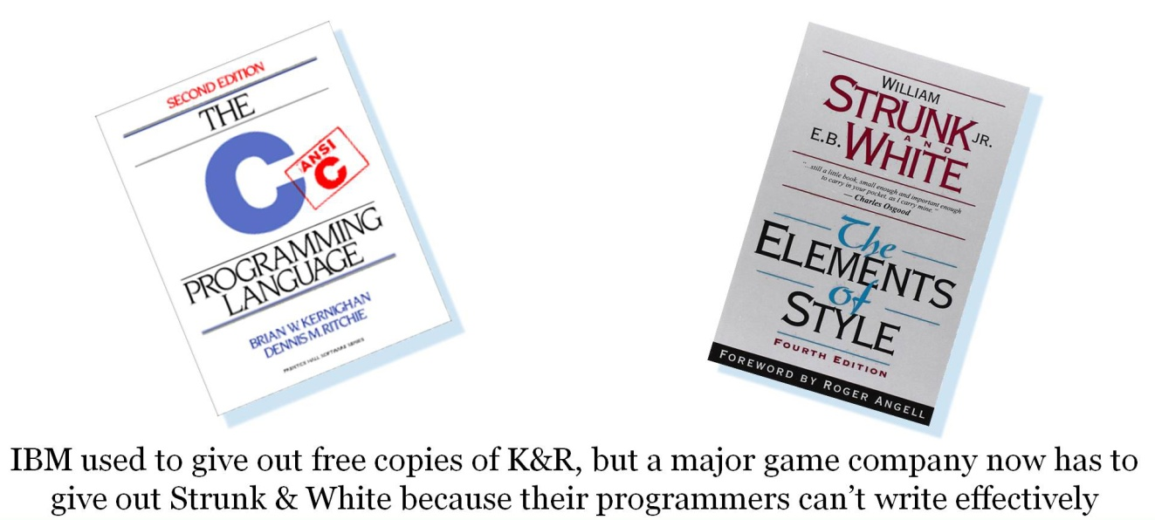
Figure 1.1. Kernighan and Ritchie[15] vs. Strunk and White ]16\

  - Standards and Communications

To return to the topic at hand, the issue of what role does interpersonal communications play in the standards community and how can standards based templates and processes increase the value of all research and help ensure it’s dissemination. The most obvious answer is that once standards are defined, they need to be communicated to the users. Use of pneumonics and intuitive standards are often beneficial but a little thought brings up a more complex view of the standards process and dissemination of how to use the new technology and tools being deployed. That involves a set of communications channels both inside and outside of the community. Additionally, good management practice would suggest clearly assigned responsibility for each communications effort, precisely set goals, specifically defined audiences, and rigorously applied metrics are in order. Software and process engineering were integrated with computer software generation systems but the utilization was minimal due to the astounding assumption that all stakeholders should work together in an integrated team rather than in the traditional smokestacks of organizational expertise, The authors of this paper freely admit that such analyses may have already been implemented and pursued at varying levels of formality, but, for reason suggested above, their experience in similar environments would indicate the benefits that might accrue were the process to become a little more formal, template and standard based with a periodic review conducted to assess the effectiveness of the effort. This should enhance the dissemination of information to allow reuse and extension of the products created Next, reviewing an illuminating research project's use of some communication management techniques may be useful.

- Current Research as an Example

It may be useful to outline two current projects to help identify some of the issues that arise. These are both projects here in the LA Basin, but have two different environments and so have very different stake holders. This will be a very brief overview, not a report on the science, which is well-documented in other papers. Both involve the provision of an engaging and communicative human/computer interface that closely emulated a live human conversation and how the virtual human could be used to teach, entertain, and disseminate information.

Although a computerized human may seem as simple as remodeling a human using CGI, it turns out that it takes many disciplines of research, significant study and effort to implement a Virtual Human, and the process can consume considerable computing power to do so effectively. The essential elements that go into the creation of an effective virtual human with lifelike abilities include natural language processing, machine learning, VR, CGI, cultural and behavioural understandings and social stimulation. Natural language understanding (NLU), will be the main focus of this discussion, though the same argument concerning the untapped potential of virtual humans (or other types of characters or docents) can be made with several of the other components. Natural language processing composes “an area of research and application that explores how computers can be used to understand and manipulate natural language text or speech to do useful things” [17]. Natural Language Generation (NLG) creates speech acts and allows the system talk to the human in return is also part of this cycle. Recent developments in NLP have made significant advances, like “a single convolutional neural network architecture that, given a sentence, outputs a host of language processing predictions: part-of-speech tags, chunks, named entity tags, semantic roles, semantically similar words and the likelihood that the sentence makes sense (grammatically and semantically) using a language model” [18].

In both cases below, the subject was recorded in a consistent setting with identical lighting over a period of days responding to questions the users/consumers were anticipated to ask. This amounted to from 600 to 1,500 questions. These recordings were then edited into short clips and the NLP program selected the best-fit answer, All the respondents reported a very "life like" experience and a sense of emotional connection not experienced in reading or in watching a video of an oral history.

The first is the New Dimensions in Testimony (NDT) project [19] to memorialize the experiences of holocaust survivors, of whom only a few remain. While the written word and video's of an oral history are useful in this context, the goal was to create, archive and assess the impact of a dialogue capable interface where the user (in this case usually a museum patron) can question the survivor. The sponsor was a Holocaust History foundation, the users were both academic institutions and museums, and the consumers were the students/museum visitors. Clearly this led to a broad range of stake holders. This project elicited very emotional reactions, e.g. man wept when asking questions or listening to the subject sing a lullaby his mother had sung to him in the camps and many people apologized to the screen for what had happened to the subject, as if the computer could be moved by their apology.


Figure 2.1. NDT Subject 3D Hologram in a College Classroom [19]

The second project was a DoD project directed at increasing the interest of high school students in Science, Technology, Engineering and Math (STEM) careers, especially in the DoD: Mentor PAL [20]. In this case, it involved the interviewing and videotaping of members of the DoD, mostly uniformed service members, about their lives and careers in various technical fields. When this program was evaluated in classrooms and at job fairs, it too received high marks for conversationality, but it was found that the high school students have very little framework out of which they could ask germane questions about future careers. In any case, several of these professionals were videotaped and presented as a "panel" to give the students a chance to ask people of different careers and backgrounds questions about their profession. The panel presented is shown below in Figure 2.2. and includes Chief Petty Officer Clinton Anderson, Commander Dan Davis and Ensign Julianne Nordhagen. Several standards issues came up, including terminology, e.g. what do you call a person recorded in this way: a virtual human, a computer agent, a virtual conversationalist.

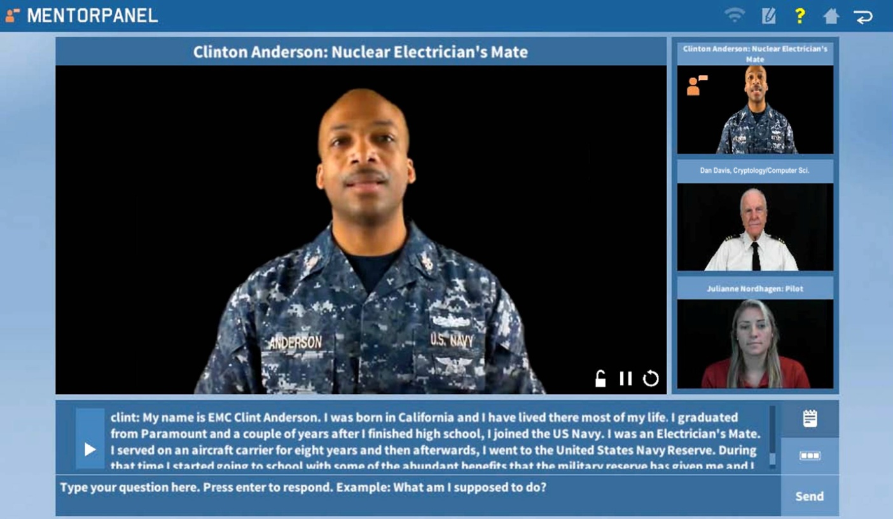
Figure 2.2. The Mentor PAL Panel [20]

This project had the more illustrative set of stake holders in a DoD context, the environment in which SISO is most active. For this reason, this project was used to consider stake holders, as in 2.3. below, and to create a notional communications management informational flow diagram, which is presented in figure 2.4. below.

  - Tools of Use in Creating a Cogent Communications Plan

Stakeholder Diagram – grouping interested parties into mutually focused groups:
The vast majority of the researchers with whom the authors have been engaged were characterized by at least a vague awareness of the people who were interested in the outcome of the effort, the general needs of the end users, or the political entities who would want to be informed of its progress and success. The standards community's activity is putatively less well delineated, but doing this exercise may be a very illuminating activity. The community has very astute and sensitive leadership, who may wish to re-visit this process periodically. Some of the more astute SISO members may even have had an organized list in their minds of who needed to be satisfied, if not actually served, by the project. System Engineering practitioners urge a more formal, but not onerous, process: the creation of an informal, but graphic, representation of such a list. This is often called a “Stakeholders Diagram.” An example of such a diagram is included as Figure 2.2.

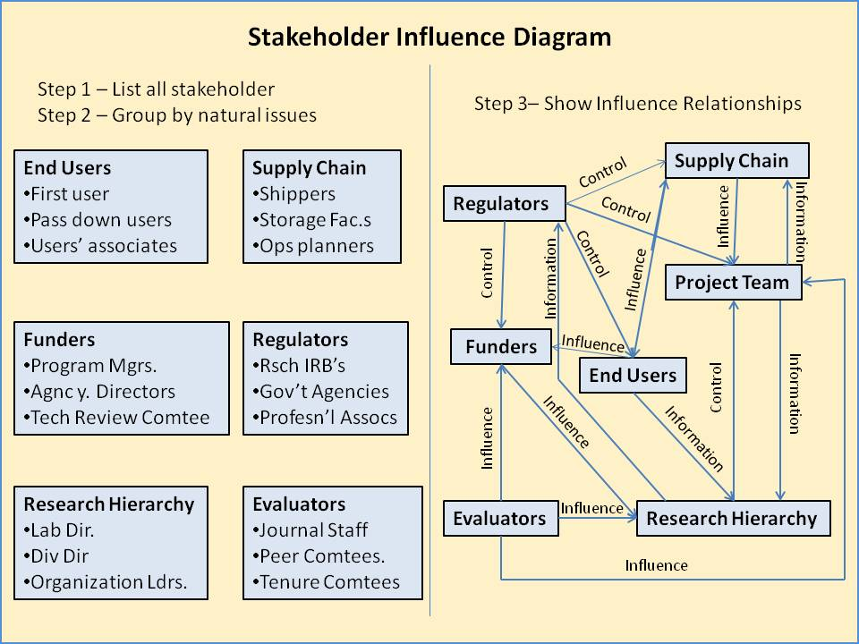
Figure 2.3. - Stakeholder Diagram

Business process improvement methods provide much more detailed models of how to map information to actual users in the 90s but were neither broadly taught nor implemented. As the creation of such is reasonably obvious, there will be no further description of steps required. Like taking notes before an exam that cannot go into the test room with the student, just the process of creation is often revelatory and creates a lasting framework in the authors mind as they execute the research or development project. These models of information, dissemination and stakeholder usage needs are best developed in multi-disciplinary team brain-storming sessions. The standards community will, of necessity have a very broad range of stakeholders, up to and including the Nation's or even global population.

Communications Plan Information Flow Chart – Mapping what information flows from whom and to whom:

This exercise has a goal of identifying all vital and desirable flows of information for the entities activity. The above mentioned Stake Holder diagram will allow a rapid filling out of the nodes of the nor providing the intended goal of creating reusable objects that could be leveraged for the next research problem chart. Then another group brainstorming session would be in order to consider all of the various information flows for the activity. A detailed process model with information systems and specific users of the systems can allow much more effective engineering of the solution needed. Using the project described above, the following diagram is a straw man version of what such a diagram may tell the leadership. It should provide a list of needed channels, a basic priority of the information flows, suggest who might best be tasked with monitoring and assuring the flows, and a way to assess the achievement of organizational goals. Continuous process improvement techniques with measurement and feedback loops are also often missing in implementations and research.

The chart (Figure 2.4) below is notionally one for the above described Mentor PAL project, and is shown as only one chart. Should the SISO organization find this approach useful, one could imagine that they might find it advantageous to create an interior and exterior communications plan flow chart and recommend to committee chairs that they consider whether one would be advisable for them as well. The communication issues are pervasive and the Ops Research professionals report there is an invariable tendency for managers to think they have it all in their heads and that it does not require formalization. Many report that the effort did help them see areas not hitherto recognized and to inculcate a procedure of review to make certain the critical flows are both timely and sufficient to support objectives of the group.
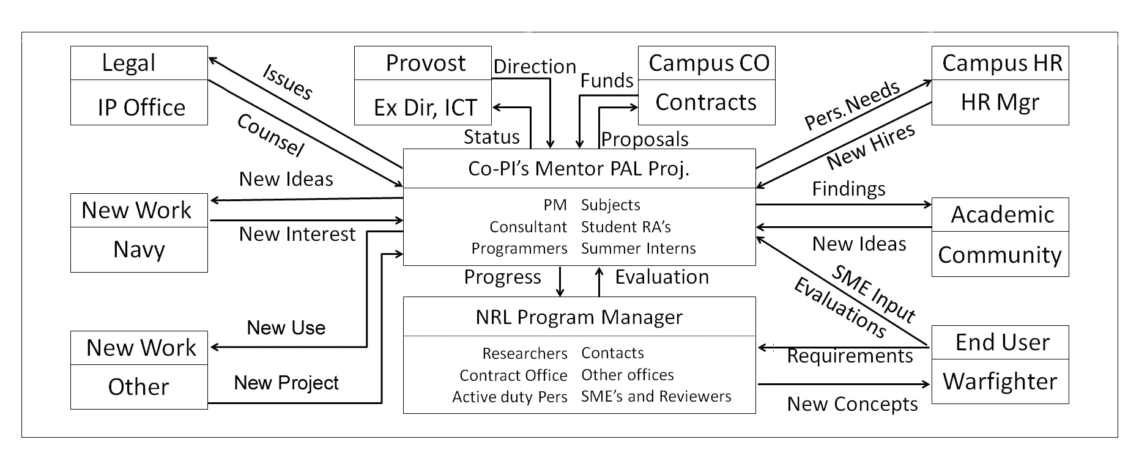
Figure 2.4. Notional Data Management Information Flow Chart

Process engineering techniques can also be applied to the communication analysis measuring how often each stakeholder needs an update, which form of communication is most appropriate for each type of information and how best to create an intuitive system and process that can be consistently implemented across large disparate populations and stakeholders. The chart above, Figure 2.4., does not have responsible parties identified, but an actual chart would have room for both the responsible person/entity and the periodicity of the flow, be it time or event triggered, e.g. "monthly" or "upon request." This chart shows unidirectional flows, but bi-directional flow is more often the norm and process feedback is key for continuous improvement and leveraged advancement. This approach emanates from a recognized academic discipline: Communications Management.

- Implementation Issues

For this concept to be of benefit to any community, a deep familiarity with the entity in question would be a virtual sine qua non. While a new unit being just now "stood up" would be well-advised to consider this, the typical case, and the one under consideration here, would be an organization with a significant history and with personnel with significant experience and sensitivities about such actions. The authors are well-aware that their knowledge of the workings of SISO are limited and while their general familiarity with defense research after decades of participation, they were (and are), rue to suggest what such an approach would produce. This paper, therefore, took the option of using a straw man from their own work.

The question then becomes, who should perform such an analysis? Who should vet such a resultant chart? Here again, a multi-discipline team from the leadership of the organization would be best able to make such determination. All this notwithstanding the possibility that it all has been done previously and was simply unknown to the authors or the SISO members to whom they spoke.

Nevertheless, it would be a propitious first beginning to take stock of where SISO is and where it is going, to define/refine SISO objectives [22], to identify key input communities and important audiences, conceptualize data flows, establish review schedules to insure continued relevance, and to evaluate the results of these activities in light of organizational goals.

The risks of such an undertaking are low, but there is a time element involved. If you go around a committee meeting room at any given time, the ten people there have a fully burdened cost totaling $200/min., so the effort must be worth the cost. It is generally seen as a productive evolution and one that enhances rather than degrades morale.

- Impacts Anticipated

Some benefits will be realized immediately in heightening the awareness of the opportunities and necessities of effective communication of SISO priorities when developed with a multi-discipline team of technology stakeholders. One should be able to expect an improved analysis of standards creation, adoption and revision among all who participate in or are informed of the activities in accord with these suggestions. The SISO international community would have better insights as to its acceptance and impact across their cultures.

Also, it is hoped this will lead to better recognition of standards, both definitional and physical, e.g. determination of a standard term for a "virtual human" and a standard for a metric to measure response lag time limits needed to support engaging virtual conversations. These effective communications all would add to an increased visibility of and respect for the standards processes among the various stakeholder groups. It would display both the viability and utility of standards to the entire range of those to whom these communication would be directed.

This would, one would hope, also contribute to enhanced visibility and viability of standards institutions, e.g. SISO. In a broader vision, it would enable more productive research and technology development. These, in turn, would lead to improved defense capabilities, economic optimization and reduced personnel losses

The processes suggested above would be reviewable by leadership at all times and there would be no significant cost incurred in reducing or expanding the effort as may be deemed useful and productive. There would be little or no ego involvement in its continuation or termination.

These approaches have been envisioned and presented group activities. This approach has significant advantages in terms of synergistic enhancements, intra-group communications, and motivational buy-ins. Nevertheless, a single person performing these analyses, with the accompanying documentation process of jotting down the results, can have very salutary impacts on improvements to the communication approaches that this paper has identified and advocated. Such a person, acting alone, can make a list of the stakeholders, consider the needed communication to and from each, then decide on who should be responsible to accomplishing that and how those processes should be reviewed, assessed and modified.

- Conclusions

Systems Engineering and Communications Management are recognized academic disciplines that offer assistance to technical personnel faced with the obligation to collect and assess community issues and to develop and promulgate standards assistance and deployed solutions implemented with processes and software. The methods proposed do require some minimal upfront time commitment, but consistently repay the time debt by both increased efficiency and otherwise unnoticed insights. Without such skills, either intuitive or learned, optimal effectiveness may be evasive. Ironically, the path to technical management was usually based upon individual contributor technical achievement ignoring all the additional skills needed for success in the leadership role. A communication management plan is a recognized way to both assess and improve that function in all phases of standards life cycles. The authors acknowledge such approaches may have long been in practice at SISO, unbeknownst to them, in which case they congratulate the leadership for being so assiduous in the pursuit of SISO goals and apologize for the redundancy hereof.

- Acknowledgements

The authors would like to thank USC PAL₃ AI team leaders, the Doctors Benjamin Nye and William Swartout for their support and guidance. Also, LCDR Mark C. Davis, PhD, U.S. Navy, Retired, provided much counsel and insight into the development of codes in the computer industry and the growth and adoption of standards in that very different environment, with its proprietary information complexities. Much of this work was supported by grants from the Office of Naval Research's STEM Program (ONR N00014-16-1-2820) and by students supported by the National Science Foundation Research Experience for Undergraduates program (NSF 1560426). Nevertheless, the positions taken in the paper are the authors’ own and do not represent in any way the views of the Department of Defense or the US Government.

- References

- Donnell, J. A., Aller, B. M., Alley, M. P., & Kedrowicz, A. A. (2011, January). Why industry says that engineering graduates have poor communication skills: What the literature says. In ASEE Annual Conference and Exposition, Conference Proceedings.
- Severance, C. (2020), Resurrecting the CDC 6500, Retrieved on 20 December, 2020 from URL: https://ieeexplore.ieee.org/stamp/stamp.jsp?tp=&arnumber=7912160
- Pugh, E. W., Johnson, L. R., & Palmer, J. H. (1991). IBM's 360 and Early 370 Systems. MIT Press.
- Bailey, E., (1971). Course notes. Taken by Dan M. Davis, University of Colorado, Fall, 1971.
- Blumenthal, K. (2012). Steve Jobs: The man who thought different. Macmillan.
- Buzzard, G., & Mudge, T. (1985). Object-based computing and the Ada programming language. IEEE Annals of the History of Computing, 18(03), 11-19.
- Dahmann, J. S., Fujimoto, R. M., & Weatherly, R. M. (1997, December). The department of defense high level architecture. In Proceedings of the 29th conference on Winter simulation (pp. 142-149).
- Fox, G. C., Williams, R. D., & Messina, G. C. (2014). Parallel computing works!. Elsevier.
- August, M. C., Brost, G. M., Hsiung, C. C., & Schiffleger, A. J. (1989). Cray X-MP: The birth of a supercomputer. Computer, 22(1), 45-52.
- Draper, J., Chame, J., Hall, M., Steele, C., Barrett, T., LaCoss, J., ... & Daglikoca, G. (2002, June). The architecture of the DIVA processing-in-memory chip. In Proceedings of the 16th international conference on Supercomputing (pp. 14-25).
- Davis, D. M., Lucas, R. F., Wagenbreth, G., Tran, J. J., Agalsoff, J., & Gottschalk, T. D. (2009). FLOPS per Watt: Heterogeneous-Computing’s Approach to DoD Imperatives. In the Proceedings of the Interservice/Industry Simulation, Training and Education Conference, Orlando, Florida, USA.
- Hyde, J. S., & Linn, M. C. (1988). Gender differences in verbal ability: A meta-analysis. Psychological bulletin, 104(1), 53.
- Reave, L. (2004). Technical communication instruction in engineering schools: A survey of top-ranked US and Canadian programs. Journal of Business and technical Communication, 18(4), 452-490.
- Fulwiler, T. (1988). Evaluating writing across the curriculum programs. Strengthening programs for writing across the curriculum, 61-75.
- Kernighan, B. W., & Ritchie, D. M. (2006). The C programming language.
- Strunk, W. & White, E.(2007). The elements of style. Penguin.
- Chowdhury, G. G. (2003). Natural language processing. Annual Review of Information Science and Technology, 37(1), 51-89.
- Collobert, R., & Weston, J. (2008, July). A unified architecture for natural language processing: Deep neural networks with multitask learning. In Proceedings of the 25th International Conference on Machine Learning.
- Traum, D., Jones, A., Hays, K., Maio, H., Alexander, O., Artstein, R., ... & Swartout, W. (2015, November). New Dimensions in Testimony: Digitally preserving a Holocaust survivor’s interactive storytelling. In International Conference on Interactive Digital Storytelling (pp. 269-281). Springer, Cham.
- Benjamin D. Nye, Dan M. Davis, Sanad Z. Rizvi, Kayla Carr, William Swartout, Raj Thacker & Kenneth Shaw (2020). Feasibility and Usability of MentorPal, a Framework for rapid Development of virtual Mentors. Journal of Research on Technology in Education
- O'Sullivan, K. J. (2007). Creating and executing an internal communications plan for knowledge management systems deployments. Journal of Knowledge Management.
- SISO, (2020). Simulation Interoperability Standards Organization, Retrieved on 22 Dec 2020, from URL: https://www.sisostds.org/AboutSISO/Overview.aspx

Authors’ Biographies

Dan M. Davis, is active as a consultant at the Institute for Creative Technologies, University of Southern California (USC), focusing on large-scale DoD simulations and avatar uses. Prior to retirement, he was the Director of the JESPP project at USC for a decade. As the Assistant Director of Advanced Computing Research at Caltech, he ran Synthetic Forces Express, bringing HPC to DoD simulations. He also served as a Director at the Maui High Performance Computing Center and in computer research roles at the Jet Propulsion Laboratory and Martin Marietta. He was the Chairman of the Coalition of Academic Supercomputing Centers and has taught at the undergraduate and graduate levels. As early as 1971, Dan was writing programs in FORTRAN on one of Seymour Cray’s CDC 6500’s. While in the Marine Corps, he saw duty in Vietnam as a Cryptologist and retired in 2002 as a Commander, U.S.N. He received B.A. and J.D. degrees from the University of Colorado in Boulder.

Milton Rosenberg is a Special Project Manager at the Institute for Creative Technologies, University of Southern California. He has managed several large research and development projects there for the Army Research Laboratory and for the Office of Naval Research. These projects were designed to engage service personnel via computer generated virtual environments and personnel. He has over 20 years of experience managing multiple projects. Milton supervised the construction and global rollout of the Whirlpool manufacturing system and holds a patent in methods for maintaining computer software. He holds a BS in Business Administration.

DANIEL P. BURNS, CAPT, USN (Ret.) is a lifelong Systems Engineer, first with the Active Duty Navy, then SAIC, and small business. He served as Naval Chair and Professor of Practice in Systems Engineering at the Naval Postgraduate School (NPS).Captain Burns also was appointed as the as the Military Associate Dean and as acting Dean of the Graduate School of Engineering and Sciences at NPS. His research interests center on analyses of both human and resource utilization in defense efforts. He successfully facilitated the creation of a new program for Air Force Officers who seek post-graduate degrees. He is currently engaged in a project at the US Air Force Base, Los Angeles. Captain Burns received a BS degree from the U.S. Naval Academy, an MS from the Naval Postgraduate School and an MS from Southern Methodist University. He is currently working with Portland State University on a Ph.D.

