Mentors, Therapists and Counselors: Leveraging Exceptional Expertise via Emerging Virtualization Technologies

Continuing needs for counseling functions still rank high in unit dissatisfaction, but new capabilities can offer accessible and effective engagement to Naval personnel

CDR Dan M. Davis, USN, Ret. and LCDR Mark C. Davis, USN, Ret.

The emerging technologies that enable virtual conversations can be invoked to provide the Naval Services with a new set of tools to address some of the otherwise ostensibly immutable and endless challenges, e.g. inaccessibility of mentors, constrained availability of substance abuse therapists and scarcity of suicide prevention counselors. All of these shortcomings vex both the wardroom and the CPO mess and they are threats to mission accomplishment, readiness and retention. They are all exacerbated by the geographical dispersion, under-staffing and hectic operations tempos that characterize service in the Department of the Navy. A consistent drum-beat of communications indentifying the need for and the paucity of these inter-personnel assets are found in many professional publications and they are the topic of many discussions while on duty. Current research supports the thesis that many of these needs could be met by increasingly sophisticated virtual-conversational on-line counselors of various kinds. These computer supported interfaces are engaging, charismatic, sensitive, globally accessible and available "twenty-four by three sixty-five" anywhere there is an internet connection or a fully populated compute facility. The following analysis focuses largely on virtual conversational mentoring, but therapy and counseling are within the Navy's reach and grasp as well.

Current

Taking mentoring as an example of an area that could benefit from additional buttressing, let us consider where that assistance would be most effective. There is a general agreement among service personnel that mentoring is a vital factor at virtually all levels. During World War II, Gen. Dwight Eisenhower was carefully and effectively mentored by Gen. George C. Marshall. Studies have shown that the only group of military officers reporting that they received adequate and useful mentoring was the alumni of the DoD service academies. That means the four fifths of the commissioned officers report insufficient mentoring. There are several characteristics found in these sub-optimal situations; they include:
- Insufficient time for sessions with mentor
- Poor matches between mentors and mentees
- Lack of ability or time to identify or select mentor
- Operational/geographical hurdles to good mentoring
- Command imprimaturs imply "ticket punch" imperatives
- Lack of consistent DoD messaging from a host of advisors

Those reporting a good mentoring relationship tend to focus on a mentee's recognizing the need for a mentor, their willingness to engage in a mentoring process, their willingness to discuss problems and weaknesses with a senior person, particularly if they are unsure that such a mentor is not now or in the future in a position where knowledge of any failings may adversely impact career, advancement or retention. Another, more abstract reason for ineffective mentoring is the mentees' inability to have insightful understanding of the obstacles to their own future. One study found that young people often do not have the life-experience to see where they need support.

This lack results in another feature of a good mentoring relationship: the ability of the mentor to insightfully initiate and steer the session to areas of concern outside of ken of the mentee. Many "live" mentors are not facile at this sort of caring probes into the needs of the mentee. Good relationships are often characterized by the mentor asking probing questions and then reacting to the responses in a nonjudgmental, but constructive way. This conundrum is common to Client-Centered Therapy as well: How does one make critical judgments about the user, without alienating the user by showing any hint of being judgmental about them? These are difficult issues for even intelligent humans.

Emerging Technologies

There are many excellent mentors in the Navy today, so a way to make them more available across the service would be advantageous. Recordings of their advice and their insights are easily made, e.g. Caltech recorded the lectures of Richard Feynman, but an interactive interface is demonstrably more personal. Two recent implementations of virtual conversationality relied on pre-recording answers to about a thousand questions, vectorizing the transcript of the session, and then using Natural Language Processing to match the answers to similarly vecotorized questions posed by the user.

The goals of the three projects at the University of Southern California were slightly different. In the first, the goal was to provide an engaging interface for patients of the Veterans' Administration who were seeking information. The second was a Navy Research Laboratory project to make the experience of Navy STEM (Science Technology Engineering and Math) professionals easily accessible by high school students who otherwise would be isolated by geography and Socio-Economic Status; the goal being to stimulate their interest in pursuing STEM education and potentially to make them available for service in the Defense sector, either in uniform or in a civilian position. In the third, the goal was the archiving of the memories of aging holocaust survivors to preserve them and make them available to museum attendees, now and in the future. In all three cases, the user could pose a question, either by keyboard entry or by microphone, and within 500 milliseconds the computer would generate a germane answer, thereby creating the illusion of a human conversation. Should the user pose a question for which no acceptable match could be found among the recorded clips or if the computer detected an unacceptable question, an "escape" phrase was used as a response, usually suggesting the user ask some other question. At the end of the response, the computer queued up the presenter's rest position until the next question was posed.
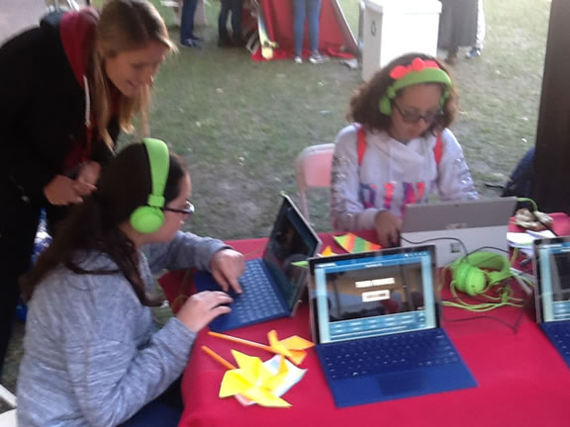
Figure 1- An Ensign researcher assists two students investigate STEM Topics using MentorPAL at a Job Fair on USC Campus.

The three methods of output used in this research were a Computer Generated Imagery (CGI) animated image on a computer monitor, a set of recorded video clip response from live Navy commissioned and senior petty officers on a monitor or recorded set from a survivor of the Holocaust displayed on a three-dimensional holographic display in classrooms or museums. Each has their own set of benefits and drawbacks, but in each case, emerging technologies promise to further exploit the benefits and ameliorate the drawbacks. Examples of these displays are shown below in Figures 2, 3 and 4.

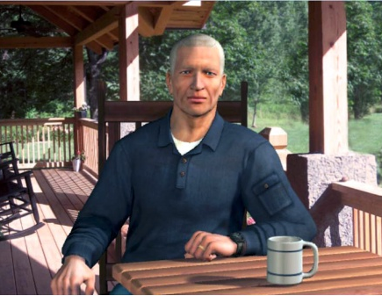 | 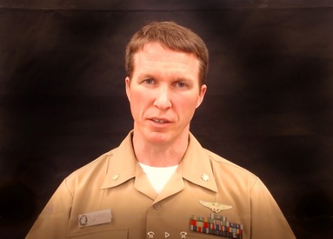 | 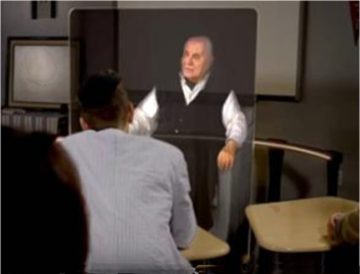
Figure 2 - Fully Animated CGI SimCoach advises Veterans about PTSD issues | Figure 3 – Recorded video clips in 2D are used to help Mentor young STEM Students | Figure 4 - Video-taped Holocaust Survivor responds to a class via holographic 3D

That the varying technologies involved in creating the virtual conversation were so successful in establishing the virtual humanity of the imagery was palpable. For want of space and time to fully explicate all of the technologies that are involved, the following list is offered, annotated by other longer papers more fully exploring the emerging and enabling nature of the techniques:

- NLP – Natural Language Processing
- HPC – High Performance Computing
- A/I- Artificial Intelligence
- Evolutionary Computing
- Voice recognition
- 2 and 3 D video production
- Haptics
- Operations Research
- System Engineering
- CGI (Computer Generated Imagery)
- Sensors (visual & auditory analyses)
- Quantum Computing
- Deep Learning
- Data Lake analyses

Impact
As meaningful as these technologies may be, the most important question is: What impact can these have on the intended users? The response to that inquiry given here will be both anecdotal and quantifiably metrical.

The SimCoach project watched the way that on-line users reacted to the animation. What they observed was that the users seemed to be engaged in more emotionally laden conversations with SimCoach, in comparison to on on-line FaceTime or Skype session with a live counselor. This was confirmed in a quantifiable objective way when the time spent in a SimCoach session was significantly longer than the sessions with the live counselor. A behavioral scientist on the team offered the insight that the critical factor in Rogerian or Client Centered therapy was the manifest and perceived non-judgmental affect of the therapist. This is especially important if the behavior in question is held in low esteem by both the subject's peer group and society in general. One study in the 70's found that Vietnam Veterans with PTSD refused to continue sessions with a therapist who had not done a combat tour in Veitnam. It is posited that CGI animated therapists provide the best of both worlds; they are credibly conversational, the they are manifestly non-human and thereby patently non-judgmental.

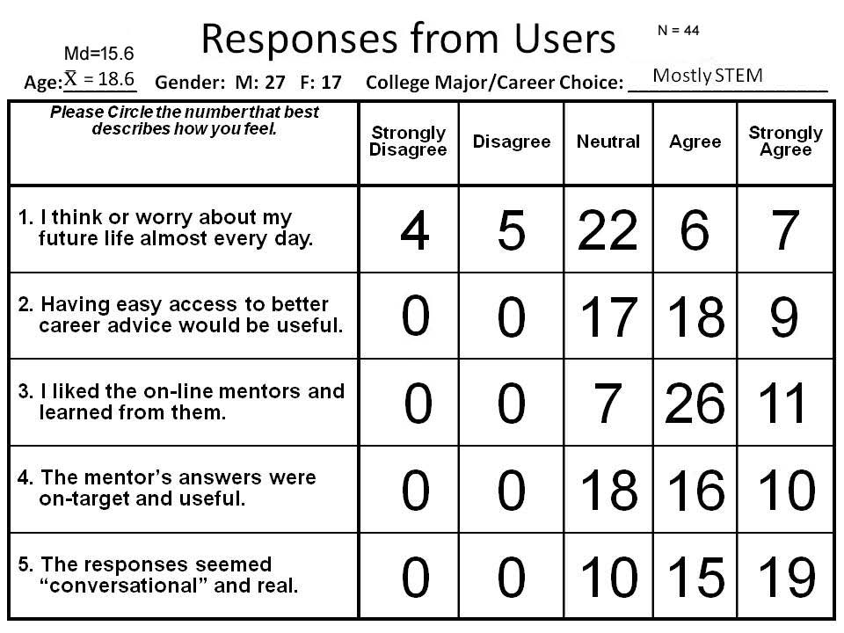
The STEM professionals in the Mentor PAL project were all viewed as very conversational by the users at a number of early field trials. The target groups were late high-school students who were given a brief description of the project then allowed to interface with the virtual-conversational on-line mentor, either typing in their questions or speaking into the laptop microphone and relying on speech recognition, with is another emerging technology. The researchers developed a short Likert-like evaluation sheet that they presented to both teen-aged students and adult parents and teachers at field trials of this program. This was not a fully qualified, statistically verified and carefully standardized survey to prove a specific thesis, but an ethnographic evaluation to merely help guide the researchers in further development, but it may give some initial insight into the impact on the users. While the informality of the evaluation would not admit of any formal findings, the researchers observed two interesting factors that may merit more careful investigation and analysis: 1) the parents and the teachers were significantly more enthusiastic about this product than were the students and 2) the students were undeniably deficient in any critical thinking approach to career evaluation or selection. The researchers developed a list of suggested questions a student might want to ask about a career and this turned out to be an observably useful exercise in stimulating student thoughts about a career.

The third project, in a way somewhat like the first two, was not focused on a quantified assessment of the effort's efficacy, but on the production of a working program. New Dimensions in Testimony was a project intended to archive Holocaust survivors recollections in a manner that would enable a dialogue between the user and the survivor. Anecdotally, the researchers observed or were later told of many user participants weeping at the history presented by Gunter, especially when they asked if he had memories of his Mother, that question triggered the response he gave to a similar question from the response data-base architect during his recording session. He remembered a Polish lullaby that he then sang very movingly which almost invariably elicited tear-filled eyes. One user was so moved by all of his answers to the questions that, before she left the display area, she apologized to the reproduced image of Gunter for what he had gone through at the hands of her fellow humans. Not having anticipated that immersive involvement, the program had no adequate response prepared for Gunter to record.

Metrics

One of the most often under-emphasized facets of development is the implementation of a valid metrics for success. Like many new technologies, A/I has helped us a humans to focus more on what the "real" figures of merit should be. The issue is more ethical than intellectual. There is an all too human tendency to choose that aspect of performance that is both easy to collect and most likely to reflect well upon the developer. In neural net "learning" as well as in life, picking the wrong criteria can render the results meaningless. As a short hand for a dramatically more complex analysis, we might say we want our service members to make better choices in the their careers, avoid the perils of substance abuse, and reduce the damage caused by suicidal ideation.

These criteria however are difficult to use, as many of them require waiting to the end of one's career to measure and most leaders would balk at the thought of supporting a program for which there were no milestones for efficacy for several decades. There are many more immediate and intermediate indicia of a programs impact on the warfighter. These include:
- Careful logging of time spent interacting with a virtual counselor
- Sensor evaluation of users body language and voice quality
- Self reporting questionnaires on user's emotional status
- Third party evaluations of the user's behavioral state
- Professional assessments (Evals, Fit-Reps, NJPs)
One benefit of all of these are the objective nature of the review in terms of not being driven by association with the computer program. They still require a careful analysis to establish causality, e.g. a warfighter attempting suicide might show a high level of time logged onto a Suicide Prevention virtual counselor, but parsing out which was the causal agent would not be trivial.

Looking at the hindrances to effective mentoring, therapy, and counseling were listed earlier. Below is a very brief analysis as to how the virtual advisor might augment the human endeavors to address the same issues:

- Insufficient time for sessions with mentor
  - Modulo operational constraints, a virtual agent has unlimited time
  - The virtual agent has no physical needs that would curtail a session
- Poor matches between mentors and mentees
  - The system envisioned would provide a wider variety of virtual agents
  - The user would be at liberty to stay with or change mentors as desired
- Lack of ability or time to identify or select mentor
  - The system could provide guidance and even "sense" a need to change
  - The user could choose their own advisor and a set of their responses created
- Operational/geographical hurdles to good mentoring
  - Whenever user needs counseling, virtual advisor is available 24x365
  - Anywhere there there is internet, there is the virtual advisor to give aid
- Command imprimaturs imply "ticket punch" imperatives
  - The virtual advisor's human/machine duality has no say in user's advancement
  - The user knows that the advisor cannot care if the "ticket was punched" or not
- Lack of consistent DoD messaging from a host of advisors
  - Pre-recording gives ample opportunity to screen out unacceptable divergences
  - A/I techniques could monitor questions/responses to identify latent problems

Grand Challenges

To close, a list of vital capabilities as yet achieved is presented, along with a vision of which of the emerging technologies will enable meeting these challenges, both for current users and for the inevitable more technically-sophisticated users of the future.

• Detection of user emotion | • Ability to manifest appropriate voice dynamics
• Detection of hyperbole | • Ability to initiate new conversational topics
• Detection of humor | • Ability to convey the advisor's emotions
• Analysis of threats to unit mission | • Ability to interactively interrupt users
• Analysis of threats to personnel | • Ability in three-way conversations
• Analysis of needs of users | • Ability to ask probing questions
• Analysis of advisor skill | • Ability to sense user's fatigue

Many, if not most of these grand challenges are amenable to the increased ability to bother internalize the vast data stores available to the computer agent/advisor and to synthesize it into appropriate responses. The fields of data management and communication will be able access Data Lakes using Deep Learning, A/I, Evolutionary Computing, OR, and Systems Engineering to identify and validate appropriate responses to the emotional state observed in the user via sensors that have been Neural-Net-trained to do so. The seemingly limitless computing capabilities of Quantum Computers, albeit non-deterministic, will be a vital asset, if not a sine qua non for detecting real emotion from either malicious deception or a misguided attempt at humor. Live humans often use subliminal cues to make such determinations, which will make identifying figures of merit for the Neural-Net training a daunting task.

The incipient break-throughs in the various projection techniques like CGI, Haptics, Video Production values, and 3D visualization will almost certainly make the virtual advisor more "human." They will also raise new intellectual challenges and ethical quandaries. If a haptics advance allows the computer to extend a hand of friendship, consolation or greeting, will its impact on the user be as expected. Leadership must be aware of and must carefully nurture and monitor the advances that are imminent.

Dan M. Davis
CDR Davis is currently a consultant at the University of Southern California, where he directed several major research projects involving the use of large super computers to enable battlefield simulations. His current work there is devoted to producing an engaging virtual conversational computer agent to conduct interpersonal exchanges with live users in several different environments. He began his cryptologic career by enlisting in the USMC, serving in Vietnam; he later was commissioned in the Navy, retiring as a Commander. He holds a BA and a JD from the University of Colorado.

Mark C. Davis
Dr. Davis is a retired Distinguished Engineer from Lenovo and IBM. A Duke University NROTC commissioned officer, he served for 12 years as a sub-surface warfare officer, prior to taking early retirement as a LCDR to pursue a PhD in Computer Science at the University of North Carolina. At Lenovo, he was responsible for the design of laptop computer cross-disciplinary technology, including PC architecture, embedded systems, open source and virtualization. Previous work was with IBM in the areas of software development and architecture involving security, storage and virtualization.

Butcher, H. C. (1946). My Three Years with Eisenhower: The Personal Diary of Captain Harry C. Butcher, USNR, Naval Aide to General Eisenhower, 1942 to 1945. New York: Simon and Schuster.
Kopser, G. J. (2002). Mentoring in the military: not everybody gets it. Military Review, 82(6), 40.
Davis, D. M., Predovich, K.B., Stassi, F.J., Spaulding, H., Shaw, K & Nye, B.D. (2018). Enhancing Menteeship: Improving Career Selection for Potential DoD Personnel. In the Proceedings of the SISO Fall Simulation Innovation Workshop. Orlando, Florida:SISO
Lafferty, P., Beutler, L. E., & Crago, M. (1989). Differences between more and less effective psychotherapists: A study of select therapist variables. Journal of Consulting and Clinical Psychology, 57(1), 76.
Kaimakis, N.J., Davis, D.M., Breck, S., & Nye, B.D. (2018). Domain-Specific Reduction of Language Model Databases: Overcoming Chatbot Implementation Obstacles. In the Proceedings of the ModSim World Conference. Norfolk, Virginia
Lucas, R. F., Davis, D. M., Wagenbreth, G., & Tran, J. J. (2009). Operational Use of a Large GPGPU-Enhanced Linux Cluster. In the Proceedings of the High Performance Computing Modernization Program Users' Group Conference. San Diego, California, 2009
Swartout, W., Nye, B. D., Hartholt, A., Reilly, A., Graesser, A. C., VanLehn, K., ... & Rosenberg, M. (2016). Designing a personal assistant for life-long learning (PAL3). In 29th International Florida Artificial Intelligence Research Society Conference, FLAIRS 2016 (pp. 491-496). AAAI Press.
Fogel, D. B. (2000). What is evolutionary computation?. IEEE spectrum, 37(2), 26-32.
Metallinou, A., Lee, S., & Narayanan, S. (2008, December). Audio-visual emotion recognition using gaussian mixture models for face and voice. In 2008 Tenth IEEE International Symposium on Multimedia (pp. 250-257). IEEE.
Traum, D., Jones, A., Hays, K., Maio, H., Alexander, O., Artstein, R., ... & Swartout, W. (2015, November). New Dimensions in Testimony: Digitally preserving a Holocaust survivor’s interactive storytelling. In International Conference on Interactive Digital Storytelling (pp. 269-281). Springer, Cham.
Cara M. Nunez, Bryce N. Huerta, Allison M. Okamura, and Heather Culbertson, “SHIFTS: Social haptic interfaces for tactile stroking,” in Proc. IEEE Haptics Symposium, 2020.
Davis, M.C., Yao, K-T., Davis, D.M., & Barnhill, D. H. (Pending 2021). Conversationally Adept Virtual Humans Technologies: Autonomous Combat Team Members' 'Incarnation'. In the Proceedings of the ModSim World Conference. Norfolk, Virginia
Burns, D.P., Davis, D.M., & Nordhagen, J. N. (2018). Systems Engineering: Optimizing Creation of Virtual Conversational Human. In the Proceedings of the ModSim World Conference. Norfolk, Virginia
Stanney, K. M., Hale, K. S., & Zyda, M. (2014). Virtual Environments in the Twenty-First Century.
Zhang, M., & Sawchuk, A. A. (2012, September). USC-HAD: a daily activity dataset for ubiquitous activity recognition using wearable sensors. In Proceedings of the 2012 ACM Conference on Ubiquitous Computing (pp. 1036-1043).
Shaw, K., Davis, D.M., Rizvi, S.Z. & Davis, M.C., (2019). Quantum Computing: Evaluating Potential Quantification of Projective Psychological Test Scoring . In the Proceedings of the ModSim World Conference, Norfolk, Virginia.
Yao, K-T., Davis, D. M., Liu, J. J., & Kaimakis, N. J., (2018). New Technologies to Enhance Computer Generated Interactive Virtual Humans. SISO Fall Simulation Innovation Workshop, Orlando, Florida:SISO
O'Leary, D. E. (2014). Embedding AI and crowdsourcing in the big data lake. IEEE Intelligent Systems, 29(5), 70-73.

