The Implementation of Virtual Humans:
Rethinking Critical Thinking and Metacognition

Dan M. Davis, Jennifer H. Nolan, and John J. Tran | Mark C. Davis
Catholic Polytechnic University | Wood Duck Research, Inc.
Pasadena, California | Mooresville, NC
{ddavis, jnolan, jtran} @catholicpolytechnic.org | davismc@ieee.org

ABSTRACT

This paper reviews the requirements and opportunities for improving critical thinking and metacognition in today’s world. It reviews some current constraints on effectively addressing those issues, and comments on advances in virtual human interfaces that can enhance efforts to augment current pedagogical approaches. The paper asserts that these new techniques would be beneficial to military personnel and it presents the case that instantiating these instructional approaches would be improved by the use of emerging, but prenascent, proactive conversational computer agents using Natural Language Processing (NLP). The paper opens with a view of the need for both metacognition and critical thinking skills in today’s defense environment and reports on the number of leaders, analysts, and staff who decry the current state of those abilities. The capability and need to begin this educational process early with the Military personnel is advanced. Then, a review of the recognized pedagogical approaches to improving these proficiencies is countered by an explication of the many personal, organizational, and social hurdles to implementing these approaches. The last major section is a description of recent advances in the modeling and simulation community leading to the availability of conversationally facile virtual humans and other computer agent avatars with the capability of counteracting the obstacles currently hampering the education required. Some of the obstacles addressed are classroom scheduling, operational schedule overloads, geographic isolation, and personal characteristics of both educator and student. Recent development outcomes are offered as examples of current system functions and future development efforts are outlined, offering design concepts and previewing some system functions of new tools that will soon be available to the professionals in this discipline. These system functions are described with sufficient detail to allow the reader to see if these programs might be applicable in their own work, either now or in the years to come.

ABOUT THE AUTHORS

Dan M. Davis, CDR, USN, Ret., is active as a consultant at the Institute for Creative Technologies, University of Southern California (USC), focusing on large-scale DoD simulations and avatar uses. Prior to retirement, he was the Director of the JESPP project at USC for a decade. As the Assistant Director of Advanced Computing Development at Caltech, he ran Synthetic Forces Express, bringing HPC to DoD simulations. He also served as a Director at the Maui High Performance Computing Center and in computer development roles at the Jet Propulsion Laboratory and Martin Marietta. He was the Chairman of the Coalition of Academic Supercomputing Centers and has taught at the undergraduate and graduate levels. As early as 1971, Dan was writing programs in FORTRAN on one of Seymour Cray’s CDC 6500’s. While in the Marine Corps, he saw duty in Vietnam as a Cryptologist and retired in 2002 as a Commander, U.S.N. He received B.A. and J.D. degrees from the University of Colorado in Boulder.

Jennifer H. Nolan, PhD, is the President of Catholic Polytechnic University and Professor of Psychology in their College of Arts and Sciences. Her earlier work specialized in memory, dementias, stroke and insulin resistance. She is a brain plasticity specialist and certified Cogmed provider. Previously, she was the C.O.O. and co-founder of a stroke and brain injury rehabilitation center. Dr. Nolan has taught university courses at the University of California Irvine, Loyola Marymount University, and Glendale Community College. She has conducted local and nationwide clinical trials, and published in both scientific journals and popular magazines. She received a BA in Psychology from Loyola Marymount University, Los Angeles and a Ph.D. in Psychology from the Dept. of Cognitive Science at the University of California, Irvine.

Mark C. Davis, Ph.D. is the Chief Technical Officer at Wood Duck Research, Inc, and is semi retired after careers in the US Navy and as a computer design engineer for both IBM and Lenovo. Rising to the level of Distinguished Engineer at Lenovo, he was responsible for the design of laptop computer cross-disciplinary technology, including PC architecture, embedded systems, open source and virtualization. Previous work was with IBM in the areas of software development and architecture involving security, storage and virtualization. Dr. Davis has been granted well over fifty patents that were filed during his service at both companies. He is a graduate of the Duke University NROTC program and was commissioned as an Ensign, attended nuclear power school, and served as a Submarine Officer for twelve years, including one duty tour as a classroom instructor. He left the active duty as a Lieutenant Commander to pursue a PhD. Mark holds a BSEE degree from Duke University and a PhD in Computer Science from the University of North Carolina, Chapel Hill, where his advisor was Professor Fredrick P. Books.

John J. Tran, Ph.D. is a Lieutenant Colonel in the California Air National Guard. He received both his BS and MS Degrees in Computer Science and Engineering from the University of Notre Dame, where he focused on object-oriented software engineering, large-scale software system design and implementation, and high performance parallel and scientific computing. He has worked at the Information Sciences Institute (ISI), University of Southern California (USC), the Stanford Linear Accelerator Center, Safetopia, and Intel Corporation. His current development centers on Linux cluster engineering, effective control of parallel programs, and communications fabrics for large-scale computation. His tours of duty included the White House Communications Agency and Kirkuk Regional Air Base (Iraq), where he was the Communications Squadron Commander. He received his Ph.D. in Computer Science from the University of Southern California,

The Implementation of Virtual Humans:
Rethinking Critical Thinking and Metacognition

Dan M. Davis, Jennifer H. Nolan, and John J. Tran | Mark C. Davis
Catholic Polytechnic University | Wood Duck Development, Inc.
Pasadena, California | Mooresville, NC
{ddavis, jnolan, jtran} @catholicpolytechnic.org | davismc@ieee.org

Introduction

The major thesis of this paper is that technologies are emerging that will enable rethinking of metacognition and critical thinking skills so that inherent intellectual system functions can better be realized. This approach is vital to the optimal pursuit of defense organizational goals. There are constraints that hinder inculcating such skills in DoD personnel and these constraints are not easily ameliorated. The paper opens with a background discussion of the need for enhanced command sophistication in defense organizations. Then, there is an introduction to the concepts of metacognition and critical thinking, followed by development into the definition and use of these terms in education and defense communities. An effort to define the term critical thinking is presented, along with the results of an informal small ethnographic survey. All this was done in an effort to set a stage for standardization of terminology and metrics. Then there is a report on the recent advances in Virtual Human (VH) technologies as potential responses to the hurdles identified earlier. There is a short review of common applicable pedagogies to assist those less familiar with them. This paper will use the term “pedagogy” as meaning the art and science of teaching, inclusive of the less familiar, but perhaps more DoD-germane term for teaching adults: “andragogy." Then there is a section on applying these system functions to the issue at hand, along with a discussion of metrics. That process is discussed and conclusions are advanced, along with issues to be addressed in the future.

Introduction and Background

Prior to discussing the technical advances that lie at the heart of this paper’s major thesis, it may be beneficial to consider the context in which such advances may be made practical and their utility made valuable. It’s being impractical to cover here so large a body of experience, insight and lore, a few germane anecdotes will be adduced to set the stage.

Populations have been at war with each other for at least as long as there was a system of recording conflicts. Combat presents an unforgiving environment for those who did not think rationally (Bond & Cave, 2009). Early on the Greeks developed the concept of massing a dense body of fighters into an almost irresistible weapon to shatter the enemy lines. Henry the Fifth’s long bowmen at Agincourt gave a person pause to consider if the efficacy of massing power was still true, but 400 years later at Waterloo, Wellington’s troops still formed shoulder-to-shoulder to face an enemy with muskets that were perhaps less accurate than Welsh long bows (Keegan, 1993). A scant fifty years after that, the US would pay in blood for not recognizing that the Civil War rifle had gotten more accurate and longer ranged (Murray, 2016). The American marksmen had grown up with firearms in their hands. Toward the end of that war, a critical thinker developed and advocated a more dispersed and agile style of attack in response to these technologies (Randolf, 1905). But all was forgotten during the American Indian Wars and the British Colonial Wars, and that oversight led to the incredible losses in WW I (Scales, 1976). German Maxims did not honor the bravery of men walking in orderly fashion toward their trenches. In fact, an extension of those inclinations to form an “iron fist” of men may have found its expression in the case of Torpedo Eight in WW II’s battle of Midway, in which every plane of that unit was shot down without a landing a single blow against the Japanese Imperial Navy (Mrazek, 2008). A dearth of critical thinking missed the fact that the concentrated planes of Torpedo Eight did not provide the Americans with an iron fist; it provided the Japanese with a single target upon which the entire fleet could concentrate their defenses. A fifth of the names on the Wall at the Vietnam Memorial did not die at the hands of the foe (Nat'l Archives, 2020) and it is unknown how many of the other four-fifths were lost due to lack of real-time critical thinking. If the nation were to be able to engage the emerging powers of virtual reality and virtual humans to improve both selection and training to reduce such errors, good work will have been done for the defense personnel who are in harm’s way.

The delegation of command authority further and further down the chain of command means that even junior Non Commissioned Officers (NCOs) now have operational distance from higher command oversight and counsel, so they must exercise independent judgment in combat operations (Hogan et al., 2203). Ironically, the locus of higher-level control has flowed from the front line Roman Centurion to the Army headquarters of World War II to the halls of Washington during the Vietnam War. Indeed, many casualties inflicted on radical Islamists came by recent decisions made by drone operators sitting in communication centers located on a different continent.

Critical Thinking
One of the major issues is that of recognizing the essential system functions and the kind of analytical reasoning needed by today’s military personnel. Good g-factor tests (basic quantifiable measures of intellectual ability) can measure intellectual system functions and these tests have been extant in one form or another for millennia, having been in place at least as early as 165 BC (Fu, 1993). Courage can be tested to some degree by challenging candidates with daunting tasks in Officer Candidate programs. However, testing for the subtle and multi-faceted characteristic that is labeled “critical thinking” is much more problematic (Sanders & Moulenbelt, 2011) and much in need of an independent study to characterize the concept and quantify its magnitude and potential. These system functions are susceptible to stress and fatigue, the two major characteristics of the combat environment. An earlier paper discussed how emerging technologies may speak to these psychometric problems as well (Shawet al., 2019).

While the term may be relatively recent (Dewey, 1910), consideration of the concept has been extant since the time of the pre-Christian Greek Philosophers. (Visser &Visser, 2019). Despite the noted exceptions, Critical Thinking was rarely emphasized during the imperial age of the Roman Empire, nor was it common during the European dark period that followed, but its tradition remained alive in the Asia (Walters, 1994). Later, it was a major focus in the Age of Enlightenment, as shown by names of thinkers ranging from Bacon through Jefferson (Withers, 2008). With the age of industry upon the world, the need for critical thinking increased even more. This need was evidencing itself within the defense structures of every nation, as weapons went from tools that can be forged at home to sophisticated machines that required elevated technical expertise to even operate. (Keegan, 2011)

Metacognition
One of the issues that has arisen is how critical thinking is developed and sustained. One method according to Philip Tetlock of Princeton is for the analyst to consider their own method of cognition (Tolstoy, 2008). Metacognition could be defined in a phrase, “thinking about how one thinks,” and it may be one of the most human of the personal characteristics (Flavell, 1981). The term metacognition is of recent advent compared to critical thinking; it was first advanced by Flavell late in the 20th Century (Flavell, 1979). He stated that metacognition refers to knowledge and to cognition about cognitive phenomena and broke that down further into subsets of metacognitive knowledge and experience (Flavell, 1979). This section will concentrate on relating the military personnel’ self examination experience and how that should and could impact their metacognitive knowledge, and therefore, their ability to command. cf. The fictional, but insightfully rendered, Shakespearean characters Fluellen and Gower (Shakespeare, 1599) in Henry the Fifth exhibit some of the paralyzing self-reflections that are more craven than creative. Some critical thinking is put to good purpose by theorists drive to advance the cause of their nation and minimize bloodshed of their countrymen, e.g. Clausewitz (Clausewitz, 1832), Mahan (Mahan, 1890), Hart (Danchev, 1998), and Scales. (Scales, 1976). On active duty, the authors have observed that junior officers and enlisted personnel have gone from being just implementers and enforcers of the General’s battle orders, to now being entrusted to make decisions of global significance and respond to situations with sophistication.

While metacognition has garnered a lot of academic interest and a plethora of professional papers, the military personnel may wonder what applicability it has for them. There have been some studies, albeit more anecdotal than statistically pure, that have shown a high correlation between metacognitive activity and performance in intellectual fields (Romainville, 1994). But, not all uses of metacognition are universally seen as beneficial. The thrust of many of these arguments seem to be that sometimes focusing on understanding the process by which one learns, is more a distraction than an aid, e.g. one cannot learn to ride a bicycle by thinking about it (Livingstone, 2003). History is replete with examples of battles being lost because the leader was paralyzed by indecision and examples of battles won by a leader’s just “picking up the flag and saying follow me” (Tolstoy, 2008). There has been significant discussion about times when metacognition is not productive (Math. Educator, 2020). One might think of Tolstoy's counter-example of instead of picking up the flag, a person analyzed the situation, threw down his weapon and said "Flee!". Being alerted to such issues, the authors maintain it is a vital skill for the warfighter, based on operational defense experience and on significant scholarly study.

Natural Language Processing
Another discipline, more associated with artificial intelligence than cognition analysis, Natural Language Processing (NLP) composes “an area of development and application that explores how computers can be used to understand and manipulate natural language (text or speech) to do useful things” (Chowdhury, 2003).Using this definition within the context of virtual environments, NLP tools use computer technology to recognize voice input, analyze voice tone, provide lifelike conversation, retrieve information, and many other applications, in combination with machine learning. Recent developments in NLP allow “a single convolutional neural network architecture that, given a sentence, outputs a host of language processing predictions: part-of-speech tags, chunks, named entity tags, semantic roles, semantically similar words and the likelihood that the sentence makes sense (grammatically and semantically) using a language model” (Collobert & Weston). This is central to cognition studies presented below.

Considerations and assumptions

Definitions
“Critical Thinking” is a term for which many people have significant experience, but little need or opportunity to consider the precise definition of the term. The authors see this as a critical and fundamental issue, as a generally accepted definition is required, both to study the issue and to validate and make use of the development into the issue. A search has not found definitive evidence of either the recent advent of the concept or an identifiable originator as champion or of the term to whom one could turn to define it. A straight forward approach may be to rely on reference sources. Critical thinking is: “The application of logical principles, rigorous standards of evidence, and careful reasoning to the analysis and discussion of claims, beliefs, and issues.” (Wiktionary, 2020). Critical thinking may be one of those concepts that is better understood in the abstract. When considering a different term, Justice Potter Stewart opined: “… I know it when I see it …” (Tetlock & Gardner, 2016). This development effort was not designed to pass statistically rigorous standards; it was merely an attempt to reconcile a more casual approach to reassuring the authors they were not just responding to their own narrow views and limited experience. Other analysts have suggested the work of Moore is illuminating (Moore, 2013)

This instrument was in no way intended or designed to be statistically compelling evidence in support of an articulated thesis. It was instead a working document to aid the developers in their work. The instrument remains on-line and the developers continue to value and to seek input on the issues covered therein. The reader is invited to contribute to this work by participating in the survey. The time required is about five minutes is most conveniently taken on a large screen device rather than a smart phone. Data is not associated in any way with the name of the persons responding to the poll. The URL is:
www.hpc-educ.org/Danz/CrtThnkSurvRedirect.html
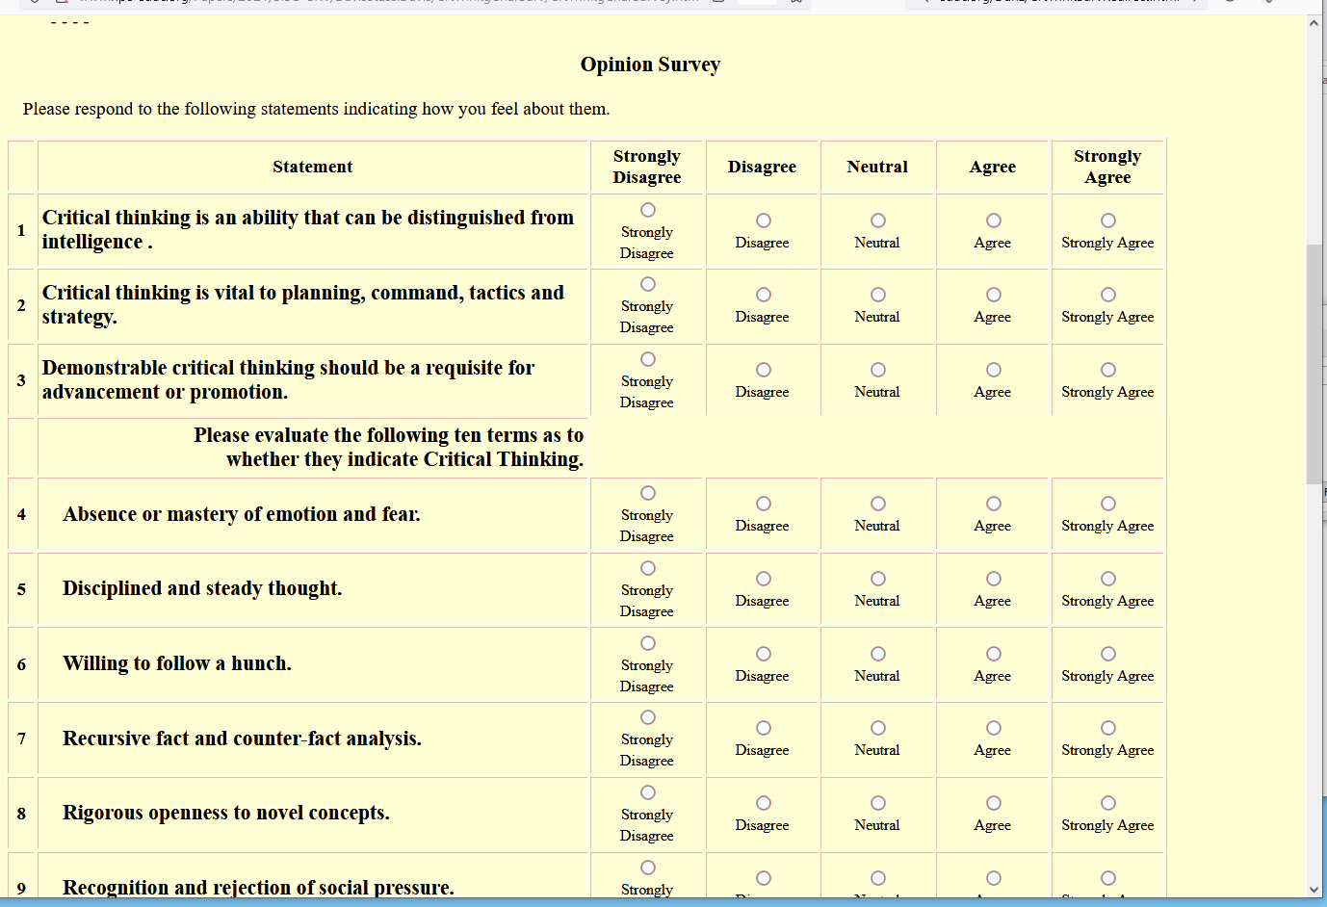
Figure 1. Informal Ethnographic Survey on Critical Thinking

A survey a diverse group of military personnel was conducted. There was no ability to do a carefully circumscribed and statistically sophisticated study, value was still to be realized from conducting an ethnographic study of a small number (n=<100) of veterans. An instrument was designed to seek input on the definition of the term “critical thinking,” observable indicia of it, and its relative value in military service. 38 veterans, E-5 through O-8 , were invited to participate.

Participants were further asked to invite veterans and civilians they knew that would be likely to respond. This technique is called “snowball sampling”; many feel these surveys have both limitations and legitimate uses (Noy, 2008). The survey consisted of a brief introduction, collection of demographic data, four questions on term familiarity and a 13-item Likert-style survey about critical thinking. That was followed by text boxes about the issues under consideration. HTML "forms" for the page and PHP code for the data management. The top of the survey instrument appears in Figure 1.

The data management program first checks for completion and then evaluates the Likert data for non-compliance (e.g. no answers or all Likert answers the same value.) Discrepancies are noted and the participant is invited to go back one page and complete the form. While there is no rigorous security to prevent specious data being maliciously submitted, the program has a function, which checks to see if the input internet address is the same as the current one, in which case a pop-up window advises the user to contact the webmeister to resolve the matter.
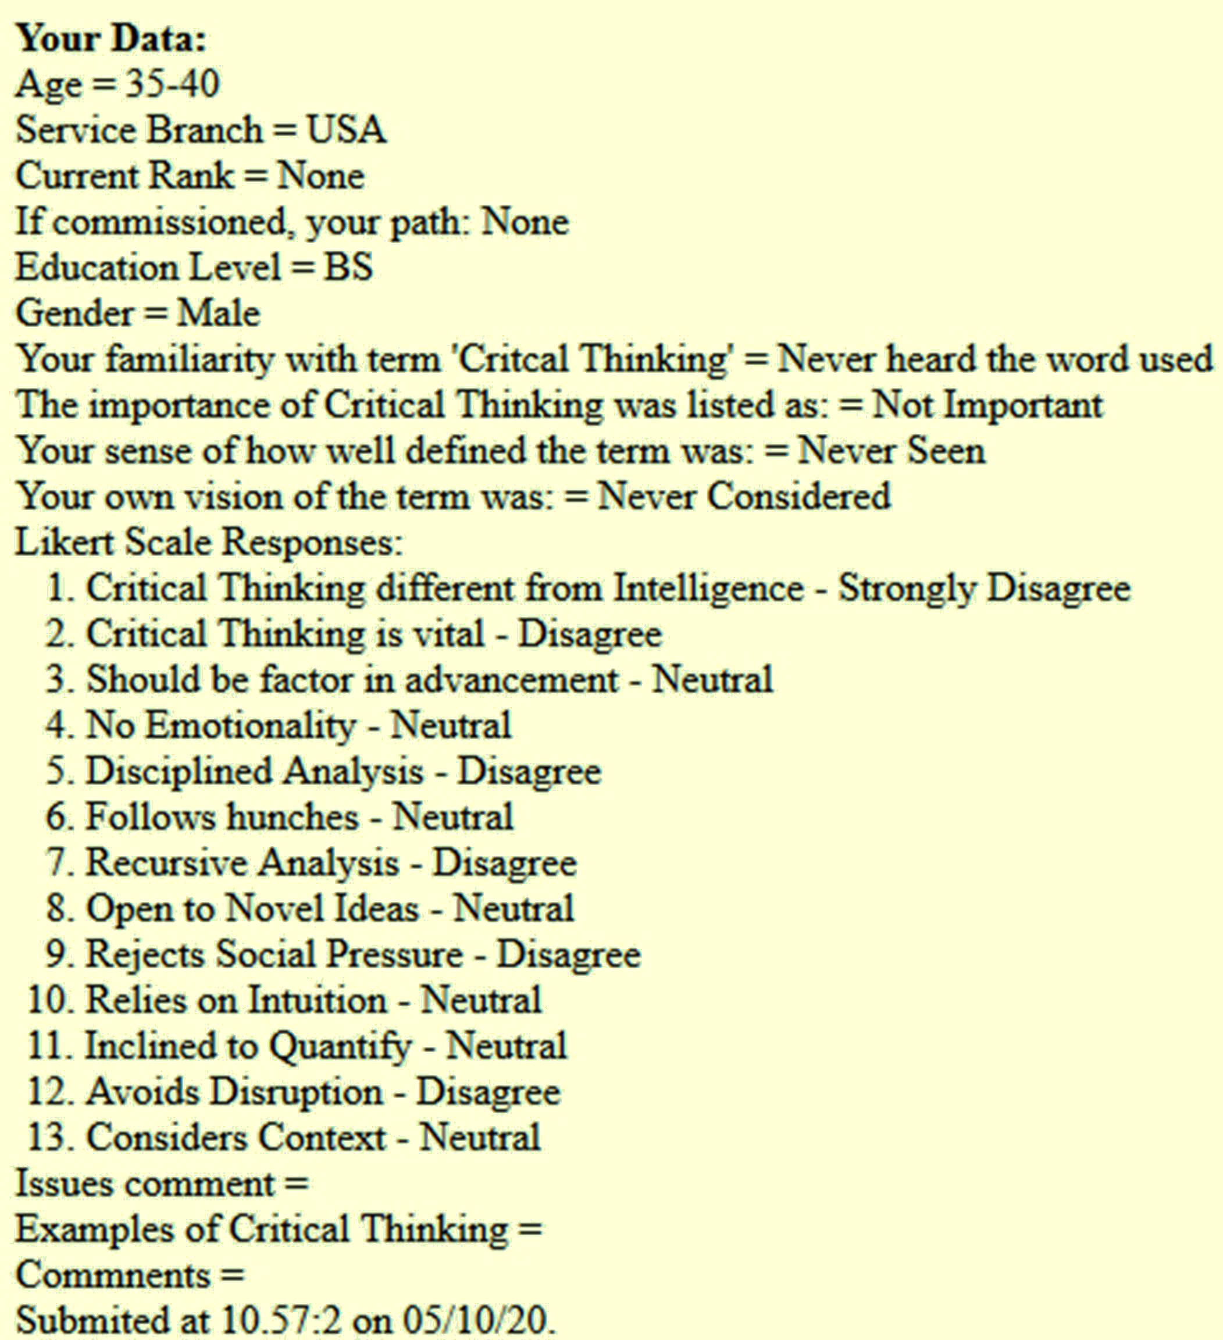
Figure 2. User response display

The data submitted, along with the text, was forwarded via eMail to the team for consideration and analysis. This function also had the benefit of providing a back up of the data, retained on the eMail server, should something go awry and the data files themselves be lost for any reason. Of the 38 invitees, no one reported technical issues pertaining to or complaints about the survey. As data is still being collected, updated data will be provided at the paper’s presentation in early December and available from the development team after the conference.

The users’ answers were then reflected back to the user as is shown in Figure 2 to the left. This page ended with an expression of the developers’ thanks and a reminder for the participant to contact other potential participants for their submission.

Most of these early responses submitted did not include any input in the three closing text boxes. The reason for this is not certain, but many of the participants had sent the developers personal eMails and two even made phone calls. As the snowball effect takes hold, more responses in the text boxes may occur. In order to facilitate the more direct method of response, more contact data was added to the user response confirmation page. The PHP data management program stored the raw data, with the exception of the suggestions additions and examples from the closing three text boxes. It was determined that there was no need for an elaborate relational data base. The content from the three text boxes, were requests for Other Characteristics, Examples of critical thinking or the lack thereof, and Suggestions, were collected This reflected a main goal: hearing what a broader group thought rather than just relying on the team. The effort did not seek to show any proof of a particular thesis or any characterization of an entire defense community. The data were kept in a comma separated values (CSV) flat file.

The issue of whether the need for critical thinking and enthusiasm about this issue is worthy of further study is being analyzed. A more sophisticated instrument, a better focused set of questions and a new look at project goals may result in ascertaining a wider mandate to pursue augmented training or a focused education initiative. One of the participants did report an effort in the US Army to address this issue and contact with that effort will be initiated.

The next issue was how to make sense of the data. As already noted, the first insight was a confirmation and quantification of how important this issue is to the American military personnel. But the target issues themselves required some more detailed consideration. In this paper, the analysis is not the main thrust of the paper, so only the raw data amalgamations will be reported. The data and the more informal insights to be drawn therefrom are left to the reader alone to evaluate and internalize. The team felt well-served by this bolstering of their own impressions and that of the previous scholars who had addressed these issues. Term familiarity responses are set forth in Table 1.
Table 1. Term Use and Familiarity (N=60)
Familiar with term: | Term Importance: | Definition experience: | Own vision of term:
4 Never heard the word used  4 Have heard others use it  16 Have used it a little  20 Used it and am interested  6 Deeply Involved  10 Participated in Discussion | 11 Not Important  0 Interesting  24 Useful Concept  0 Important to Others  15 Important to me  10 Vital to all | 10 Never Seen  4 No Consensus  19 Competing Definitions  27 Mine Evolving  0 Well defined consensus  0 Universal Term | 4 Never Considered  2 Nebulous  23 Open to new  11 Will Adopt Others  20 Comfortable with mine  0 Committed to mine

In analyzing the survey respondents’ evaluation of the characteristics offered, it was noted, somewhat to the surprise of the authors, that there were a significant number of respondents who were open to accepting intuition and willing to follow hunches as valid critical thinking processes. This had not been foreseen by either the officers or educators. This again is reflective of the need to better define the standards used in term definition and quantification metrics. Such common understanding, as fraught with the perils of disagreement they may be, are important in the authors' analysis of the issues of concern to the standards' community. An example may be a concept such as Intelligence Quotients; even while that concept is condemned by many; it is a generally accepted and useful standard of an abstract capability and its evaluative instruments. Some other early impressions were confirmed as in Table 2.
Table 2. Likert Survey Responses (N=60)
Characteristics | Strongly  Agree | Agree | Neutral | Disagree | Strongly  Disagree
Critical Thinking different from Intelligence | 31% | 49% | 17% | 3% | 0%
Critical Thinking is vital | 74% | 26% | 0% | 0% | 0%
Should be factor in advancement | 34% | 40% | 26% | 0% | 0%
No Emotionality | 6% | 46% | 20% | 14% | 14%
Disciplined Analysis | 49% | 49% | 3% | 0% | 0%
Willing to follow hunches | 11% | 40% | 34% | 14% | 0%
Recursive Analysis | 37% | 51% | 11% | 0% | 0%
Open to Novel Ideas | 40% | 43% | 3% | 14% | 0%
Rejects Social Pressure | 29% | 54% | 14% | 0% | 3%
Relies on Intuition | 6% | 40% | 17% | 29% | 9%
Inclined to Quantify | 31% | 51% | 11% | 6% | 0%
Avoids Disruption | 11% | 17% | 26% | 37% | 9%
Considers Context | 40% | 34% | 26% | 0% | 0%

Current Pedagogies
There are three recognized pedagogies that have shown promise in inculcating both metacognition and critical thinking. For want of a better set of terms, this paper will discuss these three as: Didactic, Socratic and Constructivist. These terms are commonly used, but just as commonly are disputed as to what they mean and how they should be used. However, for this paper to proceed, it is necessary to have an understanding about the terms that are to be employed here. For that reason, the following comments are offered, not to resolve the competing issues, but to define how the terms will be applied in this paper. In an artificially plain-language format, the Didactic method will be taken to mean that situation in which a “knowing entity” has information needed by an "unknowing group" and resolves that issue by telling the “unknowing group” the needed information. This approach is intuitive and is commonly available in the classroom and is often called the “lecture method” (Paulet al., 1997). Socrates found this method fell short of creating the future ability for the student to learn and unduly made the student reliant on the teacher. His Socratic method was based on propounding a series of challenges to the “unknowing entity”, thereby forcing them to learn the truth on their own. This allowed them to be better able to learn things they did not know now, but would need to know in the future. This approach has many benefits, but is difficult to use and is not facile in subjects such as teaching calculus, which is significantly more complex and abstract than is learning how to be a Greek citizen in 400 BC. The last method we shall address is Constructivism. That term will be used to identify the approach that has the “knowing entity” creating a series of tasks or challenges designed to cause the “unknowing entity” to have to master the needed skills in order to achieve the identified goal. This method can be understood to use the goal-driven activities in a germane environment in the place of the incisive questions of the Socratic master (Ng'ambi & Johnston, 2006). All three methods have their strengths, weaknesses and hazards.

There are recognized approaches to using all three of the pedagogies mentioned above to inculcate both critical thinking and metacognition. The Didactic approach works by training the student to memorize and then invoke a set of rules. These rules are on the order of: establish the situation, identify the challenge, consider a solution, review supporting facts for this solution, consider opposing facts, implement the solution, test, evaluate, and repeat the cycle (Vallillee, 1968). There is some supporting evidence that this track is not only effective, it has been shown to be durable (Heijltjeset al., 2014). The Socratic Method naturally and profoundly establishes critical thinking and metacognitive skills to provide the student a defense against the incessant grilling by the Socratic mentor (Matthews, 1998). The authors are more in accord with the adherents of the Constructivist approach who would endeavor to attain the same result, suggesting that getting to the same place by putting the student into a situation more like that they would face outside of the walls of academe. This result may be even more likely to find applicability in the high stress combat environment (Zajda, 2018).

If these approaches are known, one may ask why they are not being implemented. There are hurdles that have to be overcome for them to work. These hurdles may be manifold, but they must be overcome. Without presuming to establish them in an exhaustive way, the following is intended to identify some major impediments to each of the three previously listed pedagogies. Taking them in the order mentioned above, one of the major weaknesses of the Didactic method is its focus on the Didacts themselves and the isolation of the students from the life that awaits them. A common complaint comes from iconoclastic educators like John Taylor Gatto. They have long held that any education system that is singularly centered on the students’ satisfying their teachers will fail in imparting any sense of applicability of mastery of the subject (Gatto, 2002). This also may doom any sense of motivational immediacy in the students. The authors experience is that there has been a manifest failure of the Writing Across the Curriculum movement in the US, which is strong evidence that that teaching a skill detached from a real-life goal may not obtain after the school bell rings. The Socratic Method avoids many of those pitfalls, but every top Law School in the country will attest to the difficulty of finding effective Socratic professors. The other issue is the small class size required to adequately implement this method, especially difficult in the DoD, with its hectic operations schedules and geographic dispersions. Constructivism also speaks to some of these issues, but also has trouble with the need for hero teachers, small instructional cohorts, and creative instructional-environment creators. Staffing, scheduling, sustaining, and assessing any new approach will potentially be facilitated by the emerging technologies of the computational sciences, as discussed below.

Another approach that would also be enhanced by the implementation of virtual human teachers, tutors, and testers is the reawakened interest in the multidisciplinary and multipedagogy approach known at the Trivium and Quadrivium (Hepner, 2015). Based on the curricula of classical education, the Trivium consists of the liberal arts study of grammar, logic (or dialectic) and rhetoric followed by the more advanced study in the Quadrivium of arithmetic, geometry, astronomy and music (Littlejohn & Evans, 2006). The Trivium seems particularly well suited to enhancing both critical thinking and metacognition. The interest in this resurgence of a more classical approach to inculcating critical thinking was championed in the early 20th Century by Charlotte Mason and has a growing number of adherents (Anderson et al., 2004), especially in private schools. The Trivium/Quadrivium approach focuses on the students’ development of a generalized metacognitive and disciplined approach to analysis in a real-world exploration paradigm. It includes a recognition of the benefits of the discipline of the memorization of classical literature segments and the appreciation of the fine arts, especially the benefits of the connection of the study of music with the mastery of the mathematical skills (Barroso et al., 2019). The implementation of the Trivium/Quadrivium multi-pedagogy requires the unique ability to switch rapidly from Didactic to Socratic, a capability that may be more effective if provided by computer agents than by many classroom instructors, as discussed below.

Computer Agents and Virtual Humans

Current Status
The work described below supports the notion that there is a large and growing capability in simulation, virtual humans, global communication, and computer agents. This work suggests that all of these are highly probable as detours around the hurdles and liberty from the constraints mentioned above. Before the paper examines how, it would be appropriate to outline some of these technologies, both in terms of where they are and where they are going. The above survey is of impediments to the more effective inculcation of critical thinking and metacognition. They seem to fall into three basic categories:
- lack of ability to provide individualized germane and motivating educational learning environments,
- lack of availability of individual attention 24 x 7, and
- paucity of dynamic, charismatic mentors, tutors and instructors.

Current development is being driven by expanding technologies. A seemingly unfettered stampede of new technologies replace and make obsolete technologies that the public hardly had a chance to adopt (Christiansen, 2013). There have been advances in the responsiveness of virtual humans, the two-way transmissions of data and images with reduced latencies, increased data transmission bandwidths, Natural Language Processing accuracy, Artificial Intelligence (A/I) usefulness and neural net training efficiency. On the hardware side, General Purpose Graphics Processing Units (GPGPU’s) have provided computational headroom for increasingly human-like behavior.

There are applications of these technologies in everyday use in the civilian world. In many ways this has led the development of system functions that the DoD can exploit in real-time. Anyone who has served in the military can tell of occasions in which the civilian world had better, more durable, cheaper and more useable products than the military. Establishing the need for implementing these system functions to address the current DoD issues is the first step in future advances in national security. The technologies which are being addressed here are not just abstract visions for the future, e.g. NLP allows for the hands free oral-speech access to virtually any factoid in the world with latencies of just a few seconds. High resolution images and videos are available at any time via networking infrastructures.

New Capabilities
Many of the potential hurdles to advancing these new technologies seem to be beyond the reach of current computer capabilities, both in hardware system functions and software sophistication. (Yao et al., 2018). The advent of promising emerging technologies and approaches is worthy of consideration here. The author's experience in military training roles, is that to produce defense utility, training a “virtual human” should be orders of magnitude faster than that necessary to develop and field live human instructors. The major impediment here is the long neural net training times for so complex a set of behaviors. The amount of material to be input and then recursively looped through a training algorithm presents a daunting obstacle for sophisticated behaviors like graceful conversation initiation.

A novel software approach to data analysis is Deep learning, which uses layers of computational units to learn data representations at multiple levels of abstraction. This may emerge as the leading methodology for developing NLP applications (Young et al., 2018) & (Pouyanfar et al., 2018). The reader not familiar with the terminology in this discipline may benefit from a short introduction into terms and methods. One of the basic concepts in this field is that of Convolutional Neural Network (CNN). Word vector representation or word embeddings learned using neural networks capture the meaning of words by embedding similar words closer to each other in vector space (Mikolov et al., 2013). Distance and relative direction of words can capture semantic meaning. The word for queen can be approximated using vector arithmetic: queen = king – man + women. These word embeddings form the basis for input to deep CNN networks for a variety of NLP applications, including topic classification and sentiment analysis. In question answering (QA) applications CNN’s are used to select semantically similar answers from an existing knowledge base. CNN processes sequential data, such as sentences, by using windowing, but the window size is fixed at training time. Word context outside the window is ignored. Recurrent Neural Networks (RNNs) are designed to processes sequence data. RNN adds feedback loops into the neural network, which enables it to retain state information and process variable length of input sentences. A popular recurrent network is Long Short-Term Memory (LSTM), which introduced the notion of input, output and forget gates to regulate the flow of information (Hochreiter & Schmidhuber, 1997). This ability to remember long distance information enables LSTM to perform well in applications like natural language translation and in facilitating dialogue systems.

Digital computing has many physical limitations that have, as yet, not been overcome (McGettrick, et al., 2006). One of the alternatives frequently offered is Quantum computing. It has been seen as an improvement to digital computing since the Nobel Laureate Richard Feynman published his seminal paper in 1982. In that paper he held that: “… with a suitable class of quantum machines you could imitate any quantum system, including the physical world.” (Feynman, 1982). Quantum Computers do not use binary bits; they use qubits, which can represent multiple values simultaneously. This gives an almost unimaginable power in certain areas, but yields only probabilistic results. There is one operational design on the market: while not a general purpose quantum computer, this machine requires extremely cold temperatures (15 milliKelvin) to create a useable quantum effect (Lucas et al., 2013).
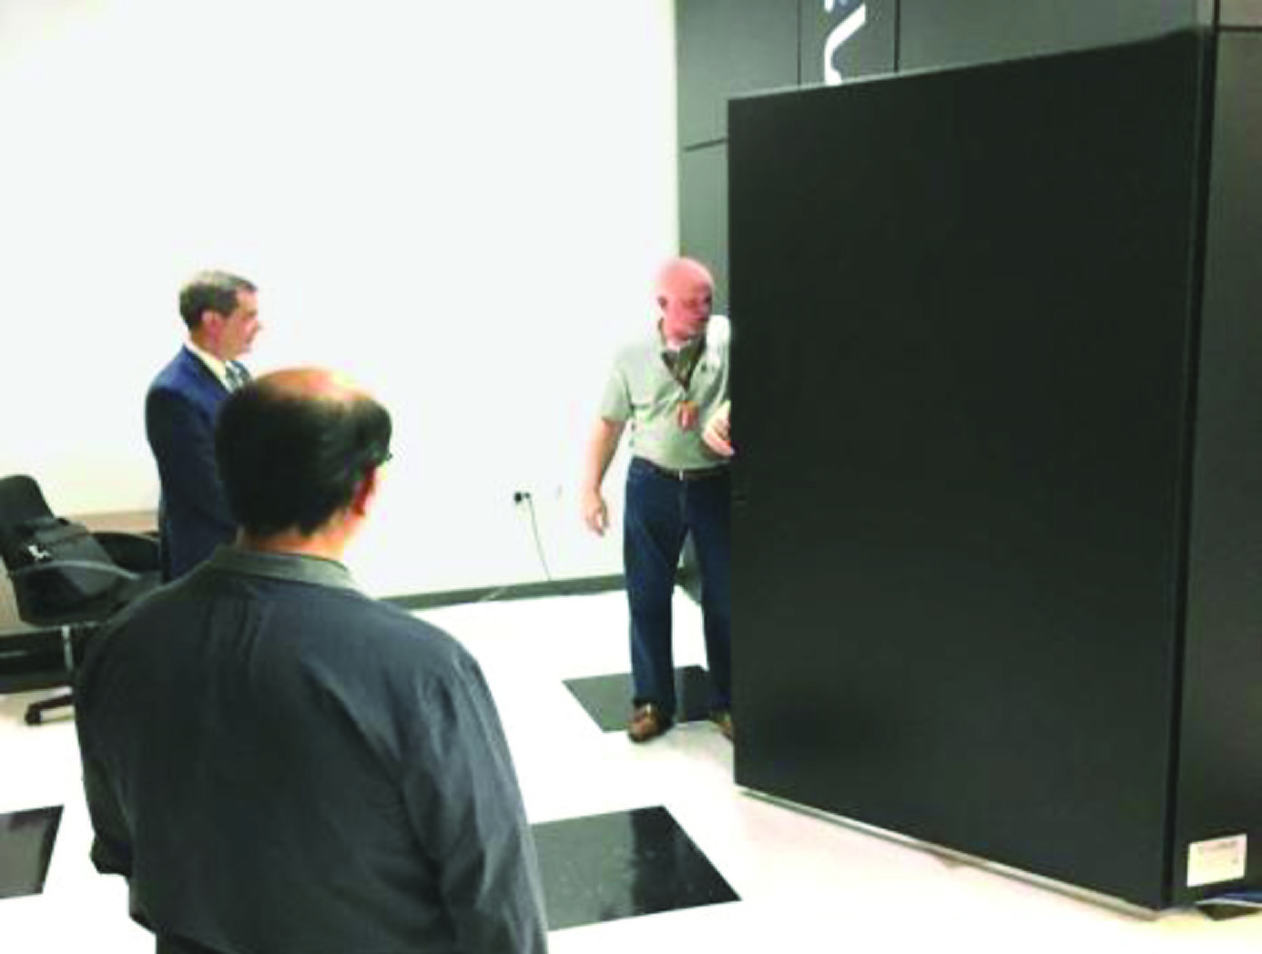
Figure 3. Case size image

At the quantum computing center in Marina del Rey California there is a D-Wave open-system adiabatic quantum annealer that is capable of sampling from Boltzmann machine network with loops, specifically chimera graphs. Although the current machine has a limited number of qubits (~2,000) and intralayer connections (six), it has been shown that the extra representational power afforded by these extra edges can decrease the training time and improve learning (Yao et al., 2018). This advance should enable more realistic and “human” virtual computer agents, especially when the number of qubits and interconnection pathways increases. These advances are significantly interesting and have attracted inquiries by government agencies, often about size, which is shown in Figure 3 to the left.

Widely used generative networks include auto-encoders, deep belief network (DBN), Deep Boltzmann Machines (DBM) and Generative Adversarial Networks (GAN) (Goodfellow et al., 2014). GANs can generate photo realistic faces (Karras et al., 2019), as well as novel paintings (Elgammal et al., 2017) and could also effectively enhance virtual humans. Please review the cited work for more detailed explication of advances.

Use in Other Domains
Experience has shown that, not only are there a range of military situations, technologies (Burmaogla, 2018), and organizational hierarchies, but these are becoming more dynamic, more complex and more transitory (Kott & Perconti, 2018). In response to this unremitting flow of new technologies over the course of a career, it seems most important to focus analyses on successful approaches, more than specific platforms and units. The insights from a system, proffered to facilitate a Squad Leader’s optimal control over a unit made up of human and non-human combat entities, may also illuminate how to best approach the control of an Unmanned Aerial Vehicle (UAV) pilot over a flight of Unmanned Aerial System (UAS) aircraft. Interoperability may not be universally feasible, but experience dictates a cautionary admonition not to become too insular, but remains open to other services’ advances in the human/non-human interfaces (Gong et al., 2001).

Another dimension of extensibility is the dual-use interest held by DoD development organizations. The issues discussed in this paper would be immediately extensible into civilian first responder contexts, but that may only be the beginning, providing a more human-like interface, critical in high stress situations, may have similar benefits in other important functions. One of these functions could be counseling, such as demonstrated in the SimCoach project (Rizzo et al., 2011), another may be assessment (Stewart, 1964) and yet another may be instructional environments, (Elstad & Davis, 2017. Additional implementations will no doubt occur to the reader. This paper asserts that it is incumbent upon the developers to abstract, identify, define and communicate their insights and approaches in this field, avoiding the tendency to focus solely on the task before them.

Progress in Virtual Humans
One useful emerging, technology is that of Virtual Humans. As that term is used in this paper, a wide range of virtuality is accepted, including using computer-selected video clips of a live human. A VH is a creation in virtual reality portrayed by an avatar which attempts to recreate the appearance, voice, feel, and interaction that a live human would produce. Using the advances in several new technologies, including natural language processing (NLP), virtual reality (VR), computer-generated imagery (CGI), machine learning, and virtual learning, live teachers can be presented. The uses, as well as the limits, of these tools are becoming evident, e.g. developers have developed programs that have been shown to be effective, e.g. SimCoach, New Dimensions in Testimony (NDT), PAL3, and others (ICT, 2019). These are studied as learning sciences, medical VR, mixed reality, narrative, social stimulation, virtual humans, and vision and graphics. The user interface has many forms, e.g. input via microphone, typed-text, menu options, etc. (Davis et al., 2020).

Early Evaluations
The SimCoach saw really gratifying advances in an automated computer agent. The SimCoach kept veterans on the phone longer for therapeutic sessions than did live counselors. PTSD patients talked longer and about more sensitive topics. In New Dimensions in Testimony, the two-way conversation in a museum were so life-like that the museum patrons started treating the electronic image like a human, weeping at the survivors tales of the death camps and even apologizing to the “survivor,” which was actually and obviously a recorded holographic image. Mentor Pal was a different, 2D approach and the students who were counseled by the virtual mentors gave the program very high marks for the computer agents’ “conversationality.” (ICT, 2019) Despite these successes, the question may be raised as whether this technology could be implemented to achieve the announced sophisticated goals of this paper. Most of the issues considered here have been analyzed and there is confidence that today’s technology could easily be adapted to new uses such as training and counseling. Experience in such programs as PAL₃ AI has revealed no issues that might preclude implementation.

Rethinking Critical Thinking and Metacognition

Considering Limitations
Naturally, there are always risks in a new approach and there is always the unexpected, but considering the issues faced in other programs, the developers can see no real issues in the way of extending the existing system functions over into a critical thinking/metacognition trainer or mentor. Time, staffing and effort are needed, but there are no apparent constraints to a full implementation by any competent organization. This is not to ignore the challenges to be met. Whether using a video-clip approach or an animated avatar approach, the success cannot be guaranteed until the prototype is demonstrated.

One issue is the need for hero teachers to be models or actors to create the data-base of potential answers. Assessing and presenting on-screen “presence” has always been a gamble, but the tried and true methods of the entertainment industry can be applied these efforts. It has been learned that vivacious and attractive people in person-to-person meetings typically translate well into on-screen personalities. Prudence requires that diversity issues must be studied and addressed. The investment in creating an entire corpus of an instructor’s answers is not so large as to preclude not fielding an instructor who did not exude the requisite charisma.

One challenge is developing sensors and sensitive software that can detect a “teachable moment” with the facility with which experienced teachers can recognize such an opportunity. Creating a video record, appropriately annotated in a way that alerted the computer that this was a teachable moment, would be a lengthy and daunting task. If such data were to be found or created, A/I techniques could eventually isolate the meaningful characteristics. The development team has found Table 4.1 useful in analyzing the best way to proceed. It rates the three pedagogical approaches versus the constraints outlined above. The Trivium/Quadrivium approach merges all three pedagogies. Such and approach might also admit of a consideration for standardization.
Table 4.1. Training Method Hurdle Matrix and Beneficial Characteristics
 | Individualization | 24 X 7 Access | Teacher Charisma
Didactic | Classroom Size of 1; self paced | Open class scheduling | 1 hero teacher, but scalable to all
Socratic | Focus questions on 1; others not idled | Mentor available globally | Private forum for challenge
Constructivist | Different environment for each student | Pause button on situation | Different levels of coach’s support

Implementing the Best Pedagogy
In selecting the best pedagogical approach, one of the issues to be addressed is the retention of the educational impact in the future by the subject. Would refreshers courses be necessary? How resilient would the behavior be in combat? Would these techniques be susceptible to subsequent peer pressures? Careful attention to metrics and input from professional pedagogists would be more than useful; it would be mandatory. This caveat is made with the concomitant assertion that many developers have seen these issues before and have successfully met them. As mentioned before, one of the important metrics would be assuring the beneficial retention of and utilization of the critical thinking and metacognitive skills. To truly measure that metric, longitudinal studies would be required. One technique that has been used in the past is visiting the students some period of time after their training. This was done once under the thin artifice of just wanting to know if new issues had arisen in their environment for which it was thought his new training should now succeed. Then the development team members were pleased to observe that the students implemented effective critical thinking approaches in resolving their current issues. Standard commonality of language is a sine qua non here.

Yet another problem may need to be addressed. The development team has witnessed, both during development and on active duty, that there is a tendency to resist any required program that interferes with either “down time” or the “real job.” That has been known to dramatically reduce the commitment to utilization of the training objectives. This result is similar to the high-school students’ not uncommon view of education as having no real meaningful impact on them, merely being a way that the system beleaguers them for no apparent reason and leading to their often observed goal of finishing the required courses with as little effort and as little impact on their day-to-day lives as possible. The technologies and approaches described above may allow recursive evaluation of the ability to “tailor” programs to meet each student’s individual motivation foci. A/I programs are envisioned that can monitor and enhance response to individual sensitivities throughout the service members' career, driven by performance evaluation insights.

Measuring Success
A major issue in this area is the lack of metrics. Without metrics, it is difficult, if not impossible, to recognize whether innovative steps are having any impact. This is an extension of the lack of consensus as to what critical thinking means. There are organizations that specialize in creating standards and psychometricians can develop tools, once they are given a set of parameters on which to evaluate their instruments. A concerted effort is required to pierce the interdisciplinary barriers still found in the military and on the campuses. Some of the emerging technologies discussed below may enable analyses that will facilitate this process, assuming new standards are used.

Making Use Possible
Experience has shown that this approach would require a significant amount of planning and forethought. The magnitude and difficulty of the design effort would depend on what was held out by the DoD program manager as required system functions. Then there would need to be a significant Validation, Verification and Test effort. The technologies cited above are workable today and the emerging technologies may make significant enhancements in both the “humanness” of the computer agents and the efficacy of the implemented pedagogical approaches.

Discussion

Potential Contributions of this Concept
There is a real and unmet need for critical thinking training and metacognition skills. Many of the remedial programs used in society today have devolved into bureaucratic burdens, where all too often the only metric of success is class attendance. As has been suggested above, emerging technologies may better address all of these issues and in a scalable way. The DoD environment imposes a most challenging training situation with its unpredictable operations schedule, 24-hour duty cycle and globally dispersed personnel. The global network and the computer agents’ scalability, individualization, pedagogy adherence, and efficacy may well prove enabling. The path forward holds the promise of an entirely new paradigm for leveraging the best, most compelling and diverse set of instruction to prepare the warfighter by maximizing their use of intelligence, in both of the senses of that word. The authors hold that this will not be forthcoming or of optimal use unless standardization allows valid evaluation and use by all forces concerned.

The emerging system functions can be foreseen today as enablers of an even more powerful set of A/I programs to deliver a sagacious, sensitive and personable mentor, tutor and instructor 24 by 7, anywhere there is network connectivity. The data adduced above indicates that such a capability has the real potential to improve battlefield performance, reduce combat losses, regularize policy instruction and individualize training, mentoring and education. The technical feasibility of these programs has been shown already, but two issues need to be resolved before they can optimally be implemented: an acceptance by the command structures that such a program has value and the implementation of the emerging system functions of quantum computing, deep learning, A/I programs, NLP interfaces, and high-production value videotaping of charismatic and engaging virtual conversation computer agents.

All of these will require a new willingness to make individual advances available to all communities in the defense realm and a new commitment to breaking down the walls of the “silos” to foster more cross-disciplinary development. All of these can combine to finally shed the oft cited aphorism that the military personnel’ commanders are always fighting the last war. As shown above, the technology is there and can be implemented,..

The need for terminology standards, standards for metrics and standards for data formats and approaches are required and an aggressive effort is required to insure a commonality of systems and measurements. In matters military, it is not just cost and efficiency that are of concern; lives, missions and national survival may be at risk.

Acknowledgements

The authors would like to thank USC PAL₃ AI team leaders, the Doctors Benjamin Nye and William Swartout for their support and guidance. Much of this work was supported by grants from the Office of Naval Development's STEM Program (ONR N00014-16-1-2820) and by students supported by the National Science Foundation Development Experience for Undergraduates program (NSF 1560426). Nevertheless, the positions taken in the paper are the authors’ own and do not represent in any way the views of the Department of Defense or the US Government.

References

Anderson, E., Macaulay, S. S., Beckman, J., Scott, B., & Cyr, M. S. (2004). When children love to learn: A practical application of Charlotte Mason's philosophy for today. Crossway. Wheaton, Illinois.
Barroso, C., Ganley, C. M., Hart, S. A., Rogers, N., & Clendinning, J. P. (2019). The relative importance of math‐and music‐related cognitive and affective factors in predicting undergraduate music theory achievement. Applied Cognitive Psychology, 33(5), 771-783.
Bond, B., & Cave, N. (2009). Haig: A Re-Appraisal 80 Years On. Pen and Sword.
Burmaogla, S., & Saritas, O. (2017). Changing characteristics of warfare and the future of Military R&D. Technological Forecasting and Social Change, 116, 151-161.
Chowdhury, G. G. (2003). Natural language processing. Annual review of information science and technology, 37(1), 51-89.
Collobert, R., & Weston, J. (2008, July). A unified architecture for natural language processing: Deep neural networks with multitask learning. In Proceedings of the 25th International Conference on Machine Learning
Christensen, C. M. (2013). The innovator's dilemma: when new technologies cause great firms to fail. Harvard Business Review Press.
Clausewitz, von, C., (1832, re-pub 2007) On War, Create Space, New York, New York.
Danchev, A., (1998). Alchemist of War: The Life of Basil Liddell Hart. Nicholson Harper Collins Publishers London
Dewey, J., (1910). How we think. D.C. Heath and Company. Lexington, MA. p 95.
Elgammal, A., Liu, B., Elhoseiny, M., & Mazzone, M. (2017). CAN: Creative adversarial networks, generating" art" by learning about styles and deviating from style norms. arXiv preprint arXiv:1706.07068.
Elstad, E.C., & Davis, D.M. (2017). Implementing Innovative Constructivism: An Architected Approach to Enhancing STEM Education. In the Proceedings of the Interservice/Industry Simulation, Training and Education Conference. Orlando, Florida, 2017
Feynman, R., (1982), "Simulating Physics with Computers", International Journal of Theoretical Physics 21 (6–7): 467–488.
Flavell, J. H. (1979). Metacognition and cognitive monitoring: A new area of cognitive-developmental inquiry. American Psychologist, v34 n10 p906-11.
Flavell, J. H. (1981). Monitoring social cognitive enterprises: Something else that may develop in the area of social cognition. Social cognitive development: Frontiers and possible futures, 11, 272-287.
Fu, Z. (1993). Autocratic tradition and Chinese politics. Cambridge University Press.
Gatto, J. T. (2002). Dumbing us down: The hidden curriculum of compulsory schooling. New Society Publishers.
Gong, L., Nass, C., Simard, C., & Takhteyev, Y. (2001). When non-human is better than semihuman: Consistency in speech interfaces. Usability evaluation and interface design: Cognitive engineering, intelligent agents, and virtual reality, 1558-1562.
Goodfellow, I. J., Pouget-Abadie, J., Mirza, M., Xu, B., Warde-Farley, D., Ozair, S., ... & Bengio, Y. (2014). Generative adversarial networks. arXiv preprint arXiv:1406.2661.
Heijltjes, A., Van Gog, T., & Paas, F. (2014). Improving students' critical thinking: Empirical support for explicit instructions combined with practice. Applied Cognitive Psychology, 28(4), 518-530.
Hepner, M. R. (2015). The erosion of critical thinking development in post-secondary education: The need to return to liberal education. In Handbook of Research on advancing critical thinking in higher education (pp. 68-96). IGI Global.
Hochreiter, S., & Schmidhuber, J. (1997). Long short-term memory. Neural computation, 9(8), 1735-1780.
Hogan, D. W., Fisch, A. G., & Wright, R. K. (2003). The Story of the Noncommissioned Officer Corps: The Backbone of the Army. Center of Military History, United States Army.
ICT, (2019). Virtual Humans, Retrieved 17 February 2019 from: http://ict.usc.edu/groups/virtual-humans/
Davis, D. M., Rosenberg, M., Davis, M.C., Burns, D.P., Jaksha, E., & Guizani, I. (2020). Proactive Natural Language Processing: Addressing Terminology Disparity and Team Coalescence. In the Proceedings of the SISO Simulation Innovation Workshop. Orlando, Florida: SISO
Karras, T., Laine, S., & Aila, T. (2019). A style-based generator architecture for generative adversarial networks. In Proceedings of IEEE Conference on Computer Vision and Pattern Recognition (pp. 4401-4410).
Keegan, J. (1993). A history of warfare. Vintage Books, New York, New York.
Keegan, J. (2011). War and our World. Vintage Books, New York, New York.
Kott, A., & Perconti, P. (2018). Long-term forecasts of military technologies for a 20–30 year horizon: An empirical assessment of accuracy. Technological Forecasting and Social Change, 137, 272-279.
Littlejohn, R., & Evans, C. T. (2006). Wisdom and eloquence: A Christian paradigm for classical learning. Crossway, Wheaton Illinois.
Livingston, J. A. (2003). Metacognition: An Overview. https://files.eric.ed.gov/fulltext/ED474273.pdf
Lucas, R. F., Wagenbreth, G., Tran, J.J., Pratt, D. R. & Davis, D. M. (2013) "Practical Adiabatic Quantum Computing: Implications for the Simulation Community." in the Proceedings of the Interservice/Industry Simulation, Training and Education Conference, Orlando, Florida, 2013
Mahan, A.T., (1890). The Influence of Sea Power Upon History, 1660-1783. Little Brown and Company, Boston, Massachusetts
Mathematics Educator, (2020). Is Metacognition ever bad? Retrieved on 22 March 2020 from: https://matheducators.stackexchange.com/questions/10939/is-metacognition-ever-bad.
Matthews, M. R. (Ed.). (1998). Constructivism in science education: A philosophical examination. Springer Science & Business Media.
McGettrick, A., Boyle, R., Ibbett, R., Lloyd, J., Lovegrove, G., & Mander, K. (2005). Grand challenges in computing: Education—a summary. The Computer Journal, 48(1), 42-48.
Mikolov, T., Sutskever, I., Chen, K., Corrado, G., & Dean, J. (2013). Distributed representations of words and phrases and their compositionality. arXiv preprint arXiv:1310.4546.
Moore, T. (2013) Critical thinking: Seven definitions in search of a concept. Studies in Higher Education, 38(4), 506-522.
Mrazek, R. J. (2008). A Dawn Like Thunder: The True Story of Torpedo Squadron Eight. Little, Brown.
Murray, J. M. (2016). Civil War Infantry Tactics: Training, Combat, and Small-Unit Effectiveness by Earl J. Hess. Journal of Southern History, 82(4), 937-939.
National Archives (2020), Military Records: Vietnam War U.S. Military Fatal Casualty Statistics. Retrieved 24 April 20 from: https://www.archives.gov/research/military/vietnam-war/casualty-statistics#category.
Ng'ambi, D., & Johnston, K. (2006). An ICT-mediated Constructivist Approach for increasing academic support and teaching critical thinking skills. Educational Technology & Society, 9(3), 244-253.
Noy, C. (2008). Sampling knowledge: The hermeneutics of snowball sampling in qualitative development. International Journal of social development methodology, 11(4), 327-344.
Paul, R., Elder, L., & Bartell, T. (1997). A brief history of the idea of critical thinking. Retrieved July, 2020 from https://wisconsinhistory.org/turningpoints/pdfs/workshophandbook.pdf
Pouyanfar, S., Sadiq, S., Yan, Y., Tian, H., Tao, Y., Reyes, M. P., ... & Iyengar, S. S. (2018). A survey on deep learning: Algorithms, techniques, and applications. ACM Computing Surveys (CSUR), 51(5), 1-36.
Randolph, H. L. (1905). Biographical Sketches of distinguished officers of the Army and DoD. Page 87. Retrieved on 02Dec21 from: https://books.google.com/books?id=4iIZx9QohXIC&printsec
Rizzo, A., Lange, B., Buckwalter, J. G., Forbell, E., Kim, J., Sagae, K., ... & Parsons, T. (2011). SimCoach: an intelligent virtual human system for providing healthcare information and support. International Journal on Disability and Human Development, 10(4), 277-281
Romainville, M. (1994). Awareness of cognitive strategies: The relationship between university students' metacognition and their performance. Studies in Higher Education, 19(3), 359-366.
Sanders, M., & Moulenbelt, J. (2011). Defining critical thinking: How far have we come?. Inquiry: Critical Thinking Across the Disciplines, 26(1), 38-46.
Scales, R.H., (1976). Artillery in Small Wars, the Evolution of British Artillery Doctrine, 1860-1914, (Doctoral dissertation, Duke University, 1976). ProQuest.
Scales, R.H., (1976). Artillery in Small Wars, the Evolution of British Artillery Doctrine, 1860-1914, (Doctoral dissertation, Duke University, 1976). ProQuest.
Shakespeare, W. (1599). The Chronicle History of Henry the Fifth. Act III, Scene II, Lines 1187 -1264. Retrieved on 10 July 2001 from http://shakespeare.mit.edu/henryv/full.html .
Shaw, K., Davis, D.M., Rizvi, S.Z., & Davis, M.C. (2019). Quantum Computing: Evaluating Potential Quantification of Projective Psychological Test Scoring. In the Proceedings of the ModSim World Conference. Norfolk, Virginia
Stewart, P (1964). Found in: 378 U.S. at 197 (Stewart, J., concurring), US Supreme Court Decisions.
Tetlock, P. E., & Gardner, D. (2016). Superforecasting: The art and science of prediction. Random House.
Tolstoy, L. (2008). War and peace. Vintage Classics, New York, New York. First published in 1869.
Vallillee, G. (1968). Lucretius, Virgil and the Didactic Method. Echos du monde classique: Classical news and views, 12(1), 8-12.
Visser, Jan & Visser, Muriel (2019). Seeking Understanding: The Lifelong Pursuit to Build the Scientific Mind. Leiden: BRILL.
Walters, K. S. (Ed.). (1994). Re-thinking reason: New perspectives in critical thinking. SUNY Press.
Wiktionary, (2020). Critical thinking. Retrieved on 18 April 2020 from the internet at: https://en.wiktionary.org/wiki/critical_thinking.
Withers, C. W. J. (2008). Placing the Enlightenment: thinking geographically about the age of reason. University of Chicago Press.
Yao, K-T., Davis, D. M., Liu, J. J., & Kaimakis, N. J. (2018). New Technologies to Enhance Computer Generated Interactive Virtual Humans. In the Proceedings of the SISO Fall Simulation Innovation Workshop. Orlando, Florida: SISO
Yao, K-T., Davis, D. M., Liu, J. J., & Kaimakis, N. J. (2018). New Technologies to Enhance Computer Generated Interactive Virtual Humans. In the Proceedings of the SISO Fall Simulation Innovation Workshop. Orlando, Florida: SISO
Young, T., Hazarika, D., Poria, S., & Cambria, E. (2018). Recent trends in deep learning based natural language processing. IEEE Computational Intelligence Magazine, 13(3), 55-75.
Zajda, J. (2018). Effective constructivist pedagogy for quality learning in schools. Educational Practice and Theory, 40(1), 67-80.

