Stemming Migrations from Engineering to Liberal Arts:
Enhanced Computer-Generated Mentor Standards

Daniel P. Burns
Home Ports Solutions, LLC.
125 East 44th Street
Savannah, GA 31405
daniel.p.burns@homeportssolutions.net

Dan M. Davis & Jennifer H. Nolan
Catholic Polytechnic University
1028 N Lake Ave MC 207
Pasadena, CA 91104
{ddavis & jnolan} @catholicpolytechnic.org

Mark C. Davis
Wood Duck Research, Inc.
129 Wood Duck Loop
Mooresville, NC 28117
davismc@ieee.org

Keywords:
Virtual Mentors, Engineering Studies, Computer-Generated Conversations, Natural Language Processing, & Virtual, Augmented & Extended Reality.

ABSTRACT: One major thesis of this paper is that Computer Generated Realities provide promise in addressing a major impediment to providing adequate numbers of engineering professional. These personnel are needed to sustain the technical ascendancy of the United States and its allies. The subject impediment is the flow of Schools of Engineering students over to Colleges of Arts and Sciences before the students' second years at the university. Many who have studied this issue cite data supporting that more than half of incoming engineering students abandon the rigors of their technical training for the more appealing entertainment afforded in the schools on the other side of the campus. The authors cite their own experiences with the divergent environments at engineering schools and arts and sciences colleges, the lack of caring mentors in early years, the sink or swim traditions, and the ineffective efforts to stem this tide. Also related are anecdotal suggestions that this was not only reflective of the public's low regard for the actual practice of professional engineers, but may also reflect a misconceived image of both the engineers’ student and professional environments, exacerbated by the dearth of skilled mentors who could have ameliorated these barriers to higher engineering school graduation rates. The ability of Computer-Generated Mentors (CGM's) to compensate for many of these short-comings is advanced, outlined and justified. Some early examples of such virtual mentorships are presented to show their promise, with an explication of both their opportunities and their limits. Current responsive CGM's with their Natural Language Processing (NLP) capabilities are discussed and the enhancing impacts of emerging technologies in addressing their current short-comings are laid out. Making the CGM's more able of initiating new conversations and making critical segues in existing conversations is presented. A road-map is set forth for future research, including the necessity for establishing an accepted canon of terminology, inter-program data exchange standards, figure of merit definitions, and metrics assessment quantification. The authors consider the sensitive issue of the value of the current culling process as an effective filter for those who really may be better-advised to seek another trade. The paper concludes with an analysis of the potential of and the risks in such an approach to the issues at hand.

Introduction

An increasingly elaborate societal infrastructure requires increasingly sophisticated personnel whose careers require education in Science, Technology, Engineering, and Mathematics (STEM) but there is an on-going need for even more and better professionals. This paper first posits that there are three major contributors to such a short-fall:
- Paucity of intellectually gifted STEM candidates
- Preselection out of STEM education disciplines before college
- Abandonment of Engineering Majors early in post-secondary education
These tendencies are well documented in the wide-spread observations of the change of collegiate majors and colleges, where the student abandons STEM majors and transfers out of Schools of Engineering in favor of "easier" majors and Colleges of Arts and Sciences, Performing Arts, Education, Business, etc. These common uni-directional changes in direction ("No one ever transfers for the College of Education to the School of Engineering!") are recorded in the first two years of post-secondary education. The paper advances the thesis that this destructive loss of vital STEM professionals could be more effectively ameliorated by better and more accessible mentoring. That mentoring, it is argued, could better be provided by emerging technologies which enable computer-generated mentors. These new capabilities could not only stem the flow of potential STEM professionals into the fields with much lower career opportunities, but will ancillarily address losses at the university admissions point. Further such and approach may reduce the wasted time, monetary losses and emotional toll of those who seek STEM training, but are intellectually ill-suited for either educational success or career performance.

This paper addresses the current conditions and unfulfilled needs in STEM training. It then turns to some definitions in simulation and virtual environments that are critical to the discussion of these topics, therefore are a proper focus of standards professionals. Then research into and the practice of mentoring is surveyed, with an eye toward potential impacts of a more universally available and consistently effective mentoring might help. The next section discusses state of the art and emerging capabilities in computer agents providing mentoring that could augment live mentors. These new techniques and technologies need careful study by standards professionals, especially in the instantiation of accepted terminology and metrics. The paper closes with a review of the issues and opportunities, but also sets out the risks and costs of such an approach. The two major thrusts of this last section will be both the analysis of this specific issue and the need to abstract the over-arching approach to further define the discipline of standards professionals.

Background

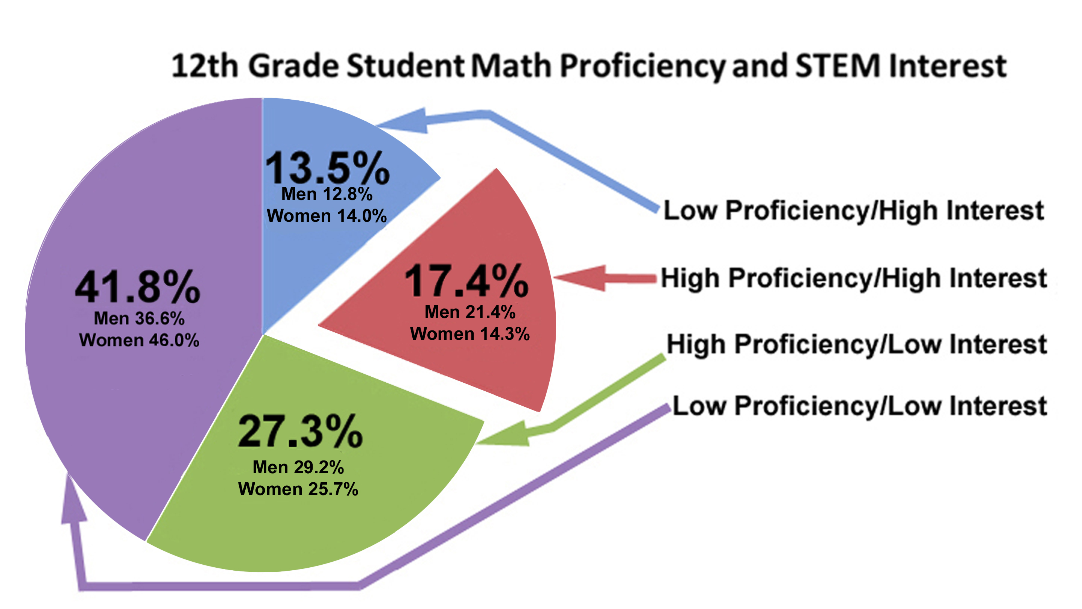
Before launching into how the problem of Engineering School drop-outs might be approached via emerging technologies, it may be well-advised to quantify the issues and examine current condition. Many authors allude to the number of students who find STEM training too daunting. This has been true since at least the early 1960's. At the Colorado School of Mines, a STEM committed institutions with SAT (max. 1,600) Scores of around 1,360, with the 25th and 75thh percentiles being 1,260 and 1,350 respectively. This means that virtually everyone there should be fully capable of even their rigorous curriculum. When they arrive on campus, a senior faculty member used to tell them: "Look at the person to your right; now look to the person on your left. Statistically speaking, neither one of them will be there next year! The first-year drop-out rate has been about 50%.". Another author suggests the two year drop-out rate is even higher. He set that rate at approximately 60%. These numbers may be somewhat skewed in that three of the most demanding STEM schools are the service academies where changes of major are not only frowned upon, they do little of relieving the cadet or midshipman of technical courses, because all graduates are required to complete some advanced mathematics, physical science and other course of the STEM disciplines.

The issue may be insufficient inherent capabilities, forcing those low scoring low in g-Factor tests to want to compete, but unable to keep up. The figure to the right shows a breakdown of pre-college skills and career interests. The reader will note that the percentage of those "high interest" but "low proficiency" is nearly as large as those with "high interest and high proficiency." Were the nation to be losing only those with "low proficiency," some might argue that it is a rational filter and beyond the power of mortals to impact that proficiency in any meaningful way, but it seems clear that the STEM student body is losing more than just the "low proficiency" group. Also, it is noted that those with "high interest," but seemingly devoid of necessary skills to succeed in this area, are not being adequately prepared and counseled to avoid making early career dreams, only to have them dashed at an emotional cost that may be greater than those who do stick with it and excel could ever imagine.

While the really top technical schools like the California Institute of Technology (Caltech) and the Massachusetts Institute of Technology (MIT) have drop-out rates that are in the single digits (both around 5%), many of the other technical schools significantly more high drop-outs. The three service academies see drop out rates on the order of 15%, but many of these students may continue to pursue STEM careers, having found the service too stressful dn physically challenging. The major research universities see the aforementioned migration from the technical majors to liberal arts majors in the nature of significantly more than half. One California State University executive, who preferred not to be personally cited, said that the drop-out rate in one of his school's biological science undergraduate programs approached 100% for certain high schools that fed into that University. Without commenting on or accepting his statements as valid, it does beg the question of whether these students had been effectively evaluated, sufficiently educated, and adequately counseled. The executive said the high drop-outs contributed to an over-all drop pf those majors by about half. The costs to the individuals, their families, the State and the Nation must be staggering.

On the "other side of the ledger," one wonders if we have enough qualified technical people in the nation or could the nation be faced with a surplus. The chart to the right gives some idea of shortfalls in projected STEM disciplines to be expected over the next few years. Issues to be considered here are the increasing social pressures to demonstrate high graduation rates and the manifest financial pressure to not lose paying students. This brings to mind the natural inclination to question the fungibility of college graduates and the effective career "life spans" of technical fields that are changing at a dizzying rate. If a student has been coerced into staying in STEM programs, may not his skill levels be in question, as well as his enthusiasm for the career into which he will be graduating. It is common to hear of mid-level STEM professionals being "eased-out" of their jobs for varying reasons. The authors could find not compelling studies on the possibility that these mid-career shocks were either common or avoidable. One industry executive spoke to the fungibility of graduate issues, again asking not to be identified by direct cites: We now hire only from Caltech, Stanford, the UC schools (Cal, UCLA, UC San Diego, UC Irvine, UC Santa Barbara, …) and the eastern schools of equivalent reputation; the other graduates just cannot do the work we need them to do. A recent review showed that the average SAT Scores for the schools he referenced were on the order of 1275 and the other state schools averaged about 985, and sigma and a half lower.

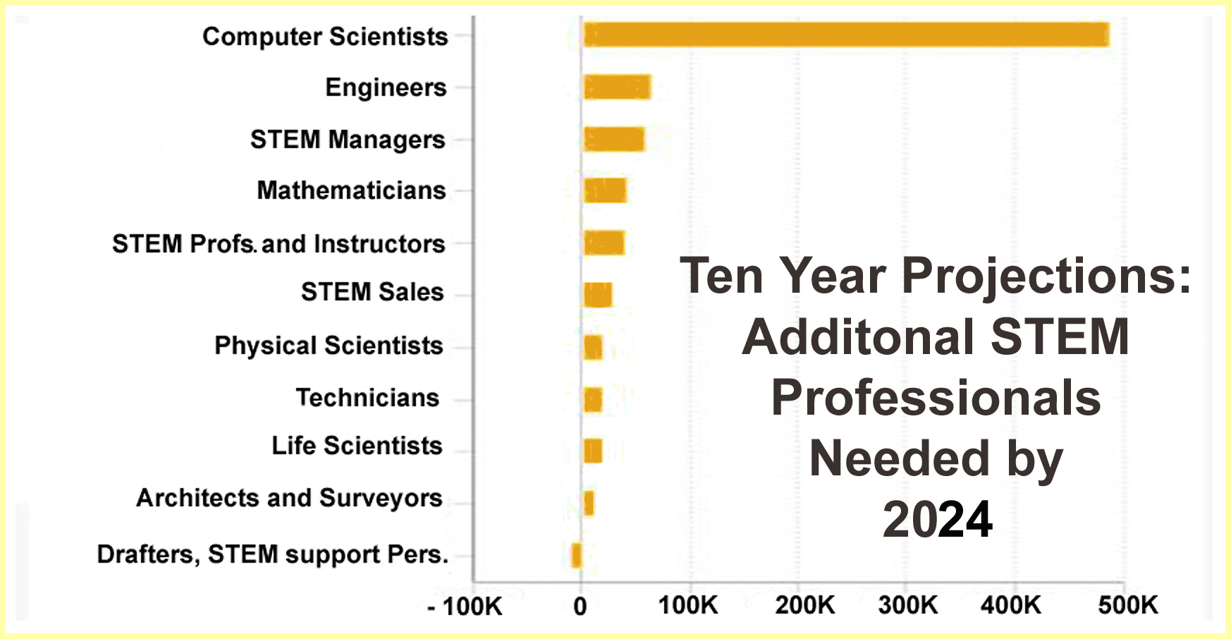
In any case, the bar graph to the left indicates a significant projection of a dangerous dearth of domestic STEM professionals. This increasing lack of American's eschewing the rigors of technical training cause Thomas Friedman to suggest that every foreign student earning a STEM degree in US Universities should have a "green card" stapled to their diploma. These are not trivial numbers and some may turn out needing even more personnel. The Nation can much better manage a surplus of trained personnel than it can remediate an economic collapse for want of the needed professionals.

It would constitute an oversight to not address the genesis of the fairly large number of capable but disinterested pre-college students. The graph above (Figure 1) finds the "high proficiency / high interest" group constitutes on ~27% of high school seniors, the "high proficiency / low interest" group is about three fifths larger at 27%. This is a potentially disabling state of affairs. The readers may, of course, develop on their own why this is true, but the authors experience is that the students shying away from STEM careers do so for a number of poorly founded reasons: the work is too hard, the work is not satisfying, the colleagues are unidimensional, and the society's regard for STEM professionals is low. When questioned as to how these conclusions were formed, the students cite several unreliable sources: characters in fictional media, e.g. the cast on "The Big Bang Theory,"; the news media pundits who are very rarely technically trained, e.g. most weather men are not graduate meteorologists, so are inclined to take dismissive attitudes toward and make disparaging comments about technical people; and high school peers who are not inclined to be respected, e.g. the star athletes and most popular students rarely achieved their ascendancy via STEM excellence and may communicate negative opinions of technical personnel, as those are sometimes outside of their realm of knowledge and antithetical to their skill sets. Anecdotal evidence collected by one of the authors indicated that even those whose parents were high-level scientists had little knowledgeof what their parents did at work. These scientists were working on nationally recognized projects (Jet Propulsion Lab professionals) and some even appeared on TV to discuss their work, but the students knew little of that.

Advances in Virtual Mentoring

Realities

    - Live

    - Virtual

    - Constructive

    - Augmented

    - Extended

Virtual Conversations

Mentoring Issues

New Technology Contributions

Standards and Metrics

Conclusions

Acknowledgements

References

[1] Author(s) name(s): “This is the Title of the Paper” Journal Name, Vol. 39, pp. 531-548, July 1992.

[2] Author(s) name(s): “This is the Book Chapter Title” Book Title, McGraw-Hill, New York 1990.

[3] More Author(s) name(s): Book Title, Peter Peregrinus, London 1992.

Author Biographies

DANIEL P. BURNS, CAPT, USN (Ret.) is a lifelong Systems Engineer, first with the Active Duty Navy, then SAIC, and small business. He served as Naval Chair and Professor of Practice in Systems Engineering at the Naval Postgraduate School (NPS).Captain Burns also was appointed as the as the Military Associate Dean and as acting Dean of the Graduate School of Engineering and Sciences at NPS. His research interests center on analyses of both human and resource utilization in defense efforts. He successfully facilitated the creation of a new program for Air Force Officers who seek post-graduate degrees. He is currently engaged in a project at the US Air Force Base, Los Angeles. Captain Burns received a BS degree from the U.S. Naval Academy, an MS from the Naval Postgraduate School and an MS from Southern Methodist University. He is currently working with Portland State University on a Ph.D.

Dan M. Davis is a Research Associate Professor at Catholic Polytechnic University (CPU) and is also active as a consultant at the Institute for Creative Technologies, University of Southern California (USC). He is currently focusing on large-scale DoD simulations and virtual human implementations. Prior to retirement, he was the Director of the JESPP project at USC for more than a decade. As the Assistant Director of Advanced Computing Research at Caltech, he ran Synthetic Forces Express, bringing HPC to DoD simulations. He has also served as a Director at the Maui High Performance Computing Center and in computer research roles at the Jet Propulsion Laboratory and Martin Marietta. He was the Chairman of the Coalition of Academic Supercomputing Centers and has taught at the undergraduate and graduate levels. As early as 1971, Dan was writing programs in FORTRAN on one of Seymour Cray’s CDC 6500’s. While in the Marine Corps, he saw duty in Vietnam as a Cryptologist and retired in 2002 as a Commander, U.S.N. He received B.A. and J.D. degrees from the University of Colorado in Boulder.

Jennifer H. Nolan, Ph..D. is the President of Catholic Polytechnic University and Professor of Psychology in their College of Arts and Sciences. Her earlier work specialized in memory, dementias, stroke and insulin resistance. She is a brain plasticity specialist and certified Cogmed provider. Previously, she was the C.O.O. and co-founder of a stroke and brain injury rehabilitation center. Dr. Nolan has taught university courses at the University of California Irvine, Loyola Marymount University, and Glendale Community College. She has conducted local and nationwide clinical trials, and published in both scientific journals and popular magazines. She received a BA in Psychology from Loyola Marymount University, Los Angeles and a Ph.D. in Psychology from the Dept. of Cognitive Science at the University of California, Irvine.

Mark C. Davis, Ph.D. is the Chief Technical Officer at Wood Duck Research, Inc, and is semi retired after careers in the US Navy and as a computer design engineer for both IBM and Lenovo. Rising to the level of Distinguished Engineer at Lenovo, he was responsible for the design of laptop computer cross-disciplinary technology, including PC architecture, embedded systems, open source and virtualization. Previous work was with IBM in the areas of software development and architecture involving security, storage and virtualization. Dr. Davis has been granted well over fifty patents that were filed during his service at both companies. He is a graduate of the Duke University NROTC program and was commissioned as an Ensign, attended nuclear power school, and served as a Submarine Officer for twelve years, including one duty tour as a classroom instructor. He left the active duty as a Lieutenant Commander to pursue a PhD. Mark holds a BSEE degree from Duke University and a PhD in Computer Science from the University of North Carolina, Chapel Hill, where his advisor was Professor Fredrick P. Books.


Figure 3.1. [“Caption Figure” style].

