All authors must submit this release prior to presenting the content of their paper or presentation at the 2022 SIW. Additionally, papers cannot be published in our online proceedings without this release form on file.

Paper/Presentation #: _2022-SIW-003_ (2022-SIW-0## or 2022-SIW-Presentation-0##)

Title: Stemming Migrations from Engineering to Liberal Arts:
Enhanced Computer-Generated Mentor Standards
__________________________________________________________

Authors: Daniel P. Burns, Dan M. Davis, Jennifer H. Nolan and Mark C. Davis_

__________________________________________________________

__________________________________________________________

__________________________________________________________

The above paper and/or presentation prepared for the 2022 Simulation Innovation Workshop (SIW) is approved for unlimited release (including to foreign nationals) and may be published by SISO in both print and electronic form.

Name: ___Dan M. Davis__________________________

Position: ___Research Associate Professor_________________

Organization/Company: ___Catholic Polytechnic University____

Telephone: ____________310 909- 3487_______________________

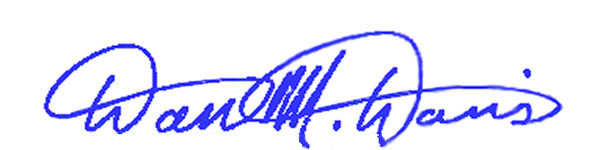
Email: _________ddavis@catholicpolytechnic.org________________________

Signed: __________________________ Date: 28 January 2022

