Stemming Migrations from Engineering to Liberal Arts:
Enhanced Computer-Generated Mentor Standards

Daniel P. Burns
Home Ports Solutions, LLC.
125 East 44th Street
Savannah, GA 31405
daniel.p.burns@homeportssolutions.net

Dan M. Davis & Jennifer H. Nolan
Catholic Polytechnic University
1028 N Lake Ave., MC 207
Pasadena, CA 91104
{ddavis & jnolan} @catholicpolytechnic.org

Mark C. Davis
Wood Duck Research, Inc.
129 Wood Duck Loop
Mooresville, NC 28117
davismc@ieee.org

Keywords:
Virtual Mentors, Engineering Studies, Computer-Generated Conversations, Natural Language Processing, & Virtual, Augmented & Extended Reality.

ABSTRACT: One major thesis of this paper is that Computer Generated Realities provide promise in addressing a major impediment to providing adequate numbers of engineering professional. These personnel are needed to sustain the technical ascendancy of the United States and its allies. The subject impediment is the flow of Schools of Engineering students over to Colleges of Arts and Sciences before the students' second years at the university. Many who have studied this issue cite data supporting that more than half of incoming engineering students abandon the rigors of their technical training for the more appealing entertainment afforded in the schools on the other side of the campus. The authors cite their own experiences with the divergent environments at engineering schools and arts and sciences colleges, the lack of caring mentors in early years, the sink or swim traditions, and the ineffective efforts to stem this tide. Also related are anecdotal suggestions that this was not only reflective of the public's low regard for the actual practice of professional engineers, but may also reflect a misconceived image of both the engineers’ student and professional environments, exacerbated by the dearth of skilled mentors who could have ameliorated these barriers to higher engineering school graduation rates. The ability of Computer-Generated Mentors (CGM's) to compensate for many of these short-comings is advanced, outlined and justified. Some early examples of such virtual mentorships are presented to show their promise, with an explication of both their opportunities and their limits. Current responsive CGM's with their Natural Language Processing (NLP) capabilities are discussed and the enhancing impacts of emerging technologies in addressing their current short-comings are laid out. Making the CGM's more able of initiating new conversations and making critical segues in existing conversations is presented. A road-map is set forth for future research, including the necessity for establishing an accepted canon of terminology, inter-program data exchange standards, figure of merit definitions, and metrics assessment quantification. The authors consider the sensitive issue of the value of the current culling process as an effective filter for those who really may be better-advised to seek another trade. The paper concludes with an analysis of the potential of and the risks in such an approach to the issues at hand.

Introduction

An increasingly elaborate societal infrastructure requires increasingly sophisticated personnel whose careers require education in Science, Technology, Engineering, and Mathematics (STEM) but there is an on-going need for even more and better professionals. This paper first posits that there are three major contributors to such a short-fall:
- Paucity of intellectually gifted STEM candidates
- Preselection out of STEM education disciplines before college
- Abandonment of Engineering Majors early in post-secondary education
These tendencies are well documented in the wide-spread observations of the change of collegiate majors and colleges, where the student abandons STEM majors and transfers out of Schools of Engineering in favor of "easier" majors and Colleges of Arts and Sciences, Performing Arts, Education, Business, etc. These common uni-directional changes in direction ("No one ever transfers for the College of Education to the School of Engineering!") are recorded in the first two years of post-secondary education. The paper advances the thesis that this destructive loss of vital STEM professionals could be more effectively ameliorated by better and more accessible mentoring. That mentoring, it is argued, could better be provided by emerging technologies which enable computer-generated mentors. These new capabilities could not only stem the flow of potential STEM professionals into the fields with much lower career opportunities, but will ancillarily address losses at the university admissions point. Further such and approach may reduce the wasted time, monetary losses and emotional toll of those who seek STEM training, but are intellectually ill-suited for either educational success or career performance.

This paper addresses the current conditions and unfulfilled needs in STEM training. It then turns to some definitions in simulation and virtual environments that are critical to the discussion of these topics, therefore are a proper focus of standards professionals. Then research into and the practice of mentoring is surveyed, with an eye toward potential impacts of a more universally available and consistently effective mentoring might help. The next section discusses state of the art and emerging capabilities in computer agents providing mentoring that could augment live mentors. These new techniques and technologies need careful study by standards professionals, especially in the instantiation of accepted terminology and metrics. The paper closes with a review of the issues and opportunities, but also sets out the risks and costs of such an approach. The two major thrusts of this last section will be both the analysis of this specific issue and the need to abstract the over-arching approach to further define the discipline of standards professionals.

Background

Before launching into how the problem of Engineering School drop-outs might be approached via emerging technologies, it may be well-advised to quantify the issues and examine current condition. Many authors allude to the number of students who find STEM training too daunting. This has been true since at least the early 1960's. At the Colorado School of Mines, a STEM committed institutions with SAT (max. 1,600) Scores of around 1,360, with the 25th and 75thh percentiles being 1,260 and 1,350 respectively. This means that virtually everyone there should be fully capable of even their rigorous curriculum. When they arrive on campus, a senior faculty member used to tell them: "Look at the person to your right; now look to the person on your left. Statistically speaking, neither one of them will be there next year! The first-year drop-out rate has been about 50%." Another author suggests the two year drop-out rate is even higher. He set that rate at approximately 60%. These numbers may be somewhat skewed in that three of the most demanding STEM schools are the service academies where changes of major are not only frowned upon, they do little of relieving the cadet or midshipman of technical courses, because all graduates are required to complete some advanced mathematics, physical science and other course of the STEM disciplines.
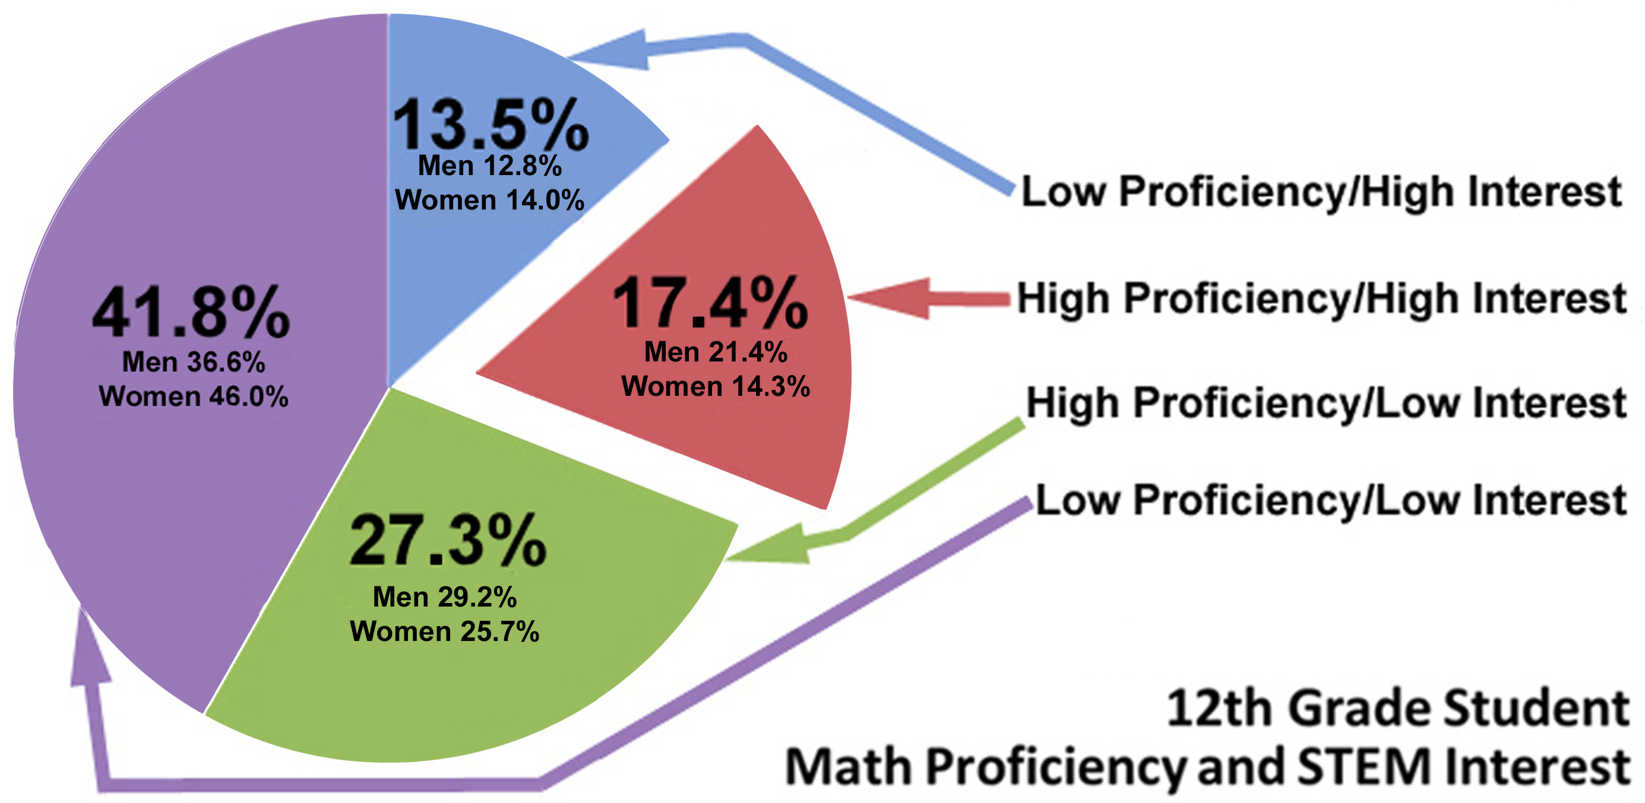
The issue may be insufficient inherent capabilities, forcing those low scoring low in g-Factor tests to want to compete, but unable to keep up. The figure to the right shows a breakdown of pre-college skills and career interests. The reader will note that the percentage of those "high interest" but "low proficiency" is nearly as large as those with "high interest and high proficiency." (Figure 1)Were the nation to be losing only those with "low proficiency," some might argue that it is a rational filter and beyond the power of mortals to impact that proficiency in any meaningful way, but it seems clear that the STEM student body is losing more than just the "low proficiency" group. Also, it is noted that those with "high interest," but seemingly devoid of necessary skills to succeed in this area, are not being adequately prepared and counseled to avoid making early career dreams, only to have them dashed at an emotional cost that may be greater than those who do persist and excel could ever imagine.
Figure 1 HS Seniors and STEM career choices.

While the really top technical schools like the California Institute of Technology (Caltech) and the Massachusetts Institute of Technology (MIT) have drop-out rates that are in the single digits (both around 5%), many of the other technical schools significantly more high drop-outs. The three service academies see drop-out rates on the order of 15%, but many of these students may continue to pursue STEM careers, having found the service too stressful and physically challenging. In the past, the Naval Academy strove for an 80-20 split: Engineering to Non-Engineering majors. It is believe USMA had the same requirements. At USNA the non-engineering majors still had to take some form of Electrical Engineering (EE). They also had to take “real engineering” courses which included Fluid Dynamics, Static, Mechanical Engineerig, Seamanship, Navigation, System Engineering and Weapons

The major research universities see the aforementioned migration from the technical majors to liberal arts majors in the nature of significantly more than half. One California State University executive, who preferred not to be personally cited, said that the drop-out rate in one of his school's biological science undergraduate programs approached 100% for certain high schools that fed into that University. Without commenting on or accepting his statements as valid, it does beg the question of whether these students had been effectively evaluated, sufficiently educated, and adequately counseled. The executive said the high drop-outs contributed to an over-all drop of those majors by about half. The costs to the individuals, their families, the State and the Nation must be staggering.

On the "other side of the ledger," one wonders if we have enough qualified technical people in the nation or could the nation be faced with a surplus. The chart to the right gives some idea of shortfalls in projected STEM disciplines to be expected over the next few years. Issues to be considered here are the increasing social pressures to demonstrate high graduation rates and the manifest financial pressure to not lose paying students. This brings to mind the natural inclination to question the fungibility of college graduates and the effective career "life spans" of technical fields that are changing at a dizzying rate. If a student has been coerced into staying in STEM programs, may not his skill levels be in question, as well as his enthusiasm for the career into which he will be graduating. It is common to hear of mid-level STEM professionals being "eased-out" of their jobs for varying reasons. The authors could find no compelling studies on the possibility that these mid-career shocks were either common or avoidable. One industry executive spoke to the fungibility of graduate issues, again asking not to be identified by direct cites: We now hire only from Caltech, Stanford, the UC schools (Cal, UCLA, UC San Diego, UC Irvine, UC Santa Barbara, …) and the eastern schools of equivalent reputation; the other graduates just cannot do the work we need them to do. A recent review showed that the average SAT Scores for the "acceptable schools he referenced were on the order of 1275 and the other state schools averaged about 985, and sigma and a half lower.
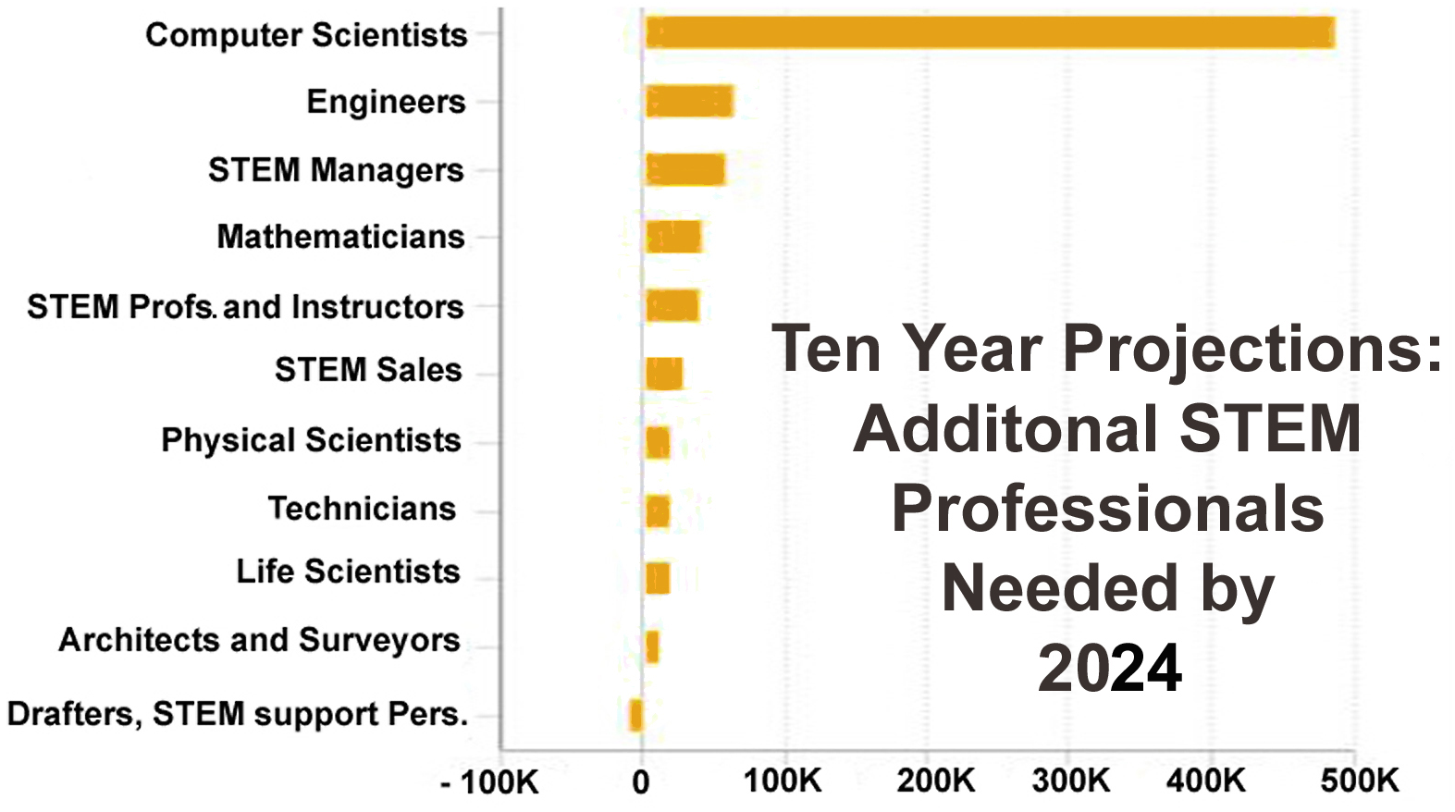
In any case, the bar graph to the left indicates a significant projection of a dangerous dearth of domestic STEM professionals(Figure 2). This increasing proclivity of American's eschewing the rigors of technical training caused Thomas Friedman to suggest that every foreign student earning a STEM degree in US Universities should have a "green card" stapled to their diploma [1 Frd]. These are not trivial numbers and some may turn out needing even more personnel. The Nation can much better manage a surplus of trained personnel than it can remediate an economic collapse for want of the needed professionals.
Figure 2 New STEM personnel needs in US

It would constitute an oversight to not address the genesis of the fairly large number of capable but disinterested pre-college students. The graph above (Figure 1) finds the "high proficiency / high interest" group constitutes on ~27% of high school seniors, the "high proficiency / low interest" group is about three fifths larger at 27%. This is a potentially disabling state of affairs. The readers may, of course, develop on their own why this is true, but the authors experience is that the students shying away from STEM careers do so for a number of poorly founded reasons: the work is too hard, the work is not satisfying, the colleagues are unidimensional, and the society's regard for STEM professionals is low. When questioned as to how these conclusions were formed, the students cite several unreliable sources: characters in fictional media, e.g. the cast on "The Big Bang Theory,"; the news media pundits who are very rarely technically trained, e.g. most weather men are not graduate meteorologists, so are inclined to take dismissive attitudes toward and make disparaging comments about technical people; and high school peers who are not inclined to be respected, e.g. the star athletes and most popular students rarely achieved their ascendancy via STEM excellence and may communicate negative opinions of technical personnel, as those are sometimes outside of their realm of knowledge and antithetical to their skill sets. Anecdotal evidence collected by one of the authors indicated that even those whose parents were high-level scientists had little knowledge of what their parents did at work. These scientists were working on nationally recognized projects (Jet Propulsion Lab professionals) and some even appeared on TV to discuss their work, but the students knew little of that.

Without endorsing or defending any of the above assertions, it is sufficient for the purposes of this paper to note that they all are commonly asserted and often discussed. Given those observations, this paper will take the position that the following could be seriously considered:
- Modern society is reliant upon advanced technologies
- These advances are to the most part quantitatively beneficial
  - Less hunger
  - Longer life spans
  - Lower poverty rates
  - Fewer debilitating diseases
  - Larger populations achievable
  - More physical comfort, e.g. heating, air conditioning, indoor plumbing, transportation, etc.
- Maintaining these advances and promoting future ones depend on an adequate technical workforce
- That workforce requires procreating, selecting, educating and motivating STEM professionals
- Distaste for the STEM professions may emanate from media and fiction detractors
- Current conditions are putatively incapable of fulfilling the current needs
- Importing foreign technical personnel is fraught with constraints
- A number of STEM candidate report a paucity of mentors
- Emerging technologies may help address these issues
- Technology needs standards and accepted terms

The rest of the paper will be devoted to a discussion about the evolving capabilities in creating and using various forms of computer generated-realities to address many of the issues above. Virtually all of these issues have a common reliance on accepted standards for terminology, interfaces, metrics and quantification. This standards discipline requires a whole community of professionals who must be educated accordingly, so are just as dependent on bolstering the current STEM workforce as are the researchers, developers, producers and trainers.

Advances in Virtual Mentoring
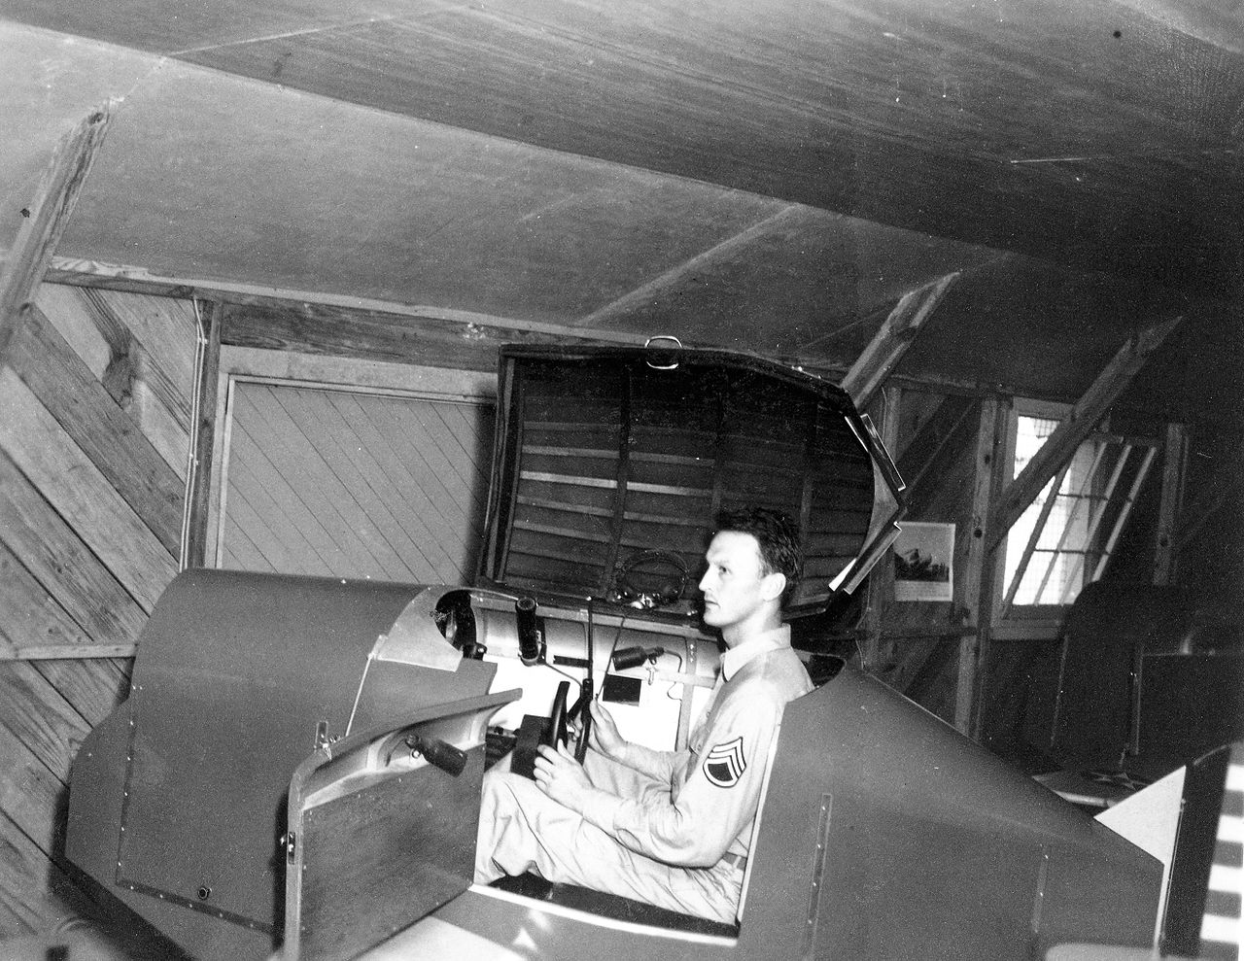
Figure 3 Link Flight Trainer, hood up

Throughout the eons of history, people have envisioned realities that were different from their own. As far back as the Second Century BC, the Babylonians have a written myth known as the Enuma Elish [1 Talon], . But the realities created by written versions of oral tales created another reality only in the mind of the listener or the reader, with no manifest or repeatable version. This, of course leads to a wide variance of the imaged reality, mainly dependent on the individuals experience and biases. Starting in the early 20th century, film animation has allowed a repeatable communications of a fanciful experience in the form of animated films. Here the imagination of the creator was set down on a repeatable and jointly observable fashion, albeit one that had no "life of its own," but that imaginative reality was static after the cels were painted and photographed. World War II saw an increasing use of mechanically driven simulators like the Link Trainers [2 DeAngelo] for individual pilot trainees (Figure 3) and an entire building-floor-sized manually manipulated Western Approaches Tactical Unit (WATU) [3 Parkin] for training small groups of ant-submarine ships' captains (Figure 4 below) All of these either followed very carefully written scripts or were carefully controlled by human operators, as is indicated by the operator's desk in the Link Trainer photo and the several WREN (Women’s Royal Naval Service) operators with the poles for moving ship tokens around the WATU simulation room floor. It should be noted that these simulators and simulation realities were all self-contained and operated by tight-knit groups of dedicated personnel. They developed their own methods, terminologies, standards and very subjective metrics of success. The manifest brilliance of the operators and trainers was obvious, but they did not require advanced technical skills, but did require analytical minds and communications and didactic skills. The devices and simulations were not linked with any simultaneous simulations to create a distributed set of environments or dispersed group of operators. While the Link Trainers contained some electro-mechanical modules requiring only those to general-purpose germane to those disciplines, there we no needs for program and device interface standards, as they were all stand-alone or human personnel directed. Of course the same could be said of live training with mock battles using blunted weapons. Such training has been utilized since before the development of written history.
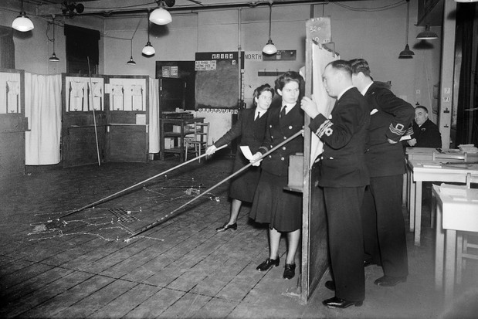
Figure 4 WW II Trainees can see only as much of the situation as they would see from their ships bridges.

Within the lifetimes of many professionals in the STEM fields, a series of enormous leaps have been made. New alternate realities allow for many simulations to provide a random set of outcomes, dependent on a range of independent random events within the time frame of the operations. These simulations have included increasingly realistic visualizations of the situation and of personnel engaged therein. Anecdotal evidence is that it was the use of tank trainers, similar to WW II Link Flight Trainers, that first spurred the desire to further advance the reality of the training by connecting several individual trainers together, reflecting the experience by war-fighters since the time of Alexander that one of the major factors in military ascendency is having a fighting force trained to fight together and to maintain that cohesiveness even in the heat of combat. This inter-device interoperability issues was further exacerbated by the need to effectively communicate between the various subcomponents of the simulation, where now battlespaces were not represented by ship tokens of a floor with chalk marks recording ship movements. Now there are elaborate simulations of terrain generated in 3 dimensional realism that have to interface efficiently with sophisticated models of virtual humans and vehicle models. Modifications and implementations can no longer be made by untrained personnel, drafted off of the streets, and quick oriented to do the work required. This heightens both the concern the simulation standards community should feel for the short-fall in STEM trained personnel to develop new standards and the over-arching concern that there will not be sufficient technical personnel to produce the underlying hardware and code necessary to implement hardware and software for which standards will be required. In an ironic twist, this paper holds that this discipline may be the primary source of the solution to their own problem.

Realities

One of the most important issues in standardizing research, development and adoption is the consensus as to terminology. In the case of an activity like the WATU, that was made more intuitive when the activity was largely driven by the intellect and personality of one man, Captain Gilbert Roberts and the smallness of his crew of WRENs who were all billeted together. But today, the NATO countries have huge simulation efforts, distributed literally all around the world, so allowing for transmission latencies, it is not uncommon to have distributed combat simulation participants that are tens of thousands of miles distant from each other [4 Gottsch]. Each establishment may have its own research and development crew and will certainly have its own group of implementers, observers and participants. It is necessary that they all are "speaking the same language", even if their native tongues may vary. Below are some common terms that are already standardized of need to be accepted in the near future.

    - Live (L)
This is the consensus term for the ancient practice of having the live human combatants participate in simulated warfare, usually with non-lethal weapons. Some rather well-known examples of these practices may be seen in the Greek Olympic Games, Roman Gladiatorial exhibitions, European Jousting in the late middle ages, various military drills in the later centuries, and the massive training maneuvers in the 20th century [5 Barbier].

    - Virtual (V)
The advent of the computer made it possible to simulate the actions of a military unit without any human intervention. Early experiments use primitive Artificial Intelligence to represent very simple characteristics [6 Horne]. These programs had the ability to run to completion without further human intervention and were useful in providing two functions: analysis (what would happen if…) and evaluation (what kind of effect would a new capability have on…)

    - Constructive (C)
In this domain, the computer has input and output (I/O) capabilities that allow the user to actively engage in decision making during the simulated combat situation. This provided the users to participate with dramatically emotional investment in outcomes, but with significant advantages in cost savings, safety improvements, data collection and repetitive interactions, all of which provided the last beneficial use triad: training. These began small and were often local, but these rapidly become increasingly sophisticated [7 Davis], realistically immense [8 Lucas], and as noted above, trans-continentally distributed. The last reality/simulation completes the simulation-use triad: LVC.

    - Augmented (AR)
A reality domain that was first seen in imagined capabilities in science fiction entities such as the Terminator, the ability of the computer to provide real time data, imagery and decision aids has created the realm of augmented reality. The simulation community has rapidly provided actual implementation of such a capability. Assessing the utility of such augmentation is now in progress. The users are able to see the "real world" as it is presented to them, but object, entities and information can be superimposed on the users' senses to provide otherwise unavailable information or assistance. This can respond in real-time situations where no time is available for further analysis or research.
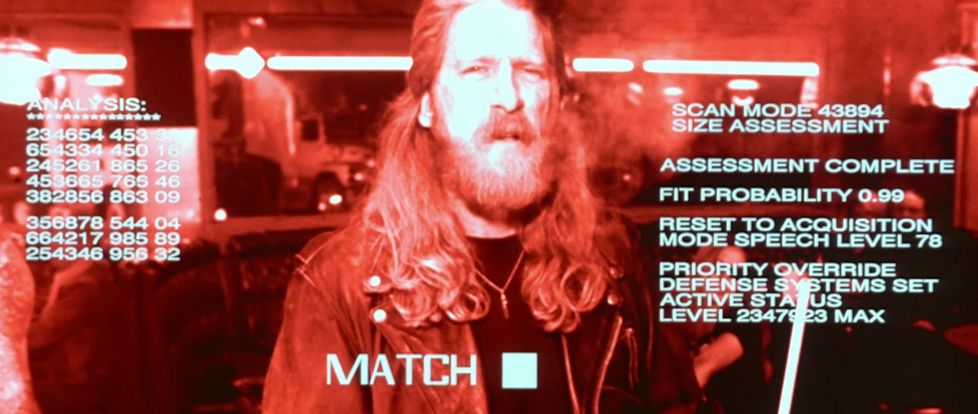
Figure 5 Augmented Reality for the Terminator.

    - Extended (XR)
A relative newcomer to the reality domains is Extended Reality (XR). This evolving term covers the range of realities, all present and available in appropriate quantities and modalities to assist the user. The emergence of the technology to support such a capability is currently under study by the Simulations Interoperability Standards Organization's study group: XR-INTEROP SG - XR Interoperability Standards, which is under the leadership of Paul Gustavson [9]. That study group is considering the nomenclature change to "eXperiential Reality", as there are some functions necessary to XR implementations that are not well represented in VR and AR, e.g. haptics and hardware sensors to detect changes in environments, humans, and emotional states. The term includes all of the "realities" and the technologies providing the necessary interfaces. This is designed to help define and enhance the XR uses in the future.

All of these realities bring the simulation community full-circle back to the major thesis of this paper. There is a dramatic and immediate need for more STEM professionals in both research and development disciplines, but also in the standards groups. These groups have a unique need for professionals who are technically excellent and are facile in the disciplines of human factors, organization behavior, communications management and military operations (if the simulations are defense oriented). With such important needs, each of these communities has a vested interest in stemming the flow of engineering and "hard science" majors into the liberal arts departments.

Virtual Conversations

Illustrative of the issues faced in providing STEM professionals to drive emerging technologies and evolving standards, is the maturation of the field of virtual conversation. One of the authors of this paper was an undergraduate when this issue was first broached, notably by the Eliza programs of the 1960's [10 Zaimodin]. At that time the interfaces were very basic: a key board and an electric typewriter. The computer was easily confused and often responded erratically, giving no impression of conversationality. Now, advances in hardware, software and sensors have allowed a much more realistic exchange between the user and a computer generated animated avatar or a selection of recorded video clips of live experts responding to anticipated questions. This blend of technologies has gotten high marks for the impression of participating in a video-call with a live human. There is a significantly more elaborate and extensive explication of advances in this field in a paper which is also submitted to the current conference [11 Davis]. The net result is that this technology has substantial promise in providing a plethora of mentoring or counseling opportunities [12 Nye] to address any number of human quandaries, including the pursuit of difficult, but rewarding, careers in technical work.

Mentoring Issues

Studies have consistently shown that the defense forces of the United States are seen by their personnel as severely lacking in adequate mentoring. Two groups stand out as reporting they have had good mentors: military academy gradates and flag rank officers. The reported deficiencies are identified in three ways: insufficient numbers of mentors [13], mentees' failure to heed advice [14 Pezeshkian] and lack of helpful counsel from those who are assigned [15]. Both military and civilian personnel report that enforced mentoring relationships are more often frustrating than useful. This is reported by both mentors and mentees.

As noted above, new capabilities in voice recognition, Natural Language Processing, internet communications, and audio-video devices have made it possible to very closely emulate a video-call or conference. This has allowed a considerable improvement in utility of these programs.

New Technology Contributions

An illustrative challenge came from a Navy organization that sought a new tool to improve a long-standing function of Naval leadership: mentoring new leaders. Seeking a different tack, this significantly increased the numbers of disciplines involved in improving the lot of the "mentor-less", as it now included such things as Operations Research, Management, and Diversity concerns. Building on both the experience and on the newly requisite disciplinary breath available at major research universities, the technologies and methods developed by the Mentor PAL project were instantiated.
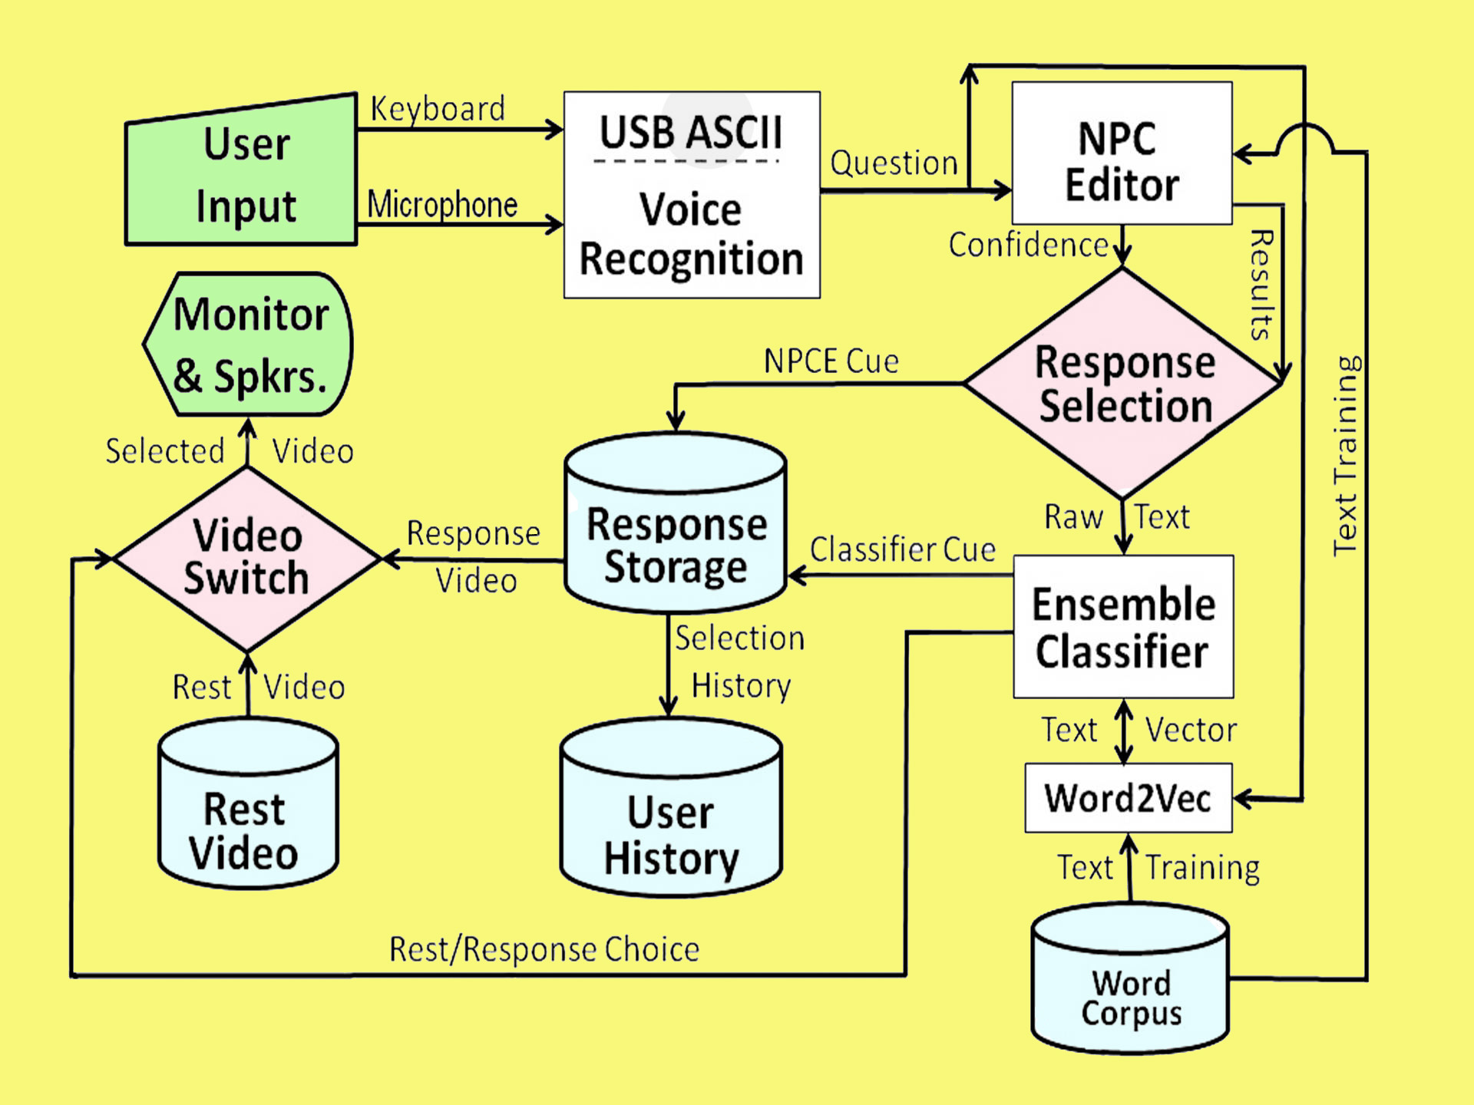
Figure 6. Notional Diagram of PAL3 Mentor Information Flows and Processing Steps
The process notional flow chart shown in Figure 6 to the right, shows the various steps in the process. As was discovered in previous research efforts, the process was then evaluated by administering the on-line “virtual mentoring” to various groups of subjects to record the reaction to the approach. Neither time nor limited funding allowed a longitudinal study of actual impact of the mentoring. Again, the results were reported in the earlier publications and were very positive in terms of “conversationality.” [12 Nye] In lieu of this more rigorous method, mentoring efficacy was evaluated using attitudinal surveys. These results will be more fully explicated in a pending article to be published in the discipline of educational technology. The intent of all of this approach is to provide a conversationally adept mentoring experience that can be available on-line, globally accessible, and regarded as helpful by potential mentees in the military environment.

One critical challenge faced by the veterans and managers on the team was the creation of a cogent and comprehensive list of questions to ask the project's model mentors, all of whom were volunteer US Naval personnel, active, reserve and retired. Some of the reported issues with mentoring in the services today have been reaffirmed in the informal survey described below. Some of the most often cited issues are: reduced access to mentors due to ops tempos, lack of a broad selection of potential mentors and feelings of hesitancy to relate needs openly to another officer. The MentorPal project purports to address many of these issues [16 Davis] by selecting insightful, articulate and engaging mentors, recording their advice in short video clips and presenting them to the mentees in a way that convincingly emulates a live conversation. Many of these issues also relate to suicide prevention efforts.

This technique has proven useful in other context, e.g. counseling for PTSD (Post Traumatic Stress Disorder) patients [17 Rizzo] and advising high school seniors of technical careers in the Navy ([18 Beck]. The goal of the current project phase is to create a mentor panel of several officers who can respond to typed or voice-recognition audio questions on-line. It follows that the first priority would be to assemble a database of two question sets: “What do young officers ask mentors?” and “What should young officers ask mentors?”. One of the first issues to be aired was the dichotomy between the academics on the team and the Navy veterans on the team as to where the greater repository of useful data would be found: Either from Junior Officers (JO's) or from seasoned officers who know what they “should have known?”. That issue is not fully resolved, but, as with all good teams, adherents of both views were open to contributions from both input streams, the meta-discipline of a central goal. The resultant mentoring was given via a screen like the one in Figure 7, which was programmed to display a varying-sized screens, including smart phones.
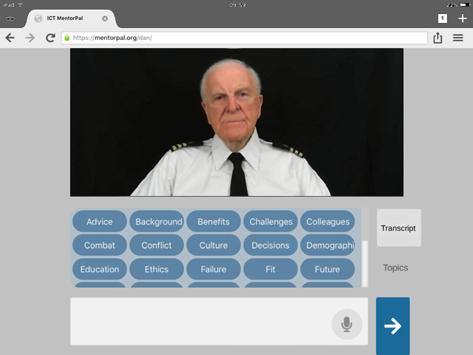
Figure 7 US Navy MentorPAL screen.

The research team included senior retired military officers, which facilitated their ability to productively host young officer trainees who were Cadets from the United States Military Academy at West Point. They met together and created a question list long enough to be used. An interesting future research thread may have been the reasoning behind certain questions asked and how might that further shape future training in various contexts. This process took on the order of two weeks and produced around 300 items. That number appeared sufficient for the “proof of concept” nature of the MentorPal project [19 Kaimakis], but it should be noted that a parallel project, New Dimension in Testimony [20 Artstein}, that was focused on creating a conversational record of Holocaust survivors had a question set of closer to 1,500, but it was a production project and for classroom and museum use.

The results were very encouraging, as are more fully explicated in the cited papers. It seems likely that a mentoring presence can be delivered and maintained despite location and scheduling constraints.

Analysis

Given the new capabilities in virtual conversational computer-generated mentors, the reported efficacy of mentoring by senior officers and the evidence of non-live human mentoring in other domains, the issue of interest raised in this paper now is: Can these emerging capabilities impact the "brain drain" from STEM majors?.

Discussion
It might be useful to break this major question into the smaller issues identified earlier: encouraging the qualified personnel to more positively view STEM careers, better inform those who are interested but lack the needed qualities to prevail, and to sustain those admitted to continue to pursue STEM careers. It will be posited below that mentoring is effective and computer generated mentoring is viable.

The first issue is countering the misinformed impressions of senior secondary school students who may be potential contributors to STEM advances. The issues are twofold: access and empathy. Many students do not have any daily access to practitioners of the STEM professions. To counteract the media induced biases, easy access to such a person may be hampered by geographical locations of student. Students in small rural towns rarely have the kind of access to technical workers of the kind that a young person living in Silicon Valley California or Los Alamos New Mexico might have. Once created and fielded, anyone with an internet connection could visit with an experienced, exciting, engaging and encouraging STEM mentor at any time during the day, twenty-four by seven.

Those interested in this career path would also have similar access, but their path may be better directed elsewhere. The virtual mentor might be alerted to of affirmatively seek out qualifications: "Did you take 'AP' calculus in high school?", "Do you like math?", "What are your favorite shows on TV?", "What were your SAT scores?" etc. Then a series of directional issues could be raised: "Have you considered pursuing a career in public polling?", "Did you know that one of the most in-demand job skill in this line of work is technical writing?" or some other analytic career that is not quite so demanding of an effortless mastery of differential equations.

On the "Don't give up the ship?" issue, a continued presence of a mentor/life coach could (should?) start as early as high school. Many of the young people interviewed after their first year of college reported they were not really prepared for the jump from easy-going high school courses to the more demanding collegiate pedagogical demands. Students need to be challenged early on to excite them, not intimidate them Later, a well-cast and empathetic mentor could give the first-year STEM student a place of refuge and a source of encouragement, day or night. With personal tales of travails, the mentor could reassure the faltering spirit that most students go through that set-back as well.

Metrics and Standards

A STEM researcher should never let personal enthusiasm cloud their professional obligations to be objective. In pursuit of improved graduation rates, a good researcher must decide what success is and how it is measured. In the case of computer-aided mentoring, practicality will constrain what may be done. But an ethical researcher would not accept lowered metric bars to point of being meaningless. That may suggest that the real measure is in the closing years of a person's life, success is when both the former student and their colleagues will say: "That was absolutely the optimal path for that student, for those close to them and for society at-large.". Unfortunately, that is both a long time off for college freshmen and the data will be hard to capture, even if the student has kept his current address up-to-date.

Perhaps the most immediate metric would be user evaluation questionnaires at the end of every session with the virtual mentor, accompanied by some way of keeping track of return visits, or follow-up inquiries after some period of time has passed since last visit by the user.

A little longer term, but still much shorter than the end-of-career assessment, would be tracking of participant's transferring to different schools or majors, graduation rates, grad-school acceptance, and first job location/position. While not completely satisfying, it would begin to give a standard against which a non-mentored student could be compared. The weakness would be that a student may graduate, but immediately abandon STEM work for another career. Remember, Frank Capra graduated from Caltech with a degree in Chemical Engineering, then immediately went to Hollywood and made movies such as: It's a Wonderful Life, It Happened One Night, and Mr. Smith Goes to Washington. His spot at Caltech could have gone to someone who would have made better use of it []. A series of periodic mid-career could be automatically sought, recorded and analyzed.

Conclusions

Technical work has created a society that needs even more technical workers. Serendipitously, the successes of earlier graduates may have provided the means of ameliorating the shortfalls occasioned by the number of students who originally eschew or subsequently abandon pursuing a STEM degree. There are demonstrable successes with emerging capabilities to field computer-generated mentors. These are more available geographically, available at any time, none-judgmental, selected to be engaging, represented via different genders and ethnicities, and distinctly congenial. Metrics and Standards could be developed to evaluate the efficacy of this endeavor.

Acknowledgements

The authors wish to thank all of their live mentors; without them we could not have contributed as well as we did. We should also note that much of the work cited was supported by grants from the Office of Naval Research's STEM Program (ONR N00014-16-1-2820) and by research assistants supported by the National Science Foundation Research Experience for Undergraduates program (NSF 1560426). Nevertheless, the positions taken in the paper are the authors’ own and do not represent in any way the views of the Department of Defense or the US Government.

References

[ 1] Friedman, T. L. (2005). The world is flat: A brief history of the twenty-first century. Macmillan, New York City, NY.

[ 2] Talon, P. (2005). The Standard Babylonian Creation Myth: Enūma Eliš, State Archives of Assyria. Cuneiform Texts, vol. IV, The Neo-Assyrian Text Corpus Project. Helsinki, Finland.

[ 3] De Angelo, Joseph (2000). "The Link Flight Trainer", (PDF). ASME. Retrieved from internet: 28 Dec 21 https://www.asme.org/wwwasmeorg/media/resourcefiles/aboutasme/who%20we%20are/engineering%20history/landmarks/210-link-c-3-flight-trainer.pdf

[ 4] Parkin, S. (2020). A game of Birds and Wolves: the ingenious young women whose secret board game helped Win World War II. Hachette, London UK.

[ 5] Gottschalk, T. D., Yao, K-T., Wagenbreth, G., & Davis, D. M. (2010). Distributed and Interactive Simulations Operating at Large Scale for Transcontinental Experimentation. In the Proceedings of the IEEE/ACM Distributed Simulations and Real Time Applications 2010 Conference. Fairfax, Virginia

[ 6] Barbier, M. K. (2003). George C. Marshall and the 1940 Louisiana Maneuvers. Louisiana History: The Journal of the Louisiana Historical Association, 44(4), 389-410.

[ 7] Horne, G. E. (2001). Beyond point estimates: Operational synthesis and data farming. Maneuver Warfare Science 2001, 1-8.

[ 8] Davis, D.M., Baer, G.D., & Gottschalk, T. (2004). 21st Century Simulation: Exploiting High Performance Parallel Computing and Advanced Data Analysis. In the Proceedings of the Interservice/Industry Simulation, Training and Education Conference. Orlando, Florida

[ 9] Lucas, R. F., Davis, D. M., Wagenbreth, G., & Tran, J. J. (2009). Operational Use of a Large GPGPU-Enhanced Linux Cluster. In the Proceedings of the High Performance Computing Modernization Program Users' Group Conference. San Diego, California, 2009

[10] Gustavson, Paul & Gravitz, Peggy (2021), XR Interoperability Standards Study Group, Simulations Interoperability Standards Organization, St Petersburg Florida. Retrieved from the Internet on 29 December 21 from: https://www.sisostds.org/StandardsActivities/StudyGroups/XRInteroperabilityStandards.aspx

[11] Zainudin, Z. N., & Yusop, Y. M. (2018). Cyber-Counseling: Is It Really New. International Research Journal of Education and Sciences (IRJES), 2(2), 19-24.

[12] Davis, D.M., Nolan, J. H., Davis, M.C. & Jacobus, J. L. (2022, Pending), Resurrecting a 55-Year-Old Program: Standards for Emerging Proactive Interactions. In the Proceedings of the SISO Simulation Interoperability Workshop, Orlando, Florida

[13] Benjamin D. Nye, Dan M. Davis, Sanad Z. Rizvi, Kayla Carr, William Swartout, Raj Thacker & Kenneth Shaw (2020). Feasibility and Usability of MentorPal, a Framework for rapid Development of virtual Mentors. Journal of Research on Technology in Education.

[14] Anderson-Ashcraft, M. (2002). Mentoring perceptions in the military. Army War College. Carlisle Barracks PA.

[15] Pezeshkian, F. (2019). Mentors Don’t Mean a Thing . . .if you don’t have them or use them. U S Naval Institute Proceedings (Annapolis). April 2019. 4(1).

[16] Gleiman, A., & Gleiman, J. K. (2020). Mentoring in the Military. New Directions for Adult and Continuing Education, 2020(167-168), 59-69

[17] Davis, D. M., Predovich, K.B., Stassi, F.J., Spaulding, H., Shaw, K & Nye, B.D. (2018). Enhancing Menteeship: Improving Career Selection for Potential DoD Personnel. In the Proceedings of the SISO Fall Simulation Innovation Workshop, Orlando, Florida: SISO

[18] Rizzo, A., Forbell, E., Lange, B., Galen Buckwalter, J., Williams, J., Sagae, K., & Traum, D. (2012). Simcoach: an Online Intelligent Virtual Human Agent System for Breaking Down Barriers to Care for Service Members and Veterans. Healing War Trauma A Handbook of Creative Approaches. Taylor & Francis. UK

[19] Beck, S., Carr, K., Davis, D. M., Nordhagen, J. N., & Nye, B. D. (2018). Virtual Mentors in a Real STEM Fair: Experiences, Challenges, and Opportunities. In Third International Workshop on Intelligent Mentoring Systems (IMS 2018) Proceedings.

[20] Kaimakis, N.J., Davis, D.M., Breck, S., & Nye, B.D. (2018). Domain-Specific Reduction of Language Model Databases: Overcoming Chatbot Implementation Obstacles. In the Proceedings of the ModSim World Conference. Norfolk, Virginia

[21] Artstein, R., Gainer, A., Georgila, K., Leuski, A., Shapiro, A., & Traum, D. (2016). New Dimensions in Testimony Demonstration. In Proceedings of the 2016 Conference of the North American Chapter of the Association for Computational Linguistics: Demonstrations (pp. 32-36).

[22] Capra, F. (1997). The Name Above the Title: An Autobiography. Da Capo Press. Boston, MA.

Author Biographies

DANIEL P. BURNS, CAPT, USN (Ret.) is a lifelong Systems Engineer, first with the Active Duty Navy, then SAIC, and small business. He served as Naval Chair and Professor of Practice in Systems Engineering at the Naval Postgraduate School (NPS). Captain Burns also was appointed as the as the Military Associate Dean and as acting Dean of the Graduate School of Engineering and Sciences at NPS. His research interests center on analyses of both human and resource utilization in defense efforts. He successfully facilitated the creation of a new program for Air Force Officers who seek post-graduate degrees. He is currently engaged in a project at the US Air Force Base, Los Angeles. Captain Burns received a BS degree from the U.S. Naval Academy, an MS from the Naval Postgraduate School and an MS from Southern Methodist University. He is currently working with Portland State University on a Ph.D.

Dan M. Davis is a Research Associate Professor at Catholic Polytechnic University (CPU) and is also active as a consultant at the Institute for Creative Technologies, University of Southern California (USC). He is currently focusing on large-scale DoD simulations and virtual human implementations. Prior to retirement, he was the Director of the JESPP project at USC for more than a decade. As the Assistant Director of Advanced Computing Research at Caltech, he ran Synthetic Forces Express, bringing HPC to DoD simulations. He has also served as a Director at the Maui High Performance Computing Center and in computer research roles at the Jet Propulsion Laboratory and Martin Marietta. He was the Chairman of the Coalition of Academic Supercomputing Centers and has taught at the undergraduate and graduate levels. As early as 1971, Dan was writing programs in FORTRAN on one of Seymour Cray’s CDC 6500’s. While in the Marine Corps, he saw duty in Vietnam as a Cryptologist and retired in 2002 as a Commander, U.S.N. He received B.A. and J.D. degrees from the University of Colorado in Boulder.

Jennifer H. Nolan, Ph..D. is the President of Catholic Polytechnic University and Professor of Psychology in their College of Arts and Sciences. Her earlier work specialized in memory, dementias, stroke and insulin resistance. She is a brain plasticity specialist and certified Cogmed provider. Previously, she was the C.O.O. and co-founder of a stroke and brain injury rehabilitation center. Dr. Nolan has taught university courses at the University of California Irvine, Loyola Marymount University, and Glendale Community College. She has conducted local and nationwide clinical trials, and published in both scientific journals and popular magazines. She received a BA in Psychology from Loyola Marymount University, Los Angeles and a Ph.D. in Psychology from the Dept. of Cognitive Science at the University of California, Irvine.

Mark C. Davis, Ph.D. is the Chief Technical Officer at Wood Duck Research, Inc, and is semi retired after careers in the US Navy and as a computer design engineer for both IBM and Lenovo. Rising to the level of Distinguished Engineer at Lenovo, he was responsible for the design of laptop computer cross-disciplinary technology, including PC architecture, embedded systems, open source and virtualization. Previous work was with IBM in the areas of software development and architecture involving security, storage and virtualization. Dr. Davis has been granted well over fifty patents that were filed during his service at both companies. He is a graduate of the Duke University NROTC program and was commissioned as an Ensign, attended nuclear power school, and served as a Submarine Officer for twelve years, including one duty tour as a classroom instructor. He left the active duty as a Lieutenant Commander to pursue a PhD. Mark holds a BSEE degree from Duke University and a PhD in Computer Science from the University of North Carolina, Chapel Hill, where his advisor was Professor Fredrick P. Books.

