Resurrecting a 55-Year-Old Program:
Standards for Emerging Proactive Interactions

Dan M. Davis & Jennifer H. Nolan
Catholic Polytechnic University
1028 N Lake Ave MC 207
Pasadena, CA 91104
{ddavis & jnolan} @catholicpolytechnic.org

Mark C. Davis
Wood Duck Research, Inc.
129 Wood Duck Loop
Mooresville, NC 28117
davismc@ieee.org

Judith L. Jacobus
Education Counselor/Therapist
1564 Merion Way.
Seal Beach, CA 90740
stately07@dslextreme.com

Keywords:
Virtual Therapist, Natural Language Processing,
Interoperability Standards, Safety Standards & Metrics

ABSTRACT: A new look at an old initiative has been stimulated by the emerging technologies called "XR". As Virtual Reality(VR) and Augmented Reality(AR)have emerged, they have begun to overlap, leading to the ill-defined concept of Extended Reality or XR. The emergence of this concept has spawned many novel approaches to wide spectra of issues, but this paper takes a retroactive look at and a promising concept for developing a computer-generated therapist. Both emotional and speech therapeutics might benefit from this new capability. Back in 1971, the Eliza program had been conceived. It was designed and implemented at the Massachusetts Institute of Technology (MIT). That program was one of the earliest attempts at Natural Language Processing (NLP) and virtual conversations. The consensus was that it fell short of the mark due to technical limitations. The paper lays out this genesis, the subsequent work, a review of the criticisms, and an outline of its legacy. Skipping forward, the progress in NLP is surveyed, with particular emphasis on the MentorPAL project at USC. The constricting limitations of the Eliza instantiations are covered in some detail, and then the ability of XR techniques to address them is listed. In these processes, careful attention is paid to the use of standards to both facilitate and evaluate the progress toward a truly effective Virtual Therapist. Both the benefits and risks of such a program are laid out, with very detailed attention to the metrics for success and the safe guards against exacerbating the subject's condition or creating dangerous reactions that could result in injury to the subject or the public. This opens us a serious discussion as to safety standards. Some of these safeguard techniques will entail both computer code functions to identify dangerous situations and procedural directives to guarantee live-human oversight of progress and interventions. Paths forward will be identified and discussed. Costs, risks and maintenance will be briefly considered. Potential extensibility into other analogous activities will be set forth, again with an eye for standards designed to promote such extensibility.

Introduction

The standards community is facing a challenge that is not really found to any reasonable degreed in the history of humankind: the virtually explosive conception, implementation, adoption and distribution of revolutionary technologies. This paper uses a known example of the radical changes in technologies that could not even had been envisioned until a half century ago and really has not become realistic in the last decade: a conversational computer agent acting as a mental health therapist. In considering how dizzying this rate is, one would need only remember that one of the greatest defense technological changes the world has ever seen was the introduction of iron weapons at the end of the Bronze Age. That earlier weapons technology had been ascendant for approximately two millennia, ~3,200 to ~1,200 BC [1]. That transition was rapid if compared to previous technical changes, but even this dramatic advance from bronze to iron took about 700 years to accomplish in any acceptance approaching continental propagation. The technologies referenced hereinbelow have spread globally in less than seven years a rate that is 100 times faster than that of the move from Bronze to Iron, that really did not even become global until the infusion of Europeans into the Americas in the 1500's, nearly three millennia after iron was adopted in the eastern Mediterranean.

The demise of technologies is similarly accelerated, as emerging technologies threaten, then supplant existing technologies before the displaced technologies have time to adopt standards for their usage. This rapid supersession of technologies was a major focus of Clay Christensen's work on "disruptive technologies." [2] This may call for a rapid prototyping of standards, the way technologies are sometimes forced to emerge in times of stress, as many technologies do in times of war.

The paper will begin with a quick look back at whence we have come and why the needs for standards are so great today. That will also suggest how the type and range of standards has grown and the channels for communication have changed, becoming as important as the content of the standards, definitions and processes have gotten much more complex and problematical. The origins of the virtual therapist will be used as a model for these issues and an exemplar of necessity of a dramatic increase in the visibility of the effort.

- Background

Computer generated conversational agents to perform mental health therapy was one of the early non-military uses suggested for the emerging digital computing capability that had witnessed phenomenal growth during World War II for both cryptologic and long range artillery analyses [3]. A program named ELIZA was conceived and implemented at the Massachusetts Institute of Technology in the late 1960's. [4]. ELIZA was designed to use a pattern-matching algorithm to emulated an initial interview by a psycho-therapist trying to establish a trusting relationship with a patient. The interface as typing on an electronic keyboard, attached to the computer. One of the authors of this paper was engaged at the University of Colorado at Boulder to participate as a subject. The program was being run on one of Seymour Cray's CDC 6500's (Figure 1.1) that had approximately 400 KB of memory in 60 bit words [6] and had a clock speed of 40 MHz and cost on the order of $70 million in 2021-dollars and weighed on the order of five tons. It can be reported from personal experience, the conversationality of the program was so severely limited as to make any use of it beyond contemplation.
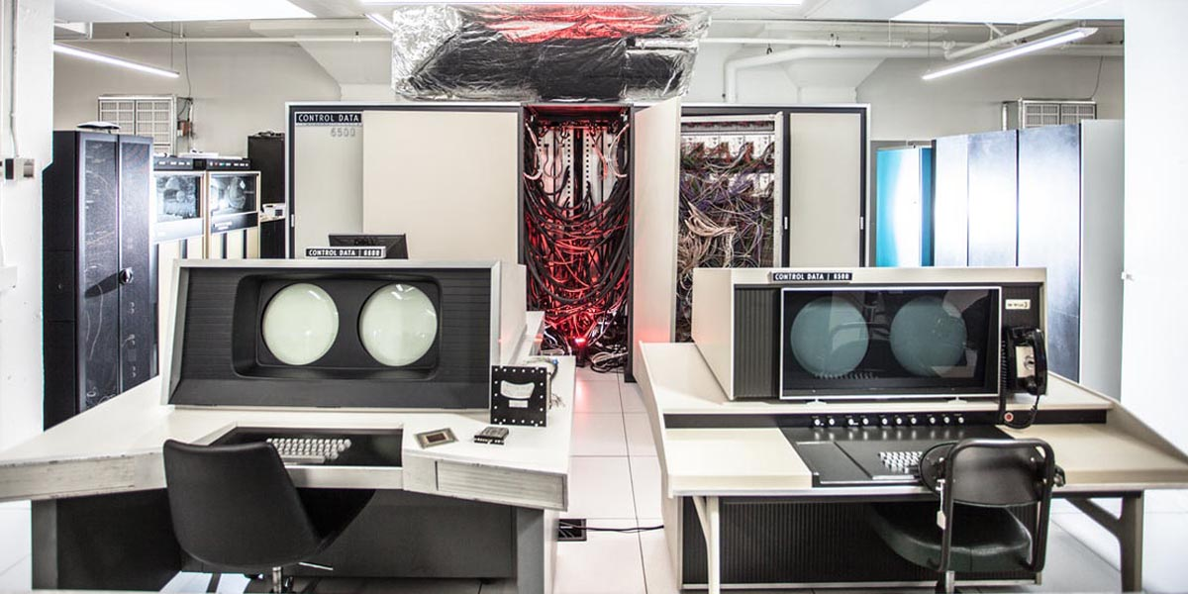
Figure 1.1. A CDC 6500 at Purdue University, ca. 1970 [5]

For comparison, the paper is being prepared on a computer with more than four orders of magnitude more memory and at speeds that are two orders of magnitude faster. All this at a cost that is now four orders of magnitude lower and weighs less than three orders of magnitude lighter. But this paper asserts that this is not where the real progress has been made, in terms of the need for effective, compelling and accepted standards. It is in the ever more complex, sophisticated and robust software based on evolving understanding of some very non-physical parameters and processes: the human emotions. The developers of the original flight trainers like the Link Flight Trainer [7] almost surely did not contemplate the complexity of the modern battlespace simulations [8] so would not have concerned themselves much with the ways in which their devices input external data and out-put device data as to position, orientation, speed and direction.
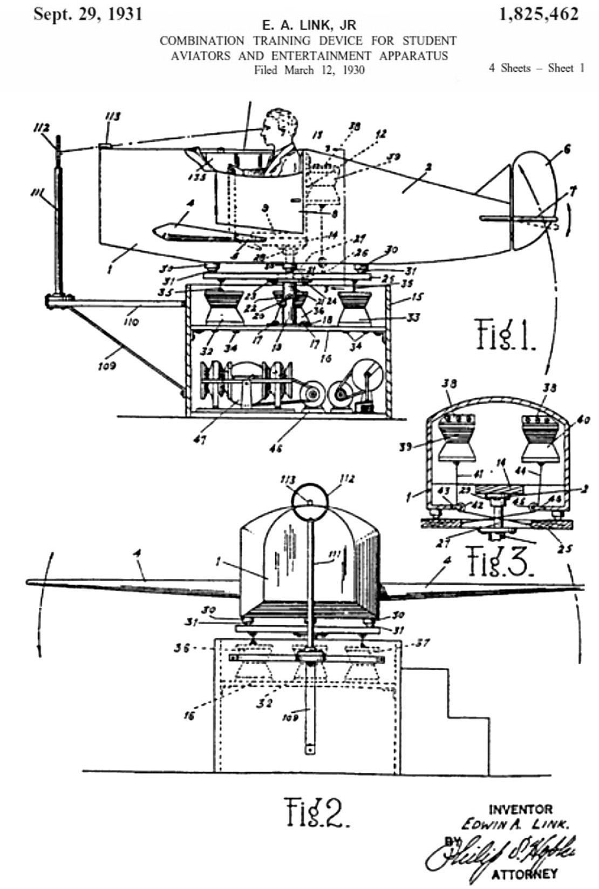
Figure 1.2. Link Trainer Patent [7]
Naturally, the crew working on ELIZA would not have had much cause to consider just which parameters of their program might need to be standardized and which metrics needed to be considered by the user community to allow a rapid and quantified assessment of learning goals, pedagogical efficacy, knowledge persistence and validity criteria. These needs are exacerbated by the rapid advent of emerging technologies, the almost instantaneous adoption of new technologies by national foes and the rapid obsolescence of all of today's newest and most fashionable breakthrough. The community no longer has centuries to perfect and accept new technology. However, new developments in computing, both hardware and software have exponentially increased the dimensions that need to be considered. The researchers sitting at an electric typewriter terminal in 1971 sought a reasonable response to simple entries to the computer; the same researcher today is faced with a much more realistic representation of the therapist, a much richer set of parameters in the users input, and a new set of issues with the prompting of the user. These may be seen as the recognized disciplines of Virtual Reality (VR), Augmented Reality (AR) and Extended Reality (XR), each with their own sets of terminology and needs for standards.

Implementation

- A Personal History of Computer-Generated Therapist

As one of the authors (D. Davis) sat in front of the electric typewriter in 1971, typing his inputs to a CDC 6500 that was connected by a phone-Modem to the off campus lab where he was working, it was clear that the interface was very non-human and quite frustrating. Random long delays and regular shorter latency issues made the "conversation" torturous at best. Most of the standards were communication-related and none had to do with human factors or reality evaluation. Simple typos were not recognized and half decade later it is a distinct memory of getting upset when one typo led to a misunderstanding and attempts to get the computer to recognize the mistake repeatedly failed, resulting in the user transmitting an Anglo-Saxon term for a body-function. It is worthy of note that the CDC 6500 finally recognized that as important and responded: "You seem upset.". Correct!

Some 50 years later, a new team recognized a shortfall in the number of Science, Technology, Engineering, and Math (STEM) professionals, for which many hypotheses have been advanced [8]. These include negative images of technical ﬁelds in the media, lack of awareness of the range of STEM careers, and mistaken notions of the actual working environments of both technical and non-technical professional ﬁelds. In many cases this is exacerbated by the lack of easy student accessibility to technical personnel, especially among students who are younger, who come from lower socio-economic-status households (SES), and those living in communities that are geographically remote from centers of technical activity (e.g., rural areas). The computer generated mentors to address these issues were developed in a project called MentorPal.

This project envisioned two complementary types of STEM outreach which were combined and they were designed using common languages (e.g. C++ and Python), to make them easily extensible on other platforms. Through both the use of the technology and by explaining the technology, the USC researchers sought to increase the students’ awareness of the range of activities that STEM personnel perform. They discussed the wide variety of personalities of technical personnel and the paths that lead to various technical careers.

The major new function that set MentorPal and its contemporaries apart from ELIZA is the vectorization of language to enable Natural Language Processing [9]. This process indentifies words as numerical vectors and then classified depending on such characteristics as frequency in a group of documents, relationships to other words, and other relationships. Having done this the computer can make assumption about how this vecrtorized word is used. In the case of the current work, the words in the question can be rapidly identified and characterized, then matched digitally to the closest vectorized value of one of several hundred video clips, all within 500 milliseconds to retain the impression of a "live" conversation. Students report a high level of "conversationality" both in oral in-person interviews and in casual evaluation summaries structured in a classic Likert-style survey.

Table 2.1 User Straw Poll Results
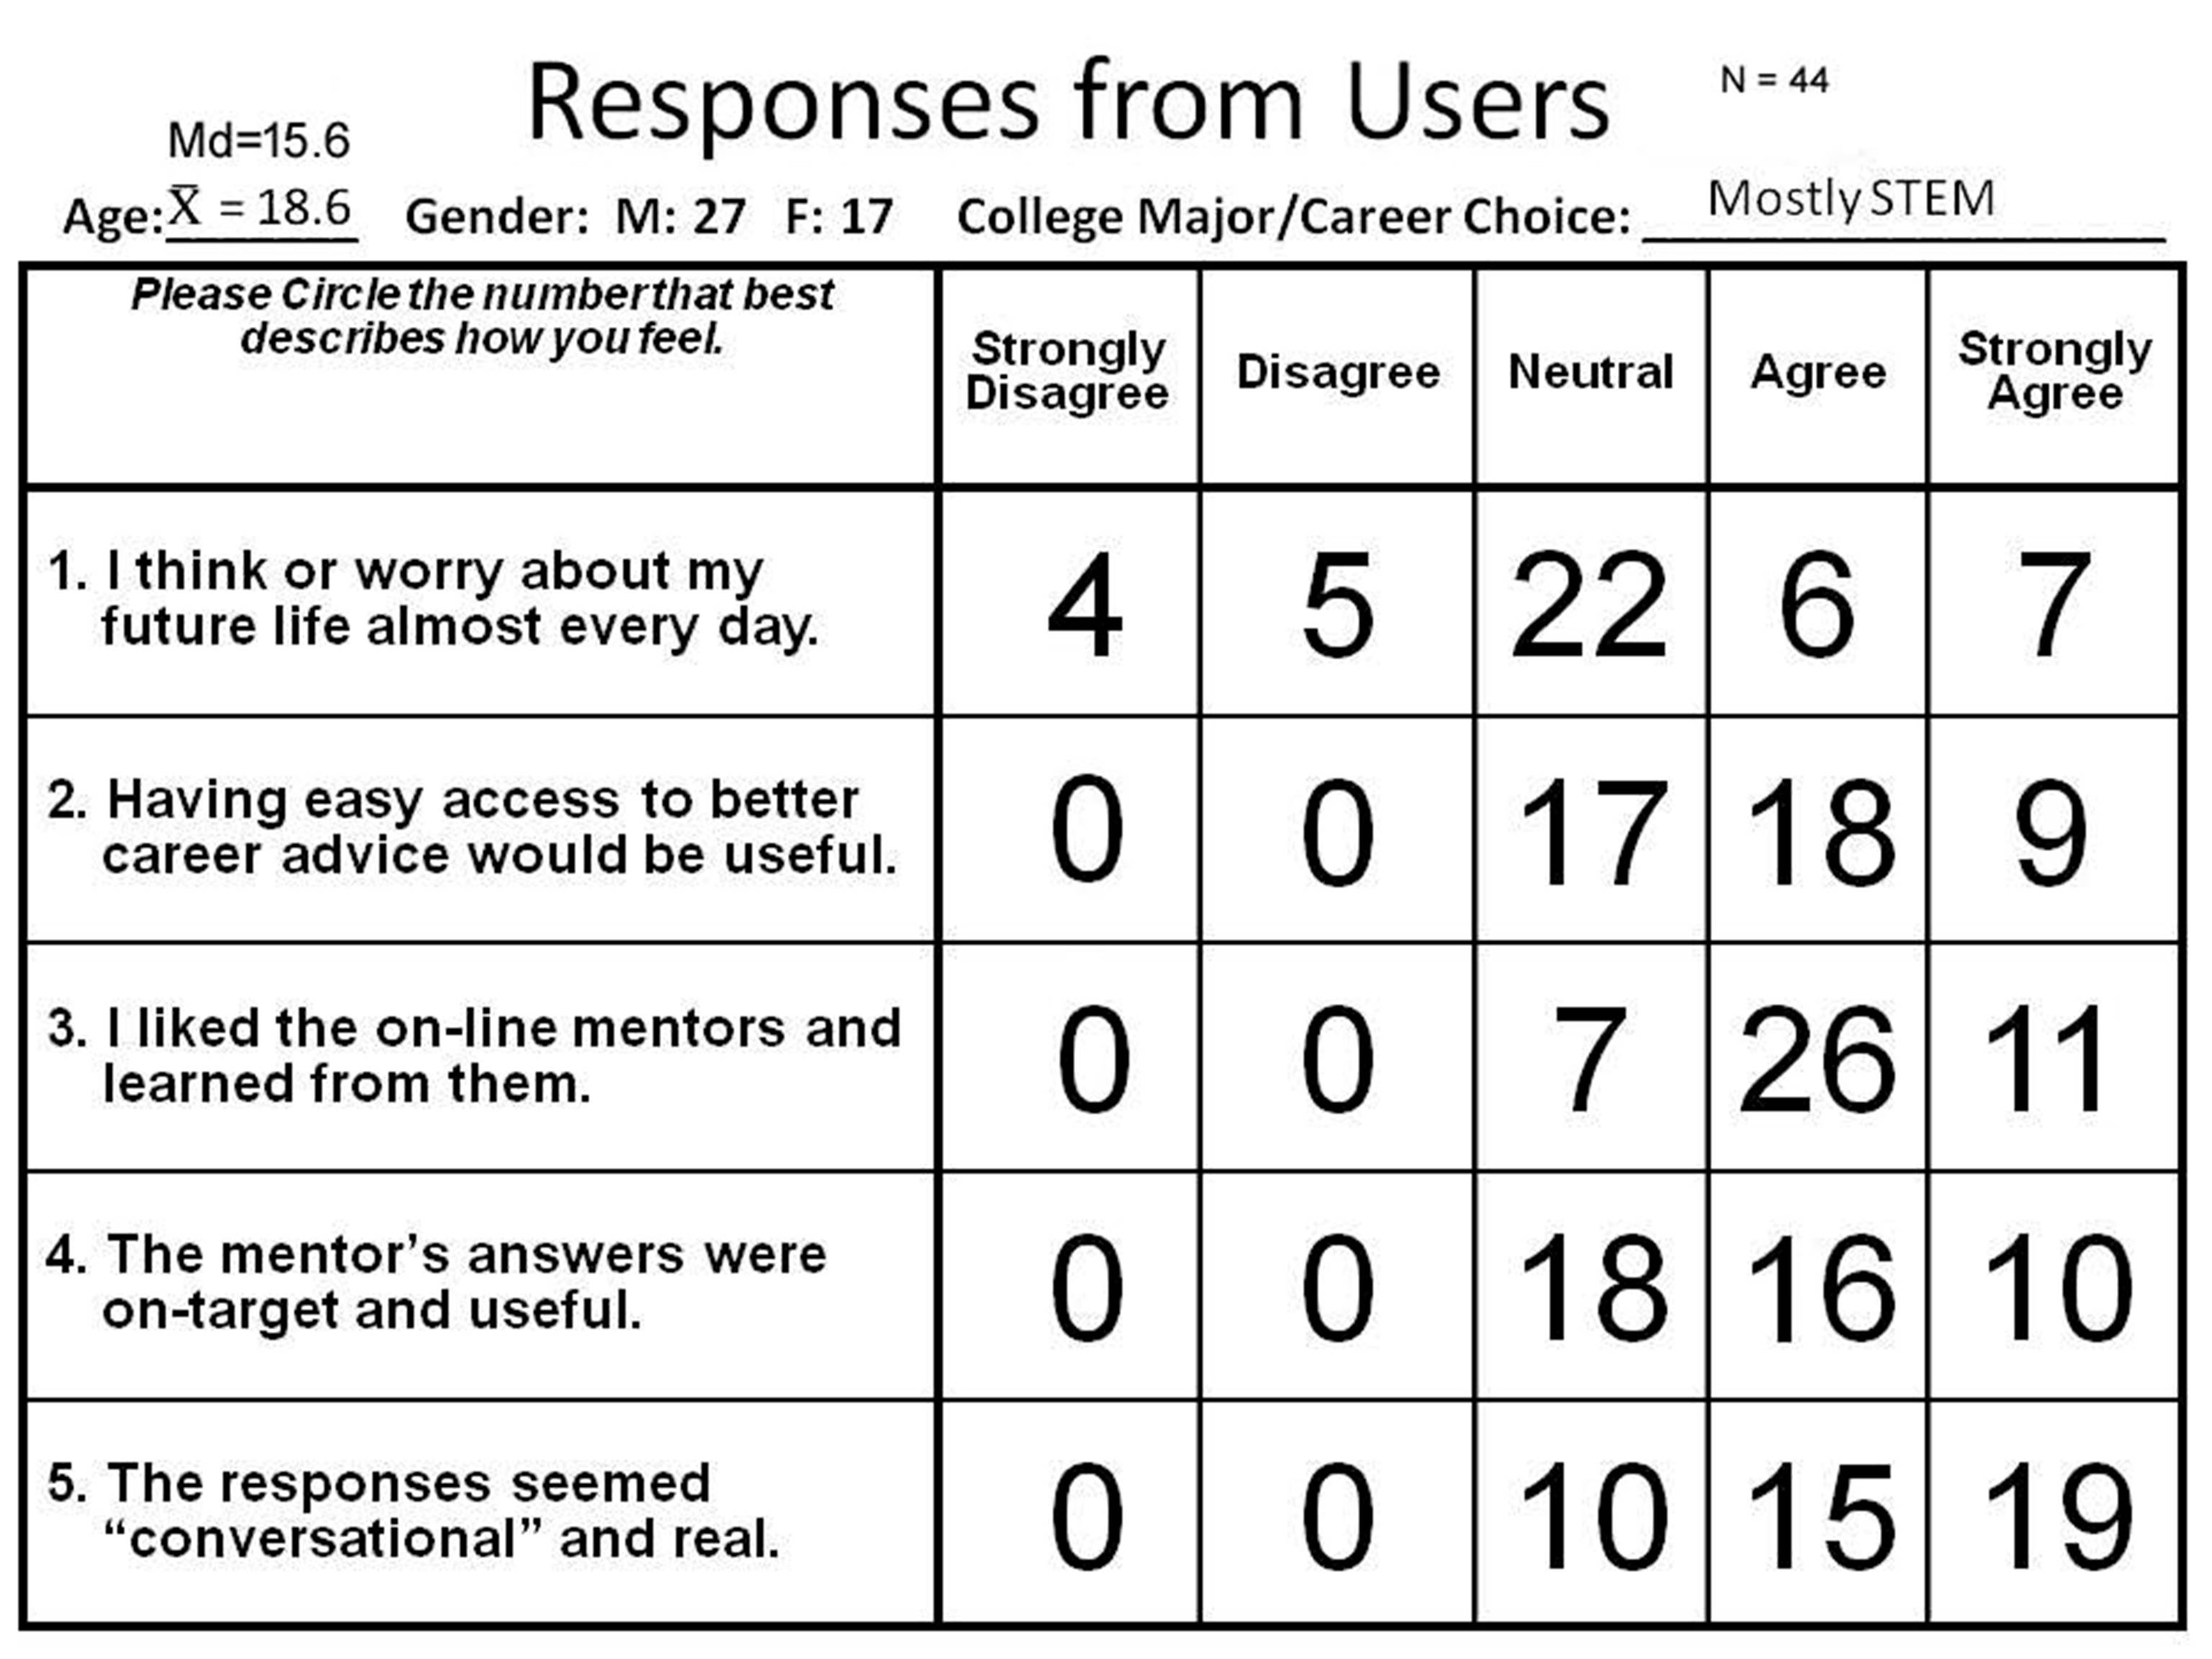

The MentorPal project draws from earlier approaches using some of the same underlying natural language dialog technology, known as NPCEditor [10], which specializes in question-answering agents. NPCEditor is one of the two methods used by MentorPal in selecting the best video clip to respond to the users' questions. An early use-case for NPCEditor technology was for an exhibit at the Boston Museum of Science called The Twins, where visitors interacted with dialog-based virtual agents who could answer questions about computer science and about how they worked [11]. Follow-up research adapted the underlying dialog technology to reproduce the experience of having an experience with Holocaust survivors, by delivering recorded video clips of the survivors as responses, as opposed to driving virtual characters [12]. These systems identiﬁed a variety of interactions and social dynamics, with a typical presentation including a facilitator who would work help a group of visitors take turns asking questions from the system. However, compared to these prior systems, MentorPal has been designed with a strong emphasis on lower cost (e.g., smaller question sets) and one-on-one dialog (e.g., limited testing with groups of users).

The focus of MentorPal is on emulating the experience of an informational interview, such as the kind a student would have with a mentor at a career fair. This can be contrasted against mentoring systems that are designed to help students working on a speciﬁc project, such as AutoMentor [13]. It can also be contrasted against intelligent mentor agents who support metacognition as part of an open learner model [14]. Compared to these systems, MentorPal is not intended to build skills. Even among mentoring agents who also handle question asking and familiarization, such as the SimCoach system [15], MentorPal is distinct due to its focus on subjective experiences. Instead of a general description of STEM careers or ﬁelds, it is intended to help learners identify a mentor whose experiences resonate with them and that enables them to explore realistic visions of careers that they might pursue.

- A look at project progress

After several small group evaluations by secondary school students, the team found it desirable to spend a few minutes discussing the entire topic of career selection with the students. Their almost universal lack of context for decisions was somewhat tempered by one of the research team and the student engaging in a face-to-face conversation before the student logged in and started to interface with the on-line MentorPal. The team maintained an on-line presence of the MentorPal for the three-year duration of the project, with the concomitant increase in features, robustness, interface usability, and content value. No significant latencies were experienced during the on-line use, but all testing was done in the State of California, where USC's servers were located, so "non-conversational latencies may exist for global uses. This is another area that may be an important topic for standardization. The question being: what latencies typically destroy the impression of conversation.

The program was field tested at a STEM fair on the University of Southern California (USC) campus in 2018. Due to signiﬁcant diﬀerences in content and changing user familiarity with technology as in earlier work with Natural Language Editor and similar systems, a live STEM fair exhibit oﬀered a diﬀerent perspective on interactions with this kind of mentor. For a STEM fair it was not certain if students would ﬁnd the system novel (e.g., due to greater availability of useful virtual assistants). Prior testing with MentorPal was conducted with one-on-one use (e.g., a student sitting at a computer), so it was part of the research to observe how diﬀerent students would interact with the MentorPal system when they were part of groups or an entity in parent-student dyads.
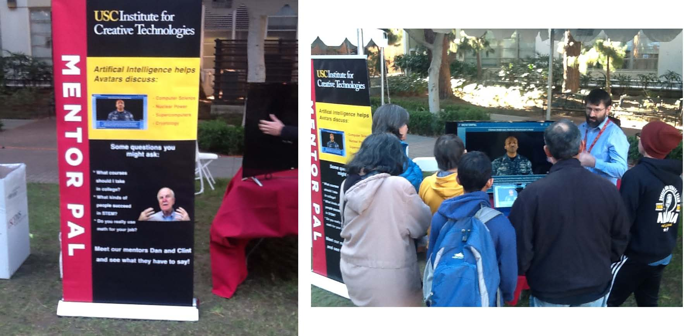
Figure2.1. MentorPal at STEM Fair at USC 2018

There is an effective current methodology for:
- Asking questions
- Cleaning transcripts
- Improving these models
- Classifying new paraphrases
- Putting these into dialog models
- Establishing alias tags for questions.
- Converting the questions into transcripts

Building a useable interactive virtual mentor from recorded videos took up to 20 hours of video footage to provide a broad coverage of responses, with approximately 60 hours of additional time for subsequent processing: about 40 for preprocessing transcripts and 20 for post-processing dialog models. Because a long-term goal of this project was to enable recording any person as a mentor (without researcher or administrator intervention), improvements to the current pipeline were noted when discussing each step of the process.

The operative question-set consisted of four types of questions:
a) Pre-set questions that are asked for all mentors (~70% of questions)
b) Mentor-speciﬁc questions related to their career or life experiences (~10%)
d) Mentor-speciﬁc common questions observed in students to mentor chat logs (~10%)
c) Follow-up questions identiﬁed in interviews and were relevant to mentor responses (~10%)

Typically, the mentors were recorded in ﬁve or so sessions (each about three hours long) to cover the question set. These sessions have a mix of these topics, with a follow up section for each session. After the initial sessions, re-recording sessions are held to record new answers to bad video clips or to record answers to common questions that were not recorded (i.e., the fourth type of question). Each follow-up session typically lasts for about 45 minutes to an hour. These follow-ups are important because they assist with creating a more natural conversational ﬂow, by enabling the mentor to answer questions that are likely to be asked after a student has heard a particular response.

Recording involved calibration with help from project staﬀ in order to ensure that the recordings are consistent and the responses are appropriate to chunk into useful videos. Standardization included ensuring that the mentor maintains a resting position three seconds before and after the question is answered. The resting position was set at about the same spot throughout the recordings, to avoid “jumping” where a mentor’s next statement has a totally diﬀerent head or body position. In addition to this, the mentor was urged to display emotion, show smiles, tell stories, and use hand motions to provide engagement. So far, each recording was standardized by using the same low-cost equipment setup (webcam, microphone, backdrop), which is shipped to mentors, who are not uncommonly located remotely. After recording, either the mentor (if remote) or research staﬀ uploaded the session ﬁles to cloud storage for post-processing. Overall, this approach has worked eﬀectively, with the quality of recordings and transitions signiﬁcantly higher than was initially anticipated. Sound quality has occasionally suﬀered,

One of the most perplexing issue that was significant departure from the ELIZA test was the lack of student ability to ether generate or to frame parameters for a "good career." When asked, one student defined a "good career" as one in which he could earn enough money to buy a Lamborghini. Even were he to have been jesting, that shows a lamentable lack of serious thought about what constitutes a fulfilling career. But, detecting sarcasm and addressing moral and ethical issues in a compelling and meaningful way are putatively outside of current capabilities. This area brings into sharp focus the implementation of an AR capability that would seamlessly interject a set of suggestion of what may be important in the choice of a career. As a stop-gap measure, a series of suggestions was developed and listed in a button box at the bottom of the MentorPal display. Below those is the panel for typing questions if the ambient noise is too loud to allow for a microphone and voice-recognition to be used as the input interface for questions from the user. The videos were shot with a plain background, but any background image can be applied digitally. In Chief Anderson's case, an unclassified photo of a nuclear control panel could be substituted.
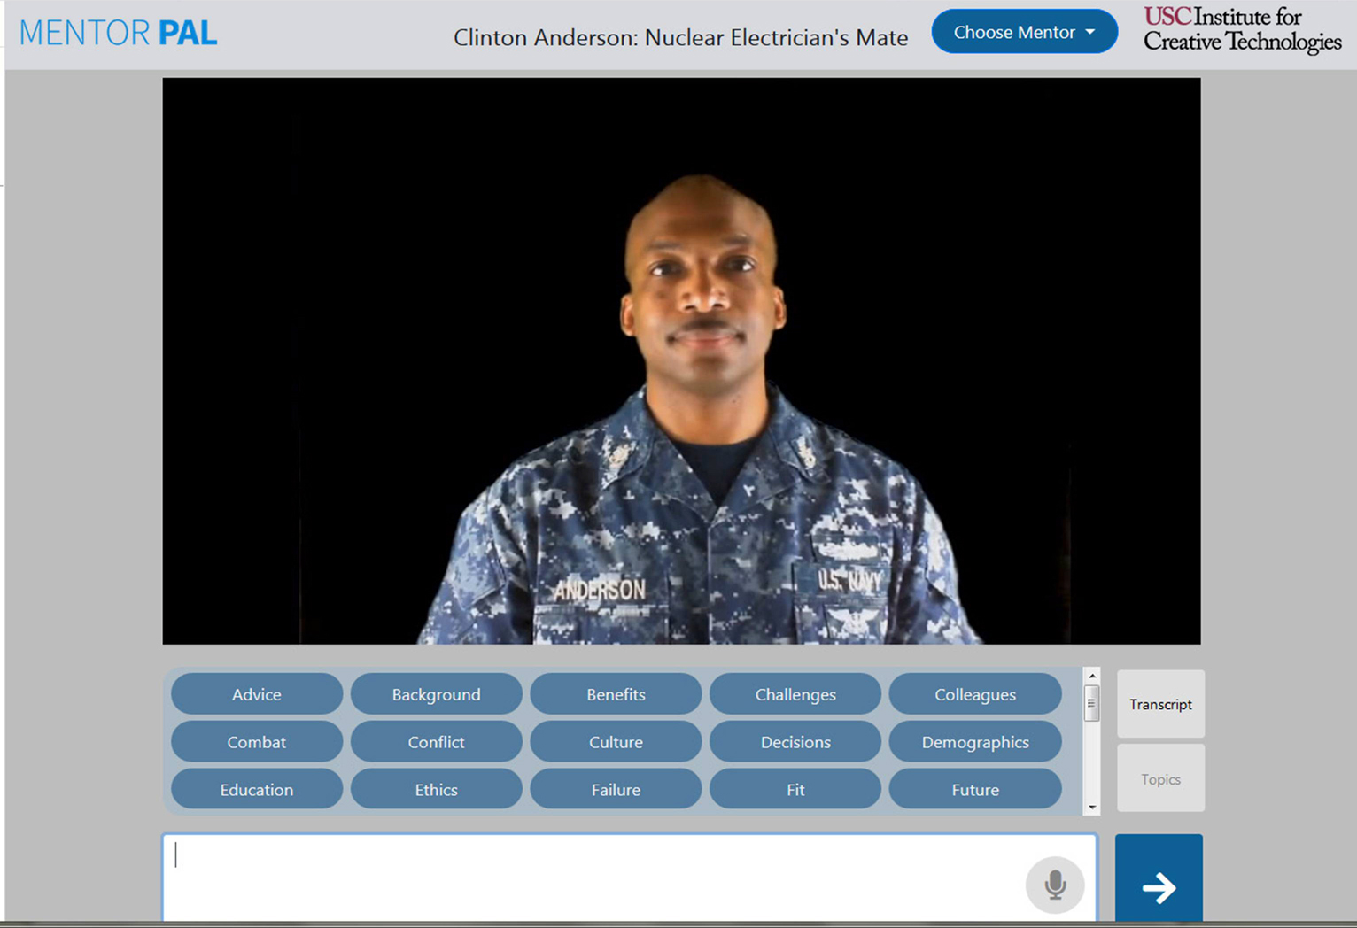
Figure 2.2. MentorPal Display showing suggested topics.

An effective AR adjunct to the current program is currently under consideration. Victorian ideals of proper social behavior held that each "civilized" conversation should be made up of three parties, two people actively exchanging ideas and a third monitoring the conversation with interest and acting as a sort of intervener to facilitate the discussion. That entity in the planned next generation of the MentorPal effort would be yet another computer agent who would keep track of the conversation, analyze the vectorized text for confusion, monitory body language and voice tone for stress or boredom and then intervene in an Augmented Reality context by interjecting a question, either by text on the screen, or a more life-like interposition of a Video-Con interface with a new character, e.g. suggesting: "Maybe you'd like to ask the Mentor about his favorite story about his career field.". This intricate interplay of the live user and Computer Agent 1 (mentor) and Computer Agent 2 (other conversation participant) would be rife with needs and opportunities for standards of terminology, interface design, uses and metrics.

- What needs will grow from anticipated progress

The systems that had their genesis in programs like ELIZA and are experiencing their current effective implementation in programs like will need a whole new series of standards in terminology, interface interoperability, utility and metrics. Some of those are already being studied by SISIO [16]. The issues they are studying are manifold, but this discussion will look at some that may come up from this narrow field of virtual conversational computer agent. The information may well relate to both animated agents like SimCoach or video-clip agents like MentorPal. As standards often apply most importantly to interfaces, a notional diagram of information flows in the future virtual conversation agents may be illustrative. As it is the program with which the authors are the most familiar, the vision diagram will focus on an extension of the MentorPal project. It should be noted and the paper's author recognize that this is a researchers' vision, informed by professionals from the stakeholders' communities, but not vetted by nor endorsed by major contractors or suppliers. It is clear that they will be the segment of the larger technical community that will do the "heavy lifting," so the flow chart offered below should be viewed with that limitation in mind and any member of the industry who wishes to comment on the paper is invited to do so.

As outlined above, the MentorPal of the future is anticipated to have three major actors and a plethora of non-active stakeholders including families, educators, employers, political leaders, and society at large. The three major actors will be identified as the user (mentee), the mentor (computer agent) and the mediator (currently staff, but in the future another computer agent.

There are, of course risks in any new endeavor. This may especially obtain in using new technology to guide young people. While no compelling research was found supporting it, the authors' uniformly have known people who have chosen the wrong career and paid a heavy price for the mistake in terms of stress and lack of fulfillment. It is a significant risk to turn this duty over to a computer. While the computational answer have very attractive characteristics: objectivity, accessibility, scalability, and economy, the costs would be high if the activities were not carefully monitored by caring adults, well-versed in adolescent vulnerabilities and the damage that incorrect advice might give.

The US Bureau of Labor Statistics (BLS) reports the future for careers in High School Counseling is good, so relieving the student load on each of the live counselors may be a good plan. The projected near-term outlook appears below.
Table 2.2 BLS Occupational Outlook for School and Career Consolers [17]
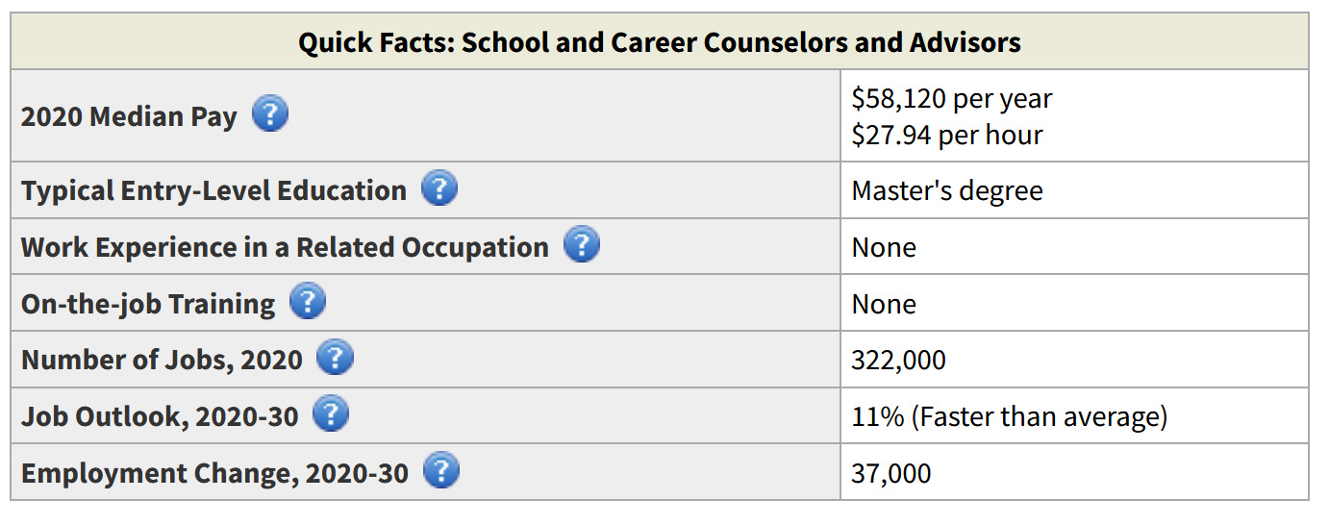

Balancing that is the fact that many report inadequate, ill-provisioned and poorly supported secondary school academic counseling offices. One counselor told the team that they spent twice as much time on behavior training and delinquent activities than they did on academic counseling. There is also the factor that many parents are inadequately trained or experienced to give good advice. Wake Forest University reported that high school security officers out number counselors in four out of ten of the largest school districts in the country. The American School Counselor Association’s (ASCA) recommendation of one counselor for every 250 students [18].

While causality is always an issue, the high schools where school counselors have fewer students to care for also have lower rates of student suspensions and fewer disciplinary incidents. The causality issue is where a well-trained counselor would want to work. Such issues are sensitive, so there are clearly more studies from countries other than the US regarding these matters.

These data suggest that career counseling may not be the top priority for secondary school counselors. The successes of the SimCoach program, mentioned above, may hold some promise that such a program might ameliorate the issues in high schools. Some adolescent behavioral problems mirror the challenges faced by the veterans with PTSD. Have a non-judgmental mental health counselor would be within the range of the MentorPal like systems, with only the figures of merit needing to be addressed to make the change to behavior counseling from career counseling.

The risks of relying too heavily on machine counseling would be even more true in this case, but a series of sub-routines could be established to "red-flag" either self-destructive or violent behavior. Consistent and concerned live human review would help avoid untoward collapses of the safety net for young people. This is a serious issue and the reasons for teen suicides are under constant study and are known to be impacted by adequate and available counseling [19].

The 24 x 7 availability of a system like the ones described above make it very attractive for this type of duty. While the computer generated response may lose of few, it may save many more than continuing the way we are now. In any case, the basic concept will remain the same and the standards for a career counselor may be found to be easily extended into suicide prevention. The data flows would be similar and the Neural Net Training to learn to recognize the differing levels of threat would equate to the Neural Net Training to optimize career choice.

The risks of relying too heavily on machine counseling would be even more true in this case, but a series of sub-routines could be established to "red-flag" either self-destructive or violent behavior. Consistent and concerned live human review would help avoid untoward collapses of the safety net for young people. This is a serious issue and the reasons for teen suicides are under constant study and are known to be impacted by adequate and available counseling.

The 24 x 7 availability of a system like the ones described above make it very attractive for this type of duty. While the computer generated response may lose of few, it may save many more than continuing the way we are now. In any case, the basic concept will remain the same and the standards for a career counselor may be found to be easily extended into suicide prevention. The data flows would be similar and the Neural Net Training to learn to recognize the differing levels of threat would equate to the Neural Net Training to optimize career choice.

Although it is early on in the process of determining the goals and utilities of a 3rd Party conversation participant fulfilling an AR role, some form has been advanced by the research team. The person might act in any or all of a number of roles:
- Prompter for a "frozen" student
  - "Why don't you ask the Mentor what he likes about his job?"
  - "What do you think you would need to know about the working conditions in a career like this?"
- Reinforcer of the Mentor's positions
  - "I agree with the Mentor; most of my best friends were work colleagues."
  - "I think I enjoy this kind of work even more than the Mentor does."
- Evaluator of the Mentor's Suggestions
  - "The Mentor may be right about travel, but I had a different experience."
  - "Here's what I did in my career that had a different outcome."
  - "Did you really mean that everyone you knew enjoyed that aspect of your work?
- Tale-teller of germane stories
  - "What the Mentor said happen to me too, but this is how it worked out."
  - "That brings to mind a really interesting issue that might fit your case too."
- Questioner of the Mentor directly
  - "Mentor, why don't you tell the user the story about your winning a best paper award."
  - "Don't forget to mention the times you got to work on-site and lived in a tent for a week."
  - "While I know you liked that, I have to say it wasn't my favorite job. How many others liked it"

So a flow diagram for one program would look much like the flows for another, but the labels on the flows may change a little. The functions of the Virtual Third Party computer generated conversationalist are intended to be very flexible, so their functions and necessary data flows may change significantly.

The proposed vision may look something like this:
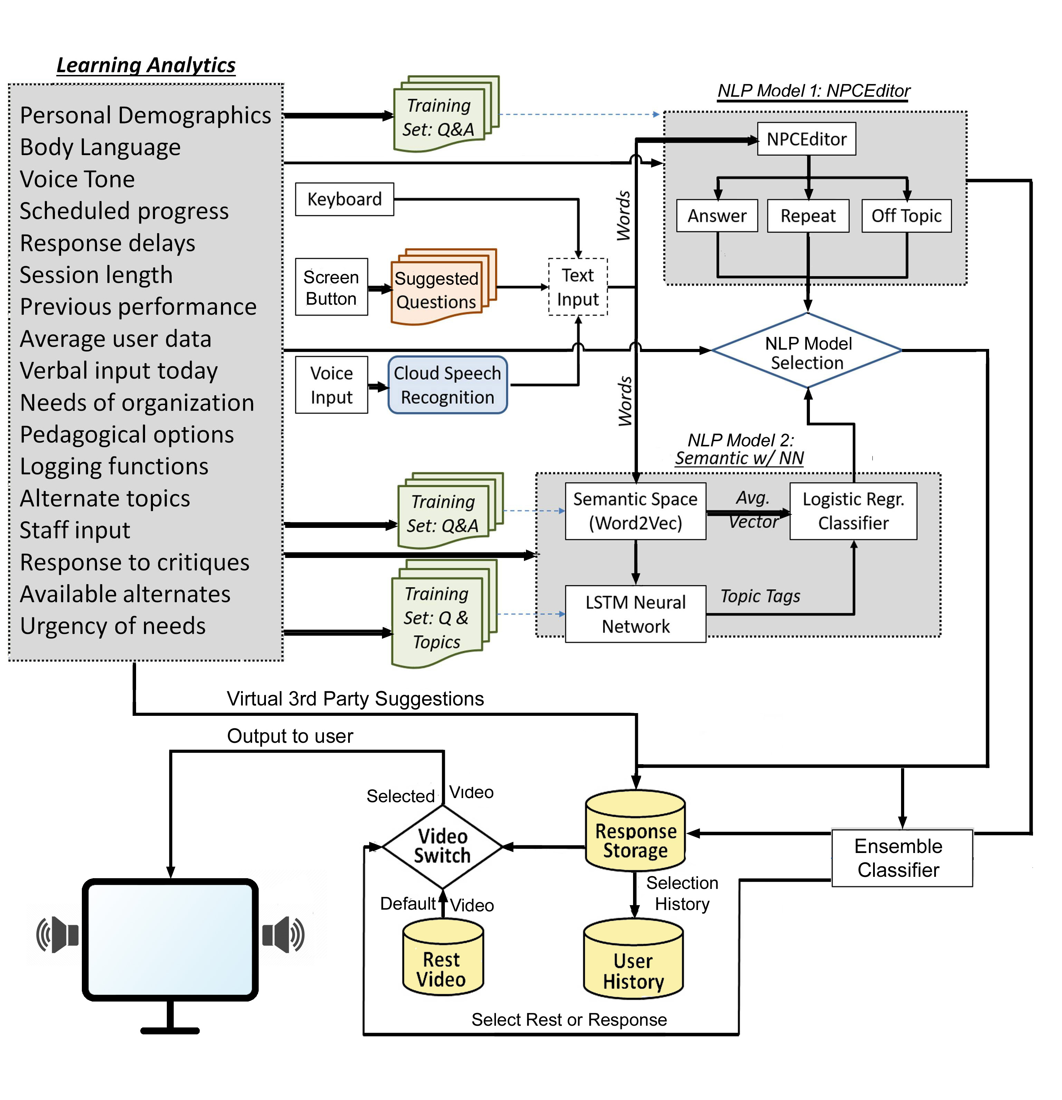
Figure 2.3. Notional Flow Chart for Envisioned Next-Generation MentorPal
While the coding has not be undertaken yet, everything on this chart is feasible and will no doubt be accomplished or something very much like this will become reality soon. The addition of a "trained" virtual 3rd party to the conversation is intended to make the user feel more like they are in a rational discussion. The research paths are open to all in this field and as has been said, "If one person has an idea, one could be assured that several others had the same idea and are already working on it.

In any case, looking at the flow chart, virtually every arrow carries with it the high likelihood that standards will be needed and if not carefully thought-out and crafted, they will grow in ways that will make later consensus difficult and rational conciliation problematic. Communicating to the researchers the "duty" to inform standards professionals early on of the projected needs for standards may become a major function of that community. The Third Party conversation concept seems very likely to require a new and robust set of standards and metrics to ensure a life-like dynamic among the live user and two computer agent entities. There may be several Neural Net Training activities going on simultaneously which may benefit from, in not absolutely require, interchanges of data in real time and ability to plumb both data and trends. The algorithmic structuring of the three-way conversations and the accompanying AI functions to allow them to evolve or to respond to user inputs appropriately will likely open new vistas but also new challenges.

Conclusions

This paper asserts that a special area of significant consequence may be that some standards in terminology and metrics. Without an agreed upon set of both, progress will be hindered and claims hard to verify. One of the major impediments to the development and adoption of new technologies is faulty communications. Emerging technologies have now made viable the dreams of Computational Scientists a half century ago. Early results are now very encouraging and research findings were adduced that users already thought one of the programs studied was ready to go and the researchers found it was needed among the secondary students with whom they visited. Also, there was a significant need not heretofore anticipated by this research team; that of almost complete lack of thought or background knowledge to make a reasoned choice of careers. The damage that is possible from such a lack is nearly incalculable. The authors' own experience, although anecdotal, is that some issues come up over and again, due to inadequate and sometimes absent, communications. This paper asserts that more visibility would well serve both the standards community and the research community at large.

Further research studying these issues in detail will lead to better solutions.

Acknowledgements

The authors would like to thank the work done by the ICT team on virtual humans showing the applicability of this technology to a wide variety of problems, most especially the Co-Principal Investigators of the MentorPal project: the Doctors Benjamin Nye and William Swartout. We should also note that much of the work cited was supported by grants from the Office of Naval Research's STEM Program (ONR N00014-16-1-2820) and by research assistants supported by the National Science Foundation Research Experience for Undergraduates program (NSF 1560426). Nevertheless, the positions taken in the paper are the authors’ own and do not represent in any way the views of the Department of Defense or the US Government.

References
[ 1] Tebes, J. M., (2020). Revolution in the Desert: A Reassessment of the Late Bronze/Early Iron Ages in North-western Arabia and the Southern Levant. Revista del Instituto de Historia Antigua Oriental, 99-125.
[ 2] Christensen, C. M. (2013). The innovator's dilemma: when new technologies cause great firms to fail. Harvard Business Review Press.
[ 3] Turing, D. (2018). The Story of Computing. Arcturus Publishing, London, UK.
[ 4] Weizenbaum, Joseph (January 1966). ELIZA--A Computer Program for the Study of Natural Language Communication Between Man and Machine. Communications of the ACM. 9: 36–35..
[ 5] Living Computers, (2021), CDC 6500, Purdue University, image retrieved from the internet on 20 Dec 21 from: https://livingcomputers.org/Computer-Collection/Vintage-Computers/Mainframes/CDC-6500.aspx ..
[ 6] Hill, M. D., Hill, M. D., Jouppi, N. P., Jouppi, N. P., & Sohi, G. S. (2000). Readings in computer architecture. Gulf Professional Publishing, Houston, Texas.
[ 7] De Angelo, J. (2000). The Link Flight Trainer: A Historic Mechanical Engineering Landmark, Roberson Museum and Science Center, Binghamton, New York, June 10, 2000.
[ 8] Ceranowicz, A., & Torpey, M. (2005). Adapting to urban warfare. The Journal of Defense Modeling and Simulation, 2(1), 3-15.
[ 9] Bird, Steven & Klein, Ewan & Loper, Edward. (2009). Natural Language Processing with Python. O'Reiley, Sebastopol, CA
[10] Rizzo, A., Lange, B., Buckwalter, J.G., Forbell, E., Kim, J., Sagae, K., Williams, J., Difede, J., Rothbaum, B.O., Reger, G., et al.: Simcoach: an intelligent virtual human system for providing healthcare information and support. International Journal on Disability and Human Development 10(4), 277–281 (2011)
[11] Smith, A., Anderson, J.: Ai, robotics, and the future of jobs. Pew Research Center 6 (2014)
[12] Swartout, W., Traum, D., Artstein, R., Noren, D., Debevec, P., Bronnenkant, K., Williams, J., Leuski, A., Narayanan, S., Piepol, D., et al. (2010): Ada and grace: Toward realistic and engaging virtual museum guides. In: International Conference on Intelligent Virtual Agents. pp. 286–300. Springer Germany
[13] Traum, D., Jones, A., Hays, K., Maio, H., Alexander, O., Artstein, R., Debevec, P., Gainer, A., Georgila, K., Haase, K., et al. (2015): New dimensions in testimony: Digitally preserving a holocaust survivor's interactive storytelling. In: International Conference on Interactive Digital Storytelling. pp. 269–281. Springer, Germany
[14] Wang, J., Li, H., Cai, Z., Keshtkar, F., Graesser, A., Shaﬀer, D.W.(2013): Automentor: Artiﬁcial intelligent mentor in educational game. In: International Conference on Artiﬁcial Intelligence in Education. pp. 940–941. Springer Germany
[15] Morbini, F., Forbell, E., DeVault, D., Sagae, K., Traum, D., & Rizzo, A. A. (2012, July). A mixed-initiative conversational dialogue system for healthcare. In Proceedings of the 13th annual meeting of the special interest group on discourse and dialogue (pp. 137-139).
[16] SISO, (2021). XR Interoperability Standards Study Group. Retrieved from the internet on 17 Dec 21 from URL: https://www.sisostds.org/StandardsActivities/StudyGroups/XRInteroperabilityStandards.aspx
[17] BLS, (2021). Quick Facts: School and Career Counselors and Advisors, Bureau of Labor Statistics, Retrieved from on 27 Dec 22, from: https://www.bls.gov/ooh/Community-and-Social-Service/School-and-career-counselors.htm
[18] Wake Forest University, (2021) Do High Schools Need More Counselors, Wake Forest University. Retrieved from the internet on 22 December 22, from: https://counseling.online.wfu.edu/blog/do-schools-need-more-counselors
[19] Niederkrotenthaler, T., Stack, S., Till, B., Sinyor, M., Pirkis, J., Garcia, D., ... & Tran, U. S. (2019). Association of increased youth suicides in the United States with the release of 13 Reasons Why. JAMA psychiatry, 76(9), 933-940.

Author Biographies

Dan M. Davis is a Research Associate Professor at Catholic Polytechnic University (CPU) and is also active as a consultant at the Institute for Creative Technologies, University of Southern California (USC). He is currently focusing on large-scale DoD simulations and virtual human implementations. Prior to retirement, he was the Director of the JESPP project at USC for more than a decade. As the Assistant Director of Advanced Computing Research at Caltech, he ran Synthetic Forces Express, bringing HPC to DoD simulations. He has also served as a Director at the Maui High Performance Computing Center and in computer research roles at the Jet Propulsion Laboratory and Martin Marietta. He was the Chairman of the Coalition of Academic Supercomputing Centers and has taught at the undergraduate and graduate levels. As early as 1971, Dan was writing programs in FORTRAN on one of Seymour Cray’s CDC 6500’s. While in the Marine Corps, he saw duty in Vietnam as a Cryptologist and retired in 2002 as a Commander, U.S.N. He received B.A. and J.D. degrees from the University of Colorado in Boulder.

Jennifer H. Nolan, Ph..D. is the President of Catholic Polytechnic University and Professor of Psychology in their College of Arts and Sciences. Her earlier work specialized in memory, dementias, stroke and insulin resistance. She is a brain plasticity specialist and certified Cogmed provider. Previously, she was the C.O.O. and co-founder of a stroke and brain injury rehabilitation center. Dr. Nolan has taught university courses at the University of California Irvine, Loyola Marymount University, and Glendale Community College. She has conducted local and nationwide clinical trials, and published in both scientific journals and popular magazines. She received a BA in Psychology from Loyola Marymount University, Los Angeles and a Ph.D. in Psychology from the Dept. of Cognitive Science at the University of California, Irvine.

Mark C. Davis, Ph.D. is the Chief Technical Officer at Wood Duck Research, Inc, and is semi retired after careers in the US Navy and as a computer design engineer for both IBM and Lenovo. Rising to the level of Distinguished Engineer at Lenovo, he was responsible for the design of laptop computer cross-disciplinary technology, including PC architecture, embedded systems, open source and virtualization. Previous work was with IBM in the areas of software development and architecture involving security, storage and virtualization. Dr. Davis has been granted well over fifty patents that were filed during his service at both companies. He is a graduate of the Duke University NROTC program and was commissioned as an Ensign, attended nuclear power school, and served as a Submarine Officer for twelve years, including one duty tour as a classroom instructor. He left the active duty as a Lieutenant Commander to pursue a PhD. Mark holds a BSEE degree from Duke University and a PhD in Computer Science from the University of North Carolina, Chapel Hill, where his advisor was Professor Fredrick P. Books.

JUDITH L. JACOBUS is retired from conducting speech therapy as a Speech and Language Specialist for more than two decades. Her experiences were in public schools settings in Orange County. California. She also previously taught for 12 years as a classroom teacher in multi-cultural communities there. Judith currently volunteers her professional skills for a local police department, so has extensive experience with dysfunctional adults and children in a variety of both every-day and traumatic situations. Her participation in amateur theatrics has more fully familiarized her with the characteristics of human behavior as they are projected via verbal, facial and body-language cues. This experience has also exposed her to the skill and art of the selection of appropriate persons for specific on-screen roles. Judith holds a lifetime Special Education Credential in Speech and Hearing Therapy, K-12 from the State of California. She earned a B. A. Degree in Speech Communications from the California State University Long Beach and an M. A. Degree in Teaching and Teacher Leadership from the Grand Canyon University in Glendale, Arizona.

