All authors must submit this release prior to presenting the content of their paper or presentation at the 2022 SIW. Additionally, papers cannot be published in our online proceedings without this release form on file.

Paper/Presentation #: _2022-SIW-005_ (2022-SIW-0## or 2022-SIW-Presentation-0##)

Title: Resurrecting a 55-Year-Old Program:

Standards for Emerging Proactive Interactions
__________________________________________________________

Authors: Dan M. Davis, Jennier H. Nolan, Mark C. Davis and Judith L. Jacobus_

__________________________________________________________

__________________________________________________________

__________________________________________________________

The above paper and/or presentation prepared for the 2022 Simulation Innovation Workshop (SIW) is approved for unlimited release (including to foreign nationals) and may be published by SISO in both print and electronic form.

Name: ___Dan M. Davis__________________________

Position: ___Research Associate Professor_________________

Organization/Company: ___Catholic Polytechnic University____

Telephone: ____________310 909- 3487_______________________

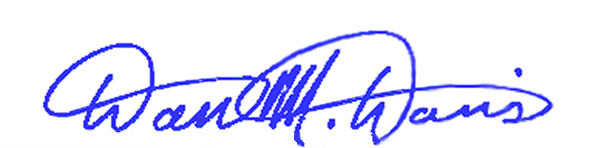
Email: _________ddavis@catholicpolytechnic.org________________________

Signed: __________________________ Date: 28 January 2022

