Resurrecting a 55-Year-Old Program:
Standards for Emerging Proactive Interactions

Dan M. Davis & Jennifer H. Nolan
Catholic Polytechnic University
1028 N Lake Ave MC 207
Pasadena, CA 91104
{ddavis & jnolan} @catholicpolytechnic.org

Mark C. Davis
Wood Duck Research, Inc.
129 Wood Duck Loop
Mooresville, NC 28117
davismc@ieee.org

Judith L. Jacobus
Education Counselor/Therapist
1564 Merion Way.
Seal Beach, CA 90740
stately07@dslextreme.com

Keywords:
Virtual Therapist, Natural Language Processing,
Interoperability Standards, Safety Standards & Metrics

ABSTRACT: A new look at an old initiative has been stimulated by the the emerging technologies called "XR". As Virtual Reality(VR) and Augmented Reality(AR)have emerged, they have began to overlap, leading to the ill-defined concept of Extended Reality or XR. The emergence of this concept has spawned many novel approaches to wide spectra of issues, but this paper takes a retroactive look at and a promising concept for developing a computer-generated therapist. Both emotional and speech therapeutics might benefit from this new capability. Back in 1971, the Eliza program had been conceived, designed and implemented at the Massachusetts Institute of Technology(MIT). That program was one of the earliest attempts at Natural Language Processing (NLP) and virtual conversations. The consensus was that it fell short of the mark due to technical limitations. The paper lays out this genesis, the subsequent work, a review of the criticisms, and an outline of its legacy. Skipping forward, the progress in NLP is surveyed, with particular emphasis on the MentorPAL project at USC. The constricting limitations of the Eliza instantiations are covered in some detail, and then the ability of XR techniques to address them are listed. In these processes, careful attention is paid to the use of standards to both facilitate and evaluate the progress toward a truly effective Virtual Therapist. Both the benefits and risks of such a program are laid out, with very detailed attention to the metrics for success and the safe guards against exacerbating the subject's condition or creating dangerous reactions that could result in injury to the subject or the public. This opens us a serious discussion as to safety standards. Some of these safeguard techniques will entail both computer code functions to identify dangerous situations and procedural directives to guarantee live-human oversight of progress and interventions. Paths forward will be identified and discussed. Costs, risks and maintenance will be briefly considered. Potential extensibility into other analogous activities will be set forth, again with an eye for standards designed to promote such extensibility.

This is a Section Title [“Heading 1” Style]

[Text is “Normal” Style]

Section Titles should be set in Times New Roman 12- point bold, numbered as shown. Upper case should be used for the first letter of every major word.

Body paragraphs (like this one) should be set in Times New Roman 10-point, and fully justified. Insert one blank line between paragraphs. Do not indent.

This is a subsection title [“Heading 2” Style]

Subsection titles should be set in Times New Roman 10- point bold, numbered using decimal notation as shown.

Equations should be set in Times New Roman, 10- point italic, size, and horizontally and vertically centered. A slightly smaller font may be used for equations, subscripts, and superscripts.

Preferably, figures should be inserted in the text, soon after they are referred to. They may be sided to fit one column, or the full page width, as appropriate to their complexity. The same applies to Tables.

References should be numbered in the order in which they are cited in the text, using numbers in square brackets. For example, see references [1], [2], and [3].

Figures, tables, equations, and references should be cited using decimal notation, such as Figure 1.1.

Please do not number your pages. Include your assigned paper number in the file name (e.g., 18F-SIW-001.pdf)
Reminder

The electronic version of your paper must be submitted via the SISO SIW Conference Web page by the date indicated above.

Other headings

    - Heading 3

[Headings 3-9 are not specified, and were configured as Times New Roman 10 pt, Regular font, legal-numbered.] Table 3.1. [“Caption Table” Style].

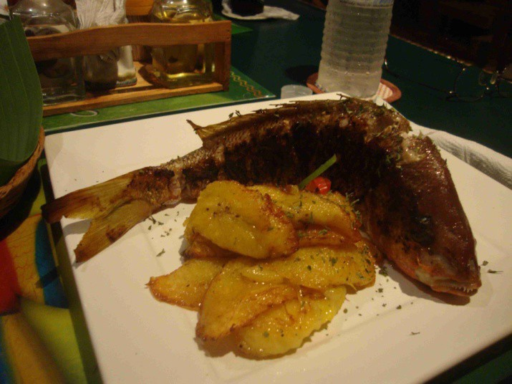

[“Graphic Inline” Style]

Figure 3.1. [“Caption Figure” style].

2 + 2 = 4 [“Equation” Style]

References

References should be set using “hanging indents,” as shown [Apply the Reference Text Style, which includes numbering]:

[1] Author(s) name(s): “This is the Title of the Paper” Journal Name, Vol. 39, pp. 531-548, July 1992.

[2] Author(s) name(s): “This is the Book Chapter Title” Book Title, McGraw-Hill, New York 1990.

[3] More Author(s) name(s): Book Title, Peter Peregrinus, London 1992.

Author Biographies

PAMELA BLECHINGER is an Operations Research Analyst at the TRADOC Analysis Center, Ft. Leavenworth, KS. She is the analytical user representative for ModSAF development activities and wrote the original Authors’ Guide for the first SISO Simulation Interoperability Workshop (SIW).
[Manually bold the author’s name in this section.]

