Resurrecting a 55-Year-Old Program:
Standards for Emerging Proactive Interactions

Dan M. Davis & Jennifer H. Nolan
Catholic Polytechnic University
1028 N Lake Ave MC 207
Pasadena, CA 91104
{ddavis & jnolan} @catholicpolytechnic.org

Mark C. Davis
Wood Duck Research, Inc.
129 Wood Duck Loop
Mooresville, NC 28117
davismc@ieee.org

Judith L. Jacobus
Education Counselor/Therapist
1564 Merion Way.
Seal Beach, CA 90740
stately07@dslextreme.com

Keywords:
Virtual Therapist, Natural Language Processing,
Interoperability Standards, Safety Standards & Metrics

ABSTRACT: A new look at an old initiative has been stimulated by the the emerging technologies called "XR". As Virtual Reality(VR) and Augmented Reality(AR)have emerged, they have began to overlap, leading to the ill-defined concept of Extended Reality or XR. The emergence of this concept has spawned many novel approaches to wide spectra of issues, but this paper takes a retroactive look at and a promising concept for developing a computer-generated therapist. Both emotional and speech therapeutics might benefit from this new capability. Back in 1971, the Eliza program had been conceived, designed and implemented at the Massachusetts Institute of Technology(MIT). That program was one of the earliest attempts at Natural Language Processing (NLP) and virtual conversations. The consensus was that it fell short of the mark due to technical limitations. The paper lays out this genesis, the subsequent work, a review of the criticisms, and an outline of its legacy. Skipping forward, the progress in NLP is surveyed, with particular emphasis on the MentorPAL project at USC. The constricting limitations of the Eliza instantiations are covered in some detail, and then the ability of XR techniques to address them are listed. In these processes, careful attention is paid to the use of standards to both facilitate and evaluate the progress toward a truly effective Virtual Therapist. Both the benefits and risks of such a program are laid out, with very detailed attention to the metrics for success and the safe guards against exacerbating the subject's condition or creating dangerous reactions that could result in injury to the subject or the public. This opens us a serious discussion as to safety standards. Some of these safeguard techniques will entail both computer code functions to identify dangerous situations and procedural directives to guarantee live-human oversight of progress and interventions. Paths forward will be identified and discussed. Costs, risks and maintenance will be briefly considered. Potential extensibility into other analogous activities will be set forth, again with an eye for standards designed to promote such extensibility.

This is a Section Title [“Heading 1” Style]

[Text is “Normal” Style]

Section Titles should be set in Times New Roman 12- point bold, numbered as shown. Upper case should be used for the first letter of every major word.

Body paragraphs (like this one) should be set in Times New Roman 10-point, and fully justified. Insert one blank line between paragraphs. Do not indent.

This is a subsection title [“Heading 2” Style]

Subsection titles should be set in Times New Roman 10- point bold, numbered using decimal notation as shown.

Equations should be set in Times New Roman, 10- point italic, size, and horizontally and vertically centered. A slightly smaller font may be used for equations, subscripts, and superscripts.

Preferably, figures should be inserted in the text, soon after they are referred to. They may be sided to fit one column, or the full page width, as appropriate to their complexity. The same applies to Tables.

References should be numbered in the order in which they are cited in the text, using numbers in square brackets. For example, see references [1], [2], and [3].

Figures, tables, equations, and references should be cited using decimal notation, such as Figure 1.1.

Please do not number your pages. Include your assigned paper number in the file name (e.g., 18F-SIW-001.pdf)
Reminder

The electronic version of your paper must be submitted via the SISO SIW Conference Web page by the date indicated above.

Other headings

    - Heading 3

[Headings 3-9 are not specified, and were configured as Times New Roman 10 pt, Regular font, legal-numbered.] Table 3.1. [“Caption Table” Style].

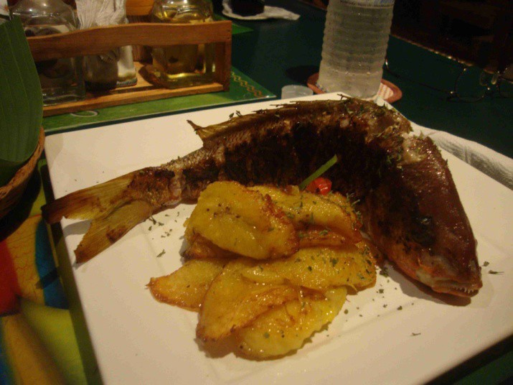

[“Graphic Inline” Style]

Figure 3.1. [“Caption Figure” style].

2 + 2 = 4 [“Equation” Style]

References

References should be set using “hanging indents,” as shown [Apply the Reference Text Style, which includes numbering]:

[1] Author(s) name(s): “This is the Title of the Paper” Journal Name, Vol. 39, pp. 531-548, July 1992.

[2] Author(s) name(s): “This is the Book Chapter Title” Book Title, McGraw-Hill, New York 1990.

[3] More Author(s) name(s): Book Title, Peter Peregrinus, London 1992.

Author Biographies

Dan M. Davis is a Research Associate Professor at Catholic Polytechnic University (CPU) and is also active as a consultant at the Institute for Creative Technologies, University of Southern California (USC). He is currently focusing on large-scale DoD simulations and virtual human implementations. Prior to retirement, he was the Director of the JESPP project at USC for more than a decade. As the Assistant Director of Advanced Computing Research at Caltech, he ran Synthetic Forces Express, bringing HPC to DoD simulations. He has also served as a Director at the Maui High Performance Computing Center and in computer research roles at the Jet Propulsion Laboratory and Martin Marietta. He was the Chairman of the Coalition of Academic Supercomputing Centers and has taught at the undergraduate and graduate levels. As early as 1971, Dan was writing programs in FORTRAN on one of Seymour Cray’s CDC 6500’s. While in the Marine Corps, he saw duty in Vietnam as a Cryptologist and retired in 2002 as a Commander, U.S.N. He received B.A. and J.D. degrees from the University of Colorado in Boulder.

Jennifer H. Nolan, Ph..D. is the President of Catholic Polytechnic University and Professor of Psychology in their College of Arts and Sciences. Her earlier work specialized in memory, dementias, stroke and insulin resistance. She is a brain plasticity specialist and certified Cogmed provider. Previously, she was the C.O.O. and co-founder of a stroke and brain injury rehabilitation center. Dr. Nolan has taught university courses at the University of California Irvine, Loyola Marymount University, and Glendale Community College. She has conducted local and nationwide clinical trials, and published in both scientific journals and popular magazines. She received a BA in Psychology from Loyola Marymount University, Los Angeles and a Ph.D. in Psychology from the Dept. of Cognitive Science at the University of California, Irvine.

Mark C. Davis, Ph.D. is the Chief Technical Officer at Wood Duck Research, Inc, and is semi retired after careers in the US Navy and as a computer design engineer for both IBM and Lenovo. Rising to the level of Distinguished Engineer at Lenovo, he was responsible for the design of laptop computer cross-disciplinary technology, including PC architecture, embedded systems, open source and virtualization. Previous work was with IBM in the areas of software development and architecture involving security, storage and virtualization. Dr. Davis has been granted well over fifty patents that were filed during his service at both companies. He is a graduate of the Duke University NROTC program and was commissioned as an Ensign, attended nuclear power school, and served as a Submarine Officer for twelve years, including one duty tour as a classroom instructor. He left the active duty as a Lieutenant Commander to pursue a PhD. Mark holds a BSEE degree from Duke University and a PhD in Computer Science from the University of North Carolina, Chapel Hill, where his advisor was Professor Fredrick P. Books.

JUDITH L. JACOBUS is retired from conducting speech therapy as a Speech and Language Specialist for more than two decades. Her experiences were in public schools settings in Orange County. California. She also previously taught for 12 years as a classroom teacher in multi-cultural communities there. Judith currently volunteers her professional skills for a local police department, so has extensive experience with dysfunctional adults and children in a variety of both every-day and traumatic situations. Her participation in amateur theatrics has more fully familiarized her with the characteristics of human behavior as they are projected via verbal, facial and body-language cues. This experience has also exposed her to the skill and art of the selection of appropriate persons for specific on-screen roles. Judith holds a lifetime Special Education Credential in Speech and Hearing Therapy, K-12 from the State of California. She earned a B. A. Degree in Speech Communications from the California State University Long Beach and an M. A. Degree in Teaching and Teacher Leadership from the Grand Canyon University in Glendale, Arizona.

