Resurrecting a 55-Year-Old Program:
Standards for Emerging Proactive Interactions

Dan M. Davis & Jennifer H. Nolan
Catholic Polytechnic University
1028 N Lake Ave MC 207
Pasadena, CA 91104
{ddavis & jnolan} @catholicpolytechnic.org

Mark C. Davis
Wood Duck Research, Inc.
129 Wood Duck Loop
Mooresville, NC 28117
davismc@ieee.org

Judith L. Jacobus
Education Counselor/Therapist
1564 Merion Way.
Seal Beach, CA 90740
stately07@dslextreme.com

Keywords:
Virtual Therapist, Natural Language Processing,
Interoperability Standards, Safety Standards & Metrics

ABSTRACT: A new look at an old initiative has been stimulated by the the emerging technologies called "XR". As Virtual Reality(VR) and Augmented Reality(AR)have emerged, they have began to overlap, leading to the ill-defined concept of Extended Reality or XR. The emergence of this concept has spawned many novel approaches to wide spectra of issues, but this paper takes a retroactive look at and a promising concept for developing a computer-generated therapist. Both emotional and speech therapeutics might benefit from this new capability. Back in 1971, the Eliza program had been conceived. It was designed and implemented at the Massachusetts Institute of Technology (MIT). That program was one of the earliest attempts at Natural Language Processing (NLP) and virtual conversations. The consensus was that it fell short of the mark due to technical limitations. The paper lays out this genesis, the subsequent work, a review of the criticisms, and an outline of its legacy. Skipping forward, the progress in NLP is surveyed, with particular emphasis on the MentorPAL project at USC. The constricting limitations of the Eliza instantiations are covered in some detail, and then the ability of XR techniques to address them are listed. In these processes, careful attention is paid to the use of standards to both facilitate and evaluate the progress toward a truly effective Virtual Therapist. Both the benefits and risks of such a program are laid out, with very detailed attention to the metrics for success and the safe guards against exacerbating the subject's condition or creating dangerous reactions that could result in injury to the subject or the public. This opens us a serious discussion as to safety standards. Some of these safeguard techniques will entail both computer code functions to identify dangerous situations and procedural directives to guarantee live-human oversight of progress and interventions. Paths forward will be identified and discussed. Costs, risks and maintenance will be briefly considered. Potential extensibility into other analogous activities will be set forth, again with an eye for standards designed to promote such extensibility.

Introduction

The standards community is facing a challenge that is not really found to any reasonable degreed in the history of humankind: the virtually explosive conception, implementation, adoption and distribution of revolutionary technologies. This paper uses a known example of the radical changes in technologies that could not even had been envisioned until a half century ago and really has not become realistic in the last decade: a conversational computer agent acting as a mental health therapist. In considering how dizzying this rate is, one would need only remember that one of the greatest defense technological changes the world has ever seen was the introduction of iron weapons at the end of the Bronze Age. That earlier weapons technology had been ascendant for approximately two millennia, ~3,200 to ~1,200 BC [1]. That transition was rapid if compared to previous technical changes, but even this dramatic advance from bronze to iron took about 700 years to accomplish in any acceptance approaching continental propagation. The technologies referenced hereinbelow have spread globally in less than seven years a rate that is 100 times faster than that of the move from Bronze to Iron, that really did not even become global until the infusion of Europeans into the Americas in the 1500's, nearly three millennia after iron was adopted in the eastern Mediterranean.

The demise of technologies is similarly accelerated, as emerging technologies threaten, then supplant existing technologies before the displaced technologies have time to adopt standards for their usage. This rapid supersession of technologies was a major focus of Clay Christensen's work on "disruptive technologies." [2] This may call for a rapid prototyping of standards, the way technologies are sometimes forced to emerge in times of stress, as many technologies do in times of war.

The paper will begin with a quick look back at whence we have come and why the needs for standards are so great today. That will also suggest how the type and range of standards has grown and the channels for communication have changed, becoming as important as the content of the standards, definitions and processes have gotten much more complex and problematical. The origins of the virtual therapist will be used as a model for these issues and an exemplar of necessity of a dramatic increase in the visibility of the effort.

Background
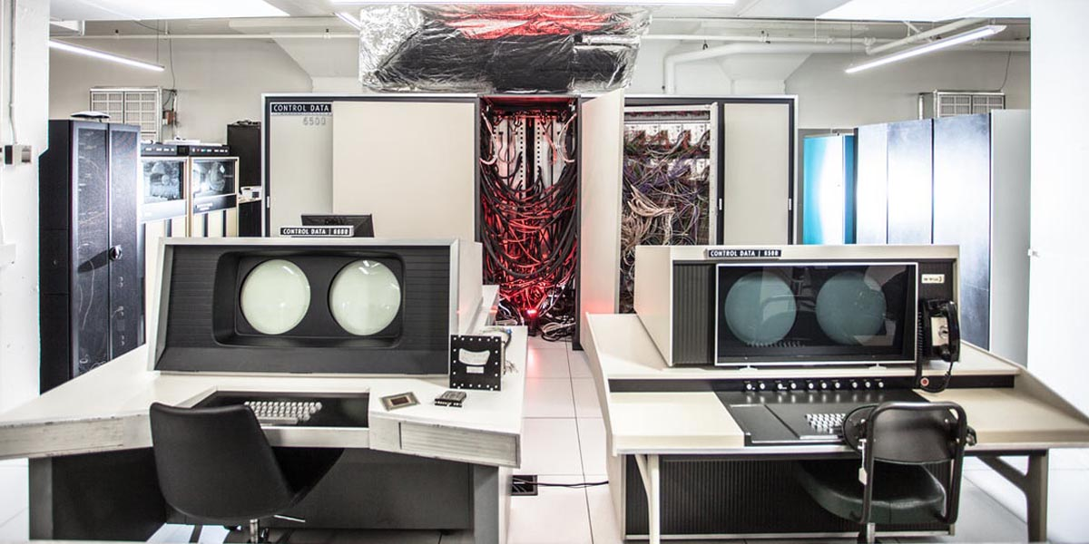
Figure 1.1. A CDC 6500 at Purdue University, ca. 1970 [5]

Computer generated conversational agents to perform mental health therapy was one of the early non-military uses suggested for the emerging digital computing capability that had witnessed phenomenal growth during World War II for both cryptologic and long range artillery analyses [3]. A program named ELIZA was conceived and implemented at the Massachusetts Intitute of Technology in the late 1960's. [4]. ELIZA was designed to use a patern-matching algorithm to emulated an intitioal interview by a psycho-therpapis trying to establish a trusting relationship with a patient. The interface as typing on an electronic keyboard, attached to the computer. One of the authors of this paper was engaged at the University of Colorado at Boulder to participate as a subject. The program was being run on one of Seymour Cray's CDC 6500's (Figure 1.1) that had approximately 400 KB of memory in 60 bit words [6] and had a clock speed of 40 MHz and cost on the order of $70 million in 2021-dollars and weighed on the order of five tons. It can be reported from personal experience, the conversationality of the program was so severely limited as to make any use of it beyond contemplation.

For comparison, the paper is being prepared on a computer with more than four orders of magnitude more memory and at speeds that are two orders of magnitude faster. All this at a cost that is now four orders of magnitude lower and weighs less than three orders of magnitude lighter. But this paper asserts that this is not where the real progress has been made, in terms of the need for effective, compelling and accepted standards. It is in the ever more complex, sophisticated and robust software based on evolving understanding of some very non-physical parameters and processes: the human emotions. The developers of the original flight trainers like the Link Flight Trainer [7] almost surely did not contemplate the complexity of the modern battlespace simulations [8] so would not have concerned themselves much with the ways in which their devices input external data and out-put device data as to position, orientation, speed and direction.
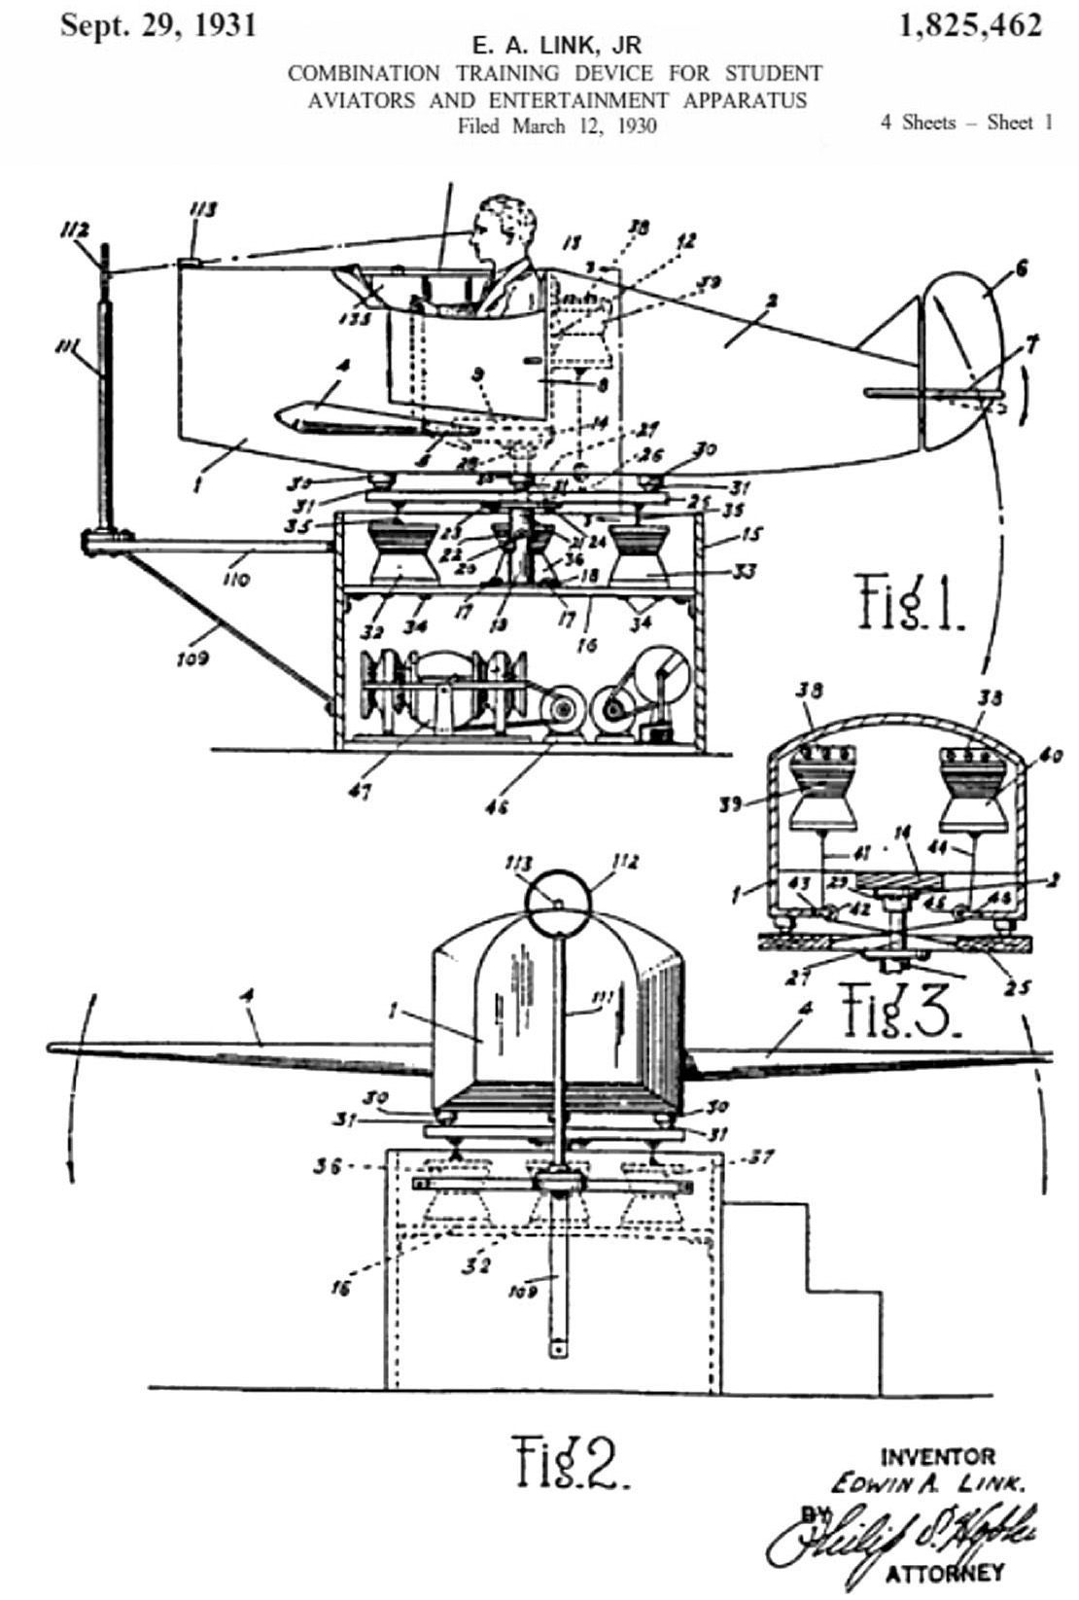
Figure 1.2. Link Trainer Patent [7]
Naturally, the crew working on ELIZA would not have had much cause to consider just which parameters of their program might need to be standardized and which metrics needed to be considered by the user community to allow a rapid and quantified assessment of learning goals, pedagogical efficacy, knowledge persistence and validity criteria. These needs are exacerbated by the rapid advent of emerging technologies, the almost instantaneous adoption of new technologies by national foes and the rapid obsolescence of all of today's newest and most fashionable breakthrough. The community no longer has centuries to perfect and accept new technology. However, new developments in computing, both hardware and software have exponentially increased the dimensions that need to be considered. The researchers sitting at an electric typewriter terminal in 1971 sought a reasonable response to simple entries to the computer; the same researcher today is faced with a much more realistic representation of the therapist, a much richer set of parameters in the users input, and a new set of issues with the prompting of the user. These may be seen as the recognized disciplines of Virtual Reality (VR), Augmented Reality (AR) and Extended Reality (XR), each with their own sets of terminology and needs for standards.

A Personal History of Computer-Generated Therapist

As one of the authors (D. Davis) sat in front of the electric typewriter in 1971, typing his inputs to a CDC 6500 that was connected by a phone-ModDem to the off campus lab where he was working, it was clear that the interface was very non-human and quite frustrating. Random long delays and regular shorter latency issues made the "conversation" torturous at best. Most of the standards were communication-related and none had to do with human factors or reality evaluation. Simple typos were not recognized and half decade later it is a distinct memory of getting upset when one typo led to a misunderstanding and attempts to get the computer to recognize the mistake repeatedly failed, resulting in the user transmitting an Anglo-Saxon term for a body-function. It is worthy of note that the CDC 6500 finally recognized that and responded: "You seem upset.". Correct!

Some 50 years later, a new team recognized a shortfall in the number of Science, Technology, Engineer-ing, and Math (STEM) professionals, for which many hypotheses have been advanced [8]. These include negative images of technical ﬁelds in the media, lack of awareness of the range of STEM careers, and mistaken notions of the actual working environments of both technical and non-technical professional ﬁelds. In many cases this is exacerbated by the lack of easy student accessibility to technical personnel, especially among students who are younger, who come from lower socio-economic-status households (SES), and those living in communities that are geographically remote from centers of technical activity (e.g., rural areas). The computer generated mentors to address these issues were developed in a project called MentorPal.

This project envisioned two complementary types of STEM outreach which were combined and they were designed using common language (e.g. C++), to make them easily extensible on other platforms. Through both the use of the technology and by explaining the technology, the USC researchers sought to increase the students’ awareness of the range of activities that STEM personnel perform. They discussed the wide variety of personalities of technical personnel and the paths that lead to various technical careers.

The MentorPal project draws from earlier approaches using some of the same underlying natural language dialog technology, known as NPCEditor [4], which specializes in question-answering agents. NPCEditor is one of the two meth¬ods used by MentorPal in selecting the best video clip to respond to the users questions. An early use-case for NPCEditor technology was for an exhibit at the Boston Museum of Science called The Twins, where visitors interacted with dialog-based virtual agents who could answer questions about computer science and about how they worked [9]. Follow-up research adapted the underlying dialog technology to reproduce the experience of having an experience with Holocaust survivors, by delivering recorded video clips of the survivors as responses, as opposed to driving virtual characters [10]. These systems identiﬁed a variety of interactions and social dynamics, with a typical presentation including a facilitator who would work help a group of visitors take turns asking questions from the system. However, compared to these prior systems, MentorPal has been designed with a strong emphasis on lower cost (e.g., smaller question sets) and one-on-one dialog (e.g., limited testing with groups of users).

The focus of MentorPal is on emulating the experience of an informational interview, such as the kind a student would have with a mentor at a career fair. This can be contrasted against mentoring systems that are designed to help students working on a speciﬁc project, such as AutoMentor [11]. It can also be contrasted against intelligent mentor agents who support metacognition as part of an open learner model [12]. Compared to these systems, MentorPal is not intended to build skills. Even among mentoring agents who also handle question asking and familiarization, such as the SimCoach system [13], MentorPal is distinct due to its focus on subjective experiences. Instead of a general description of STEM careers or ﬁelds, it is intended to help learners identify a mentor whose experiences resonate with them and that enables them to explore realistic visions of careers that they might pursue.

The program was field tested at a STEM fair on the University of Southern California (USC) campus in 2018. Due to signiﬁcant diﬀerences in content and changing user familiarity with technology as in earlier work with Natural Language Editor and similar systems, a live STEM fair exhibit oﬀered a diﬀerent perspective on interactions with this kind of mentor. For a STEM fair it was not certain if students would ﬁnd the system novel (e.g., due to greater availability of useful virtual assistants). Prior testing with MentorPal was conducted with one-on-one use (e.g., a student sitting at a computer), so it was part of the research to observe how diﬀerent students would interact with the MentorPal system when they were part of groups or an entity in parent-student dyads.
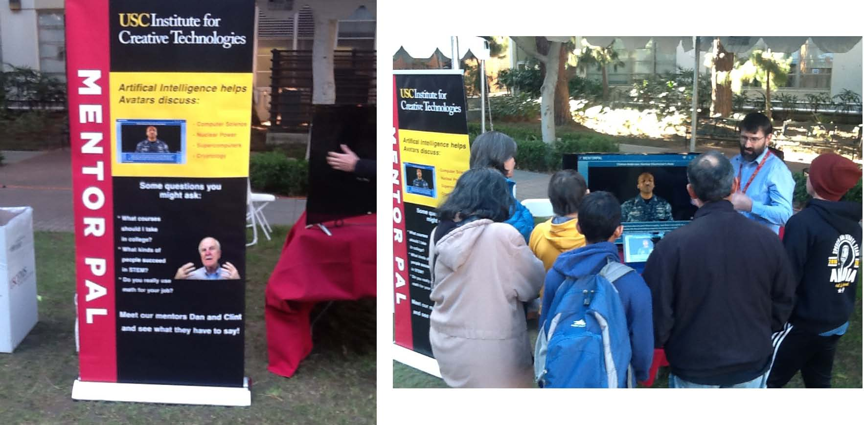
Figure1.3. MentorPal at STEM Fair at USC 2018

There is an effective current methodology for:
- Asking questions
- Turning questions into transcripts
- Cleaning transcripts
- Feeding these into dialog models
- Improving these models
- Classifying new paraphrases
- Establishing aliases for questions.

Building a useable interactive virtual mentor from recorded videos took up to 20 hours of video footage to provide a broad coverage of responses, with approximately 60 hours of additional time for subsequent processing: about 40 for preprocessing transcripts and 20 for post-processing dialog models. Because a long-term goal of this project was to enable recording any person as a mentor (without researcher or administrator intervention), improvements to the current pipeline were noted when discussing each step of the process.

The extant question set consisted of four types of questions:
a) preset questions that are asked for all mentors (˜70% of questions),
b) mentor-speciﬁc questions related to their career or life experiences (˜10%)
d) mentor-speciﬁc common questions observed in students to mentor chat logs (˜10%)
c) follow-up questions identiﬁed during interviews which were relevant to mentor responses (˜10%)

Typically, the mentors were recorded in ﬁve or so sessions (each about three hours long) to cover the question set. These sessions have a mix of these topics, with a follow up section for each session. After the initial sessions, re-recording sessions are held to record new answers to bad video clips or to record answers to common questions that were not recorded (i.e., the fourth type of question). Each follow-up session typically lasts for about 45 minutes to an hour. These follow-ups are important because they assist with creating a more natural conversational ﬂow, by enabling the mentor to answer questions that are likely to be asked after a student has heard a particular response.

Recording involved calibration with help from project staﬀ in order to ensure that the recordings are consistent and the responses are appropriate to chunk into useful videos. Standardization included ensuring that the mentor maintains a resting position three seconds before and after the question is answered. The resting position was set at about the same spot throughout the recordings, to avoid “jumping” where a mentor’s next statement has a totally diﬀerent head or body position. In addition to this, the mentor was urged to display emotion, show smiles, tell stories, and use hand motions to provide engagement. So far, each recording was standardized by using the same low-cost equipment setup (webcam, microphone, backdrop), which is shipped to mentors, who are not uncommonly located remotely. After recording, either the mentor (if remote) or research staﬀ uploaded the session ﬁles to cloud storage for post-processing. Overall, this approach has worked eﬀectively, with the quality of recordings and transitions signiﬁcantly higher than was initially anticipated. Sound quality has occasionally suﬀered,

The most perplexing issue that was significant departure from the ELIZA test was the lack of student ability to ether generate or to frame parameters for a "good career." When asked, one student defined a "good career" as one in which he could earn enough money to buy a Lamborghini. Even were he to have been jesting, that shows a lamentable lack of serious thought about a fulfilling career. But, detecting sarcasm and addressing moral and ethical issues in a compelling and meaningful way are just outside of current capabilities. This area brings into sharp focus the implementation of an AR capability that would seamlessly interject a set of suggestion of what may be important in the choice of a career. As a stop-gap measure, a series of suggestions was developed and listed in a button box at the bottom of the MentorPal display. Below those is the panel for typing questions if the ambient noise is too loud to allow for a microphone and voice-recognition to be used as the input interface for questions from the user. The videos were shot with a plain background, but any background image can be applied digitally. In Chief Anderson's case, an unclassified photo of a nuclear control panel could be substituted.
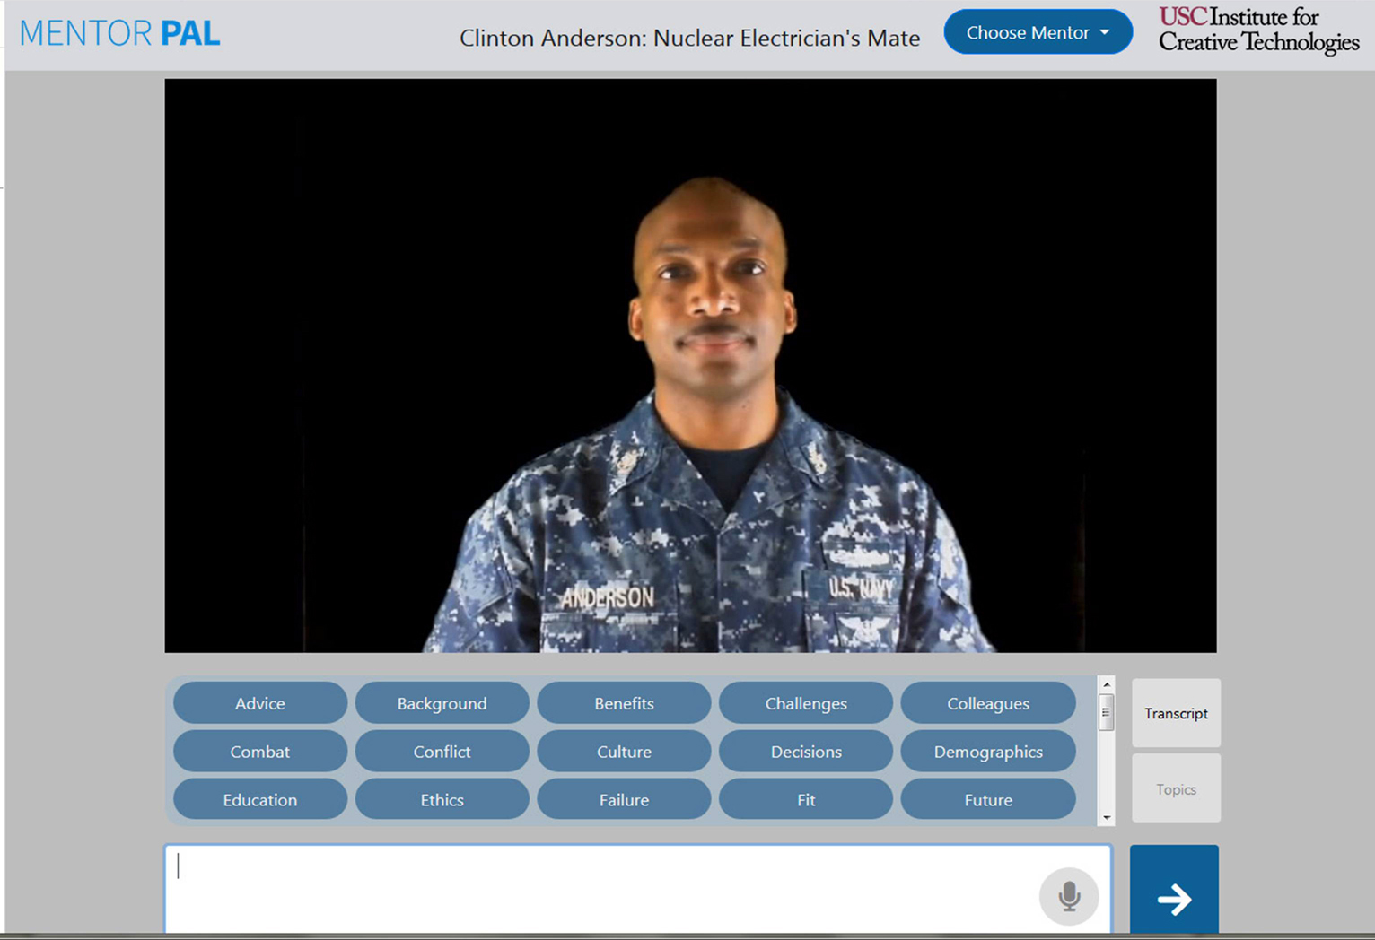
Figure 1.4. MentorPal Display showing suggested topics.

the vehicle in its ‘real-time’ location. This illuminates a number of challenges that were perhaps manifest in manned operations, but are now largely ancillary [11] Callahan, 2014. Using manned aircraft as an example, the pilot is the ultimate arbiter of what they decide to act upon. The use of situational awareness to make informed decisions is a key tenet in the operation of any aircraft. However, in operating unmanned aircraft, at best a pilot’s situational awareness is muted, at worst it is significantly degraded (Figure 1.) Throughout flight school, student pilots are told to rely on their instruments. They must not rely solely on their kinesthetic sense because a pilot’s body and mind are easily misled. However, the sensory indications that pilots feel as they fly aircraft are essential to build situational awareness in order to evaluate what the aircraft is “telling” them. A short example: a caution light illuminates; the pilot sees it and immediately references gauges associated with the light. Once the gauges are evaluated, the pilot may evaluate the feel of the aircraft (i.e. vibrations, sounds, smells). Ultimately, a decision is made. The senses help build the extra information necessary to make informed decisions. All of this happens, usually, in a matter of seconds.
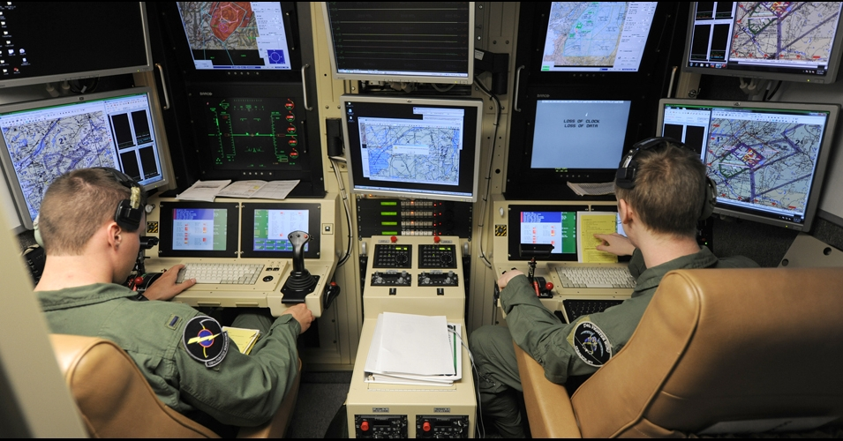

Figure 3. US Reservists staff a Drone Control Console (US Air National Guard Photo)

The aforementioned example is largely absent in unmanned operations. The operator will get a visual indication on a problem, but the sensory indicators are absent. Evaluation is hampered due to the sensory deprivation and oftentimes, the only option is to direct the vehicle or drone to return to its base of operations. There is little troubleshooting that an operator can do to fix a remote problematic situation.

This is further exacerbated by the filter of technology. In most cases, an unmanned operator is operating two systems in series. They sit at a console or some sort of control station that takes inputs and then feeds the information to the vehicle. Likewise, the flow returns. While this is necessary, this ‘filter’ means that there are two separate pieces of equipment that can have problems and, again, detract from the operator’s ability to properly and efficiently evaluate situations, whether it be mission or aircraft-related. This “filtering” idea is further compounded by the communications latencies associated with unmanned operations. Again, using aviation as an example, if a pilot moves his hands to manipulate aircraft controls, the aircraft responds almost instantaneously. By contrast, the operator at a control station makes a control input, the control station sends the input via communication link and the unmanned system responds. The idea of “real time” action is not yet possible in the unmanned or autonomous systems.

This leads inevitably to further discussion on what unmanned aircraft should be “allowed” to do. In a military context, decisions using drones are not taken at face-value. Drone usage has often been confined to environments that allow them to be there. There is little or no threat to their being destroyed or shot down. To put it simply, there is no appreciable threat to their destruction. However, implementation of drones in a real-time combat situation will require careful evaluation of the Law of Armed Conflict (LOAC) [12] Green, 2018 and associated governing directives. If a force is not actively putting its own personnel at risk (i.e. death, maiming), are they adhering to the tenets of LOAC if the other force is? This idea of mutual risk has been the major tenet of LOAC and made it acceptable. If we risk nothing but machinery, is it still armed conflict? Or is it something else? Also, the issue of the emotional impact on the operator may be different than that of the live pilot in a cockpit.

On a less philosophical level, consideration must be given to how much do humans trust unmanned assets to help them make time-critical informed decisions. Regarding the idea of latencies, the information received via drone (in the current construct) will always be less timely than if a human passes that information [13] Hoppe et al., 2019. Part of this distrust is resultant from the fact that a decision maker cannot easily ask further questions of a drone like they might of a human. Basically, the limited sensor data one sees from a drone are often constrained. Analysis is left up to those at the base who may be significantly detached emotionally, for good or for ill. A more human interface might make these issues more amenable to current training, skills, and practice. In the time it took for the information to get from the drone to the operator to the staff to the decision maker, things may have changed. Having a virtual human as the communications interface might reduce human reaction latencies enough to counter communication latencies. If this were to be possible with humans-in-the-loop, there might be faster updates and more clarification.

In order for unmanned systems to execute more than rudimentary functional military tasks, the interaction between operator and remote vehicle would benefit from resembling that of a typical human experience. Interfaces such as haptics must allow for greater situational awareness that allows the operator to “feel” the drone as it operates [14] Knierim et al., 2017. While technology is a force multiplier, its complexity can prevent the operator from effectively and efficiently using their vehicle. The filter, while likely ever-present, must be reduced in scope such that time-lag is as small as possible. Information passage must be of high fidelity such that real-time analysis is possible and answers inevitable questions of clarification. This list of necessary changes is not exhaustive and simply represents a starting place for better human-machine interactions. To make progress this is where one must begin.

Ethical Control of Combat

To maintain the ethical control required by society, the autonomous entity capability must be limited, and a human supervisor must control the lethal actions of the entity. For a remotely piloted aircraft, the interface can parallel an existing aircraft and few additional problems are introduced. But a combat infantry drone is another matter. Although the nature of the controlling interface for such a drone is not clear, the dramatic increase in information flow is clear and will certainly be a problem.

Information Overflow

Information flow and specifically too much information has been a major and well-studied problem. It is widely acknowledged that information overflow can be deadly to warfighters [15] Shankar & Richtel, 2011, [16] Bateman, 1998. In high technology areas such as piloting fighter aircraft, getting the right information has been a problem under study for many years [17] Hettinger & Haas, 2000

Vision of the concept

Throughout history, militaries have hone command and control to assure that combat meets the strategic and ethical objectives of organizational leadership as described centuries ago by Sun Zu [18] Griffiths, 1963. Rather than create a totally new approach to warfare, a logical development is to integrate the autonomous entity into existing military command relationships with minimal changes. This would enable limiting the ethical decision-making to well-trained, trusted warriors who would be in control. The relationship between this trusted human and the autonomous entity would then resemble the relationship between a sergeant and his squad.

Arguably, an autonomous private should not have all of the ethical responsibilities of a human private. This change in role is not a dramatic. The ethical requirements of a fighter pilot are analogous, so the modification in role should be achievable. Similarly, in many combat teams’ minor revisions to duties, responsibilities and ethics of the roles would enable autonomous entities to serve in that capacity.

One advantage of this approach is that it leverages all of the existing military training and thought. All levels of command would continue to use the commands and concepts they have already learned to use this new technology. The impact to training organizations and operations would thus be minimized.

The vision is to place autonomous entities into the existing military hierarchy with minimal changes. In particular, the command and control language and semantics should be as close to existing practice to take advantage of the thousands of years of experience represented.

Elements of the Concept

The elements of this concept include
- A mechanical device capable of physical tasks necessary for a combat mission
- An artificial intelligence to operate the device and support the interface with the command structure
- A command structure utilizing the function of the device, including humans designated to control the device
- An optimal user interface to efficiently use the abilities of the device and the human controller

This paper will not address the technologies of the mechanical devices. The existing technologies discussed above will logically be extended to provide the capabilities required for autonomous warfighting devices. The best command structure is the existing command structure that has evolved over centuries that has already adapted to changes in technology and human society. The interface for this task may be Virtual Humans. This technology is introduced below. It should be noted that advancements in artificial intelligence will enhance both the interface and the capability of the autonomous entities. Quantum computing is one of these technologies and is discussed below in relation to Virtual Humans.

Current Advances and Emerging Technologies in Virtual Humans

One accepted, but emerging, technology is that of Virtual Humans. As that term is used in this paper, a wide range of virtuality is accepted, including using computer-selected video clips of a live human. It is a creation in virtual reality portrayed by an avatar which attempts to recreate the appearance, voice, feel, and interaction that a live human would produce. Using the advances in several new technologies, including but not limited to natural language processing (NLP), virtual reality (VR), computer-generated imagery (CGI), machine learning, and virtual learning, “live” person entities can be presented. The uses, as well as the limits of these tools are becoming evident. Researchers at ICT have developed programs that have been shown to be effective, e.g. SimCoach, New Dimensions in Testimony (NDT), PAL3, and others [19] ICT, 2019. These are generalized under learning sciences, medical VR, mixed reality, narrative, social stimulation, virtual humans, and vision and graphics. The field of knowledge available here is immense, and countless resources and expertise are now becoming available in this promising field. The user interface can take many forms, as in Figures 3, 4 and 5 below.\

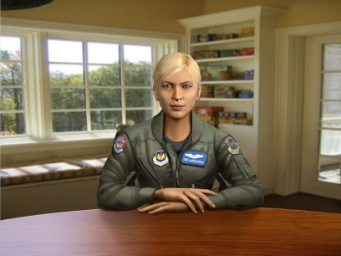 |  | 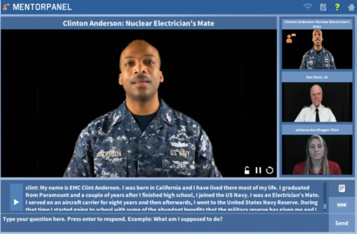
Figure 4.1, SimCoach uses CGI to advise PTSD patients | Figure 3,2. A 3D holographic display makes a Holocaust Survivor “real” | Figure 3.3.– Mentor Pal uses recorded video clips to help STEM Student

Natural language processing comprises “an area of research and application that explores how computers can be used to understand and manipulate natural language text or speech to do useful things” [20] Chowdhury, 2003.Using this definition within the context of virtual environments, NLP tools allow computer technology to recognize voice input, analyze voice tone, provide lifelike conversation, retrieve information, and many other applications in combination with machine learning. Recent developments in NLP have made amazing bounds like “a single convolutional neural network architecture that, given a sentence, outputs a host of language processing predictions: part-of-speech tags, chunks, named entity tags, semantic roles, semantically similar words and the likelihood that the sentence makes sense (grammatically and semantically) using a language model” [21] Collobert & Weston, 2008.

The MentorPal project was designed to produce a virtual conversational computer agent to assist high school students select a career. In order for the project to gain some insight into the “conversationality” of the mentors, they made the product available in three settings: an engineering fair on campus, a class room setting at a private tutorial organization, and in a computer lab at the Naval Postgraduate School’s summer program for high school students. For students using the system individually, they were content to ask questions from MentorPal for fairly long periods of time, approaching ﬁfteen minutes. However, it should be noted that these students were not randomly selected, and the data does not presume to be probative of a formal thesis.

As the intent of the project was to create a conversational easiness with the student that would encourage the mentor-mentee relationship, one of the areas in which the team was most interested was the students’ casual impression of their dialogue with the mentor. Since this effort was to help guide the programmers, rather than as a research study, no formal survey was done of all of their views. However, to help benefit from suggestions about how to improve the system and collect visitor reactions, a straw poll was oﬀered to students and adults who spent significant time with the mentors. The data from this straw poll are summarized in Table 1. A smaller preliminary subset of this data was reported in an earlier paper by the authors [22] Beck et al., 2018. The most dramatic factor was the high level of “conversationality” perceived by the students and the few adults who also opted to assess it.
Table 1. Likert-style Straw Poll on “Conversationality?
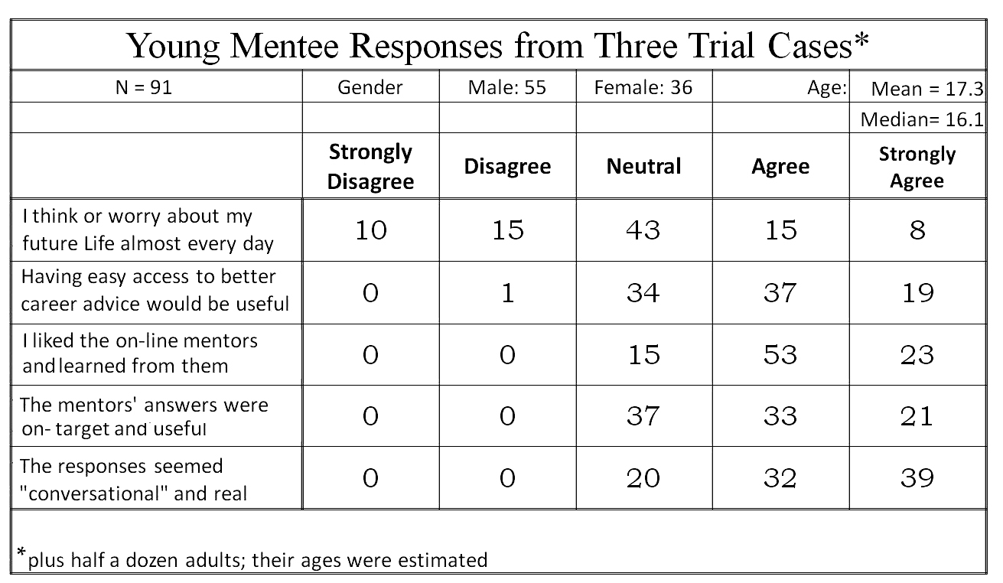

Applications of interest in cross reality (XR), as a synthesis of several vitalities and reality, can use developments in the interpretation of language which have been recently enhanced by the many researchers focusing their studies on the field. At ICT alone, progress has been made in training/learning environments [23] Kenny et al., 2007, multi-party dialogue[24] Traum & Rickel, 2002, ethics and cooperation [25] Allwood & et al., 2000, health applications [26] Rizzo et al., 2011 , and representation and reasoning [27] Swartout et al., 2006. Although automated speech recognition (ASR) is far from perfect, some of the best software, “Google achieved 73.3% of exact recognized phrases with a 15.8% [Word Error Rate] ” [28] Kudryavtsev et al., 2008, and the technology will continue to improve. It is also important to note that many of the errors in ASR are caused by slurred speech, cultural slang, and context, stemming from a “lack of consistent units of speech that are trainable and relatively insensitive to context” [29] Lee, 1988. Although this causes problems when comparing these transcriptions with global data, models can be trained locally using software such as CMU Sphinx from Carnegie Mellon University, as applied to languages such as Arabic [30] Satori, et al., 2011. All of these will continue to improve with time, as hardware, software, and data storage and availability are areas within which research is eminent and directly valuable. Specifically, the speed and application of quantum computing will engender significant advancement in NLP and its applications: one of which is the impactful area of virtual humans.
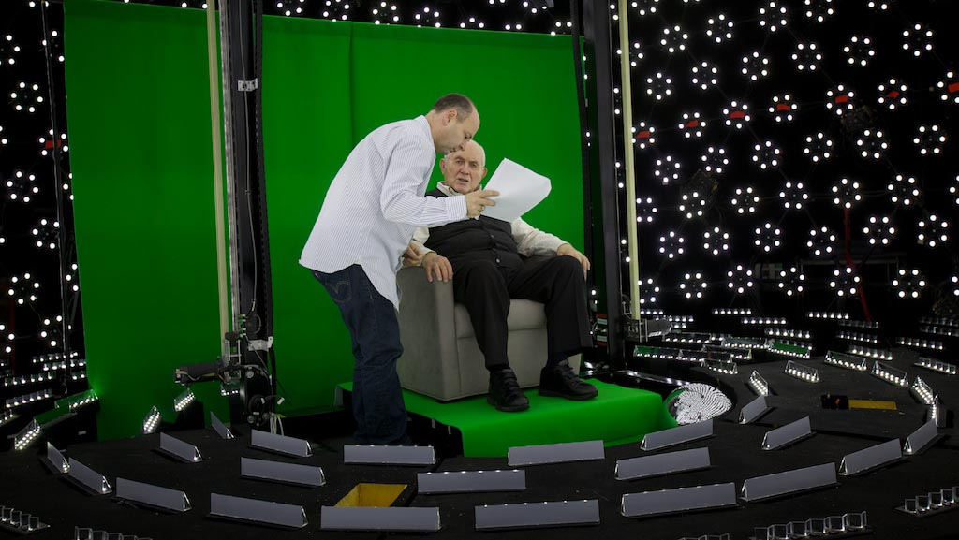
Figure 4.1. Subject receiving direction in light stage
used for generating 3-D imagery for holographic display

Effective Conversational Interfaces

The SimCoach system (see Figure 3 above) experience aimed to “motivate users to take the first step – to empower themselves to seek advice and information regarding their healthcare”. These virtual systems have been shown to have more success, generating deeper levels of confidence with patients than even live healthcare interactions [31] Rizzo, et al., 2011. The successes of these operations so far foreshadow abundant uses in the near future.

A closer analog may be found in the area of storytelling and gaming. The New Dimensions in Testimony project “allows people to have an interactive conversation with a human storyteller (a Holocaust survivor) who has recorded a number of dialogue contributions (Figure), including many compelling narratives of his experiences and thoughts” [32] Traum et al., 2015. The project’s important mission of preserving the stories of Holocaust survivors can be applied to endless amounts of other important persons and tales. Advances in gaming allow for utilization in learning, entertainment, healthcare, and lifelike training for things like combat and critical thinking.

Some of the current negatives concerning virtual learning are the difficulties of personalizing learning, handling live questions, accommodating different learning styles, and similar issues.

Future fields of focus will come in increased sophistication in such virtual environments and interaction. For example, imagine a system which takes in a live recorded interview with a president, or other prominent or knowledgeable figure, and generates an interactive environment in which a user can experience the interview by asking the questions themselves. Such things are already in existence, and they will only become more prominent and powerful. However, the need for extensive processing power, efficiency, and data storage and transfer remains a limiting factor for such developments. We believe that the aforementioned applications call for considerable further exploration and research.

4.1 Computational Advances will Enhance the Experience.

Many of the looming hurdles to advancing these new technologies seem to be beyond the reach of current technologies, both in hardware capabilities and software sophistication. [33] Yao et al., 2018. The advent of promising emerging technologies and approaches is worthy of consideration here. To have defense utility, training a “virtual human” should be orders of magnitude faster than that necessary to develop and live human. The major impediment here is the long training times for so complex a set of behaviors. The amount of material to be input and then recursively looped through a training algorithm presents a daunting obstacle.

Deep learning, which uses layers of computational units to learn data representations at multiple levels of abstraction, has emerged as the leading methodology for developing NLP applications [34] Young et al., 2018, [35] Pouyanfar et al., 2018. These networks are called Convolutional Neural Networks (CNN). Word vector representation or word embeddings learned using neural networks can capture the meaning of words by embedding similar words closer to each other in vector space [36] Mikolov, 2013. Distance and relative direction of words can capture semantic meaning. The word for queen can be approximated using vector arithmetic: queen = king – man + women. These word embeddings form the basis for input to deep CNN networks for a variety of NLP applications, including topic classification and sentiment analysis. In question answering (QA) applications CNN are used to select semantically similar answers from an existing knowledge base.

CNN processes sequential data, such as sentences, by using windowing, but the window size is fixed at training time. Word context outside the window is ignored. Recurrent neural networks (RNNs) are designed to processes sequence data. RNN adds feedback loops into the neural network, which enables it to retain state information and process variable length of input sentences. A popular recurrent network is long short-term memory (LSTM), which introduced the notion of gates (input, output and forget gates) to regulate the flow of information [37] Hochreiter, 1997. This ability to remember long distance information enables LSTM to perform well in applications like natural language translation and dialogue systems.

Stochastic neural networks, or Boltzmann machines, are a type of neural network that introduces randomness into the computation units. Instead of neurons firing at fixed input thresholds, Boltzmann machines fire stochastically based on the input.

These neural networks are sometimes referred to as generative networks because they learn the probability distribution of the input training data and they are able to stochastically regenerate the data. Popular generative networks, include the autoencoder, deep believe network (DBN), deep Boltzmann machine (DBM) and generative adversarial network (GAN) [38] Goodfellow et al., 2014. GAN pairs a deep generative network with regular deep discriminative network. These two networks are evolved simultaneously, where the generative network creates artifacts and the discriminative network critiques the artifacts. GANs are capable of generating photo realistic faces [39] Karras et al., 2019 as well as novel paintings [40] Elgammal et al., 2017.

Boltzmann machines allows for arbitrary network topology, but most generative networks forbid connection within a network layer, i.e. using restricted Boltzmann machines (RBM) as layers. The reason for the restriction is to support computational efficiency. Intralayer edges introduce loops in the network which dramatically increase the training time in an undesirable manner.

At the University of southern California’s Information Sciences Institute \ the quantum computing center is in possession a of D-Wave open-system adiabatic quantum annealer that is capable of sampling from Boltzmann machine network with loops, specifically chimera graphs. Although the current generation has limited number of qubits and intralayer connection, we have shown that the extra representational power afforded by these extra edges can decrease the training time and improve learning [41] Yao et al., 2018, [42] Liu et al.,, 2020. This advance should enable more realistic and “human” virtual computer agents.

One of the issues facing both the previous work on MentorPal and the projected future work on the incarnation of the robotic warfighter is the identification, assessment and ranking of various scenarios and environments. The prior experience of the selection of issues to be addressed will be critical as we face the problems of effectively controlling the virtual battlefield superimposed on the real battlefield. In previous work, the authors had to ascertain the corpus of questions to be asked. They developed useful techniques for ascertaining this corpus.

These advances are significantly interesting and have attracted inquiries for various agencies of the government, Figure 4.1&2, who also often have questions about the size of current quantum machines (Figure 4.1&2).
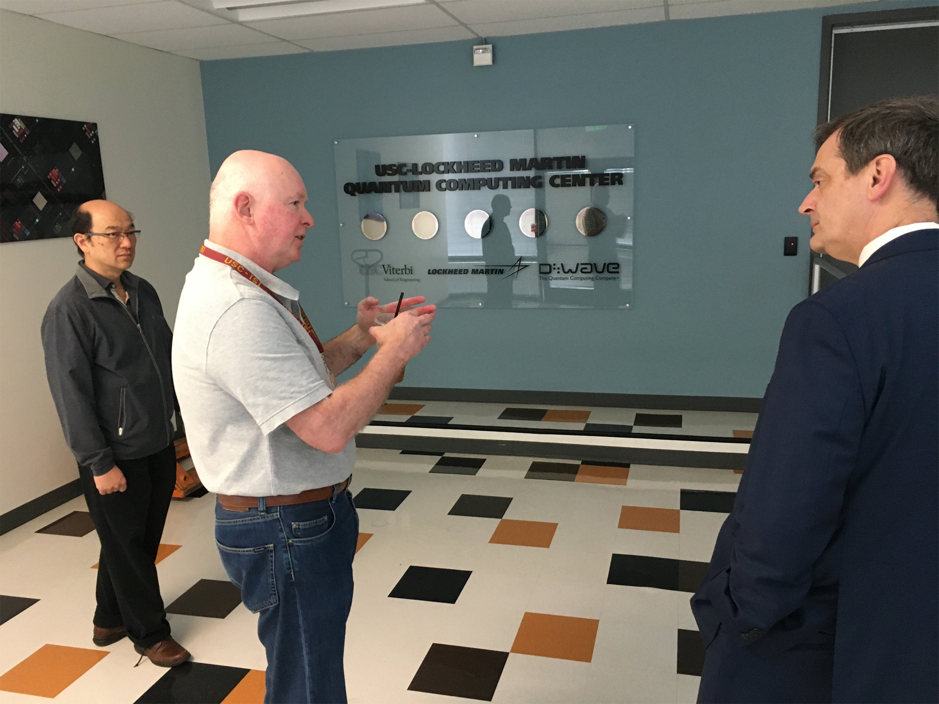
Figure 4.2 Dr.s Yao and Lucas briefing
Asst. Dir Biometric Identity Mgmt, DHS
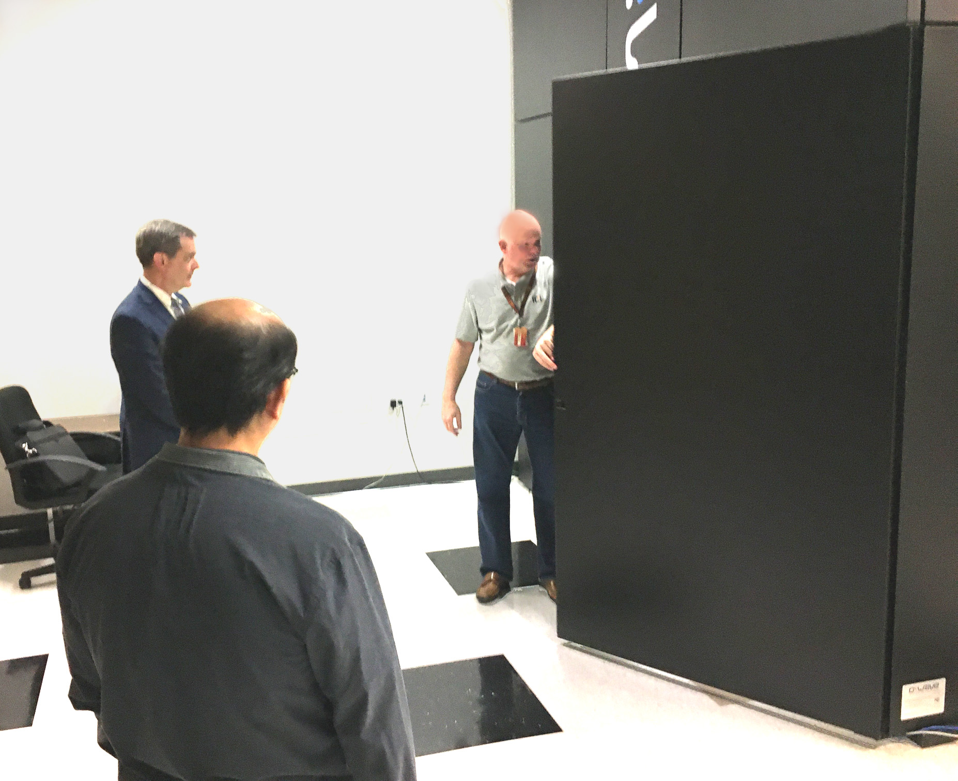
Figure 4.1 Demonstrating the scale of
Quantum Annealer Case
The utility of the Incarnation suggested herein would have dual use attractions to those outside of the Department of Defense, and wide promulgation of research efforts would be advisable. Dual use technologies are typically more easily funded and the funding is more easily defended,

New display and sensor technologies are expanding rapidly. The holographic displays in use by the New Dimensions in Testimony project cited above might find significant applicable utility in the provision of a “virtual humanizing” of battlefield robotic entities. The pervasive use of virtual, augmented, mixed, and cinematic reality is the core of the definition of cross reality, also called XR. This paper’s major thesis not only will require, but may be the paradigm case for the emergence of this new discipline. This cross-disciplinary approach is central to the success of the proposed effort to support the warfighter in ways that will be effective in high-stress situations. Such a development strategy will also assist in preventing untoward actions by a rogue autonomous entity that would violate the Laws of Armed Conflict.

4.2 Extensibility

Experience has shown that, not only are there an unfathomable plethora of military situations, technologies [43] Burmaogla & Saritas, 2017 and organizational hierarchies, but these are becoming more dynamic, more complex, and more transitory[44] Kott & Perconti, 2018. In response to this ostensibly inevitable flow of new technologies over the course of a career, it seems most important to focus analyses on successful approaches more than specific platforms and units. The insights from a system to facilitate a Squad Leader’s optimal control over a mixed unit made up of human and non-human entities may illuminate how to best approach a UAV pilot’s control of over a flight of UAS aircraft. Interoperability may not be universally feasible, but experience dictates a cautionary admonition not to become to insular and remain open to other services’ advances in the human/non-human interfaces [45] Gong et al., 2001.

Another dimension of extensibility is the dual-use interest held by DoD research organizations. Clearly the issues discussed in this paper would be immediately extensible into civilian first-responder contexts, but that may only be the beginning, The authors hold that providing a more human-like interface, critical in high stress situations, may have similar benefits in other important functions. One of these functions could be that of counseling, such as demonstrated in the SimCoach project [46] Rizzo et al., 2016, another may be that of assessment [47] Shaw et al., 2019 and yet another may be that of instructional interfaces, [48] Elstad & Davis, 2017. Additional implementations will no doubt occur to the reader. This paper asserts that it is incumbent upon the researchers to abstract, identify, define, and communicate their insights and approaches in this field, eschewing the proclivities to focus solely on the task before them.

4.3 Inculcating Appropriate Behavioral and Communication Styles

One area of potential is the area of computer agent personality, whether the agent is a pure virtual human, e.g. an animated agent, or a live human, e.g. the use of a library of video-clips as in the MentorPal project [49] Burns et al., 2018. Based on more than half a century experience in leading personnel in dangerous military situations, this paper asserts that a commander’s primary concern is knowing their people, understanding their needs, and providing the guidance they require. Some need their confidence bolstered, some are foolhardy and require constraints, and some need constant “motivation” in order to achieve mission goals. It seems clear that the passionless voice of HAL in the film 2001 [50] Kubrick, 1968 which was characterized by a lack of affect, would not be compelling or optimal in a highly stressed situation such as combat. However, it might be beneficial to modify both the computer agent’s basic personality and their emotional tone, as may be warranted by the situation. This would hold for situations calling for a human/non-human interface both up and down the Chain of Command. This paper’s vision was the issues arising when a live human is controlling computer-driven entities, but it is within the authors’ Weltanschauung that there may be times when an intermediary computer agent will be relaying direction from a senior commander to the warfighter in the field [51] Khalid et al., 2018.

The application to combat would require some general customization of the personality of the devices based on the roles of the device. Study will be required to determine customizing personalities for individual devices is useful.

4.4 Scenarios

We showed in an earlier paper [52] Davis, et al., 2018 that this interface could assist information flow. Some examples of this concept are:
- Privates in an infantry unit could be replaced by autonomous privates.
- Various functional teams on a warship could be replaced by entities.
- A flight of autonomous attack aircraft could be controlled by a single human flight commander.

For the example of an infantry squad, the human leader would take the role of a sergeant leading his privates. The squad would stay in close proximity autonomously, but tactics and use of lethal fire would be employed only at the verbal command of the squad leader. The autonomous privates would communicate orally and via the use of computer enabled avatars. along with real time data channels such as video and audio.

An entire submarine could be run by a single Captain, with AI-enabled computer agents operating the propulsion, weapons, sensors, and fire control systems. They would communicate with the Captain using Natural Language Processing capabilities shown effective in virtual conversational capabilities cited above. The Captain’s communications interfaces would be similar to those functions as experienced with typical human crews.
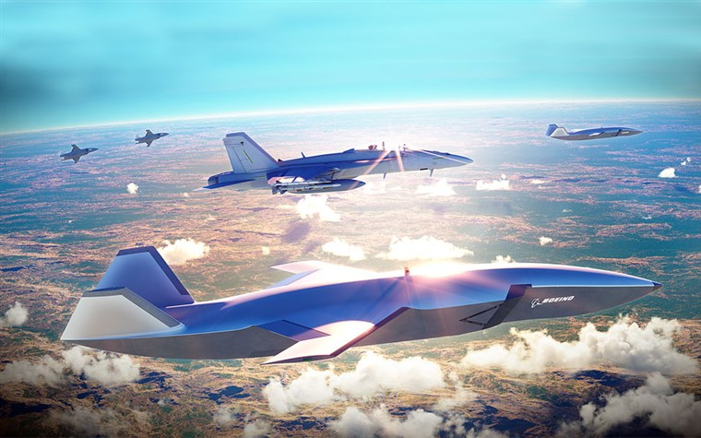
Figure 5. Artist’s Rendition of a Mixed Drone
and Manned Aircraft Flight (Boeing Photo)

A flight of autonomous aircraft could be controlled by a single human flight commander flying in concert with the swarm of drones. An example of the type of drone and the possible tactics are described in [53] Levik, 2019. The issue raised here is that of the best way to make his control similar to the way it is now. A couple of potential paths of implementation would be based on the technologies propounded above, based on current successes and emerging capabilities in NLP. One issue to be addressed would be that of verbal garbles. Like so many things that are ostensibly easy for humans, understanding human speech is often a matter of knowing what to expect, when to “fill in the gaps” and when to ask for a clarifying repeat. Lethality, ethics and the Law or Armed Conflict mandate a set of redundant fail safes to prevent, or at least minimize, catastrophic failures. Carefully crafted and explicitly delimited specifications would be required, and the experience is that having a full-time team member who has actual combat operations experience is invaluable. Seeing a Subject Matter Expert once a month is no substitute. Such a capability is envisioned in Figure 9 by the Boeing Corporation.

Conclusions

Early participation by the standards community will facilitate a more orderly adoption of emerging technologies. XR is particularly in need of consensus building and standard terminology. Using more technology to fight will have advantages in efficiency and safety for the warriors. As more autonomous weapons are introduced, the ethical challenges will emphasize the criticality of the interface between the human commanders and the incarnation of the autonomous warfighting entities. The best interface is the centuries’ proven human to human interaction using natural language. The interactions of the classic chain of command have been developed over the millennia to optimize the sensing of situations, personal capabilities, fatigue, and morale, these translated into effective control and assessment of appropriate delegation of responsibility. AI can assist in these functions if the appropriate emerging technologies are enhanced and adopted effectively. The technologies exist to support this type of interfaces utilizing virtual humans and exploiting emerging technologies such as quantum computing, Natural Language Processing, Deep Learning, advanced sensors and sophisticated display and haptics.

Further research studying these scenarios in detail will lead to better solutions.

Acknowledgements

The authors would like to thank the work done by the ICT team on virtual humans showing the applicability of this technology to a wide variety of problems, most especially the Co-Principal Investigators of the MentorPal project: the Doctors Benjamin Nye and William Swartout. We should also note that much of the work cited was supported by grants from the Office of Naval Research's STEM Program (ONR N00014-16-1-2820) and by research assistants supported by the National Science Foundation Research Experience for Undergraduates program (NSF 1560426). Nevertheless, the positions taken in the paper are the authors’ own and do not represent in any way the views of the Department of Defense or the US Government.

References
[ 1] Tebes, J. M., (2020). Revolution in the Desert: A Reassessment of the Late Bronze/Early Iron Ages in North-western Arabia and the Southern Levant. Revista del Instituto de Historia Antigua Oriental, 99-125.
[ 2] Christensen, C. M. (2013). The innovator's dilemma: when new technologies cause great firms to fail. Harvard Business Review Press.
[ 3] Turing, D. (2018). The Story of Computing. Arcturus Publishing, London, UK.
[ 4] Weizenbaum, Joseph (January 1966). ELIZA--A Computer Program for the Study of Natural Language Communication Between Man and Machine.. Communications of the ACM. 9: 36–35..
[ 5] Living Computers, (2021), CDC 6500, Purdue University, image rereived from the internet on 20 Dec 21 from: https://livingcomputers.org/Computer-Collection/Vintage-Computers/Mainframes/CDC-6500.aspx ..
[ 6] Hill, M. D., Hill, M. D., Jouppi, N. P., Jouppi, N. P., & Sohi, G. S. (2000). Readings in computer architecture. Gulf Professional Publishing, Houston, Texas.
[ 7] De Angelo, J. (2000). The Link Flight Trainer: A Historic Mechanical Engineering Landmark, Roberson Museum and Science Center, Binghamton, New York, June 10, 2000.
[ 8] Smith, A., Anderson, J.: Ai, robotics, and the future of jobs. Pew Research Center 6 (2014)
[ 9] Swartout, W., Traum, D., Artstein, R., Noren, D., Debevec, P., Bronnenkant, K., Williams, J., Leuski, A., Narayanan, S., Piepol, D., et al. (2010): Ada and grace: Toward realistic and engaging virtual museum guides. In: International Conference on Intelligent Virtual Agents. pp. 286–300. Springer (2010)
[10 Traum, D., Jones, A., Hays, K., Maio, H., Alexander, O., Artstein, R., Debevec, P., Gainer, A., Georgila, K., Haase, K., et al. (2015): New dimensions in testimony: Digitally preserving a holocaust survivors interactive storytelling. In: International Conference on Interactive Digital Storytelling. pp. 269–281. Springer (2015)
[11] Wang, J., Li, H., Cai, Z., Keshtkar, F., Graesser, A., Shaﬀer, D.W.(2013): Automentor: Artiﬁcial intelligent mentor in educational game. In: International Conference on Artiﬁcial Intelligence in Education. pp. 940–941. Springer (2013)
[11]
[11]
[11] [11]

Author Biographies

Dan M. Davis is a Research Associate Professor at Catholic Polytechnic University (CPU) and is also active as a consultant at the Institute for Creative Technologies, University of Southern California (USC). He is currently focusing on large-scale DoD simulations and virtual human implementations. Prior to retirement, he was the Director of the JESPP project at USC for more than a decade. As the Assistant Director of Advanced Computing Research at Caltech, he ran Synthetic Forces Express, bringing HPC to DoD simulations. He has also served as a Director at the Maui High Performance Computing Center and in computer research roles at the Jet Propulsion Laboratory and Martin Marietta. He was the Chairman of the Coalition of Academic Supercomputing Centers and has taught at the undergraduate and graduate levels. As early as 1971, Dan was writing programs in FORTRAN on one of Seymour Cray’s CDC 6500’s. While in the Marine Corps, he saw duty in Vietnam as a Cryptologist and retired in 2002 as a Commander, U.S.N. He received B.A. and J.D. degrees from the University of Colorado in Boulder.

Jennifer H. Nolan, Ph..D. is the President of Catholic Polytechnic University and Professor of Psychology in their College of Arts and Sciences. Her earlier work specialized in memory, dementias, stroke and insulin resistance. She is a brain plasticity specialist and certified Cogmed provider. Previously, she was the C.O.O. and co-founder of a stroke and brain injury rehabilitation center. Dr. Nolan has taught university courses at the University of California Irvine, Loyola Marymount University, and Glendale Community College. She has conducted local and nationwide clinical trials, and published in both scientific journals and popular magazines. She received a BA in Psychology from Loyola Marymount University, Los Angeles and a Ph.D. in Psychology from the Dept. of Cognitive Science at the University of California, Irvine.

Mark C. Davis, Ph.D. is the Chief Technical Officer at Wood Duck Research, Inc, and is semi retired after careers in the US Navy and as a computer design engineer for both IBM and Lenovo. Rising to the level of Distinguished Engineer at Lenovo, he was responsible for the design of laptop computer cross-disciplinary technology, including PC architecture, embedded systems, open source and virtualization. Previous work was with IBM in the areas of software development and architecture involving security, storage and virtualization. Dr. Davis has been granted well over fifty patents that were filed during his service at both companies. He is a graduate of the Duke University NROTC program and was commissioned as an Ensign, attended nuclear power school, and served as a Submarine Officer for twelve years, including one duty tour as a classroom instructor. He left the active duty as a Lieutenant Commander to pursue a PhD. Mark holds a BSEE degree from Duke University and a PhD in Computer Science from the University of North Carolina, Chapel Hill, where his advisor was Professor Fredrick P. Books.

JUDITH L. JACOBUS is retired from conducting speech therapy as a Speech and Language Specialist for more than two decades. Her experiences were in public schools settings in Orange County. California. She also previously taught for 12 years as a classroom teacher in multi-cultural communities there. Judith currently volunteers her professional skills for a local police department, so has extensive experience with dysfunctional adults and children in a variety of both every-day and traumatic situations. Her participation in amateur theatrics has more fully familiarized her with the characteristics of human behavior as they are projected via verbal, facial and body-language cues. This experience has also exposed her to the skill and art of the selection of appropriate persons for specific on-screen roles. Judith holds a lifetime Special Education Credential in Speech and Hearing Therapy, K-12 from the State of California. She earned a B. A. Degree in Speech Communications from the California State University Long Beach and an M. A. Degree in Teaching and Teacher Leadership from the Grand Canyon University in Glendale, Arizona.

