XR Standards for Conversationally Adept Virtual Humans:
Autonomous Combat Team Members’ “Incarnation”

Mark C. Davis
Wood Duck Research, Inc.
129 Wood Duck Loop
Mooresville, NC 28117
davismc@ieee.org

Jennifer H. Nolan & Dan M. Davis
Catholic Polytechnic University
1028 N Lake Ave MC 207
Pasadena, CA 91104
{ jnolan & ddavis } @catholicpolytechnic.org

Judith L. Jacobus
Education Counselor/Therapist
1564 Merion Way.
Seal Beach, CA 90740
stately07@dslextreme.com

Keywords:
XR, Autonomous Devices, Human/Machine Interfaces
Human Factors, & Artificial Intelligence

ABSTRACT: This paper addresses the needs for standards in the Modeling and Simulation (M&S) community to facilitate the extension of emerging XR capabilities in a use-case for human warfighters. The authors posit that these non-humans might take various forms, the nature of which is left to the passage of time to reveal. The various existing forms of autonomous devices and the degree of their autonomy are surveyed are. The next section briefly reviews the rapid and accelerating progress in virtual human behavior and adduces evaluative comments from users in the authors’ research projects into virtual humans. Based on their operational and research experience, the future of such technology trends is extrapolated. A scenario is advanced in which various non-human operational entities would be infused with doctrinal guidance and controlled locally by a human with back-up, The man/machine interfaces are suggested and analyzed in light of current on-going research in which some of the authors are participating. The benefits of using non-humans for dangerous tasks is considered, as are the ethical and societal risks of loosing machines with lethal weapons into the confusion and tumult of the modern, often urban, warfare. The beneficial interface impacts of making the non-human entities respond to human control and appear human, via augmented reality, to human controllers would be major human factors research goals, which the paper will outline, and pursue in the abstract. They will discuss the avenues of research in Artificial Intelligence that will surely be applicable and raise issues of checks on learned behaviors becoming violative of civilized standards or US humanitarian mandates. These issues are considered in a way that should be extensible into other areas with similarly conundrumal issues, e.g. valuable unique critical benefits, but significant risks. The paper closes with an articulation of the needed community support and contributions..

This is a Section Title [“Heading 1” Style]

[Text is “Normal” Style]

Section Titles should be set in Times New Roman 12- point bold, numbered as shown. Upper case should be used for the first letter of every major word.

Body paragraphs (like this one) should be set in Times New Roman 10-point, and fully justified. Insert one blank line between paragraphs. Do not indent.

This is a subsection title [“Heading 2” Style]

Subsection titles should be set in Times New Roman 10- point bold, numbered using decimal notation as shown.

Equations should be set in Times New Roman, 10- point italic, size, and horizontally and vertically centered. A slightly smaller font may be used for equations, subscripts, and superscripts.

Preferably, figures should be inserted in the text, soon after they are referred to. They may be sided to fit one column, or the full page width, as appropriate to their complexity. The same applies to Tables.

References should be numbered in the order in which they are cited in the text, using numbers in square brackets. For example, see references [1], [2], and [3].

Figures, tables, equations, and references should be cited using decimal notation, such as Figure 1.1.

Please do not number your pages. Include your assigned paper number in the file name (e.g., 18F-SIW-001.pdf)
Reminder

The electronic version of your paper must be submitted via the SISO SIW Conference Web page by the date indicated above.

Other headings

    - Heading 3

[Headings 3-9 are not specified, and were configured as Times New Roman 10 pt, Regular font, legal-numbered.] Table 3.1. [“Caption Table” Style].

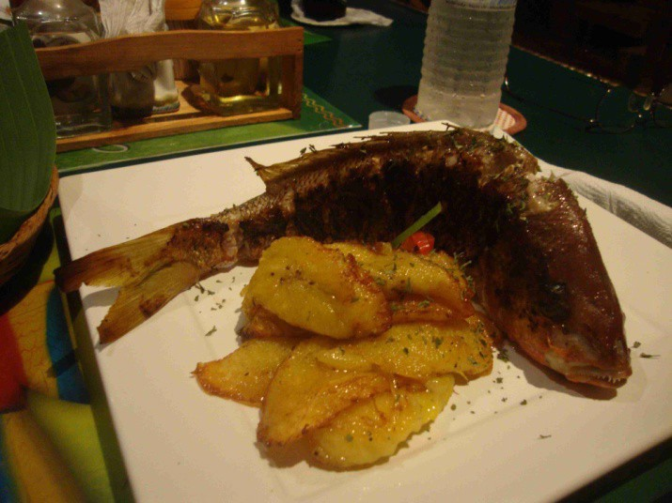

[“Graphic Inline” Style]

Figure 3.1. [“Caption Figure” style].

2 + 2 = 4 [“Equation” Style]

References

References should be set using “hanging indents,” as shown [Apply the Reference Text Style, which includes numbering]:

[1] Author(s) name(s): “This is the Title of the Paper” Journal Name, Vol. 39, pp. 531-548, July 1992.

[2] Author(s) name(s): “This is the Book Chapter Title” Book Title, McGraw-Hill, New York 1990.

[3] More Author(s) name(s): Book Title, Peter Peregrinus, London 1992.

Author Biographies

PAMELA BLECHINGER is an Operations Research Analyst at the TRADOC Analysis Center, Ft. Leavenworth, KS. She is the analytical user representative for ModSAF development activities and wrote the original Authors’ Guide for the first SISO Simulation Interoperability Workshop (SIW).
[Manually bold the author’s name in this section.]

