The Title Should Be Set in 14 pt Times New Roman, Bold, and Centered [“Title” Style]

[“Author Names” Style]
Anthony A. Adams Barbara B. Brown Acme Associates, Inc.
[“Author Address” Style] 111 Ash Avenue
Anchorage, AK 99508
aadams@acme.com, bbrown@acme.com

Col. Charles C. Cromwell
U.S. Development Command Snowshoe Ridge Outpost Tuluksak, AK 99551
cromwelc@remote.af.mil

[“Keywords” Style] Keywords:
Times New Roman, 10 pt., and centered.

ABSTRACT: [Apply the “Abstract” Style, and manually Bold and un-italicize the Abstract title by selecting the word “ABSTRACT:” then pressing Ctrl-b, Ctrl-i] This is an example containing instructions for the preparation of the SISO SIW Conference final papers. Please follow these guidelines as closely as possible. Your paper must be submitted electronically to the SISO Conference Web site. The maximum number of pages is twelve. Use of Times New Roman font is strongly encouraged throughout the paper. Abstract text should be typed using 10-point italics, fully justified. Please note the setting of the word “ABSTRACT'' at the beginning of the paragraph (bold, upper case, non-italics). The title, authors, and affiliation, are all centered on the page.

- This is a Section Title [“Heading 1” Style]

[Text is “Normal” Style]

Section Titles should be set in Times New Roman 12- point bold, numbered as shown. Upper case should be used for the first letter of every major word.

Body paragraphs (like this one) should be set in Times New Roman 10-point, and fully justified. Insert one blank line between paragraphs. Do not indent.

This is a subsection title [“Heading 2” Style]

Subsection titles should be set in Times New Roman 10- point bold, numbered using decimal notation as shown.

Equations should be set in Times New Roman, 10- point italic, size, and horizontally and vertically centered. A slightly smaller font may be used for equations, subscripts, and superscripts.

Preferably, figures should be inserted in the text, soon after they are referred to. They may be sided to fit one column, or the full page width, as appropriate to their complexity. The same applies to Tables.

References should be numbered in the order in which they are cited in the text, using numbers in square brackets. For example, see references [1], [2], and [3].

Figures, tables, equations, and references should be cited using decimal notation, such as Figure 1.1.

Please do not number your pages. Include your assigned paper number in the file name (e.g., 18F-SIW-001.pdf)

Reminder

The electronic version of your paper must be submitted via the SISO SIW Conference Web page by the date indicated above.

Other headings

    - Heading 3

[Headings 3-9 are not specified, and were configured as Times New Roman 10 pt, Regular font, legal-numbered.] Table 3.1. [“Caption Table” Style].

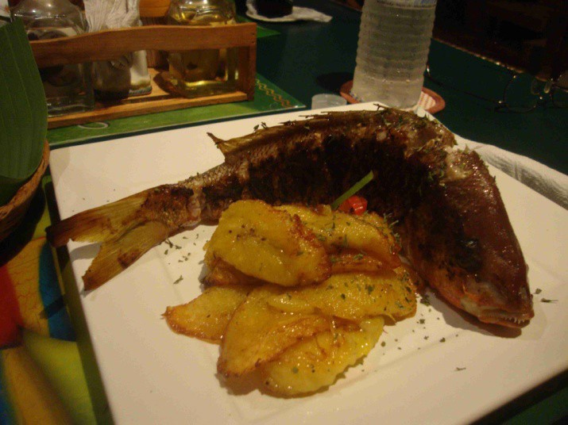
[“Graphic Inline” Style]

Figure 3.1. [“Caption Figure” style].

2 + 2 = 4 [“Equation” Style]

Other headings

    - Heading 3

[Headings 3-9 are not specified, and were configured as Times New Roman 10 pt, Regular font, legal-numbered.] Table 3.1. [“Caption Table” Style].

[“Graphic Inline” Style]

Figure 3.1. [“Caption Figure” style].

2 + 2 = 4 [“Equation” Style]

References

References should be set using “hanging indents,” as shown [Apply the Reference Text Style, which includes numbering]:

[1] Author(s) name(s): “This is the Title of the Paper” Journal Name, Vol. 39, pp. 531-548, July 1992.

[2] Author(s) name(s): “This is the Book Chapter Title” Book Title, McGraw-Hill, New York 1990.

[3] More Author(s) name(s): Book Title, Peter Peregrinus, London 1992.

Author Biographies

PAMELA BLECHINGER is an Operations Research Analyst at the TRADOC Analysis Center, Ft. Leavenworth, KS. She is the analytical user representative for ModSAF development activities and wrote the original Authors’ Guide for the first SISO Simulation Interoperability Workshop (SIW).
[Manually bold the author’s name in this section.]

