Dual-use Extensibility Issues:
Implementing DoD Virtual Mentors for Police

Dan M. Davis & Jennifer H. Nolan | Judith L. Jacobus | John A. Parker
Catholic Polytechnic University | Speech & Language Therapist | Platt Investigations
Los Angeles, California | Seal Beach, California | Signal Hill, California
{jnolan & ddavis}@catholicpolytechnic.org | jjacobus@hpc-educ.org | jparker@jpallc.com

ABSTRACT

There is a need for improved mentoring of civilian law enforcement personnel; the DoD has similar needs and has funded development of globally accessible and extremely engaging virtual mentors. There is a short review of current efforts to respond to these issues, including results. The paper then sets the goals of reducing negative impacts in order to sustain a robust career field in law enforcement. This paper reports on an initiative to identify, scope, plan and implement the use of DoD funded capabilities to respond to the law enforcement needs. The early contacts with police who served in various levels of law enforcement environments are reported. Then it reviews the reported major stresses on such personnel resulting in difficult recruitment, low morale, early attrition, and high .suicide rates. The development of a survey document to more precisely ascertain the major pathogenic bases for police problems is described. Some preliminary results are reported. A vision for how a virtual mentor might be effective in this situation is then presented. Beginning with a quick review of the Navy's MentorPAL project, existing capabilities are given. The implementation problems and risks are extensively analyzed. Issues of potential detrimental impacts, schedule disruptions, and cost/benefit are examined. The need for such a project to be implemented outside of the academic community raises several issues, some of which may be problematic. There is a section that considers how major government contractors might be enticed to pursue such a program. Then the metrics for judging whether such an implementation was progressing accordingly and had reached its ultimate goal are carefully laid out. Where longitudinal studies are going to be required, the paper sets forth issues to be considered and parameters to be included. The conclusions are recorded, along with several emerging technologies, techniques and research paths.

ABOUT THE AUTHORS
Dan M. Davis, CDR. USN, Ret. is a Research Associate Professor at Catholic Polytechnic University and a consultant at the Institute for Creative Technologies, University of Southern California (USC), focusing on large-scale DoD simulations and avatar uses. Prior to retirement, he was the Director of the JESPP project at USC for a decade. As the Assistant Director of Advanced Computing Research at Caltech, he ran Synthetic Forces Express, bringing HPC to DoD simulations. He also served as a Director at the Maui High Performance Computing Center and in computer research roles at the Jet Propulsion Laboratory and Martin Marietta. He was the Chairman of the Coalition of Academic Supercomputing Centers and has taught at the undergraduate and graduate levels. As early as 1971, Dan was writing programs in FORTRAN on one of Seymour Cray’s CDC 6500’s. While in the Marine Corps, he saw duty in Vietnam as a Cryptologist and retired in 2002 as a Commander, U.S.N. He received B.A. and J.D. degrees from the University of Colorado in Boulder.
Judith L. Jacobus, MA is retired from a career of conducting speech therapy as a Speech and Language Specialist for more than two decades. Her experiences were in public schools settings in Orange County. California. She also previously taught for 12 years as a classroom teacher in multi-cultural communities there. Judith currently volunteers her professional skills for a local police department, so has extensive experience with dysfunctional adults and children in a variety of both every-day and more traumatic situations. Her participation in amateur theatrics has more fully familiarized her with the characteristics of human behavior as they are projected via verbal, facial and body-language cues. This experience has also exposed her to the skill and art of the selection of appropriate persons for specific on-screen roles. Judith holds a lifetime Special Education Credential in Speech and Hearing Therapy, K-12 from the State of California. She earned a B. A. Degree in Speech Communications from the California State University Long Beach, California and an M. A. Degree in Teaching and Teacher Leadership from the Grand Canyon University in Glendale, Arizona.
John A. Parker, MA, is the General Manager at Platt Investigations and a retired police executive. He is a state-licensed private investigator with twenty-six years of local law enforcement experience and over fifteen years experience in electronic security design and implementation. He has conducted, or participated in, hundreds of criminal and civil investigations. He served as faculty advisor to the Administration of Justice Department at Los Angeles Harbor College, and authored several articles dealing with business security and human resource issues. He is a lifetime member of the California Organization of Police and Sheriffs. John has a Bachelors Degree in Criminal Justice from Westfield State University in Westfield, Massachusetts and a Master's Degree in Business Management at the University of California San Diego.
Jennifer H. Nolan, PhD, is the President of Catholic Polytechnic University and Professor of Psychology in their College of Arts and Sciences. Her earlier work specialized in memory, dementias, stroke and insulin resistance. She is a brain plasticity specialist and certified Cogmed provider. Previously, she was the C.O.O. and co-founder of a stroke and brain injury rehabilitation center. Dr. Nolan has taught university courses at UC Irvine, Loyola Marymount University, and Glendale Community College. She has conducted local and nationwide clinical trials, and published in both scientific journals and popular magazines. She received a BA in Psychology from Loyola Marymount and a Ph.D. in Psychology from the Dept. of Cognitive Science at the University of California, Irvine.

Dual-use Extensibility Issues:
Implementing DoD Virtual Mentors for Police

Dan M. Davis & Jennifer H. Nolan | Judith L. Jacobus | John A. Parker
Catholic Polytechnic University | Speech & Language Therapist | Platt Investigations
Los Angeles, California | Seal Beach, California | Signal Hill, California
{jnolan & ddavis}@catholicpolytechnic.org | jjacobus@hpc-educ.org | jparker@jpallc.com

Introduction
This paper will address the issues that arise when planning the implementation of a DoD Artificial Intelligence-enabled counseling program in the “dual-use” environment of law enforcement. The salient issues will be identified, the needs will be characterized, and the use of the previously developed program will be justified. Preliminary investigations of the issues will be described and the development of a tool to further refine programmatic content of the on-line counseling program reported. Early results of the use of that tool will be quantified and the use of those results described. While evidence will be adduced to support all these activities, but as this is still a program in progress, this paper does not purport to be a formal proof of any ultimate thesis. The justification of the issuance of this paper at this time is that, similar to any counseling process, the final data of its efficacy (e.g. the impact on retention over a 20-year career) may be decades in the future, but the approach herein described may be useful to the simulation community during the interim. The support presented will be both from the authors’ personal research and insights arising out of their participation in the DoD project.

The paper will begin with the definition of some terms that will be used. This will be followed by examples from history emphasizing the necessity for addressing personnel issues with counseling that is accessible, discrete and efficacious. These issues have currency in today’s daunting law enforcement profession that mandate redress by computer-aided counseling to produce officers who are better equipped with and fortified supportive counselors from their own profession and available 24 hours a day and 365days per year. This is critical for police officers who face a long career of varying duty schedules, frequently interrupted by emergency work-schedule re-assignments. The authors take the position that this would optimally be a locally malleable program, with local personnel assets being utilized or remote counselors being provided for those who would be more comfortable with a non-department person. Suicide rates are also reported to be increasing. The barriers to the adoption of these concepts in an already over-tasked and under-funded police force will be forthrightly discussed. The advantages of computer aided training will be laid out and several existing and emerging technologies will be high-lighted. There are sections on the vision for implementation of such a system and on the envisioned users’ experience. The conclusion will feature the path forward and a discussion of the effort by commercial contractors required for implementation.

Terminology
As used in this paper, the term police department will be used when referring to locally organized and funded law enforcement organizations. The departments that are the focus of this early work are two of the smaller departments in communities of the Los Angeles Basin. One is a small force in a largely industrial and commercial community and has 36 sworn officers and 15 staffers. The other is similarly situated, but not adjacent to the first. With nearly the same total number of personnel, the second department has 29 sworn officers and 18 staffers.

The major dichotomy in police department personnel is between sworn and non-sworn positions. A Law Enforcement career organization explains the difference thusly: “Sworn are those positions which in the performance of their duties carry a firearm, have arrest power, and have a badge. This would include police officers, deputy sheriffs, state troopers, and FBI Agents.”, while the other department employees are referred to non-sworn: “Non-Sworn do not have at least one of the items mentioned above and these positions may include criminal analysts, crime scene technicians and crime lab personnel. While these jobs may be performed by sworn personnel, the position itself is not a sworn.” (Go Law Enforcement, 2023). The needs of both groups are important and will be discussed.

A last definitional issue needs to be addressed. The above referenced DoD counseling project has been shown effective and it is made globally accessible at any time by using a large library of video clips of counselors that are presented when triggered by a germane question that is selected by the program. As this agent is not really virtual (they are real living humans), the conversation is not “live.” For that reason, in this paper, the terms virtual conversations and virtual conversationalists will be used in the stead of “virtual human/s.”

Background of Issues facing law Enforcement personnel
The speed of the change of social morays is problematic to society in general and especially to those charged with enforcing the enacted and established laws. (…) This special pressure has resulted in dramatic and manifestly disruptive impacts on individual officers, on supervisors and on departments as a whole. (…) With the assistance of local sworn officers and non-sworn personnel, several major threats to good order and discipline, were quickly established:
- Recruitment shortfalls negatively impacting both numbers and quality
- Retention declines increasing training costs and reduction in professional capability
- Respect deteriorations which provide a negative feedback when combined with the first two

As community support ebbs, the recruitment issues rise. (Skaggs, Harris & Montgomery, 2022) Chief among those found are lack of support, decline of operational standards and compensation. The authors cited start with support as a major issue. The high regard for policing in US society over the past few centuries has been eroded by a number of societal pressures which are outside of the department personnel. Police work is often arduous and not infrequently dangerous, but the sense of pride of the officers in their service to the community has been demonstrably under assault. The “defund the police” movement is a far cry from the earlier invitations to places of honor in parades and celebrations. (Alcadipani, Lotta, & Rodrigues, 2021) This has a deleterious recruitment. Some authors have found that this impact is exacerbated by media sensationalist treatment of police actions. (Shjarback, 2022) Contra: (Wojslawowicz, et al., 2023).

Retention is critical to effective policing. Increasing early retirements have been blamed on the negative media and changing social impressions, but some studies have found a plethora of causes for early retirements (Mourtgos, Adams, & Nix, 2022). In any case, all of the reasons cited, e.g. transparency, shift management, participation in decisions, and others were reported in a UK study of voluntary resignations. (Charman & Bennett, 2022). As with recruitment, retention is putatively amenable to competent and meaningful counseling.

Respect is another issue that is somewhat convoluted in its presentation. One quantification of societal respect is the income proffered by the employer. A number of studies have shown that there is a consistent listing of pay as a major issue in all employment, including policing. However, there is some evidence that this remuneration focus is more chimerical than provable. There is some evidence that people cite pay as it is an easily described and articulated issue, but has little impact on continued employment. In California, the police pay in 2019 was reported as:
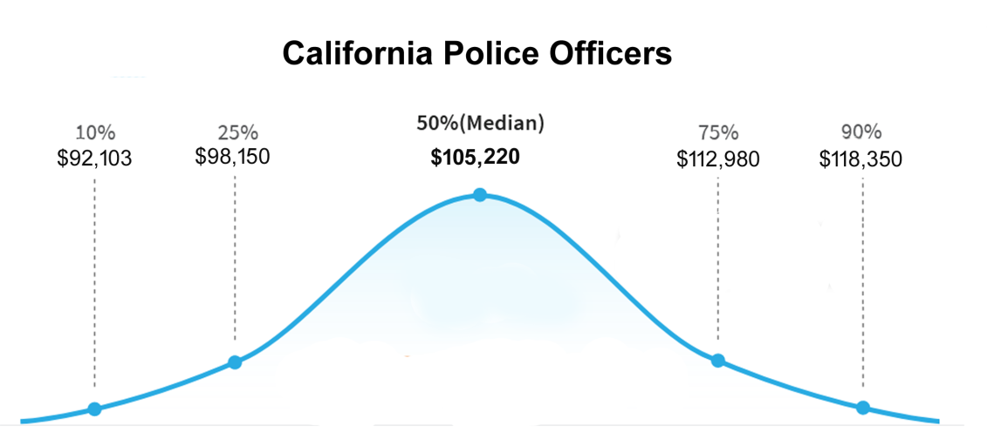
Figure 1 Police Pay in a High Cost of Living State (Forbes, 2023)

It could be argued that perceived respect has a larger impact on retention than reported by the officers and that pay has a significantly lower contribution to retirement. One of the authors (Parker) reports there is a ready market for former police officers in the private sector. Forbes also reports much lower 2019 pay in many states; Mississippi is listed as the lowest at a mean of $36,290. The median state was New Hampshire at $58,820; the mean of the states average salaries was $61,227 in 2019 (Forbes, 2023). The average American made $54,132 in 2022, with the average police pay that year listed as $60,202 (Indeed, 2023). The mean salary in California is reported as $95,207 (Average Salary Survey, 2023), but the median household income is reported as $78,672 (World Population Review, 2023). That means the police officers are making nearly one and half times the salary of the average resident. This paper takes the position that many of the factors impacting recruiting, retention and respect are amenable to counseling and that those, like pay levels, that are not are minor determinates in career decisions.

Another factor in policing is the matter of officer suicides. One report from the National Institutes of Health reports that law enforcement officers are 54% more likely to die from suicide than other employees. (NIH, 2023) Studies have shown the efficacy of intervention teams (Nick et al., 2022). There is also reported a culture among the serving professions (military, first responders, firefighters) to internalize stress and not seek help. The use of a virtual conversational counseling may overcome this reluctance.

Virtual CONVERSATIONs Research

One area of rapid growth in the computational sciences is the area of Virtual Humans and Natural Language Processing. As the world has recognized, early predictions of virtual human simulations and other advances in this arena have not matched the predictions. Some areas have sprung ahead in ways not envisioned. Dick Tracey's wrist watch phone has been put to shame by current models of smart watches that not only provide instant communications anywhere in the world, but also sense an unexpected fall and summon medical care on their own (Technokogizer, (2019). On the other hand The "HAL 9000" fully conversational, sentient and self-aware computer from the movie Space Odyssey may still be a significant ways off (Wikipedia, 2019). However, great strides have been made at USC's Institute for Creative Technologies and elsewhere.

Advances at The Institute for Creative Technologies

Artificial Intelligence (A/I) and Natural Language Processing have now achieved the stage in which personal conversational interfaces are possible. Acceptance of these means that large-scale implementation issues are increasingly seen as imminent challenges (Tram, et al., 2015 ). That, coupled with the popularity of hand-held devices such as tablets, MP3 players, and smart-phones has brought to the fore the issue of not over-burdening these limited resources with data storage and data transfer requirements that would tax their memory storage limits and bandwidth constrictions. The Institute for Creative Technologies (ICT) of the University of Southern California has been engaged by the Office of Naval Research to conduct research on MentorPal, a computer-generated mentor capable of sustaining a conversational series of responses to secondary school students who are considering careers, especially careers in one of the Science, Technology, Engineering, and Math (STEM ) disciplines. An early version is shown in Figure 2 above. The prototype for this interactive mentor targeted the Microsoft Surface® line of tablet computers. The limited power, RAM and secondary memory of these small portable devices mandates optimal sizing of all processes and data storage and transfer (Nye et al., 2017).
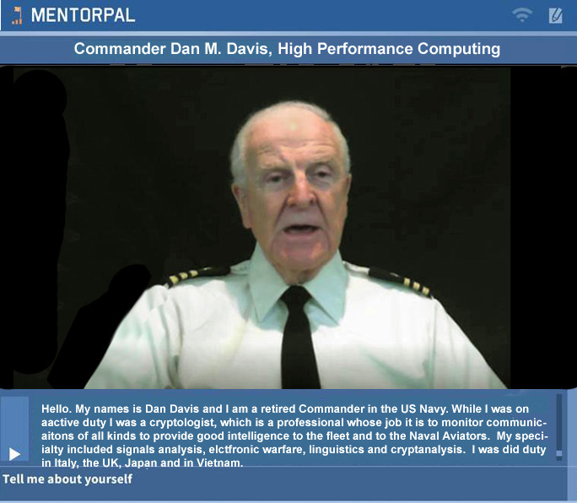
Figure 2 – ICT's MentorPal Display

The authors assert that the insights gained and the techniques employed apply to model reductions in practically any specific domain, rather than only to chatbots. Part of this assertion is recognizing the need to prepare for operations under conditions of limited computational power and data capacity, while at the same time designing code to make it amenable to scaling if a less constricted environment is available. This would allow computer assistance for team formation, no matter where the team members were stationed prior to the teams converging. These constrained environment issues are known to be common in much of the work currently being conducted at ICT (ICT, 2018).

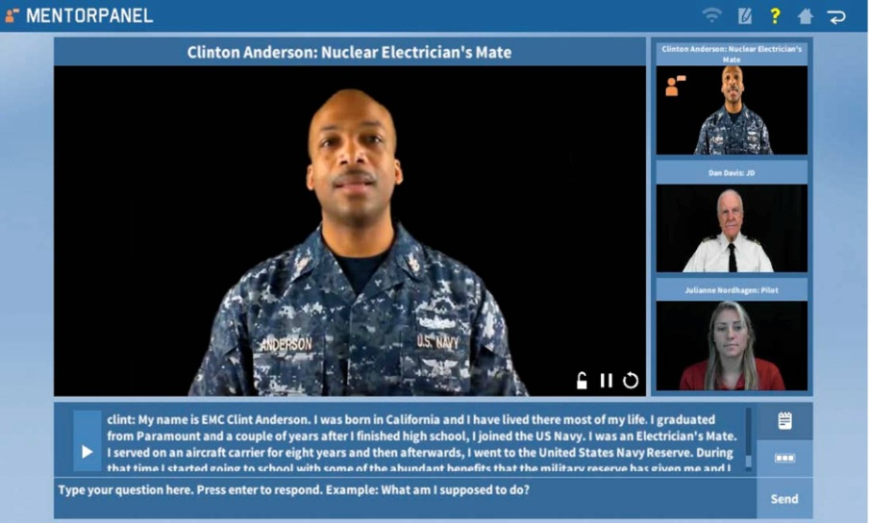
The basic objective of the Mentor PAL project was to provide a proof-of-concept version of career mentoring to students who may otherwise have no, or severely limited, access to advice or mentoring as they face the daunting task of selecting a career. The ultimate goal is to increase the number of technically trained personnel available. They might be used in the uniformed services or as civilian researchers for the DoD. To accomplish this, prospective career candidates may make other choices if they do not have someone to whom to speak who is experienced in and feels positively toward the desired careers. The authors envision a similar mentoring process in the team formation scenarios of the future. Users, who do not otherwise, have access to a mentor, may benefit from a virtual mentor. The reason for such lack of access may be due to a number of reasons, the two most prevalent of which the authors hold to be: geographic remoteness and poor network connectivity (Crisp et al., 2009).
Figure 3 – Mentor PAL for Advising High School Seniors
about STEM Careers in the Navy

The solution advanced by ICT was to produce a computer-generated mentor to be available via any system with the appropriate software installed. The user would be presented with a computer screen interface via which he could engage a mentor in a conversation-like exchange about issues of concern. Input from the user would be by text entry or audio speech recognition software. This mentor was envisioned as being both compelling and engaging. ICT advanced the position that the mentors would be most compelling and engaging if they were real people (Traum et al., 2915) recorded live and exhibiting a demonstrated screen presence.

Making a Conversational Agent with Initiative

Initially, a list of germane questions would be drafted. Depending on the topic, this might total a thousand or so items. The creative process requires a broad knowledge of both the questions that are a part of the mentor’s experience and represent the questions that the target users are likely to ask. In the previous projects, the team considered input from several members who had professional and Navy experience in order to generate a thorough list of questions. A previous paper (Nye et al., 2017) discussed this process at greater length.

The next step is to have the mentors record a varying number of video clips relating to their experience in the service and their duty in their own profession. These clips are then stored in a standardized database. When the user poses a question the program selects the most appropriate clip to play. This must be done very rapidly to sustain the desired “conversational” effect of the exchange. Based on the team’s experience with briefing users, the clips were designed to be on the order of 90 seconds or less. This technology rests on previous research into the use of Virtual Humans acting as program interfaces in counseling (Morbini, et al., 2012) and in history capture (Artstein et al., 2014). The team found that these videotaped mentors are difficult to classify easily: sometimes being referred to as Virtual Humans, but they are actually intelligent agents that sequence and present recordings of real people. This has been termed “time-offset interaction” in some related work. There still needs to be a substantial corpus of carefully collected questions and answers available to the system that can be answered within the latency limits that circumscribe the feel of conversational dialogue.

In Figure 4, the flow begins at the top left and proceeds clockwise through the process. The icons are notional only and should not deceive the reader as to their importance, weight or size, e.g. the storage icons approximately the same image-on-page size, whereas, in physical fact they differ by three orders of magnitude in data size. The important steps are the data flows from the storage locations into and out of the computational functions.

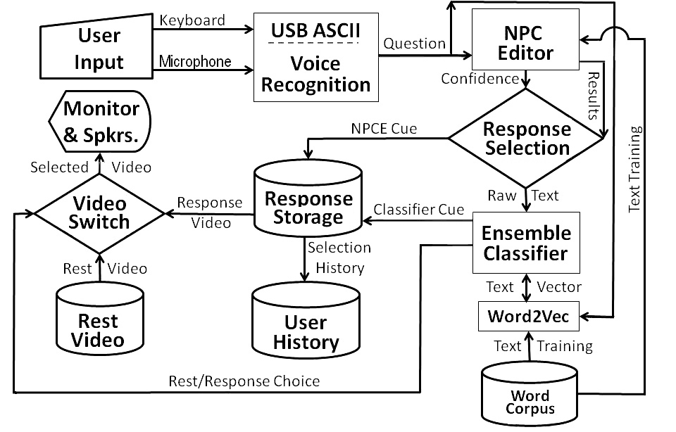

Figure 4- MentorPal Notional Flow Chart
ICT's Virtual Mentor Implementation

A Computer-Aided counseling Approach
Many of the inhibitions mentioned above may be successfully overcome by Computer Aided Counseling. New advances in high performance computing, globally distributed computer communications, animated or video-captured avatars, natural language processing, and Human-Computer Interaction technologies can effectively address all of these issues. They will be discussed in the order originally mentioned, with no implication as to the relative seriousness of the issue or the efficacy of the recommended computer system’s response to that issue.

A large portion of human communication becomes more compelling, more cogent and more comprehended if presented by a human, (EduNote, 2016) but the provision of humans is expensive and sometimes dangerous, e.g. sending instructional personnel into combat zones. Technologies conceived, developed, and validated at the Institute of Creative Technologies have fielded very engaging and lifelike conversation computer interfaces. (Reger, et al., 2015) These make use of a wide range of computer capabilities to: input both keyboard typed and spoken words from the user, analyze that content, select the appropriate response to the input, then cue up and display the response on-screen, so quickly that it accurately mirrors the pace of a human-to-human conversation (ICT, 2015a). At ICT, three types of display are used to best communicate with different target audiences, see Figures 2, 3, and 4: MentorPal, New Dimensions in Testimony and SimCoach, respectively.
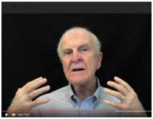
Figure 2 - Video-taped Interview
Head and Shoulders on monitor

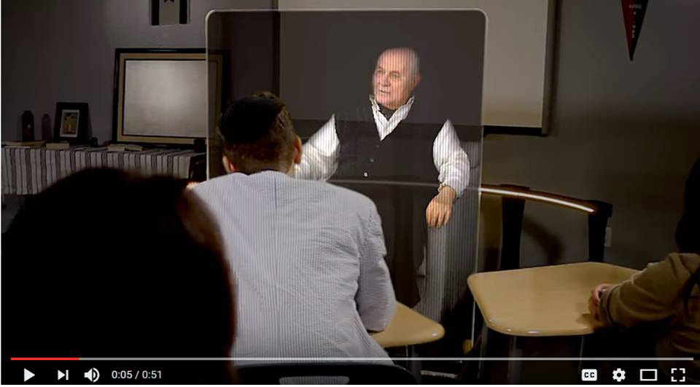 Figure 3 - Video-taped holocaust victim
in Holographic classroom display

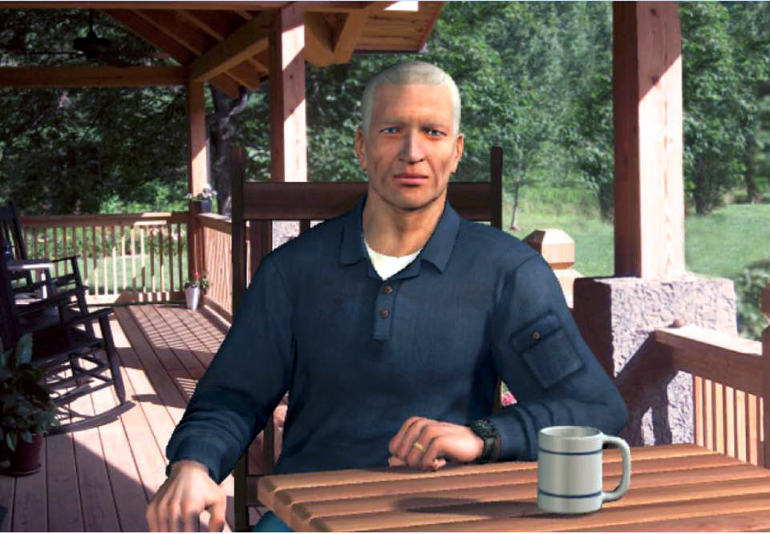 Figure 4 - Fully Animated SimCoach
CGI with alternative characters

If an animated avatar is used, the appearance of the avatar can easily be altered to present different ages, genders, ethnic appearance and social/military status. Once this capability is prepared, the avatar can be available to engage in a “one-on-one” conversation with as many users as the servers can support, anywhere in the world there is network capability. Further, it can be provided at any time and is not seriously disrupted by unanticipated breaks in instructional time, being ready to resume where it left off, immediately upon being cued that the user is on-line again. This 24 by 7 availability and immunization against disruption due to intruding operational requirements addresses the above noted operational constraints.

Spawning new avatars requires very little marginal costs, mostly additional computer processing power and storage space. Careful and easily modifiable design characteristics of the avatar also can provide a range of styles and “looks” to satisfy the majority of users’ needs for a mentor fitting their image of a senior advisor. In fact, they can switch with whom they interface with no penalty in terms of costs or continuity. While web sites like the Khan Academy (Khan, 2016) offer excellent instruction via written and visual materials, those kinds of interfaces lack the compelling quality of a “face-to-face” conversation with a responsive avatar. Especially in the area of Socratic dialogues, the responsive avatar has been shown to be more arresting and retain interest of the user longer and elicit more conversational input from the user. (ICT, 2015b)

Implementation Vision
While there are a wide range of implementation approaches that would satisfy the primary goal of this initiative, the following approach will give some clarity to a future implementation. The New Dimensions in Testimony (NDT) project developed an interactive storytelling avatar after interviewing several Holocaust survivors. Students used the technology and evaluated their experience in surveys, “The post-surveys showed that the system gave students a connection to the survivor, kept their attention, and had a positive impact” (Traum et al., 2015). The data gathered from the NDT experiments illustrate that interacting with a virtual avatar is as effective, if not more effective, as interacting with a live survivor, as shown in Table 1 below. Students reported a greater connection with the survivor and predicted that the experience would have an impact on them in the future. Though the live survivor more effectively retained the attention of the users, the system performed very effectively without a major decrease in attention. The interesting story given by the holocaust survivor did not suffer because it was displayed within a new medium, and the interaction proved to be relatable, intriguing, and significant. Some users wept and some offered condolences and apologies to the avatar.

 | Live survivor (N = 28) | System (N = 25)
I felt that I could connect with the story of the survivor. | 57 | 72
I felt that the activity kept my attention. | 100 | 80
I think that my experience in this activity will have a positive impact on me. | 86 | 92

Table 1 Percent of students rating the statements as “Strongly agree” or “Agree”. (Traum et al., 2015.)
Beyond NDT, the SimCoach project, also developed at ICT, hypothesized that users would be more willing to trust and interact on a personal level with a virtual avatar than with another human. The reason for this is that an interaction with an avatar contains no human judgment, whereas an interpersonal human conversation would suffer from the fear of judgment. After testing one interaction in which subjects were told that they were being observed and one in which they were not, the study demonstrated, “[Virtual Humans] are able to have this impact because they allow patients to feel as though their responses are not currently being judged. Because the only difference between frames was the belief that another human was observing responses during the interview session, we can establish that the power of VH-interviewers to elicit more honest responding comes from the sense that no one is observing or judging” (Lucas, et al.). To this effect, it is likely that interactions with virtual avatars actually elicit a greater degree of trust than human interaction. Using the frame of a virtual avatar has been shown to be effective in increasing trust, all the while retaining an unaffected interest from the user. In the SimCoach project, the avatar retained interest more than a live coach. (ICT, 2015)

Another concern regarding the effectiveness of virtual humans comes in the misconception that the lack of faultless automated speech recognition (ASR) renders successful virtual human interaction ineffective. The merit for this concern is that if a system does not understand a question, how can it provide an effective response? The answer to this question comes in three parts. First, even without an entirely precise transcription of user utterances, a response classifier can still generate an adequately accurate reply. The classifier chooses the best matching response based on the input it receives compared to the bank of answers that it contains. As such, even an incomplete recognition of user utterances can provide enough context to determine a feasible answer. Second, even if the response isn’t an exact match, as long as it is not completely off base, the answer will likely satisfy the user. It is unlikely that the voice recognition entirely misinterprets user input, and with even limited context, the classifier can provide appropriate feedback.

Because such classifiers determine the probabilities that each response matches the given input, choosing the response with the highest probability, the system will still determine a reasonable match based on the information it has. As such, even limited recognition results in somewhat suitable responses, which illustrate to the user that the system did, if to a limited degree, identify the theme of the user’s prompt. Even such small evidence gives the user the impression of comprehension by the virtual avatar. Finally, on top of the fact that effective classifiers can provide accurate responses despite limited or incorrect recognition, current ASR technologies are rapidly approaching an acceptably accurate response rate. Back in 2016, a study done by Andrew Kudryavtsev showed that Google’s ASR was the most accurate, “Google achieved 73.3% of exact recognized phrases with a 15.8% [Word Error Rate]” (Kudryavtsev, 2016). However, there have been major improvements over the last few years. (Wang et al., 2022 and Kim et al. 2019). When combined with natural language processing technologies, all these processes continue to improve and are already at a point where they are quite useful. Considering all of these factors, natural language processing and virtual interaction are reaching levels wherein virtual agents can, to a degree sufficient to support conversation, comprehend and interact productively with live humans, who also have a “word error rate.”.

Operational Vision
The most effective path for improving the threats to law enforcement might well be the provision of the accessible and engaging relationship with a knowledgeable and congenial mentor via the virtual conversational process described above. The first task would be to define the appropriate and predicted issues that may come up and develop a cogent list of from 1,500 and 2,500 questions that active duty police may propose to a living mentor. An approach this paper reports was initiated by interviewing a few members of the two police departments cited above. They provided some insights into what was of a concern and what was not. Then the team developed an on-line survey instrument to get even more data. The instrument was not intended to produce or support any specific trend or information. Instead, the goal was to begin to identify what issues were of concern to the law enforcement personnel. It matters little whether these issues were universal or rational, therapies, especially Rogerian or Client-Centered Therapy, do not focus on attempting to convince the subject to re-evaluate their concerns, but to urge them to express and explain their own concerns. For this reason, the instrument was not subject to the statistical rigor of a thesis-proving instrument. It was merely to inform the list generating team with a more general list of concerns to begin building the list. Based on the work at ICT cited above led to the desirable inclusion of routines that captured unanswered questions propounded by the subjects. Experience in the in the Mentor Pal project indicated that even interim sets of around 600 questions were sufficient to produce a “human-like” conversation. The rare questions that were not found to correlate with a previously recorded comment were handled with a generic “I am not sure I have to offer anything on that. Please ask another question.”

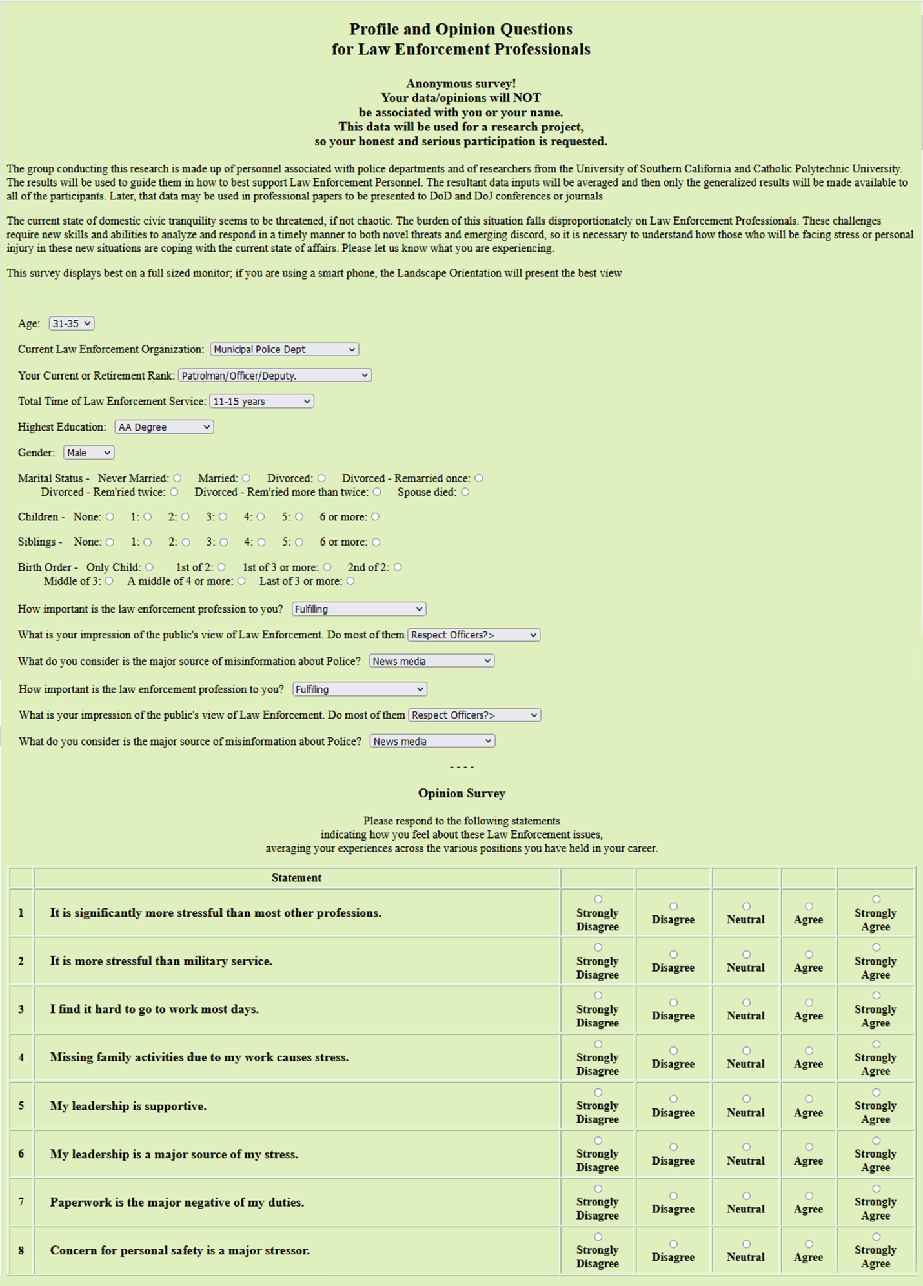

The date produced is manipulated by the program in which some arithmetic calculations were designed and coded, The form was then put on-line and offered to the members of the two departments, both sworn and un-sworn. This effort then produced information that was formatted to look like this:

Table 2 Preliminary Results from Likert Questionaire
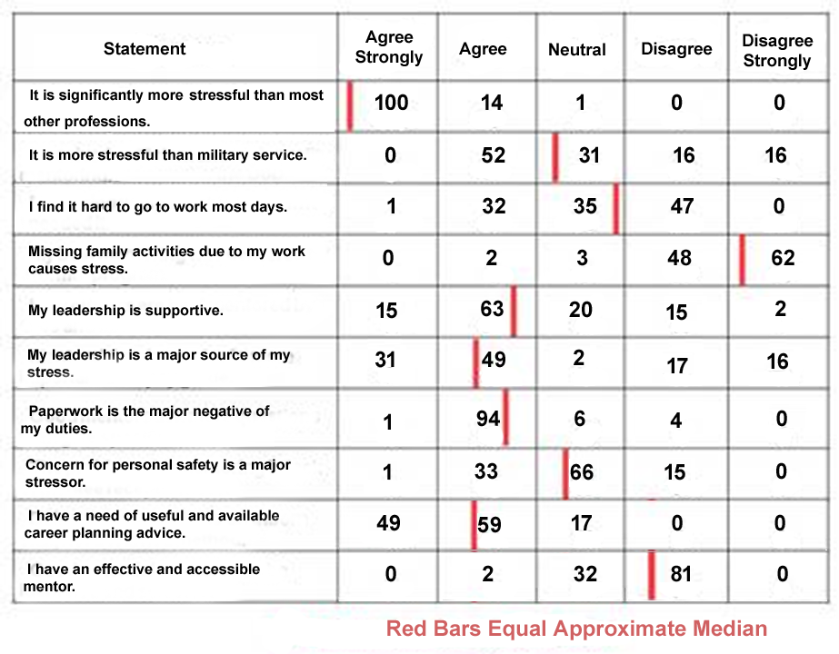

Another major development was the discussion of who in the departments would be the best virtual counselor and whether outside personnel might be considered, e.g. using a well-suited person from one of the other closely located departments. One variant, which is not being considered here, is the provision of several different counselors so the officers would have a choice in the person with whom they were “conversing.” It is the authors’ experience that effective mentoring and counseling is a very individualistic relationship, wherein one pairing of mentor and mentee may resonate well where another may not. Another factor, also not studied here, might be the loss of the sense of confidentiality conveyed to the subject when dealing with a virtual conversationalist (ICT, 2015a and 2015b)might be lost if the person recorded is well-known to the subject (and is probably senior to them and maybe even a reporting senior.)

The concept is that this program can then engage the subject at any time a network connection can be established and that the subject can probe a capable counselor with questions concerning issues of interest. As recording a counselor is not a technically difficult task, changes in personnel, policies, issues of concern, etc. are easily incorporated in the bank of appropriate responses. The ICT work cited above has shown that the users do experience and conversation-like connection with the counselor. One of the issues that is of concern is the rising suicide rate among law enforcement personnel. The authors propose that it would be possible to establish a list of suicidal thought expressions that could be recognized in a potential user’s questions or statements, and then issue an alert to the appropriate member of the department for further support for that person. This is technically feasible, but there may be ethical or privacy issues that need to be considered and resolved.

One further issue is of some moment, that of an effective exit interview. One of the authors (Davis) in 1970 read a USMC instruction covering exit interviews (due to the passage of time, a cite cannot be given to that document). The instruction required an commissioned officer or senior NCO should conduct the interview with the explicit direction for soliciting and recording any complaints about service in the Marines that were held by the Marine who was leaving active duty. The instruction pointed out that research had found that letting the exiting Marine voice their own thoughts dramatically reduced there negativity about the Corps. He found that none of his one-enlistment compatriots had ever gotten that exit interview. It was surmised that was because it is very difficult for even the highly trained therapist to endure personal attacks on themselves or their profession. In that era (the Vietnam War) there was an on-going sense of ill-ease between the one-enlistment Marines and their career brethren. It is worth considering whether a virtual conversational counselor might be a way to afford the departing law enforcement officer an opportunity for a departing officer to purge his psyche, thereby increasing the likelihood that his comments to others would later be more positive, as was found in the USMC study.

The instrument developed asked for demographic data, then asked 17 items in a “Likert-Scale-like” format, and closed with asking the subject to rank their concerns. Here is a truncated sample of what the instrument looks like on-line.

Conclusions
In order to meet the dynamic threats posed to the U.S. in the 21st Century and still honor the constraints of societal norms and financial limits, the DoD must make optimal use of the strengths of the nation that are not common in other cultures. Among these are a highly educated and motivated intellectual elite that has an unparalleled set of infrastructure tools available to teach improved analytic and decision approaches to military personnel at every level and in every environment. The authors maintain that critical thinking is vital, can be inculcated by training and is most practicably implemented by distributed computer-aided instruction and skill maintenance.

References

Alcadipani, R., Lotta, G., & Rodrigues, C. (2021). Police officers and the meaning of work: The forgotten dimension. Public Organization Review, 1-17.
Average Salary Survey, (2023). California/Salary, Retrieved from the internet on 17 May 2023 from https://www.averagesalarysurvey.com/california
Charman, S., & Bennett, S. (2022). Voluntary resignations from the police service: the impact of organizational and occupational stressors on organizational commitment. Policing and Society, 32(2), 159-178.
Forbes, (2023). Here’s How Much Money Police Officers Earn In Every State, Retrieved on 17 May 2023 https://www.forbes.com/sites/andrewdepietro/2020/04/23/police-officer-salary-state/?sh=3496d6e92010
Go Law Enforcement, (2023), Law Enforcement – Sworn vs Un-Sworn – Which Police Career Path is Right for You?. Retrieved from the internet on 17 May 2023 from https://golawenforcement.com/articles/sworn-vs-un-sworn-which-police-career-path-is-right-for-you/ .
ICT, (2015a), Video of SimCoach in action. Retrieved from the internet on 27 June 2015 from https://www.youtube.com/watch?v=2bsMESwBeyg&index=14&list=PLBF277FAE78E8CB39
ICT, (2015b). Selected Slides from presentation to the Army Research Laboratory. Retrieved on 29Nov16 from the internet at: http://www.hpc-educ.org/AFIT-Init/Materials/Slides/VH-or-Voice-or-StaticImage.pdf
Indeed, (2023), Police Salary in United States, Retrieved from the internet on 17 May 2023 from https://www.indeed.com/career/police-officer/salaries
Kim, J. Y., Liu, C., Calvo, R. A., McCabe, K., Taylor, S. C., Schuller, B. W., & Wu, K. (2019). A comparison of online automatic speech recognition systems and the nonverbal responses to unintelligible speech. arXiv preprint arXiv:1904.12403.
Kudryavtsev, A. (2016). Automatic Speech Recognition Services Comparison. Grid Designer's Blog. N.p., 11 Jan. 2016. Retrieved 20 Apr. 2017 from: http://blog-archive.griddynamics.com/2016/01/automatic-speech-recognition-services.html.
Mourtgos, S. M., Adams, I. T., & Nix, J. (2022). Elevated police turnover following the summer of George Floyd protests: A synthetic control study. Criminology & Public Policy, 21(1), 9-33.
Nick, G. A., Williams, S., Lekas, H. M., Pahl, K., Blau, C., Kamin, D., & Fuller-Lewis, C. (2022). Crisis Intervention Team (CIT) training and impact on mental illness and substance use-related stigma among law enforcement. Drug and Alcohol Dependence Reports, 5, 100099.
NIH, (2023). Law enforcement worker suicide: an updated national assessment. Retrieved from the internet on 17 May 2023 from https://www.ncbi.nlm.nih.gov/pmc/articles/PMC8056254/
Skaggs, S. L., Harris, C., & Montgomery, L. (2022). The impact of police–community relations: Recruitment and retention concerns of local police agencies. Policing: A Journal of Policy and Practice, 16(3), 462-475.
Shjarback, J. A. (2022). An examination of professional/trade law enforcement publication consumption and sensitivity to the ferguson effect among us police chiefs. Journal of Police and Criminal Psychology, 37(3), 669-680.
Wang, W., Chen, T., Sainath, T. N., Variani, E., Prabhavalkar, R., Huang, R., ... & Rybach, D. (2022). Improving rare word recognition with LM-aware MWER training. arXiv preprint arXiv:2204.07553.
Wojslawowicz, A. N., Doan, R. J., Fish, J. T., & Spencer, J. A. (2023). Gauging the impact of negative media publicity on career decisions: exploring police recruit motivations during a recruitment crisis. Policing: An International Journal, 46(2), 383-400.
World Population Review, (2023). Median Household Income by State, Retrieved from the internet on 17 May 2023 from https://worldpopulationreview.com/state-rankings/median-household-income-by-state

Davis, D.M. & Lucas, R. F. (2006). Joint Experimentation, Data Management and Analysis Enabled by Trans-Continentally Distributed Linux Clusters, at HPCMP Users’ Group Conference, Denver, Colorado

