Learning Analytics and Deep Learning:
New Quantification for STEM Instruction

Dan M. Davis, Jennifer H. Nolan, Jerome C. Placido & John J. Tran
Catholic Polytechnic University
Pasadena, California
{ ddavis, jnolan, jplacido & jtran }@catholicpolytechnic.org

ABSTRACT

The better quantification of results, analysis of efficacy, and enhancement of teaching techniques is now being enabled by advances in emerging technologies. Learning Analytics, Deep Learning, Neural Net Training, and Meta-Disciplinary approaches to the evaluation, selection, and preparation of instructional personnel are now feasible. Across the millennia, history reports that sages, teachers, and mentors have been sought to help prepare people for productive lives. Most of the evaluation of that search has been based on subjective and unquantified impressions. The obfuscation by human emotions has masked even the modest ability that previous generations had to evaluate pedagogical effectiveness. This paper adduces data to show how this conflation of the teacher's attractiveness and their effect on students has predestined early attempts to evaluate teacher skills to disappointment. During research into virtual conversational interfaces, the authors observed a number of issues concerning teacher evaluation. Researchers have made significant strides in Learning Analytics suggesting Artificial Intelligence communities may have insights that could be useful in live-instruction environments. Also, several emerging capabilities in the computational sciences have showed both results and future promise. These new technologies are outlined and reviewed. The paper disuses emerging capabilities of machine learning and learning analytics. They might deliver improved evaluation of human teachers. All of these issues are then synthesized to produce a viable path to a new set of psycho-metric tools for a better pre-selection evaluation, tailored training, and final competency assessment of instructional personnel. This is an especially pressing current concern of the authors.

ABOUT THE AUTHORS
Dan M. Davis is a research staff member at Catholic Polytechnic University and is active as a consultant at the Institute for Creative Technologies, University of Southern California (USC), focusing on large-scale DoD simulations and avatar uses. Prior to retirement, he was the Director of the JESPP project at USC for a decade. As the Assistant Director of Advanced Computing Research at Caltech, he ran Synthetic Forces Express, bringing HPC to DoD simulations. He also served as a Director at the Maui High Performance Computing Center and in computer research roles at the Jet Propulsion Laboratory and Martin Marietta. He was the Chairman of the Coalition of Academic Supercomputing Centers and has taught at the undergraduate and graduate levels. As early as 1971, Dan was writing programs in FORTRAN on one of Seymour Cray’s CDC 6500’s. While in the Marine Corps, he saw duty in Vietnam as a Cryptologist and retired in 2002 as a Commander, U.S.N. He received B.A. and J.D. degrees from the University of Colorado in Boulder.
Jerome C. Placido serves on the Advisory Board for Catholic Polytechnic University in the San Gabriel Valley, California. He also is the Director of Software Application Development at Workday, Inc. in the Bay Area. With over a decade of experience in higher education technology and his primary research interests are in organizational effectiveness and concrete applications for combinatorial optimization in student success scenarios. He has also held leadership and technology positions at Envisions in Irvine California and while serving on the board for YCP Silicon Valley. His continuing professional interests are in developing an integrative understanding of the human/machine interfaces in application to service delivery. Jerome received a B.S. degree in Computer Science from the University of California Riverside and an M.S. degree in Psychology from Divine Mercy University..
John J. Tran is the Chairman of the Computer Science Department of the Catholic Polytechnic University and he is a Major in the California Air National Guard. He has worked at ISI, USC, the Stanford Linear Accelerator Center, Safetopia, and Intel Corporation. At USC, he focused on Object-oriented software engineering, large-scale software sys-tem design and implementation, and high performance parallel and scientific computing. Air Force tours included the White House Communications Agency and Kirkuk Regional Air Base (Iraq), where he was the Communications Squadron Commander. He received both his BS and MS Degrees in Computer Science and Engineering from the University of Notre Dame and was awarded his PhD in Computer Sciences at the University of Southern California, where he was an advisee of Dr. Robert F. Lucas.
Jennifer H. Nolan, PhD, is the President of Catholic Polytechnic University and Professor of Psychology in their College of Arts and Sciences. Her earlier work specialized in memory, dementias, stroke and insulin resistance. She is a brain plasticity specialist and certified Cogmed provider. Previously, she was the C.O.O. and co-founder of a stroke and brain injury rehabilitation center. Dr. Nolan has taught university courses at the University of California Irvine, Loyola Marymount University, and Glendale Community College. She has conducted local and nationwide clinical trials, and published in both scientific journals and popular magazines. She received a BA in Psychology from Loyola Marymount University, Los Angeles and a Ph.D. in Psychology from the Dept. of Cognitive Science at the University of California, Irvine.Frederica J. Stassi is a Science Education Analyst, working in the Central Coast of California. Her background includes research for the National Science Foundation in which she was funded to study pedagogies and efficacies in U.S. Science museums. This research involved museums from the East Coast to O‛ahu in Hawai‛i. Her doctoral research was conducted under the guidance of Professor William McComas and focused on the development of science standards for the State of California. She received a B.A. degree from Tabor college in Hillsboro, Kansas as well as an M.A. Degree in music performance and an Ed.D., both from the University of Southern California in Los Angeles.

Learning Analytics and Deep Learning:
New Quantification for STEM Instruction

Dan M. Davis, Jennifer H. Nolan, Jerome C. Placido & John J. Tran
Catholic Polytechnic University
Pasadena, California
{ddavis, jnolan, jplacido & jtran}@catholicpolytechnic.org

INTRODUCTION

This paper proposes to advance the cause of computational science in enabling analysis of efficacy of pedagogical efforts that were hitherto unavailable to educators, leaders and societies. All three situations will be covered: exiting technologies, emerging techniques, and visions not yet coalesced. The concepts of both forcing technology and of disruptive technology management will be surveyed and considered. Where available, existing successes and data will be adduced to both support the worth of current advances and to suggest both the desirability and the possibility of future visions, implementations, and exploitations. Since the beginnings of history, people have questioned the impact of study and teachers on those in need of skill honing. Even with the quantifications of change that have come into use in the last century and a half, the utility of instruments of measurements were often countered by the imposition of personal bias and the seemingly endless list of convoluting factors. These made it difficult to isolate the impact of training and education that had occurred, and left the critics tools with which to oppose any actions they disliked. However, the better quantification of results, the more sophisticated analysis of efficacy, and metrics of enhancement of teaching techniques is now improved. All these are being enabled by advances in recognized technologies. Learning Analytics, Deep Learning, Neural Net Training, and Meta-Disciplinary approaches. On the Human Performance side, the improved evaluation, selection, and preparation of instructional personnel are all now feasible.

Since recorded history began, there have been reports that sages, teachers, and mentors have been sought to help prepare people for productive lives. Most of the evaluation of the search for teachers, trainers and mentors has been based on subjective and unquantified impressions of those in control. They have not had well-defined metrics nor adequate data collection capabilities to make rational decisions. The obfuscation of relevant achievement data by human emotions has masked even the modest ability to evaluate pedagogical effectiveness that previous generations had. In a Violation of one of the fundamentals of science, the appliers of the education and training were alone entrusted to evaluate their effectiveness. There is evidence that this still pervades the institutions of learning today. Despite the voluminous evidence of the efficacy of aptitude testing, there are many today who favor abandoning that kind of testing for many societal and emotional reasons. Emerging technologies may allow the decision makers more quantified and more unassailable tools on which to base their choices in these matters.

This paper reviews data to show how this conflation of the individual teacher's attractiveness and the effects of this orthogonal impact on students' rating of their instrucatos has predestined early attempts to evaluate teacher skills to disappointment. During research into virtual conversational interfaces, the authors observed a number of issues concerning teacher evaluation. Researchers have made significant strides in Learning Analytics suggesting Artificial Intelligence communities may have insights that could also be useful in live-instruction environments. Also, several emerging capabilities in the computational sciences have showed both results and future promise inteasing what real impacts have been delivered. Several of these new technologies are outlined and reviewed. The paper disuses emerging capabilities of machine learning and learning analytics. The ways in which they might enable the improved evaluation of human teachers are discussed. All of these issues are then synthesized to produce a viable path to a new set of psycho-metric tools for a better pre-selection evaluation, tailored training, and final competency assessment of instructional personnel. One of the more complex issues is that of expected outcomes. The new technologies may have the critical capability of discerning how much intellectual growth is due to the instruction and how much is a preordained improvement based on factors external to the educational setting. This is an especially pressing current concern of the authors. The risks associated with these new capabilities are also covered. Such a revolutionary ability will be threatening to many people and precautions must be addressed to ameliorate these concerns. The paper does not take a position on sensitive issues of society, but considers how technology may plavy a part in how this evolution proceeds over the next decades.

BACKGROUND .

Just as it is hard to denote at which time one of our humanoid ancestors emerged up from the great apes into a sub-group: Hominidae, it is hard to establish when Homo-Sapiens began to recognize that the leader needed intellectual skills more than just brute strength physical strength. Nevertheless, at the very end of the time of humans, written language was available and even early writings speak of various religious and warrior classes receiving education and the status that brought to the educated individual. By the time of Classical Greeks, there is at least one tale of the society evaluating, criticizing and finally punishing the mentor of young people (Linder, 2002). The fact that this was more a political matter than a pedagogical efficacy controversy is telling. The populace had only their personal observations and analysis upon which to rely.

Stakeholders
One issue that arises early is what groups of people are the most impacted by the advent of a new series of technologies, techniques and approaches to better understanding, modeling and quantifying learning. Centuries of bemoaning the lack of any reliable way of assessing teaching achievements were caused by the amount of data and the length of time between the learning activity and the final evidence of its efficacy (Caspersen et al., 2017). Now data can be collected real-time, click-by-click, keyboard entry key-by-key and duration of sessions response-by-response, which indicate not only duration but engagement levels. Data can be stored intentionally, tracking the utilization of the learning by the learner and monitored vicariously due to the vast ranges and staggering amounts of collected data that can now be both rigorously analyzed and evaluated using evolutionary computing and Neural Net training to isolate hitherto unrecognized opportunities (Chebbi et al., 2015). The groups who may be impacted, either positively or negatively, are identified below in a listing that is neither exclusionary nor static.

- Learners in general  - Parents and other care-takers  - Learners requiring special education  - Teachers, Trainer, Instructors and Professors  - Education professionals outside of the classroom | - Development personnel and organizations  - Education deans, & officers  - Future employers  - Legislators  - Society

Emerging capabilities
Some of the emerging capabilities mentioned above are now decades old, but many are still on Clayton Christensen's curve of disruptive technologies (Christensen, 1997) and many are well-known only in the conference environment, but remain mysterious to the education practitioners in the classrooms. A quick review and a shallow survey may help the reader understand the rest of this paper. Some of the Learning Analytics terminology is not only vague in definition, but not uncommonly the source of considerable controversy and heated disagreement (D Gašević et al., 2017 ). This paper takes not position on those issues which will be resolved by an evolving consensus on how the terms are to be used, so authors in the future will be well-advised to consult the published papers on those topics regularly and use the most current usage. The list below should be taken as applying to this paper only.

Technologies to be considered:
- Learning Analytics,
the over-arching concept, is the computerized collection and analysis of data about learners and their environments for the purpose of better understanding and improving learning outcomes.
- Deep Learning
is a neural network with three or more layers. These neural networks attempt to simulate the behavior of human intellect, allowing it to “learn” from large amounts of unstructured data.
- Neural Net Training
is a computational machine-learning operation that uses a network of functions to understand and translate a data input of one form into input for another function, often a control device.
- Meta-Disciplinary Efforts
are an extension of multi-disciplinary efforts in that they have a more deeply collegial relationship and do not force all of the disciplines to subservience of the predominant one.
- Social Network Analysis
is an outgrowth of cryptologic network analysis and it is a process of quantitative and qualitative analysis that measures and maps the flow of knowledge between various entities.
- Data Mining
is the process of using computational scicence to search large (gargantuan) sets of data to discern patterns and vectors, utilizing those findings to isolate insights and develop predictions.
- Natural Language Processing
is a function within artificial intelligence (AI) that enables computers to recognize, understand human and manipulate either spoken or written language, comprehending natural languages.
- Data Visualization
is the representation of data through use of common graphics, such as charts, plots, and animations to communicate complex interactions and data-driven insights for info-graphics.

Research and Implementation Setting in which Learning Analytics Would be Useful
To better set the environment into which inputs from Learning Analytics could be injected with significant benefit, a program at the University of Southern California used a computer agent. As reported previously (Nye, 2017), that was manifest as a two-party video call with the user being one party and a selection from a series of pre-recorded video clips of effective mentors providing the advice. While still at the developmental phase of its implementation, it showed both its efficacy at current levels of maturity and the need for even more sophistication in the selection of the appropriate clips. Learning Analytics could both provide the needed enhanced sophistication and a more compelling way of evaluating whether the program was having its intended effect on the user: in this case, increasing the likelihood the user would consider a career in the STEM (Science, Technology, Engineering, and Math).

During an informational career interview, a student asks questions about a mentor’s job to get a better understanding of how well that career fits their interests and goals. MentorPal leveraged approaches from earlier projects, including New Dimensions in Testimony (NDT) (Traum et al., 2015). The NDT project, which is intended to maintain and share the experiences of Holocaust survivors (Fig. 1), serves as a model for building systems to communicate personal life experiences (or career experiences). In NDT, recorded answers and questions were transcribed, and a predictive algorithm was developed based on the question-answer pairs, using machine learning. This algorithm predicts the words that are likely to appear in the answer. Arstein found that about 1,400 recorded answers could answer 70% of questions in an open-ended conversation, and iterative improvement allowed fewer than 2,000 answers to cover 95% of questions in a highly-natural conversation (Arstein et al. 2014).

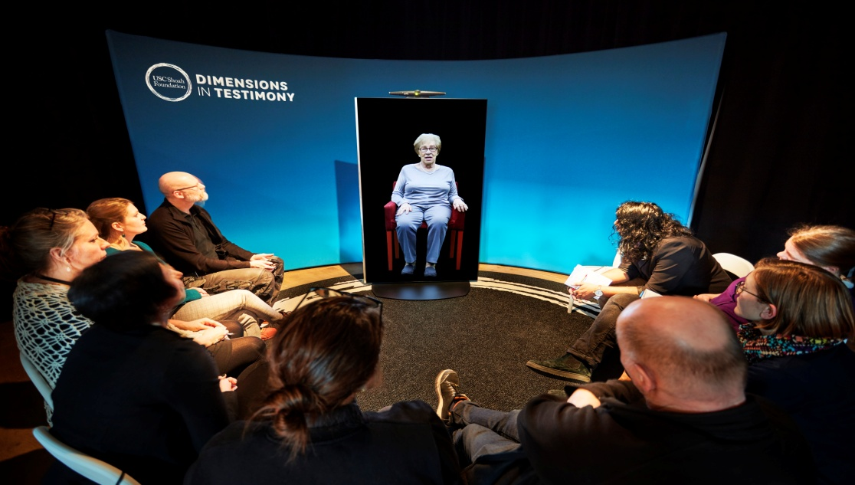
Figure 1. NDT via a 3-D Holographic display at a Swedish Museum

MentorPal User Operations
The MentorPal interface was designed to resemble video conference interface designs. Users submitted a question and the system classifier found the best-matching answer, which, within 500 milliseconds, then triggered a video of the real-life mentor answering (or a video noting that the mentor did not have an answer). Based on internal feedback and later user testing (Beck et al., 2018), new features were implemented including pause, replay, a conversation transcript, replay functionality, subtitles, and voice input of user questions (speech to text).

However, after testing with students, it was noted that many high school students had trouble generating germane questions. In response, to help students get started with questions, a brief practice session was conducted, in which experimenters modeled asking a few questions. Dialog prompts by the mentor were programmed (e.g., “You can ask me about how I started my career, my time in Japan…”). While those techniques helped, some students (particularly younger teens) continued to struggle. As a result, an alternate interaction mode was designed. To scaffold question-asking, topic buttons were added. This cycled through possible questions (shown beneath the video panel in Figure 2). Topic buttons did not ask the question, but filled the text box with potential questions. Cycling through one question at a time helps a student explore the space of questions they should be asking and that they could submit. While not assessed in this study, topic buttons may have a distinct learning effect, since manually exploring the questions associated with each topic should help students frame which factors to consider in career choice. As a result, MentorPal has three options for input:
- Free Text: Typing a question into the text box, e.g. a specific concern or a follow-up question. Pedagogically, both free text and speech input support a caring environment (McDaniel, et al., 2007).
- Speech Input: Activating the microphone to input speech, which is converted to text-input to submit.
- Topic Buttons: Show a range of suggested questions in a topic of interest, in an order by researchers. Pedagogically, these buttons scaffolded question-asking as noted above (Graesser et al., 2014).
Students reported the single mentor interface as useful (eck et al., 2018), but this interface showed limitations after more mentors were recorded. The original concept assumed that a student would close a mentor if they wanted to talk to another. The advantages of MentorPanel quickly became clear. First, the panel approach offered an effective way to become familiar with at least four mentors and their points-of-view rather than just one. This seemed likely to give a better chance that users could find a career or individual who they preferred. Second, by adding a “lock” button, the MentorPanel could emulate a one-on-one chat. Third, by having multiple mentors offer their views, a student could compare and contrast different careers or viewpoints. Finally, the panel approach helps mitigates issues due to limited answer sets, since only some of the mentors need to answer a question for the system to feel conversational, as in Figure 2 below. NB: the transcribed text beneath the speaker and text box below that.

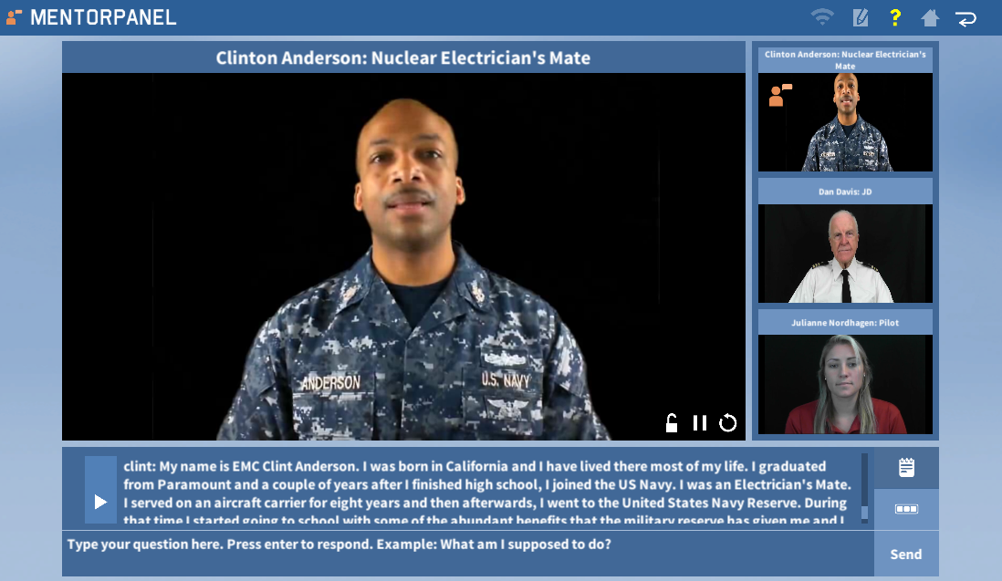
Figure 2. MentorPal Panel Display

Feedback from early users also impacted the design process. Specifically, multiple locations expressed concern about using a downloadable application. This was due to the challenge of installing and debugging a local app and also due to the desire to reach students who were located in rural settings that might be difficult to reach for live mentoring. As a result, new iterations of MentorPal are now web-based (Figure 3).
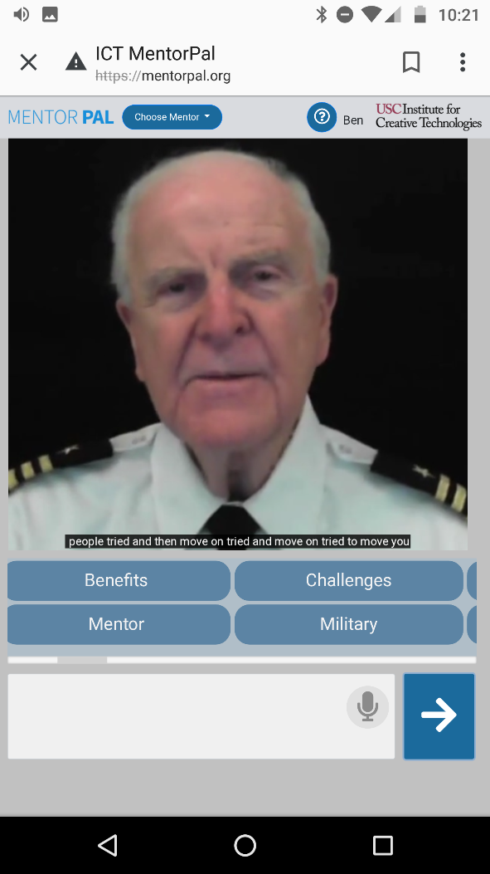
Figure 3. Web Based MentorPal
(Mobile PhoneView)

MentorPal Design Considerations
The MentorPal technology is only a medium: effective mentoring is determined by the quality of the engagement and advice from the human mentor. The full panel of mentors was selected to span a diverse set of backgrounds and career stages, as shown in Table 1 (listed in order of recording). The primary inclusion criteria for mentors were that they had prior experience as mentors in their field. A secondary inclusion criterion was that mentors needed to be able to share their experiences using engaging stories. It is important that students have opportunities to talk with mentors in different career fields and who they relate to in terms of life experiences. Recruiting for the panel targeted a balance of two women and two men. However, a female physicist selected was unable to continue, so a previously-recorded male panelist was used for this panel. A second mentor also received transfer orders with only 1/5 of their questions recorded. However, it was identified that they could still work effectively as part of a panel. Despite the range of experiences and careers in this prototype, the limitations of even four mentors were evident: only a small set of STEM fields were covered (Nye et al., 2020.)

One goal of this project was to help students become familiar with STEM careers relevant to both the Navy and to society overall; mentors with experience in Navy-relevant STEM careers were selected. However, the goal of these recordings was not to advocate for a career, but to convey useful information about the realities of each career: both what makes their careers appropriate or not. Table 2 summarized the topics for each career. Some highlight career benefits (e.g., Growth) while others highlight difficulties or day-to-day headaches (e.g., Challenges). Nye gives a more thorough overview of the mentor selection, recording, and content development process (Nye et al., 2017).

The primary pedagogical technique encouraged during recording was the use of narrative, such as brief anecdotes to make key information memorable and salient (Dahlstrom, 2014). Before each session, mentors were reminded to answer questions as if they were talking to high-school students. For responses with relatively low career information, mentors were advised to remain brief. While most answers were recorded only once, mentors were encouraged to re-record an answer to highlight an element that was particularly compelling, to improve conversation flow (e.g., long pauses, too long), or to allow mentors to re-phrase their answers.

Table 1. Mentor Careers, Demographics, and Training Set Size (Nye et al., 2020.)
Mentor | Career(s) | Career Stage | Demographics & Geographics | # Answers | # Q&A Training
Clint | - Nuclear Electrician's Mate Chief (EMC)  - Computer Science | Mid | African American Male. In Japan & CA, and from CA, Flint MI, and Alabama. | 381 | 2623
Dan | - Supercomputers  - Navy Cryptologist (CDR) | Late | White Male. In CA and from Colorado Springs. | 365 | 2671
Carlos | - Marine Logistics (Civ)  - Logistics (Warrant Off.) | Mid | Latin American Male. In S. Carolina, from Northeast | 307 | 1896
Julianne | - Systems Engineering  - Naval Aviator (ENS) | Early | White Female. In CA and from Boca Raton, FL. | 61 | 307

There was a pre determined structure for choosing the questions. Both experienced professionals and young students were part of the question generating process. This sub-team included service academy cadets as summer interns.

Table 2. Examples of question topic categories, with example questions (Nye et al., 2020.)
Category | Question
Background | Where did you grow up?
Benefits | How do the educational benefits of your work?
Challenges | What is your strategy for overcoming hardships?
Conflict | Tell me about a time when your priorities conflicted with that of management.
Culture | What do you find unique about your career field?
Ethics | Is sexual harassment common in the military?
Failure | What are the failures for which you are the most unhappy?
Mentor | Who are the best people to talk to when making a career choice?
Motivation | Why do you love your job?
STEM | What is something most people don’t know about computer science?
Travel | How much travel did you do during active duty?

Some of the results of the field test on students (17 and 18-year-olds) are shown below:

Table 3. Interest Rating for Specific Mentors (Nye et al., 2020.)
(Post-Survey, N=31, Scale from 1=Not at All Interested to 6=Highly Interested)
Mentor | Career(s) | Interest Ratings |  | % Top Rated | % Students Listing Career  in Free Text
Mentor | Career(s) | M | SD | % Top Rated | % Students Listing Career  in Free Text
Clint | CS, Electrical | 4.48 | 1.09 | 39% | 23%  (13% CS, 13% EE)
Dan | Cryptology, Supercomputers | 4.55 | 1.18 | 48% | 6%  (3% Cryptology,  3% Supercomputers)
Carlos | Logistics | 2.65 | 1.56 | 10% | 0%
Julianne | Systems Engineer, Aviator | 3.81 | 1.47 | 23% | 6% (Aviation)

As an exploratory analysis for potential impact, Table 4 presents the change in interest in STEM fields from the virtual mentoring session.

Table 4. Change in interest in STEM and the career fields represented (N=31)
Career(s) | Pre-Survey  Interest Ratings |  | Post-Survey Interest Ratings |  | Difference
Career(s) | M | SD | M | SD | Difference
Computer Science | 3.5 | 1.2 | 3.55 | 1.36 | 0.05
Electrical Engineering | 2.97 | 1.25 | 3.03 | 1.27 | 0.06
Logistics | 3.13 | 0.81 | 2.71 | 0.97 | -0.42*
Supercomputers | 3.03 | 1.43 | 3.19 | 1.33 | 0.16
Systems Engineering | 2.94 | 1.00 | 2.87 | 0.92 | 0.07
STEM Overall | 4.35 | 0.88 | 4.48 | 0.85 | 0.13
Military | 2.55 | 1.46 | 2.74 | 1.41 | 0.19
*p<0.05, **p<0.01 on two-tailed t-test

Non-significant increases were observed for Supercomputers, Military Careers, and STEM fields overall. A significant drop in interest was observed for Logistics. This decrease aligns reasonably with the students’ existing career goals, which were fairly heavily concentrated on topics such as biomedicine, engineering, and computer science. A different set of results would surely have been observed in different SES levels. Many of the tested groups turned out to be from professional households.

Many issues arose in the testing that were illuminating, not the least of which was the pervasive lack of the students' awareness of career selection parameters considered to be of consequence to more experienced team members. There was, as would be expected, a significant amount of variance in this lack of thought on careers, some of it depending on Socio-Economic Status (SES) and K-12 education environment (Nye et al., 2020.).

Learning Analytics in a system

The partially complete vision may warrant some discussion at this juncture. The capabilities of Learning Analytics and its many subcomponents could become a major driver for the future of education. To start with, it seems certain to be poised to strike disruptive blows on both sides of pedagogical divides: formal and informal education, in-person and on-line education, self;-paced and semester-scheduled instruction, didactic and constructive. All of these would be amenable to the kinds of direction Learning Analytics might bring to the table (Siemans, 2013).
- Learner Parameterization: identifying, measuring, and understanding a learner.
- Knowledge tracking: addressing how to pursue the knowledge that occurs during the learning process.
- Learning cost/benefit analysis: referring to how to make learning more effective and economic
- Individualization: designing for special learners and personal for each via computational technology.
- Content comparison: improving learning by comparing the learner’s knowledge with the learning goals

It may be illuminating to see how the technologies might be implemented to address current hurdles in computer assisted education. Then the paper will address how these may be exploited to enhance current efforts to develop an improved and more human-like interface. This work was conducted at the University of Southern California, in which two of this paper's co-authors from the faculty at Catholic Polytechnic University were team-members.

Learning Analytics
Much of the work in this area grew from computer training scenarios and is now being applied more broadly to learning environments. As will be later presented, technology can now deliver individualized and targeted education and training in ways that were not possible a few decades ago. One of the hurdles then was which option for training should be taken. Time was a major obstacle: real-time results were difficult to capture and long-term results were difficult to pursue due to various issues such as retaining contact and extracting evidence from the learner who may then be geographically separated, if not socio-economically resistant to further contact from decades and decades distant experiences. As far as real-time adjustments, the previous teachers' skills and curses were being able to, yet forced to, teach to the least capable learner. Learning analytics with its more objective data capture, real-time analysis and immediate adjustment of optimal learning styles can address any number of perplexing educational issues. Given a typical classroom, even if the teacher had the ability to freely individualize the instruction for every student, it would be a herculean task to evaluate, monitor, design, alter and apply metrics to even a small class. With Learning Analytics implemented, such issues could be done without strain and careful documentation accomplished.

Deep Learning
One of the aspects of Learning Analytics is establishing the context in which targeted educational goals will be pursued and then accessing the necessary information to allow adequate presentation of the selected pedagogical approach. Deep Learning can fill this gap. With its increasingly effective capability of incorporating and manipulating large data stores in the quest to seek out the appropriate back ground and the most comprehensive data points to achieve the teaching goals, it can respond to both computer-generated and human-input requests for changes in goals, schedules, and pedagogical approaches. This computational science asset can also assist in defining goals and assessing progress.

Neural Net Training
Any time a figure of merit can be established, Neural Net Training or Evolutionary Computing has been shown to be very effective at optimizing solutions and discovery hitherto unrecognized methods for achieving the optimal score on the figure of merit. While this has not found wide application in education and training, it will now be enabled by the other sub-programs in Learning Analytics. Always allowing for safe-guards in the decision process and fail safes in the implementation phases, Neural Net Training can relieve the educator of much of the burden of the drudgery of the administration of education.

Meta-Disciplinary Efforts
By its still evolving definition, Learning Analytics is multi-disciplinary and it effective implementation and use will require the participation of several other components of the over-all solution. The inclusion of the behavioral sciences, pedagogies, human factors, and physiology will make this a paradigm case for a new and more synergistic amalgam of the broadest range of disciplines

Social Network Analysis
Communications is often the key stone of human activities; so it will be with Learning Analytics. Autonomous computational assets, heterogeneous human entities, and physical support systems will have to act in accord and focus on the central goal of optimal learning. The design and modification of this communication realm can be enhanced by the previously mentioned Deep Learning and Neural Net Training.

Data Mining
This is the "first cousin" of Deep Learning. Data Mining is the sophisticated management of data for the benefit of the both the learner and the teacher. Instead of relying on intuition or investing precious time doing research, this capability can seek out and retrieve data, trends, and correlations in both the learning processes and in the lesson content required for the instruction.

Natural Language Processing (NLP)
Most everyone is now familiar with, if not a frequent user of, Siri, Alexa, or their "companions." Their responsiveness to questions: "Alexa; how cold is it in Washington?" or to simple commands: "Siri; set timer for ten minutes." is now accepted. However, the next great leap will be situation awareness: "You seem a little down today." and conversation initiation or topic change: Siri: "I'd like to talk to you about your last test." or Alexa: "Let's not get angry, but let's talk about why you did poorly on the exam.". NLP will need input from Learning Analytics to achieve this, but then it should be able to provide a new dimension to learning endeavors.

Data Visualization
As the data and access to it becomes more available, the next question will be how it can be managed to provide useful data to learners, teachers, and evaluators. Data Visualizations are now largely hand designed and created as more like works of art than products of science. Finding ways to make this automatic, economic and significant may become a major goal of those advancing the utility of Learning Analytics.

Metrics

This paper takes the position that in any analysis of education, metrics are a sine qua non. In the consideration of the use of Learning Analytics to enhance and foster education by using emerging technologies, this topic appears at several levels. One is the use of appropriate metrics to analyze that use of Learning Analytics. There must be a serious and objective look at just what the goal for such use is. Even the goal-setting is not trivial. The authors are well aware that there are many convoluting factors in educating any group, and their hope is that once goals are set, Learning Analytics will deliver both the sensors/recorders to capture various changes in attitudes, knowledge base, skills and productivity of the users. The implementation of this new set of evaluative skills may further drive the educators to reconsider the goals of education at a number of levels.

Beyond the impact of Learning Analytics, the new technologies should also allow a better view of the education process itself. One issue in education has been that of establishing the proper quantification of which activities are really having and educational impact on the learner. The above listed processes do present a new and better way of objectively isolating and improving on those activities that have the most beneficial impact on the user. This may also bring on a vital reconsideration of an even higher set of aspirations for society in general. This will also allow a retrograde looks at whence and how the students got where they are and a chance to observe whither they are going. Using Learning Analytics to generate expected outcomes based on the user's background and to predict where they may be the most successful would be an enticing function in the face of the current lack of establishing those characteristics with any sense of certainty and without the normal human biases about people.

Implementation

Injecting Learning Analytics Input into MentorPal
In order to make timely use of the insights provided by Learning Analytics, it is necessary to contemplate how those results could be injected in the process. Naturally, the operators and the designers would be able to make good use of the findings, but that process could also be accelerated by real-time interjection of germane data. For the MentorPal system to emulate a video conference with an engaging mentor, a dialog engine was required. This engine optimized multiple operating characteristics: response latency, classification quality, dialog moves (e.g., handling repeat questions), and system resources e.g., available RAM; (Kaimakis, et al., 2018). The set of features used in the usability study included the ones that were most stable and useful; while certain features were disabled.
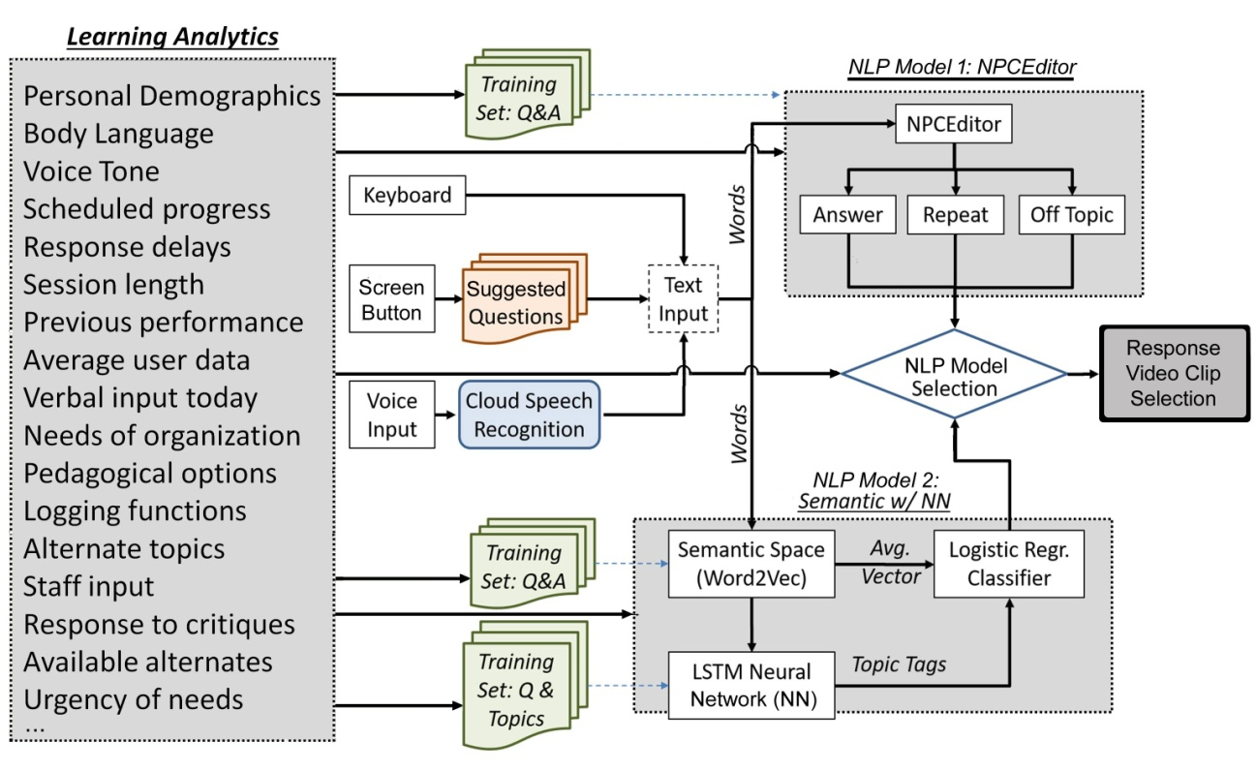
Figure 4. Learning Analytics Outputs as MentorPal Inputs

CONCLUSIONS

As this paper focuses more on potentials from a series of emerging technologies and approaches than a formal investigation of a concurrently advanced thesis, the conclusions match this theme. The paper's major thesis was a speculative one: can't Learning Analytics now be implemented with very beneficial results. The early progress cited is encouraging, but implementation and adoption is now the question. As academics, it is recognized that many factors outside of academia will come to bear on these issues. Nevertheless, the benefits at both a personal individual level and at a more general societal level seem likely and these conclusions well-supported. Based on personal experience, the authors have observed that the ability to understand the data has not grown at the rate that the volume of data has grown. It is for that reason that the discipline of data visualization has been included in the areas to be consulted. If better ways cannot be found to help the inundated individual to make use of the data, all of that growth may be of little help as the challenges of tomorrow are faced. Learning Analytics would present a good opportunity to both facilitate its optimizing the educational processes, but a well-structured effort in which to show the benefits of visualized data. The technology is available; direction and commitment is required.

ACKNOWLEDGEMENTS

Nearly all of the work involving Virtual Humans reported in this paper came from a series of research projects of which the Principal Investigator was Dr. Benjamin D. Nye, Director of Learning Sciences at ICT. Without his technical vision and unflagging support, none of this would have taken place. The various projects mentioned were supported by a range of DoD organizations and, while this paper reports insights gained during that work, which was not the focus of the research. Much of this work was supported by grants from the Office of Naval Research's STEM Program (ONR N00014-16-1-2820) and by students supported by the National Science Foundation Research Experience for Undergraduates program (NSF 1560426). Nevertheless, the positions taken in the paper are the authors’ own and do not represent in any way the views of the Department of Defense or the US Government.

REFERENCES

Artstein, R., Traum, D., Alexander, O., Leuski, A., Jones, A., Georgila, K., ... & Smith, S. (2014). Time-offset interaction with a Holocaust survivor. In ACM Conference on Intelligent User Interfaces (IUI) 2014 (pp. 163-168). ACM Press.
Beck, S., Carr, K., Davis, D. M., Nordhagen, J. N., and Nye, B. D. (2018). Virtual Mentors in a Real STEM Fair: Experiences, Challenges, and Opportunities. In Third International Workshop on Intelligent Mentoring Systems (IMS 2018) Proceedings.Caspersen, J., Smeby, J. C., & Olaf Aamodt, P. (2017). Measuring learning outcomes. European Journal of Education, 52(1), 20-30.Do.
Chebbi, I., Boulila, W., & Farah, I. R. (2015). Big data: Concepts, challenges and applications. In Computational collective intelligence (pp. 638-647). Springer.
Christensen, C. M. (1997). The innovator's dilemma: the revolutionary book that will change the way you do business Collins business essentials, HarperBusiness; Reprint edition (October 4, 2011).
Dahlstrom, M. F. (2014). Using narratives and storytelling to communicate science with nonexpert audiences. Proceedings of the National Academy of Sciences, 111(Supplement 4), 13614-13620.
Gašević, D., Kovanović, V., & Joksimović, S. (2017). Piecing the learning analytics puzzle: A consolidated model of a field of research and practice. Learning: Research and Practice, 3(1), 63-78..
Kaimakis, N.J., Davis, D.M., Breck, S. & Nye, B.D. (2018). Domain-Specific Reduction of Language Model Databases: Overcoming Chatbot Implementation Obstacles. In the Proceedings of the ModSim World Conference, Norfolk, VA..
Linder, D. (2002). The trial of socrates. Available at SSRN 1021249.
McDaniel, M. A., Anderson, J. L., Derbish, M. H., & Morrisette, N. (2007). Testing the testing effect in the classroom. European Journal of Cognitive Psychology, 19(4-5), 494-513
Nye, B., Swartout, W., Campbell, J., Krishnamachari, M., Kaimakis, N. & Davis, D. (2017). MentorPal: Interactive Virtual Mentors Based on Real-Life STEM Professionals. in the Proceedings of the Interservice/Industry Simulation, Training and Education Conference, Orlando, Florida, 2017.
Nye, Benjamin D., Davis, Dan M., Rizvi, Sanad, Z.,Kayla Carr, Swartout, William. Thacker, Raj & Shaw, Kenneth (2020). Feasibility and Usability of MentorPal, a Framework for rapid Development of virtual Mentors. Journal of Research on Technology in Education.
Siemens, George (2013). "Learning Analytics: The Emergence of a Discipline". American Behavioral Scientist. 57 (10): 1380–1400.
Traum, D., Jones, A., Hays, K., Maio, H., Alexander, O., Artstein, R., ... & Swartout, W. (2015, November). New Dimensions in Testimony: Digitally preserving a Holocaust survivor’s interactive storytelling. In International Conference on Interactive Digital Storytelling (pp. 269-281). Springer, Cham..

