Incorporating Ethics in Defense M & S:
New Frontiers in Standards

Dan M. Davis & Jennifer H. Nolan
Catholic Polytechnic University
1028 N Lake Ave MC 207
Pasadena, CA 91104
{ ddavis & jnolan } @catholicpolytechnic.org

Mark C. Davis & Robin G. Bitterlin
Wood Duck Research, Inc.
129 Wood Duck Loop
Mooresville, NC 28117
{ mark & rgb }@woodduckresearch.org

Judith L. Jacobus
Speech Analyst/Educator
1564 Merion Way.
Seal Beach, CA 90740
stately07@dslextreme.com

Keywords:
Law of War, Ethics; Defense M & S, Simulation Implementations, AI, and Professionalism

ABSTRACT: The Defense Modeling and Simulation (M&S) Standards community is well-positioned to use technology to further the analysis of military ethical behaviors. The explosively rapid evolution of technical adjuncts to contemporary combat has impacted all three of the traditional applications of M&S: Training, Analysis and Evaluation, This includes addressing emerging issues, hitherto not faced, i.e. the ethics of the proper use of AI controlled weapons. This rapid expansion has left little time to consider the need to recognize the potential role for M&S, e.g. ethical implications of AI culpability. This paper is a call for a more reasoned and grounded consideration of these issues. A survey is laid out of the concepts of interest, the existing ethical guidance, the theological/philosophical underpinnings and the novel issues of concern. Also covered are the historical and parallel issues as addressed by the medical, legal, police, and research communities. Some of the questions addressed are: Should simulations contain ethicality components of battlespace modeling? Should ethical quandaries be included in combat training exercises? Should human inputs during training be assessed for ethical behavior? Where does culpability lie if AI makes a morally important decision on the application of deadly force? Later sections of the paper include discussions of current practices and potential improvements in all these areas. A brief discussion is advanced for the possible results from various approaches considered on a spectrum of defense issues ranging from recruitment efficiency through combat efficacy and on to long-term psycho-pathological effects such as Veterans’ Post Traumatic Stress Disorder.

Introduction

The goal of this paper is to identify, examine and analyze the needs to incorporate ethics, humanity and the Law of War into virtual, constructive and live simulations of combat. Based on the authors’ experience and an initial literature survey, there seems to be a paucity of inclusion of ethical challenges presented in military simulations, yet it is a main focus of training, despite some comments by media suggesting it is not being included in the training syllabi [public denial of ethics training]. Other professionals include ethics training in their curricula and professional, often referred to as Continuing (Professional Area) Training. As in many instances, the military professional are routinely met with ethical issues that contain national and even international concerns. This paper asserts that the inclusion of ethical challenges into the plethora of existing battle simulators would enhance the impact of existing, classroom, instruction. There is significant evidence that combat stress can eradicate or militate against application of training into actual behaviors, but that simulated events tends to counteract that tendency. Positing that such is the case, a question might arise about the need for standards of passing these quandaries between the range of simulators and making the output of results standardized and quantified in a way that could optimize the clarity, utility, and reliability of such efforts. The paper opens with a quick review of the Law of War, current training methods, potential sources of combat ethics scenarios, evaluative instruments and analytic tool issues. Some early thoughts on the approaches to these issues are presented, along with suggestions of the order of magnitude of implementing such scenarios into legacy and emerging simulations. Part of this process is an early design of a measurement instrument to assess the nature of the need for further efforts into this area. This “straw-man” instrument is offered and is briefly discussed. Various impediments, risks and cost of pursuing such a universal inclusion into the defense simulation environment are considered. A short analysis of metrics of efficacy is set forth. Failure to conform to carefully created social and moral dictates have been reported to be causative or exacerbative agents in the proliferation of Post-Traumatic Stress Disorder (PTSD), which is also referred to as “PTS”, as some view it as an injury, not a disorder. This possibility could be analyzed as part of the implementation program and analysis of participants’ responses, then correlating such data with actual PTSD rates among future combat veterans. Conlusory comments are presented and suggested future research areas are considered.

- Background
A quick look at the ethical, moral and statutory rules that govern human conduct during combat and national disagreements is desirable prior to discussing the defense simulation communities obligations and opportunities in communicating and enforcing policy. Many terms and precepts in this area are matters of current and continuing contention, so this outline will lay out the way the terms are used, with an acknowledgment that such a set of declarations is open to question. As none of the authors has been on active duty for at least three decades, no inference should be taken that the following represents current U.S. Policy nor is is suggestive of any declaration that any of the statements herein below should be adopted. It is an attempt to define the terms as they are commonly used in the international community.

As one looks back at the paleontologic record and works up the phylogentic scale, animals begin to demonstrate increasingly sophisticated and aggressive behaviors based on survival and territoriality. Darwinian selections favor the survival of those who can appropriate sustenance and defend the sources thereof. Homo Sapiens Sapiens has left anthropologic evidence of both group structure and a significant advance in conceptual approaches to life and death, e.g. ceremonial burial and non-utilitarian decorative arts. Also there is the beginnings of what is the written record assumes to have been an articulation via the oral tradition that was set to a written physical record starting on the order of 6,000 BC, with more sophisticated histories being evident in the near-east from around 3,500 BC. Of these early writings, many were “war stories,” both historical and mythological. Early mentions of constraints to non-human aggressiveness during conflicts appeared as early as the Code of Hammurabi (1750 BC) [Degos, J. G. (1998). La Mésopotamie, berceau de la finance et de la comptabilité. La revue des sciences de gestion, (174), 53.], which prohibits the imposition by the powerful over the weak. The Book of Deuteronomy was originally held in an oral tradition based on events involving the prophet Moses (ca. 1350 BC?), which were committed to writing after that and with written versions being extant from much later (ca. 30 BC?), in which an admonition is declared to restrict combatants from cutting down fruit trees [Book of Deuteronomy 20:19–20 l] and from treating captured women as slaves and selling them. [21:10–14 ] . In any case, elaborate sets of rules of conduct seem to have arisen in almost every society and have ranged from being just short or total animalistic bedlam to such strictures that were so restrictive to make combat a mere ritualistic exhibition of mutual distaste, bereft of violence and injury.

A major milestone in this analysis was generated by a Roman Catholic citizen of Rome, who was of Berber ethnicity educated in Carthage, and by all evidence, was never a combatant. He is now known of Saint Augustine of Hippo. He spoke eloquently about the concepts of a “Just War.” These precepts were expanded upon by others, including Saint Thomas Aquinas, and set some standards that are foundations for what are currently accepted as binding on all combatants around the world today. This is separated into two sets of precepts: Jus ad bellum (justice before war) and Jus in bello (justice during war).

Table 1 Just War Parameters as per St. Augustine of Hippo

Jus ad bellum | Jus in bello
Damage inflicted by the aggressor on the other must be lasting, grave, and certain | Moral law retains validity during armed conflict. The mere fact that war has broken out does not mean that everything becomes licit between the warring parties
All other means of putting an end to it must have been shown to be impractical or ineffective | Actions contrary to the law of nations and to its universal principles are crimes, as are the orders that command such actions. Blind obedience does not suffice to excuse those who carry them out. Extermination of a people, nation, or ethnic minority must be condemned. One must resist orders that command genocide.
There must be serious prospects of success | Non-combatants, wounded soldiers, and prisoners must be respected and treated humanely.
Use of arms must not produce evils and disorders graver than evil to be eliminated | Every act of war directed to the indiscriminate destruction of whole cities or vast areas with their inhabitants is a crime against, which merits firm and unequivocal condemnation

As commonly understood by the international academic and justice communities toconstitute the current Law of War that obtains throughout the globe. This does not represent a treaty or other signed document, but is accepted as a standard to which all persons can be held accountable. This presents somewhat of a conundrum as the value of human life and the rules that protect it do vary from culture to culture, but there are held to be some standards to which any person may be held to account for committing. This includes a new set of issues: Jus Post Bellum, or Justice After War, that were not directly addressed by St. Augustine but were treated by his other writings on ethics..

Table 2 Just War Parameters

Jus ad bellum | Jus in bello | Jus post bellum
Just Cause | rules between enemies for the conduct of hostilities and protection of war victims | Just cause for termination
Comparative Justice | rules between belligerents and neutrals | Right intention
Competent Authority | rules for military occupation | Meaning no revenge
Right Intention | duties during peacetime that help implement the above rules | Use legitimate existing authority that respects human rights

As is its wont, the Defense Department is in need of a more precise analysis and promulgation of what that should meanto the warfighter. Therefore, the U.S. DoD advances a less complex set of basic criteria and promulgates a 1,300 page explication thereof: [Preston, S. E., & Taylor, R. S. (2016). Department of Defense law of war manual. General Counsel of the Department of Defense Washington United States.]. This is the manual for use by U.S. military personnel. These are offered to be a complete recitation and analysis of actions and situations that must be considered.

Table 3 Just War Parameters as per U.S. DoD

Jus ad bellum | Jus in bello | Jus post bellum
A competent authority | Rules between enemies for conduct of hostilities and protection of war victims | Just cause for termination an agreement to end hostilities,
A just cause  (e.g, self-defense) | Rules between belligerents and neutrals | Right intention an agreement to end hostilities
Means must be proportionate to cause | Rules for military occupation | Meaning no revenge an agreement to end hostilities,
All alternatives must have been exhausted | Duties during peacetime to help implement the above rules | Complete subjugation of an enemy State and its allies
Right intention on the part of just belligerent |  | Simple cessation of hostilities

  - Current Instruction Methods

Current curricula at all of the service academies and Reserve Officer Training Corps (ROTC) programs offer lecture courses entitled “Law or War” or similar nomenclature. Most fields of study make this a requirement. The authors report that their military active duty in both the Navy and the Marine Corps had regular (annual?) refresher courses in the Law of War and appropriate behavior in combat situations. All of this training was in the typical lecture format, with a significant amount of time being spent on these topics in extracurricular discussions in various settings. Despite uninformed suggestions to the contrary, one of the authors [xxxx] had a series of half a dozen lectures presented to those destined for duty during the Vietnam War, with all of these focused on appropriately humane and constrained actions in combat, as well as cultural differences and the need to avoid any negative behavior or attitudinal offensive comments directed to those of a different ethnicity or class.

Research has demonstrated the pervasiveness of such training [VanLandingham, R. E. (2022). Directive 2311.01 on the Law of War Program (US Dept. Defense). International Legal Materials, 61(2), 193-206.], cf. studies that show these efforts have produced impacts that are measurable but may not be sufficient. [Bell, A. (2022). Combatant socialization and norms of restraint: Examining officer training at the US Military Academy and Army ROTC. Journal of Peace Research, 59(2), 180-196.] The authors have taught at various levels and their experience is that lecture format training is often more effective as training for tests and other formal assessments than it is in the implementation of lessons learned in the classroom in a “real world” situation. Constructive educational theories and practice is aimed at inculcation and implementation of lesson plan goals into effective behaviors and skills in professional and personal settings. Some of these efforts have shown some efficacy in fields not closely related to Law or War behavioral goals. [Alqahtani, T. M., Yusop, F. D., & Halili, S. H. (2023). Content validity of the Constructivist Learning in Higher Education Settings (CLHES) scale in the context of the flipped classroom in higher education. Humanities and Social Sciences Communications, 10(1), 1-12.]. On the other hand, the authors see techniques like role-playing and discussion groups as not easily designed and administered to produce lasting impacts in the context of combat.

Having experienced the lectures in combat ethics mentioned above, one effort at the Institute for Creative Technologies at the University of California had a mandate from the Navy to develop a program to improve management techniques in the leadership billets in the Navy. This included defining and analyzing four different leadership styles: Transformational, Servant, Transactional and Authoritarian. The major thrust of the program was a virtual mentor, provided by a series of questions asked of a real life Naval mentor, running on the order of a half a minute to an three minutes. These were selected by an Artificial Intelligence program (see: http://www.hpc-educ.org/MentorPal/Web/MntPal_Index.html) using Natural Language Processing (NLP) to select and present on screen the correct answer within a 500 millisecond limit, thereby providing a convincing “video-call” experience.

The original users reported that they had trouble imagining the sorts of situations what would employ the theories being advanced. As a non-contracted adjunct to provide more context for the to the user, the team on which one of the authors was currently serving, was conceived and developed to engage the users. A side-bar bit of history may be of use; USC’s ICT was originally stood up to make use of the plethora of entertainment skills available in the Los Angles Basin. The authors had observed that many of their compatriots in the service remembered commercial movie representations of military leadership much more vividly than their assiduously delivered lectures. They then developed a pedagogical tool using clips from the film industry. It was easy to find very dramatic and engaging incidences, some based on actual military personnel, historical speeches, and well-known settings.

They then presented these clips (typically lasting three minutes or so) along with a series of questions as to how they would apply to the training they had received in their leadership classes. Then the user would be asked to indentify and contemplate the style represented and it’s appropriateness to the situation as set forth in the clip. To some degree the authors were relying on their observation that many of the users would have seen the entire movies being used and would need little background as to the environment. Even had they not, there was a hope that the situations would stand on their own.

The users who tried this method reported that it did operate as a reinforcing supportive tool adding to the impact of the more personal lectures. It also was seen as a clearly organized and focused communication method that the dialogue of the leadership mentor using NLP. This is advanced in this paper as an auxiliary pedagogy to the battlefield simulation inclusion of Law of War issues to be raised later. To further explicate this concept, the following images and comments should give a better understanding of the result. Also the reader may find it interesting were they to view the clips and briefly review a few of the analyses at: http://www.hpc-educ.org/Danz/PAL3/LdrShpClips.php

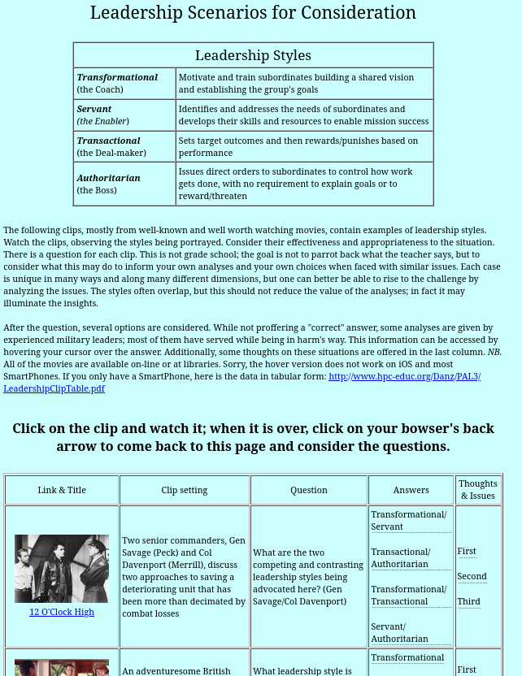
Figure 1 Screen Capture of training aid using clips from Motion pictures

A little more detail is provided in the following images and comments.

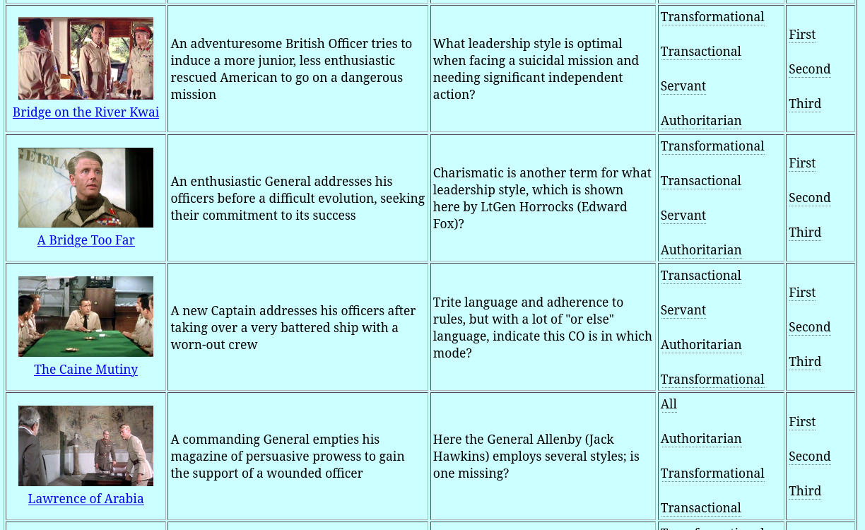

Figure 2 Screen Capture Close up of selected examples of concept entries

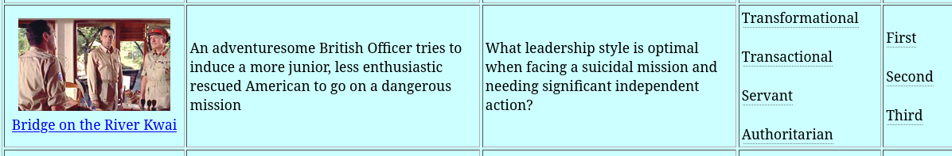
Figure 3 Screen Capture Close up of detail example of concept entry

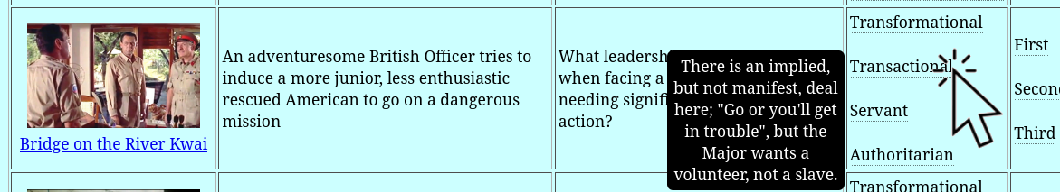
Figure 4 Screen Capture Close up of detail example
with mouse hover on one selected answer with guess analyzed.

However, several studies and anecdotal evidence have surfaced that reinforce the ability of carefully constructed and realistically presented simulated combat has produced both measurable and actual combat success results. It is the authors experience that a carefully constructed battlefield scenario that is presented in a sufficient fidelity to engage the user will an emotional and competitive “buy-in” that will come as close to live combat as possible. To support that contention, one of the authors once had to physically interpose himself between two opposing (one red team; the other blue team) participants in a simulation exercise to prevent them from coming to blows. It is in just such times when stress is severe and emotions are high that the constraints are most in danger of failing. Flowing from that is the main thesis of this paper: US DoD simulation efforts should include ethical issues and capture observed behaviors for later analysis and counseling.

  - Other Professions’ Approaches

It is deemed useful and prudent to consider how other professions define and train for such issues. The three that are covered here are: Medicine, Police and Law

Medical Ethics

The American Medical Association has adopted the following articulation of ethics [Riddick, F. A. (2003). The code of medical ethics of the American Medical Association. Ochsner Journal, 5(2), 6-10.], example excerpts of which are shown below.:
- A physician shall be dedicated to providing competent medical care, with compassion and respect for human dignity and rights.
- A physician shall uphold the standards of professionalism, be honest in all professional interactions, and strive to report physicians deficient in character or competence, or engaging in fraud or deception, to appropriate entities.
….
IX A physician shall support access to medical care for all people.

These are taught in all accredited medical schools in the US and are requisite portions of continuing medical education is the United States. Instruction is almost entirely by lecture. Like military ethics, in medicine, more than reputation and monetary values are commonly at stake: lives and limbs hang in the balance and mistakes often cannot be rectified later. There is a similar code for the profession of nursing, promulgated by the American Nurses Association [https://nursing.rutgers.edu/wp-content/uploads/2019/06/ANA-Code-of-Ethics-for-Nurses.pdf]. Its short form contains nine provisions and is more completely fleshed out in a 252 page Guide to the Code of Ethics for Nurses: With Interpretive Statements: Development, Interpretation, and Application which is taught in BSN programs as part of ethics education. [American Nurses Association. (2001). Code of ethics for nurses with interpretive statements. Nursesbooks. org.]

Police Ethics

The police Code of Ethics is issued by the International Association of Chipefs of Police [https://www.theiacp.org/resources/law-enforcement-code-of-ethics]. It it short enough to be shown here in its entirety:

Law Enforcement Code of Ethics

“As a law enforcement officer, my fundamental duty is to serve the community; to safeguard lives and property; to protect the innocent against deception, the weak against oppression or intimidation and the peaceful against violence or disorder; and to respect the constitutional rights of all to liberty, equality, and justice.

I will keep my private life unsullied as an example to all and will behave in a manner that does not bring discredit to me or to my agency. I will maintain courageous calm in the face of danger, scorn or ridicule; develop self-restraint; and be constantly mindful of the welfare of others. Honest in thought and deed both in my personal and official life, I will be exemplary in obeying the law and the regulations of my department. Whatever I see or hear of a confidential nature or that is confided to me in my official capacity will be kept ever secret unless revelation is necessary in the performance of my duty.

I will never act officiously or permit personal feelings, prejudices, political beliefs, aspirations, animosities or friendships to influence my decisions. With no compromise for crime and with relentless prosecution of criminals, I will enforce the law courteously and appropriately without fear or favor, malice or ill will, never employing unnecessary force or violence and never accepting gratuities.

I recognize the badge of my office as a symbol of public faith, and I accept it as a public trust to be held so long as I am true to the ethics of police service. I will never engage in acts of corruption or bribery, nor will I condone such acts by other police officers. I will cooperate with all legally authorized agencies and their representatives in the pursuit of justice.

I know that I alone am responsible for my own standard of professional performance and will take every reasonable opportunity to enhance and improve my level of knowledge and competence.

I will constantly strive to achieve these objectives and ideals, dedicating myself before God to my chosen profession… law enforcement.”

The authors note that this code is the only one they reviewed that is stated in the first person singular and that mention a deity in the text, raising a more challenging philosophical question as to the relationship of role of faith in a god in the formation of ethics or the swearing of an oath. This code is taught at most Police Academies and is commonly posted in police department offices. The authors have seen it recited by the new officers who are being sworn-in at their badging ceremony, in the presence of the badging authority and invited guest.

Legal Ethics

The American Bar Association promulgates their Model Rules of Professional Conduct in a document that covers 85 Rules and uses 272 pages to fully discuss them. The Supreme Courts in every jurisdiction have adopted some form of these ethics. Law schools require an entire course in legal ethics. The issues covered are complex and sometimes difficult to parse, e.g. the very complex issues of how much effort and what kinds of tactics are legal when giving adequate representation to which a criminal client is morally and constitutionally entitled, while at the same time not violating an officer of the courts obligation to uphold the law. After admission to the bar, all lawyers must complete annual continuing legal education that must include ethics issues. The Bar Exam administered in by the cognizant Supreme Court usually contains at least one ethics issue that must be identified and analyzed. Contrary to commonly held misconceptions, courses in legal ethics to not focus on basic honesty, but on the complex conflicts that may catch the practicing attorney unawares.

Here is a sample of the rules: Rule 4.4
“Respect for Rights of Third Persons
Transactions With Persons Other Than Clients
(a) In representing a client, a lawyer shall not use means that have no substantial purpose other than to embarrass, delay, or burden a third person, or use methods of obtaining evidence that violate the legal rights of such a person.
(b) A lawyer who receives a document or electronically stored information relating to the representation of the lawyer's client and knows or reasonably should know that the document or electronically stored information was inadvertently sent shall promptly notify the sender.”

[Model Rules of Professional Conduct, (2023). Retrieved from the internet from https://www.americanbar.org/groups/professional_responsibility/publications/model_rules_of_professional_conduct/model_rules_of_professional_conduct_table_of_contents/]

  - Impact of Other-Field Experience on Military Ethics Training

All of these systems have had significant impact on the ethics, ethical awareness and professional behaviors of the involved communities. Nothing in this paper should be taken to be a manifest or latent criticism of those efforts. Instead, it is an acknowledgment of the special stress and invariable loss of members of tightly-knit combat teams. There are approximately 800,000 sworn officers in the US. In 2022, 120 lost their lives in the line of duty, about half of whom were killed by felonious assaults by assailants, the rest from accidental deaths. That means a year of active police work resulted in about one chance in 6,300 of dying on duty. The average year of combat in the Vietnam was resulted in one in 50 dying there. Three men in one of the authors’ boot camp platoon of 44 were dead within 12 months of graduation and two of the 50-man unit with he served, died during his one-year tour there. This is a pressure that exceeds that of the other fields by ten times. Even a 25-year police career does not come within an order of magnitude of that faced by the average warfighter in Vietnam in one year.

That kind of pressure requires a very deep level of awareness of ethical imperatives and manifest rational command to enforce the Laws of War when the pressures of combat destroy all but the most imminent issues be addressed with each human’s limited cognitive resources. Therefore, the authors assert that even more engaging training be considered, implemented, and repeated so that it will be instantiated practice and be effectively operational, even in the most desperate of circumstances. Various observations of the authors and a few studies have shown that well-designed and administered battlefield simulations to emulated the physiological reactions of those in combat to some degree.

- Issues Related to Incorporating Ethical Training and Evaluation in Simulated Scenarios

A number or questions arise when the inculcation of more stress-resistant ethical behavior in warfighters. These will be addressed below, with the caveat, the analyses are based mainly on the authors’ life experience in the military, medical professions, and police work.

  - Should simulations contain ethicality components of battlespace modeling?

As

  - Should ethical quandaries be included in combat training exercises?

L

  - Should ethical quandaries be included in combat training exercises?

As

  - Where does culpability lie if AI makes a morally important decision on the application of deadly force?

As

- Analysis
As

- Conclusions
Ed

- Acknowledgements

The authors wish to thank all of the simulation professionals with whom they have worked over the last three decades. This discipline is blessed with a fine group of creative and productive career scientists. We should also note that much of the work cited was supported by grants from the Office of Naval Research's STEM Program (ONR N00014-16-1-2820) and by research assistants supported by the National Science Foundation Research Experience for Undergraduates program (NSF 1560426). Nevertheless, the positions taken in the paper are the authors’ own and do not represent in any way the views of the Department of Defense or the US Government.

- References

- Hublin JJ, Ben-Ncer A, Bailey SE, Freidline SE, Neubauer S, Skinner MM, et al. (June 2017). "New fossils from Jebel Irhoud, Morocco and the pan-African origin of Homo sapiens" (PDF). Nature. 546 (7657): 289–292
- Marean, Curtis; et al. (2007). "Early human use of marine resources and pigment in South Africa during the Middle Pleistocene" (PDF). Nature. 449 (7164): 905–908.
- BBC, 2003. When Humans faced Extinction. British Broadcasting Corporation, Retrieved from the internet on 22 Dec 23 via: http://news.bbc.co.uk/2/hi/science/nature/2975862.stm
- Scarre, Chris (2018). "The world transformed: from foragers and farmers to states and empires". In Scarre, Chris (ed.). The Human Past: World Prehistory and the Development of Human Societies (4th ed.). London: Thames & Hudson. pp. 174–197
- Assmann, Jan (2003). The Mind of Egypt: History and Meaning in the Time of the Pharaohs. Cambridge, MA: Harvard University Press.
- Lynch, John Patrick (1972). Aristotle's School; a Study of a Greek Educational Institution. Berkeley: University of California Press.
- Brickhouse, T. C., & Smith, N. D. (1990). Socrates on trial. OUP Oxford.
- World Data, (2022) Primary school enrolment, World, 1970 to 2016. Retrieved from the internet on 06 Dec 23 via URL: https://ourworldindata.org/grapher/primary-school-enrolment-by-sex
- World Bank, (2021). Learning Poverty. Understanding Poverty Project. Washington, D.C., USA
- [Davis, D.M. (2023). Oral Comment on Teacher Ratings, Professor O.J. Harvey, University of Colorado, Boulder, Colorado. 1972. No source cited.
- Brosan, L., Reynolds, S., & Moore, R. G. (2008). Self-evaluation of cognitive therapy performance: do therapists know how competent they are?. Behavioural and Cognitive Psychotherapy, 36(5), 581-587.
- Christensen, C. M., & Eyring, H. J. (2011). The innovative university: Changing the DNA of higher education from the inside out. John Wiley & Sons.
- Lawrence, M. (Director/Writer). (2015). The Rewrite [Film; DVD release]. Castle Rock Entertainment.
- Dietz-Uhler, B., & Hurn, J. E. (2013). Using learning analytics to predict (and improve) student success: A faculty perspective. Journal of interactive online learning, 12(1), 17-26.
- LAK 11 (2011). Learning and Analytics Conference, 2011. Alberta Canada. Retrieved from the internet on 17 Dec 22, from URL: http://www.wikicfp.com/cfp/servlet/event.showcfp?eventid=11606
- Peng, S., Cao, L., Zhou, Y., Ouyang, Z., Yang, A., Li, X., ... & Yu, S. (2022). A survey on deep learning for textual emotion analysis in social networks. Digital Communications and Networks, 8(5), 745-762.
- Davis, D.M. (2023). The Mentor –Pal Project. Insitute for Creative Technologies, USC. Retrieved from a project web site on the internet on 20 Dec 23 from: http://www.hpc-educ.org/MentorPal/Web/MntPal_Index.html
- Hackett, G., & Betz, N. E. (1995). Self-efficacy and career choice and development. Self-efficacy, adaptation, and adjustment: Theory, research, and application, 249-280.
- Naik, H., Dedhia, S., Dubbewar, A., Joshi, M., & Patil, V. (2022, August). Myers Briggs Type Indicator (MBTI)-Personality Prediction using Deep Learning. In 2022 2nd Asian Conference on Innovation in Technology (ASIANCON) (pp. 1-6). IEEE.
- Smalley, G., & Trent, J. (2019). The two sides of love. Focus on the Family.
- Dimmitt, C. (2009). Why evaluation matters: Determining effective school counseling practices. Professional School Counseling, 12(6), 2156759X0901200605
- Parisi, G. I., Kemker, R., Part, J. L., Kanan, C., & Wermter, S. (2019). Continual lifelong learning with neural networks: A review. Neural networks, 113, 54-71.

Author Biographies

DAN M. DAVIS, CDR, USN, Retired is a Research Associate Professor at Catholic Polytechnic University (CPU) and is also active as a consultant at the Institute for Creative Technologies, University of Southern California (USC). He is currently focusing on large-scale DoD simulations and virtual human implementations. Prior to retirement, he was the Director of the JESPP project at USC for more than a decade. As the Assistant Director of Advanced Computing Research at Caltech, he ran Synthetic Forces Express, helping to bring HPC to DoD simulations in the 1990’s. He has also served as a Director at the Maui High Performance Computing Center and in computer research roles at the Jet Propulsion Laboratory and Martin Marietta. He was the Chairman of the Coalition of Academic Supercomputing Centers and has taught at the undergraduate and graduate levels. As early as 1971, Dan was writing programs in FORTRAN on one of Seymour Cray’s CDC 6500’s. While in the Marine Corps, he saw duty in Vietnam as a Cryptologist and retired in 2002 as a Commander, U.S.N. He received B.A. and J.D. degrees from the University of Colorado in Boulder.

JENNIFER H. NOLAN, PH..D. is the President of Catholic Polytechnic University and Professor of Psychology in their College of Arts and Sciences. Her earlier work specialized in memory, dementias, stroke and insulin resistance. She is a brain plasticity specialist and certified Cogmed provider. Previously, she was the C.O.O. and co-founder of a stroke and brain injury rehabilitation center. Dr. Nolan has taught university courses at the University of California Irvine, Loyola Marymount University, and Glendale Community College. She has conducted local and nationwide clinical trials, and published in both scientific journals and popular magazines. She received a BA in Psychology from Loyola Marymount University, Los Angeles and a Ph.D. in Neuro-Psychology from the Dept. of Cognitive Science at the University of California, Irvine.

MARK C. DAVIS, PH.D. is the Chief Technical Officer at Wood Duck Research, Inc, and is semi retired after careers in the US Navy and as a computer design engineer for both IBM and Lenovo. Rising to the level of Distinguished Engineer at Lenovo, he was responsible for the design of laptop computer cross-disciplinary technology, including PC architecture, embedded systems, open source and virtualization. Previous work was with IBM in the areas of software development and architecture involving security, storage and virtualization. Dr. Davis has been granted well over fifty patents that were filed during his service at both companies. He is a graduate of the Duke University NROTC program and was commissioned as an Ensign, attended nuclear power school, and served as a Submarine Officer for twelve years, including one duty tour as a classroom instructor. He left the active duty as a Lieutenant Commander to pursue a PhD. Mark holds a BSEE degree from Duke University and a PhD in Computer Science from the University of North Carolina, Chapel Hill, where his advisor was Professor Fredrick P. Books.

Robin G. Bitterlin is retired from surgical nursing. She is associated with Wood Duck Research, Inc as a Research Ethics Advisor and Consultant. Her research interests focus on Medical Ethics as shaped by theological precepts and daily professional practices. She has management experience in the field of commercial real estate development. Her professional life experience includes serving as a Registered Nurse (RN) Supervisor for operating rooms and school nursing. Robin earned a B. S. Degree in Health Sciences from the University of California Davis and then earned an additional B.S.N. degree from Mount St. Mary’s College in Newburgh, New York.

JUDITH L. JACOBUS is retired from conducting speech therapy as a Speech and Language Specialist for more than two decades. Her experiences were in public schools settings in Orange County. California. She also previously taught for 12 years as a classroom teacher in multi-cultural communities there. Judith currently volunteers her professional skills for a local police department, so has extensive experience with dysfunctional adults and children in a variety of both every-day and traumatic situations. Her participation in amateur theatrics has more fully familiarized her with the characteristics of human behavior as they are projected via verbal, facial and body-language cues. This experience has also exposed her to the skill and art of the selection of appropriate persons for specific on-screen roles. Judith holds a lifetime Special Education Credential in Speech and Hearing Therapy, K-12 from the State of California. She earned a B. A. Degree in Speech Communications from the California State University Long Beach and an M. A. Degree in Teaching and Teacher Leadership from the Grand Canyon University in Glendale, Arizona.

