Authors must submit this release prior to presenting the content of their paper or presentation at the 2023 SIW. Additionally, papers cannot be published in our online proceedings without this release form on file.

Paper/Presentation #: _____2023-SIW-011________

Title: __ Military Writing in Simulations and Operations:___________________

___ Establishing Metrics and Standards _________________

__________________________________________________________

Authors: __Dan M. Davis, Jennifer H. Nolan, Mark C. Davis, & Judith L. Jacobus

____ _____________________________________________________

__________________________________________________________

The above paper and/or presentation prepared for the 2023 Simulation Innovation Workshop (SIW) is approved for unlimited release (including to foreign nationals) and may be published by SISO in both print and electronic form.

Name: ___Dan M. Davis____________________________________________

Position: ___Research Associate Professor______________________________

Organization/Company: __Catholic Polytechnic University___________________

Telephone: ____1-310-909-3487_________________________________________

Email: ____ddavis@catholicpolytechnic.org__________________________________
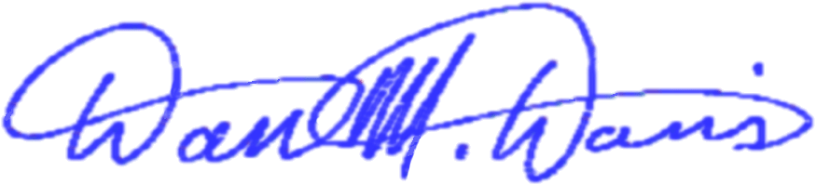
Signed: __________________________ Date: ______ 27 Jan23_________

