Addressing Misconceptions in Career Selection:
Research-based Implementations for STEM Students

Dan M. Davis & Jennifer H. Nolan | Karen B. Predovich | Judith L. Jacobus
Catholic Polytechnic University | Academic Counselor  career Counselor | Speech & Language Therapist
Pasadena, California | Cañon City, Colorado | Seal Beach, California
{ddavis & jnolan} @catholicpolytechnic.org | predovichk@gmail.com | jjacobus@hpc-educ.org

ABSTRACT

This paper discusses the response to the lack of solid informational foundations on which students can make important decisions: what college majors and career paths to pursue. Shortfalls are described in STEM professionals needed to support DoD objectives for the defense of the nation. The major issues are lack of exposure to practicing professionals, reliance on fictional portrayals of professions, and assumptions most professionals make that everyone knows what their daily activities are. The authors report on their recent project prototyping a computer agent for mentoring students about STEM careers. It was observed that high school seniors not only lacked detailed knowledge of the STEM professions, there was an almost total lack of comprehension of major parameters that defined defining fulfilling careers. The adolescents were focused on theatrical stereotypes of the professions and on dreams of a fanciful work experience. The paper then outlines the work on the virtual mentor and explains the dichotomy between the data conveyed and the impact on the students. Next, a program is outlined to ameliorate the missing reasoned framework and to fill the gap between the questions they should have asked and what they really asked. The emerging technologies enabling such an effort are identified. Other researchers' efforts and findings and the local team's insights are adduced to support the paper's thesis that this effort is vital for both this issue and extensible for other projects using the computer/human interfaces. The choices of appropriate metrics are considered and analyzed.

ABOUT THE AUTHORS
Dan M. Davis, CDR, USN, Ret. is a Research Associate Professor at Catholic Polytechnic University and is active as a consultant at the Institute for Creative Technologies, University of Southern California (USC), focusing on large-scale DoD simulations and avatar uses. Prior to retirement, he was the Director of the JESPP project at USC for a decade. As the Assistant Director of Advanced Computing Research at Caltech, he ran Synthetic Forces Express, bringing HPC to DoD simulations. He also served as a Director at the Maui High Performance Computing Center and in computer research roles at the Jet Propulsion Laboratory and Martin Marietta. He was the Chairman of the Coalition of Academic Supercomputing Centers and has taught at the undergraduate and graduate levels. As early as 1971, Dan was writing programs in FORTRAN on one of Seymour Cray’s CDC 6500’s. While in the Marine Corps, he saw duty in Vietnam as a Cryptologist and retired in 2002 as a Commander, U.S.N. He received B.A. and J.D. degrees from the University of Colorado in Boulder.
Jennifer H. Nolan, PhD, is the President of Catholic Polytechnic University and Professor of Psychology in their College of Arts and Sciences. Her earlier work specialized in memory, dementias, stroke and insulin resistance. She is a brain plasticity specialist and certified Cogmed provider. Previously, she was the C.O.O. and co-founder of a stroke and brain injury rehabilitation center. Dr. Nolan has taught university courses at the University of California Irvine, Loyola Marymount University, and Glendale Community College. She has conducted local and nationwide clinical trials, and published in both scientific journals and popular magazines. She received a BA in Psychology from Loyola Marymount University, Los Angeles and a Ph.D. in Psychology from the Dept. of Cognitive Science at the University of California, Irvine.
Karen B. Predovich, MA continues to consult in educational matters after retiring as a long-time high school counselor for pre-college students in a modestly sized Colorado city. She was active in her professional life in finding assets for students outside of major metropolitan areas, where professional role models and mentors are very difficult to locate. Her observations have resulted in a professional stance of articulating the need for and the parameters of a new approach to guidance counseling on a national basis. Karen has focused decades of her counseling in characterizing the difficulties of finding technically oriented mentors in geographically remote or socially isolated areas. She received a BA and an MA in Guidance and Counseling from Western Colorado University (formerly Western State College of Colorado.)

Judith L. Jacobus, MA is retired from a career of conducting speech therapy as a Speech and Language Specialist for more than two decades. Her experiences were in public schools settings in Orange County. California. She also previously taught for 12 years as a classroom teacher in multi-cultural communities there. Judith currently volunteers her professional skills for a local police department, so has extensive experience with dysfunctional adults and children in a variety of both every-day and more traumatic situations. Her participation in amateur theatrics has more fully familiarized her with the characteristics of human behavior as they are projected via verbal, facial and body-language cues. This experience has also exposed her to the skill and art of the selection of appropriate persons for specific on-screen roles. Judith holds a lifetime Special Education Credential in Speech and Hearing Therapy, K-12 from the State of California. She earned a B. A. Degree in Speech Communications from the California State University Long Beach and an M. A. Degree in Teaching and Teacher Leadership from the Grand Canyon University in Glendale, Arizona.

Addressing Misconceptions in Career Selection:
Research-based Implementations for STEM Students

Dan M. Davis & Jennifer H. Nolan | Karen B. Predovich | Judith L. Jacobus
Catholic Polytechnic University | Academic Counselor  career Counselor | Speech & Language Therapist
Pasadena, California | Cañon City, Colorado | Seal Beach, California
{ddavis & jnolan} @catholicpolytechnic.org | predovichk@gmail.com | jjacobus@hpc-educ.org

INTRODUCTION

The thrust of this paper is the emerging capabilities of computers to augment humans in the areas of therapy and counseling may be effective in countering the often negative way in which STEM students are perceived by their peers and by themselves. Current efforts to achieve this result are identified and evaluated. The need for such study and the future impacts of not meeting that need are considered. A brief review of the emerging technologies that may provide a way forward is given, but the authors do not favor or support any of these. The position taken is that several approaches may have unique niches in which they would be useful. A range of technologies, methodologies and metrics are surveyed and their potentials are listed. Potential impacts are discussed and metrics for measuring them are detailed and considered. The hurdles and potential pit-falls are also laid out. Time frames and competing demands on resources are recognized. The theses are there is a problem which is the projected shortfall in capable STEM professionals, some causes are observed, and that emerging technologies may ameliorate the impact of those negative forces.

The paper begins with the background of the issues of STEM student procurement and the difficulties that arise in that process. This delineation features both statistical data and personal anecdotal experiences. A few external factors that may play heavily in this evolution are suggested. A brief introduction into some of the technologies that may be effective is outlined. Then the paper turns to an analysis of the "stakeholders" in the issues identified. The potential implementations will be presented in enough detail to allow the reader to analyze their own situations with an eye toward the use of the technologies and techniques advanced or to start their own initiative to use capabilities of which they are aware to better meet the challenges presented. Included is a treatment of the benefits of a multi-disciplinary approach to all of these issues. A section is then given over to metrics. This is followed by an over-arching consideration of the problems and emerging technologies potentials in resolving them. Conclusions are recorded to close out the paper.

BACKGROUND

It is often good advice to consider the past when looking at current problems. For approximately 250,000 years humans have existed as Homo Sapiens on the planet. During the first 235,000 years, career choice was not a Darwinian selector. Successful societies had structures in which men took the arduous and dangerous jobs of hunting and defending the group; women focused on child bearing, rearing and gathering of food stuffs. Societies that reversed those goals did not persist, as the loss of females constrained the birth rate, while the loss of males did not. Around 15,000 years ago, humans began to organize, grow grains, and build settlements. That led to some specialties, but still the vast majority of men were hunters or farmers and the vast majority of women were child care workers and "domestic engineers." The industrialization of the civilized world began perhaps three millennia ago. But the trend became almost invariable; a person followed the career of their parent of your gender, with men largely farming and women bearing and raising children. It was really only about 200 years ago that such traditions began to lose their grip on a person future. Since that time there has become a gradual move away for family channeled career choice, for both genders (Furstenberg, 1966).

That means that for about a million and a quarter generations, people lived their lives immersed in the same endeavors as the parent of their own gender. They learned those skills by assisting the parent and observing their mastery of the parents' duties. The men may have had some periods of peace punctuated by warfare, and for the last several millennia, standing armies employed some on a full-time basis. After the fall of Rome, some more advanced traditions began to emerge: in Europe the oldest son of a noble family was expected to manage, then inherit, the family estate, the second son would join the church, and the later sons would seek fame and fortune in the military. Daughters would be married off in the way that best impacted the family as a whole. Romantic marriage was unknown. In each of these cases, career choice was non-existent and social mobility was extremely limited, but is recorded in cases of military achievements.

In the Western World, most of these directing institutions fell away as the 19th century progressed. The World Wars of the first half of the 20th Century accelerated this process for both genders. Farmers' sons were pulled from their homes and became ship builders and pilots; mid-western daughters abandoned their kitchens and became airplane assemblers and cryptologists. Both travelled to the literal "ends of the earth." The ratchet of societal change tends to resist the members from going back to the way things were. The accelerating technical foundation of the economy produced a range of career choices that would have left people of a century before completely awestruck and dumbfounded. Concomitantly, the exacting nature of the work and the need for specialized equipment and locations meant that children were not exposed to the work their parents did outside of the home.

All of these factors led to the western societies producing young adults who had very little notion of what their parents did or what other choices there were in career paths. An informal poll was conducted among the High School students in La Ca$ñada$ California, which is adjacent to Caltech's Jet Propulsion Laboratory. The students were asked: "What do your parents do when they are at work?". Not one of the student queried could cogently report on what either their Father or their Mother did at work, only being able to give their job title. About half could not even describe the work place environment in which their parents spent 2,000 hours every year. Some had participated in "Bring your child to work days.", but had only memories of non-germane activities, e.g. "I got to make a Xerox copy of my face.". However, when queried as to professions, all had very certain impressions of which were attractive and which were to be avoided. That begs the question: "Where do they get these impressions?".

Without seeking funding to do a more reliable and reportable study on what shapes the students' zeitgeist, a few anecdotal observations can be offered. When probed s to their impressions, many of the high school students made references to dramatic characters, mostly those appearing in TV shows, but a few emerging from the film repertoire. This blending of fiction with reality was further confirmed when the discussion turned to the opportunities of practicing physicians to do creative medicine and organize innovating research. One student said that dramatic and innovative medicine was common, noting "Look at the doctor on 'House'.". Another told one of the authors, who worked at Caltech for a decade, that no student wanted to be like the characters on "The Big Bang Theory." Think of the issues that causes when the major source of information is the dramatic arts.

When one of the co-authors was still working only 20% of students needed a bachelor's degree or higher to qualify for a reasonable career. Now that requirement has grown to about 35%. The highest percentage of open positions were for skilled workers who had vocational training, through community college certificate programs, apprenticeships, on the job training, associate degrees or military training. A lower number of desirable careers did not require anything above a high school diploma; fewer still would accept drop-outs. Even many otherwise accessible jobs are requiring a high school diploma or GED, e.g. after the poor performance of the McNamara's Project 100,000, it is very difficult to enlist in the US Military without such proof of academic achievement (Dawson, 1995). Most all of those no-diploma/drop-out jobs were among the lowest paying.

During this time, many parents, educators, and counselors put a lot of pressure on high school students to go into a four-year college program The bachelor's degree was seen as the ticket to success. Then there was a time period when a student with his college degree in hand could not get a job and some had to go back and work in their high school job doing menial labor. This was sometimes a function of the choice of a major that was not in high demand in the work force. This paper makes no moral judgment on the desire of some students to focus on non-career oriented majors, but it is regrettable if the student does not recognize that a focus on an esoteric topic and an academic record on a low demand skill set, may not satisfy employers in a competitive job market.

When the job market changed these students may have found better paying jobs, but the majority had burdensome student loans to pay. It was observed that there were many who felt that they "had" to go to a four-year college but really did not know what they wanted to do and many would eventually drop out with a student loan to pay off. As counselors, the high school staff members would try to encourage those students who had a creditable plan, as well as the motivation and aptitudes to be successful, to attend college. As an example, there was a talented student who loved carpentry and didn't want to go on in an academic environment, but the counselor found a school that offered construction management as a major and the student successfully pursued that. Another student was being pressured by her family to attend their alma mater, but she struggled academically and had little interest doing so. What she wanted was to be a cosmetologist. She went to a school for that and picked up some business classes and now she owns her own beauty shop and is doing well. This is why it is so important to offer students, especially from rural areas, many opportunities to explore jobs and careers and most importantly, the educational opportunities that are available. They should be exposed to four year colleges, community college, apprenticeships, the military and "on the job" training, as may best befit them. They need to be aware of the costs of the programs as well as the expected salaries. Many counselors try to impress on the students to follow their passion. "

It is also extremely important that they and their parents understand the whole Financial Aid story. Many of the indigent will borrow as much as they can and the parents will get loans also. The government makes it all so easy to borrow the money without much counseling about the students' have to paying the loans back. They had "free" money, so they are inclined to live well as a college students and not similarly induced to create good budget discipline. As they entered young adulthood that loan has became a yoke around their necks. We have heard all the whining from today's young graduates who want the government now to pay their student debt.

The rising cost of tertiary education is another major factor. The price tag is exorbitant, as some of the colleges and universities have added so many amenities to the college campus life, that perhaps a student might lose sight of why they are there. Some students will choose a school based on the these extracurricular attractions, rather than focus on the academic programs.

The nature of those misconceptions is not a trivial matter. Were they fairly distributed, that might not have such a bad effect, but they are driven by a number of forces that make them destructively misleading. Some of these forces are guided by the requirements of the media, e.g. action must be exciting and dangerous. This leads to many commonly held misconceptions:
Table 1 Common misconceptions mentioned by subjects
Fiction-base concepts | Quantified Data Reality
Soldiers spend all their time shooting people | Only 25% of US soldiers are in combat arms units and only half actually can fire weapons, fewer still, actually do so
Lawyers spend all their time in court | The average for all lawyers is in court about 10% of the time, but the range varies greatly; many never go to court
Police are often engaged in gun fights | Policeman have about one chance in 8,000 of firing their weapon in any given week; 75% never fire a weapon in their entire career
Intelligent people have poor social skills | A study found that social skills, evaluated by others, showed a strong positive correlation to IQ; anomalies create the stereotypes
Many criminal defendants are innocent  NB: Perry Mason never had a guilty one | One defense attorney reported that he did not have any innocent clients in his entire career. Estimate: 1 in 2,000 are really innocent

Another issue is the bias of the creators of the media. Each profession attracts, for good or for ill, certain archetypes of personnel. Unlike juries that must be drawn from a population in a way that best represents the community, being successful in the media may tilt toward people with certain skills. Many have the ability to tell a story; many have a story to tell. With the exception of the aforementioned Frank Capra (Caltech, class of 1918), most entertainment producers were not adept in advanced mathematics, hard sciences and engineering. This group's memory of those topics in secondary and tertiary education environments may have been uncomfortable. The question raised here is whether this has led to the frequent portrayal of STEM professionals as villains, mad scientists or comedy relief misfits. An issue not addressed here is the potential impact on society of a bias of any kind in the major communications professional communities, but this paper takes positive approach: that of considering how to present the most accurate and even view of professional choices so as to benefit the individual person and to reduce needless wastes for society.

Sampling of factors that may separate the student from the truth about careers:
- Uncommunicative professionals
- Geographical separation between student and professionals
- Student focus on high school social environment
- Time constraints on both student and professionals
- Attractiveness of remaining in a dream-world rather than face reality
- Lack of education concerning critical thinking

Another finding of the MentorPAL researchers is that the students had no frame of reference for making an optimal selection. When offered the chance to ask both live and virtual mentors questions, they asked either self-centered reaffirming questions about their own dreams (e.g. an intelligence analyst was asked: "Did you kill anybody in Vietnam".) or nonsensical questions of the virtual mentors (e.g. a MentoPal was asked: "How high is Mt. Kilimanjaro?".) Meeting the students where they are and drawing them into thinking rationally about the future is critical to the goal of improving career choices. This suggests some kind of introductory setting of issue might be useful for the students, such as a significant discussion of the issues that may be important such as the below:

Issue of Consequence to Career Selection:
- Work physical environment  (Office? Out-doors? Lab? Vehicle?)  - Colleague characterization  - Work schedule  - Travel required  - Compensation  - Advancement  - Danger/health hazards | - Personnel turnover rates  - Typical day activities  - Public regard for profession  - Work/family balance  - Socializing outside of work  - Resonates with personal passion  - Mirrors personal hobby parameters  - …???

Shortfalls in STEM professionals
Up to this point, the short fall of STEM professionals has be taken as a given, but the paper would be remiss without giving some support to the contention. The complicating factor in the matter may be the anecdotal reports of STEM personnel having trouble finding work. Some of this may be the fact that such personal reports are more emotionally arresting, but statistically the unemployment rate among STEM employees is typically about half of what the unemployment rate among non-STEM occupations is (BLS, 2020b). Some of the unemployment is just the friction of the job changes, the hesitancy to move to where jobs are available, professional obsolescence or career
mismatch leading to poor performance or desired to find new profession.

The defense of the nation depends to a large degree on a vital body of technically trained persons, but the Bureau of Labor projects shortfalls of tens of thousands per year in these fields. Other data suggest that less than half of the population are capable of doing the math necessary for this type of work, and worse yet, that more than half of that half have little, if any, interest in a technical career. Without informing and motivating the ‘capable but uninterested’ segment of our society, we have little chance of filling our needs. Notwithstanding efforts by career counselors to provide information to K-12 students about Science, Technology, Engineering, and Mathematics (STEM) careers, the students do not know what STEM professionals do on a day-to-day basis, what education is needed, or what STEM fields exist. This prevents many students from underrepresented populations from entering STEM disciplines, since students opportunities are impacted by their science and mathematics achievements as early as high school.

Table 2 Bureau of Labor Statistics 2020 Projection of STEM Needs. [BLS, 2020]
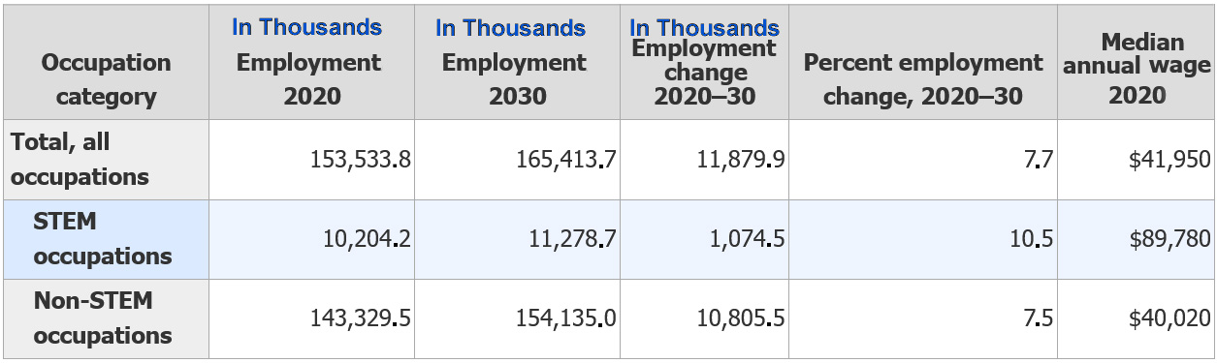

It is said that a picture is worth a thousand words; the above table shows a projected need for 1,074,500 new STEM professionals by 2030, shows a growth level of about one and a half of the rest of the economy and a pay rate of more than twice than that of the less technical occupations. Several sources also noted that just funding and issuing more degrees in STEM subjects is not the solution required. These sources, who are naturally disinclined to be identified, already hold that some STEM degreed personnel are not capable of doing the quality of work required. These sources report experience has shown them that only graduates from the most selective Universities are able to perform at the level needed to complete the tasks for which they have been hired. This further emphasizes the need to attract, recruit, retain and graduate the most competent professionals

In summary, if the community at large needs more STEM professionals, but problems of supply prevail due to marginal performers selecting STEM education, qualified but misinformed students picking other programs, and attractive programs, and potentially productive engineering students dropping STEM training, a new approach may be in order. The military in the democracies and the population in the totalitarian systems can just order the best and brightest into the STEM fields; that option is not viable in the Western Cultures. Current methodologies have not had much impact.

Major Concerned Entities
When considering a new initiative, the entities that may be impacted should be identified and analyzed. The sorts of entities that a program such as envisioned above are identified below and a few brief comments made about their involvement to their anticipated reactions to potential impacts from the program

Students
The students may be the most difficult to assess in both receptivity and in impact. Live mentors report a consistent lack of responsiveness from this age group. Some of it may be explained by the previously discussed lack of context in which to discuss these matters, some may be due to the "generation gap," and so

Educators
They will want to best students they can attract. The initiative could use this emerging technology to convey the great potential of graduating STEM professionals that will go ahead and make news with successful new products that will bring the Universities recognition, funding and even better students (Sample, 2003).

Employers
The consumers of STEM graduates are already clamoring for new, better, reliable and security clearable students.

Individual Citizens
Even those not directly engaged need the technology; the employers cannot produce the quality of life sought to the populace without the STEM workers. It is conjectured the employers would be happy to produce videos portraying the exciting work they are doing and how fun and fulfilling it is to work on their projects.

Society at Large
The community whence the students come is filled with people with direct concerns for family members and acquaintances for whom they wish to provide a robust and productive education. The society also is a major funder of that education K-12 and tertiary studies, so they have a vested financial interest in how their funds are being expended. Finally, the society depends on advanced technologies to solve the problems that face the nation and the world. That technology literally may live or die in the hands of the students of today who will become the STEM professionals of tomorrow.

A Virtual Mentor Project: MentorPAL
As an example of how a virtual mentor could provide high-quality assistance, below you will find a brief discussion of a project funded by the Navy to provide global and all day mentoring to enlisted and commissioned officer personnel. This program has been field tested and validated (Nye et al., 2020). The MentorPal team is leveraging USC's experience in natural language processing to create computer enabled virtual mentors to address these issues. Optimally, students isolated by Socio-Economic Status (SES) or geography can have 24 by 7 access to a computer-generated MentorPal. Guidance counselors and teachers would be able to easily organize activities such as career fairs, where every student could talk with representative STEM role models, both live and virtual. Research has shown that such activities are highly effective for increasing awareness of, motivation for, and engagement in STEM careers. However, individual counselor and group job fairs do not scale well: professionals have limited time, and those who do volunteer will tend to be connected to the school. MentorPals could always be available for such events and for individual counseling.

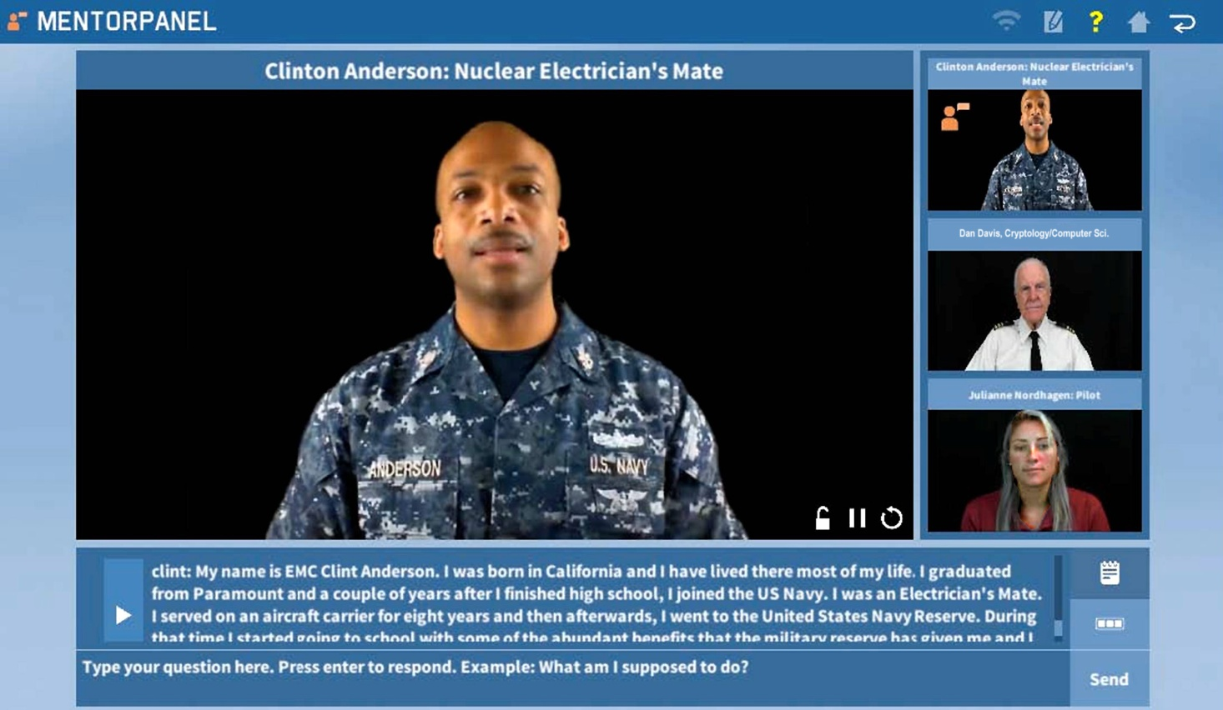
Figure 1 The Mentor Panel allows the user to choose the mentor or to sample all the mentors' responses.
The image above is a screen capture of MentorPal as it is manifest in its local implementation, to be displayed on a tablet, a laptop or a desktop. As now instantiated, it accesses some of its utilities from the web, but those could also be downloaded and stored on the local machine for remote site use where internet connectivity bandwidth was an issue. The mentor shown is a Navy EMC who is currently a Masters student at USC. Below are two images showing different configurations of the web-enabled MentorPal. The program also automatically detects and format for use on tablets and smart phones. All present suggested topics to pursue with the mentor. These were added when it was found that secondary school students had little idea of what to ask a mentor about a prospective career. Most of the students who used MentorPal spent more time using this feature than typing in questions of their own. MentorPal also works using voice recognition via the computers' microphone, but this was seldom used in the large group tests due to high-noise environment of the evaluation sites.

When using MentorPal, the student can just ask questions via a microphone or type them in. The virtual mentor will reply conversationally within half a second with a germane answer, selected by a Natural Language Processing program. Then the virtual mentor will await the next question. Of course, various techniques are used when the question is outside the assumed context. Test users uniformly report a sensation of a conversational exchange.
Currently, the students who need these types of experiences the most are usually the least likely to receive them. At a recent summer STEM intern program, discussions with the interns found a surprising number were the progeny of parents with two or more advanced degrees, so these students already have access to experienced professionals.
Moreover, since in-person interactions rely on the rare opportunity for students' to find people with current STEM careers, students may erroneously form career goals based on media mischaracterization or be led astray by focusing on obsolete, non-technical fields, rather than the burgeoning STEM fields that are relevant to the future. Even more unfortunate is the fact that the entertainment industry has a ostensible distaste for technical personnel, with STEM professionals often portrayed as socially inept or malevolent.

The major issue in this early research was the acceptance the intended user would have of the Mentors as being conversationally responsive and engaging. As previously reported, they uniformly found it an attractive concept, with the mean score of 4.8 out of 6.0 on the statement "Using MentorPAL is a good idea."

Table 3 Efficacy Study Post-Survey Usability Mean and Standard Deviation
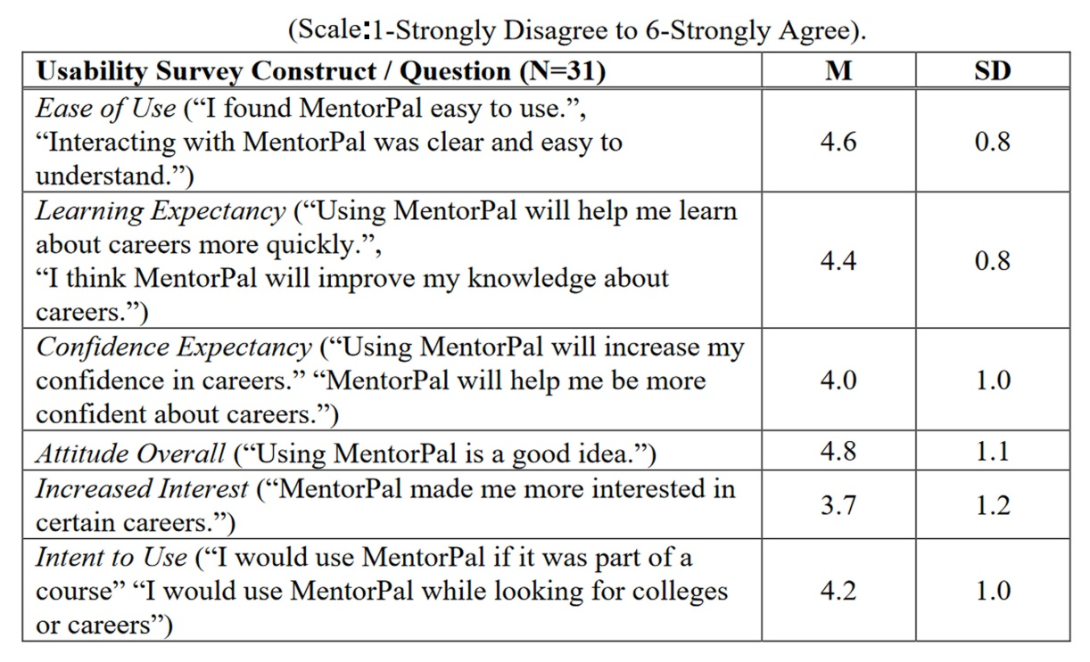
Another issue is that of student receptivity. When queried orally by the research personnel, the students also gave the program high marks and said they would use it, but it may be necessary to have a more anonymous evaluation, conducted by personnel who are not part of the project team. By the time they are Seniors in high school, students have be socialized to not challenge teachers or question teaching effectiveness. Other studies of unsuccessful mentoring project rated mentee receptivity very low and to some degree ascribed failure to achieve the real goals to the students not appreciating what the mentors could do for them.

There is an essential requisite for a STEM role-model amplifier. To respond to this need, the US must implement a technology or methodology that enables students to have access to the value of a frank, one-on-one discussion with real-life and engaging professionals. Then the students could understand more about what a career really requires, what the work is like, and whether that career might be a good match for them. To address this problem, the ICT/USC researchers are designing and testing a scalable tablet and web-based application called MentorPal that gives students the opportunity to converse interactively with short video-clips of real-life STEM professionals.

In any case, a more complete program to highlight the otherwise un-recognized positive aspects of a STEM career could be fashioned, based on existing technologies. Any number of defense contractors could accomplish this initiative. The initiative might begin with a short video describing the work, then and introduction to the mentor panel so the student can start thinking about to whom they would like to speak. Perhaps a few minute discussion of parameters of a successful career could get the students thinking about: "What makes a fulfilling career."

The authors envision the program as providing:
- A series of attractive mentors of varying ages, disciplines and ethnicities
- Mentors available 24x7 who are exciting, engaging, and enthusiastic about STEM
- A series of video clips of the mentor in other settings: Rooms, Labs, Production Facilities, etc.
- An A/I function to recognize new topics, sort them, store them and alert team of the need to respond
- A function that would identify a need to engage other mentor and a graceful way to accomplish that change
- A series of "YouTube-like" videos portraying the kinds of work the mentor talks about in a way useful to users

Implementation

An implementation of this order should go a long way to ameliorate the hurdles mentioned above. It could easily address the late adolescents wavering ego strength by allowing them to interface with a very human-like computer agent, who nevertheless is not a human who can shame or embarrass them. This can and will open up new vistas and courses of exploration without any fear of being humiliated.

Earlier work at USC has found that Veteran who suffered from PTSD spent more time on video-cons with the animated counselor called SimCoach than they did on similar video-calls with live PTSD counselors. (Rizzo et al., 2011) The reasons for this are manifold and have not been studied to the best of the authors' knowledge. Some early research shows that PTSD sufferers from the Vietnam era were very reluctant to talk to anyone of their experiences who had not served in Vietnam. This may be peculiar to that particular war, but may be a function of the Veteran's not feeling comfortable with their own inability to handle the stress they faced. (Peeples et al., 2008) The reason this issue is important in the context of this paper is that similar issues may arise with those in the throes of adolescent insecurities that would also impact the relative effectiveness of live or virtual mentors in achieving the goals of improving STEM career choices, be they positive or negative.

Others have done much good research, not mentioned above. Linnea Rademaker looked at on-line "live" mentorships for dissertation development and has some insightful conclusions (Rademaker et al. 2016). Perhaps more on point for the main thesis of this paper, Jo Fayem and others looked at the efficacy of on-line mentors impacting motivation of undergraduates (Fayem et al., 2018). On Sri Lanka, Prof. Vimalini has developed some really good analysis of efficacy of on-line training, education and counseling. It bears internalizing. His findings are both insightful and encouraging, as in table below. (Vimalini & Arulrajah, 2021)

Table 4 Descriptive Statistics Regarding Student Satisfaction with On-Line Learning
Variable | Mean | Standard Deviation
Instructor quality | 3.53 | 0.65
Perceived usefulness and ease of use | 3.29 | 0.76
Course delivery | 3.59 | 0.66
Technology | 2.32 | 0.40
Interaction | 2.43 | 0.49
Satisfaction | 3.35 | 0.70
(1.0 ≤ X ≤ 2.5→Low level), (2.5 < X ≤ 3.5→Moderate level), & (3.5 < X ≤ 5.0→High level)

The various team members who worked on MentorPAL did discover some operation issues as the project progressed. As US Naval personnel were sought, a message was disseminated by higher authority soliciting candidates. Usually, a member of a unit was "volunteered," with all of the candidates turning out to be excellent. One of the issues the team at USC ran into was the consistent hesitancy by potential mentor to record video tapes. Camera shyness, like other stage fright seemed to dissipate quickly with the support of an engaging questioner and an informal setting for the taping. The sites for the backdrop, lights and camera were variously: classrooms, offices, a break room, and a home basement. Person-to-person interviews were a required feature of the mentor recruit process. A vivacious and engaging personality was a sine qua non of the selection phase of the videotaping. Having a personality that was seen as being almost too "over-the-top" was found to produce the best taping subject, as that personal characteristic transferred well to the screen.

The most serious thesis of this paper is that these capabilities are already proven to be useful and arresting for many people. The need is there, as is the technology. Not only that, but the basic approach would be easily extensible in any number of ways in different disciplines faces with similar issues.

One thing did become obvious; there was a need for a meta-disciplinary approach involving several disciplines. All of the individual steps were on the leading edge of development, so each required a thoughtful and elegant coder to produce both the code and the associated documentation to ensure a stable code base. The illusion of the virtual conversation could be easily interrupted by any computer glitch. The three most important disciplines are:
- Computer science – to implement the Natural Language Processing algorithms and I/O
- Behavioral science – to design and asses the mentoring, especially the metrics
- System engineering.- to ensure that all the processes functioned as on unit

DATA VALIDATION

Some of the data cited are very encouraging. This however is only the beginning of a very lengthy process. To be meaningful work, there must be a significant effort expended in developing a realistic way of ascertaining and quantifying the goal of the effort. That means an objective measure of merit must flow from a similarly well defined and justified ultimate goal. There should also be periodic measures of reported results. Some interim tests could be self-reported changes in attitude, decision to pick a STEM Major, decision to remain in a STEM program, and a self-evaluated satisfaction with the University.

In any case, the long-term goal should remain the centering of the user on the correct approach to critical thinking and projection of immediate goals onto long-term developmental goals (Tetlock & Gardner, 2016). Helping students realize their role in selecting an appropriate career is only a small step; teaching them to have both a process and faith in that process to make sound decisions is vital to their career and their entire life.

CONCLUSIONS

As this paper focuses more on relating the lessons learned from a development process than a formal investigation of a previously advance thesis, the conclusions match this theme.

Nevertheless, the authors feel their theses have been substantiated by both their anecdotal evidence and by the statistical data provided: There is a need for STEM-trained professionals. The current situation is less than optimal.
Many human traits stand in the way of clearing the path to realization of good career selection and societal needs for more technical personnel. Limitations of individual humans have cause separation by students from mentors capable of providing assistance to them. New emerging technologies can investigate opportunities to intervene productively in a way that live humans cannot. This will ameliorate the STEM personnel shortage issues, albeit not eliminate the issues. These approaches are extensible in other areas.

ACKNOWLEDGEMENTS

Nearly all of the work involving Virtual Humans reported in this paper came from a series of research projects of which the Principal Investigator was Dr. Benjamin D. Nye, Director of Learning Sciences at ICT. Without his technical vision and unflagging support, none of this would have taken place. The various projects mentioned were supported by a range of DoD organizations and, while this paper reports insights gained during that work, which was not the focus of the research. Much of this work was supported by grants from the Office of Naval Research's STEM Program (ONR N00014-16-1-2820) and by students supported by the National Science Foundation Research Experience for Undergraduates program (NSF 1560426). Nevertheless, the positions taken in the paper are the authors’ own and do not represent in any way the views of the Department of Defense or the US Government.

REFERENCES

BLS, (2020). Employment in STEM Occupations, Bureau of Labor Statistics, Washington DC, Retrieved from Internet on 14 Dec 21 from: https://www.bls.gov/emp/tables/stem-employment.htm
BLS. (2020b). Labor Force Statistics from the Current Population Survey (CPS), Concepts and Definitions. Retrieved 09 Dec 2021 from https://www.bls.gov/cps/definitions.htm#population.
Davis, D. M., Lucas, R. F., Gottschalk, T. D., Wagenbreth, G., & Agalsoff, J. (2009). FLOPS per Watt: Heterogeneous-Computing’s Approach to DoD Imperatives. In the Proceedings of the Interservice/Industry Simulation, Training and Education Conference. Orlando, Florida, 2009
Dawson, D. A. (1995). The Impact of Project 100,000 on the Marine Corps. History and Museums Division, Headquarters, US Marine Corps.
Fayram, J., Boswood, N., Kan, Q., Motzo, A., & Proudfoot, A. (2018). Investigating the benefits of online peer mentoring for student confidence and motivation. International Journal of mentoring and Coaching in Education.
Furstenberg, F. F., (1966), "Industrialization and the American family: A look backward." American Sociological Review (1966): 326-337.
Nye, B., Swartout, W., Campbell, J., Krishnamachari, M., Kaimakis, N. & Davis, D. (2017). MentorPal: Interactive Virtual Mentors Based on Real-Life STEM Professionals. in the Proceedings of the Interservice/Industry Simulation, Training and Education Conference, Orlando, Florida, 2017
Nye, Benjamin D., Dan M. Davis, Sanad Z. Rizvi, Kayla Carr, William Swartout, Raj Thacker & Kenneth Shaw (2020). Feasibility and Usability of MentorPal, a Framework for rapid Development of virtual Mentors. Journal of Research on Technology in Education. London, UK.
Peeples, A., Havrilla, S., & Romero, E. (2018). Vietnam Era Veterans With PTSD: Barriers, Facilitators, And Preferences For Treatment Engagement. Innovation in Aging, 2(Suppl 1), 514.
Rademaker, L. L., Duffy, J. O. C., Wetzler, E., & Zaikina-Montgomery, H. (2016). Chair Perceptions of Trust between Mentor and Mentee in Online Doctoral Dissertation Mentoring. Online Learning, 20(1), 57-69.
Rizzo, A., Lange, B., Buckwalter, J. G., Forbell, E., Kim, J., Sagae, K., ... & Parsons, T. (2011). SimCoach: an intelligent virtual human system for providing healthcare information and support. International Journal on Disability and Human Development, 10(4), 277-281
Sample, S. B. (2003). The contrarian's guide to leadership (Vol. 14). John Wiley & Sons.Tu.
Tetlock, P. E., & Gardner, D. (2016). Superforecasting: The art and science of prediction. Random House.
Vimalini, N., & Arulrajah, A. A. (2021). Exploring the critical factors influencing the student satisfaction in online learning during the COVID-19 pandemic. The Journal of Business, 5, 02.

