Learning Analytics and Deep Learning:
Emerging Standards for Instructional Metrics

Dan M. Davis, Jennifer H. Nolan, Jerome C. Placido & John J. Tran
Catholic Polytechnic University
1028 N Lake Ave MC 207
Pasadena, CA 91104
{ ddavis, jnolan, jplacido, & jtran } @catholicpolytechnic.org

Judith L. Jacobus
Education Counselor/Therapist
1564 Merion Way.
Seal Beach, CA 90740
stately07@dslextreme.com

Keywords:
Learning metrics, instructor evaluation, machine learning, AI, skill assessment

ABSTRACT: The better quantification of results, analysis of efficacy, and enhancement of instructional techniques is now being facilitated by advances in emerging technologies. This suggests the need for implementations of these techniques in the Modeling and Simulation (M&S) discipline. Learning Analytics, Deep Learning, Neural Net Training, and Meta-Disciplinary approaches to the evaluation, selection, and preparation of instructional personnel are now feasible. Across the millennia, history reports that sages, instructors, and mentors have been sought to help prepare people for productive contributions. Most of the evaluation to date has been based on subjective and unquantified impressions, often generated by the instructors themselves. The obfuscation caused by human emotions has masked even the modest ability that previous generations had to evaluate pedagogical effectiveness. This paper adduces data to show how this conflation of the instructor's personal charisma has predestined early attempts to evaluate pedagogical skills to disappointment. During research into virtual conversational interfaces, the authors observed a number of issues concerning instructor evaluation. The very act of replacing "live humans" with computer-generated avatars is potentially insightful. Researchers have made significant strides in Learning Analytics, suggesting that Artificial Intelligence communities may have observations that could be useful in live-instruction environments. Also, several emerging capabilities in the computational sciences have showed both results and future promise. These new technologies are outlined and reviewed. The paper disuses emerging capabilities of machine learning and learning analytics. That leads to the concomitant opportunity for salient standards in the M&S community. Such standards would help quantify improved evaluation of human instructors. All of these issues are then synthesized to produce a viable path to a new set of psycho-metric tools for a better pre-selection evaluation, more tailored instruction, and improved final competency assessment of instructional personnel. This is an especially pressing current concern of the authors.

Introduction

One of the issues facing organized societies has been the training of members of the society for various duties. These efforts were recorded virtually from the time of written language, as were assessments of those who sought to teach. These assessments were largely anecdotal, with little attention as to how effective the efforts were. Advances in technology have brought about both a heightened awareness of the need to more reliably assess training and education efficacy and some emerging capabilities to more rationally perceive which techniques and which personnel were the most effective. This ability to isolate important characteristics of successful instructional capabilities calls into question the higher order goals of the processes themselves. This then calls for a re-evaluation of the foundation for those goals. This faces the society and, more pointedly, the simulations standards community with the recurring question: "What are the germane figures of merit and how are they justified?".

This paper is not so much designed to resolve those questions as it is to highlight the recent advances in monitoring education. Then it calls for an effort to analyze how those technologies have elevated the evaluation of teacher/teaching efficacy to levels that will require the eventual appraisal of a new vision for training and education. The journey begins with looking at a general statement of where the society may want to go. Then there will be a section on how it is trying to get there now, with a brief look at how they have tried to get there in the past. Then a "strawman" vision for the future will be identified, so as to give focus to the analyses that will follow. The next section will discuss which technologies might be a good path to that vision. Having set that stage, there will be a consideration of alternatives and of comparative costs and benefits to the various paths. The paper will conclude with a set of issues to be addressed and the potential cost, risks and benefits of them.

- Background

Something on the order of 250,000 – 350,000 thousand years have elapsed since homo-sapiens broke off from one of the progenitor great apes [1]. There is commonly thought to be a "knee" in the modenarity level of the species about 100,000 years ago [2], with another sharp acceleration after the time of the near-extinction has been proposed [3]. Anthropological evidences shows that for almost the entirety of human existence, the vast majority of people lived in hunter/gatherers societies. In these, current studies of primitive peoples suggest that almost all training was in an apprentice-like relationship, with the parent of the same gender teaching the child the necessary skills for survival [4]. The advent of agriculture and then urbanization had dramatic impacts on society, leading to a more formal recognition of "learned people" and concomitant desire for educating the powerful and well-to-do. There are historical records that indicate schools existed in classical Egypt [5] and Greece [6] In the latter, a very harsh form of teacher evaluation is extant in the story of Socrates [7]. The industrial age put new emphasis on education and today about 90 of children attend primary school [8], but others observe that only about of 50% of post-school children from third world countries can read [9].

  - Teacher self-evaluation

So, given the numbers suggested above, one may question the effectiveness of the teachers or the system. The evaluation of students' learning is most often quantified in grades presented. This seems reasonable on its face, but misses the scientific dictum that the evaluation should be done, not by the practitioner, but by some unbiased observer, who ideally does not have any relationship with the teacher. In the case of the trappings of self-evaluation, there is clearly strong impetus for the teacher to "see" improvement worthy of a better grade, both for career advancement reasons and for ego reissuance that the work being expended is worthwhile.

  - Student evaluations

Another common method is the student survey. This is more common in Colleges and Universities where the student population is interested in which professor is entertaining, non-demanding and a generous grader. But it exists in grade school where a rating by the students found almost a +1.0 correlation between the scores given by the elementary school children and the ratings given by adult of the beauty of the teachers as portrayed in their photographs [10]. As humans, most all of us enjoy being liked and our careers often depend of students' "signing up" for our courses. The inclination to curry favor with the students is patent. If the reader did not see this sort of thing, Figure 1 is shown below.

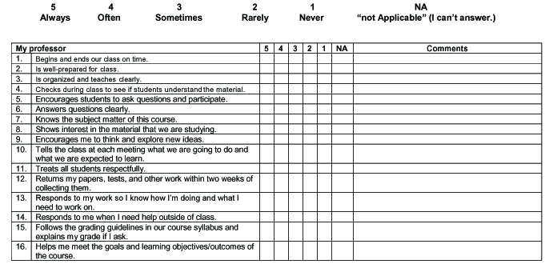
Figure 1 Typical Professors' Evaluation Form (Vanderbilt Center for Teaching)

  - Senior teacher evaluations

Within the experience of the authors a similar notion is observed with evaluations are performed by senior teachers. Rather than as judges, they often see themselves more as mentors. Therefore, the mentor is potentially driven to observe improvement in their mentee, rather than to impartially point out deficits in performance. This is not unique to teachers; therapist are similarly more likely than an independent evaluator to see progress in patients where there is little or none [11].

  - Research achievements predominate

Another factor to be considered is the consistent emphasis in most U.S. universities on research as the key to retention, tenure and advancement [12]. This means that there may be little other than a natural inclination to teach in some professors that drive them to excel in the classroom, cf. a dramatic portrayal of the joys of the professoriate in a 2014 film. [13]

  - Employers and other consumers of student capabilities

Two anecdotes will help illuminate this issue. 1) When one of the authors (Davis D.M.) was at a major research university in the Los Angeles basin, he was invited to a lecture from the CEO of one of the larger computer software companies in the US. This person commenced with excoriating the assembled professors for turning out technically capable students who lacked an important basic skill that is a vital education goal: the ability to write concise, cogent and compelling documents. He reported having to buy each new employee a copy of Strunk and White. 2) The existence of so many remedial classes at U.S. universities is certainly an undeniable indicium of a failure in the system somewhere. The authors have been told by senior university officers that they are admitting students with "straight 'A' GPA's" who cannot read well and can hardly write a simple sentence.

  - Parents and other personally concerned parties

Even parents who are deeply committed to their children's welfare are rarely in a position to assess the competency of their teachers. Their focus is, and should be, on how well their child is progressing and behaving. They occasionally get standardized tests to give them an inkling of increasing proficiency, but again are more likely to regard the teacher-generated grade card as the standard.

- Advances in Assessing Instructional Capabilities

Today, computer capabilities have increased the objectivity, accessibility and extensibility of the educational processes. A brief summary and evaluation of a few of the major advances will be presented, with links to the underlying research for pursuit by those wishing a more complete explication of the technology/approach.

  - Learning Analytics

When an educator/trainer wants to be able to obtain the collection, measurement, and analysis of data about learners and their environments, they would not be ill-advised to consider their task in terms of Learning Analytics (LA) [14] for purposes of understanding and optimizing learning and the environments in which it occurs. One of its early definitions was from the LAK 11 (Learning Analytics and Knowledge 2011) [15] conference. It has subsequently garnered a lot of interest, particularly in higher education. It is a technique wherein the student data can be captured and analyzed. When learners use network-enabled, online tools, their selections, navigation history, active participation, frequent contacts, messaging, and ideation can be inferred with some confidence through exchanges that can be tracked. It is facilitated by digital information, to which it has easy access e.g. on-line courses. It offers additional data for educators to track, evaluate, and optimize teaching and learning, promising insights for all educational systems.

  - Deep learning
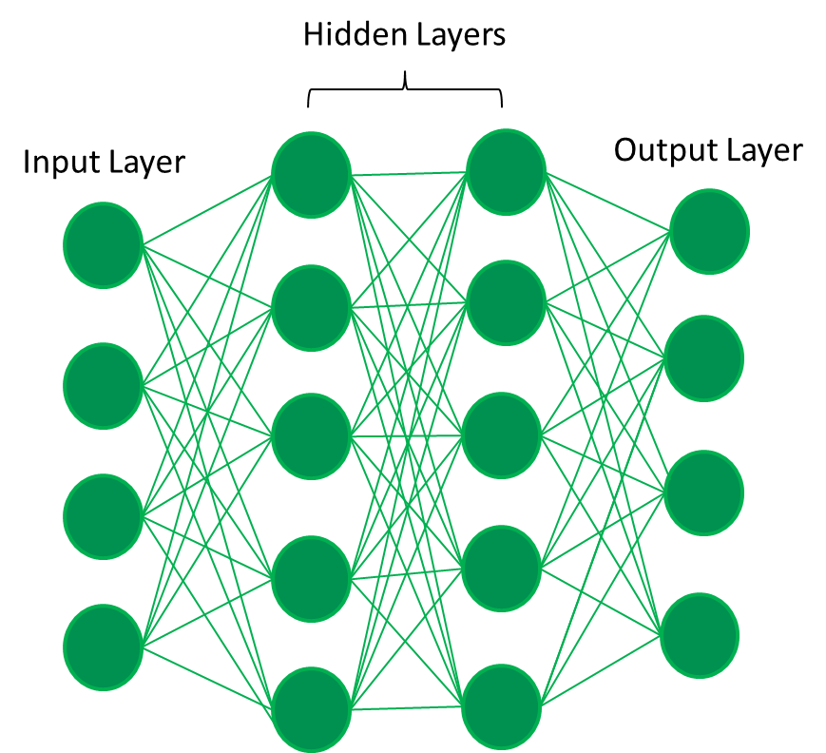
Figure 2 Notional & Truncated Deep Learning Diagram
(Apache Spark Computer Photo)

As discussed before in earlier papers, [16], Deep Learning (DL) is a machine learning technique that constructs more elaborate artificial neural networks. One can add to that layers analogous to the function and operation of the human brain. In its use, DL hierarchical learning uses a unimaginably huge amount of data and significant numbers of hidden layers of layers, say half a dozen (only two are shown in Figure 2). This filters data using nonlinear processing to identify and record features from all of that data and then render the data back in meaningful ways. By being both ever-vigilant and never forgetful, it can discover connecting relationships not recognized before. It clearly is an enabling tool for the above defined Learning Analytics and other teacher evaluative processes.

  - Virtual conversations

LA and DL are ways in which the researcher can extract information previously not available, but in Virtual Conversations, the information flow is the other way. It produces the most life-like presentation of information in a reassuringly concerned human, day or night, rain or shine, pandemic or good health. With the new insights from LA and DL, a surfeit of new information may swamp the human teacher and call for increased individualization of the material, but the computer through the use of virtual conversational techniques is in no way constrained by human frailties. [17]

  - Neural Net Training

A neural network is a category of computer programming, mottled after live neurons. Animal brains are capable of solving complex problems, but each one is only tasked with understanding a very small segment of the issue at hand. They are made up of cells that work together to identify and characterize segments of a behavior. Give a set of constraints and figures of merit they can quickly optimize the solution. One example often used is their ability to watch, learn and win at chess. Each individual sub part of the program is only responsible for learning a small part of the problem. This is one way to perform artificially intelligent analyses. Neural networks are an paradigm example of machine learning, in that a program can evolve as it learns to solve a problem. Given the correct figure of merit, the neural network will experience training and, with each example, conceive a better approach. In general, the larger the neural network, the more runs it will need to achieve and optimum solution. Sometimes they need mega or even peta-iterations to rise to the level of deep learning.

  - Meta-Disciplinary

As many of these emerging capabilities become commonplace, there will be very important synergies that will be possible of producing some almost unimaginable improvements in both educating and assessing that education. Meta-discipline projects will not just borrow a skill or two, but will be founded on a project genesis that fully incorporates what the technologies can do in concert.

- Search for underlying goals

  - A needed foundation

Most of our colleagues hold that the one critical issue in any computer effort is a well-defined and carefully justified goal. As is true for some many things in the "first world," concepts like this seem to become even more critical when the effort becomes more complex. The goal of a farmer to produce enough food to feed his family so they will not starve appears more straight forward than: "Why are we educating our children?" and "What do they really need to make their lives better?". While these decisions are perhaps outside of the purview of this paper and the purview of this community, the authors assert that standards professionals should stand firm when considering their work; they (we) must have clearly defined goals and those for which this community can ardently support.

  - Standards impact on goal formation

If the standards are to be set for Learning Analytics evaluation and for Artificial Intelligence training, the goal-setters may profit from knowing ahead of time what is required. To make ad absurdum propositions at the boundaries might shed some light on what that might mean in setting educational goals. Clearly the goal of: "Making every student happy." is too broadly posited and too indistinct to make a good goal and to subjective to allow a programmer to input a metric as a figure of merit in any of the AI programs. On the other hand, if the goal is: "Making everyone know the language of the Tuvans." it is too unproductive and specific, with little chance that any standards professional would know where to start finding a way to measure that effectively.

  - Close and productive interaction

Further, such an effort would be difficult in any case, but more difficult if both parties receded back into their comfort levels instead of congenially assisting others with civil questions and friendly challenges of definition and value. Then the normal tendencies of picking easily quantified and high face-value goals could be moderated and deep and meaningful goals established. There was the oft-told tale that Human Relations departments used to measure the speed of typists with regularity until it was pointed out to them that most of the people they were hiring would type very little and the most highly prized personal assistants were those who were organized and pleasant.

- Future technological opportunities

Four new technologies were set forth above. They bring a number of new possibilities to solving age-old problems and making human behavior analysis not quite so random. Even doing correlation coefficient calculation was a daunting task of the past, especially with very large numbers of data entries. Now computers can do this almost instantaneously with great accuracy. The issue with the above identified capabilities is what might they do that has never before been tried because it was too difficult.

  - Learning analytics: What works?

With such good new sensors and capable analysis programs, it may be possible in ways that were unheard of to measure what is effective in teaching and teachers. This would allow assessment of the degree to which the goals were being met and by whom. Such a capability would enable teachers to hone their skills, students to make valid career choices, and societal leaders to direct efforts to take advantage of assets and remediate deficits.

  - Deep Learning: Who should do what?

One of the issues constantly faced by today's students is which career to follow [18]. Parental guidance is not always well-informed and notoriously ignored by students. Childhood dream have surely been more often met with disappointment than success. Following a teen-age crush or good friend along path may also not be rewarding. With Deep Learning, various studies could show who is well suited to a certain field. The Myers-Briggs [19] and the Smalley and Trent [20] instruments have their detractors, but a Deep Learning analysis might have the depth to overcome the shortcomings of those two.

  - Virtual conversations: Who can help me with my education?

Most every student the authors have known has had some point in their careers when they needed a person with whom they could speak. Often a friendly teacher was that source, but many report that they had access to no such person. The work cited above on Virtual Conversations showed that a computer driven substitute for a live human, either animated or video clips of live humans, resulted in longer conversations and were more likely to evince emotional intimacy than did live humans. Person after person has told us that their High School Counselor was of absolutely no assistance [21].

  - Neural net training: How do we optimize education for each student?
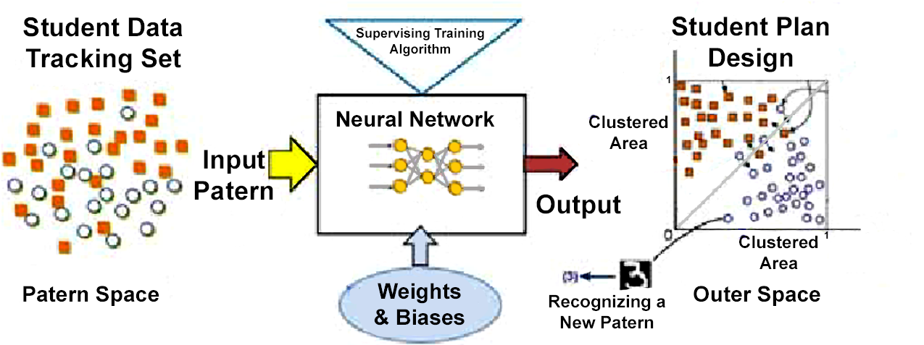

Figure 3 Neural Net Functional Diagram
Makoto Mizukawa Image
One thing that all good teachers tell us is that every student is different and special. The number of students they have in their care prevents their best meeting the needs of everyone. With computer generated instruction strategies [22], pacing and directions could be tailored, leaving the teacher the time they need to both care for the individuals needing their attention. (Figure 3) They could also have more time for monitoring the students to make sure the Neural Net training is on the correct track.

  - Meta-Disciplinary: Can we make sure that no student IS left behind?

Every student is valuable; every life should be treasured. Giving the individual teacher the appropriate support they need and freeing them from the drudgery of grading papers and lecturing outside of their strengths and interests would be an improvement for them and a blessing for their students. Considering the complexity of each student, it seems desirable to have a multi-disciplinary group of professionals to respond, even in small and under-staffed schools [23].

- Visions for Future

Considering all the data above, it seems there are several areas where simulation standards professionals would bring to the table some very important skills and valuable experience. It further would appear that the flow of information would be bi-directional. The educators would benefit from the injection of the quantitatively focused M&S standards professionals and the collaboration in integrating emotional considerations, sensors and analysis would benefit both parties.

There would, of course, be risks of contention, costs of time for learning on both sides and the ever-present worry that animosities could cause disruption. Nevertheless, the "quantification" of the educators outlook and the sensitizing of the M&S standards personnel should bring value to both.

  - Discussion
Being aware of the dangers of professional hubris and yet admitting that other research communities have thoughtful professionals whose duties and capabilities overlap with the M&S community, it seems like this may be an opportunity to seek out and nurture closer relationships with the educators and consider, collaboratively, their educator evaluation quandaries.

  - Metrics and Standards

One specialty that should be addressed by this community is the one of metrics and standards of human performance. The M&S community would bring interoperability and precise metrics' expertise, while the educators would bring human evaluation metrics experience. Both communities could be enhanced by the interaction of their constituents. One of the theses of this paper is that the advances discussed herein have opened up a new set of tools for assessing human behavior in a fairly scientific way.

- Conclusions

Educators have faced hyper-complexity and human bias in evaluating teachers effectiveness for several millennia, but new advances have shown that an improved approach could be adopted. Many issues could be addressed, but they would be better addressed by a multi-disciplinary team that include the M&S standards community. The risks and costs are appreciable, but the potential benefit may outweigh that in the final analysis.

- Acknowledgements

The authors wish to thank all of the simulation professionals with whom they have worked over the last three decades. This discipline is blessed with a fine group of creative and productive career scientists. We should also note that much of the work cited was supported by grants from the Office of Naval Research's STEM Program (ONR N00014-16-1-2820) and by research assistants supported by the National Science Foundation Research Experience for Undergraduates program (NSF 1560426). Nevertheless, the positions taken in the paper are the authors’ own and do not represent in any way the views of the Department of Defense or the US Government.

- References

- Hublin JJ, Ben-Ncer A, Bailey SE, Freidline SE, Neubauer S, Skinner MM, et al. (June 2017). "New fossils from Jebel Irhoud, Morocco and the pan-African origin of Homo sapiens" (PDF). Nature. 546 (7657): 289–292
- Marean, Curtis; et al. (2007). "Early human use of marine resources and pigment in South Africa during the Middle Pleistocene" (PDF). Nature. 449 (7164): 905–908.
- BBC, 2003. When Humans faced Extinction. British Broadcasting Corporation, Retrieved from the internet on 22 Dec 23 via: http://news.bbc.co.uk/2/hi/science/nature/2975862.stm
- Scarre, Chris (2018). "The world transformed: from foragers and farmers to states and empires". In Scarre, Chris (ed.). The Human Past: World Prehistory and the Development of Human Societies (4th ed.). London: Thames & Hudson. pp. 174–197
- Assmann, Jan (2003). The Mind of Egypt: History and Meaning in the Time of the Pharaohs. Cambridge, MA: Harvard University Press.
- Lynch, John Patrick (1972). Aristotle's School; a Study of a Greek Educational Institution. Berkeley: University of California Press.
- Brickhouse, T. C., & Smith, N. D. (1990). Socrates on trial. OUP Oxford.
- World Data, (2022) Primary school enrolment, World, 1970 to 2016. Retrieved from the internet on 06 Dec 23 via URL: https://ourworldindata.org/grapher/primary-school-enrolment-by-sex
- World Bank, (2021). Learning Poverty. Understanding Poverty Project. Washington, D.C., USA
- [Davis, D.M. (2023). Oral Comment on Teacher Ratings, Professor O.J. Harvey, University of Colorado, Boulder, Colorado. 1972. No source cited.
- Brosan, L., Reynolds, S., & Moore, R. G. (2008). Self-evaluation of cognitive therapy performance: do therapists know how competent they are?. Behavioural and Cognitive Psychotherapy, 36(5), 581-587.
- Christensen, C. M., & Eyring, H. J. (2011). The innovative university: Changing the DNA of higher education from the inside out. John Wiley & Sons.
- Lawrence, M. (Director/Writer). (2015). The Rewrite [Film; DVD release]. Castle Rock Entertainment.
- Dietz-Uhler, B., & Hurn, J. E. (2013). Using learning analytics to predict (and improve) student success: A faculty perspective. Journal of interactive online learning, 12(1), 17-26.
- LAK 11 (2011). Learning and Analytics Conference, 2011. Alberta Canada. Retrieved from the internet on 17 Dec 22, from URL: http://www.wikicfp.com/cfp/servlet/event.showcfp?eventid=11606
- Peng, S., Cao, L., Zhou, Y., Ouyang, Z., Yang, A., Li, X., ... & Yu, S. (2022). A survey on deep learning for textual emotion analysis in social networks. Digital Communications and Networks, 8(5), 745-762.
- Davis, D.M. (2023). The Mentor –Pal Project. Insitute for Creative Technologies, USC. Retrieved from internet on 20 Dec 23 from: http://www.hpc-educ.org/MentorPal/Web/MntPal_Index.html
- Hackett, G., & Betz, N. E. (1995). Self-efficacy and career choice and development. Self-efficacy, adaptation, and adjustment: Theory, research, and application, 249-280.
- Naik, H., Dedhia, S., Dubbewar, A., Joshi, M., & Patil, V. (2022, August). Myers Briggs Type Indicator (MBTI)-Personality Prediction using Deep Learning. In 2022 2nd Asian Conference on Innovation in Technology (ASIANCON) (pp. 1-6). IEEE.
- Smalley, G., & Trent, J. (2019). The two sides of love. Focus on the Family.
- Dimmitt, C. (2009). Why evaluation matters: Determining effective school counseling practices. Professional School Counseling, 12(6), 2156759X0901200605
- Parisi, G. I., Kemker, R., Part, J. L., Kanan, C., & Wermter, S. (2019). Continual lifelong learning with neural networks: A review. Neural networks, 113, 54-71.

Author Biographies

DAN M. DAVIS is a Research Associate Professor at Catholic Polytechnic University (CPU) and is also active as a consultant at the Institute for Creative Technologies, University of Southern California (USC). He is currently focusing on large-scale DoD simulations and virtual human implementations. Prior to retirement, he was the Director of the JESPP project at USC for more than a decade. As the Assistant Director of Advanced Computing Research at Caltech, he ran Synthetic Forces Express, bringing HPC to DoD simulations. He has also served as a Director at the Maui High Performance Computing Center and in computer research roles at the Jet Propulsion Laboratory and Martin Marietta. He was the Chairman of the Coalition of Academic Supercomputing Centers and has taught at the undergraduate and graduate levels. As early as 1971, Dan was writing programs in FORTRAN on one of Seymour Cray’s CDC 6500’s. While in the Marine Corps, he saw duty in Vietnam as a Cryptologist and retired in 2002 as a Commander, U.S.N. He received B.A. and J.D. degrees from the University of Colorado in Boulder.

JENNIFER H. NOLAN, PH..D. is the President of Catholic Polytechnic University and Professor of Psychology in their College of Arts and Sciences. Her earlier work specialized in memory, dementias, stroke and insulin resistance. She is a brain plasticity specialist and certified Cogmed provider. Previously, she was the C.O.O. and co-founder of a stroke and brain injury rehabilitation center. Dr. Nolan has taught university courses at the University of California Irvine, Loyola Marymount University, and Glendale Community College. She has conducted local and nationwide clinical trials, and published in both scientific journals and popular magazines. She received a BA in Psychology from Loyola Marymount University, Los Angeles and a Ph.D. in Psychology from the Dept. of Cognitive Science at the University of California, Irvine.

MARK C. DAVIS, PH.D. is the Chief Technical Officer at Wood Duck Research, Inc, and is semi retired after careers in the US Navy and as a computer design engineer for both IBM and Lenovo. Rising to the level of Distinguished Engineer at Lenovo, he was responsible for the design of laptop computer cross-disciplinary technology, including PC architecture, embedded systems, open source and virtualization. Previous work was with IBM in the areas of software development and architecture involving security, storage and virtualization. Dr. Davis has been granted well over fifty patents that were filed during his service at both companies. He is a graduate of the Duke University NROTC program and was commissioned as an Ensign, attended nuclear power school, and served as a Submarine Officer for twelve years, including one duty tour as a classroom instructor. He left the active duty as a Lieutenant Commander to pursue a PhD. Mark holds a BSEE degree from Duke University and a PhD in Computer Science from the University of North Carolina, Chapel Hill, where his advisor was Professor Fredrick P. Books.

JUDITH L. JACOBUS is retired from conducting speech therapy as a Speech and Language Specialist for more than two decades. Her experiences were in public schools settings in Orange County. California. She also previously taught for 12 years as a classroom teacher in multi-cultural communities there. Judith currently volunteers her professional skills for a local police department, so has extensive experience with dysfunctional adults and children in a variety of both every-day and traumatic situations. Her participation in amateur theatrics has more fully familiarized her with the characteristics of human behavior as they are projected via verbal, facial and body-language cues. This experience has also exposed her to the skill and art of the selection of appropriate persons for specific on-screen roles. Judith holds a lifetime Special Education Credential in Speech and Hearing Therapy, K-12 from the State of California. She earned a B. A. Degree in Speech Communications from the California State University Long Beach and an M. A. Degree in Teaching and Teacher Leadership from the Grand Canyon University in Glendale, Arizona.

